FACILITATING CHANGE AND MANAGING QUALITY
NAME: OLOLADE ADEDIRAN
STUDENT NUMBER: 1903205
WORD COUNT: 5000 WORDS
MODULE LEAD: JAN HOWELLS
19/04/2024

Table of Contents
Abstract 2
Introduction 2
Digital Transformation in Mental Health 4
Adoption of Digital Tools in the NHS 5
Teletherapy Services 5
Online Self-Help Resources 7
Impact of Digital Transformation 9
Enhancing Access to Services 9
Challenges and Limitations 10
Service Improvements 11
Digital Versus Traditional Services 12
Critical Evaluation 13
SWOT Analysis 14
Future Directions and Recommendations 15
SMART Goal 15
PDSA Cycle 15
Kotter Change Model 16
Conclusion 18
References 20
Appendix 25
Survey Question 25
Response Interview Question 26

Digital Approach in Transforming Mental Health Care in the NHS

Abstract
NHS digital transformation has altered UK mental health treatment. Digital technologies are transforming mental health care to meet expanding needs, improve quality and efficiency, and increase patient access. Teletherapy, online self-help, and healthcare professional platforms are part of the NHS's decade-long mental health digitization. COVID-19 has enhanced remote care utilisation to continue therapy during difficult times. The NHS is digitising to meet present demands and future-proof its mental health agenda. The NHS wants to use digital technology to develop a more inclusive, patient-centered care model that crosses geographical and temporal boundaries to provide immediate aid and manage mental health. This paper critiques NHS mental health care's decade-long digital shift, its drivers, and its future. Digital transformation and its consequences are examined using mixed-methods research and qualitative and quantitative data analysis. This extensive study of research, case studies, NHS performance indicators, and patient satisfaction surveys examines digital mental health project successes and failures. Digital technology has made mental health therapy faster and more accessible for varied patients. Apps for online self-management empower mental health sufferers. Digital services gather and analyse data for customisation and enhancement. The digital gap, technological dependability, and therapeutic alliance impact necessitate a technology-human care balance. VR and AI provide new therapeutic and patient contact potential. NHS mental health benefits from global digital collaboration. The NHS must meet patient requirements and strategically incorporate digital health technologies into the healthcare ecosystem as it digitises mental health services.

Introduction
Digital technology improves mental health services' accessibility, quality, and efficiency (Whelan et al., 2020). The NHS, which provides free, comprehensive healthcare, started this transition. This research critically explores the NHS's decade-long digital revolution of mental health treatment, including its effects, causes, and future prospects. Digital technology use has skyrocketed in all areas, including healthcare, in the past decade. Mental health digital revolution influences treatment delivery and reception beyond technology-driven services (Pierri and Herlo, 2021). New NHS mental health services include teletherapy, online self-help, and healthcare professional digital platforms (Barnett et al., 2021).
Many vital needs drive this change. Increasing mental health service demands surpass in-person therapy (Stepanova et al., 2024). Digital scalable solutions provide more with less. Second, early mental health intervention boosts awareness and results. Despite distance, digital platforms may hasten rehabilitation, mental health stigma hinders therapy and anonymous web services help avoiders are primary contributor for this (Adler et al., 2022). COVID-19 emphasises digital health services. Remote care has grown due to lockdowns and social distance, indicating digital platforms can provide continuity. This has accelerated digitization, affecting NHS mental health policy. A comprehensive look at how teletherapy and online self-help fit within service paradigms. A study of how digital innovations effect service accessibility, patient engagement, and treatment quality. Analysing digital strategy implementation challenges. Use of Kotter's Change Management Theory and the PDCA cycle to improve digital mental health services will be focused on this work. This comprehensive approach examines digital transformation in mental health treatment, including its triumphs and areas for development.
The study used mixed-methods research combining qualitative and quantitative data. This plan describes digital transformation and results. This inquiry examined peer-reviewed articles, NHS records, and government documents. This study examines digital mental health programme assessments, policy analyses, and healthcare change management theories. Research indicates NHS digital mental health initiatives. These case studies demonstrate digital transformation project management, challenges, and rewards. Patient satisfaction surveys, NHS performance assessments, and digital mental health care consumption statistics assess digital transformation. This study finds gaps, trends, and digital intervention effectiveness. PDCA and Kotter's Change Management Theory aid digital transformation evaluation. The PDCA cycle improves service quality and effectiveness, whereas Kotter's eight-step method assesses change management's strategic elements.
Aims
This report critically explores the NHS's digital transformation of mental health services, focusing on digital tool uptake, service quality and accessibility, and change management. This article studies the past decade to evaluate how digital activities affect health service goals, issues, and outcomes.

Digital Transformation in Mental Health
Digital health can transform NHS mental health treatment, but several factors must align. Recent studies are used to critically evaluate NHS digital services. Williams et al. (2020) critically examines English health commissioners' NHS digital healthcare uptake issues. The future of healthcare depends on digital medicines, but how to commission them is unclear. Structured interviews with 37 health commissioners identify key barriers, including a lack of familiarity with emerging technologies, information governance issues, and user and decision-maker digital literacy gaps. Developers and innovators must acknowledge these limits to construct complex, user-friendly, and well-governed digital health systems. We found that intensive training and clear governance structures are needed to increase digital literacy and incorporate digital therapies into NHS services. This will facilitate the transition to a digitally enhanced healthcare environment that embraces innovation and satisfies patients' and providers' shifting needs. Dave et al. (2021) credit the COVID-19 pandemic for the quick move from in-person to telepsychiatry. Physicians and patients embraced this change, signalling a paradigm shift in UK mental health treatment. The report acknowledges pre-pandemic human, technological, and institutional barriers to digital adoption. During the pandemic, telepsychiatry was required and accepted. According to the study, academic, educational, and clinical leadership must consolidate pandemic gains and develop digital psychiatry. Telepsychiatry's beneficial effects might alter post-pandemic mental health treatment by incorporating digital solutions deeper into ordinary clinical practice, enhancing accessibility.
In the context of increased demand and resource constraints, Dawoodbhoy et al. (2021) study how AI may simplify mental health treatment. Patient flow issues and AI solutions are identified through extensive literature study and expert interviews. Despite differing prognostic criteria, research show that AI may enhance patient flow by automating administrative operations and improving resource allocation. Real-time data analytics from AI can improve therapeutic decision-making, indicating a shift towards proactive and customised mental health care. The paper highlights investment and infrastructure to realise AI's NHS potential. It also emphasises data usage, legal compliance, and transparency to guarantee AI integration fulfils stakeholder expectations and ethical standards. This study shows that AI can improve mental health treatment, but strategic planning, research, and framework development are needed. Paterson et al. (2022) discuss NEON Intervention development and deployment expenses. Their research shows that developing, testing, and maintaining digital health remedies is costly. Two controlled studies with psychosis and non-psychosis mental health issues cost evaluation. Lived Experience Advisory Panels and software development are expensive. Construction is capital-intensive, while distribution costs scale with user cost after infrastructure is built. Major expenses include content updates and digital platform maintenance. Sensitivity research shows administrative costs dominate spending, boosting efficiency. The paper states that digital therapies like NEON require long-term financial planning, resource allocation, and fixed and variable cost management. Studies imply cautious optimism. Though useful and maybe supported by stakeholders, digital revolution in mental health care is difficult. Overcoming commissioner-user digital literacy gaps, preserving post-pandemic digital uptake, safely incorporating AI into patient care procedures, and controlling digital intervention development and costs are examples. The NHS's digital health plan must include these. It must be agile and adaptable, incorporating technology innovations while understanding change in a complicated service context.

Adoption of Digital Tools in the NHS

Teletherapy Services
Over the past decade, NHS mental health treatments in the UK have relied on teletherapy (Appleton et al., 2021). This feat was hastened by technology, patient demands, and the global COVID-19 epidemic, which required quick remote care adoption (Shaw et al., 2021). NHS mental health care is always in-person. The NHS investigated teletherapy as a service augmentation using digital technology. First by phone, teletherapy helped faraway or disadvantaged patients, then online. Smartphones and fast internet opened up teletherapy (Murphy et al., 2021). This enabled synchronous teletherapy applications like video conferencing and asynchronous ones like email and messaging services. The NHS adopted digital tools and platforms developed and commissioned. The Improving Access to Psychological Therapies (IAPT) project treated mild to moderate mental health illnesses with digital methods including cCBT. Teletherapy adoption changed during COVID-19. Virtual therapy became popular due to social isolation and the necessity to restrict contact. NHS providers swiftly included advanced mental health teletherapy. Secure video conferencing, online self-management, and teletherapy increased in regular care. Attend Anywhere Virtual face-to-face therapy resembles in-person sessions. Ideal for video technology beginners or those without dependable internet. Patients can chat privately via encrypted messaging networks. Online/mobile CBT and therapy courses. VR PTSD therapy is rare but being studied. Immersion helps. Teletherapy has dramatically expanded mental health care. Counselling from anywhere helps isolated and underprivileged people. Teletherapy has mental health benefits for chronically sick or disabled people. Teletherapy fits modern life due to its flexibility. For busy professionals and caretakers, schedule appointments outside of work hours. Teletherapy is easier and less stigmatising for digital native youths and young adults. Teletherapy's advantages and negatives affect participation (Hughes et al., 2021). Teletherapy is easy and private, so patients may start and maintain it. Instant aid, especially with asynchronous messaging, improves therapeutic engagement. Several issues may prevent teletherapy patient engagement. Not all patients enjoy or can utilise technology. Due to digital literacy, individuals struggle online. Virtual worlds can damage therapist-patient relationships. Without physical presence, nonverbal and in-depth emotional treatment may be limited. Despite these issues, teletherapy patient engagement is positive. Digital platforms allow the NHS to accommodate patient preferences. Data analytics and patient feedback have enhanced NHS services by measuring participation and outcomes.
The study conducted by Taylor et al. (2022) examined health care workers' high stress levels, which are exacerbated by the availability and cost of stress-reduction methods. In England, the study contrasts the unguided digital Mindfulness-Based Self-Help (MBSH) Headspace app versus an active control group using the Moodzone to reduce NHS staff stress. The Headspace app reduced stress, melancholy, anxiety, and enhanced well-being, mindfulness, self-compassion, compassion for others, and worry despite small effect sizes. These findings show that flexible, accessible, and effective digital MBSH treatments can lower healthcare worker stress. The lack of significant effects on burnout, ruminative brooding, and sickness absence indicates the complexity of stress and its manifestations, suggesting that digital therapies may support a multi-faceted mental health care plan for healthcare workers. The study stresses the need of regular practice and self-compassion for stress management by focusing on the Headspace app's mediation advantages. To alleviate healthcare worker stress, Taylor et al. propose using digital mental health therapy with in-person and organisational methods. The small impact sizes imply a bright future for digital mental health treatments, with population-level benefits and more technological integration in mental health support systems.
The study conducted by Murphy et al. (2020) examine UK mental health care's key debate on digital technology integration. A Delphi study identified hurdles and facilitators to digital mental health technology adoption in primary and secondary care in England, Scotland, Wales, and Northern Ireland. Three rounds of online exercises with 16 stakeholders—service providers, health professionals, policymakers, people with lived experience, small and medium enterprises, and academics—show the study's comprehensive approach to consensus-building on important issues. The findings agree on eight statements across five key themes: co-production, emphasising collaborative design and implementation of digital solutions; the human element, emphasising personalised care; data security, emphasising patient data protection; funding, acknowledging the need for financial investment for development and sustainability; and regulation. These findings suggest that digital mental health care integration requires more than technical innovation, giving a roadmap. A multimodal plan that respects mental health care's complexity, blends digital therapies with human connection, safeguards patient data, gets appropriate funding, and follows strict regulations is needed. If three enablers are addressed, digital technology can make mental health therapy more accessible, efficient, and responsive.

Online Self-Help Resources
The study conducted by Cullen, Topolska, and Phillips (2023) analyse Irish digital mental health during the COVID-19 pandemic in three phases. This temporal division allows study on how healthcare needs and delivery strategies have affected digital mental health services. Pre-pandemic digital mental health in Ireland evolved steadily. This growth was driven by grassroots and top-down policies. Progressive development revealed a basic interest in leveraging digital technology to improve mental health care. To encourage general acceptance, the digital gap, variable computer literacy among potential users, and the necessity for large infrastructural and legal frameworks were additional challenges. COVID-19 boosted digital mental health service adoption. Due to the unexpected requirement for social distance and less face-to-face contacts, healthcare practitioners quickly shifted to online platforms. Common video-conferencing changed mental health therapy. Digital mental health solutions were flexible and adaptable, but preparation, accessibility, and efficacy were lacking. Post-pandemic efforts have focused on consolidating gains and correcting faults. The survey found coordinated and sustained integration of digital mental health services within the healthcare environment. To provide good care and efficacy, quality assurance frameworks for digital mental health applications are created. The paper proposes new ontological frameworks to describe and accept complicated, technology-driven care. Rethinking healthcare policies and strategies to incorporate digital mental health while reducing risks and ensuring equitable access is needed.
The study conducted by Mackintosh et al. (2020) examined how internet and mobile apps help pregnant women. The online survey of 632 postnatal mothers at three UK hospitals revealed different prenatal health opinions. Self-diagnosing, learning, and making decisions, women used 91 internet resources to enhance maternity care. Foetal motions frightened 62%. This highlights prenatal care issues and how digital technologies may identify and increase treatment. Using "mix and match" digital and traditional materials shows how digital literacy and access are changing healthcare. Study recommends integrating digital health solutions into clinical practice. Women seeking professional treatment stated clinical, organisational, and digital staff responses enhance patient outcomes. This means healthcare systems should detect and support women's 'digital work' during prenatal care and integrate digital technologies into care pathways and consultations to improve collaborative decision-making and care escalation. Mackintosh et al. found that prenatal care is increasingly embracing digital technology and suggests an approach. This method increases perinatal care by encouraging women to seek medical treatment and allowing clinicians to offer more guidance.
The study conducted by Bell et al. (2021) study examines how youth mental health professionals and youth see digital mental health resources. This study emphasises the need for user-informed design and development of digital mental health solutions to maximise their potential benefits in the context of growing interest in technology-enabled mental health treatment. A major online study of young people and doctors indicated widespread smartphone use and strong online engagement. The study indicated that young people and doctors use and like digital mental health therapy differently. Clinicians use technology extensively and are interested in digital mental health therapy, while young people are less involved with mental health apps despite liking web-based and mobile self-help. This gap offers a chance to connect mainstream IT with teen mental health. Due to their frequent mobile and internet use, youngsters may include digital mental health therapies into their everyday lives if they suit them. Bell et al.'s study highlights youthful users and physicians in digital mental health technology design for interest and success. Understanding these key stakeholders' demands and interests helps developers create more focused and engaging digital mental health solutions that employ young people's ubiquitous technology use to improve mental health services.
The study conducted by Morriss et al. (2021) compare the NHS Moodzone to the Big White Wall (BWW), a digital platform for mild-to-moderate depression and anxiety. This study tested if a completely automated RCT for web-based public health remedies might succeed. The online public health research effort struggled to recruit and retain members. White women dominated the trial, restricting it. Workers pay a lot for mild-to-moderate depression and anxiety. Only 16.6% of participants completed the primary outcome evaluation, limiting BWW platform performance. Morriss et al. (2021) found that while effective and accessible digital mental health therapies are needed, fully automated RCTs may not be the best assessment method. Poor communication of participation advantages and lack of personal contact hurt recruiting and retention. Personal connection is crucial in digital health intervention trial design for participation and clinical efficacy evaluation, according to this study.
The study conducted by Spadaro et al. (2023) study digital technology and mental health therapy in the UK, highlighting the unpleasant reality of mental illness. The study suggests a big portion of the population has diagnosable mental health issues yet struggles to get treatment. A web-based survey collects data on mental health interactions with GPs, diagnostic waiting times, and treatment satisfaction. Many neurodevelopmental, bipolar, and personality disorders have six-month wait periods. Delays might aggravate symptoms, impair quality of life, and increase ER visits. Many interviewees said doctors didn't take their mental health concerns seriously or offer psychoeducation or therapy options. The poll found that most respondents used mental health applications or websites. Users seek a severity score and support recommendations for mental health issues, therefore psychoeducation, referral to healthcare practitioners, and symptom monitoring apps are popular. These findings reveal UK mental health care shortages and the potential of digital screening apps to fill them. Digital technologies for thorough mental health evaluations, symptom monitoring, and direct pathways to care are suggested for a more accessible, knowledgeable, and responsive mental health care system.

Impact of Digital Transformation

Enhancing Access to Services
Digitalizing NHS mental health services enhances access and quality. Digital platforms have made mental health treatments faster and more flexible (Smith et al., 2020). This portion of the study examines digital services' quantifiable benefits and user experiences. NHS digitization makes mental health treatments more accessible. Survey data reveals that many customers find these services straightforward to use, improving service reach. Access is simpler because to digital platforms, which remove appointments, travel, and rapid assistance. Convenience makes digital services appealing (Sanderson, Kouzoupi and Hall, 2020). Home therapy is convenient and helpful. This convenience eliminates commuting stress, which can delay therapy. It also makes mental health therapy more accessible and less disruptive by fitting into busy schedules. Online self-help tools abound in NHS digital mental health services. The diversity of materials to learn about and manage mental health at their own pace delighted users. Mental health autonomy benefits self-directed consumers and those waiting for one-on-one therapy (Burke et al., 2024). Contemporary mental health patients value anonymity and privacy in digital services. Digital networks enable shameless help-seeking. Security encourages help-seeking and early action.
The 24/7 availability of online media has dramatically altered mental health therapy. Crisis or acute patients outside clinic hours find solace in continued help. This 24/7 access is handy and crucial for crisis management. Digital mood trackers and mindfulness exercises help regulate mental health. These mental health approaches promote self-care and awareness. Users claimed these tools helped traditional treatment by providing continuity and support between sessions. Digital mental health services have improved patient access and experience in several critical areas, according to statistics and user ratings. Logistics and time barriers have been removed by the NHS to improve mental health care. The NHS must build on these achievements to innovate and enhance digital health services. Digital platforms' simplicity, resource availability, privacy, accessibility, and interaction can enhance service reach. By investing in digital infrastructure and adjusting services to user input, digital transformation will enhance NHS mental health treatment.

Challenges and Limitations
The NHS must overcome mental health care digitization challenges. The digital divide the difference between those with computers and the internet and those without limits their adoption. Customers have highlighted systemic and user-specific issues that require strategic solutions. The digital divide limits digital mental health care (Spanakis et al., 2021). The digital literacy gap goes beyond technology. Online mental health services may intimidate non-technical persons. Personal data privacy and security problems hamper digital service adoption. Trusting users needs honest communication and data security. User input has helped the NHS uncover numerous key digital mental health service concerns. These services are becoming increasingly vital to the healthcare system, thus detecting and fixing these issues is crucial to their performance and consumer satisfaction (Watson et al., 2021).
Users mention tech difficulties, especially during video conferences. Therapy is regularly interrupted by software instability. Interruptions threaten therapeutic partnership in mental health care. Technical issues might reduce therapeutic uniformity and trust. Digital platforms were lauded for their simplicity. Services with complicated interfaces may dissuade non-technical consumers. Digital mental health services must be accessible to a varied user base, including individuals with little computing abilities, with an intuitive and user-friendly design (Zidaru, Morrow and Stockley, 2021). Service inclusion and equity require better navigation, instructions, and processes. Another concern is digital mental health services' poor physical presence. Remote access is handy, but in-person interaction may impact therapy. Trust and empathy are built via physical presence and nonverbal communication in therapy (Burn et al., 2022). The challenge is recreating this intimacy digitally without jeopardising therapeutic connection. Many people worry about privacy. In an era of regular data breaches, digital mental health clients value data security. These platforms should improve data protection communication. Users desire excellent security and data protection. Comments urge greater help, especially for non-technical users. Lack of technical assistance may hinder digital service use. Technical helplines and online chat may boost customer satisfaction. Technical help may make user experiences more engaging and less annoying.

Service Improvements
Innovative technology and user needs analysis must improve digital mental health services. Digital platforms can change mental health treatment if done well. Service consumers lead in positive comments and improvement proposals. Remote video conferencing in digital mental health services requires reliable software (Morris et al., 2023). Users want reliable software for uninterrupted sessions. Prevention of therapeutic interruptions requires technology. Software and service suppliers must emphasise durable solutions that allow therapeutic interaction's sensitive details. Also important is user-identified digital platform design. To make mental health treatments accessible, design must be user-friendly. User engagement with digital services may be increased via easy design, navigation, and instructions. To build universally intuitive interfaces, designers must be user-centered and include feedback from a variety of users, including low-tech customers.
In hybrid care, digital convenience and in-person engagement are balanced. In-person engagement allows internet resources and virtual consultations. This may be useful for early evaluations, difficult case presentations, or in-person therapy. The hybrid paradigm gives comprehensive therapy utilising both modalities. Users recommend more online mental health self-help and self-management options (Howgego, Sharma and Kalu, 2020). Adding online tools and resources strengthens mental health management by fulfilling additional needs and preferences. Everyone may find what they need in our wide resource collection, from interactive symptom monitoring and management tools to mental health literacy instruction.
Digital service confidence is maintained via transparent data security and privacy communication (Turner et al., 2021). Users desire secure data. Service providers must notify users, secure data, and disclose processing. Transparency safeguards user privacy and fosters therapeutic engagement, not simply compliance. Including user input in digital mental health service development and enhancement goes beyond happiness. It recognises mental health therapy and patient demands complexity. Mental health professionals, interface designers, software developers, and service users must collaborate (Gilbert et al., 2022). Growing digital mental health services must be successful, inclusive, egalitarian, and private. The NHS's mental health digital transformation shows how user participation may improve services. User feedback may make digital mental health services more resilient, responsive, and adaptable to a large user base, boosting mental health outcomes and public health infrastructure.

Digital Versus Traditional Services
The NHS's digital revolution of mental health care reveals this new treatment frontier is tough. Digital platforms change mental healthcare, with pros and cons. This complicates internet vs. in-person treatment. People who may have trouble getting digital mental health care. Mental health treatment is provided to remote, disabled, and busy people. The convenience may lessen the closeness of face-to-face relationships. Therapeutic involvement may decline without physical presence in mental health therapy (Warren et al., 2020). Digital connections are easy, but they lack the warmth and immediacy of a therapist's little suggestions and shared space to heal. Digital services' capacity to treat outside of typical hours and locations is valuable. However, technological dependability remains a challenge. Therapists and clients work hard to create trust and progress, but technological obstacles, network concerns, and programme limits can disrupt sessions. Interruptions during essential emotional disclosure may impede treatment.
Digital tools encourage mental health self-management. Many find autonomy strong, generating agency and self-efficacy. Traditional treatment motivates and holds others accountable. Some struggle with self-discipline and determination, especially amid severe mental health crises. Tailored treatment requires digital services. Digital systems manage numerous consumers, but customisation may suffer. Transactional or general therapies may devalue mental health care because everyone's experience is different. Therapy is personalised in traditional services. Communication quality matters. Online therapy-critical speech and nonverbal communication may be missed. Body language, eye contact, and the therapy room's unstated emotions help identify and meet client requirements (Johns et al., 2021). Though digital platforms have evolved, they may miss these subtleties, impeding therapeutic engagement. The digital revolution in mental health therapy is complex. Expanding access and flexibility while preserving therapeutic relationship quality is needed. Traditional therapeutic techniques may be learned and integrated into digital platforms (Gega et al., 2022). This may entail improving video chats to match in-person interactions, customising interfaces, and providing technical assistance for treatment sessions. It may also need knowing when digital services aren't right for a consumer and providing conventional care.

Critical Evaluation
NHS mental health services will be digitally modernised to increase access, efficiency, and quality. This indicates innovation and technology-based patient-centered care. It connects those with easy access to mental health care to those without owing to geographic, economical, or social restrictions. Once-office-only services are now 24/7. Accessibility helps homebound persons survive. Digital services equally benefit mobility-impaired and underprivileged persons. Digitalization has drawbacks. Digital platforms scare some, especially the elderly and tech-illiterate. Technical issues, inconsistent connectivity, and platform incompatibilities can delay crucial therapy sessions and destroy patient-caregiver confidence in digital services. Dependability issues may increase exclusions and erode accessibility improvements. Digital difficulties affect care quality. Standardised and data-driven therapy is achievable, but in-person involvement is frequently lost, impeding a thorough understanding of a patient's needs. Internet therapy lacks the 'human touch,' which builds a deep therapeutic relationship, and mental health therapies may suffer. These new realities need the NHS to expand services while retaining quality and depth. Digital health care must avoid deepening or creating new divisions to maximise benefits. Digital transformation has shown that accessibility entails making services useable and relevant to everyone. Success in digital transformation depends on how well technologies are incorporated into consumers' lives, not just their complexity. NHS must adapt to patient requirements.

SWOT Analysis
Strengths
Digital services have freed mental health treatment from geography and logistics. This adaptability meets patients' needs and schedules quickly and easily. Therapy applications and self-help platforms are NHS innovations. New technologies enable mental health self-management. Digital patient data customises services. Analytics can demographically adapt mental health care.
Weaknesses
Technology dependency can cause service interruptions and usability issues that disrupt therapy and undermine patient confidence in digital services. The digital gap restricts service delivery and digital literacy despite gains. The gap might increase mental health care disparity. Digital services may lack in-person therapy's nuanced interaction, which might impair the formation of a strong therapeutic bond, a key component of mental health treatment.
Opportunities
AI, VR, and mobile health apps provide exciting opportunities to develop novel treatment methods that may enhance patient outcomes and therapy. Digital services may enhance the NHS's mental health policy through global alliances, benchmarking, and information exchange. The mental health care digital revolution allows for study on mental health issues and digital remedies.
Threats
As services become digital and exposed to data breaches and cyberattacks, data privacy and security are vital. Digital services may ignore in-person mental health therapy when allocating resources. Healthcare system resistance may impede progress. Conventional providers and suspicious patients may be wary of digital offerings, limiting the strategy's benefits.

Future Directions and Recommendations

SMART Goal
To launch a user-friendly digital mental health platform to provide cognitive-behavioral therapy for 10,000 users with mild to moderate depression and anxiety, achieving a 70% program completion rate and a minimum 4 out of 5 user satisfaction score within 12 months.
The NHS's digital mental health care transition can benefit from clear, practical, and verifiable SMART goals. A new online mental health platform delivering mild-to-moderate depression and anxiety CBT. Site features include interactive classes, real-time therapist chat, and mood and anxiety monitoring tools. Reach 10,000 users six months after debut. Aim for 70% CBT programme completion and 4/5 user satisfaction. Create a mobile- and desktop-friendly platform that meets NHS data protection and privacy standards. Create content with mental health experts and establish a therapist conversation network. Fund platform marketing and technical assistance. The online platform satisfies the growing need for mental health treatments and fast, accessible interventions. Online evidence-based CBT reduces therapy wait times and helps people without easy access to face-to-face therapy. Develop and test the platform in 9 months to assure full functionality and safety. Launch the platform publicly in the 12th month and assess and refine consumer feedback and use statistics.

PDSA Cycle
Plan
Target definition is needed for the NHS's digital mental health PDSA cycle planning change. Programme aims to increase digital mental health care access. An new digital mental health service like a CBT app to handle anxiety and depression is needed to establish a holistic approach. This crucial planning process examines app features, user interface, and content to fulfil user demands. Today, we need clear objectives. User involvement, PROMs, and therapeutic wait times are measurable. Setting targets lets the NHS measure success and evaluate the effort.
Do
The 'Do' phase pilots the digital service in a specific region or set of users. This approach allows controlled real-world service testing. Staff get significant training to support consumers and manage the digital platform. The service must be promoted through several methods to increase sign-ups and feedback. Collecting utilisation, user happiness, and mental health results helps assess and improve the service.
Study
In 'Study', 'Do' data is carefully scrutinised. This stage evaluates how well the digital service meets success metrics and proposes changes. The NHS may analyse digital service triumphs and failures, including unexpected outcomes and usage impediments. This phase assesses service efficacy and utility. Diversifying research with service users, healthcare professionals, and IT workers helps find areas for improvement.
Act
Based on 'Study', 'Act' alters digital services. Technology to increase app reliability and user experience, user and staff assistance and training, and marketing to reach more users are examples. The NHS employs pilot learning to enable a seamless rollout if the trial works. Continuous service enhancement is planned by PDSA. Organised digital mental health service uptake and improvement shows a commitment to innovation and quality improvement, supporting user-responsive digital transformation.

Kotter Change Model
Applying Kotter's 8-Step Change Model to the digital transformation of mental health services within the NHS offers a structured framework for enacting profound and lasting organizational change.
1. Create a Sense of Urgency
- Highlight the growing demand for mental health services and the limitations of traditional delivery methods.
- Use data and patient testimonials to emphasize the necessity for immediate action to improve access and quality of care through digital means.
2. Build a Guiding Coalition
- Assemble a diverse team of leaders from across the NHS, including mental health professionals, IT experts, policy makers, and patient representatives.
- This coalition will drive the change, offering diverse perspectives and fostering collaboration across departments.
3. Form a Strategic Vision and Initiatives
- Imagine how digital change can improve mental health care's accessibility, efficiency, and customisation.
- Discuss therapeutic digital platforms, self-help tools, and staff/patient training.
4. Enlisting of Volunteer
- Mobilize support across the NHS, encouraging staff at all levels to engage with and advocate for the digital transformation process.
- Create forums and discussion groups to gather input, share progress, and maintain momentum.
5. Enable Action by Removing Barriers
- Determine and overcome technological, regulatory, and cultural change obstacles.
- Develop and apply digital tools more efficiently and follow data protection and privacy rules.
6. Generate Short-term outcomes
- Start digital service pilots and report patient engagement and waiting time reduction.
- Celebrate victories to promote change confidence and demonstrate benefits.
7. Sustain Acceleration
- Use early accomplishments to create and integrate digital services.
- Get user and stakeholder feedback to improve and evolve digital goods for new requirements and technology.
8. Institute Change
- Integrate digital transformation into NHS mental health care.
- To strengthen the NHS's mental health care role, ensure training, policy, and practises reflect its digital innovation.

Conclusion
Digital technologies are needed by NHS mental health services to meet demand. This critical analysis examines this unique journey's impact, obstacles, and opportunities. Technology has helped the NHS increase accessibility, quality, and efficiency for a decade. Teletherapy, online self-help, and healthcare professional digital technology have expanded mental health care. Healthcare digitises for patient-centered care. Digitization is hard. The digital divide, technical reliability, and therapeutic alliance concerns have hindered digital technology adoption. These issues show the delicate balance between technology innovation and compassionate care. NHS mental health digital transformation offers several opportunities. Despite its challenges, digitally integrated mental health care is enabling revolutionary advances and worldwide connectedness that may change therapy. AI-VR integration is crucial to this change. New technologies provide new therapies and patient interaction. AI's processing and learning capacity will transform mental health diagnosis, treatment, and management. Data-driven crisis prediction and customisation can enhance mental health treatment using AI.
VR enhances non-clinical care. VR treatment helps people overcome phobias, anxiety, and PTSD safely. Immersive VR may help mindfulness, relaxation, tension, and emotion management. Digital platforms offer unprecedented global cooperation and information sharing. Online forums, teleconferences, and cooperative research projects allow mental health specialists worldwide to share ideas, best practices, and knowledge to enhance therapy. This global network advances and democratises cutting-edge research and treatment, putting the NHS and its overseas partners at the forefront of mental health care. NHS fosters digital learning and growth. Digital platforms can assist mental health providers pursue research. Real-time big dataset analysis can indicate treatment efficacy, patient outcomes, and service utilisation patterns. Data-driven service enhancements meet population demands. Mental health services online may empower and engage. Online self-help, interactive software, and digital support networks empower patients to manage their treatment. Digital services help patients manage therapy and access resources, promoting recovery. The NHS is reimagining mental health treatment with new tools in its digital revolution. AI, VR, and global digital platforms improve mental health treatment efficacy, inclusivity, and connection. NHS digital mental health treatment is promising. By seizing these possibilities, the NHS can overcome the digital divide and other challenges to create a more accessible, tailored, and empowered mental health care system. Through ongoing learning and development, the NHS's digital mental health transformation will meet current and future requirements.
Threats occur despite opportunity. Control cybersecurity, resource allocation, and change resistance. The NHS must address these issues in its digital health plan to improve mental health treatment quality and access. The digital transformation of NHS mental health services is a healthcare milestone. Though difficult, enhanced accessibility, care quality, and innovation are worth it. The NHS knows digital health will transform mental health. The NHS can guarantee its digital health strategy satisfies patient requirements and forecasts and solves future concerns by embracing change, promoting cooperation, and committing to improvement.

References
Adler (USA), N.J., Sackmann (Switzerland), S.A., Arieli (Israel), S., Akter (Bangladesh), M. (Mimi), Barmeyer (Germany), C., Barzantny (France), C., Caprar (Australia and New Zealand), D.V., Lee (Taiwan), Y., Liu (China), L.A., Magnani (Italy), G., Marcus (Turkey), J., Miska (Austria), C., Moore (United Kingdom), F., Park (South Korea), S.H., Reiche (Spain), B.S., Søderberg (Denmark and Sweden), A.-M., Solomons (Rwanda), J. and Zhang (China), Z.-X. (2022). The Grand Challenge None of Us Chose: Succeeding (and Failing) Against the Global Pandemic 1. Advances in Global Leadership, pp.3–85. doi:https://doi.org/10.1108/s1535-120320220000014002.
Appleton, R., Williams, J., Vera San Juan, N., Needle, J.J., Schlief, M., Jordan, H., Sheridan Rains, L., Goulding, L., Badhan, M., Roxburgh, E., Barnett, P., Spyridonidis, S., Tomaskova, M., Mo, J., Harju-Seppänen, J., Haime, Z., Casetta, C., Papamichail, A., Lloyd-Evans, B. and Simpson, A. (2021). Implementation, adoption and perceptions of telemental health during the COVID-19 pandemic: a systematic review. Journal of Medical Internet Research, [online] 23(12). doi:https://doi.org/10.2196/31746.
Barnett, P., Goulding, L., Casetta, C., Jordan, H., Sheridan-Rains, L., Steare, T., Williams, J., Wood, L., Gaughran, F. and Johnson, S. (2021). Implementation of Telemental Health Services Before COVID-19: Rapid Umbrella Review of Systematic Reviews. Journal of Medical Internet Research, 23(7), p.e26492. doi:https://doi.org/10.2196/26492.
Bell, I.H., Thompson, A., Valentine, L., Adams, S., Alvarez-Jimenez, M. and Nicholas, J. (2021). Ownership, usage and interest in digital mental health technologies amongst clinicians and young people across a spectrum of clinical care needs (Preprint). JMIR Mental Health. doi:https://doi.org/10.2196/30716.
Burke, E., Renna, T.D., Mustafa, N., Ginter, C., Carter, W., Corkery, C., Sheffe, S., Wilson, R., Lemos, N. and Bosma, R. (2024). Empowered management for pelvic pain: The experiences of women with persistent pelvic pain participating in an online self-directed self-management program while they wait for interprofessional care. Women’s Health, 20. doi:https://doi.org/10.1177/17455057231224960.
Burn, A.-M., Ford, T.J., Stochl, J., Jones, P.B., Perez, J. and Anderson, J.K. (2022). Developing a Web-Based App to Assess Mental Health Difficulties in Secondary School Pupils: Qualitative User-Centered Design Study. JMIR Formative Research, [online] 6(1), p.e30565. doi:https://doi.org/10.2196/30565.
Cullen, K., Topolska, D. and Phillips, D. (2023). Development of digital mental health in Ireland. L’information psychiatrique, [online] 99(3), pp.161–167. doi:https://doi.org/10.1684/ipe.2023.2564.
Dave, S., Abraham, S., Ramkisson, R., Matheiken, S., Pillai, A.S., Reza, H., Bamrah, J.S. and Tracy, D.K. (2021). Digital psychiatry and COVID-19: the Big Bang effect for the NHS? BJPsych Bulletin, [online] 45(5), pp.259–263. doi:https://doi.org/10.1192/bjb.2020.114.
Dawoodbhoy, F.M., Delaney, J., Cecula, P., Yu, J., Peacock, I., Tan, J. and Cox, B. (2021). AI in patient flow: applications of artificial intelligence to improve patient flow in NHS acute mental health inpatient units. Heliyon, 7(5), p.e06993. doi:https://doi.org/10.1016/j.heliyon.2021.e06993.
Gega, L., Jankovic, D., Saramago, P., Marshall, D., Dawson, S., Brabyn, S., Nikolaidis, G.F., Melton, H., Churchill, R. and Bojke, L. (2022). Digital interventions in mental health: evidence syntheses and economic modelling. Health Technology Assessment (Winchester, England), [online] 26(1), pp.1–182. doi:https://doi.org/10.3310/RCTI6942.
Gilbert, A.W., Jones, J., Stokes, M. and May, C.R. (2022). Patient, clinician and manager experience of the accelerated implementation of virtual consultations following COVID‐19: A qualitative study of preferences in a tertiary orthopaedic rehabilitation setting. Health Expectations, 25(2), pp.775–790. doi:https://doi.org/10.1111/hex.13425.
Howgego, G., Sharma, I. and Kalu, P. (2020). The rules for online clinical engagement in the COVID era. Journal of Plastic, Reconstructive & Aesthetic Surgery, 73(12), pp.2127–2135. doi:https://doi.org/10.1016/j.bjps.2020.08.045.
Hughes, L., Petrella, A., Phillips, N. and Taylor, R.M. (2021). Virtual care and the impact of COVID‐19 on nursing: A single centre evaluation. Journal of Advanced Nursing, 78(2). doi:https://doi.org/10.1111/jan.15050.
Johns, G., Burhouse, A., Tan, J., John, O., Khalil, S., Williams, J., Whistance, B., Ogonovsky, M. and Ahuja, A. (2021). Remote mental health services: a mixed-methods survey and interview study on the use, value, benefits and challenges of a national video consulting service in NHS Wales, UK. BMJ Open, 11(9), p.e053014. doi:https://doi.org/10.1136/bmjopen-2021-053014.
Mackintosh, N., Agarwal, S., Adcock, K., Armstrong, N., Briley, A., Patterson, M., Sandall, J. and Sarah) Gong, Q. (2020). Online resources and apps to aid self-diagnosis and help seeking in the perinatal period: A descriptive survey of women’s experiences. Midwifery, 90, p.102803. doi:https://doi.org/10.1016/j.midw.2020.102803.
Morris, A., Ibrahim, Z., Moghraby, O.S., Stringaris, A., Grant, I.M., Zalewski, L., McClellan, S., Moriarty, G.L., Simonoff, E., Dobson, R. and Downs, J. (2023). Moving from development to implementation of digital innovations within the NHS: myHealthE, a remote monitoring system for tracking patient outcomes in child and adolescent mental health services. DIGITAL HEALTH, 9. doi:https://doi.org/10.1177/20552076231211551.
Morriss, R., Kaylor-Hughes, C., Rawsthorne, M., Coulson, N., Simpson, S., Guo, B., James, M., Lathe, J., Moran, P., Tata, L.J. and Williams, L. (2021). A Direct-to-Public Peer Support Program (Big White Wall) Versus Web-Based Information to Aid the Self-management of Depression and Anxiety: Results and Challenges of an Automated Randomized Controlled Trial. Journal of Medical Internet Research, [online] 23(4), p.e23487. doi:https://doi.org/10.2196/23487.
Murphy, C., Thorpe, L., Trefusis, H. and Kousoulis, A. (2020). Unlocking the potential for digital mental health technologies in the UK: a Delphi exercise. BJPsych Open, 6(1). doi:https://doi.org/10.1192/bjo.2019.95.
Murphy, M., Scott, L.J., Salisbury, C., Turner, A., Scott, A., Denholm, R., Iyer, G., Lewis, R., MacLeod, J. and Horwood, J. (2021). The implementation of remote consulting in UK primary care following the COVID-19 pandemic: a mixed-methods longitudinal study. British Journal of General Practice, [online] 71(704), p.BJGP.2020.0948. doi:https://doi.org/10.3399/bjgp.2020.0948.
Paterson, L., Rennick-Egglestone, S., Gavan, S.P., Slade, M., Ng, F., Llewellyn-Beardsley, J., Bond, C., Grundy, A., Nicholson, J., Quadri, D., Bailey, S. and Elliott, R.A. (2022). Development and delivery cost of digital health technologies for mental health: Application to the Narrative Experiences Online Intervention. Frontiers in Psychiatry, 13. doi:https://doi.org/10.3389/fpsyt.2022.1028156.
Pierri, P. and Herlo, B. (2021). Exploring digital sovereignty: open questions for design in digital healthcare. Design for Health, 5(1), pp.161–175. doi:https://doi.org/10.1080/24735132.2021.1928381.
Sanderson, C., Kouzoupi, N. and Hall, C.L. (2020). Technology Matters: The human touch in a digital age - a blended approach in mental healthcare delivery with children and young people. Child and Adolescent Mental Health. doi:https://doi.org/10.1111/camh.12385.
Shaw, S.E., Hughes, G., Wherton, J., Moore, L., Rosen, R., Papoutsi, C., Rushforth, A., Morris, J., Wood, G.W., Faulkner, S. and Greenhalgh, T. (2021). Achieving Spread, Scale Up and Sustainability of Video Consulting Services During the COVID-19 Pandemic? Findings From a Comparative Case Study of Policy Implementation in England, Wales, Scotland and Northern Ireland. Frontiers in Digital Health, 3. doi:https://doi.org/10.3389/fdgth.2021.754319.
Smith, K., Ostinelli, E., Macdonald, O. and Cipriani, A. (2020). COVID-19 and Telepsychiatry: Development of Evidence-Based Guidance for Clinicians. JMIR Mental Health, [online] 7(8). doi:https://doi.org/10.2196/21108.
Spadaro, B., Martin-Key, N.A., Funnell, E., Jiri Benacek and Bahn, S. (2023). Opportunities for the Implementation of a Digital Mental Health Assessment Tool in the United Kingdom: Exploratory Survey Study. JMIR formative research, [online] 7, pp.e43271–e43271. doi:https://doi.org/10.2196/43271.
Spanakis, P., Peckham, E., Mathers, A., Shiers, D. and Gilbody, S. (2021). The digital divide: amplifying health inequalities for people with severe mental illness in the time of COVID-19. The British Journal of Psychiatry, 219(4), pp.1–3. doi:https://doi.org/10.1192/bjp.2021.56.
Stepanova, E., Thompson, A., Yu, G. and Fu, Y. (2024). Changes in mental health services in response to the COVID-19 pandemic in high-income countries: a rapid review. BMC Psychiatry, 24(1). doi:https://doi.org/10.1186/s12888-024-05497-6.
Taylor, H., Cavanagh, K., Field, A.P. and Strauss, C. (2022). Health Care Workers’ Need for Headspace: Findings From a Multisite Definitive Randomized Controlled Trial of an Unguided Digital Mindfulness-Based Self-help App to Reduce Healthcare Worker Stress. JMIR mHealth and uHealth, 10(8), p.e31744. doi:https://doi.org/10.2196/31744.
Turner, A., Morris, R., Rakhra, D., Stevenson, F., McDonagh, L., Hamilton, F., Atherton, H., Farr, M., Blake, S., Banks, J., Lasseter, G., Ziebland, S., Hyde, E., Powell, J. and Horwood, J. (2021). Unintended Consequences of Online consultations: a Qualitative Study in UK Primary Care. British Journal of General Practice, 72(715), p.BJGP.2021.0426. doi:https://doi.org/10.3399/bjgp.2021.0426.
Warren, A., Chiu, Y.-D., Villar, S.S., Fowles, J., Symes, N., Barker, J., Camporota, L., Harvey, C., Ledot, S., Scott, I. and Vuylsteke, A. (2020). Outcomes of the NHS England National Extracorporeal Membrane Oxygenation Service for adults with respiratory failure: a multicentre observational cohort study. British Journal of Anaesthesia, [online] 125(3), pp.259–266. doi:https://doi.org/10.1016/j.bja.2020.05.065.
Watson, A., Mellotte, H., Hardy, A., Peters, E., Keen, N. and Kane, F. (2021). The digital divide: factors impacting on uptake of remote therapy in a South London psychological therapy service for people with psychosis. Journal of Mental Health, pp.1–8. doi:https://doi.org/10.1080/09638237.2021.1952955.
Whelan, P., Stockton-Powdrell, C., Jardine, J. and Sainsbury, J. (2020). Comment on ‘Digital Mental Health and COVID-19: Using Technology Today to Accelerate the Curve on Access and Quality Tomorrow’: A UK Perspective. JMIR Mental Health, 7(4), p.e19547. doi:https://doi.org/10.2196/19547.
Williams, M.G., Stott, R., Bromwich, N., Oblak, S.K., Espie, C.A. and Rose, J.B. (2020). Determinants of and barriers to adoption of digital therapeutics for mental health at scale in the NHS. BMJ Innovations, [online] 6(3). doi:https://doi.org/10.1136/bmjinnov-2019-000384.
Zidaru, T., Morrow, E.M. and Stockley, R. (2021). Ensuring patient and public involvement in the transition to AI‐assisted mental health care: A systematic scoping review and agenda for design justice. Health Expectations, 24(4), pp.1072–1124. doi:https://doi.org/10.1111/hex.13299.

Appendix

Survey Question
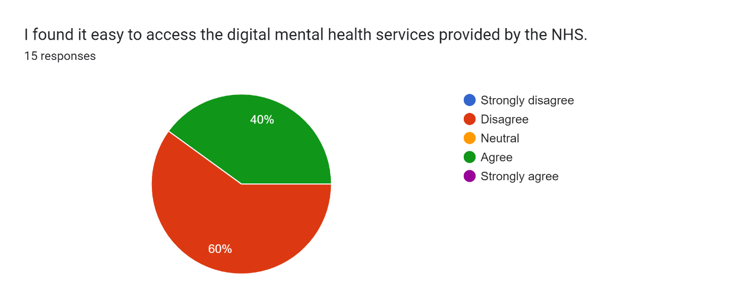
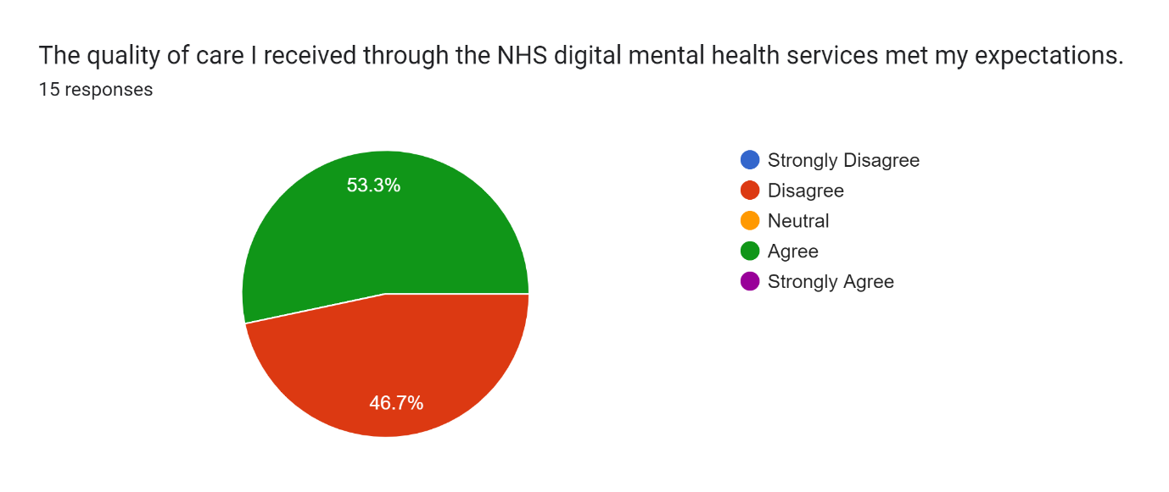
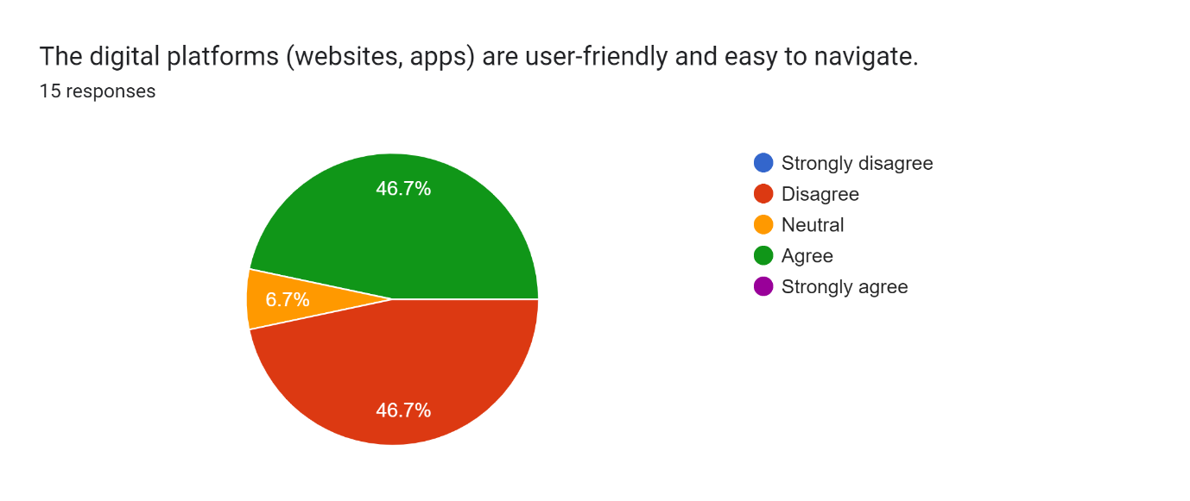
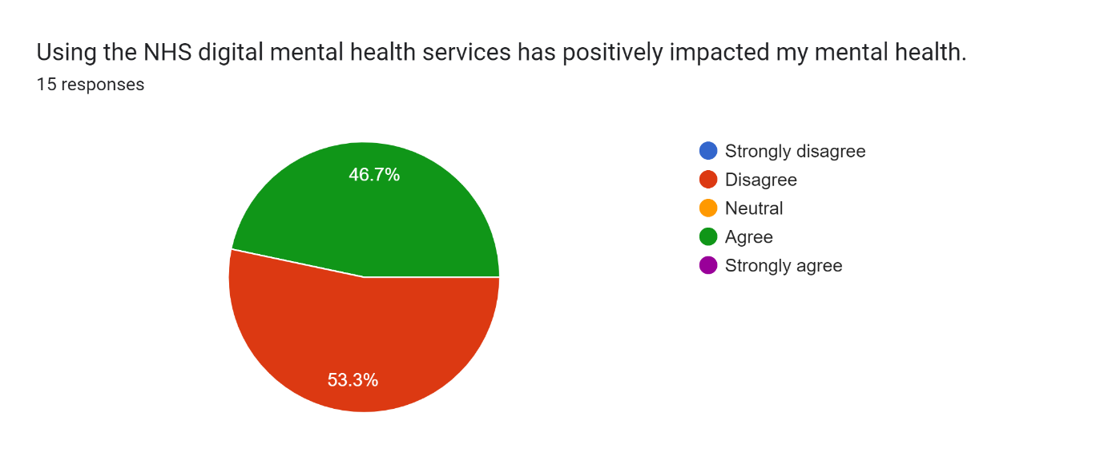
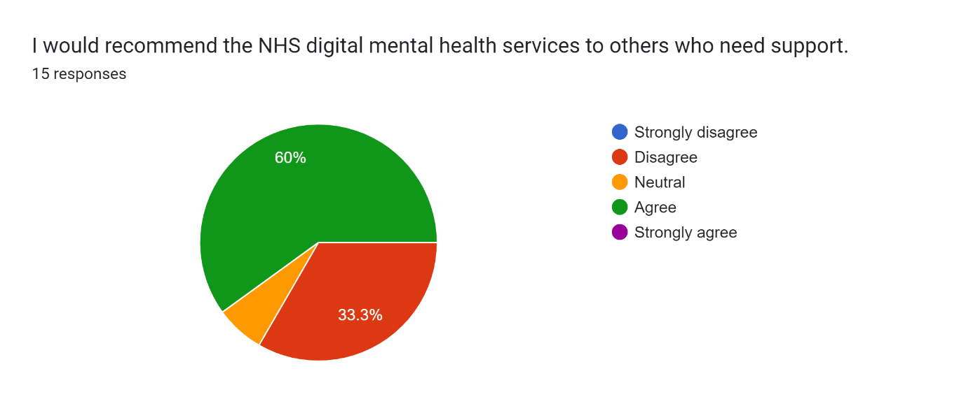

Response Interview Question
Q.1 What aspects of the NHS digital mental health services did you find most beneficial?
- The ability to access therapy sessions from the comfort of my home was incredibly beneficial. It removed the stress of commuting and made it easier to fit appointments into my busy schedule."
- I found the range of self-help resources available online very helpful. Being able to work through modules at my own pace allowed me to better understand my mental health issues.
- The anonymity and privacy offered by digital services gave me the confidence to seek help for the first time. I felt less judged and more open to discussing my problems.
- When my anxiety rose late at night and traditional resources were unavailable, the 24/7 digital platform helped me.
- Mood trackers and mindfulness exercises help me manage my mental health. They revealed my triggers.
Q.2 Were there any challenges or difficulties you faced while using the digital mental health services? Please describe.
- Sometimes the video calls would freeze or disconnect, which disrupted the flow of therapy sessions. It made discussing sensitive topics more challenging.
- Setting up and using the digital platform was challenging. A simpler, user-friendly design would have improved it.
- I had trouble connecting with my therapist remotely. Occasionally, screens felt like obstacles.
- I worried about data security and privacy. Transparent data protection communication would have eased my anxieties.
- Due to my lack of tech skills, I would have wanted more technical support or a helpline for digital tools.
Q.3 How do you feel the digital services could be improved? Please share any specific suggestions you have.
- Increasing video conferencing software stability and quality would improve online therapy.
- A more user-friendly platform interface could let non-techies use the services.
- A hybrid model with occasional in-person sessions may provide better support.
- Expanding self-help services to other mental health issues and incorporating interactive content may boost user engagement.
- Clear data security and privacy rules would reassure people.
Q.4 If you have used both traditional in-person and digital mental health services, how does your experience with the digital services compare? What advantages or disadvantages have you noticed?
- Digital services offer unparalleled convenience and accessibility. I miss the personal connection with my therapist.
- Digital services allow flexible scheduling and instant response. Technology may destroy an experience.
- The internet platform transformed mental health tools. It requires more self-motivation than in-person care.
- Digital services seem commercial and impersonal. Improved care personalisation may close this gap.
- I think communication isn't always good, but digital services make treatment more accessible. Body language and nuance may be lost in translation.

