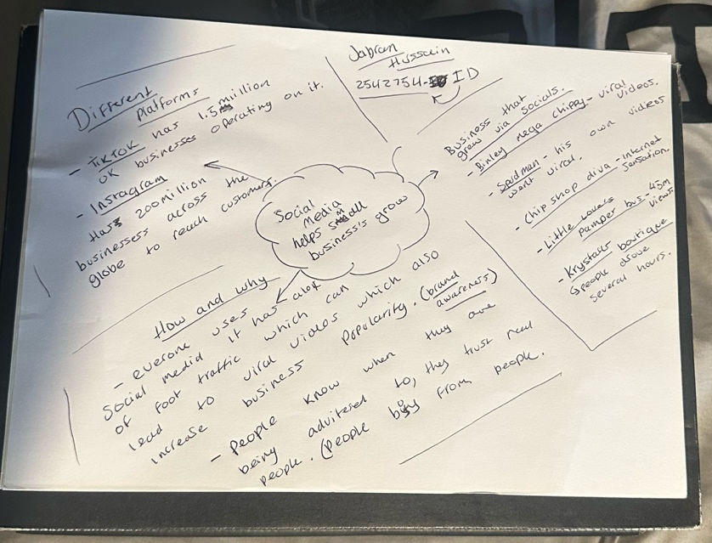
A. The main idea of the article is that social media platforms such as TikTok and Instagram can significantly benefit small businesses by increasing their visibility and driving customer growth, sometimes resulting in viral exposure that translates into higher levels of trade.

- B. Key point 1is that social media platforms like TikTok and Instagram help small businesses reach a much wider audience than traditional marketing.

- B2. Key point 2 is that viral content can increase sales by attracting more customers, including those willing to travel long distances.

- C. The most important part of the text is the idea that social media can directly increase the visibility and sales of small businesses. This is significant because it shows how online platforms like TikTok and Instagram are not just for promotion, but can also have a real impact on customer behaviour and business growth.

- D. There were no major points of confusion in the text, as the main ideas were presented clearly and simply.

- E. Working in a group helped me understand the text better because we talked about it together and shared ideas. It also made it easier to understand the main points.

The hardest part was making sure I understood the text clearly and could explain it in my own words.
References: By Elliot Deady
Essex
- Published
19 October 2025
https://www.bbc.co.uk/news/articles/cm2701py5npo

