Janna Bint-E Saif (2129742)

Module code: EYEC 5009 (Part 1&2)

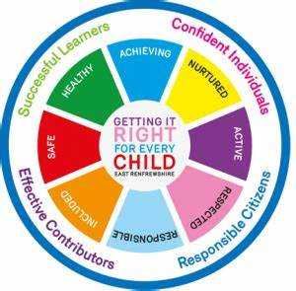
Part 1. Health, Wellbeing and Lifestyle
Introduction
This poster aims to clarify health, well-being, and lifestyles while emphasising the significance of these aspects of early life. Additionally, it will explore various models and ideas and relate them to early year practise. The topic of the conversation will also include the practitioner's role in early childhood settings and how to assist young children's lifestyles, health, and overall development. My poster will explore the connection between health, well-being, and lifestyle, which are crucial elements in the lives of young children.

Early childhood establishes the foundation for critical aspects of human development, encompassing intellectual, emotional, and physical growth. The experiences encountered during this formative period can profoundly influence various dimensions of health and well-being, including obesity, heart disease, mental health, educational achievement, and economic status, as highlighted by Sir Michael Marmot in 2010.
According to Cheung (2018), lifestyle, well-being, and health are all related and have an impact on one another. A child's growth and well-being may be impacted by their unhealthy lifestyle, which can also have a detrimental effect on their health. Harbottle (2023) discovered that children aspire to grow up feeling content, healthy, and well. In the Big Ask survey of 2021, children indicated a preference for good physical health, especially younger children who particularly expressed a wish for a healthy lifestyle.

Health-
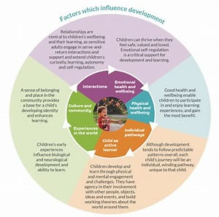
World Health Organisation (WHO), (2024), defines health as more than just the absence of illness or disability; it is a condition of whole physical, mental, and social well-being. The right to the highest achievable standard of health is a fundamental human right, and the ability to live harmoniously in a changing environment is crucial for the healthy development of a child, which is of utmost importance. According to Felman (2020) Health is not merely an objective; it is a resource that enables individuals to fulfil their role within society. A healthy lifestyle furnishes the means to lead a full life enriched with meaning and purpose. Musgrave (2017) posits that health is the outcome of a combination of physical, social, intellectual, and emotional factors.
All early childhood educators must adhere to the Early Years Foundation Stage (EYFS) framework's standards in order to ensure that children learn and develop as well as being kept safe and healthy (DfE, 2024). Children require proper nourishment, good health, a sense of safety and security, and learning opportunities from birth in order to grow and develop to their full potential (WHO, 2024). Good health is crucial as it forms the basis for a joyful and fruitful life (Currie and Rossin-Slater, 2014). Howard, Burton, and Levermore (2020) assert that nurturing one's holistic health is key to enhancing life quality and fulfilling personal ambitions.
The well-being of children is a crucial indicator of a society's overall health. They are susceptible and depend on the dedication of various entities, including parents, educational institutions, healthcare professionals, and policymakers, to guarantee their care. Promoting children's health necessitates addressing the extensive factors that affect their health and well-being (Korin, 2016). Maintaining good health in young children from an early age is vital, as highlighted by WHO (2022) research, which underscores the importance of nurturing care for children to promote their proper development and enhance their future opportunities. Parents and caregivers must be equipped to meet the needs of young children, and they may require assistance to do so. This assistance could encompass addressing the mental health of caregivers as a crucial component of services that promote the healthy growth and development of children. Marmot et al. (2012) suggest that early intervention in the health and well-being of young children has lasting effects. Musgrave (2017) supports this view, stating that early emotional support can lower the likelihood of hindered growth and development and decrease the risk of poor physical, cognitive, and emotional health in later life.
Healthy development in the early years, starting with the potential mother's state of health prior to conception, supports the maturing biological systems that allow children to flourish and mature into healthy people. The development of a strong brain architecture in children is facilitated by positive early experiences, and this brain architecture supports a wide range of abilities and learning capacities until old age. The mental health and development of children are shaped by the relationships they establish, the experiences they encounter, and the environments in which they mature. Children's growth is affected by a range of factors, including trauma and abuse, which in turn impact their cognitive, behavioural, and social well-being. The overall wellness of a child is the result of the interplay between different aspects of their development and health (NSPCC,2024).
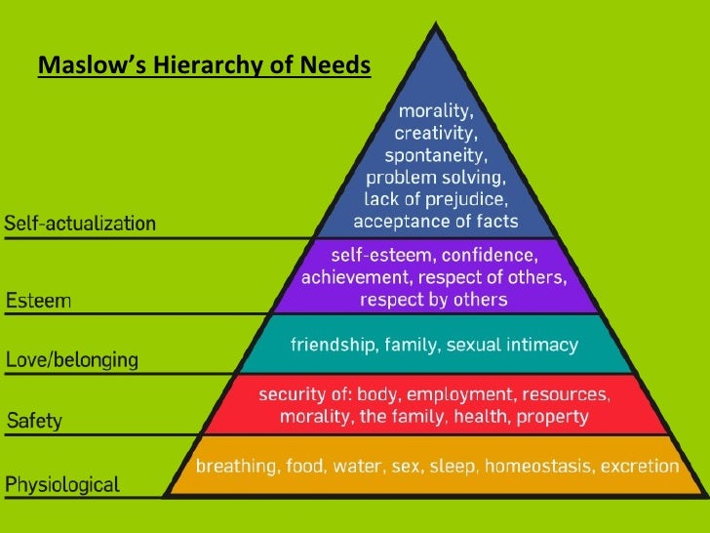
Maholmes (2014) agrees and suggest that the child's living situation, their parents' financial situation, their surroundings, their parents' occupation, and other factors can all contribute to their social well-being. The mental health of a child is influenced by various elements that can impact their emotional state. The Healthy Child Programme stands at the core of public health services for children and families, consolidating evidence to ensure good health, wellbeing, and resilience for every child (GOV.UK, 2023).
Figure 2 Slideshow, 2017
Early childhood programme professionals, family members, and other stakeholders must work together to ensure that children have a healthy start in life. The emotional, psychological, and social well-being of an individual influences their thoughts, feelings, and behaviours, according to Bradshaw (2016). According to Maholmes (2014), children who grow up in impoverished neighbourhoods and whose parents face financial difficulties are more likely to be under stress and concern, which can negatively affect not only their mental but also physical health.
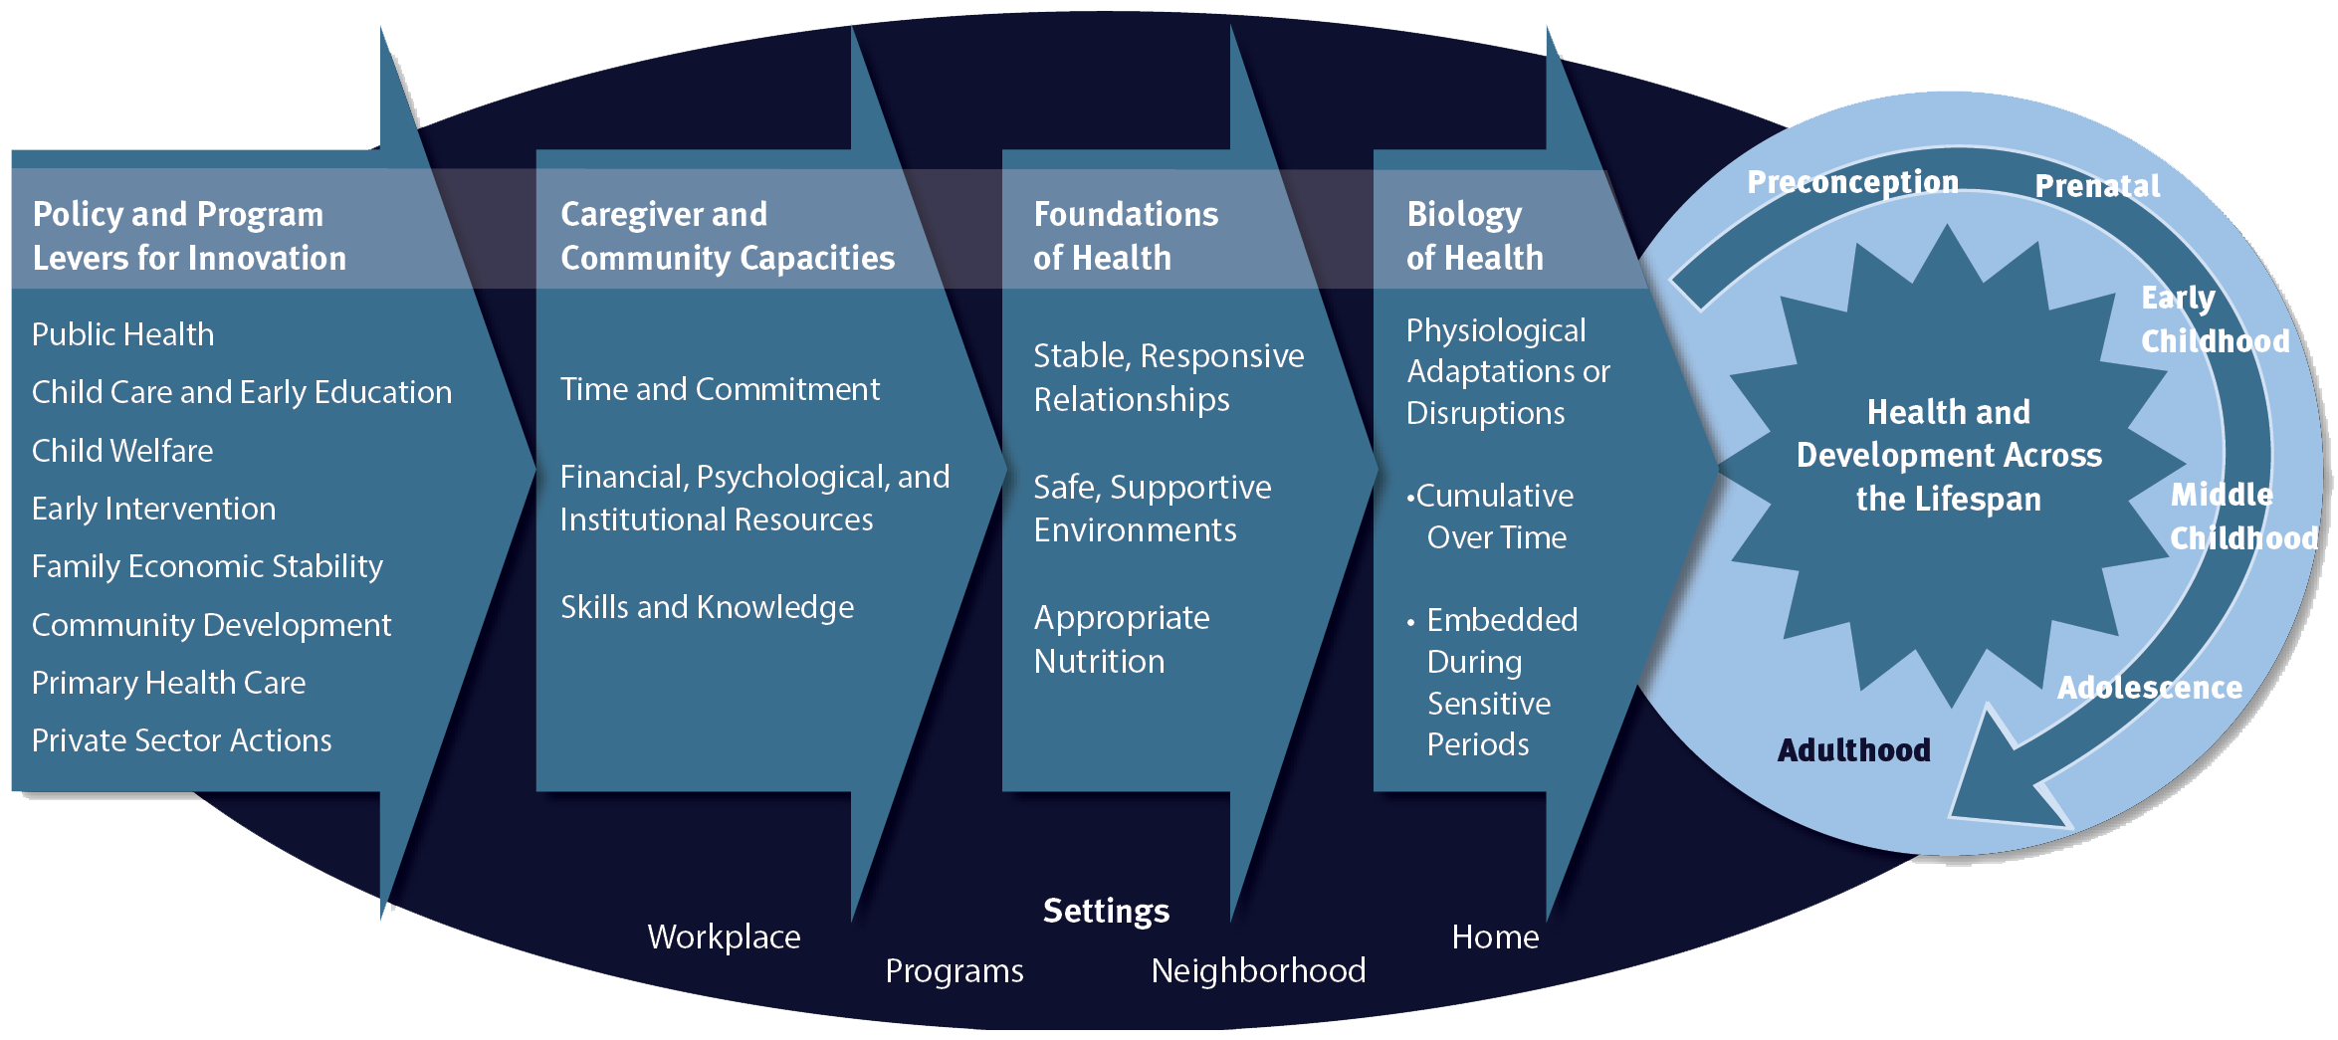
Early childhood health service providers make sure children are secure, fed, and involved in active play and learning. They also create environments that help children, families, and staff feel more confident in their social and emotional skills. The task of caring for young children is increasingly shared by early childhood educators and their parents. A setting that prioritises health and wellness is one in which children know and feel their worth. Youngsters who receive encouragement to be who they are and make healthy decisions for themselves are more likely to have happy, fulfilling lives in the future (GOV.UK, 2023).

Well-being
According to Statham and Chase (2010) wellbeing is defined in various ways. An emerging consensus suggests that it is multi-dimensional, encompassing physical, emotional, and social wellbeing. Well-being is a vital component of children's emotional, mental, social, physical, environmental, and spiritual growth. Maintaining a healthy and balanced lifestyle during these formative years is key to children’s personal well-being, consistent growth, and the cultivation of a comprehensive outlook on life (Kelly, 2019). Ashdown and Bernard (2012) agree, identify several dimensions of well-being, such as physical, emotional, spiritual, social, and intellectual health. To conduct a thorough assessment, it is crucial not to neglect any of these aspects.

Musgrave (2017) describes well-being is the state of being at ease, content, or in good health. NSCPP (2022) states that a child's total wellbeing is shaped by every facet of their development and health. Wellbeing represents the peak health condition of both individuals and groups. It encompasses two primary concerns: achieving an individual's maximum potential in physical, psychological, social, spiritual, and economic aspects, and fulfilling one's roles and expectations within the family, community, place of worship, and other environments (WHO, 2024).

Well-being is more than just getting by or managing to survive, according to research done in (2009) by the National Children's Bureau and London Metropolitan University. It includes growing, blooming, and being in good health. The emotional well-being of children is just as important as their physical health, according to Zacher and Rudolph (2021). Children can manage life's obstacles and develop into well-adjusted adults when they have good mental health, which builds resilience.
Berlinski and Norbert (2015) describes having good relationships with others is the foundation for positive well-being for young children. The potential for young children to experience wellbeing can be enhanced by ensuring that emotions are accepted and understood within close, consistent relationships. It is important that experiences align with children's self-perception and that their unique interests are valued. From birth, friendships should be nurtured and cherished, enhancing the child's sense of belonging to a group. Children should have free access to engaging and challenging play materials and spaces, within the setting and the community. There should be numerous opportunities for unrestricted imaginative play outdoors.

Additionally, families, in all their diverse forms, should be supported and appreciated. Children feel very much a part of their environment and neighbourhood, where they are sought out and appreciated for their contributions and are heard, acknowledged, and validated. Musgraves (2017) states that this will make them feel comfortable and ready to learn.
A person's mental health and general well-being may be significantly impacted by a number of the health variables stated Wilkinson and Marmot (2003). A child's upbringing, experiences, and relationships significantly influence their mental and developmental health. Every aspect of a child's growth and health contributes to their overall well-being (NSPCC).

The Department of Health (2014) states that while well-being varies over the course of a person's life, it is important to start off strong because a child's experiences during their first five years of life have a lasting effect on their wellbeing. Furthermore, there is a substantial correlation between the mental health of parents and the well-being of their young children. Thus, it is essential to assist parents and other carers in fostering health and well-being. The Healthy Child Programme offers families guidance on health, wellbeing, and parenting. The programme is central to public health services for children to ensure good health, wellbeing, and resilience for every child. (GOV.UK, 2009). Encouraging children's and youth's well-being is essential for their protection, growth, and smooth transition into adulthood (Public Health England, 2021).
Lifestyle
Lifestyles are ways of living that are distinguished by specific behavioural patterns, according to the World Health Organisation. Bagordo et al. (2017), states a combination of social connections, individual traits, and the environmental and economical elements of one's environment all have an impact on these patterns. A person's lifestyle has a significant impact on their health and quality of life starting in childhood, according to Daniel et al. (2009). Studies reveal that a child’s socioeconomic background influences their lifestyle decisions, which in turn affects their health. A person's lifestyle can be influenced by their physical location as well as the environmental, cultural, and social aspects of the place they live in.

Lifestyle can be defined in multiple ways; it is often interpreted by social researchers as a way of life, as noted by Jensen (2007). A child's lifestyle can have a direct impact on their health and well-being, as noted by Sieck (2014). An overall healthy lifestyle is beneficial to a child's wellbeing (Marques et al. 2019). Musgrave (2017) agrees, saying that choosing a good diet and exercise routine requires knowledge. This helps children stay physically fit and improves mental health in addition to strengthening their bones and muscles, all of which are important for their overall health. The World Health Organisation (WHO) (2010) suggests eating a range of fruits and vegetables, reducing fat, sugar, and salt intake, and getting regular exercise to maintain a healthy lifestyle.
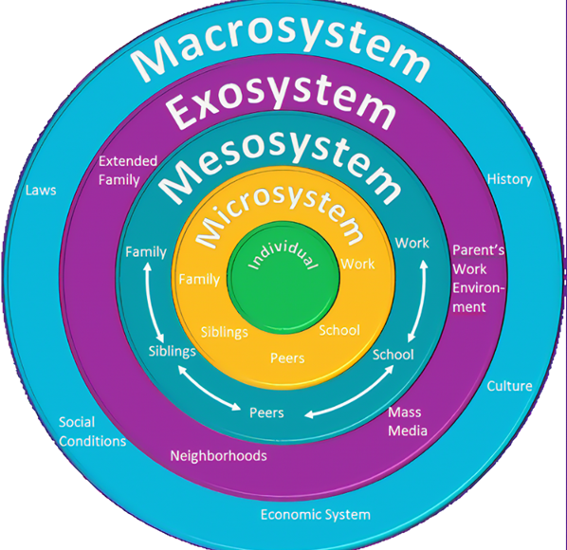
Sustaining a healthy lifestyle can improve self-perception and potentially reduce the likelihood of depression (Yilmaz, 2022). A lifestyle often mirrors an individual's attitudes, values, or worldview (Larry Lewis, 2019). A person's lifestyle decisions have a direct impact on their health and well-being, according to Rodriguez et al. (2013). It is generally the responsibility of parents or other carers to determine what is best for their young children, as they are unable to make such decisions for themselves.The Department of Education states that receiving healthy, balanced food during the day is a crucial component of high-quality childcare and that a strong early education is essential to putting every child on the path to realising their full potential (DfE, 2017). Physical activity and a healthy environment are crucial for a child's development, health, and well-being. They foster a healthy lifestyle that can positively impact their mental health and cognitive development, benefits that will extend into adulthood (NHS). Schools play a significant role in influencing children's well-being. (Jordan and Rees, 2020).
To encourage a healthy lifestyle, early childhood environments and educators are essential. According to Bronfenbrenner's ecological systems theory, several layers of the environment, from the close home and school setting to the larger cultural values, laws, and practices, all have an impact on a child's development. Children who live in a secure environment and have loving relationships with their parents or other carers are likely to see improvements in their health and general well-being, according to Marmot et al. (2012).

Conclusion
The greatest approach to preserve health is to lead a healthy lifestyle and take proactive measures to preserve well-being. The initial years of a child's life, including the prenatal stage, are crucial in laying the groundwork for long-term development. Early years practitioners increasingly share the responsibility of caring for young children with their parents. A setting focused on health and wellbeing is one where children and adults feel valued and are aware of their value. Children who are supported in being themselves and making healthy choices for themselves, stand a better chance of a positive future (Harbottle, 2023).

Reference list

Ashdown, D.M. and Bernard, M.E., (2012). Can explicit instruction in social and emotional learning skills benefit the social-emotional development, well-being, and academic achievement of young children?. Early childhood education journal, 39, pp.397-405.
Bagordo, F., De Donno, A., Grassi, T., Guido, M., Devoti, G., Ceretti, E., Zani, C., Feretti, D., Villarini, M., Moretti, M., Salvatori, T., Carducci, A., Verani, M., Casini, B., Bonetta, S., Carraro, E., Schilirò, T., Bonizzoni, S., Bonetti, A. and Gelatti, U. (2017). Lifestyles and socio-cultural factors among children aged 6–8 years from five Italian towns: the MAPEC_LIFE study cohort. BMC Public Health, [online] 17. doi:https://doi.org/10.1186/s12889-017-4142-x.
Bessesen, D.H. (2008). Update on Obesity. The Journal of Clinical Endocrinology & Metabolism, 93(6), pp.2027–2034. doi: https://doi.org/10.1210/jc.2008-0520.
Berlinski, S. and Schady, N., (2015). The early years: child well-being and the role of public policy (p. 288). Springer Nature.
Danaei, G., Ding, E.L., Mozaffarian, D., Taylor, B., Rehm, J., Murray, C.J. and Ezzati, M., 2009. The preventable causes of death in the United States: comparative risk assessment of dietary, lifestyle, and metabolic risk factors. PLoS medicine, 6(4), p.e1000058.
Department for Education (2017). Healthy eating guidance published for the early years sector. [online] GOV.UK. Available at: https://www.gov.uk/government/news/healthy-eating-guidance-published-for-the-early-years-sector.
Department for Education (2024). Early years foundation stage statutory framework (EYFS). [online] GOV.UK. Available at: https://www.gov.uk/government/publications/early-years-foundation-stage-framework--2.

Department of Health (2014). WELLBEING -WHY IT MATTERS TO HEALTH A SUMMARY OF KEY POINTS Levels of wellbeing vary across the lifecourse Starting Well. [online] Available at: https://assets.publishing.service.gov.uk/media/5a7c08d8ed915d41476225b3/Wellbeing_-_why_it_matters_to_health_summary_of_key_points.pdf.
Department of Health and Social Care (2009). Healthy Child Programme: Pregnancy and the First 5 Years of Life. [online] GOV.UK. Available at: https://www.gov.uk/government/publications/healthy-child-programme-pregnancy-and-the-first-5-years-of-life.
Felman, A. (2020). Health: What does good health really mean? [online] www.medicalnewstoday.com. Available at: https://www.medicalnewstoday.com/articles/150999#what_is_health.
Harbottle, E. (2023). The importance of health and well-being to children and young people. [online] Children’s Commissioner for England. Available at: https://www.childrenscommissioner.gov.uk/blog/the-importance-of-health-and-well-being-to-children-and-young-people/.
Jensen, M. (2007). Defining lifestyle. Environmental Sciences, 4(2), pp.63–73. doi: https://doi.org/10.1080/15693430701472747.
Johnson, E. (2023). Safeguarding Children | Legislations and Policies surrounding safeguarding. [online] CPD Online College. Available at: https://cpdonline.co.uk/knowledge-base/safeguarding/legislation-safeguarding-children/.
Jordan, A. and Rees, E. (2020). Children’s views on well-being and what makes a happy life, UK: 2020 - Office for National Statistics. [online] www.ons.gov.uk. Available at: https://www.ons.gov.uk/peoplepopulationandcommunity/wellbeing/articles/childrensviewsonwellbeingandwhatmakesahappylifeuk2020/2020-10-02.
Kelly, C. (2019). The importance of child wellbeing. [online] The Institute Of Wellbeing. Available at: https://theinstituteofwellbeing.com/the-importance-of-child-wellbeing/.

Korin, M.R. (2016). Introduction: What Is Health Promotion for Children and Adolescents? Health Promotion for Children and Adolescents, pp.3–8. doi:https://doi.org/10.1007/978-1-4899-7711-3_1.
Larry Lewis (2019). What is a Healthy Lifestyle? [online] Healthylifestylesliving.com. Available at: https://www.healthylifestylesliving.com/health/healthy-lifestyle/what-is-a-healthy-lifestyle/.
Marmot, M. et al. (2012) ‘WHO European review of social determinants of health and the health divide’, The Lancet, 380(9846), pp. 1011-1029.
Marques, A. et al. (2019) ‘Few European Adults are Living a Healthy Lifestyle’, American Journal of Health Promotion, 33(3), pp. 391-398.
Musgrave, J. (2017). Supporting Children’s Health and Wellbeing.
NHS (n.d.). Keeping active: Tameside Children and Young People. [online] tamesidechildrenandyoungpeople.nhs.uk. Available at: https://tamesidechildrenandyoungpeople.nhs.uk/what-typical-development/being-healthy/keeping-active.
NSPCC (2021). Promoting Mental Health and Wellbeing. [online] NSPCC Learning. Available at: https://learning.nspcc.org.uk/child-health-development/promoting-mental-health-wellbeing.
NSPCC (2022). Child Health and Development. [online] NSPCC Learning. Available at: https://learning.nspcc.org.uk/child-health-development.
NSPCC (2024a). Child health and development. [online] NSPCC Learning. Available at: https://learning.nspcc.org.uk/child-health-development#:~:text=Children%27s%20mental%20health%20%E2%80%93%20their%20cognitive%2C%20behavioural%20and [Accessed 14 Jun. 2024].

NSPCC (2024b). Child protection system for England | NSPCC Learning. [online] NSPCC Learning. Available at: https://learning.nspcc.org.uk/child-protection-system/england.
publication, A. (2019). Healthy and Active Lifestyles - top tips for early years settings. [online] early years alliance. Available at: https://www.eyalliance.org.uk/healthy-and-active-lifestyles-top-tips-early-years settings#:~:text=Gain%20further%20inspiration%20and%20ideas%20to [Accessed 19 Aug. 2024].
Reilly, J.J. (2006). Obesity in childhood and adolescence: evidence based clinical and public health perspectives. Postgraduate Medical Journal, [online] 82(969), pp.429–437. doi: https://doi.org/10.1136/pgmj.2005.043836.
Statham, J. and Chase, E. (2010). Childhood Wellbeing: A brief overview. [online] Available at: https://assets.publishing.service.gov.uk/media/5a7acd89ed915d71db8b2946/Child-Wellbeing-Brief.pdf.
Teach Early Years Magazine (2020). Wellbeing in the Early Years. [online] Teach Early Years. Available at: https://www.teachearlyyears.com/a-unique-child/view/wellbeing-in-the-early-years.
world health organisation (2024). Healthy growth and development. [online] www.who.int. Available at: https://www.who.int/teams/maternal-newborn-child-adolescent-health-and-ageing/child-health/healthy-growth-and development #:~:text=Healthy%20growth%20and%20development%20To%20grow%20and%20develop [Accessed 14 Jun. 2024].
World Health Organization (2010). A healthy lifestyle - WHO recommendations. [online] World Health Organisation. Available at: https://www.who.int/europe/news-room/fact-sheets/item/a-healthy-lifestyle---who-recommendations.
World Health Organization (2024). Constitution of the World Health Organization. [online] World Health Organisation. Available at: https://www.who.int/about/accountability/governance/constitution.
Yilmaz, E. (2022). Healthy Lifestyle: Definition, Benefits, & Examples. [online] The Berkeley Well-Being Institute. Available at: https://www.berkeleywellbeing.com/healthy-lifestyle.html.
Zacher, H. and Rudolph, C. W. (2021) ‘Individual differences and changes in subjective well-being during the early stages of the COVID-19 pandemic’, American Psychological Association, 76(1), pp. 50-62.

Part 2 Obesity
Obesity, a complex chronic condition, is characterized by excessive fat accumulation that can jeopardize health. It leads to various complications, including type 2 diabetes, heart disease, changes in bone health and reproductive functions, and a heightened risk of certain cancers. Obesity can also hinder mobility and disrupt sleep patterns. To diagnose overweight and obesity, a person's weight and height are measured to calculate the body mass index (BMI) using the formula: weight (kg)/height^2 (m^2). Twenty-seven million people worldwide suffered from obesity in 2022, while 37 million children under five were overweight (Railey, 2006).
According to Balasundaram and Krishna (2023) the buildup of excess fat in the body is referred to as obesity. Currently considered a worldwide pandemic, childhood obesity is one of the most significant public health issues of the twenty-first century.

The World Health Organisation defines overweight and obesity as abnormal or excessive fat accumulation that poses a health concern. Based on body mass index, a person over 25 is deemed overweight, and a person over 30 is deemed obese (BMI). A higher-than-optimal body mass index (BMI) was expected to be the cause of 5 million deaths in 2019 from noncommunicable diseases (WHO, 2024).

According to studies, three-year-olds who are obese experience behavioural problems more frequently than their non-obese peers. (Hamblin, Fellowes and Clements, 2017). Childhood obesity primarily results from lifestyle factors, such as inadequate physical exercise and high caloric intake from food and drink. It's also possible that hormones and genetics play a role. Problems with a child's physical, social, and emotional wellbeing are often brought on by childhood obesity. Peer bullying and mocking towards obese children is common, and it can cause low self-esteem as well as increased risks of anxiety and depression (Office for Health Improvement and Disparities, 2022).

The development of obesity is significantly influenced by both environmental and individual variables. Environmental factors that have been associated with a rise in childhood obesity incidence include bigger serving sizes, greater sugary drink intake, more sedentary lifestyles, and easier access to high-calorie fast food. Apart from genetic and biological factors, certain medicines may also be relevant (Romieu et al., 2017).

Childhood and adolescent obesity can lead to negative psychosocial outcomes, impacting school performance and overall quality of life. Additionally, children with obesity are at a greater risk of remaining obese into adulthood and have an increased likelihood of developing non-communicable diseases (NCDs) later in life (Bessesen, 2008).In 2019, the World Obesity Federation projected that by 2025, there would be 206 million children and adolescents aged 5–19 years with obesity, and by 2030, the number would rise to 254 million (Lobstein, 2019).

According to NHS Digital (2022), about 76.5% of children in reception (ages 4 and 5) were at a healthy weight during the 2018–2019 academic year. For children in year 6 (ages 10 and 11), approximately two-thirds, or 64.3%, were at a healthy weight. Compared to reception, where 22.6% were overweight or obese, year 6 had a higher rate of overweight and obesity (including severe obesity) at 34.3%. The highest rates of obesity are found in the poorest 10% of the population.

The UK has a higher percentage of overweight or obese children and adolescents compared to the average in high-income countries. As of 2013, it was estimated that 29.2% of girls and 26.1% of boys aged 2–19 in the UK were overweight or obese. In the 2016–17 academic year, about 23.6% of children in England's reception age group were classified as overweight or obese (Cheung, 2018).

Miller et al. (2021) stated, that enhancing sleep hygiene in children and young adults through a consistent bedtime routine, regular sleep-wake cycles, and decreased screen time results in multiple positive outcomes and beneficially affects behaviours related to weight management.
The impact of childhood obesity on mental and physical health is significant. Preventive measures are the most successful way to lower obesity rates. Reducing sedentary behaviour and encouraging childhood physical exercise are vital steps in the fight against obesity.

Piercy et al (2018) suggest, after age two, skim milk can safely take the place of whole milk. Food, especially sweets, should never be used as a reward by parents or other carers. Research indicates that parental behaviour can influence childhood obesity, as children often mimic the eating habits, preferences, and openness to new foods of their parents, caregivers, and friends. Families that dine together usually eat more nutritious foods. Furthermore, by supporting wholesome eating in schools, societal and governmental policies could promote healthy behaviours even more (Patric and Nicklas, 2005).
Early childhood nutrition is critical because it supplies the nutrients needed for healthy growth and development as well as lifetime wellbeing, according to Professor Judy Buttriss as about 25% of children start school overweight or obese, it is critical to prioritise their well-being in the formative years in order to combat the obesity pandemic.
High sugar consumption is a significant factor in both obesity and dental health issues, with one in four 5 years olds in England starting school with tooth decay. The UK Government’s Childhood Obesity Action Plans outlines strategies to reduce and prevent childhood obesity by working with local communities, the food industry, schools, and the NHS. The government prioritizes tackling obesity and promotes a comprehensive systems approach to its policy on obesity and healthy eating. Early years services are crucial in identifying children who are overweight or at risk of obesity, aiding in better outcomes for children and families through integrated planning, delivery, monitoring, and review (PHE, 2021).

Early years settings and practitioners are pivotal in laying the groundwork for children's lifelong learning and development (Bakken, Brown, and Downing, 2017). To combat obesity, strategies targeting the physical environment might include providing only nutritious foods and beverages to children in care. In the sociocultural environment, strategies could involve educators modelling healthy eating and physical activity. Early Childhood Education Care services are adopting policies and practices designed to enhance the quality of children's diets, boost their physical activity levels during care, and minimize sedentary behaviour (Brennell et al., 2014).
Obese children have a higher chance of becoming obese adults, and obese adults frequently experience worsening health, economic, and social consequences. Underprivileged parts of England have twice as many children who are obese as areas that are rich (PHE, 2018). It is therefore imperative that studies including low-income families with preschool-aged children be made accessible and comprehensive in order to contribute to the fight against obesity.

The UK Governments Childhood Obesity: Action Plan directs schools in working with health centres, school nurses, and local authority healthy weight teams, among other resources, to help children lead healthier lifestyles. As the most dependable adults in a child's life, parents and carers should naturally be included in initiatives to keep children from becoming obese. To avoid childhood obesity, it is important to address the issue of disadvantaged parents not receiving sufficient interventions. In order to prevent the problems that come with being overweight or obese when children enter school, it could be helpful to standardise educational programs for parents and young children that concentrate on nutrition and physical exercise (Narzisi and Simons, 2020).
According to Michalopoulou et al., (2024) early childhood development offers opportunities for intervention and is critical for the establishment of healthy behaviours. Enhancements in lifestyle practices have been documented, potentially mitigating the likelihood of childhood obesity. As a result, the formative years are crucial for achieving a healthy weight because they provide a window of opportunity for introducing a lifestyle that promotes healthy growth (Pearce, Webb-Phillips, and Bray, 2015).

To combat obesity and promote healthy eating, it's crucial to involve families and children in choosing the meals and snacks provided. Teachers can plan lessons where children can take part in gardening. Families are encouraged to engage in food-related activities to foster healthy cooking skills. Educators dine with the children, providing interaction and positive role modelling. Parents can receive guidance on choosing healthy food and drink options for items brought from home. Cooking classes and educational outings offer chances for parents/caregivers and children to engage in food-related activities together. By promoting health education and implementing them educators can help children learn about the importance of a balanced diet and physical activity, and they are prompted to discuss ways to maintain health and wellbeing (Reilly, 2006).
Elrick (2018) asserts that although educators may not have control over outside variables, they can still serve as positive role models and promote healthful habits. Physical activities can be incorporated into class plans on a daily basis. These activities can range from quick sessions of basic exercises like push-ups and jumping jacks to simple stretching breaks for students.

Early years environments offer a perfect chance to encourage young children to adopt healthy eating habits and learn about nutrition. This not only safeguards their health during childhood but also lays the groundwork for their long-term health and well-being.

The children's health and safety are the main priorities of the EYFS framework. In wealthy countries, obesity significantly affects healthcare systems. Obesity-related illnesses in the UK cost the NHS £44.7 billion annually, or 5% of its budget. 'Lifespan' approaches are becoming acknowledged as the best way to address childhood obesity. The early years sector has a unique opportunity to influence important elements like sleep, physical activity, nutrition, and screen time because of its regular interactions with young children and their families (Thomson, 2016).

Reference list
Bakken, L., Brown, N. and Downing, B. (2017). Early Childhood Education: The Long-Term Benefits. Journal of Research in Childhood Education, 31(2), pp.255–269. doi: https://doi.org/10.1080/02568543.2016.1273285.
Balasundaram, P. and Krishna, S. (2023). Obesity Effects on Child Health. [online] PubMed. Available at: https://www.ncbi.nlm.nih.gov/books/NBK570613/.
Brennan, L.K., Brownson, R.C. and Orleans, C.T., 2014. Childhood obesity policy research and practice: evidence for policy and environmental strategies. American journal of preventive medicine, 46(1), pp. e1-e16.
Cheung, R. (2018). International comparisons of health and wellbeing in early childhood. [online] Available at: https://www.observatoriodelainfancia.es/ficherosoia/documentos/5575_d_Child-health-international-comparisons.pdf.
Elrick, L. (2018). A Teacher’s Gu@ide to Childhood Obesity Prevention in the Classroom. [online] Rasmussen University. Available at: https://www.rasmussen.edu/degrees/education/blog/obesity-prevention-in-the-classroom/#:~:text=Obesity%20in%20children%20is%20influenced%20by%20a%20variety [Accessed 24 Aug. 2024].
Hamblin, E., Fellowes, A. and Clements, K. (2017). Working together to reduce childhood obesity. [online] Available at: https://www.nice.org.uk/Media/Default/sharedlearning/18-31%20obesity%20report%20supporting%20info.pdf.
Jackson, J.K., Jones, J., Nguyen, H., Davies, I., Lum, M., Grady, A. and Yoong, S.L. (2021). Obesity Prevention within the Early Childhood Education and Care Setting: A Systematic Review of Dietary Behaviour and Physical Activity Policies and Guidelines in High Income Countries. International Journal of Environmental Research and Public Health, [online] 18(2). doi: https://doi.org/10.3390/ijerph18020838.
Lobstein, T., 2019. Obesity prevention and the Global Syndemic: Challenges and opportunities for the World Obesity Federation. Obesity Reviews, 20.
Mayo Clinic. (2024). Childhood obesity - Symptoms and causes. [online] Available at: https://www.mayoclinic.org/diseases-conditions/childhood-obesity/symptoms-causes/syc-20354827#:~:text=Childhood%20obesity%20is%20a%20serious%20medical%20condition%20that. ( Accessed 4th August 2024)
Miller, M.A., Bates, S., Ji, C. and Cappuccio, F.P., (2021). Systematic review and meta‐analyses of the relationship between short sleep and incidence of obesity and effectiveness of sleep interventions on weight gain in preschool children. Obesity Reviews, 22(2), p.e13113.
Narzisi, K. and Simons, J. (2020). Interventions that prevent or reduce obesity in children from birth to five years of age: A systematic review. Journal of Child Health Care, [online] 25(2), p.136749352091786. doi: https://doi.org/10.1177/1367493520917863.
Michalopoulou, S., Sifaki, M., Packer, J., Lanigan, J., Stansfield, C., Viner, R.M. and Russell, S. (2024). Assessing the impact of obesity interventions in the early years: a systematic review of UK-based studies. BMJ open, [online] 14(5), p.e076479. doi: https://doi.org/10.1136/bmjopen-2023-076479.
Office for Health Improvement and Disparities (2022). Childhood obesity: applying All Our Health. [online] GOV.UK. Available at: https://www.gov.uk/government/publications/childhood-obesity-applying-all-our-health/childhood-obesity-applying-all-our-health.
Pearce, M., Webb-Phillips, S. and Bray, I. (2015). Changes in objectively measured BMI in children aged 4–11 years: data from the National Child Measurement Programme. Journal of Public Health, [online] 38(3), pp.459–466. doi: https://doi.org/10.1093/pubmed/fdv058.
Piercy, K.L., Troiano, R.P., Ballard, R.M., Carlson, S.A., Fulton, J.E., Galuska, D.A., George, S.M. and Olson, R.D. (2018). The Physical Activity Guidelines for Americans. JAMA, [online] 320(19), p.2020. doi: https://doi.org/10.1001/jama.2018.14854.
Public Health England (2021). Early years high impact area 4: Supporting healthy weight and nutrition. [online] GOV.UK. Available at: https://www.gov.uk/government/publications/commissioning-of-public-health-services-for-children/early-years-high-impact-area-4-supporting-healthy-weight-and-nutrition.
Romieu, I., Dossus, L., Barquera, S., Blottière, H.M., Franks, P.W., Gunter, M., Hwalla, N., Hursting, S.D., Leitzmann, M., Margetts, B., Nishida, C., Potischman, N., Seidell, J., Stepien, M., Wang, Y., Westerterp, K., Winichagoon, P., Wiseman, M. and Willett, W.C. (2017). Energy balance and obesity: what are the main drivers? Cancer Causes & Control, [online] 28(3), pp.247–258. doi: https://doi.org/10.1007/s10552-017-0869-z.
Reilly, J.J. (2006). Obesity in childhood and adolescence: evidence based clinical and public health perspectives. Postgraduate Medical Journal, [online] 82(969), pp.429–437. doi: https://doi.org/10.1136/pgmj.2005.043836.
Sahoo, K., Sahoo, B., Choudhury, A.K., Sofi, N.Y., Kumar, R. and Bhadoria, A.S. (2015). Childhood obesity: Causes and Consequences. Journal of Family Medicine and Primary Care, [online] 4(2), p.187. doi: https://doi.org/10.4103/2249-4863.154628.
WHO (2024). Obesity: Health consequences of being overweight. [online] www.who.int. Available at: https://www.who.int/news-room/questions-and-answers/item/obesity-health-consequences-of-being-overweight.
World Health Organization (2024). Obesity. [online] World Health Organization. Available at: https://www.who.int/health-topics/obesity#tab=tab_1. (Accessed 21st August 2024)

