Plan
My plan for this project is to animate a scene showcasing a small dragon causing chaos in a shop. This chaos will include running, knocking over items and flailing. The idea behind this developed during discussions of my major project, in which one event idea for our game proposal was to have a small dragon let loose in a shop, causing chaos for the shopkeeper (the main and only playable character within my team’s game.)

The dragon asset was taken from a list of tutor-provided assets and the shop scene was taken from an early whitebox made by a classmate, Tom, for our major project.

There are a few elements of this animation which I’ve never attempted before. Firstly, I have not animated a winged quadruped prior to this brief, Furthermore as this asset was not created by myself i am constrained by the skill of the modeller and rigger. Prior to this task i had only animated short segments of animations - at most 5 seconds of material. Therefore providing a well animated Scene of 20 - 30 seconds in length will likely be a challenge.

Scene & First Pose
Today I spent my time setting up the Maya Scene for animating. The dragon rig and the shop were referenced into the file. This was so that I can't accidentally cause elements of either the scene or the dragon to break in my animation file. Referencing also allows me to adjust elements of the scene later if needed.

The Dragon rig was also put into its starting pose so that it would look more natural within the scene. 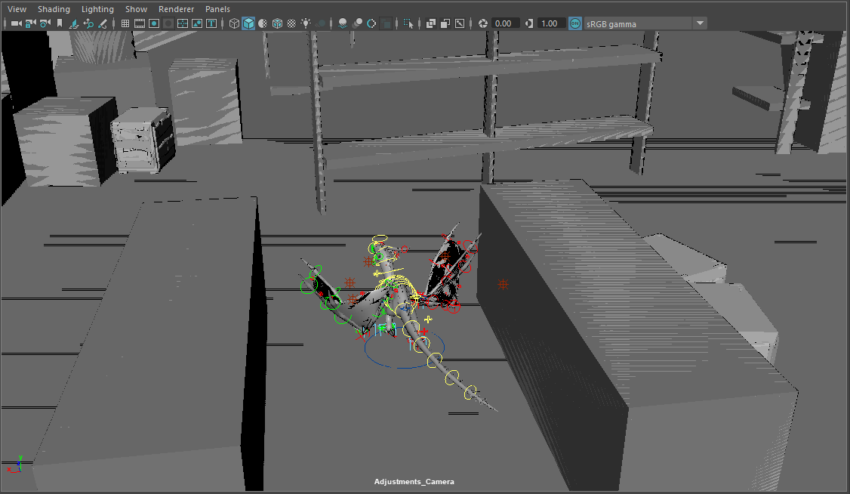
(Figure 1.)

As there are many controls within this rig, I decided it would be best to set up a quick reference sheet. To do this i downloaded the ATools plugin and set the controls to the reference sheet. This will let me animate the scene far quicker as it prevents me from having to hunt for regularly-used controls on the rig.
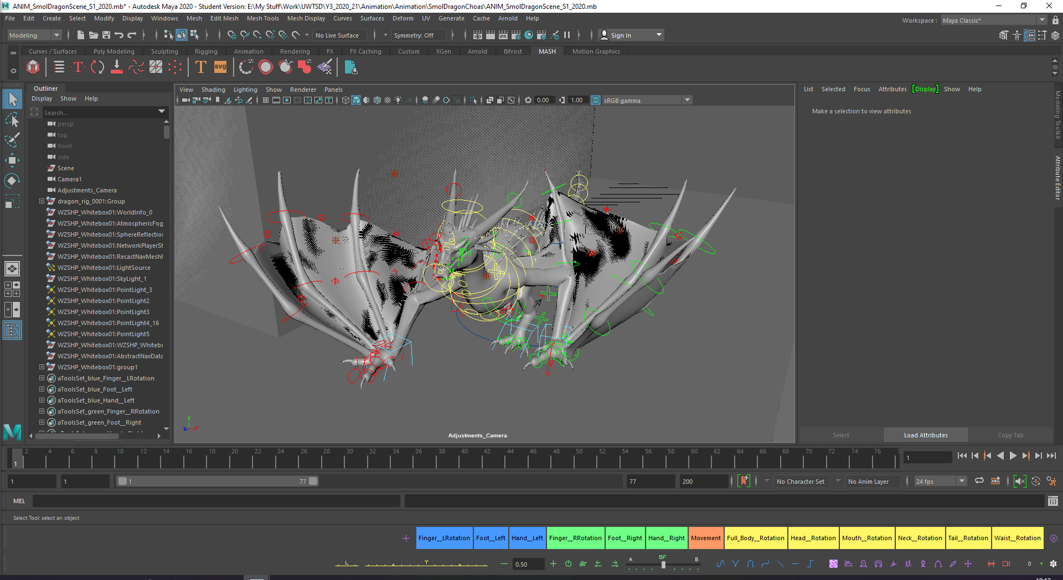
(Figure 2.)

Rough Walk Blockout
The walk cycle for the dragon was blocked out today. The main focus for this set of animations was the hand placement, the movement of the dragon, and the body movement as the dragon moves forward. This can be seen in figures 3 - 6.

Pose 1
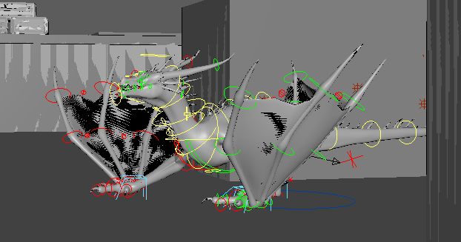
(Figure 3.)

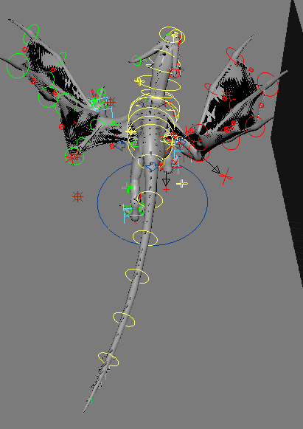
(Figure 4.)

Pose 2
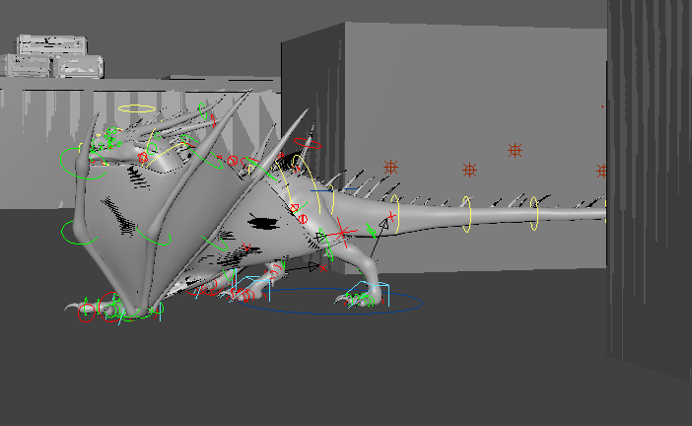
(Figure 5.)

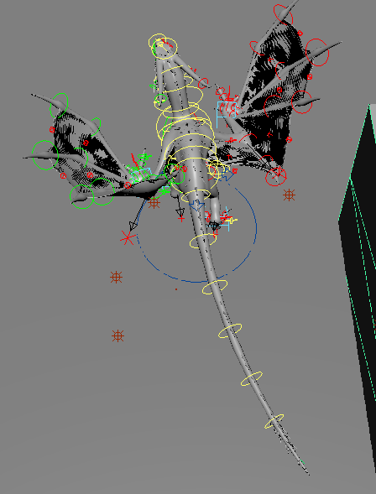
(Figure 6.)

Camera Movement
I mainly set up cameras and considered composition today. Figures 7-9 is the current plan for how the camera will establish the scene. A second idea was considered, with the camera first starting from the Shopkeeper’s (Who i do not plan on animating for this brief) perspective and then zooming into the dragon. However the shots from that setup did not convey the right tone, and ended up looking clunky. For now this camera setup is what I plan on using going forward.

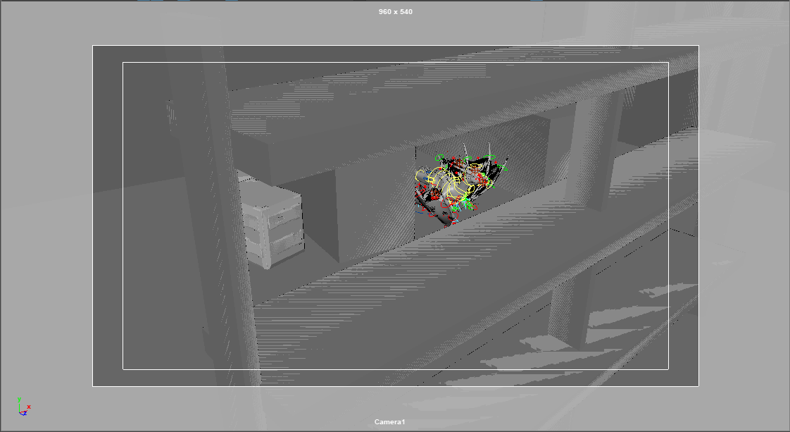
(Figure 7)

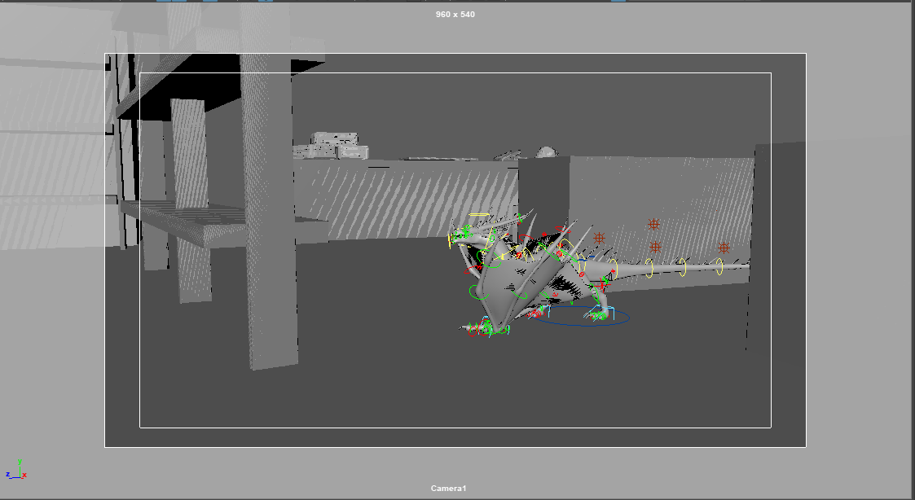
(Figure 8)
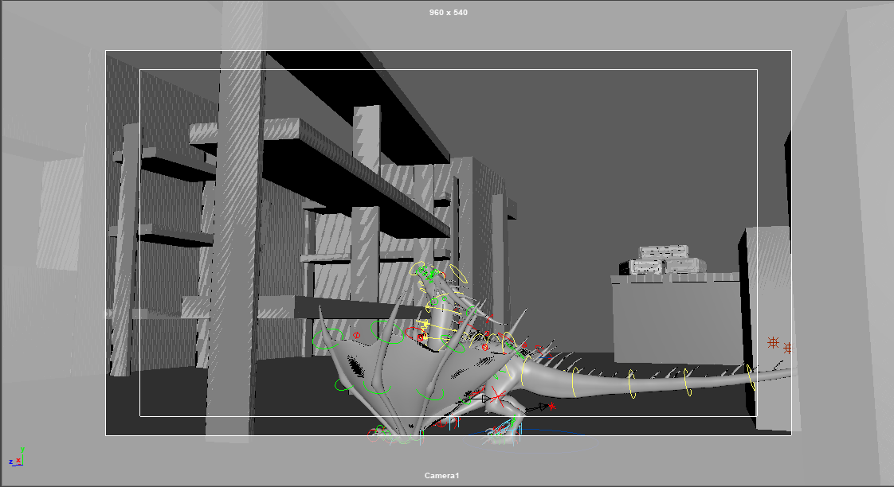
(Figure 9)

30/11/2020 Jump Blockout
The goal for today is to block out the jump off the ground launch. The dragon’s goal being to jump up onto a shelving unit, only for it to topple over. My inspiration for this is models that suggest that pterosaurs, which have a similar body plan to this dragon, launched into flight using a vaulting method. An example of this can be seen in figure 10 which is an infographic taken from a times newspaper article.

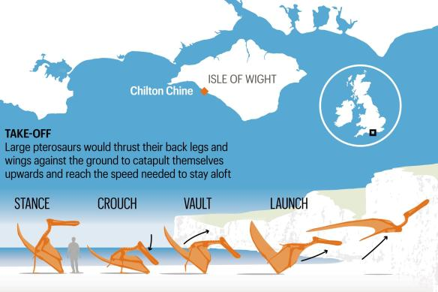
(Figure 10: [1])

Below, figures 11 - 13 showcase my initial pose blockout using this vaulting method as reference.
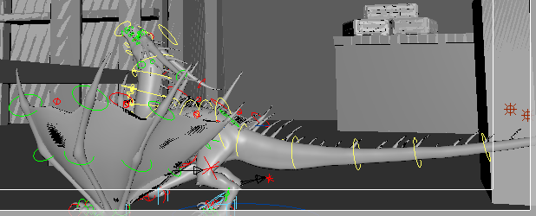
(figure 11)

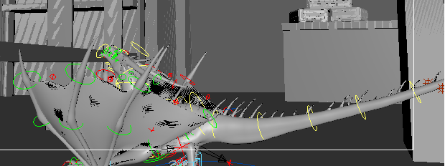
(Figure 12)

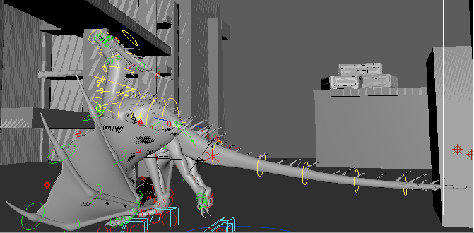
(Figure 13)

From figures 11-13 I noted that the wings were currently positioned in an awkward manner. This caused problems when trying to block out the upswing poses in the next few frames. Because of this I decided to go back and correct the wing posture.

Adjusting Wing posture

New Wing Position
Inspired by Pterosaur Wings, as the wing structure of this dragon seems mainly like a cross between Pterosaur and Bat The similarities of which as showcased when contrasting the next two figures
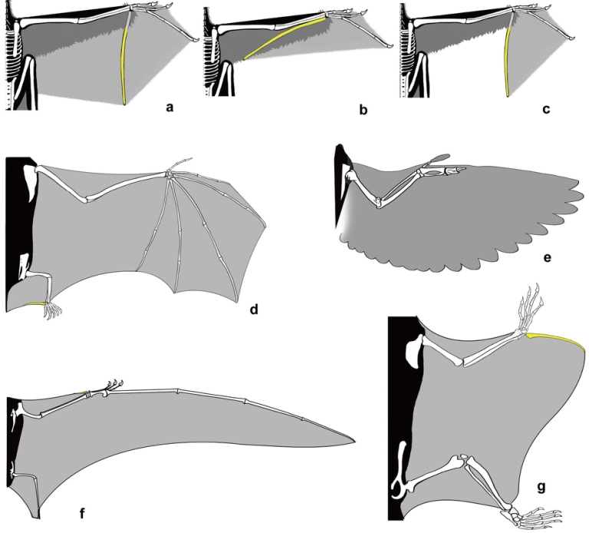
(Figure 13: [2] Extended data figure 2 from Xu et al. (2014)) Showcases various aerial-performing “wings.” A-C depicts possible reconstructions of the “wing” in Yi qi. D, a bat; E, a bird; F, a (rhamphorhynchoid) pterosaur; G, a petauristine sciurid (squirrel).

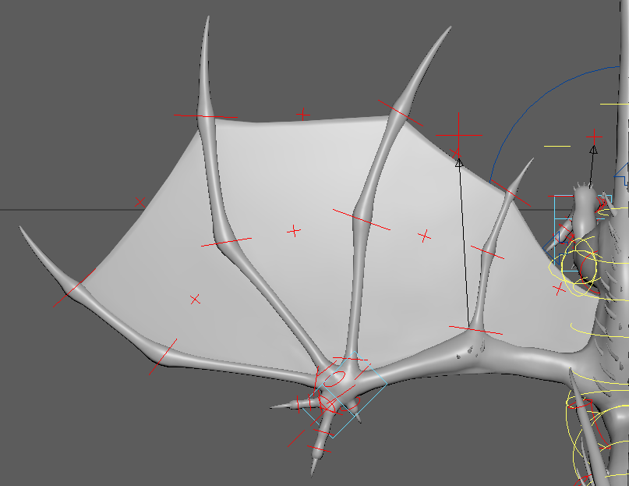
(figure 14: Dragon Wing outstretched)

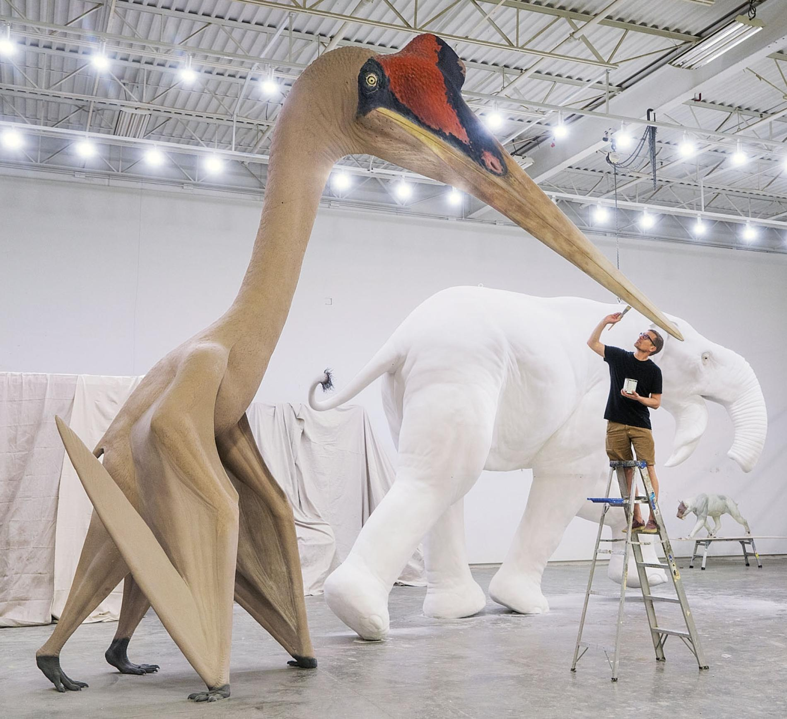
(Figure 15: [3] Life-size sculpture of Quetzalcoatlus northropi created by Blue Rhino Studio in Minneapolis. Photograph by Robert Clark.)

In figure 15, you can see the wing positioning I was aiming towards. However as these depictions show, the feet of pterosaurs face outwards from the body, rather than in front as i had initially placed them. Because of this further adjustment is likely necessary.

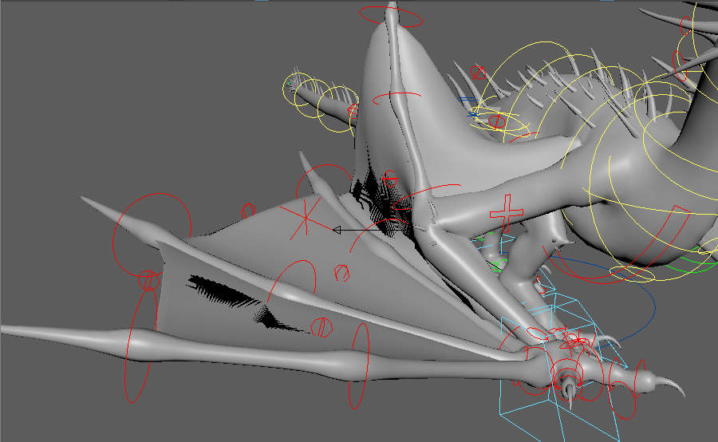
(Figure 16: Old Wing Position)

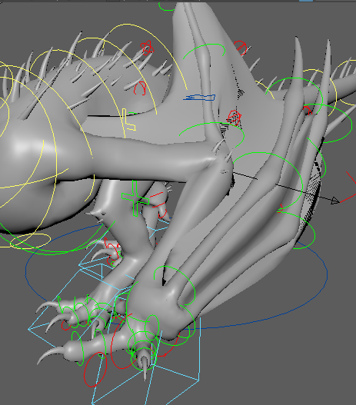
(Figure 17: Adjusted Wing position 1)

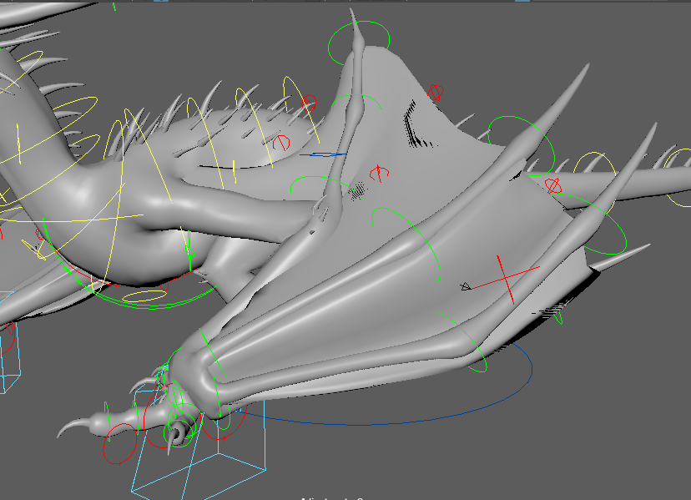
(Figure 18: Adjusted Wing Position 2)

This slight adjustment was mainly me returning the front wing position to the rotation it had originally. As when making my first walk pose i had straightened it out due to the sideways appearance initially looking odd. However that was a mistake on my part as I failed to consider that the sideways position was likely intentional due to how the wing joints would naturally be positioned facing backwards.

Foot & wing placements were also adjusted today so that there was less “sliding” as the dragon moved. This currently only fixes the sliding in the stepped animation mode. In Betweens are likely required to prevent “sliding” between key poses

Take off
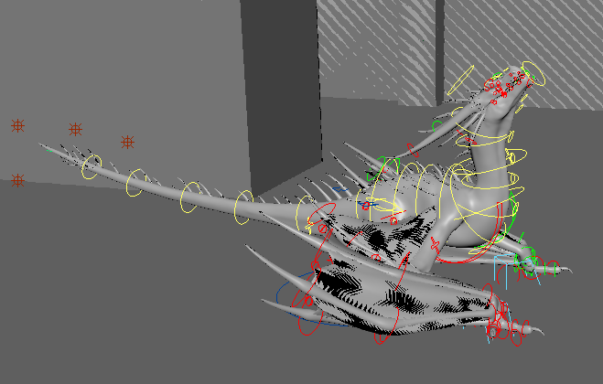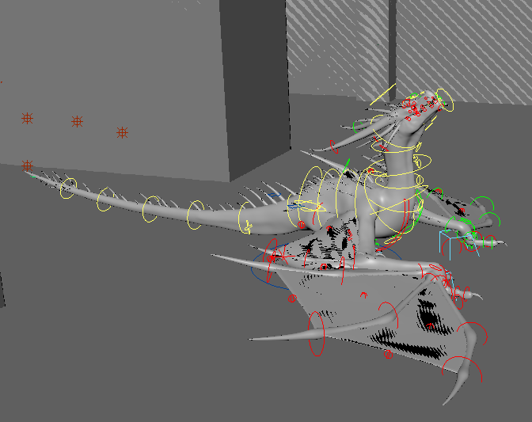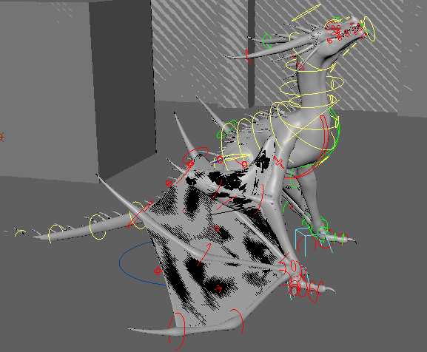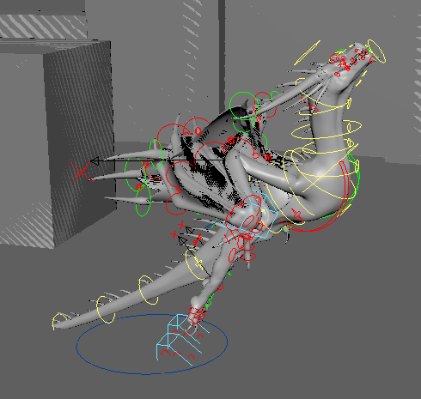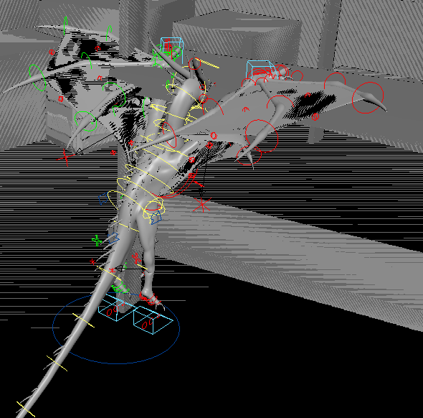
(Figure 19: Takeoff key frames)

The style used to jump into flight here is a mix of a 4 legged jump and how figure 10 depicts a potential method for pterosaurs to take flight. Initially I was going for the latter idea - which is a sort of vault into the air primarily using the front limbs, however due to the angle of takeoff, It ended up looking more like a 4 legged jump, like how bats will launch into flight when grounded. I may consider moving the start position of the dragon This will likely be necessary to allow for more space between the push off point and the shelves. However it may be easier to just move the scene over slightly at this stage, rather than adjust several key frames individually.

01/12/2020

Today was mainly spent adding and adjusting keyframes. An “All” set in ATools was made so that keyframe timings can more easily be adjusted. Furthermore, the camera’s movement and key frames were also adjusted to better fit the animation.

The key frames regarding wing movements were adjusted due to the elbow wing finger joint clipping when the wings were contracted. This was fixed by rotating the joint into a position which stopped the clipping. However the result of this looks somewhat broken and unnatural. There is little I can do about this due to this elbow wing finger being a flaw of the dragon’s design. Different configurations for this likely would also not work without causing these wing fingers to clip and overlap eachother.

While considering the shelf movement, I discovered that moving props in the scene may be more difficult than previously thought. With the shelf, this is due to it being composed of several separate objects that do not currently move together as one.

02/12/2020

Work today focused on making adjustments to the scene so that the shelf can be animated. As mentioned previously; due to the nature of the shelf being composed of several unconnected boxes there is not currently a way to animate it as one moving object.

Initially i tried grouping it as a set group, however the individual parts of the shelf would move disconnected from each other when testing. Other attempts caused the shelf to minaturise or vanish from its reference. My last attempt today was to group it as try and animate it from the group node. However this could not be keyed as a single asset due to the following error:

Warning: file: C:/Program Files/Autodesk/Maya2020/scripts/others/doSetKeyframeArgList.mel line 633: Current manipulator and active objects have no keyable attributes, or animation layers are present and the BaseAnimation bar is not selected or locked.

So. As all of my attempts have failed, I plan on speaking with my lecturer, Phil, tomorrow and see if he can help me solve this issue

03/12/2020
With the help of Phil. I created a Locator and parented the shelf assets underneath it. This locator can be keyed and solves the issue which prevented me from animating the shelf and the dragon animation that goes with it.

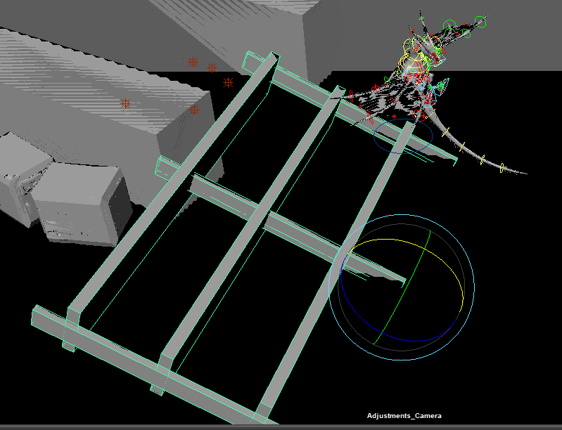
(Figure 20)

Figure 20 above showcases a screenshot of me roughing the bookshelf falling over.

Minor Key frame adjustments were made today regarding the timing of pauses and an iteration of the wing claw placement. I also played with the camera positioning for the shelf-focused key frames. A second camera perspective may be needed to focus on the dragon’s reactions. I plan on testing the one perspective before adding in a second camera however.

I’m contemplating how I want the dragon to flail after it realises the shelf is going to fall. Initially I had planned it would push off and flap as the shelf fell inwards, however I don’t think that will give me a lot of time or space to work with.

Regardless, I keyframed the “Realising shelf will fall” transition between landing on the shelf and toppling it over. This will likely last from frame 135 - 155, after which the dragon will flail into action.

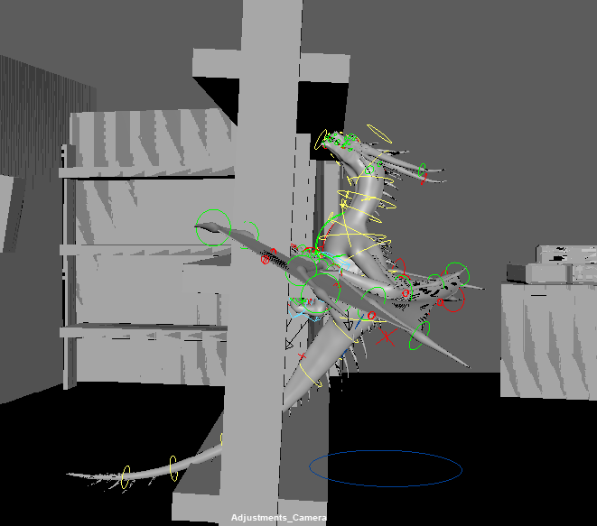
(Figure 21: Realisation it’s about to fall)

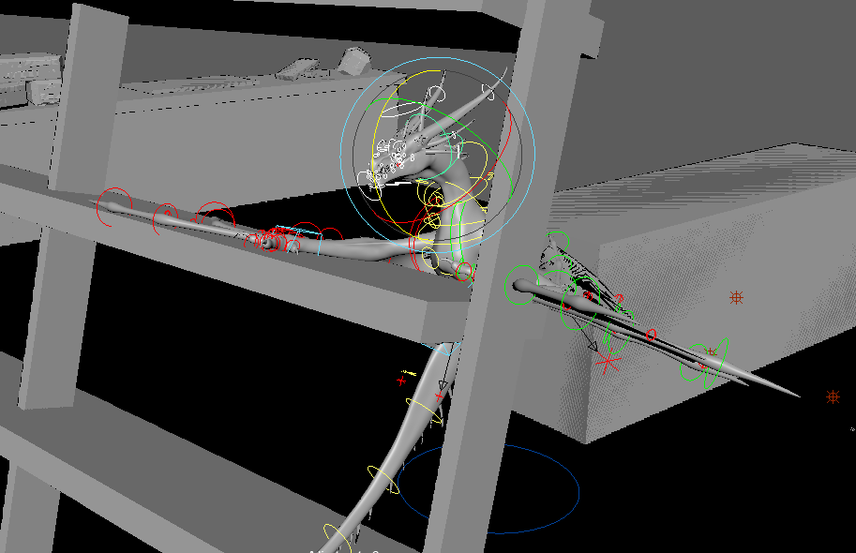
(Figure 22: Action start)

04/12/2020 - 05/12/2020

On Friday I posed out the shelf scramble and adjusted the timings for the whole sequence. This timing adjustment was done so the whole animation flowed better and to give space and breathing room for key poses.

The shelf leap was also blocked out although some tweaking still needs to be done. Today (saturday) I adjusted to camera key frames once more and, as i’ve decided to have the dragon scramble over and off the shelf, I don’t feel the need to add a second camera to this setup.

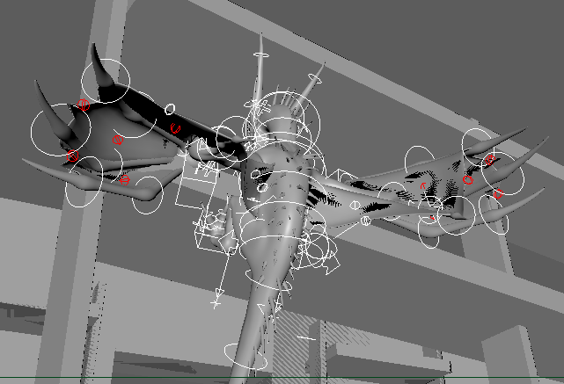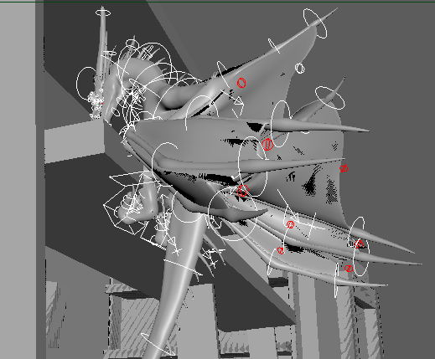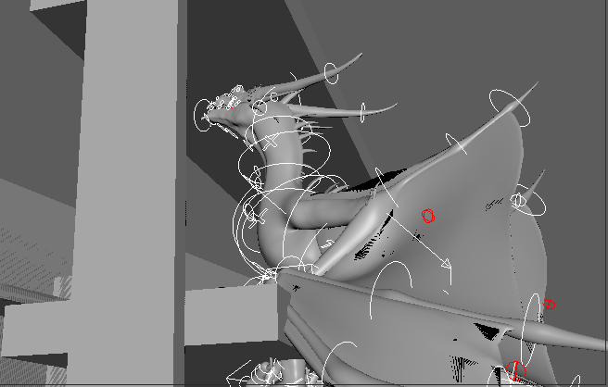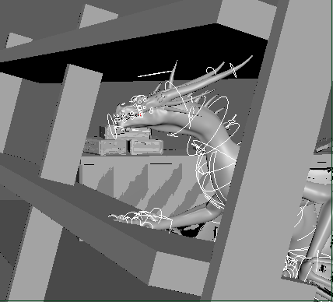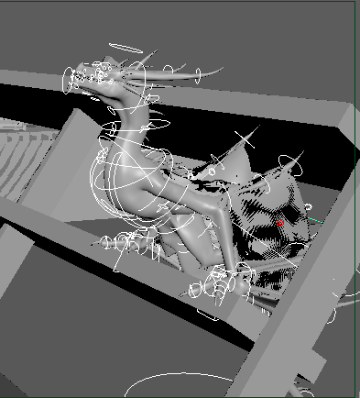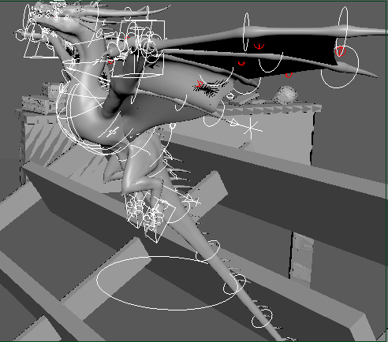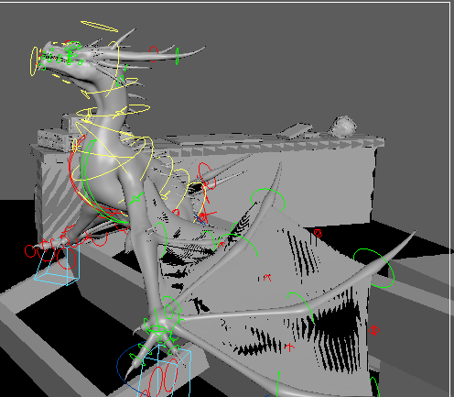
(Figure 23: Camera 1 key frames for the shelf interaction)

06/12/2020
As hand in for the animation is due tomorrow, Today has been spent making minor adjustments and turning this animation into clips within the Time Editor.

Reflecting on this project, I feel that my time management could have been improved as I delayed starting this project in favour of working on other assignments. However, I do feel this project enhanced my skill at animating through improving my familiarity with Maya’s animation tools. The complexity of the rig also developed my skill as it gave me insights into how animation aids an understanding of the mechanics of creature design as well as developed my troubleshooting skills.

While this animation isn’t truly a part of my independent project, it has used assets developed during pre-production. The skills developed while developing this animation will be useful in my independent project.

Bibliography

[1]
Kelly, Jonathan Leake and Nathan. “Isle of Wight Find Proves Winged Dinosaurs Took off by ‘Vaulting’ into the Air.” The Times, 22 Sept. 2019, www.thetimes.co.uk/article/isle-of-wight-find-proves-winged-dinosaurs-took-off-by-vaulting-into-the-air-zq0q8thtp. Accessed 7 Dec. 2020.
‌
[2]
Xu X., Zheng X.-t., Sullivan, C., Wang X.-l., Xing L., Wang Y., Zhang X.-m., O’Connor, J. K., Zhang F.-c., Pan Y.-h. 2015. A bizarre Jurassic maniraptoran theropod with preserved evidence of membranous wings. Nature (Online before Print 29 April, 2015) DOI: 10.1038/nature14423
‌
[3]
Blue Rhino Studio. Life-Size Sculpture of Quetzalcoatlus Northropi. Photograph by Robert Clark.

‌

