
“I confirm that I have not used any AI tools in the research and creation of this assignment. I confirm that I have not presented any AI generated materials as my own work. I confirm I have copies of my drafts, notes, and other resources I used, which I may be asked to provide in evidence.”
PORTFOLIO (six elements)

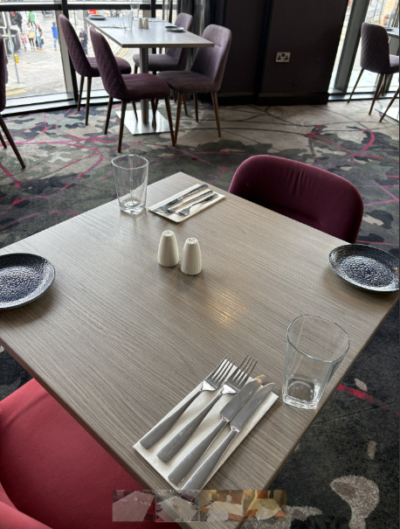

Programme: BA Hospitality and Hotel Management
Module: FOOD & BEVERAGE OPERATIONS
Module code: BMIH5008
Lecturer: DANIEL PAYNE, LISA BASSLER
Student name: NICOLETA ANDREEA ROSCA
Student number: 2009573

Contents
Part 1: Reflective Writing Using Gibbs’ Model 2
Introduction 2
Main Body 2
Gibbs Reflective Model 2
Description 2
Feelings 3
Evaluation 3
Analysis 4
Conclusion 5
Action plan 6
Part 1 References 7
Part 2: Hotel Mentor Feedback 9
Part 3: Placement Tutor Feedback 9
Part 4: Reflection on Hotel Placement Tutor Feedback 12
Introduction 12
Main body 12
Understanding The Feedback 12
Impact of the Feedback 13
Action Steps for Growth 14
Conclusion 15
Part 4 References 15
Part 5: Presentation on Placement Experience 16

Part 1: Reflective Writing Using Gibbs’ Model

Introduction
Using the Gibbs Reflective Writing Cycle (1988), this report will analyse the experience I had during my placement in the Food and Beverage Department of my designated hotel, at Clayton Hotel in Cardiff (Trimasse, 2025). Built in 2011, embracing the local culture and ecosystem education, the hotel has eleven floors, summarising 216 rooms, bar and restaurant, coffee, and tea areas, seven meeting rooms and computer station. Close to Cardiff Castle, National Museum and Cardiff Shopping Centre, Clayton Hotels offers top rated customer experiences and exceptional services with the help of a diverse, multinational, and well-prepared team (Expedia, 2026). I had practical experience working in diverse departments such as bar, restaurant, and event meeting rooms. I engaged in service, order taking, organisation and decision-making situations.

Main Body

Gibbs Reflective Model

Description
First, I was trained by a food and beverage employee on how to serve breakfast, prepare the layout on tables for lunch and afternoon tea, how to clean and maintain the required hygiene standards. Second, I learned how to correctly clean plates and polish glasses and cutlery. After, I participated in customer service, taking orders and delivering food were the principal occupation during the placement hours in this department. Everything was new and scary for the start, but enjoyable and full of current information and situations. Also, I encountered a demanding situation with busy periods, missing staff, and customers complaints. As an example, was when one of the customers complained about the speed of service. Fact observed in the online reviews later.
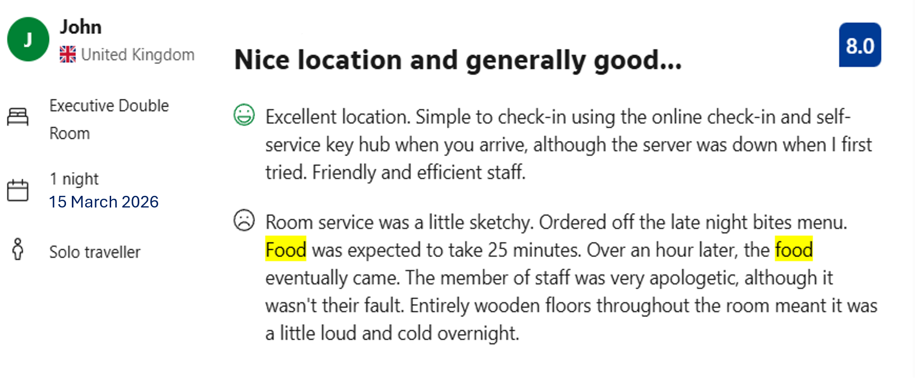
(Booking.com, 2026)
I proceed to listen carefully to his problem. I apologised trying to explain that is it a peak hour and we have a group present I hotel that required an extend time for their food preparation. I tried to find out from the kitchen what was the status on their order and when is possible to be ready. The customer was frustrated but calmed right away when the order was on the table.

Feelings
Initially I felt nervous and overwhelmed by the customer expressed dissatisfaction. I was lacking confidence and worried about making mistakes in how to oversee this situation. I recall what I learned in classes about complaint handling (Salem, 2021) and decision-making (Jerger & Wirtz, 2017), and I started to feel more confident. I managed to keep myself calm and professional, active listening (Min et al, 2021) to his needs. I manage to gain his trust, deescalating the situation, talked to kitchen and bring their food to the table, offer them a small discount on the order, and everyone was finally happy.

Evaluation
There were both positive and challenging elements to this experience and many more throughout my full placement period. Maintaining a professional and attentive approach, using active listening (Min et al, 2021) and prevent the situation to escalate, made the customers to gain trust, to calm down and made possible to contain and solve all issues effectively. However, I recognise a key area for improvement: my lack of initiative in proactively informing the customer about possible delays. I responded only when the customer raised concern, rather than anticipating the issue and addressing it in advance. Taking earlier action would likely have reduced the dissatisfaction and enhanced the overall customer experience. I was fortunate to be able to rely on the restaurant and especially on the kitchen team, which wanted and were happy to collaborate in resolving this problem promptly.

Analysis
When I analyse this experience through the lens of hospitality management theory (Armstrong & Taylor, 2024), I can clearly see how several core concepts shaped both strengths and weaknesses of my performance. Service quality models (Ford & Sturman, 2025) particularly the dimension of reliability and responsiveness (Sharif et al, 2025), provide a useful starting point. In this situation the delay in food delivery directly impacted the reliability of service that me and the team were responsible for. My responsiveness became noticeable only when the customer raised the issue, which made my action rather reactive than initiative-taking. This reveals a gap between what I intended to deliver and what the customer actually experienced.
Reflecting on the incident through service recovery theory (Stokburger-Sauer & Hofmann, 2023), I recognise that I did implement some appropriate recovery strategies, such as active listening (Min et al, 2021), apologising and explain the cause of delay. These actions helped to stabilise the atmosphere and contributed to restoring the customer trust. However, I realised that I could have taken more initiative by informing the customer about the busy kitchen before they felt the need to complain. Initiative-taking communication is a key element of effective service recovery, and this issue made me aware of how important it is to act early rather than wait for dissatisfaction to surface. The incident also revealed an operational management issue, particularly around communication between the kitchen and service team. The delay was partly caused by a breakdown in information flow, which prevented me from giving the customer accurate updates. Hospitality operations rely heavily on effective communication between departments, and this experience demonstrated how even small gaps cand escalate into service failures. It reinforces the need for clearer procedures and stronger coordination to support consistent excellence in service delivery.
Through the interaction, I had to manage my own nervousness and maintain calm, friendly, and professional demeanour. This required conscious emotional regulation (Tariq et al, 2025), part of emotional labour (Mullins & Dossor, 2013), which is an important skill required in hospitality roles. Even though I felt an internal emotional pressure, I manage to keep my behaviour composed and professional. This reminded me of emotional demands of service work that we discussed in classes, and how important is to know how to balance authenticity with professionalism.
Overall, this situation and many other happened during my placement period in Clayton Hotel Cardiff food and beverage department, help me to understand how personal action and organisational systems interact to shape service outcomes. While I managed to manage the issue effectively, the experience highlighted areas where I can grow, particularly in taking initiative, communicating proactively, and supporting smoother operational coordination. Moving forward, I aim to strengthen these aspects so that I can contribute to a more seamless and client-driven service environment.

Conclusion
This experience has been highly valuable for my professional development. Along with all knowledge gain in my classes allowed me to recognise several key lessons that are essential in hospitality practices. First, I learned how to execute all tasks involved in food and beverage department. Second, I discovered how important is to remain calm and composed when dealing with challenging customer interactions. Third, I realised that communication and active listening are fundamental skills in conflict resolution and play a key role in achieving excellence in customer satisfaction (Najmudin et al. 2026). Being able to regulate my emotions and respond with clarity helped me manage the situation more confident.
I also realised that being initiative-taking rather than active is crucial in customer service. anticipating potential issues and informing customers in advance can significantly reduce dissatisfaction and enhance he overall customer experience. This incident along others made me aware that taking initiative is not only beneficial for guests but also reflects professionalism and strong service awareness.
Another key insight from this experience was the value of teamwork within food and beverage department. Coordinating effectively with colleagues, especially during peak hours and when big groups arrive, is essential for maintaining service quality. This example of issue demonstrates how communication and collaboration between team members directly influences operational effectiveness and customer service outcomes.
Finally, this experience helped me unite the gap between theory and practice. The theory about service quality, service recovery, and emotional labour became much clearer when I applied them in real working environment. Understanding how these theories operate in practice has strengthened my ability to translate academic knowledge into practical skills.
Overall, this reflection has enabled me to identify both my strengths and areas for improvement. It has provided a solid foundation for my continued growth in the hospitality industry and has reinforced my commitment to develop as a competent, reflective, and customer focused professional.

Action plan
To perform more effectively in the future, I created an action plan that includes the areas that I have to improve, the actions that I will take in order to achieve it, the way I will be doing it and the time limit that will be needed.
Areas to improve | Actions | How will I do it | Time limit
Communication  skills | Improve clearness with customers. | -Practice clear and polite speaking.  -Provide regular updates to the guests. | Ongoing
Proactiveness | Anticipate the customers’ needs. | -Monitor order times and inform about any changes or delays early. | During shifts periods
Confidence | Build confidence in handling complaints. | -Oversee more customer interactions and learn from experiences. | 1 to 3 months
Service recovery | Apply better recovery strategies | -Read about it and learn when and how to apologise, compensate, and offer solutions. | Ongoing
Teamwork | Improve coordination with staff | -Communicate clearly with the other departments colleagues during service. | Every shift
Feedback | Continuous  Improvement | -Ask supervisors and customers for constructive feedback after every shift and service. | Every day

Part 1 References
Armstrong, M., and Taylor, S. (2024) Armstrong’s handbook of human resource management practice: a guide to the theory and practice of people management. 16th edition. London; Kogan Page.
Booking.com, (2026), Clayton Hotel Cardiff customer reviews, Available at: https://www.booking.com/hotel/gb/clayton-hotel-cardiff.en-gb.html?aid=2276424&label, [Accessed 01 April 2026].
Expedia, (2026), Clayton Hotel Cardiff, Available at: https://www.expedia.co.uk/Cardiff-Hotels-Clayton-Hotel-Cardiff.h4254642.Hotel-Information?chkin=2026, [Accessed 01 April 2026].
Ford, R.C. and Sturman, M.C. (2025) Managing hospitality organizations: achieving excellence in the guest experience. Third edition / Robert C. Ford, Michael C. Sturman. Thousand Oaks: Sage.
Jerger, C. and Wirtz, J. (2017) “Service Employee Responses to Angry Customer Complaints: The Roles of Customer Status and Service Climate,” Journal of service research: JSR, 20(4), pp. 362–378. Available at: https://doi.org/10.1177/1094670517728339, [Accessed 01 April 2026].
Min, K.S., Jung, J.M. and Ryu, K. (2021) “Listen to their heart: Why does active listening enhance customer satisfaction after a service failure?” International journal of hospitality management, 96. Available at: https://doi.org/10.1016/j.ijhm.2021.102956, [Accessed 01 April 2026].
Mullins, L.J. and Dossor, P. (2013) Hospitality management and organisational behaviour. Fifth edition. Harlow, England: Pearson.
Najmudin, M. et al. (2026) “Emotional and Experiential Drivers of Customer Satisfaction in Luxury Hospitality,” Journal of quality assurance in hospitality & tourism, pp. 1–19. Available at: https://doi.org/10.1080/1528008X.2026.2632209, [Accessed 02 April 2026].
Salem, S.F. (2021) “Do Relationship Marketing Constructs Enhance Consumer Retention? An Empirical Study Within the Hotel Industry,” SAGE open, 11(2). Available at: https://doi.org/10.1177/21582440211009224, [Accessed 01 April 2026].
Sharif, S. et al. (2025) “Provider–Recipient Dyadic Interactions: Impact of Service Quality on Customer Behaviours Using a Multi-Modelling Approach,” Global business review, 26(4), pp. 876–899. Available at: https://doi.org/10.1177/09721509211038828, [Accessed 02 April 2026].
Stokburger-Sauer, N.E., and Hofmann, V. (2023) “Can a smile help healing service failures? The interplay of employee emotions, guest emotions, and justice perceptions for successful service recoveries in the hospitality industry,” Journal of hospitality and tourism management, 55, pp. 261–276. Available at: https://doi.org/10.1016/j.jhtm.2023.03.018, [Accessed 02 April 2026].
Tariq, S. et al. (2025) “Customer Reactions to Emotional Labor: Moderating Role of Human Resource Practices between Emotional Labor and Customer Outcomes,” Contemporary management research, 21(2), pp. 161–197. Available at: https://doi.org/10.7903/cmr.24435, [Accessed 02 April 2026].
Trimasse, N. (2025) “The use of reflective reports in higher education,” Reflective practice, 26(1), pp. 154–171. Available at: https://doi.org/10.1080/14623943.2024.2424520, [Accessed 01 April 2026].

Part 2: Hotel Mentor Feedback
Student Name: Nicoleta Rosca
Placement Hotel: Clayton Hotel Cardiff
Did the Student complete the required hours of 16h per week?
Yes
Food and Beverage Operations. Knowledge of menu and service standards: Did the student demonstrate an understanding of menu items, allergies, and service etiquette?
Yes, she worked a mixture of early and late shifts and got to develop her breakfast/lunch/afternoon tea menu knowledge. the difference in service standards and restaurant table layout between each service and guest requirements.
Speed and efficiency in service: Was the student able to deliver food and drinks promptly and correctly?
Yes, her confidence grew in this area. you could see her service and communication skills developing as there was more time with different team members on the floor.
Ability to upsell and engage with guests: Did the student actively promote menu items and create a positive guest experience?
Her confidence in this area grew over time. guest interactions across the hotel grew and her confidence and hotel knowledge grew.
Food and Beverage Feedback: Please provide specific feedback on the student’s performance in the Food and Beverage department.
Her confidence and guest interaction grew as the weeks have progressed. Her team working skills developed also as each day/shift was so different and the demands of each shift resulted in time management and teamworking skills having to be called upon.

Part 3: Placement Tutor Feedback
Time Management
“Nicoleta began her placement slightly later than expected due to the hotel’s scheduling requirements. Despite this, she has made steady progress and has currently completed approximately 112 hours, demonstrating a clear commitment to meeting the overall placement requirements.
Her working pattern has been set by the hotel, consisting primarily of Tuesday mornings and Thursday afternoons. While this has allowed her to maintain consistency, it does limit her exposure to the full range of operational activities within the hotel. However, as Nicoleta is also employed within the housekeeping department at the same hotel, she has additional opportunities to observe the operation on other days, which supports her overall understanding.
Nicoleta has shown good awareness of her remaining hours and has been proactive in tracking her progress to ensure she meets the required total. This level of organisation is a positive aspect of her approach.
From a tutor’s perspective, Nicoleta has attended all scheduled meetings and maintained consistent communication. Moving forward, continuing to balance her placement hours alongside the academic requirements will be important to ensure successful completion of all elements.
Communication
Nicoleta has demonstrated strong and consistent communication throughout her placement. She has maintained regular contact via email, ensuring that updates are shared and any queries are addressed promptly.
She has attended all scheduled meetings and has been clear and professional in her communication. While she has asked fewer questions in relation to the academic assignment, she has shown initiative by requesting to submit a draft for feedback, which is a positive step towards improving her work.
Within the workplace, Nicoleta has received positive feedback from both the General Manager and HR team, who have highlighted her friendly and approachable nature. Her positive attitude and ability to engage well with others are strong attributes within the hospitality environment.
Looking ahead, continuing to build confidence in asking questions, particularly in relation to her academic work, will further support her development.
Behaviour
Nicoleta has demonstrated a highly positive and professional attitude throughout her placement. She is a hardworking, friendly, and approachable individual, which has been reflected in the positive feedback received from the hotel team.
As this is her first placement, Nicoleta has shown good adaptability in moving between departments, including Housekeeping and Food & Beverage, and is due to begin experience within Reception. Initially, she expressed some concern about transitioning into Food & Beverage; however, she has since grown in confidence and is now more comfortable within this area. This development is particularly encouraging and highlights her ability to step outside of her comfort zone.
Nicoleta has engaged well with the placement overall and has shown enthusiasm in her role. Moving forward, continuing to build confidence across different departments will further strengthen her ability to adapt and succeed in a variety of hospitality settings.

Problem-Solving
Nicoleta has begun to develop her problem-solving skills throughout her placement, particularly as she gains exposure to different departments. Her willingness to move into new areas, despite initial uncertainty, demonstrates a positive approach to learning and development.
As Nicoleta continues to gain experience, developing greater confidence in unfamiliar situations and taking more initiative in asking questions or seeking clarification will further enhance her problem-solving abilities.
Looking ahead, it may be beneficial for Nicoleta to consider undertaking her Level 6 placement in a different hotel environment. This would allow her to gain a broader perspective of the industry and further develop her skills in a new setting.
Nicoleta should take confidence from the positive feedback she has received and the progress she has made so far. By continuing to build her confidence, maintaining her strong work ethic, and placing greater focus on the academic element alongside her placement, she will be well positioned for future success within the hospitality industry.”

Tutor: Daniel Payne
Signature: Daniel Payne
Date: 19th March 2026

Part 4: Reflection on Hotel Placement Tutor Feedback

Introduction
This part of portfolio examines the feedback I received during my placement in the food and beverage department in Clayton Hotel Cardiff, guided by my hotel mentor and placement tutor. Feedback is essential to professional growth, particularly in hospitality, where service quality is and customer satisfaction depends directly on individual performance (Najmudin et al, 2026). During my placement period, I gained practical experience across restaurant, bar operations, and meeting room preparation, which helped me understand how different departments contribute to overall guest experience.
The tutor feedback allowed me to identify strengths in communication and teamwork, while also recognising areas where I need to take more initiative. Throughout the placement, I demonstrated commitment and organisation by proactively managing my hours and maintaining consistent attendance, despite beginning slightly later due to scheduling requirements. My communication was identified as key strength, reflected in my regular updates and positive interactions with colleagues, including recognition from the General Manager and HR team.

Main body

Understanding The Feedback
Reflecting on the feedback I received from my hotel mentor and placement tutor has given me a deeper understanding of my development during this period and the areas where I still need to grow. Engaging with this feedback has allowed me to critically evaluate my performance in the food and beverage department and to connect my practical experiences with the theoretical concepts I have studied. This process was important in helping me build a clear understanding of my strengths, limitations, and futures plans as a hospitality professional.
One of the most encouraging aspects of the feedback was recognition for my communication skills. My mentor highlighted that I consistently demonstrate attentiveness and friendliness when interacting with customers, quality associated with positive encounters (Hao & Chon, 2022). I found this reassuring because effective communication is a key in guest satisfaction and knowing that I was able to create a positive impression reinforced my confidence in this area. My placement tutor also acknowledged my academic and reflective abilities, noticing that I began to show stronger links between theory and practice (Kloutsiniotis & Mihail, 2018). This recognition motivated me to continue developing my reflective skills, as they are essential for long time professional growth.
My placement at Clayton Hotel Cardiff gave me extensive exposure to the hotel operational structure. The layout of the, with the restaurant on the ground floor, seven meeting rooms on the second floor, and the guests’ rooms on upper levels, allowed me to observe how different departments interact without face-to-face communication. Working within this environment made me develop a practical understanding of how food and beverage service operates in a real hotel setting. As an example, I gained hand-on experience in breakfast service, where I learned how to welcome guests, manage settings, and maintain efficiency during peak periods. These tasks required me to balance speed with accuracy, and they helped me appreciate the importance maintaining composer under pressure (Jiang et al, 2023).
Also, I understand from the feedback that I developed skills necessary in lunch and afternoon tea preparation and serving, including professional table setting techniques and the standards required for diverse types of service. It shows that these experiences enriched my understanding of service quality and consistency, which are essential components of hospitality operations. Beyond guest orientated tasks, I also was responsible for maintaining hygiene and cleanliness. This includes sanitising cutlery, polishing glassware, and preparing the restaurant for the next service period. Having honest feedback made me understand that even that we are working in the back of the house we are still contribute to the overall customer experience.

Impact of the Feedback
The feedback I received has had a significant impact on my personal and professional development. One of the most important outcomes was gaining a clear understanding of my strengths. Being recognised for communication skills, cheerful outlook, and professionalism increased my confidence and reassured me that I am developing the interpersonal qualities. Knowing that managers and HR team viewed me as a friendly and approachable helped me appreciate the value I bring to guest interaction and team dynamics.
The feedback also encouraged me to reflect more deeply on areas where I need to grow. For example, learning that I sometimes struggle with task prioritisation during busy periods made me more aware of the importance of staying organised under pressure. This insight has motivated me to develop stronger time- management strategies and to be more initiative-taking in anticipating operational need. Similarly, being encouraged to build confidence in handling customer complaints highlighted the need of growing my assertiveness and problem solving.
Also, the feedback reminded me that professional development is not only about practical skills but also about engaging critically with theory and seeking support when needed.
Overall, this feedback helped me to develop greater self-awareness, bigger motivation to improve, and provided me a clear direction for my future growth in hospitality industry.

Action Steps for Growth
Areas for improvement | Actions | How will I do it | Time limit
Time management | Improve task prioritisation. | -Use checklists  -Organise tasks by urgency | Every shift
Confidence | Manage complaints effectively. | -Observe senior staff  -Practice real interaction | 1-2 months
Communication | Enhance guest’s interactions. | -Provide clear updates  -Practice active listening | Ongoing
Critical thinking | Improve academic analysis. | -Apply theories in reflections  -Seek feedback | Ongoing
Professional growth | Develop industry readiness | -Take initiative  -Learn from practical experiences | Continuous

Conclusion
The feedback I received has had a strong impact on how I see my progress and my potential in hospitality. Being recognised for my skills and cheerful outlook, boosted my confidence and helped me observe that I naturally contribute to a welcoming guest experience. At the same time, the comments about improving my task prioritisation and confidence, especially during peak periods or when overseeing complaints, made me more initiative-taking, organised, and assertive. Overall, it has strengthened my motivation to keep developing professionally and personally.

Part 4 References
Hao, F., and Chon, K.K.-S. (2022) “Contactless service in hospitality: bridging customer equity, experience, delight, satisfaction, and trust,” International journal of contemporary hospitality management, 34(1), pp. 113–134. Available at: https://doi.org/10.1108/IJCHM-05-2021-0559, [Accessed 03 April 2026].
Jiang, J. et al. (2023) “Employees’ proactive customer service performance in hospitality: impacts of customer mistreatment and team performance pressure,” Tourism review (Association internationale d’experts scientifiques du tourisme), 78(6), pp. 1414–1432. Available at: https://doi.org/10.1108/TR-05-2022-0261, [Accessed 03 April 2026].
Kloutsiniotis, P.V. and Mihail, D.M. (2018) “The link between perceived high-performance work practices, employee attitudes and service quality: The mediating and moderating role of trust,” Employee relations, 40(5), pp. 801–821. Available at: https://doi.org/10.1108/ER-08-2017-0201, [Accessed 03 April 2026].
Najmudin, M. et al. (2026) “Emotional and Experiential Drivers of Customer Satisfaction in Luxury Hospitality,” Journal of quality assurance in hospitality & tourism, pp. 1–19. Available at: https://doi.org/10.1080/1528008X.2026.2632209, [Accessed 03 April 2026].

Part 5: Presentation on Placement Experience
Slide 1
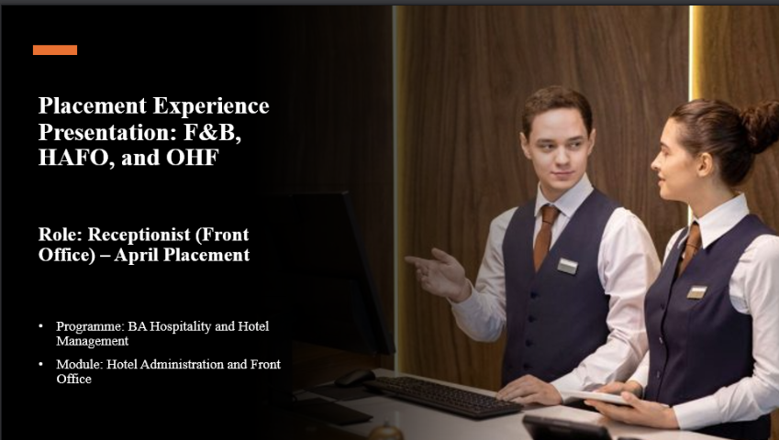
Slide 2
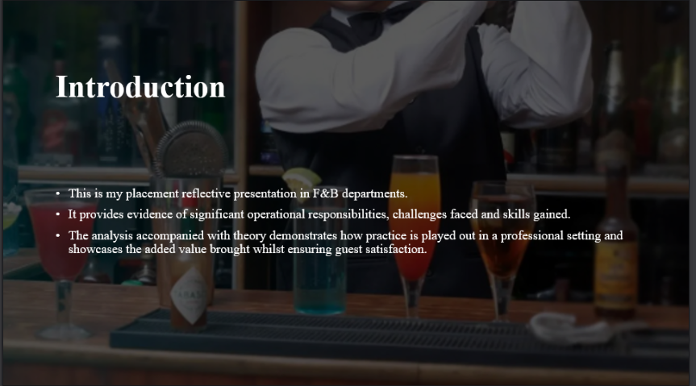

Slide 3
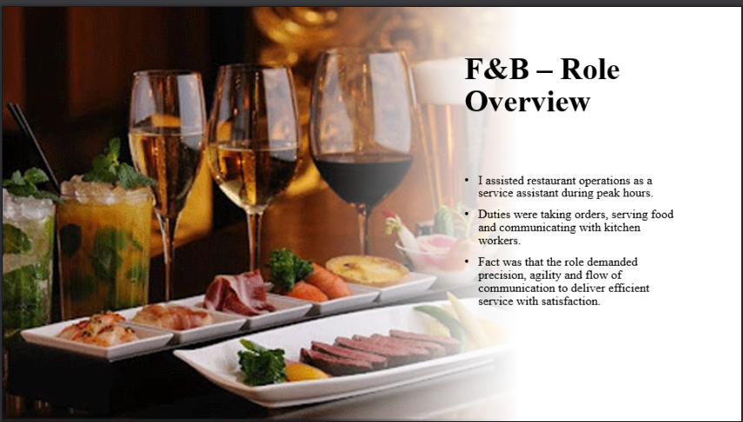
Slide 4
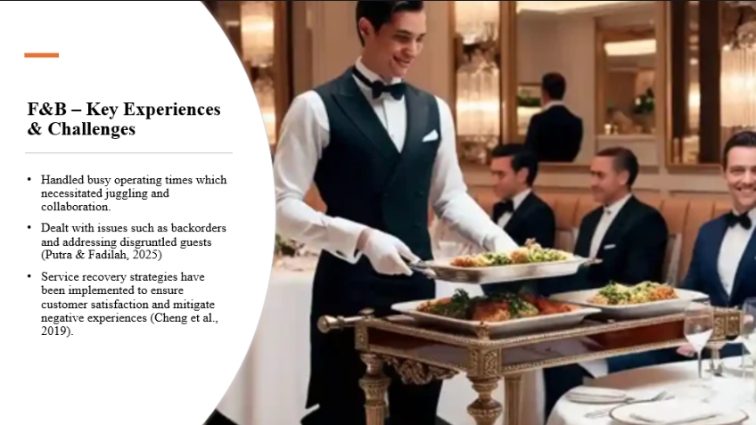

Slide 5
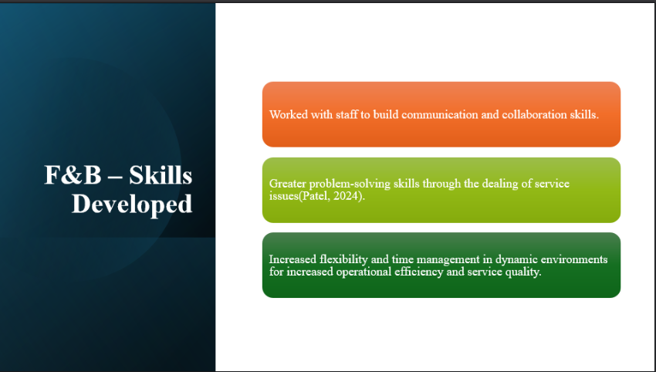

Slide 6
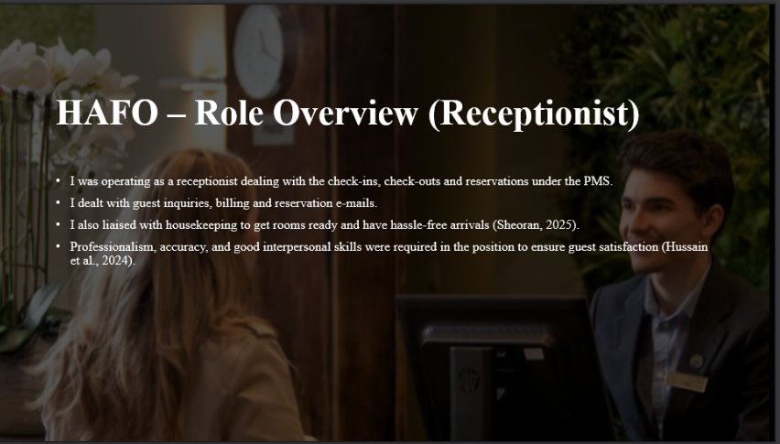

Slide 7
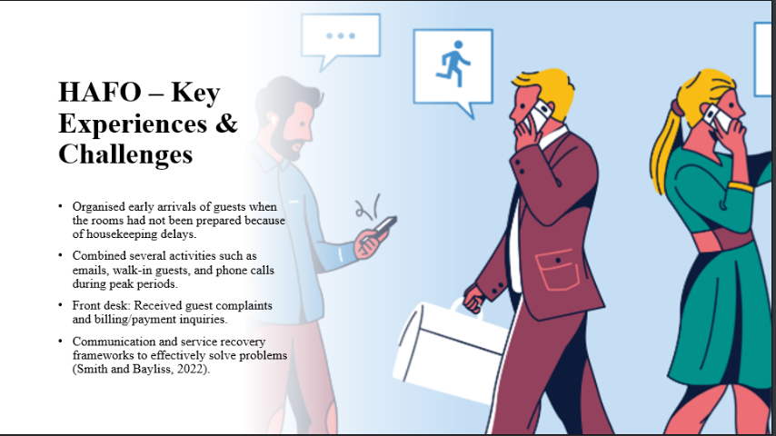

Slide 8
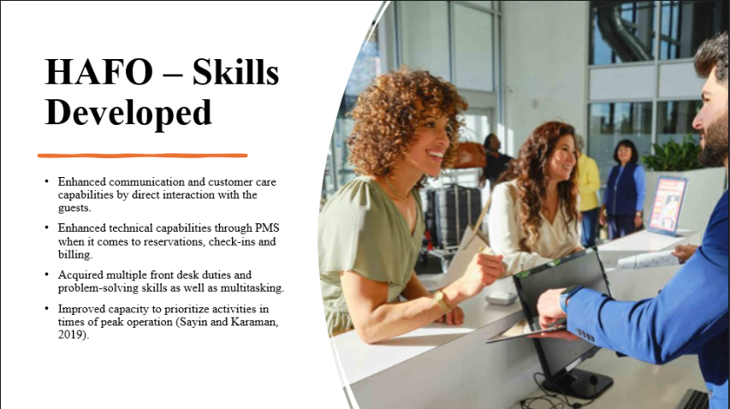

Slide 9
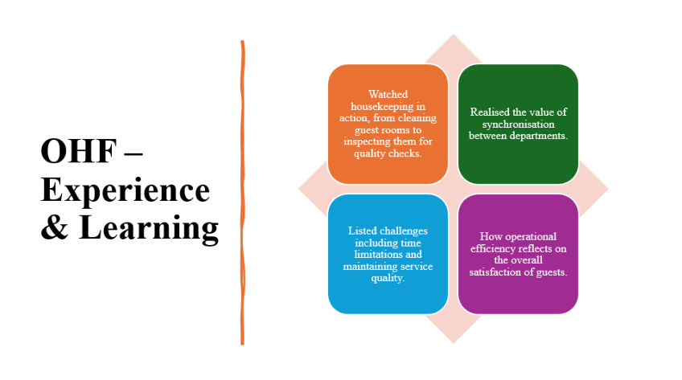

Slide 10
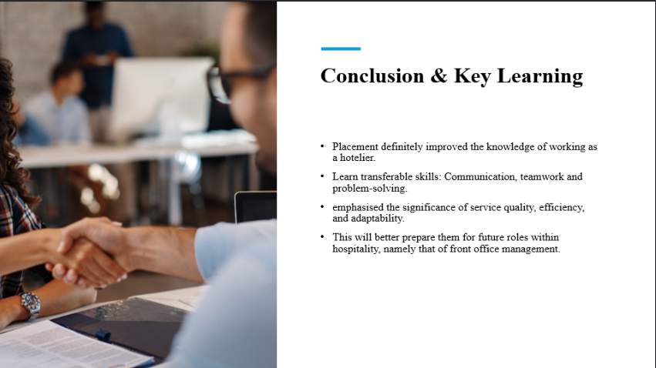

Slide 11


