
Teamwork and communication in the workplace


June 25, 2021
University of Wales Trinity Saint David

Corina Cernat 2019920
UWTSD
25.06.2021
Word count 2172

Executive Summary

The purpose of this report is to provide an analysis into how different teamwork theories and 2-way communication methods can improve the work in a studied organisation.
The two theories applied in ABC Technology are Tuckman’s and Belbin’s that identify how to overcome the conflict situations that the members are facing, discover their strengths, and appoint a leader and help them connect.
The report then has illustrated the importance of effective virtual communication in the workplace and how the obstacles identified in the organisation can be removed by using a 2-way communication system and strategies that allow all the members to engage effectively.
It has been concluded that the senior managers of the organisation will need to identify each member’s natural role, reorganise the poor performance teams and apply a different leadership style suitable for virtual teams.
The best communication model that can benefit the teams of the studied company is Schramm’s model as it is a circular one and allows for feedback and interpretation of the message for both the sender and receiver, which is crucial for improving the broken communication between the employees.
A few recommendations have been suggested in the end that will mainly help the managers to establish ground rules for the communication, openness, and deliver helpful appraisals.

Table of Contents
Executive Summary 1
Terms of Reference 3
Procedure 3
Introduction 3
Findings 3
Teamwork theories role in improving performance. 3
Belbin 3
Tuckman 5
Importance of 2-way communication in the workplace 6
Shannon-Weaver 6
Berlo 7
Schramm 7
Importance of virtual communication and team working. 8
Importance of effective communication in the studied organisation 8
Conclusion 9
Recommendations 9
References 10
Appendices 12
Acknowledgements 19

Terms of Reference
The current report has been requested by my lecturer Melanie Squire to exemplify how teamwork theories can be applied to improve effectiveness in the organisation and the importance of effective communication in the presented case study.
The report has been composed by Corina Cernat and is due to be submitted on the 25.06.2021.

Procedure
The information required has been collected from online journals, e-books, websites. I have also used figures to represent communication models and inserted Belbin’s SPI in the appendices.

Introduction
High performance teams are essential for the success of every organisation. This report will focus on how high productive teams can be build with the help of teamwork theories and effective communication models. It will illustrate ways on how to overcome conflict situations and provide a series of recommendation for the studied organisation that will build trust and improve the team dynamics.
As it is outlined in the case study, the two teams were used at working together and discuss ideas in face-to-face meetings, but since these have been disrupted by the pandemic, they have fallen behind with the project and cannot seem to go over the conflict situations. This can also impact the whole organisation as they have always relied on innovative projects to remain competitive.

Findings

Teamwork theories role in improving performance.

Belbin
Having to work remotely on the new project has impacted the engagement of the team members, fact that is also demonstrated by the new research on virtual teamwork during the pandemic (Belbin, 2021). All the subjects that worked purely remotely have either had the same level of engagement as in the office or far lower.
In this situation, once each member has identified their natural team role, the managers can explore the opportunity to recreate the teams. This is recommended when a team is showing poor results or when the leaders sense a team is heading towards failure.
To identify the natural role for each team member, the managers from ABC Technology should use the Belbin Self Perception Questionnaire (Appendix 1) for each team member to discover the strengths and weaknesses of everyone and to maximise their performance (Mostert, 2015). An ideal team is considered one where all the 9 roles are working together, however this is not always possible and, in some situations, members will need to work together and supply a missing role.
Conflict can arise because of this and one way of resolving it is by changing from the natural role to a manageable role. This can only be one with similar affinity to the natural one as it will reduce the strain and should fill in the missing gap. When deciding which one needs to be adopted, the team member must first study the role of the person they have to deal with and select a complimentary role. For completing the project, this strategy can be adopted in ABC Technology, but is not recommended to be done for a long period of time as it can cause increased strain.
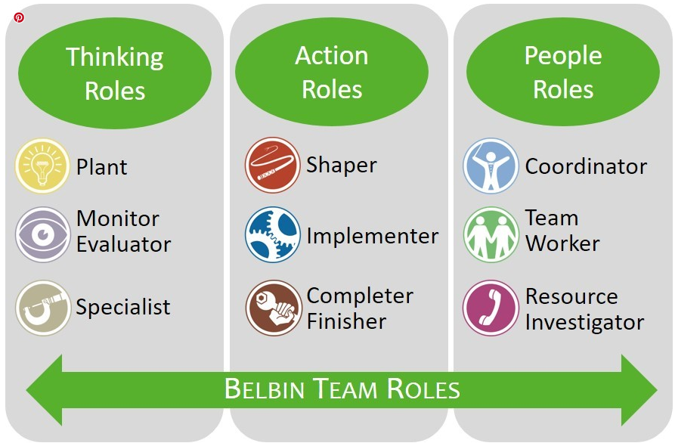
Figure 1. Belbin Team Roles Categories (SMARTT STRATEGIES, 2017)
Considering they are working on a complex project, the members should also be flexible and consider that each stage of the project can benefit from the inputs of a certain role (Belbin, 2010).
Examples how the team roles can best contribute to the working stages of a project are displayed in the figure below.
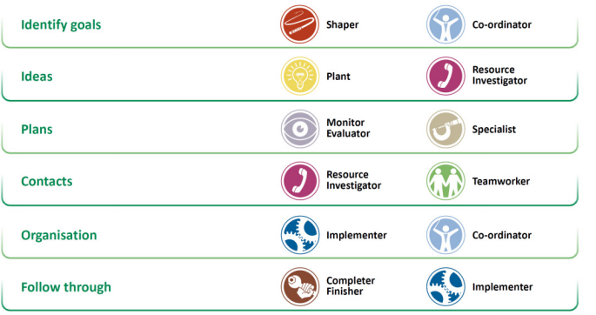
Figure 2. Belbin roles in Project stages (BELBIN, 2018)
Although the teams are geographically dispersed, the reorganisation is possible thanks to the virtual ways of communication. For the unforeseen, they must learn to work together and communicate via digital channels, and this brings opportunities for new team dynamics to be formed.
Once the team is formed and the roles of each member identified, a final step in effectively building the team would be to identify the style for conducting the operation. This again depends on the majority of roles in the team, for example one with high social role (TW, Co or RI) will highly benefit from meetings, whereas those identified with action roles (CF, IM, SH) would consider this a waste of time and would prefer to get the work done as soon as they can (Belbin, 2010).

Tuckman
According to Dr Tuckman (1965), to become an effective team, members are meant to go through five development stages.
Forming. The initial phase when the tasks are meant to be defined and members get to know each other. As the two teams have worked together before, it can be concluded they have already passed this stage. However, if the managers decide to reorganise the teams following the poor performance, the members will have to go through this stage again and is essential to have a Coordinator who can define their goals and bring them together. If the team role distribution allows it, it is a good moment to consider having a combination of Plant, Resource Investigator and Specialist in every team, as this is considered the most creative mix for an innovative project.
Storming. It is the phase when disagreements appear and if conflict between members is not resolved, the team can no longer survive. The members of the two teams of ABC Technology are still in this phase, they do not have a clear communication, are not motivated, and do not have a clear leader. It is a good opportunity for Team Workers to help build relationships and for Plants to come up with new ideas (Brown, 2017). It is very important for conflict to be addressed and focus on the positives it can bring. The roles must be clearly set, and a leader appointed, along with accountability for everyone involved.
Norming. Once the conflicts are managed successfully, the team members become more unite and start focusing on their tasks. To get to this stage, the studied teams need to find a good 2-way communication system and to make good use of the digital tools available.
Performing. The members will be reaching this stage when they can work effectively, even without the constant presence of their leader and are clear on their goals and keep themselves motivated.
Adjourning. The members of the two teams would have reached this stage with the completion of their project. Although they would have finished, it is important not to diminish the importance of this phase as it is a good opportunity to reflect on the positive aspects and their strengths, and to ensure the merits are recognised.

Importance of 2-way communication in the workplace

Shannon-Weaver
This represents the most popular model of communication and is a starting point for many communication theories. It has been developed by Shannon and Weaver (Shannon & Weaver, 1949) to improve the understanding of communication. The steps are explained in the figure below.
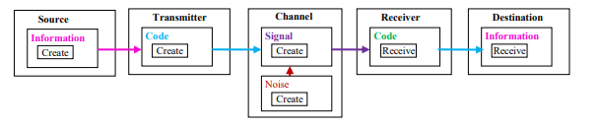
Figure 3. Shannon Weaver communication model (Al-Fedaghi, 2020)
The model has some advantages, like explaining the barriers for effective communication, it also can be applied in multiple situations, and it explains the process into easily understandable components.
However, it is a one directional model and is best applied in interpersonal communication as opposed to group communication. The receiver plays a passive role and for this model to become efficient, the receiver must pass the feedback to the sender.
Although it considers the disruptions that are occurring between the team members and their broken communication since working remotely, applying this model is not recommended as it does not account for feedback and how the sender can communicate effectively with multiple receivers.

Berlo
The model developed by David Berlo is the simplest communication model and is based on the SMCR scheme, like in the figure below. It is an important concept in recognising factors that can affect communication and its elements (Bhashin, 2020).
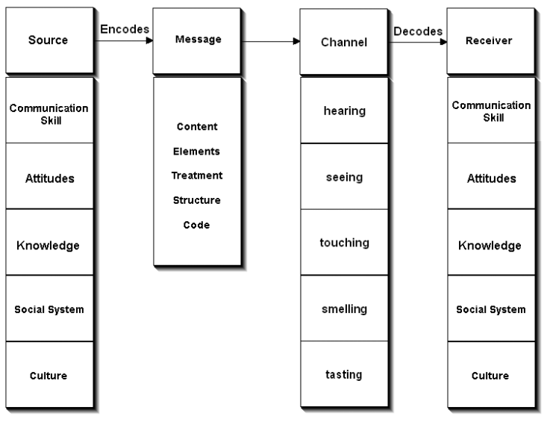
Figure 4 Berlo’s communication model (Businesstopia, 2018)
This model would not be beneficial in the presented teams as it is a linear model, it does not account for feedback which is crucial for understanding the message. Most importantly, the model does not consider any disruptions in the communication process, like the noise that often is the cause for failing to send the message across.

Schramm
Built on the classic model of Shannon- Weaver, the Schramm’s communication model also includes modern elements like noise and feedback and is a circular model as he indicates that the message can go in both directions (Wrench, et al., 2020).
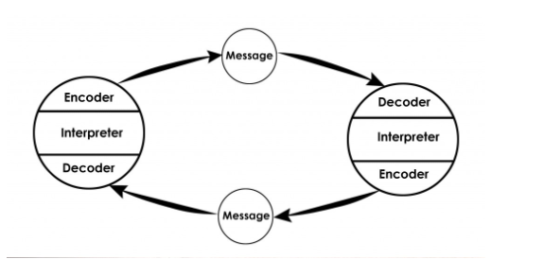
Figure 5. Schramm communication model (Communication Theory, 2016)
The main benefit of this model is that it allows the interpretation of the message and is more practical than the previous models. In the studied company, it would be beneficial to apply as it allows the recipients of the message to interpret and comprehend the message. Once this happens, then they can send a message back to the sender and wait in return to see if it was understood.

Importance of virtual communication and team working.
In today’s workforce there is an increase demand for skilled people that are often required to work in a digitalized economy as part of a virtual teams (Loucks & Ozogul, 2020). A virtual team can be defined as a team with members from different locations, time zones, cultures, even different organizations, that uses technology for communication and coordination between its members (Schmidt, 2014).
Thanks to the advanced technology, workforce geographical distribution and globalization, virtual teams have become even more frequent (Gilson, et al., 2015).
Among the benefits of virtual teams there are cost reductions both for employees and the company, chances to build a team of experts from different locations, greater flexibility that increases retention, and participation for the employees.

Importance of effective communication in the studied organisation
After analysing the case study, it is obvious that the teams were not communicating effectively, which had a negative impact on their working schedule and performance, fact that is also demonstrated by researchers (Morgan, et al., 2014).
The poor communication also led to conflict between them and a loss in coordination. The members did not have defined roles and responsibilities, and this resulted in low productivity and not meeting deadlines.
One of the factors that led to the broken communication was the poor leadership. Virtual communication is different than the face to face one as it does not include nonverbal communication, which is what the people perceive most of when they receive a message.
In virtual teams the communication tools and techniques that the leader adopts can even become a substitute for their leadership style (Newman, et al., 2020). The most important techniques are those who allow the leaders to communicate frequently, in a timely manner, with high responsiveness, clearly and with suitable digital tools (emails, group meeting, conference call) that are required for different messages or receivers (Marlow, et al., 2017). More important than the message sent is also the ability to listen effectively. Active listening is an important communication skill that builds stronger relationships, helps in decision making and in handling conflict.
It is important that the managers establish from the beginning clear communication guidelines and reinforce them regularly. They should implement strategies to engage all the members in the communication process.

Conclusion
By applying the teamwork’s theories of Tuckman and Belbin, the managing directors can successfully redesign the poor performing teams, establish the strengths and weaknesses of each member and understand that teams need to go through certain phases to grow and become productive. It is important for each member to identify their natural role in the team, as well as secondary roles that can then be used to fill a missing role if the task requires it.
Although most of the popular communication models can bring certain benefits, the employees from ABC Technology can benefit most from the Schramm’s model as it is a circular model that allows feedback and interpretation for both the sender and the receiver.
Effective communication is crucial amongst all the members as it reduces conflict and helps in developing trust, productivity, and organisational culture.

Recommendations
Based on the main findings of this report, the senior managers can implement several strategies to ensure effective communication between the members and increased productivity.
- Define clear remote communication channels and share it with the members.
- Create templates and video tutorials to clarify the tasks.
- Continue to review the team roles as behaviours can change and is important to ensure individuals are still working at their best.
- Schedule regular check-ins for the team and individually every week and plan a virtual workshop for the members before the project is due for submission.
- Assess communication skills for both the managers and team members and identify areas of improvement.
- Communicate with the poor performance members.
- Offer truthful and helpful appraisals.

References
- Al-Fedaghi, S., 2020. Underpinning Theories of Software Engineering: Dynamism in Physical Sources of the Shannon Weaver Communication Model. International Journal of Computer Science and Network Security, 20(9), pp. 121-130.
- BELBIN, 2018. How to Build Lean Belbin Teams. [Online]
Available at: https://www.belbin.com/media/2183/belbin2018-lean-teams.pdf
[Accessed 23 June 2021].
- Belbin, 2021. Virtual Teamwork and Team Roles. [Online]
Available at: https://www.belbin.com/media/2906/belbin-remote-working-and-belbin-team-roles-survey-analysis.pdf
[Accessed 20 June 2021].
- Belbin, M., 2010. The art of building a team. In: Team roles at work. London: Routledge, pp. 98-103.
- Belbin, M., 2010. When to keep and when to change the teams. In: Team Roles at Work. London: Routledge, pp. 104-105.
- Bhashin, H., 2020. Berlos Model of Communication Explained. [Online]
Available at: https://www.marketing91.com/berlos-model-of-communication/
[Accessed 23 June 2021].
- Brown, V., 2017. Belbin and Tuckman: Supporting your team at every stage. [Online]
Available at: https://www.belbin.com/resources/blogs/belbin-and-tuckman
[Accessed 23 June 2021].
- Businesstopia, 2018. Berlo’s SMCR Model of Communication. [Online]
Available at: https://www.businesstopia.net/communication/berlo-model-communication
[Accessed 23 June 2021].
- Communication Theory, 2016. OSGOOD- SCHRAMM MODEL OF COMMUNICATION. [Online]
Available at: https://www.communicationtheory.org/osgood-schramm-model-of-communication/
[Accessed 23 June 2021].
- Gilson, L. L., Maynard, M. T., Young, N. C. & Vartiainen, M., 2015. Virtual Teams Research: 10 Years, 10 Themes, and 10 Opportunities. Journal of Management, 41(5), p. 1313.
- Loucks, S. & Ozogul, G., 2020. Preparing Business Students for a Distributed Workforce and Global Business Environment: Gaining Virtual Leadership Skills in an Authentic Context. TechTrends, 64(4), pp. 655-665.
- Marlow, S. L., Lacerenza, C. N. & Salas, E., 2017. Communication in virtual teams: A conceptual framework and research agenda. Human resource management review, 27(4), pp. 575-589.
- Morgan, L., Paucar-Caceres, A. & Wright, G., 2014. Leading effective virtual teams: The consequences of methods of communication. Systemic Practice and Action Research, 27(6), pp. 607-624.
- Mostert, N. M., 2015. Belbin – the way forward for innovation teams. Journal of Creativity and Business Innovation, Volume 1, pp. 35-49.
- Newman, S. A., Ford, R. C. & Marshall, G. W., 2020. Virtual Team Leader Communication: Employee Perception and Organizational Reality. International Journal of Business Communication,, 57(4), pp. 452-473.
- Schmidt, G. B., 2014. Virtual leadership: An important leadership context.. Industrial and Organizational Psychology, 7(2), pp. 182-187.
- Shannon, C. E. & Weaver, W., 1949. The Mathematical Theory of Communication. Urbana: University of Illinois Press.
- SMARTT STRATEGIES, 2017. A Simple Game Highlights the FUNdamentals of Awesome Teams. [Online]
Available at: https://www.smarttstrategies.com/blog/a-simple-game-highlights-the-fundamentals-of-awesome-teams
[Accessed 23 06 2021].
- Wrench, J., Punyanunt-Carter, N. M. & Thweatt, K. S., 2020. Models of Interpersonal Communication. [Online]
Available at: https://socialsci.libretexts.org/@go/page/66549
[Accessed 24 June 2021].
- Tuckman, B W (1965) Developmental sequence in small groups. Psychological Bulletin, 63.

Appendices
Belbin’s Team Role Self-perception Questionnaire
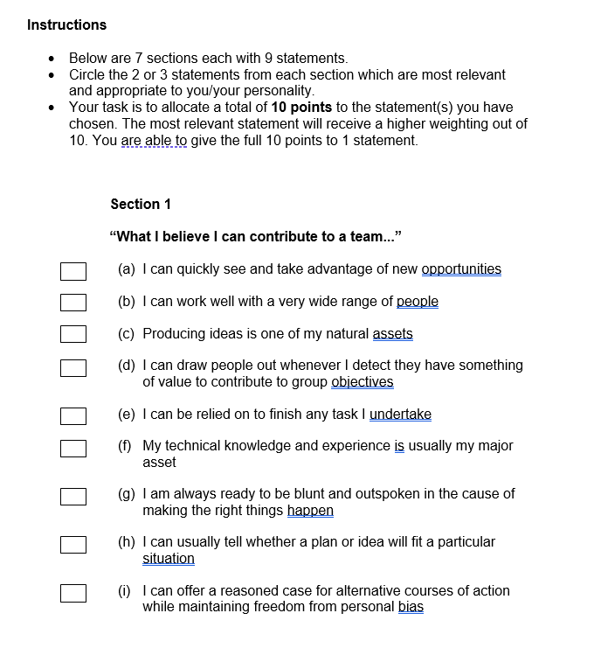
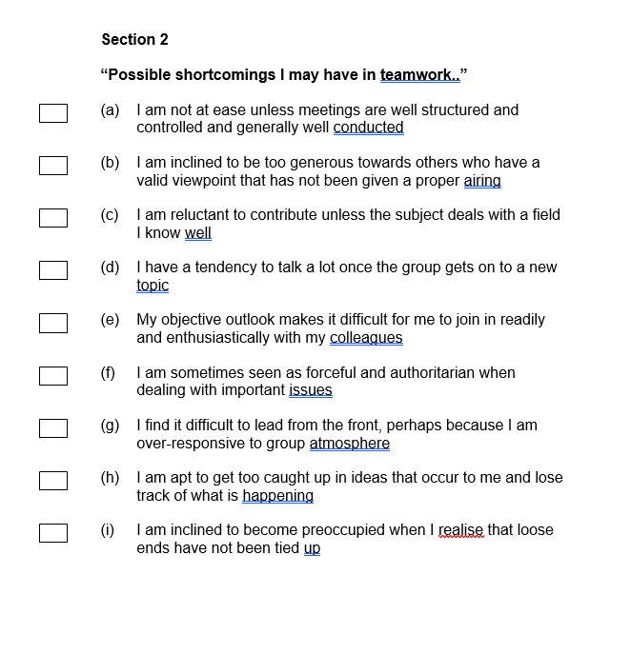
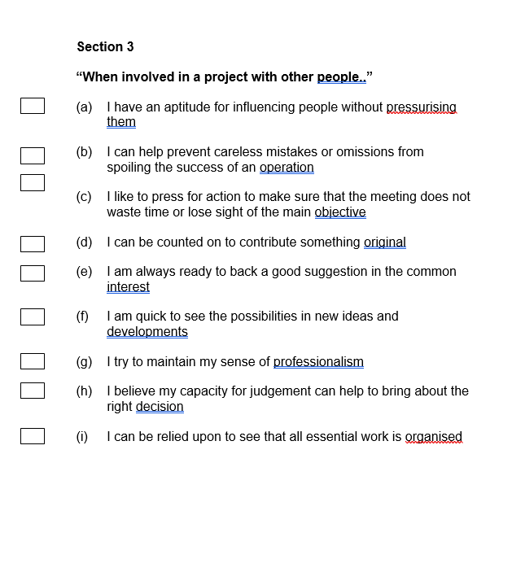
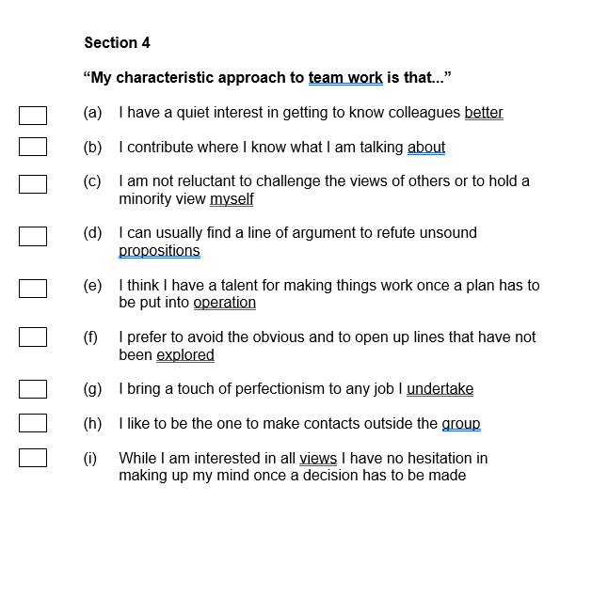
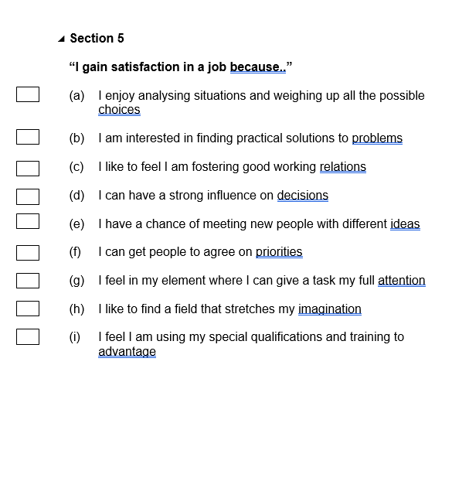
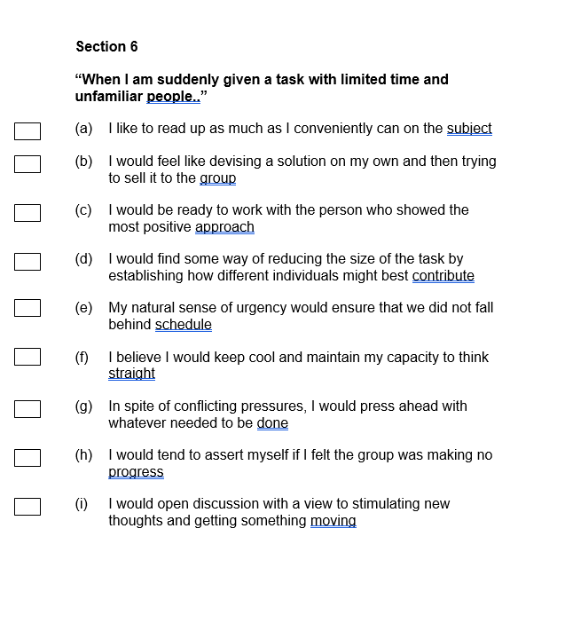
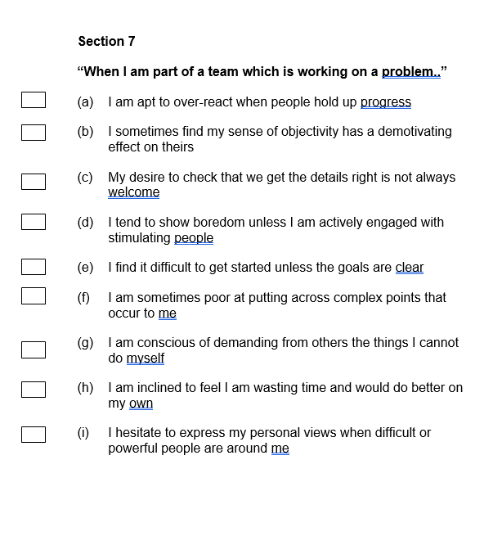
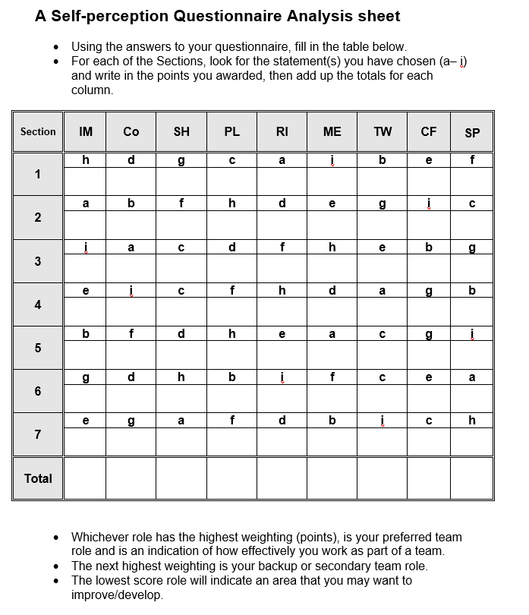

Acknowledgements
I would like to express my appreciation to my lecturer Melanie Squire for the help and dedication in making me understand this module thoroughly and be able to apply the studied theories in my reports.
I would also like to thank my family members who have been supportive and allowed me the extra time to focus on my assignments.

