Coursework Title
Module Name: Computer Architecture and Operating Systems
Module Code: ACCA4022
Student Name: Mohammed Tanvir Chowdhury
Student ID: 2220749
Lecturer Name: Md Shantanu Islam

Submission date: 27th March 2026

Contents
Introduction 4
Key functions of general Operating Systems 4
Task Management: 4
Application/Program Management: 5
File/Directory Management: 6
Device Management: 7
Security Management: 8
Use of Windows OS CLI commands 9
Example 1: 9
Example 2: 10
Example 3: 11
Example 4: 11
Example 5: 12
Example 6: 12
Example 7: 13
Example 8: 14
Example 9: 14
Example 10: 15
Use of Linux OS CLI commands 15
Example 1: 15
Example 2: 16
Example 3: 16
Example 4: 16
Example 5: 16
Example 6: 17
Example 7: 17
Example 8: 17
Example 9: 17
Example 10: 18
Use of Linux OS scripts 18
Example 1: 19
Example 2: 19
Use of Windows OS scripts 20
Example 1: 20
Example 2: 21
Conclusion 22
References 22
Appendices 23

Introduction
This report is to show my understanding of the general purpose operating system and the key functions. There are a number of different operations but I will be focusing on five which are : Task Management, Application/Program Management, File Management, Device Management and lastly Security Management, all within the Microsoft operating system. I will also display my work on Windows OS CLI commands as well as Linux OS CLI commands, followed by an explanation of each command and it’s output.

Key functions of general Operating Systems
Microsoft Windows operating system debuted in 1985, it entails a graphical user interface and intuitive design. Which completely changed personal computing [1]. It has become a key component for supporting a variety of applications and making it easier for broad computer accessibility. As it improves Process management memory management file systems and hardware interaction are important features efficiency and productivity while being a link between users and computer systems [2].

Task Management:
Windows task management Is a key feature that allows users to keep an eye on system performance I'm processing was also allowing them to manage them. Task manager, is a system monitoring tool that provides data on CPU usage, memory, disc activity and running apps, this is the main use for this. It maximises performance and users can regulate launch programmes, stop unresponsive processes and manage current apps. Windows also comes with configuration tools that help manage tasks, identify problems and modify system behaviour. These features assure effective overall system performance for users, enhanced ability and effective resource allocation [3].
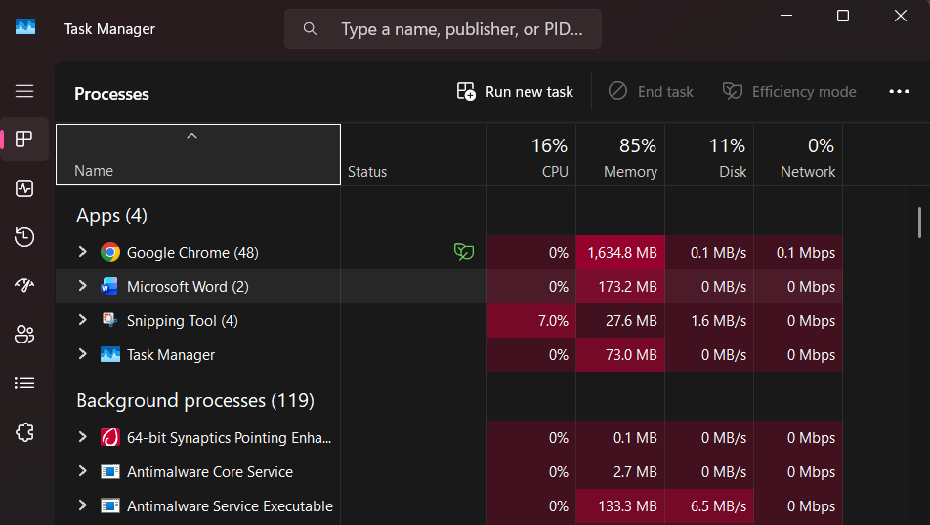
Figure 1: Task Manager Application in Windows Operating System

Application/Program Management:
In Windows, Application or Program management is referred to the process of handling software through it’s lifecycle, including installation, configuration, execution and removal. The system provides built in tools such as Settings, Control Panel and System Configuration abilities to help users control applications effectively. These who's allow Jesus too manage permissions, monitor performance and troubleshoot issues when programmes start to fail or slowing down the system. Programme management also entails updating software and managing startup behaviour to keep up efficiency. Overall, it allows applications to run smoothly and securely within coordination with system resources, supporting reliable and consistent user experience [4].
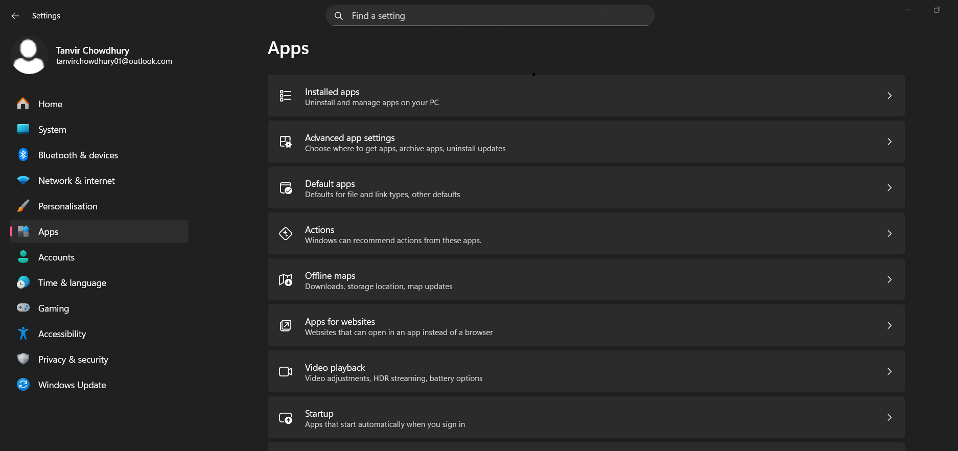
Figure 2: Application Management in Windows Operating System (Settings – Apps)

File/Directory Management:
In Windows, File/Directory management describes how a Logical hierarchy of folders is used to organise, store and retrieve data within the system. With the help of File Explorer’s graphical user interface, users can efficiently locate, open, arrange and manage files and folders, including copying, moving, renaming and deleting objects [5]. In order to improve productivity and navigation, it also has the capabilities like search and quick access. To improve organisation, users can also Adjust views and file properties. To add, it guarantees effective data processing, increase system usability and access ability.
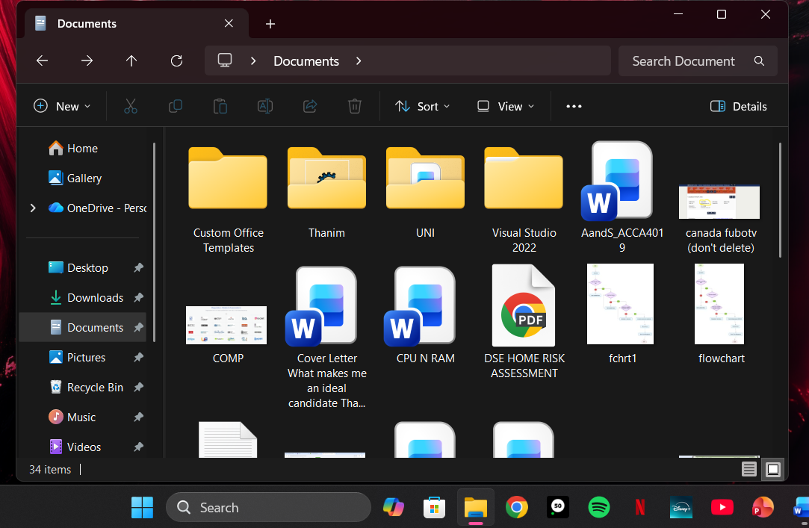
Figure 3: File/Directory Management (File Explorer application) in Windows Operating System

Device Management:
In windows, device management is a way of managing and keeping an eye on hardware that is attached to a computer, this includes network adapters, printers and storage devices. According to Microsoft, you just can “upgrade drivers through device manager” 2 make sure that hardware continues to work properly and is compatible with the system [6]. Device manager offers a central interface to troubleshooting, updating, it's a blink come up uninstall and drivers and viewing hardware. Hardware reliability, system stability and seamless operations insured by effective device management. You just can avoid conflicts and maximise their overall performance across all connected devices by maintaining suitable driver support.
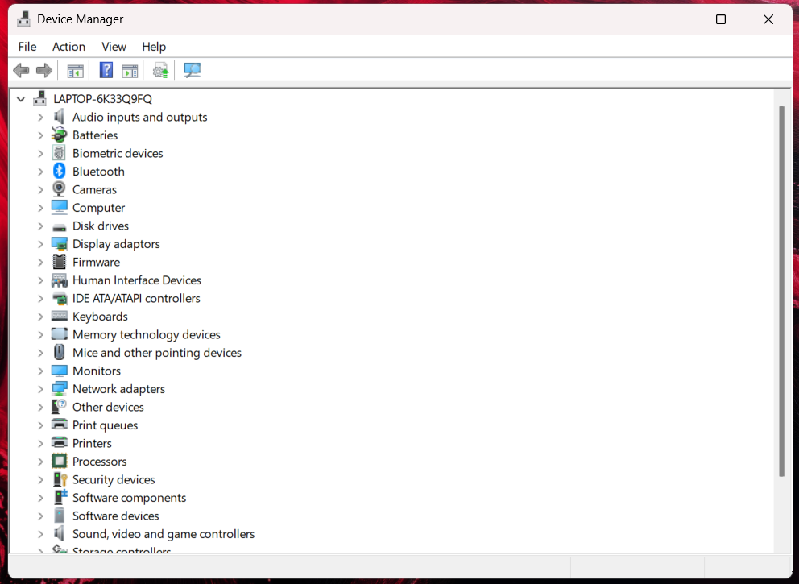
Figure 4: Device Manager in Windows Operating System

Security Management:
Through the use of the Windows Security software, which integrates Numerous defences into a single interface, security management in windows focuses on safeguarding devices, data and use it accounts against malware, viruses and unwanted access [7]. From a single point of area, you just kind of conduct scans, check system status and adjust firewall, antivirus, account protection and app security settings. The software also delivers real time threat detection to avoid breaches, data loss and unwanted activity. A safe and dependable computing environment is maintained, system integrity is ensured, user privacy is improved and device performance is improved through effective security management.

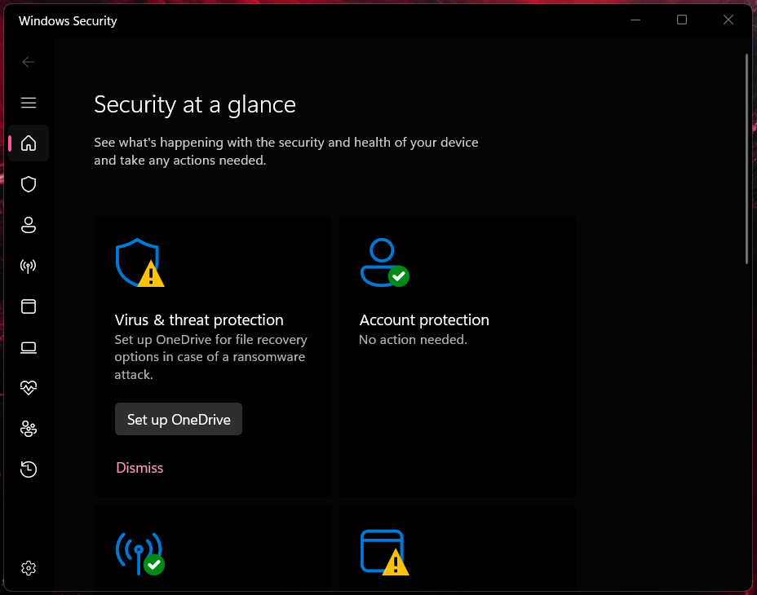
Figure 5: Security Management in Windows Operating System

Use of Windows OS CLI commands
File management, system setup and troubleshooting are made possible via windows command line interface [CLI] features, that offer a text based method of system interaction. Microsoft states that command line tools facilitate administration and automation which increases user control and efficiency [8].

Example 1:
The dir command in Windows lists all files as well as folders in the current directory, to show details such as names, sizes and dates. This helps users to view and navigate folder contents.
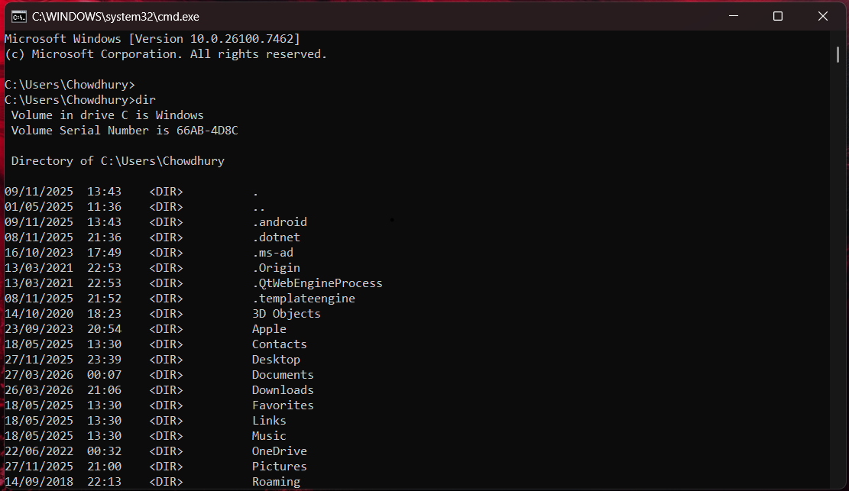
Figure 6: dir Command

Example 2:
The cls command once inputted, the output of the command will clear all text from the Command Prompt screen, displaying a clean workspace without closing the current session or changes in the directory, resulting in easier readability for new outputs.
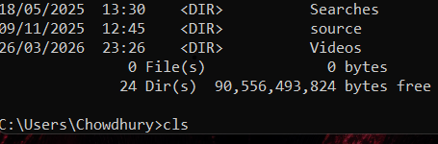
Figure 7.1: cls command input

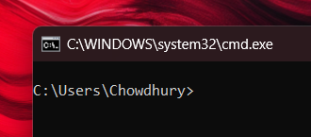
Figure 7.2: cls command output

Example 3:
The echo command input in Windows allows for messages or texts to be displayed. The input for this is echo hello world. The displayed output was the message hello world. By being able to do this helps users test commands or display information.
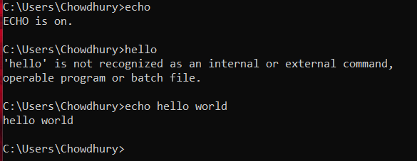
Figure 8: echo command (hello world)

Example 4:
This command once inputted shows network information for your computer, including the likes of IP Address, subnet mask and default gateway, allowing users to troubleshoot network connections and verify connectivity in Windows.
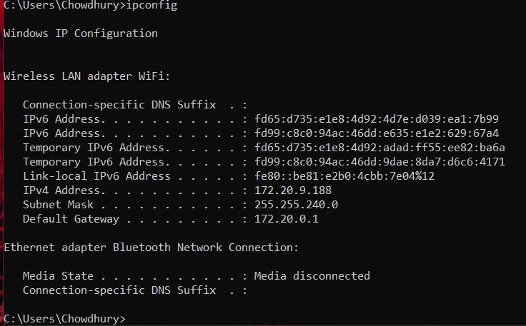
Figure 9: ipconfig command

Example 5:
The ping command is a way of testing network connectivity between the computer and a website. It sends signals and calculates the response time, which helps diagnose internet or local network issues in Windows.
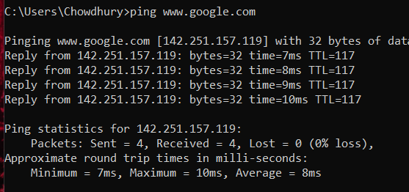
Figure 10: ping command (google)

Example 6:
This command creates a new folder in Windows in the current directory. It helps organise files by enabling users to quickly generate directories for storage or project purposes. To view the new file input command dir and the output will how the new file made.
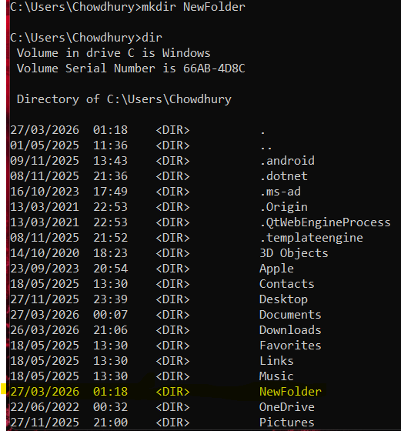
Figure 11: mkdir NewFolder command

Example 7:
This command deletes empty folders from the current directory. It helps remove unnecessary directories, keeping the file system maintained and clean without affecting other files. Inputting the dir command will output the removal of the folder.
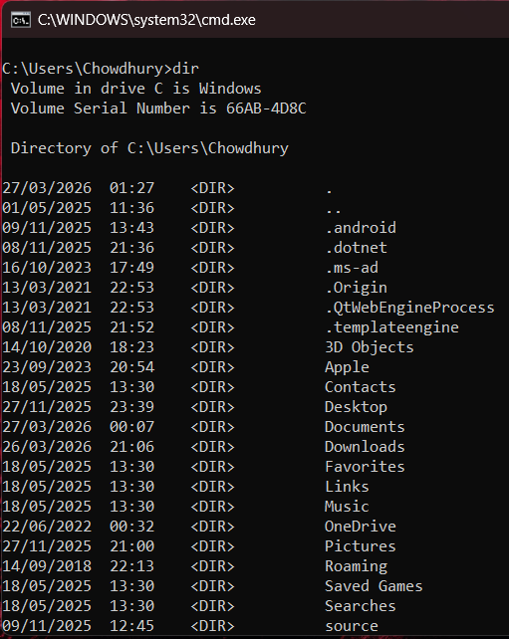
Figure 12: rmdir NewFolder command

Example 8:
The command to input is date, within the directory users can use this to display the date as the output, it will show the current system date directly in the command prompt screen and allow users to change the date too.
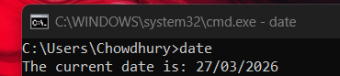
Figure 13: date command

Example 9:
This time the command input is time, within the directory users can use this to display the time as the output, it will show the current system time directly in the command prompt screen and allow users to change the time too. Keeping the clock on the computer accurate.
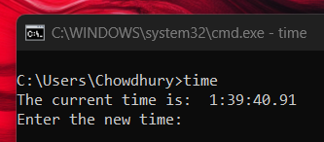
Figure 14: time command

Example 10:
The ver command in Command Prompt will output the operating system version. This makes it easy for users to quickly identify which Windows edition and build are running, as well as being useful for troubleshooting and software compatibility checks.
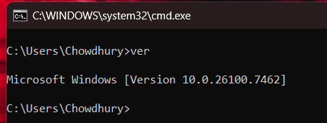
Figure 15: ver command

Use of Linux OS CLI commands
With the Linux command line interface, it let's users to be able to automate processes, launch applications and manage files. For more experienced users and administrators, it offers speed and accuracy as well as efficiency in scripting, system administration and navigation [9]

Example 1:
All of the files and directories within the current folder are listed by the Linux command ls. It allows for rapid content viewing and effective file system navigation from the terminal.
Figure 16: ls command and output

Example 2:
In Linux, the whoami command output the username of the user who was presently logged in. It allows for quick account identification of the user, especially when handling administrative responsibilities or multiple users.

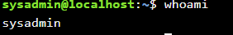
Figure 17: whoami command

Example 3:
The date command in Linux displays the current system date and time via this command. Without having to open a calendar or clock, it allows users to swiftly verify the date or time immediately within the terminal.
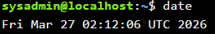
Figure 18: date command

Example 4:
In Linux, The path of the current working directory is shown by the pwd command. Whilst navigating between folders in the terminal, it helps users in knowing their exact location throughout the file system.
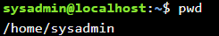
Figure 19: pwd command

Example 5:
The clear command in Linux Remove all previous text from the terminal screen. It makes output simply to read and offers a tidy workspace without shutting down the terminal or interfering with any active activities.
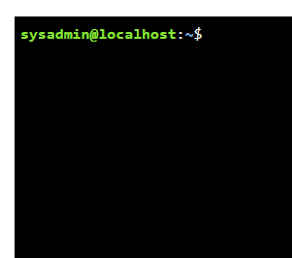
Figure 20: clear command and output

Example 6:
The echo command in Linux Shows text in the terminal. In this case, it helps users test instructions or quickly generate basic messages by printing “Hello” on the screen.
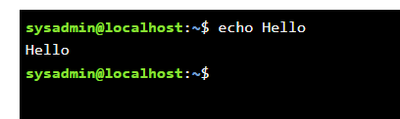
Figure 21: echo Hello command

Example 7:
This command displays a list of users who are currently logged in. It helps in keeping track of the computers active sessions by displaying usernames, terminals and logging times.
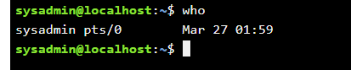
Figure 22: who command

Example 8:
This command shows the system or computers name. Especially when connected to networks or distant systems, it helps users in identifying the computer that they're using.
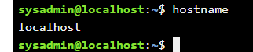
Figure 23: hostname command

Example 9:
This command provides usage, options and function explanation for the ls command.

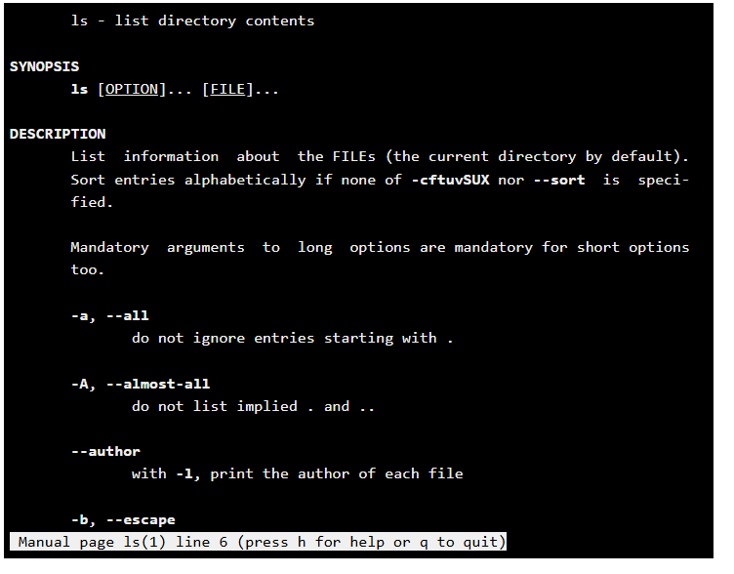
Figure 24: man ls command input and output

Example 10:
The exit command in Linux Closes the current terminal session. It locks the user out of the shell or end the script, hoping to safely terminate command line of work.
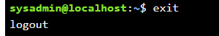
Figure 25: exit command

Use of Linux OS scripts
Bash scripting is a series of running instructions contained in a script file, It performs tasks in Linux and Unix systems. It improves efficiency, consistency and reliability for both users and system administrators as it is frequently used for file management, software deployments and system administration as well as other processors [10].

Example 1:
This bash script uses Reed -p to ask the user to enter their age. To determine whether the ages 18 or older, it then employs an if statement. If the age is equal to or greater than 18 you are eligible to vote! Is printed if it is true. If not, you are not eligible to vote yet is printed.
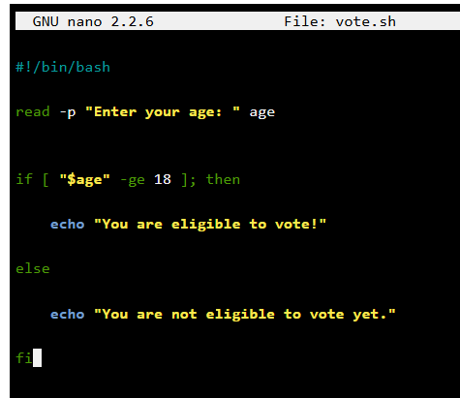
Figure 26: vote BASH command input
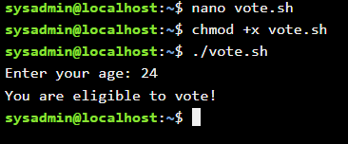
Figure 27: vote BASH command output

Example 2:
This BASH script asks the user for their name using read -p then saves it in the variable name. After that, the echo command uses that variable to print a customised greeting. Descriptor runs in the BASH shell. The script first will prompt the user to enter their name, after in putting their name and the user presses enter the message “Hello name! Welcome to Linux scripting”.
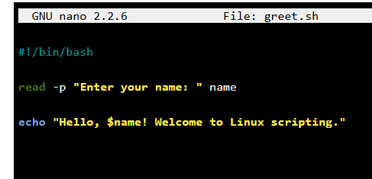
Figure 28: welcome BASH input command
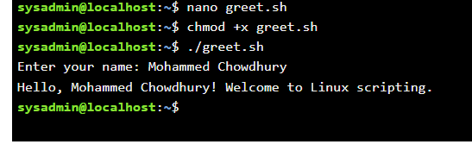
Figure 29: welcome BASH output command

Use of Windows OS scripts
By performing a series of command line instructions contained in a plain text file, but scripting automates repetitive window tasks. It is used a lot for file management Anne system upkeep plus programme execution and consistency for administrators and users as it improves accuracy [11].

Example 1:
This batch script allows the user to add 2 integers using this command. The user is prompted to provide the 1st and 2nd numbers using the set/p commands. The set/a command computes the sum of num1 and num2 using arithmetic. The outcome is shown on the command prompt via the echo command. Until a key is pressed, the pause command maintains the window open. This script teaches users how to use windows scripting for input management, arithmetic operations and output.
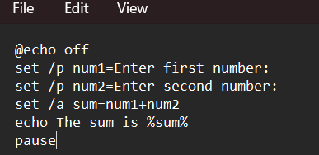
Figure 30: addnumber.batch command input
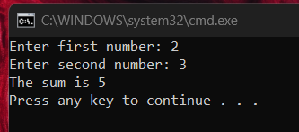
Figure 31: output of command

Example 2:
This grouped uses set/p 2 prompt the user to enter their age. The if statement determines if the input age is equal to or greater than 80. If the age is equal to or greater than 18 a message will appear quoting you are eligible to vote! And if the age is not equal to 18 then a message will appear saying you are not eligible to vote yet. Pause keeps the command prompt window open so the user can read the message before closing, and @echo off hides the commands for a clearer view.
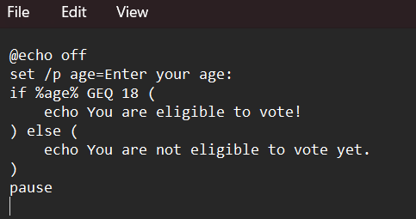
Figure 32: vote command input
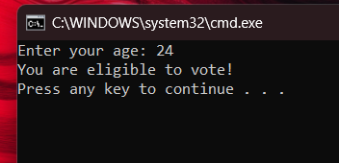
Figure 33: vote command output

Conclusion
Summarize the report and your understanding of these tasks. (50 words)

References

[1] | Microsoft, “The history of PCs | Microsoft Windows,” Microsoft, 31 12 2024. [Online]. Available: https://www.microsoft.com/en-us/windows/learning-center/history-of-the-pc. [Accessed 9 03 2025].
[2] | A. Tanenbaum and H. Bos, “Modern Operating Systems,” Pearson Prentice Hall, Cop, 2024. [Online]. Available: https://api.pageplace.de/preview/DT0400.9781292727899_A46720136/preview-9781292727899_A46720136.pdf. [Accessed 12 03 2026].
[3] | Microsoft, “System configuration tools in Windows - Microsoft Support,” Microsoft, 2024. [Online]. Available: https://support.microsoft.com/en-us/windows/system-configuration-tools-in-windows-f8a49657-b038-43b8-82d3-28bea0c5666b. [Accessed 09 03 2026].
[4] | Microsoft, “System configuration tools in Windows - Microsoft Support,” Microsoft, 2024. [Online]. Available: https://support.microsoft.com/en-us/windows/system-configuration-tools-in-windows-f8a49657-b038-43b8-82d3-28bea0c5666b. [Accessed 09 03 2026].
[5] | Microsoft, “File Explorer in Windows - Microsoft Support,” Microsoft, 2025. [Online]. Available: https://support.microsoft.com/en-us/windows/file-explorer-in-windows-ef370130-1cca-9dc5-e0df-2f7416fe1cb1. [Accessed 09 03 2026].
[6] | Microsoft, “Update drivers through Device Manager in Windows - Microsoft Support,” Microsoft, 2025. [Online]. Available: https://support.microsoft.com/en-us/windows/update-drivers-through-device-manager-in-windows-ec62f46c-ff14-c91d-eead-d7126dc1f7b6. [Accessed 09 03 2026].
[7] | Microsoft, “Windows Security App Overview - Microsoft Support,” Microsoft, 2025. [Online]. Available: https://support.microsoft.com/en-us/office/windows-security-app-overview-ae70cc96-a9cd-4443-a210-e41cb973d3a6. [Accessed 09 03 2026].
[8] | M. Learn, “Windows commands,” Microsoft Learn, 02 06 2026. [Online]. Available: https://learn.microsoft.com/en-us/windows-server/administration/windows-commands/windows-commands. [Accessed 12 03 2026].
[9] | A. Riso, “Linux Command Line Interface Introduction: A Guide to the Linux CLI | Linux Journal,” Linuxjournal.com, 06 10 2020. [Online]. Available: https://www.linuxjournal.com/content/linux-command-line-interface-introduction-guide?. [Accessed 12 03 2026].
[10] | G. O. System, “Bash Reference Manual,” GNU Operating System , 19 09 2022. [Online]. Available: https://www.gnu.org/software/bash/manual/bash.html. [Accessed 12 03 2026].
[11] | R. Awati, “What is a batch file? - SearchWindows Server,” TechTarget, 2017. [Online]. Available: https://www.techtarget.com/searchwindowsserver/definition/batch-file?. [Accessed 12 03 2026].

Appendices
Online Course name: LabEx – Linux
(Would not allow me to carry on without having to pay a fee to become a member stopped after lesson of file content and comparing).

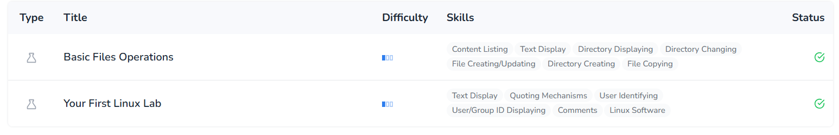
Figure 34: First Linux Lab completed and Basic Files Operation completed.

