Human Resource Management BMMB7007

Philippa Fitzgerald
UWTSD 1905945
3/26/2023
Improvement of an HR priority area Improvement of an HR priority area
Executive Summary
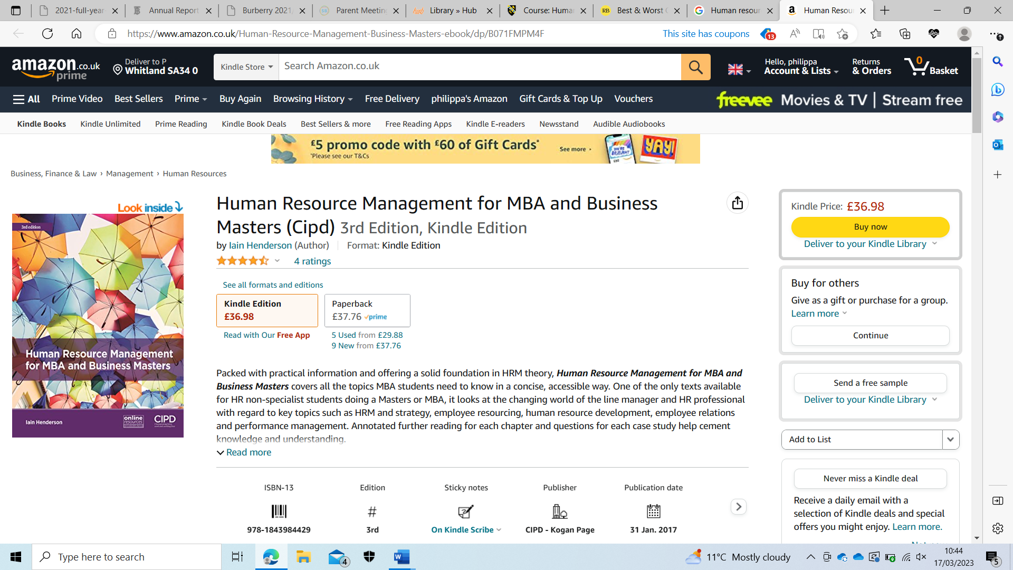
This report critically analyses the company known as Sports Direct, this company employs over 30,000 people in warehouses and retail stores, in 2022 it had an annual net income £308 million. The researcher highlights the key issues within the company focusing on the human resource department and the area recruitment, selection, and onboarding, the researcher has found that Sports Direct fails on supporting employees within their role in the company allowing for low morale, unfair pay, hazardous working conditions and the abuse of zero hour contracts. The report highlights how Michael Ashley former CEO has neglected to be aware of the shortcomings within his company. The report raises the issue that the human resource department does not follow any of the basic models that have been tried and tested previously within other successful companies. The report acknowledges that with a high net income it is seen to be a financially successful company but at the expense of their employees and the treatment of them, it has been advised that Sports Direct need to address the short comings of their human resource department and implement achievable goals to improve the overall reputation of the company, this will see an increase in employee relations leading to an increase in return on investment.
Table of Contents
Introduction 3
Organisational overview 3
Figure 1 4
Sports Direct HR 4
Objectives of HR 4
Media 5
Motivational theories 7
Maslow 7
Figure 2 8
Alderfer 8
Hertzberg 8
Conclusions 9
Recommendations 9
Bibliography 10

Introduction
In this report the researcher will critically evaluate the recruitment, selection, and onboarding from a human resource management perspective within the company the Fraser group better known as Sports Direct. The researcher will look at the importance of human resource management and how to use effective tools and models to help achieve this. Human resource management (HRM) is a department within a company or organisation that allows for the management of employees in a fair and just manner, a successful human resource management department can lead to a positive working relationship between employee and employer this can then lead to increase in productivity and overall return on investment (Armstrong & Taylor, 2020), previous research shows that being valued at work has links to overall better mental and physical health (Investors In People, 2019), also it has shown that employees are more engaged and enthusiastic resulting in higher motivation within their current roles, this behaviour was also observed with the Hawthorn experiment that took place in the 1920s (British Library, 2023). It is important to have successful recruitment, selection and onboarding for a company to help an employee achieve their best potential within the company, successful recruitment not only allows the company to employ the best person for that role it has the potential to save time and money going forward, as if the new employee already has knowledge and understanding of their role any training given will only benefit their already underlying knowledge, however if the recruitment is not done correctly at the start this could cost the company by having to retrain several times which is a drain on resources (CIPD, 2022).

Organisational overview
Sports Direct which is also now known as Frasers group is a retail company which sells sporting goods on the high street as well as online, in 2022 the company had a net income of 308 million. The company’s headquarters is based in the United Kingdom but has stores globally, currently employing over 30,000 people (Market Line, 2023). Sports Direct falls into the top five companies not to work for because of the way they treat their employees amongst other issues raised in this report (Schutte, 2015)The researcher has found no online content regarding the human resource management function and how it operates within the company, however having interviewed an employee of Sports direct it was made clear that to contact the human resource department you would have to be an employee of the company which gave them access to a bot that deals with the initial requests and refers them to the relevant departments, however as the researcher is not an employee this could not be confirmed. When researching the company through Market Line they do not appear to have any key employees working in the human resource department (Market Line, 2023), it could be argued that this could show that they do not view human resource as a key part of the organisation, as you can see in Figure 1 below HR is a small percentage of the staff employed.

Figure 1
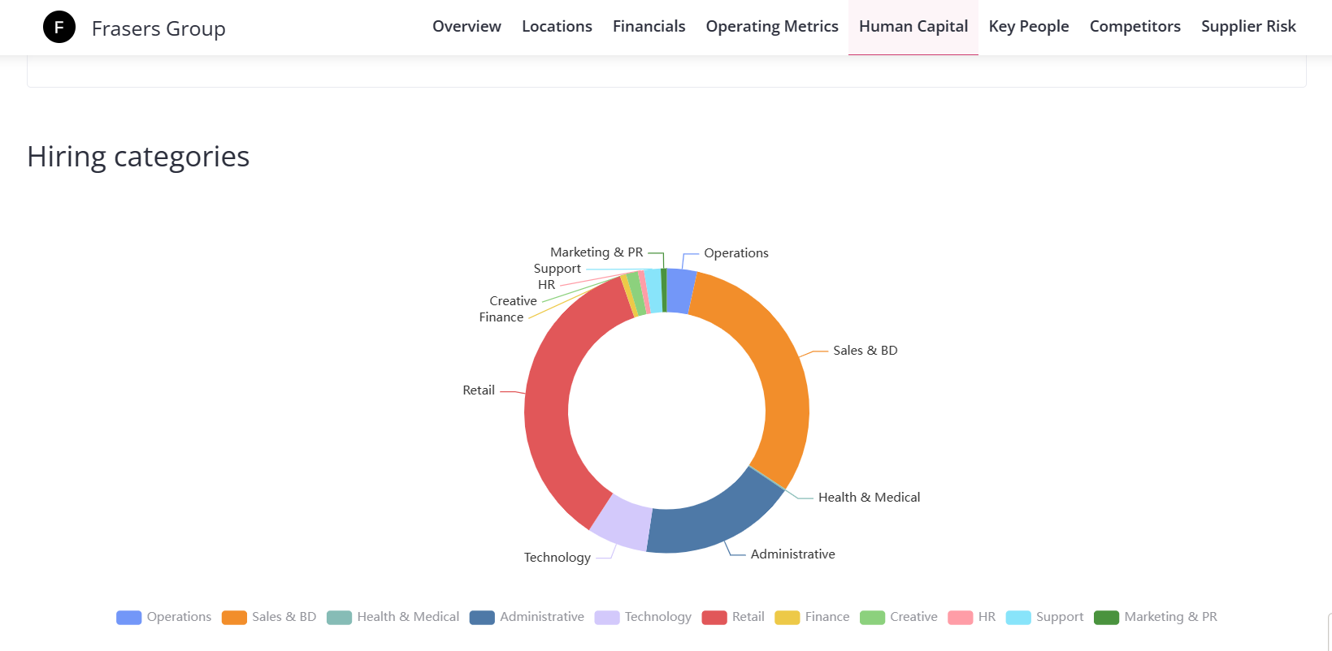
(Craft, 2023)

Sports Direct HR
The idea of Human resource management first came about around the 1980s and was seen as more of a viewpoint, until then what we now know now as human resource management was known as personal management (Boxall, 2017), this has evolved over time and has become a vital part of any organisation or company, allowing employers and employees to have clear boundaries with resources to help rectify any issues they may have within the company or organisation (Henderson, 2017). It seems sports direct has breached some of these basic employment legislations by paying below minimum wage and placing employees in unnecessary danger Sports Direct need to analyse where their Human Resource Department is failing to prevent further HR issues (Desklib, 2023).

Objectives of HR
Within a Human Resource department employees can be referred to as human capital this can be seen as a very clinical term for the management of people, as it has been suggested that a successful human resource department will employ people who have high emotional intelligence allowing for a personal connection between employees. There are four main objectives of human resource management these are Organisational objectives, Functional objectives, Societal objectives, and Personal objectives.
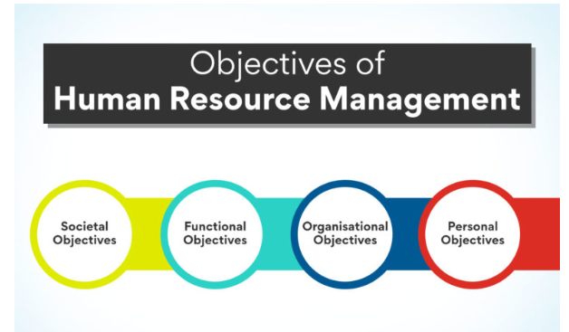
(higherEd, 2022)

- Organisational objectives - the goal of this objective is to have plans and resources in place that allows the company to increase profits and growth whilst maintaining efficiency to help meet that goal.
- Functional objectives - the goal for this objective is to enhance and develop the area of individual or group employment allowing for training or up skilling this allows the company to promote internally saving time and resources for future job vacancies.
- Societal objectives - this goal is to ensure that all aspects that are legal requirements such as environmental, ethical and employment.
- Personal objectives – this goal is based around job satisfaction, working conditions and employee satisfaction this area is catered around each individual (Subramanian, 2021).

Media
Sports Direct, Fraser group have been in the press as early as 2015 because of the way that they have treated their employees in the past and present, they are known for employing staff on zero hour contracts (Goodley & Ashby, 2015), which leaves employees in uncertain situations regarding their pay as well as working conditions and with little knowledge of employee benefits and rights, zero hour contracts have become more and more popular with in organisations allowing companies to employ on a temporary basis this gives the employer the ability to request staff when needed and only pay for work that is completed, it could be argued that for a company that could be struggling financially it could mean saving the company from paying unneeded staff or possibly not being able to pay staff that are on a full-time contract, even worse see the company having to close its doors due to bankruptcy because of unmanageable overheads, however people feel about zero hour contracts, they are legal within the UK and employees do have workers’ rights which can be exercised through the relevant human resource department if for any reason it is seen necessary, (Hopkins, 2014). An undercover investigation done by the Guardian at their Shirebrook depot in England found that employees were given zero hour contracts as well as having to go through rigorous searches when leaving their shifts for the day these searches are reported to be necessary to prevent employees from stealing goods form the warehouse, this process could take up to 15 minutes after they had clocked off, because these searches were mandatory it was seen that the employees should be paid for this time (Goodley & Ashby, 2015), which they were not and as they were not they were then receiving under the minimum wage at the time which for an adult in 2015 was £6.50 this was set out by the government (Gov.uk, 2015), as well as this it was made clear that employees were not allowed to wear certain brands of clothing and accessories (Goodley & Ashby, 2015), this shows a strict culture with in the working environment.
Sports Direct sells sports clothing and equipment as well as other fashion and travel items, it also sells gaming consoles and accessories (Frasers group, 2023), this has given the company a wide demographic to include sporty types as well as gamers and tourists these demographics also have a large age range, with such a large portfolio of customers Sports direct have to have high employment rates to keep up with demand, Sports direct is known for having a high turnover of staff due to their mistreatment of staff and poor working conditions, this includes employees having to have medical treatment and ambulances called to the Shirebrook site (House of Commons, 2016), it is attracting a bad reputation as a company to work for which not only effects the ability for them to retain the staff they have but it also effects their ability to recruit new staff, however it could be argued that this high turnover could be related to the positive side to having zero hour contracts as this encourages a younger generation of employees that are looking for flexible working hours that allows them to earn while they study, or for people to top up their earnings with a second job.
Michael Ashley the former director when called to respond to the findings admitted that he did not fully know what was happening within his own company, it could be argued that this was untrue as he was reported as visiting the warehouse at least once a week (Lawrence, 2016), and as the majority shareholder should be aware of what is happening with in his company. This shows a lack of communication within the organisation, communication plays a big role in the smooth running of any company.

Motivational theories
As discussed, people have a need to feel valued, motivation in the workplace is important as this will allow employees to give the best that they have and employers to reap the benefits from them, there are three motivational theories that can be seen to help achieve this, Maslow’s hierarchy of needs, Alderfer’s ERG theory, and Hertzberg’s two factor theory (Mullins, 1996).

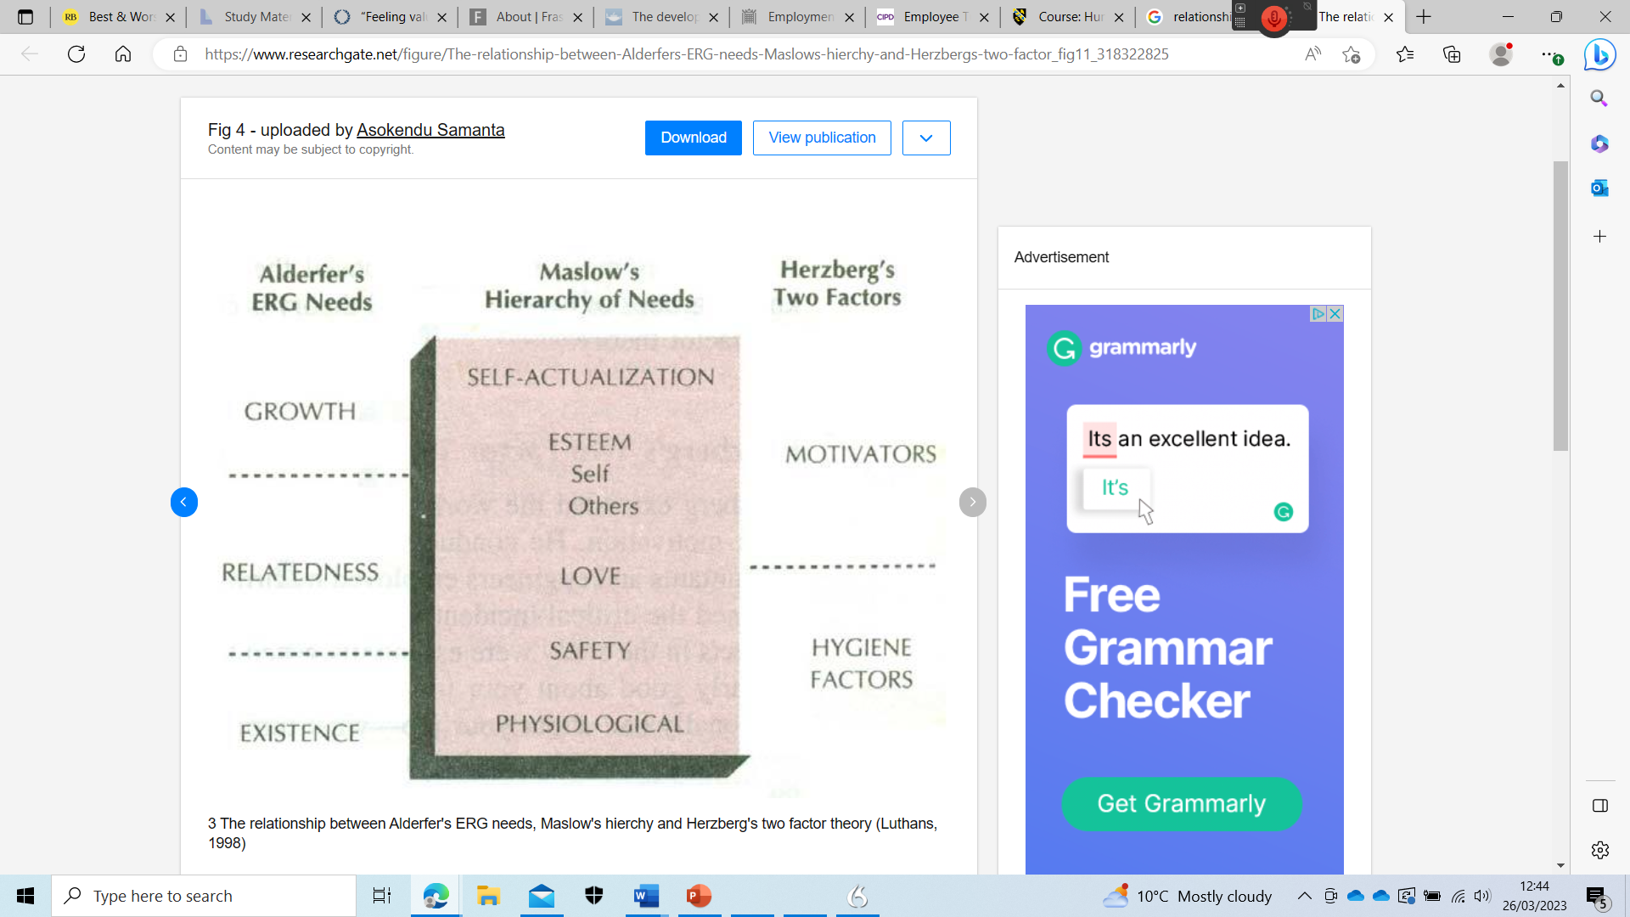
(Samanta, 2010)

Maslow
Maslow’s hierarchy of needs suggests that people have a five stage process before reaching the top of the pyramid self-actualisation (Maslow, 1954) it can be seen in figure 2 the needs are:
- Stage 1
Basic psychological needs, this this is what is expected at the very least, a basic wage for work completed this allows for the assurance of covering the cost of living and being able to provide food, drink and warmth.
- Stage 2
Safety and security needs is where a person feels reassured that they are guaranteed the weekly income to afford the basics below.
- Stage 3
Love needs or referred to as social needs, this allows a person to feel like they belong in the workplace developing friendships and relationships with colleagues.
- Stage 4
Esteem needs, this level enables a person to feel respected and have respect for others around them this is where a person’s confidence will grow as well as receiving appreciation for the roles they have played within the workplace.
- Stage 5
Self-actualisation, this is the final stage in Maslow’s hierarchy of needs, and this is where person feels they have reached their full potential.

Figure 2
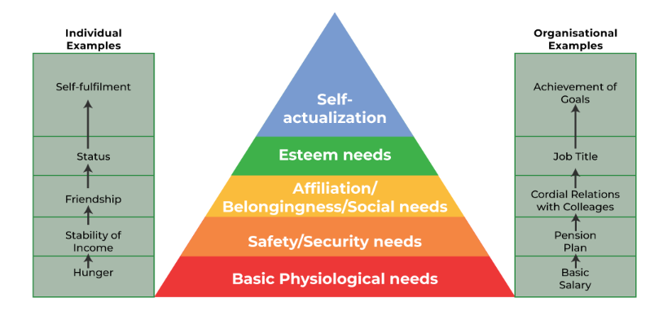
(geeksforgeeks, 2022)

Alderfer
Alderfer’s theory is very similar to Maslow’s theory but a simplified version where only three levels of needs exist these are, existence needs, relatedness needs and growth needs.
- Existence needs cover the same basic needs such as food, drink, warmth, all the things we need to exist.
- Relatedness needs cover aspects such as relationships, belonging, and love this is in relation to where we sit within society and social standing.
- Growth need is the top tier of this theory and is where a person can reach the self-actualisation that is mentioned within the Maslow’s model, this is the highest point for a person to reach.

Hertzberg
Hertzberg’s theory has two aspects which are hygiene factors and motivators, interviews were conducted on accountants that asked how they felt about their current or previous job the results led to the two factor theory.
- Hygiene factors are the lower level factors that affect a worker such as food and warmth these are the basics.
- Motivators this is the higher end of the scale and was recorded to show that these motivators are social standing wages and responsibility.
It can be seen that Sports Direct do have access to these three motivational theories however they do not seem to put them into practice as reports show from previous media coverage employees are unsatisfied within the workplace, aligned with the lowest tier of the three theories where they are only just meeting employees basic needs, which has resulted in a high turnover of staff as well as it being difficult to retain staff, they could also find it difficult to recruit staff in the future (CIPD, 2021).

Conclusions
In conclusion it can be seen that Sports Direct have suffered negative press regarding its treatment of employees this has resulted in low staff morale, as well as a high turnover rate, Michael Ashley has stated that he was unaware of some of the findings in the government report that was compiled but did admit that he would look into trying to improve conditions in the future. This report also found that there was insufficient evidence of an effective human resource department, and it could be argued that because of this it has resulted in employees not having the support and guidance required, as a company they do not seem to implement any of the basic HRM models such as Maslow’s hierarchy of needs, Alderfer’s ERG theory Hertzberg’s two factor theory again affecting morale in the workplace. However Sports Direct as a company has had another successful year in profit, this could show that even though their HR department needs a lot of attention it has not had an impact on their ability to achieve a high profit turnover.

Recommendations
Recommendations for Sports Direct human resource department would include developing the current HRM setting goals that can be achievable within set timeframes this would see the company address the many issues that has been raised in this report, these include the implementation of a fair wage as well as looking at health and safety issues, and also improving on the well-being of the employee allowing for staff in the future to be allowed contracts that give guaranteed hours each week instead of the many zero hour contracts that are in place at present, this alone could see higher employee morale, possibly raising future profitability.

Bibliography

Armstrong, M. & Taylor, S., (2020). Armstrong's Handbook of Human Resource Management Practice. 15th ed. London: Kogan Page.
Boxall, P., (2017). The Development of Strategic HRM: Reflections on a 30-Year Journey. [Online]
Available at: https://www.tandfonline.com/doi/full/10.1080/10301763.2018.1427423?scroll=top&needAccess=true&role=tab
[Accessed 23 March 2023].
British Library, (2023). Elton Mayo. [Online]
Available at: https://www.bl.uk/people/elton-mayo
[Accessed 20 March 2023].
CIPD, (2021). Employee turnover and retention. [Online]
Available at: https://www.cipd.co.uk/knowledge/strategy/resourcing/turnover-retention-factsheet#gref
[Accessed 22 March 2023].
CIPD, (2022). Recruitment: An Introduction. [Online]
Available at: https://www.cipd.co.uk/knowledge/fundamentals/people/recruitment/factsheet#gref
[Accessed 17 march 2023].
Craft, (2023). Fraser Group. [Online]
Available at: https://craft.co/frasers-group
[Accessed 20 March 2023].
Desklib, (2023). Human Resource Management Case Study (Sports Direct). [Online]
Available at: https://desklib.com/document/view/a95ee42a-8b7e-441b-8f83-44ba54b87c94/
[Accessed 22 March 2023].
Frasers group, (2023). About us. [Online]
Available at: https://frasers.group/about
[Accessed 22 March 2023].
geeksforgeeks, (2022). Maslow’s Hierarchy of Needs Theory. [Online]
Available at: https://www.geeksforgeeks.org/maslows-hierarchy-of-needs-theory/
[Accessed 21 March 2023].
Goodley , S. & Ashby, J., (2015). Revealed: How Sports Direct Effectively Pays Below Minimum Wage. [Online]
Available at: https://www.theguardian.com/business/2015/dec/09/how-sports-direct-effectively-pays-below-minimum-wage-pay
[Accessed 22 March 2023].
Gov.uk, (2015). New National Minimum Wage Rates Announced. [Online]
Available at: https://www.gov.uk/government/news/new-national-minimum-wage-rates-announced
[Accessed 20 March 2023].
Henderson, I., (2017). Human Resource Management for MBA and Buisness Masters. 3rd ed. London: Chartered Institute of Personnel and Development.
higherEd, E., (2022). Objectives of Human Resource Management. [Online]
Available at: https://www.edureka.co/blog/objectives-of-human-resource-management/
[Accessed 22 March 2023].
Hopkins, L., (2014). Employer Perspectives on ‘Zero Hours’ Contracts in UK Higher Education. [Online]
Available at: https://www.researchgate.net/publication/330292484_Employer_perspectives_on_'zero_hours'_contracts_in_UK_higher_education
[Accessed 20 March 2023].
House of Commons, (2016). Employment Practices at Sports Direct, London: House of Commons.
Investors In People, (2019). "Feeling Valued:" The Dimensions Organisations Must Deliver On. [Online]
Available at: https://www.investorsinpeople.com/knowledge/feeling-valued-the-dimensions-organisations-must-deliver-on/
[Accessed 17 March 2023].
Lawrence, F., (2016). This is a Brutal and Inhumane Way to Treat Staff – and Sports Direct is Not Alone. [Online]
Available at: https://www.theguardian.com/commentisfree/2016/jun/08/inhumane-sports-direct-mike-ashley-workforce
[Accessed 21 March 2023].
Market Line, (2023). Frasers Group plc. [Online]
Available at: https://advantage-marketline-com.ezproxy.uwtsd.ac.uk/Company/Summary/sports_direct_international_plc
[Accessed 19 March 2023].
Maslow, A., (1954). Motivation and Personality. 1st ed. New York: Harper and Row.
Mullins, L. J., (1996). Management and Organisational Behaviour. 4th ed. London: Pitman Publishing.
Samanta, A., (2010). The Relationship Between Alderfer's ERG needs, Maslow's hierchy and Herzberg's Two Factor Theory. [Online]
Available at: https://www.researchgate.net/figure/The-relationship-between-Alderfers-ERG-needs-Maslows-hierchy-and-Herzbergs-two-factor_fig11_318322825
[Accessed 22 March 2023].
Schutte, S., (2015). The Five Best and Worst Companies to Work For. [Online]
Available at: https://realbusiness.co.uk/the-five-best-and-worst-companies-to-work-for
[Accessed 22 March 2023].
Subramanian, S., (2021). Objectives of HRM – Unfolding 4 Main Objectives. [Online]
Available at: https://pulsehrm.com/objectives-of-hrm-unfolding-4-main-objectives/
[Accessed 22 March 2023].

