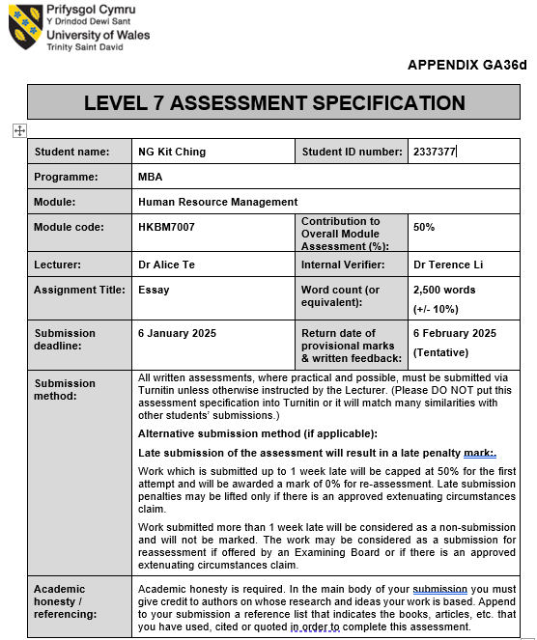
1

I Executive Summary

SJM Holdings Ltd (SJM), a leading operator and developer of casinos and integrated entertainment resort that has been rooted in Macau for more than 50 years, its business development scope and commercial investment activities have always been concentrated in Macau and Hong Kong.

SJM is planning to establish Sales & Marketing Offices in Singapore and South Korea to cooperate with the Macau SAR Government's goal to attracting overseas tourists to Macau.

As a traditional Chinese company with no experience in regional expansion, SJM will encounter various difficulties when preparing to open offices outside Macau. Among them, the problems related to human resource management (HRM) are the first ones that SJM will face.

Apart from identifying potential challenges associated with employee recruitment, training and development during the regional expansion, there are also recommendations and action plans for SJM to address the challenges for a successful expansion.

2

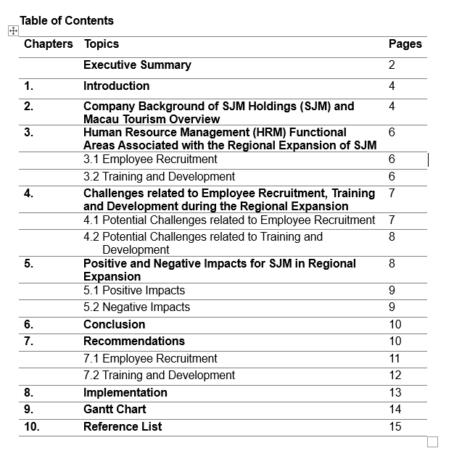

3

- Introduction

The success of a business often depends on whether the company can implement human resource management (HRM) efficiently and effectively, thereby improving and optimizing the potential and productivity of employees, which has a positive impact on the company's performance. Therefore, whether in the early stages of enterprise development or in the process of business expansion, human resource management (HRM) is one of the most important parts of the business environment (Agustian et al., 2023).

In this report, we will discuss and analyze the human resource management (HRM) challenges encountered by one of the key players of Macao’s gaming and tourism industries, SJM Holdings (SJM) in the process of expanding overseas operations, and the positive and negative impact these challenges have on SJM and their stakeholders.

- Company Background of SJM Holdings (SJM) and Macau Tourism Overview

With roots in Macau for more than 50 years, SJM Holdings (SJM) is a leading operator, operator and developer of casinos and integrated entertainment resorts in Macau. SJM is one of six gaming concessionaires in Macau and is authorized by the Macau SAR Government to operate casinos and gaming areas (Secretary, n.d.).

In addition to operating the most familiar and long-standing Lisboa hotel brand, SJM's most recent and talked about development is the Grand Lisboa Palace Integrated Resort, which opened in Cotai, Macau on July 30, 2021. The resort cost more than HK$30 billion and took seven years to build. The resort provides three hotel towers (a total of 1,400 hotel rooms), more than 20 restaurants, a shopping mall with duty-free shops and more than 100 retail shops (www.grandlisboapalace.com, n.d.).

4

As of 31 December 2024, SJM has a market cap of HK$18.96 billion and 19,700 full-time employees (Companiesmarketcap.com, 2025).

As one of six gaming concessionaires in Macau, SJM has an important responsibility to cooperate with the Macau SAR Government's goal on tourism development. An important part of this is attracting overseas tourists to Macau.

According to the information from the Statistics and Census Service (DSEC) (Government of Macao Special Administrative Region Statistics and Census Service, n.d.), Mainland Chinese tourists have always been the main source of tourists for Macau's tourism industry. According to statistics over the past few decades, more than 70% of Macau's tourists are from mainland China. And, in the first 11 months of 2024, the total number of tourists entering Macau was 31,880,000, of which 70% were from mainland China and 21% were from Hong Kong. overseas tourists (excluding China and Hong Kong) only accounted for 9%.

In view of this, one of the main requirements from the Macau SAR Government in issuing the latest gambling license operators is that the operators should focus on investing in non-gaming tourism facilities in Macau, thereby increasing the number of overseas tourists in Macau.

In the gaming concession contract submitted by SJM to the Macau SAR Government, in terms of attracting foreign visitors, SJM promised to focus on developing the Northeast and Southeast Asian markets and they will establish overseas offices in major cities of Northeast and Southeast Asian markets to attract different customers to Macau. In the first phase, SJM is planning to establish Sales & Marketing offices in Singapore and Korea (IAG, 2022).

5

- Human Resource Management (HRM) Functional Areas associated with the
Regional Expansion of SJM

Establishing Sales & Marketing Offices in new markets such as Singapore and South Korea, key responsibilities of HRM include employee recruitment, compensation and benefits administration, performance management and appraisal, training and development, talent retention, employee relationship and ensure legal and regulatory compliance (hrbrain.ai, 2024). We will discuss and analyze the different aspects related to employee recruitment, training and development in this essay.

  - Employee Recruitment

Regardless of the stages (startups, expansion etc) of the enterprises, small and medium-sized enterprises (SMEs) or multi-national corporations (MNCs), employee recruitment is very important to the company (Team Alp, 2024).

Employee recruitment for overseas expansion includes understanding local regulations and practices that are related to legal compliance and cultural awareness, sourcing talent by engaging with local recruitment agencies, job fairs and online job platforms, establishing recruitment collaborations with local universities and training institutions (Team Alp, 2024).

  - Training and Development

There are numerous benefits for the company that provide Training and Development Program to employees. The program increases employee engagement, enhances employee performance, encourages new ideas and improves the company’s productivity and profitability.
6
Training and development for overseas expansion includes designing and providing training related to cultural sensitivity, language, cross-cultural leadership development and e-learning platforms (Built In, n.d.).

- Challenges related to Employee Recruitment, Training and Development during the Regional Expansion

Establishing Sales & Marketing Offices in new markets such as Singapore and South Korea, SJM faces different challenges, especially in key functional areas within Human Resources Management, such as employee recruitment, training and development (Combine, 2024).

4.1 Potential Challenges related to Employee Recruitment
- Cultural Differences:
- Entering Singaporean and Korean markets, SJM Holdings will encounter distinct cultures, affecting communication, leadership styles, and employee engagement. Cultural differences can complicate the recruitment process. Different attitudes towards work-life balance, communication styles and workplace hierarchy may influence how people view a position.

- Different Job Markets:
- Singapore and South Korea have unique cultural and economic environments that require SJM to understand local job market dynamics, including salary expectations, skills availability and labor laws.

- Talent Acquisition and Retention:
- As competition for skilled professionals is fierce in Singapore and South Korea, SJM needs to build a strong employer brand to attract and retain top talent among local and international competitors.

7

- Compliance with Local Labor Laws:
- Both Singapore and South Korea have unique labor laws related to employment contracts, benefits, dismissal and dispute resolution. To establish compliance with these regulations is a complex but necessary task for SJM.

- Technologies, Data Privacy and Security:
- Implementing new technology systems in global recruitment is essential, however there are concerns related to data protection. particularly when personal employee data crosses borders. Different countries have varying regulations in data privacy and security, this is important for SJM to ensure compliance in line with the local regulations.

4.2 Potential Challenges related to Training and Development
- Communication breakdown due to language barriers.
- Cultural sensitivity is due to differences on local traditions, beliefs, and customs.
- Conflicts arising from cultural misunderstandings.
- Poor performance on customer satisfaction related to the local market’s cultural preferences.
- Poor performance on employee satisfaction due to various cultural backgrounds and perspectives.

- Positive and Negative Impacts for SJM in Regional Expansion

The establishment of Sales and Marketing Offices in Singapore and South Korea will lead to numerous positive and negative impacts on SJM:

8

5.1 Positive Impacts
- Enhanced Skill Development:
  - Employees receive training, leading to improved skills and increased productivity which benefit both the employees and the company.

- Increase Competitive Advantage:
- A Cross-country skilled workforce allows SJM to operate more efficiently and effectively in new markets.

- Improve Employee Satisfaction and Retention:
- Training and development programs will increase higher job satisfaction and reducing turnover rates.

- Cultural Exchange and Diversity:
- Establishing offices in different regions fosters cultural exchange and creates a more diverse and inclusive working environment.

5.2 Negative Impacts
- Cost Concerns:
- Recruiting and training require significant financial investment and may strain budgets.

- Resource Allocation:
- Time and resources devoted to recruitment and training may affect the allocation for other operational needs.

- Resistance to Change:
- There will be friction between employees and SJM as employees might be resistant to new training methods or corporate culture.
9

- Potential Skill Gaps:
- Misalignment of training could lead to skill gaps which affect employee performance and productivity.

- Compliance and Regulatory Challenges:
- The regulatory environment in Singapore and South Korea can be complex and can lead to potential legal and compliance issues if not managed properly.

- Cultural Difference:
- Differences in workplace culture and expectations can cause integration challenges and impact team dynamics.

- Conclusion

Expanding SJM’s sales and marketing operation into Singapore and South Korea required strategic planning in related functional areas of HRM. Successful recruitment requires a detailed understanding of the local market and investment in tailored training and development programs. By following the recommendations mentioned below, SJM can develop a proficient and culturally competent team to drive foreign visitors to Macau.

- Recommendations

Following the above analysis, it is recommended that SJM may consider the following approaches to solve the potential challenges in employee recruitment, training and development:

10

  - Employee Recruitment
- Understanding Local Regulations and Practices:
- Legal Compliance: familiar with the labor laws, employment contracts, and other regulations in the specific countries.
- Cultural Awareness: understand cultural norms and practices which may affect the recruitment process, such as interview etiquette and employment expectations.

- Sourcing Talent:
- Engage with local recruitment agencies, job fairs, and online platforms (e.g. JobStreet in Singapore, Saramin and JobKorea in Korea) to source potential candidates.

- Diverse Recruitment Strategies:
- Collaborations with Local Institutions: partnership with universities and training institutions to build a pipeline for potential candidates in the future.
- Multilingual Support and Translation Services: ensure that recruitment platforms, training portals, and materials are available in multiple languages, particularly English, Korean, and Mandarin, to accommodate a wider range of candidates and employees.
- Implement recruitment marketing tailored to local needs with localization of job advertisements.

- Selection Processes:
- Localized Interview Techniques: tailor interview processes to align with local expectations so to ensure the candidates meet the required skills and cultural fit.
- Inclusive Approach: to ensure diversity and inclusion throughout the recruitment process.
11

- Localized HR Policies:
- Develop policies that reflect local labor laws and cultural expectations to ensure both compliance and employee satisfaction.
- Work closely with legal advisors that familiar with local laws to ensure all recruitment and training technology complies with regional data protection regulations, such as Singapore’s Personal Data Protection Act (PDPA) and Korea’s Personal Information Protection Act (PIPA).
- Use advanced data encryption practices and comply with local regulations to protect employee information

- Comprehensive Onboarding Programs:
- Develop an onboarding plan that includes cultural assimilation processes and introductions to locally specific corporate values.

  - Training and Development
- Invest in Customized Training Programs:
- Cross-cultural Sensitivity Training: provide training that focuses on cultural awareness and communication styles so to enhance team synergy, ensure effective customer interactions and create a harmonious working environment.
- Skill Development: design programs to address skill gaps and improve competencies needed for specific markets.

- Continuous Learning:
- Ongoing Education: implement systems for continued learning and development, such as workshops, seminars, and online courses.
- Feedback: encourage employees to provide feedback and continuously improve training programs to make the trainings more effective and relevant.

12

- Language Support:
- Language Training: provide language classes to ease communication barriers and enhance operational effectiveness.

- Leadership and Management Development:
- Local Leadership Building: focus on nurturing local leaders who understand the business and cultural landscapes.
- Cross-Cultural Leadership: develop cross-cultural leadership skills among managers to enhance global collaboration.

- Technology Training Initiatives:
- E-Learning Platforms: utilize digital platforms for training to make learning accessible and flexible.
- Virtual Reality (VR) and Augmented Reality (AR) for Training: incorporate VR and AR technology to create immersive and interactive training experiences, which can be personalized for different cultural contexts and learning styles.
- Continuous Feedback Mechanism: implement technology that allows for constant feedback during both the recruitment and training stages. This could include AI-driven analytics tools that monitor engagement and provide insights for continuous improvement.

- Implementation
- Short-term Action Plan:
- Form dedicated teams to research and understand the local job markets before implementing recruitment and training programs.
- Roll out recruitment and training initiatives in phases, allowing room for adjustment based on feedback and efficiency.
- Involve local HR professionals and trainers to bridge cultural and language gaps effectively.
13
- Long-term Action Plan:
- Conduct regular research to identify cultural trends and tailor HR strategies accordingly.
- Use local platforms to promote SJM and attract high potential talents.
- Arrange regular workshops and seminars to ensure HR policies in line with local circumstances.
- Partnership with local educational institutions for upskilling initiatives.
- Conduct regular audits and updates on data security that in line with local legislation.
- Perform regularly evaluation on the effectiveness of recruitment and training initiatives and adapt strategies when needed.

- Gantt Chart
The following Gantt Chart outlines the timeline of the above-mentioned short-term and long-term action plans.

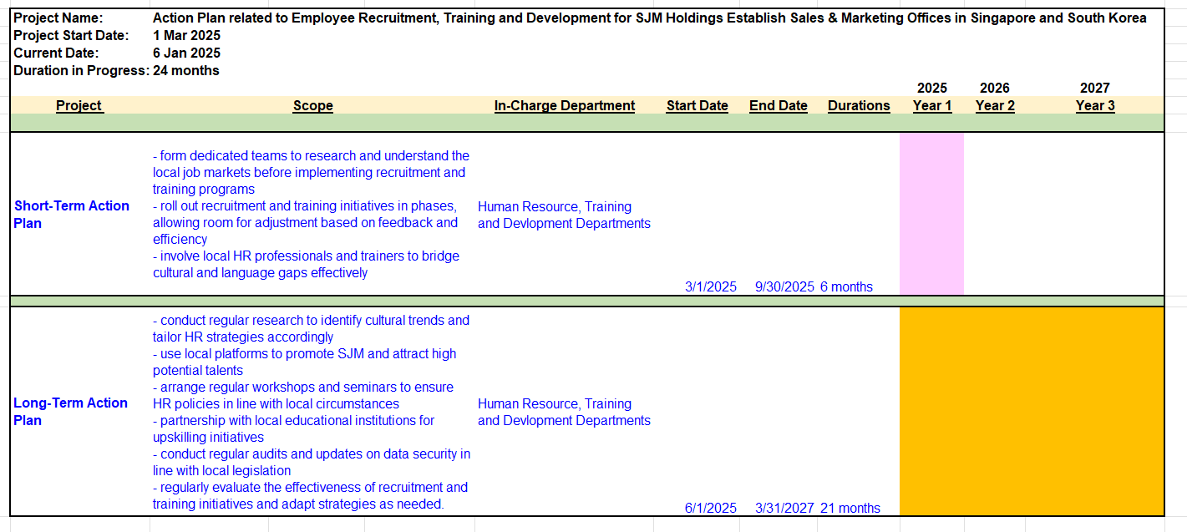
14

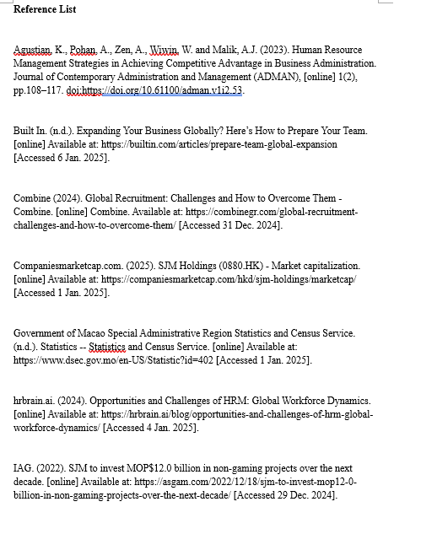
15

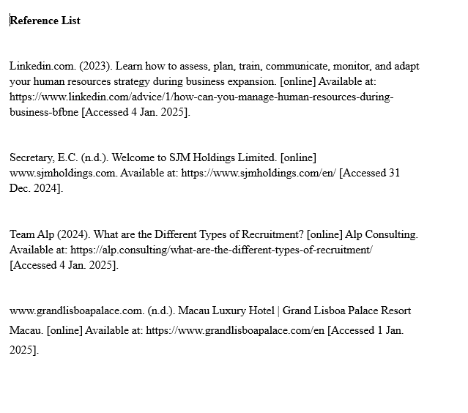

16

