

“SmartConnect: A Digital Platform Linking Mosques and Communities”

Name: Sana Khan
Student ID: 2239157
Supervisor: Dr Shantanu Islam
Module Code: ACCA6020
Module Name: Independent Project
Programme: BSc Cloud Computing
Assignment Title: Component 1: Research Proposal
Submission Date: 28th November 2025

Table of Contents
Introduction 2
Case Study 3
1. Problem Statement 4
Aim 4
Objectives 4
Methodology 5
Expected Outcomes 5
2. Project Design 7
Project Outline 7
Structure Diagram 9
Data Collection Methods 9
Tools and Techniques 10
Challenges and Risks 10
Ethical, Legal, and Privacy Considerations 10
Reliability, Validity, and Generalisability 11
Data Analysis and Evaluation 11
3. Resources and Planning 12
Resources Required 12
Project Timeline 13
References 14

Introduction
Religious institutions like mosques play key social and spiritual roles, extending beyond worship to education and charity. While many adopt digital tools for community engagement [1], smaller UK towns lack unified mosque platforms, causing fragmented communication [2][3]. Studies from Europe show uneven social media use among mosques [4], with digital culture reshaping faith practices [5]. Online tools now influence authority, gender, and cohesion [6], as seen in global apps like Muslim Pro with 170M+ users [8] and rising Islamic lifestyle apps driven by trust and usability [9]. Yet, limited research explores digital unification across small-town mosques [7].

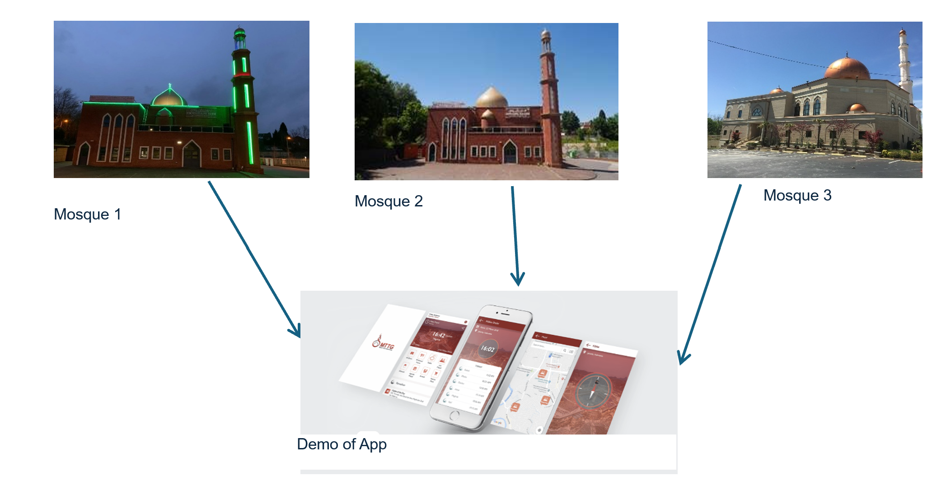

Figure 1: Example image

Case Study
A relevant example of digital transformation within mosque communities can be seen in the Baitussyarif Muhammadiyah Mosque in Jambi, Indonesia, where researchers developed a mobile-based mosque management system to enhance communication, transparency, and administrative efficiency [10]. The project adopted a mixed-method approach involving interviews with mosque leaders, community surveys, and iterative prototype testing using Android Studio. Results showed a 45% reduction in administrative workload and an 85% satisfaction rate among users, demonstrating the effectiveness of digital tools in fostering community engagement and trust [10]. Similarly, a case study at Al Abroor Mosque tested a mobile application for muezzin and khatib scheduling, achieving a high usability score (SUS 85.6), confirming that a user-centred design significantly improves adoption and user experience [11]. Another study explored the Smart Mosque Application initiative in Indonesia, which integrated event management, financial reporting, and congregational data into one platform to promote inclusivity and better information flow [12]. Despite positive outcomes, challenges such as limited digital literacy and resource constraints persisted, echoing similar issues identified in small-town religious institutions. These findings align with recent research in Islamabad, Pakistan, showing that technology adoption in mosques enhances inclusivity, transparency, and communication but requires leadership support and community training [13]. In the UK, Bradford Grand Mosque developed a hybrid, cross-platform app that pulls live content directly from the mosque, including daily prayer and jama‘at timings, educational courses, live broadcasts, event notifications, and Qur’an content among others; its introduction has allowed community members to stay more engaged with current mosque announcements and teachings [14]. This UK example reinforces that such apps can work well not only in larger urban centres but also in diverse local communities [15].
Collectively, these case studies highlight that a centralized mobile application can effectively unify mosque operations, improve communication, and strengthen social cohesion when designed with user needs, cultural sensitivity, and accessibility in mind.

1. Problem Statement
In our town, three mosques serve a diverse Muslim population, but no centralized digital system exists to unify them. Each mosque relies on its own communication practices, often informal or fragmented, leading to missed announcements, reduced collaboration, and weaker community cohesion. New residents or visitors face challenges in accessing consistent information, such as prayer schedules, events, or educational activities. The lack of a unified platform undermines inclusivity and restricts opportunities for collective engagement. Addressing this problem requires a solution that bridges institutional divides and provides accessible, real-time updates for all.

Aim
The aim is to design and evaluate a centralized mobile application that enhances communication, information sharing, and engagement among the three mosques and the wider Muslim community in the town.

Objectives
To achieve this aim, the study will:
- Analyse current communication practices and challenges within the three mosques.
- Evaluate existing digital mosque platforms and identify best practices.
- Design and develop a prototype centralized mobile application (using XML for UI and Java/JavaScript for functionality).
- Assess usability and potential impact through stakeholder feedback.
- Ensure data privacy, security, and ethical handling of user information within the platform.
- Integrate key mosque functions such as announcements, event management, and prayer timetables into one accessible interface.
- Test and refine the prototype using usability testing tools (JUnit, Espresso, Android Emulator).
- Compare prototype outcomes with existing mosque communication methods to evaluate improvement in efficiency and engagement.
- Provide recommendations for long-term adoption, scalability, and sustainability of digital solutions within small-town mosque communities.

Methodology
A mixed-method approach will guide the study. First, a literature review will synthesise research on digital communication in religious contexts. Primary data will be gathered via interviews with mosque leaders and surveys with community members to understand needs and expectations. A prototype app will then be developed using Android Studio, with XML for layout design and Java/JavaScript for functionality. Finally, usability testing and focus group discussions will evaluate user satisfaction, accessibility, and effectiveness.

Expected Outcomes
The study will deliver a prototype mobile application that consolidates announcements, prayer times, and events across the three mosques as shown below ”figure 2” as a example picture. It will also provide a comprehensive report with recommendations for scalability and long-term sustainability. Expected outcomes include:
- Improved communication flow and inclusivity.
- Stronger collaboration among mosques.
- Practical insights for faith-based organizations adopting digital tools.
- Academic contribution by addressing a gap in literature on mosque digitalization in small towns.
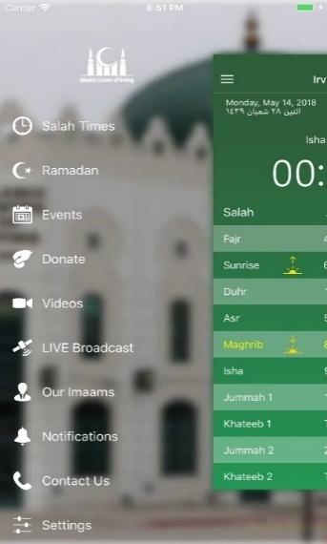
Figure 2: Example execution of the app

By developing and critically evaluating a mobile application, this project aims to transform fragmented communication into an integrated, accessible system. It contributes to both practical community needs and scholarly understanding of digital religion in the 21st century.

2. Project Design

Project Outline
The project involves the design, development, and evaluation of a centralized mobile application that connects the three mosques in the town and provides real-time updates, announcements, and event information to the local Muslim community as shown in below picture.

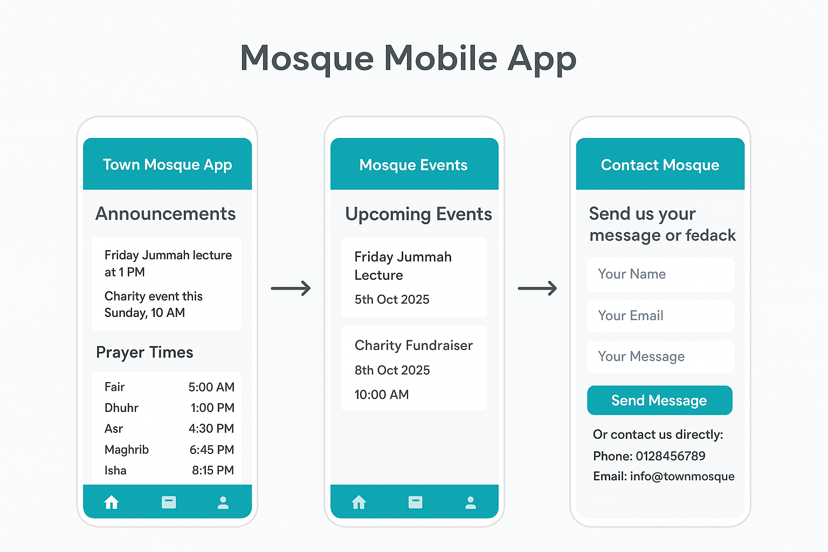

Figure 3: Demo of Layout of the App.

The app will be developed using:
- XML for UI design and layout (Android standard).
- Java for core functionality and backend logic.
- JavaScript (where required) for interactive features, APIs, and potential integration with web-based services.
The development will follow the Agile methodology with iterative design, testing, and evaluation cycles:
- Requirement Gathering and understanding needs of mosque leaders and community members.
- System Design – wireframing app interfaces and database schema.
- Development – implementing features (prayer times, event calendar, announcements).
- Testing & Evaluation – usability and acceptance testing with stakeholders [16].

Structure Diagram
This structure diagram illustrates the prototype's key components and their interconnections. It provides a visual representation of the system's architecture, helping to clarify the functional layout and design logic.

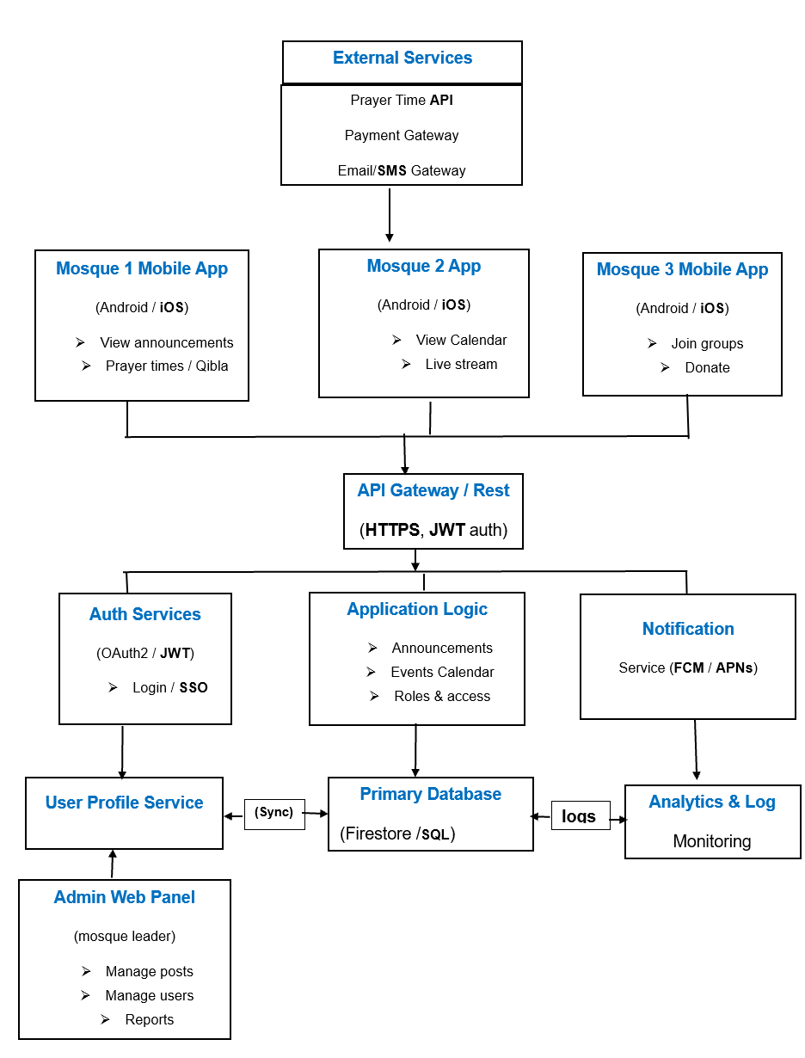
Figure 4: Structure Diagram

Data Collection Methods
The application will be tested with simulated data therefore no real data collection is required.

Tools and Techniques
Development Tools:
- Android Studio (IDE for XML + Java) [19].
- Gradle (build automation).
- SQLite or Firebase (for storing mosque announcements and user data).
- UI/UX Design Tools: Figma for mock-ups, Android XML for actual layouts [19].
- Testing Tools: Android Emulator, JUnit for Java unit testing, Espresso for UI testing.
Techniques:
- User-Centred Design (ensuring app usability).
- Agile Development (iterative improvements).
- Push Notifications (via Firebase Cloud Messaging).

Challenges and Risks
Key risks include data privacy and security, as sensitive personal information may be processed. To mitigate this, the app will utilize simulated data. For real world implementation GDPR rules will be followed to ensure data privacy and safety.

Ethical, Legal, and Privacy Considerations
- GDPR compliance for app data (user login, push notifications) [20].
- Secure storage (Firebase / SQLite with encryption for sensitive data).
- Respect for cultural sensitivity in design (e.g., modest UI, clear Islamic context).

Reliability, Validity, and Generalisability
- Reliability: Achieved by rigorous app testing (unit + UI tests) and consistent survey instruments.
- Validity: Triangulation of data sources (literature, interviews, app testing).
- Generalisability: The app design can be replicated in other towns with multiple mosques, with only minor contextual adjustments (e.g., names, languages, events).

Data Analysis and Evaluation
The performance will be evaluated by alpha and beta test. During the test few key parameters will be checked such as synchronization between multiple mosques, ease of use, accuracy etc.

3. Resources and Planning

Resources Required
Table: Project Resources, Advantages, and Disadvantages
Category | Resources/Tools | Purpose | Advantages | Disadvantages
Hardware | Computers & Android devices | App development, testing, deployment | Supports coding and testing; allows real-device validation | Costly; performance varies across devices
Development Tools | Android Studio, XML, Java/JavaScript, Gradle | App coding, UI design, build automation | Comprehensive tools; widely supported; efficient build management | Steep learning curve; resource-intensive; complex setup
Database | Firebase / SQLite | Store mosque data, user info, events | Scalable, secure, supports real-time sync | Internet required (Firebase); storage limits (SQLite)
Design Tools | Figma | UI/UX wireframes and mock-ups | Collaborative; easy prototyping; visual clarity | Limited offline use: advanced features require paid plan
Testing Tools | Android Emulator, JUnit, Espresso | Functional and UI testing | Simulates devices; automated testing improves reliability | May not fully replicate real device behaviour; setup can be complex
Collaboration & Storage | GitHub, Cloud Storage | Version control and secure backups | Enables teamwork; protects against data loss | Internet-dependent; learning curve for Git workflow
Informational Resources | Academic journals, online repositories | Literature review and best practices | Evidence-based insights; supports academic rigor | Time-consuming; subscription may be required
Community Engagement | Interviews & surveys | Collect user input; inform user-centred design | Ensures app meets community needs; builds trust | Time-consuming; potential bias in responses

Project Timeline
By allocating resources effectively and adhering to this structured timeline shown below in Figure 5, the project ensures milestones are achieved on time, risks are managed, and the final mobile application is both functional and user-friendly. This demonstrates rigorous planning and readiness to address the communication needs of the three mosques and the wider Muslim community.

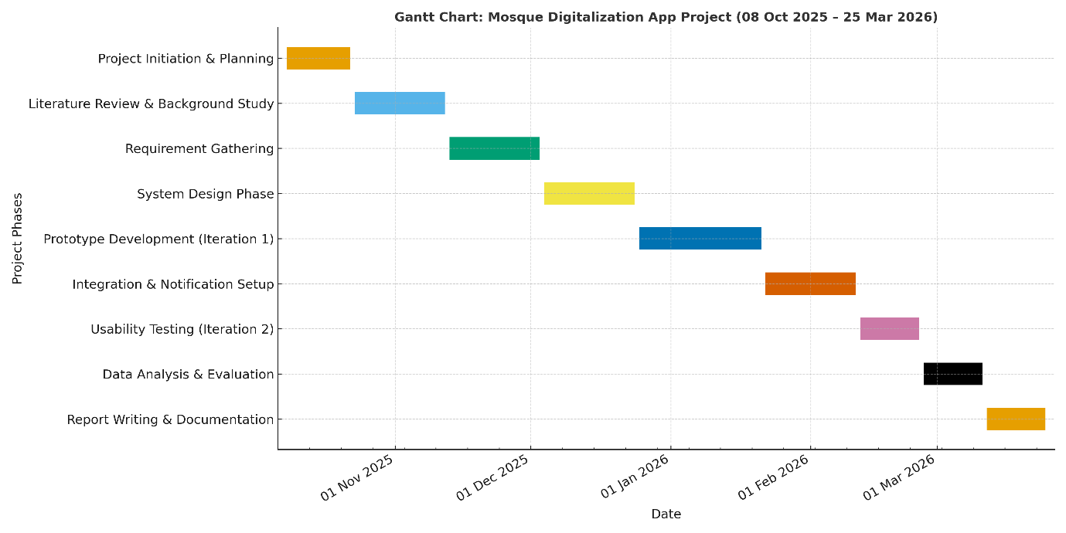
Figure 5: Timeline (Gantt Chart ) for the project

References
[1] Pew Research Center (2023). Use of Apps and Websites in Religious Life. Pew Research.
[2] Office for National Statistics (2021). Religion in England and Wales: Census 2021. ONS.
[3] Muslim Pro App Hits 170M Downloads (2025). Connecting Muslims Worldwide. APN News.
[4] Ajouaou, M., & de Ruiter, J. J. (2019). Online activity of mosques and Muslims in the Netherlands: A study of Facebook, Instagram, YouTube and Twitter. Religions, 10(12), 660.
[5] Haberli, M. (2019). The Transformation of Religion and Piety in the Digital Age. Mediad Journal, 2(2), 113–125.
[6] Lövheim, M., & Lundmark, E. (2019). Gender, Religion and Authority in Digital Media. ESSACHESS – Journal for Communication Studies, 12(1), 73–88.
[7] Islam, M. T. (2019). The Impact of Social Media on Muslim Society: From Islamic Perspective. International Journal of Social Humanities Sciences Research, 6(41), 3475–3485.
[8] Pew Research Center (2023). Use of Religious Apps, Websites and Digital Tools in Daily Worship. Pew Research.
[9] Rahman, N. et al. (2024). The Adoption of Halal App Among Young Muslim Consumers: A Study on ACIS Student, UiTM Shah Alam. Al-Qanatir Journal of Islamic Studies, 22(1), 45–60.
[10] S. Yaakub, W. J. Pranoto, T. A. Y. Siswa, I. S. Windiarti, R. Priyanti, and Alghazali, “Enhancing mosque governance through mobile-based system: a case study at Baitussyarif Muhammadiyah Jambi,” Int. J. Sustainable Community Services and Development, vol. 1, no. 1, pp. 1–10, Feb. 2025.
[11] R. Wijaya, C. Cahyana, and B. Pudjoatmodjo, “Usability and User Experience Test on the Muezzin and Khatib Scheduling Mobile Application: Case Study: Al Abroor Mosque,” Int. J. Applied Information Technology, vol. 5, no. 1, pp. 1–7, Nov. 2021.
[12] F. Febrianty, A. M. Thantawi, S. Budilaksono, N. Anwar, and S. Komsiah, “Utilization and development of Smart Mosque Applications,” Sinkron: Jurnal dan Penelitian Teknik Informatika, vol. 7, no. 1, pp. 119–129, 2023.
[13] G. M. Channa, A. N. Mugheri, and H. Mugheri, “The Adoption and Utilization of Technology in the Mosques: A Case Study of Islamabad,” Social Science Review Archives, vol. 3, no. 1, pp. 1–17, Jan.–Mar. 2025.
[14] Bradford Grand Mosque. “Bradford Grand Mosque App,” hybrid cross-platform application giving live prayer & jama‘at time updates, course info, Qur’an content and live broadcasts [Online]. Available: https://app.bradfordgrandmosque.co.uk/ app.bradfordgrandmosque.co.uk+1
[15] MosqueApp Ltd. Case examples include Chesham Mosque, Al Madina Mosque Barking, Aylesbury Mosque, Sutton Islamic Centre, WISE Masjid etc., showing use of branded apps with push notifications, donation integration, events, announcements etc. mosqueapp.co.uk
[16] Rahman, N. et al. (2024). The Adoption of Halal App Among Young Muslim Consumers: A Study on ACIS Student, UiTM Shah Alam. Al-Qanatir Journal of Islamic Studies, 22(1), 45–60.
[17] Ajouaou, M., & de Ruiter, J. J. (2019). Online activity of mosques and Muslims in the Netherlands: A study of Facebook, Instagram, YouTube and Twitter. Religions, 10(12), 660.
[18] Haberli, M. (2019). The Transformation of Religion and Piety in the Digital Age. Mediad Journal, 2(2), 113–125.
[19] Export Kit, “Convert Figma to Android Studio XML and Java,” Export Kit, 2022. Available: https://exportkit.com/plugin/environments/xml/convert-figma-to-android-studio/
[20] European Union (2021). General Data Protection Regulation (GDPR) Compliance Report. EU Commission.
[21] Pew Research Center (2023). Use of Religious Apps and Digital Tools in Daily Worship. Pew Research.
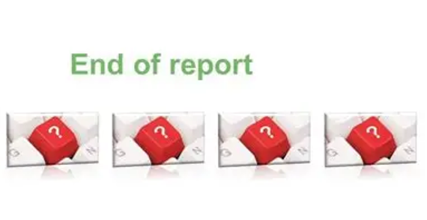
[22] R. Wijaya, C. Cahyana, and B. Pudjoatmodjo, “Usability and User Experience Test on the Muezzin and Khatib Scheduling Mobile Application: Case Study: Al Abroor Mosque,” *International Journal of Applied Information Technology*, vol. 5, no. 1, pp. xx-yy, Nov. 2021. doi:10.25124/ijait.v5i01.2778.

