Module: Digital Skills and Research Methods
Module code: BMSK4003
Student name: Veronika Topolcanyova
Student ID number: 1806303
Assignment Title: Group Tasks – Creating Website and questionnaire using Google Forms
Submission deadline: 5th July 19
Task 1.
Questionnaire
Google drive Log in: 1806303veronika@gmail.com
Password: digital2019

/Example of questionnaire, frequently asked questions/
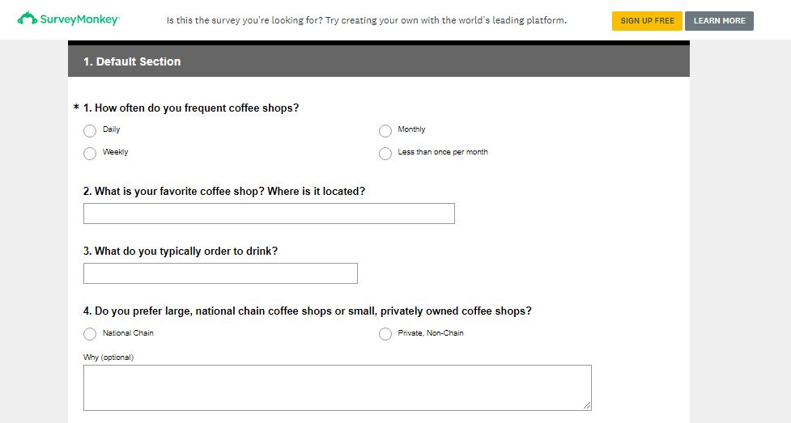https://www.surveymonkey.com/r/BHJ8NLC, Accessed July 1st, 2019

1st question:
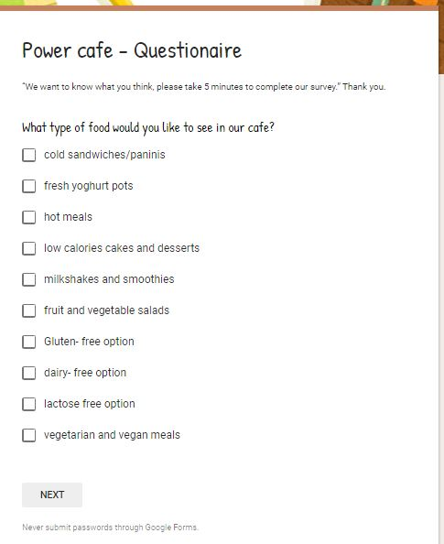
/Created by Veronika Topolcanyova/

Graph generated from 10 responses:
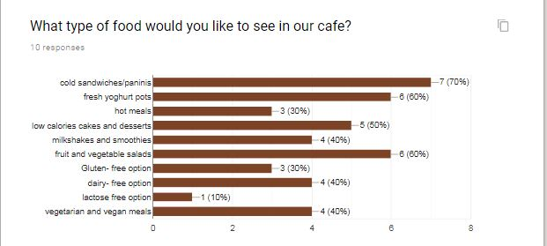
/Created by Veronika Topolcanyova/
Based on our questionnaire findings, our new business can use information gathered to find out customers preferences and create menu for our café, if there is market for allergen free meals, hot or cold options and if it is worth to provide and maintain fresh salad bar.

Question 2:
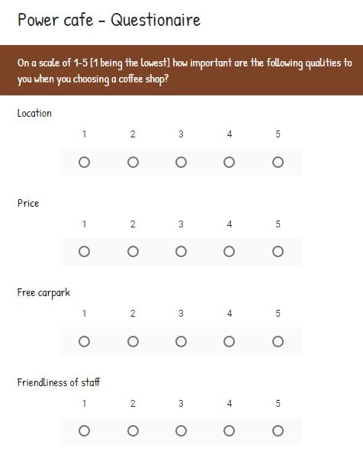
Graph:
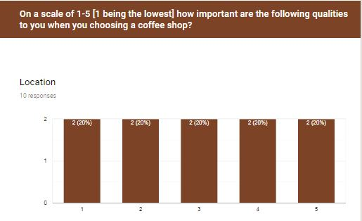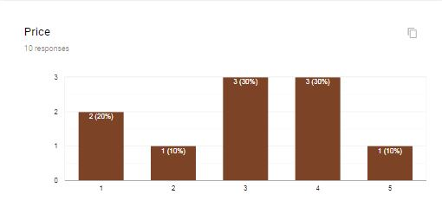

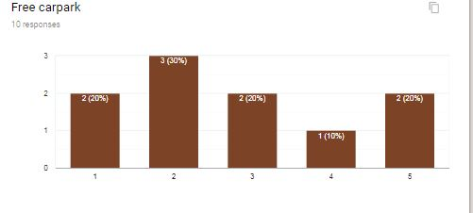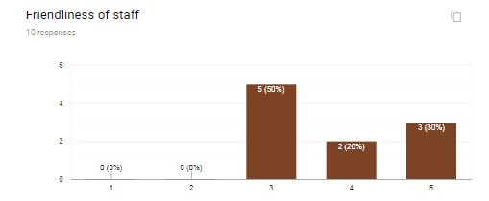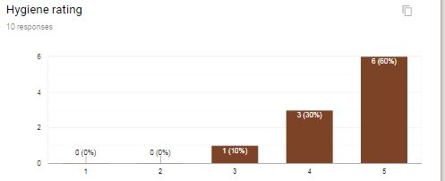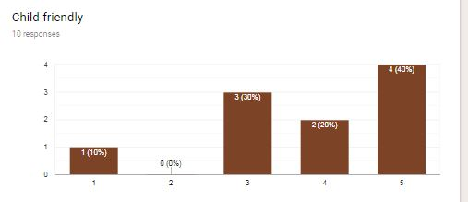
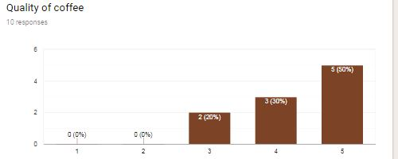
The purpose of second question was for business to find out level of importance for customers.
Aim was to find out right demographic and geographic location for the business, if price is leading factor for customers for choosing certain products, and if they prefer quality instead of quantity, just because offering healthy dishes made from local ingredients might rise the price of food and drinks and might be slightly greater than competitors prices.
Do they care about cleanliness of the premises and hygiene rating or quality of coffee served in our café?
As a conclusion it is great and affordable way for businesses to gather data and analyze them for business purposes to improve business services and head to the right direction in the business avoiding big mistakes and profit loss.
It is major for business to conduct questionnaires and surveys in the beginning of their venture, at the start to avoid disappointment and failure. At the end every business goal and objective is to run successfully and have a great reputation in the market.

What are the benefits of online survey for your business?
- It is great and useful tool for marketing purposes to gather data important for business strategies
- It is cheap option for business to find out information about competitors, what products and services they offer, for what price, what quality
- It is easy way to collect information about customer needs and requests
- If you post your questionnaire online, or social network there is potential to receive thousands responses
- It describes characteristics of a wide population
- It helps businesses to make right decisions knowing customers’ needs
- It is very flexible way to collect information, for instance by phone, in person – face to face, by e-mail, social networking / Facebook, Twitter, Instagram../
- It is confidential
- You can create different types of question and gather more descriptive answers
- Easy to conduct data and create graphs and charts / using google forms/
Task 2
Website
Weebly Log In: 1806303veronika@gmail.com
Password: digital2019
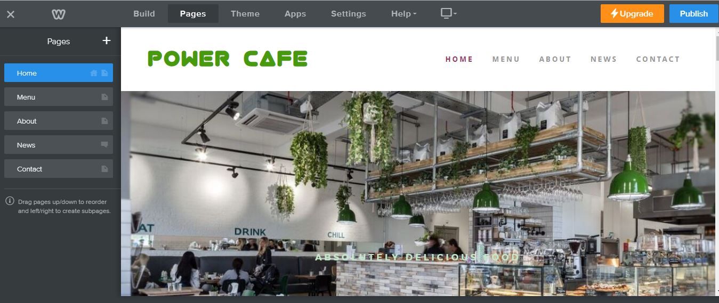

From Clay to Cup

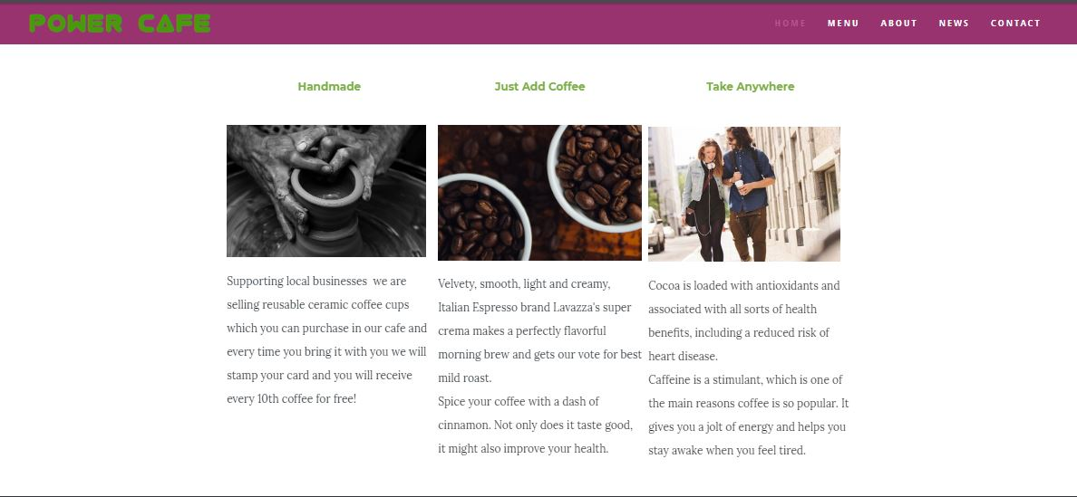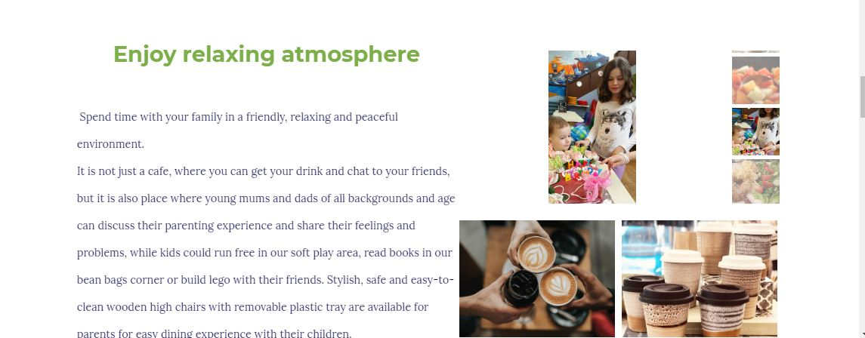
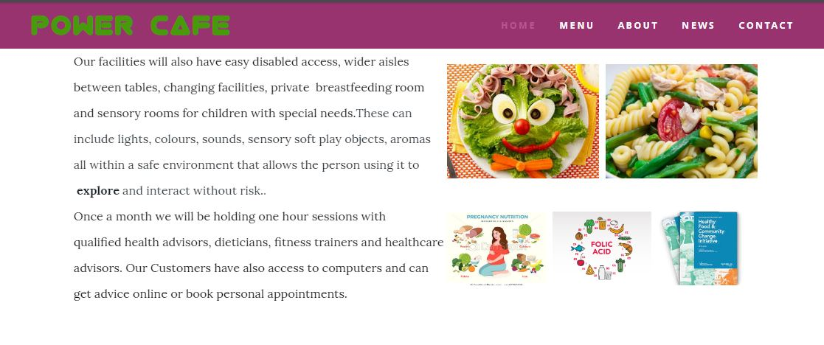
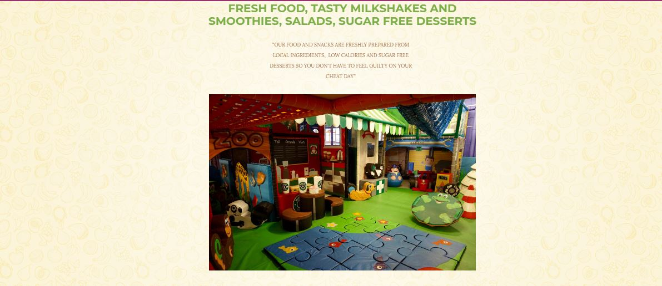
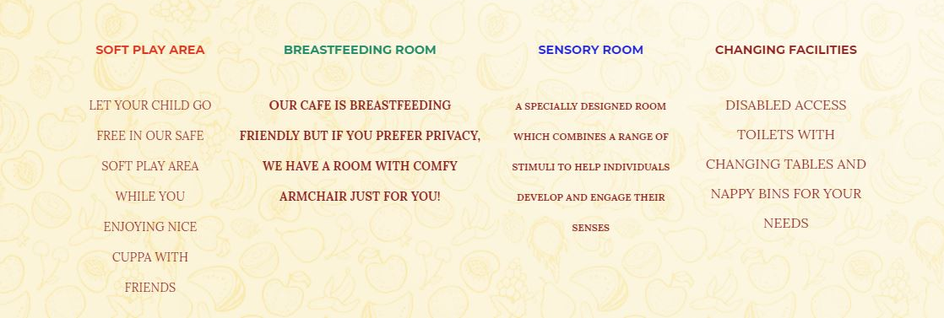
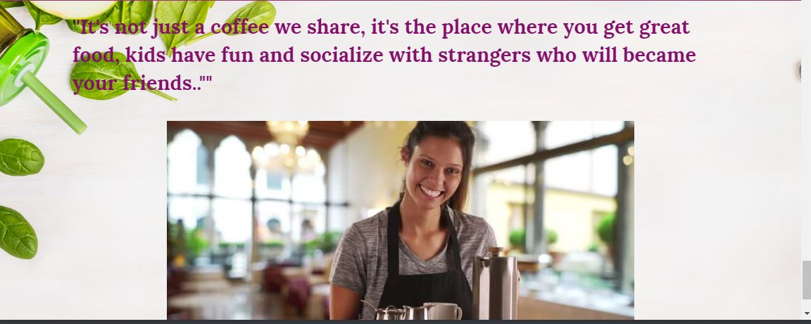
/Created by Veronika Topolcanyova using Weebly/
Creating website using Weebly is easy and low cost way for your company to ‘’get online’’ and promote your business.
My part in this assignment creating website was HOME PAGE.
I choose a random picture from google which perfectly match a vision how our café should look.
I have saved the picture to my computer and used it for the background for the main page.
Watching Weebly tutorial it was surprisingly easy to do it as only thing you have to do is to upload the picture from your computer, then, amend it, add title, choose font, size of letters and color.
It is easy to replace picture or delete it if you not satisfied with the look of it.
Then adding more sections I have used gallery option and choose some images of food and drinks just simply dragging gallery tool where I have wanted it and upload pictures into it.
As next step I have added slide show and choose automatic option to change pictures.
With every section I add little description of products and services we offer and introduced company aims and objectives.
Finishing page with our mission statement was great touch and reminded our customers that enjoying life is most important part of our journey and we can do daily tasks different and much more enjoyable for them to deal with daily stress and challenges.

