Name: ELENA ONIGA
Student no.:1905210
Module title: LCBB4004 Marketing Fundamentals
Marketing Fundamentals: Analysis and Evaluation – Assessment 2
Lectures name:Tushara Balendran

Introduction
For an organisation to stay relevant in the market, it is necessary to continuously create value in terms of its products and services, and this can be done through the right combination of the market mix (Tu and Chih, 2013). Also, in order to reach out to the customers, it is important to ensure that the internal as well as the external stakeholders work in perfect synchronisation (Johansen, Aggerholm and Frandsen, 2012), thereby indicating the need for proper communication tactics to establish the same. This essay will aim to analyse the processes and stages of marketing by exploring the various macro-environmental analytical frameworks such as PESTEL and Porter’s five forces, while also elaborating on the role that marketing mix plays. It shall also analyse the role that marketing has in terms of creating value to the customers, and describe the communication processes between the internal and the external stakeholders. A critical reflection on the tactical communication tools has also been included. The organisation considered for this essay is Nike, which is a multinational corporation involved in the designing and manufacturing of sports shoes, apparel and other sports accessories. Currently, the company is the world’s largest manufacturer and supplier of sports goods, particularly apparel and athletic shoes.

Processes and stages of marketing including the role of the marketing mix

PESTEL analysis
Political: Nike being an American company enjoys significant benefits and advantages due to the stable government and the trade regulations. Furthermore, due to its environmental-friendly policies such as the recycling of old shoes (Nike, 2020), the company also receives a commendable level of tax benefits. However, the in countries such as the UK, the business operations are being impacted due to the looming threat of a no-deal Brexit (Wilkes, 2019).
Economic: Nike usually tends to control its production costs by outsourcing its manufacturing processes to the Asian countries such as China, due to the availability of low-cost labour. However, this has started to become a major issue due to the economic growth and prosperity in this region, which has raised the standards of living. Consequently, the low wages became a problem, which can be understood from the workers’ protests in 2014 (Kaiman, 2014). Moreover, the profit margins keep fluctuating due to the changes in the foreign currency rates, which are dependent on the economic conditions of the respective countries.
Socio-cultural: People all over the world have become increasingly conscious about their health and fitness (Lau, et al., 2013), which has caused a spike in the demand for sports apparel and gym-wear. Nike has further benefited from the increased brand awareness of the consumers, who view the company as a reputed brand that produces high quality products. The number of female customers has also increased significantly, which has further aided Nike’s business and profits.
Technological: Nike is one of the pioneers when it comes to sporting goods, and thus, makes sure that its footwear and other apparel are manufactured using the latest technologies and best-quality raw materials. Its innovative designs along with the utilisation of a refined manufacturing process makes it easier for the company to appeal to a wide range of consumers ranging from the topmost athletes to the common man.
Environmental: The increase in the problems related to global warming has made it mandatory for major corporations such as Nike to think of ways that would be less wasteful and consequently gentler in terms of the impacts they have on the environment. The company has thus taken a pledge to reduce its carbon footprint (Young, 2010) and also regulate the waste produced along its supply chain from the various processes. As stated earlier, Nike also recycles some of its shoes (Zhang, et al., 2018), which allows the brand to maintain a green and eco-friendly image.
Legal: Nike and Adidas have been involved in head-on collision when it comes to the sports apparel industry, and on numerous occasions have been in the tabloids for allegations on the copying of designs and other issues such as proprietary secrets (Singh-Kurtz, 2019). Moreover, Nike has been under significant scrutiny due to issues related to the exploitation of child labour as well as minimum wage practices (Bain, 2017). The company has also been accused of utilising offshore accounts for its transactions in a bid to avoid paying taxes.

Porter’s five forces analysis
Bargaining power of buyers: For Nike, the bargaining power of the buyers or customers is moderate, since there are a limited number of high-end companies in the market that manufacture and market quality sportswear. Furthermore, these alternative companies have a price range similar to Nike, which makes it irrelevant for the customers when it comes to switching over to them, given the fact that Nike’s quality is unmatched.
Bargaining power of suppliers: For Nike, the suppliers have a very low bargaining power because most of the raw material providers work on a contractual basis and are part of Nike’s RSL or Restricted Substances List (Nike, 2019). This makes it difficult for the suppliers to switch to a different manufacturer because of the monopoly that Nike exercises over them. Moreover, the company also controls the suppliers through regular quality checks with the help of its auditing teams.
Threat of new entrants:The threat of new entrants is low for Nike, because of its market position and also because of the amount of capital required to start conducting business in the sports apparel industry. Thus, not many investors or manufacturers would have access to that kind of resources in order to threaten Nike’s topmost position (Statista, 2019) in the market, which implies that its market share is quite safe and secure.
Threat of substitutes: Nike faces a moderate level of threat from the substitute products. This is because a majority of the people across the world are still not well-equipped with the disposable income that would be needed for being able to afford the premium-priced products manufactured by the company. Thus, the emergence of numerus counterfeit products, along with locally made sports shoes and goods, often serve as an easy and comparatively cheaper alternative to the consumers.
Competitive rivalry: The competitive rivalry that Nike faces is rather intense and is thus high, because of the presence of numerous noteworthy competitors such as Adidas, Puma and Under Armour. The primary competitor of Nike is Adidas, and the competition has only worsened, owing to numerous lawsuits between the two companies, along with the rivalry to get the best athletes to sign up for endorsements.

Advantages and disadvantages of the macro-environment
From the above analysis, it is clear that Nike faces both advantages and disadvantages in terms of its macro-environment. For instance, the market entry capital is high, due to which Nike enjoys a beneficial and risk-free position in the sports apparel sector. However, Adidas has been making it difficult for the brand to maintain this market share on a global scale, since the rival brand too manufactures high-quality products at more or less the same selling prices. Moreover, Nike is also subject to the demands and changes in the sports industry as well as the sports fashion sector, which makes it necessary for it to regularly keep track of its external environment and the market dynamics in order to ensure that it does not lose its reputation or market share.

Marketing mix and its elements
The marketing mix approach is an important tool that can help understand the product or service offering of an organisation, and also the elements that can assist with the successful marketing of the same (Singh, 2012). The most commonly used framework for the marketing mix is that of the 4Ps, where the four factors are product, price, place and promotion.
Product: The product element in the marketing mix approach is the service or the physical goods that are offered by an organisation to the customers (Gordon, 2012; Singh, 2012). This product is usually aimed at fulfilling the market needs and consumer demands. Nike has a diverse product range, which includes shoes, bags, sports garments, and other athletic accessories. The company also manufactures hockey sticks and other miscellaneous sports equipment, which has helped it penetrate the niche markets.
Price: The price is the financial cost that buyers must pay when purchasing the product, and should thus be on a value for money basis to get the best outcomes (Gordon, 2012; Singh, 2012). Nike’s high quality automatically indicates that it would prefer a premium pricing strategy. The brand targets the high-end and upper middle-class sections of the societies through this pricing strategy. Moreover, in case of those products where Nike might face a rivalry from Adidas or Puma, the company follows a competitive pricing strategy to encourage buyers to shop from them.
Place: The place is the physical set-up as to where an organisation sells or markets its products. It also takes into consideration the distribution and supply chain processes (Gordon, 2012; Singh, 2012). Nike distributes and sells its products through both online and offline channels. The brand utilises its specialty stores (direct channel) as well as the multi-brand retail stores (indirect channel) for the sale of its products, and also offers delivery through the major e-commerce websites.
Promotion: This element encompasses the different marketing techniques that are used by an organisation to communicate with the customers, such as advertising, public relations, and other offers such as discounts (Gordon, 2012; Singh, 2012). A majority of Nike’s promotional funding goes into celebrity endorsements by athletes such as Tiger Woods, Mike Jordan, and many players from the Brazilian football team. Along with these well-known brand ambassadors, Nike’s “Just Do It” branding is also extremely famous and easily recognisable, owing to the company’s successful television and internet advertisement campaigns.

Role of marketing in creating value for customers
The marketing concept is essentially a philosophy that indicates that business organisations need to analyse the needs and demands of the customers and then make appropriate decisions to satisfy those requirements in a manner that allows them to be better than the market rivals (Eagle, et al., 2013). The social marketing concept is essentially the integration of the marketing concepts with the appropriate social changes, and this helps to influence the behaviours that would not only benefit the customers but also make it possible to create a positive change for the greater good in the society (Dibb, 2014). The simple act or concept of marketing generates value for the customers through the creation of intangible connections between the products and the people, and the communities and the companies (Tadajewski and Jones, 2012). Thus, as a brand that serves the consumers, Nike must aim its marketing strategies to creating valuable and meaningful relationships with the buyers in order to sustain themselves in the market.

Advantages and disadvantages
The marketing concept has a major advantage – the business gets promoted among the potential consumers in the target market (Eagle, et al., 2013), and thus can help Nike with widespread brand recognition, thereby indicating the chance for improving the profits.
However, it can have disadvantages as well – the costs required to promote the products is often high, and thus Nike needs to conduct appropriate research before investing its time and money. It is also important to keep track of its initiatives so that they can ensure that no time is wasted behind any campaign that would be unsuccessful in the end (Eagle, et al., 2013).

Stakeholder engagement and impact on marketing activities
In simple words, stakeholder refers to a group, entity or individuals who has a stake in the concerned business, a sort of essential interest in the activities and processes within the business. For a business organisation such as Nike, the stakeholders are those individuals or elements, which can be affected by the company’s actions, policies and objectives (Carroll and Buchholtz, 2014). There are usually two kinds of stakeholders, the internal and the external. The internal stakeholders are the entities that exist within the business, such as the investors and the board of directors. On the other hand, the external stakeholders are the entities that are outside Nike’s administration but can be affected by its market performance, such as the consumers and the suppliers, which are illustrated below:
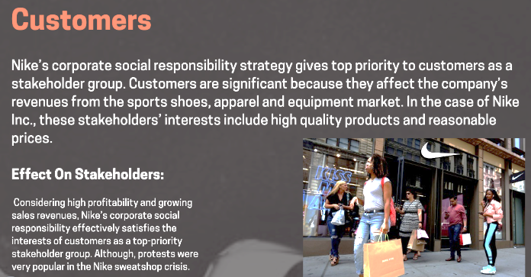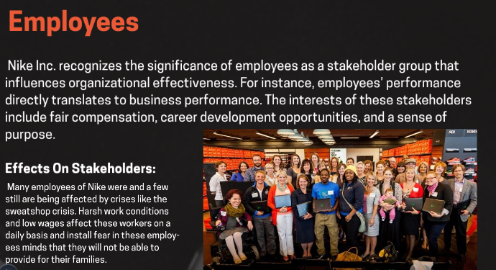
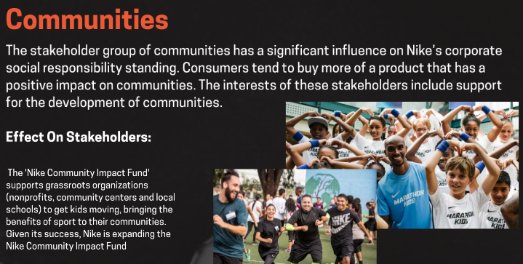
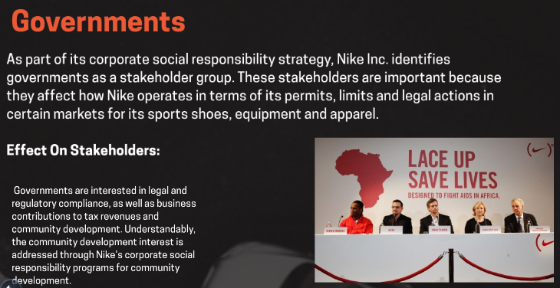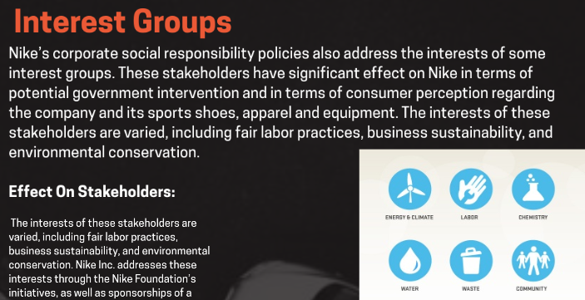

(Source: Nike, 2017)

Communication of internal and external stakeholders
In order to ensure that the marketing activities are being conducted in an optimum manner, it is important to ensure seamless communication between the internal and the external stakeholders. For instance, a major sports apparel company such as Nike needs to conduct regular marketing audits to ensure that it has access to the best quality raw materials from the suppliers, and also to analyse the market demand from the customers. The internal stakeholders such as the board of directors and the investors can be well-equipped with the resources and tools to tackle the changes and meet the demands only when they are aware of the current situation (Phillipson, et al., 2012). Thus, stakeholders need to be engaged together in order to ensure the success of not just the marketing activities but also the organisation.

Critical reflection of the tactical communication tools
The tactical communication tools usually refer to those approaches and frameworks that are utilised for the appropriate fulfilment of the strategies of a project. There are numerous communication channels that can be utilised for this purpose, such as social media, emails, blog-writing, and public relations. Social media has become one of the most prominent channels for communication in both the business as well as the individual fields (Ashley and Tuten, 2015; Felix, Rauschnabel and Hinsch, 2017).
For this project, I have utilised two main tactical communication tools – emails and blog posts. The emails were sent to the relevant representatives of Nike, since I required information regarding the company in order to complete the project. This has helped me understand the manner in which to proceed with corporate communication, and has thus enhanced my email writing skills considerably.
The other tactical communication tool that I have used for this project in order to generate awareness and spark interest in my project is that of blog posts. I have directed the posts in such a manner as to let people know about my project, and what they can learn from it. I have also included details on how I had made background preparations for the project before I started writing it, which can be interesting to the readers since it is very important to have a strong project plan before proceeding with it. In case of academics, project planning makes it easier to understand the different tasks associated with the writing of the project, and helps deliver a comprehensive and inclusive project well within the designated deadline, while also adhering to the intended outcomes or results.
I have learned a lot in terms of utilising the different tactical communication tools, which, in my opinion would help me improve my work and complete future projects in a better manner. The blog writing made it easier for me to understand the different elements that should be present within a blog, and what information is relevant for being communicated to the readers. Moreover, the little communication I had with the company representatives has also helped me understand how corporate proceedings take place, as I now have a fair idea regarding the same. Thus, I believe that I shall be able to compose my projects better in the future, and shall also be able to use the tactical communication tools more effectively.

Conclusion
Nike as a brand needs to integrate its stakeholder communication in order to ensure the appropriate application and subsequent success of its business activities. Furthermore, having the right combination of the marketing mix elements can also help the sports apparel manufacturer have a grip over the factors that impact its business processes externally.

Reference List
Ashley, C. and Tuten, T., 2015. Creative strategies in social media marketing: An exploratory study of branded social content and consumer engagement. Psychology & Marketing, 32(1), pp.15-27.
Bain, M., 2017. Nike is facing a new wave of anti-sweatshop protests. [online] Quartz. Available at: <https://qz.com/1042298/nike-is-facing-a-new-wave-of-anti-sweatshop-protests/ > [Accessed 18 April 2020].
Carroll, A.B. and Buchholtz, A.K., 2014. Business and society: Ethics, sustainability, and stakeholder management. London: Nelson Education.
Dibb, S., 2014. Up, up and away: social marketing breaks free. Journal of Marketing Management, 30(11-12), pp.1159-1185.
Eagle, L., Dahl, S., Hill, S., Bird, S., Spotswood, F. and Tapp, A., 2013. Social marketing. London: Pearson Education.
Felix, R., Rauschnabel, P.A. and Hinsch, C., 2017. Elements of strategic social media marketing: A holistic framework. Journal of Business Research, 70, pp.118-126.
Gordon, R., 2012. Re-thinking and re-tooling the social marketing mix. Australasian Marketing Journal (AMJ), 20(2), pp.122-126.
Johansen, W., Aggerholm, H.K. and Frandsen, F., 2012. Entering new territory: A study of internal crisis management and crisis communication in organizations. Public Relations Review, 38(2), pp.270-279.
Kaiman, J., 2014. Strike spreads at Chinese supplier to Adidas and Nike. [online] The Guardian. Available at: <https://www.theguardian.com/world/2014/apr/22/strike-spreads-chinese-supplier-adidas-nike-yeu-yuen-factory-jiangxi-guangdong > [Accessed 18 April 2020].
Lau, T.C., Chan, M.W., Tan, H.P. and Kwek, C.L., 2013. Functional food: a growing trend among the health conscious. Asian Social Science, 9(1), p.198.
Nike, 2017. Stakeholder Engagement for FY16/17 Sustainable Business Report. [omline] Available at: <https://purpose.nike.com/stakeholder-engagement > [Accessed 18 April 2020].
Nike, 2019. Nike Chemistry Playbooks & Restricted Substance List. [online] Available at: <https://about.nike.com/pages/chemistry-restricted-substances-list > [Accessed 18 April 2020].
Nike, 2020. What is Nike’s reuse-a-shoe program?. [online] Available at: < https://www.nike.com/help/a/recycle-shoes> [Accessed 18 April 2020].
Phillipson, J., Lowe, P., Proctor, A. and Ruto, E., 2012. Stakeholder engagement and knowledge exchange in environmental research. Journal of Environmental Management, 95(1), pp.56-65.
Singh, M., 2012. Marketing mix of 4P’s for competitive advantage. IOSR Journal of Business and Management, 3(6), pp.40-45.
Singh-Kurtz, S., 2019. Adidas has sued pretty much everyone who has used stripes. [online] Quartz. Available at: <https://qz.com/quartzy/1647995/adidas-has-sued-pretty-much-everyone-who-has-used-stripes/> [Accessed 18 April 2020].
Statista, 2019. Nike: Global market share in athletic footwear 2011-2025. [online] Available at: <https://www.statista.com/statistics/216821/forecast-for-nikes-global-market-share-in-athletic-footwear-until-2017/> [Accessed 18 April 2020].
Tadajewski, M. and Jones, D.B., 2012. Scientific marketing management and the emergence of the ethical marketing concept. Journal of Marketing Management, 28(1-2), pp.37-61.
Tu, Y.T. and Chih, H.C., 2013. An empirical study of corporate brand image, customer perceived value and satisfaction on loyalty in shoe industry. Journal of Economics and Behavioral Studies, 5(7), pp.469-483.
Wilkes, G., 2019. Bailout for business in a no-deal Brexit. [online] Institute for Government. Available at: <https://www.instituteforgovernment.org.uk/sites/default/files/publications/no-deal-business-bailout.pdf> [Accessed 18 April 2020].
Young, T., 2010. Nike cuts carbon footprint. [online] The Guardian. Available at: <https://www.theguardian.com/environment/2010/jan/26/nike-cuts-carbon-footprint> [Accessed 18 April 2020].
Zhang, Z., Wei, X., Wu, H., Wang, Q., Zheng, W. and Tang, X., 2018, July. The present situation of the old shoes recycling and the existing old shoes treatment method. In IOP Conference Series: Materials Science and Engineering (Vol. 382, No. 3, p. 032055). IOP Publishing.

