(AC 1.1) Evaluate the advantages and disadvantages of different types of organisation structures, including the reasons underpinning them. A divisional structure and a matrix structure. Within the evaluation, you should include the reasons underpinning each structure.
Organisational structure is critical (David, David and David 2020) to achieve competitive advantage (McCloskey 1996), establishing clear decision-making processes, defining authority, responsibilities, shaping relationships and strategy (Burnes 2009). There are several ways to structure (Gutterman 2023). PAI (current SME employer), relies on one or two individuals covering multiple functions (Waite et al 2021).
Despite ambiguous definitions (Radoslaw 2017), there are four classical structures: traditional, functional, divisional and matrix. No structure is perfect. It depends on business’s unique factors, its customers and external environment (Zaki et al 2015).
Divisional and matrix are unsuitable for narrow product or geographical range businesses. Also, SMEs and start-ups, as they lack resources to support such structures (Gutterman 2023).
Divisional Structure:
Found in larger organisations (previous employer: multinational producer of aluminium), where ‘departments are grouped together based on organisational outputs’ (Anand and Daft 2007.p330). Each division serves different customer bases, geographical market, or product lines (Figure 1), creating ‘more manageable business units’ (Gutterman 2023,p12).
Figure 1: Divisional Structure (Chalk 2024).
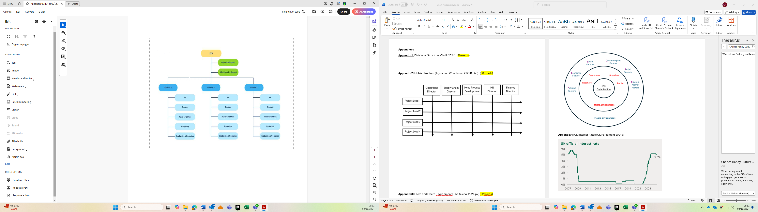

This enables agility, allowing each unit to have full control over its specialised area (Ajagbe et al 2016). Team members focus on issues particular to its business, leading to improved relevant knowledge, responsiveness, and innovations (Taylor and Woodmans 2022b).
Poor knowledge sharing between divisions leads to inefficiency and increased costs. Divisional conflicts do not benefit the entire company (Zaki et al 2015). Departmental duplication and added management layers at headquarters increase costs. Nevertheless, it provides localised expertise within profit-driven business units. These can be evaluated based on individual efficiency and performance (Gutterman 2023).

Matrix Structure:
Found in complex, innovative, project-based organisations with multiple level management reporting, combining functional, divisional and project roles (Figure 2), aligning across multiple authorities (David, David and David 2020). This maximises productivity, flexibility, and resource utilisation (Taylor and Woodman 2022b).
Figure 2: Matrix Structure (Taylor and Woodhams 2022b,p.58)
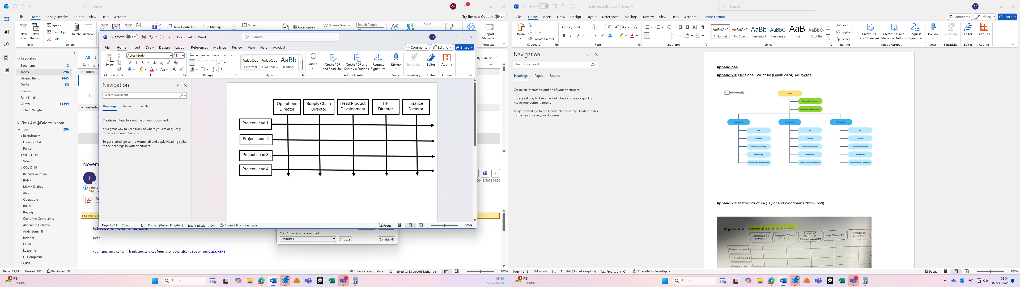
Expensive and complicated, often leading to opposing priorities and dual reporting. Employees struggle with competing demands from different managers, creating ‘conflict and fuzzy authority’ (San Cristobal, Fernadez and Diaz 2018,p.796). Managers lose some control over teams. If not managed effectively, matrix can ‘stifle the entrepreneurial spirit’ (Chi and Nystrom 1998,p.148). Nonetheless, it enables efficient resource allocation, supports specialised projects and shared skills at reduced costs.

(AC 1.2) Analyse connections between organisational strategy, products, services and customers. (in your organisation (or an organisation with which you are familiar) helps to ensure products or services meet customers’ needs.
Strategy involves ‘direction and scope of an organisation over the long-term period, which helps to attain benefit through its configuration of resources’ (Ajagbe et al 2016,p.52). A well-defined strategy requires progressive goals driving improvements toward achieving the organisation's ultimate vision. Underpinned by the company’s mission, objectives, and specific mechanisms it uses to achieve targets (Burnes 2009). Understanding specific customers’ requirements, supply-chain capabilities, and external factors are essential in developing successful strategies (Figure 3).
Figure 3 : Micro and Macro Environments (Waite et al 2021,p.7)
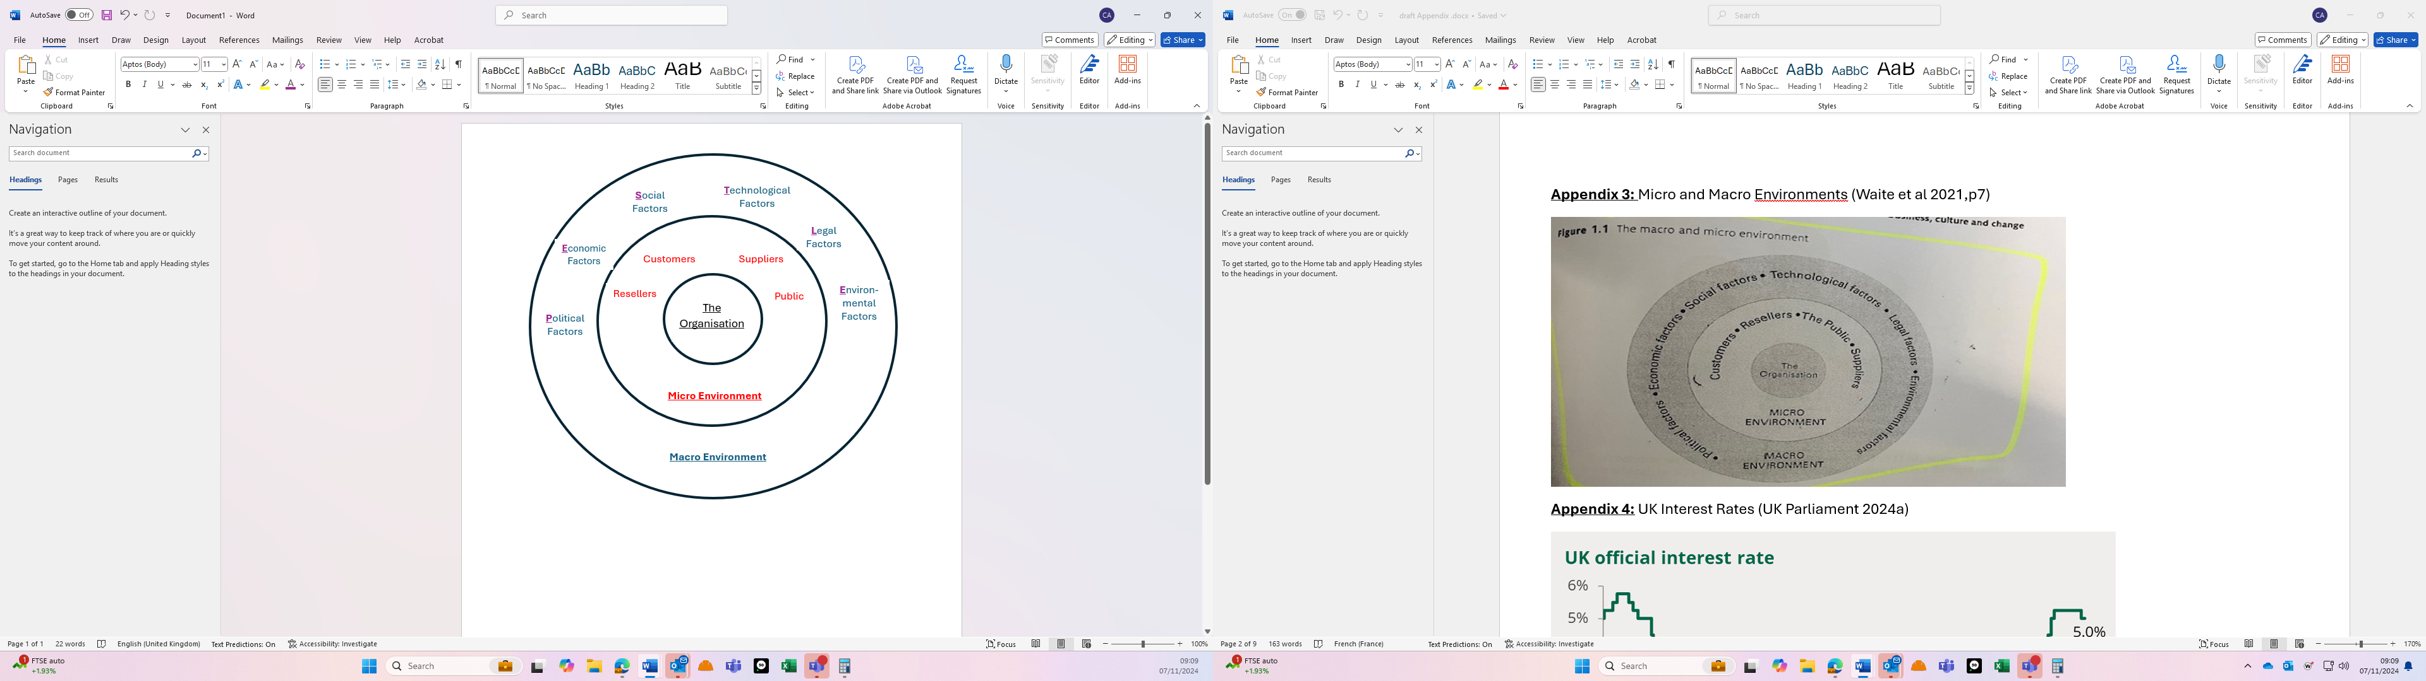
Despite strategy’s vital importance, less than 10% are success. Often because implementation is challenging and misaligned (Carucci and Shappell 2022) as its ‘too complex to be neatly described by universal models’ (Jarvalt and Randma-Liiv 2010,p.243). There are ‘no magic wands’ for driving organisational performance (Briner 2024b).
However, a thorough analysis of strategy will identify potential challenges and opportunities. Strategy development allows for detailed plan with clear milestones. Strategy implementation follows, putting plans into action by managing resources and monitoring. Ensuring targeted decision-making, adaptability, and sustained focus, translates vision into reality (Cameron and Green 2015).
As a private sector SME, PAI originally adopted informal working practices, relying on emergent rather than planned strategies. This is beneficial in dynamic and evolving markets (Taylor and Woodhams 2022b). Over time, PAI has moved towards more formal strategies, including segmentation to increase customer intelligence and service delivery. Identifying different sectors unique requirements, gathering insights, conducting market research enables proposal refinement by better understanding their customers' needs.
This strategic move is bolstered by specialist training. PAI maintains ISO9001, AVIXA, ECA, and Constructionline Gold certification (paigroup.com ND). These position PAI as a trusted and reputable business by evidencing best practice working, which in turn increases productivity and sales (QMSUK ND). However, training opportunities are targeted towards operational staff, not developing office employees.
PAI's primary focus is maintaining medium-term competitive advantage through enhanced operational agility, technical service delivery, and innovation. This combination is believed to support the business's long-term future, creating a plan with leadership support, which is continually reviewed and adjusted as needed (Salavou, Baltas and Lioukas 2004). Nevertheless, like many private sector enterprises, the underlying objective remains to drive performance to maximise profit for its entrepreneurial owner (Taylor and Woodmans 2022b).

(AC 1.3) Analyse external factors and trends impacting organisations to identify current organisational priorities. (interest rates, inflation and one other external factor on your organisation
Several internal and external factors influence organisational performance, value, and survival (Pangestuti and Lousia 2020). In VUCA global markets its crucial to constantly monitor environments for improvement opportunities (Taylor and Woodmans 2022b). This dynamic environment is the ‘lifeblood for organisational success’ (Akpoviroro and Owotutu 2018,p.499). Both micro and macro environments (Figure 3) directly impact business survival.
Various tools assess internal and external factors. SWOT for internal analysis and PESTLE for external issues including interest rates, inflation, and legislation (Crawshaw, Budwer, and Davis 2017).
Interest rates represent borrowing costs or return on savings (BoE 2024). 5% (October 2024) was UK’s highest in fifteen years. The sharp increase following the Truss budget significantly impacted businesses and individuals. A crucial business economic factor, especially for SMEs, who rely on short and long-term borrowing. Higher rates restrict cashflow with high debt levels and negatively impacts investment. Additionally, it reduces consumer and business confidence, potentially decreasing sales (Everett and Watson 1998). However, companies with significant cash reserves may have higher returns, which could offset some costs and enable further investment. These benefits may be temporary if other investments stay at lower rates.
Inflation measures ‘change in prices for goods and services’ (ONS 2024). CPI is 1.7% (September 2024), below Bank of England’s 2% target. Between 2021-23 inflation reached 10%, driven by conflicts limiting supply, unfavourable exchange rates, and higher interest rates. Inflation influences investment decisions, costs, pricing, and sales (Suharyanto and Zaki 2021). Staffing being a major business expenses, the increased wage pressure during high inflation can prevent company’s ability to deliver services. Businesses then cut costs, potentially reducing productivity. Long-term inflation and interest rates have ‘the greatest impact on business failures’ (Everett and Watson 1998,p383).
New laws change business operations, working conditions, and requirements. SMEs struggle to focus on operations due to this additional administrative cost (FSB 2016). Compliance costs burden SMEs disproportionately (Crawshaw, Budwer and Davis 2017) spending £3.7billion annually on conformity (Harrison 2013). Construction, in which PAI operates, has fatalities/injuries cost of £1.4billion (BSC 2014). PAI must adapt to new health and safety standards, including updated height practices and certification. Prior to tendering PAI must first verify working practices via external accreditation. Improved safety practices reduce risks, lower costs through decreased absenteeism, and improves productivity (HSE ND).
These external factors influence organisational priorities by introducing new risks or opportunities, shaping strategic decisions, and guiding resource allocation.

(AC 1.4) Assess the scale of technology within organisations and how it impacts work. In February 2024, Peter Cheese, current CEO of CIPD stated, “AI is transforming jobs, careers and workplaces. People professionals have a key role to play in encouraging safe experimentation and rapid learning, so that we can reap the benefits and mitigate the risks.” Assess the extent that AI is, or could be, used in your organisation (or an organisation with which you are familiar) and assess how AI impacts work.
Technology directly influences business operations. Future advances are expected (Crawshaw, Budwer and Davis 2017), particularly in AI, which will ‘undoubtedly completely transform the job market’ (Moscatel and Moscatel 2021,p.30).
83% of employees feel overwhelmed by AI (Willis 2024), with scholars ‘lagging’ (Moscatel and Moscatel 2021) in this speciality. AI concerns include data security and trust (Redshaw 2024). A third of employees would ban workplace AI, with 50% worrying about technology taking their job (Mayne 2024b). Marriott workers staged industrial action negotiating 165-day notice for any new technology strategies and retraining guarantees (ACAS 2019).
AI organisational benefits include enhanced quality, increased revenue, and cost reduction. Unilever reported recruitment AI saved them £1 million annually (Tan 2022). People professionals play a crucial role in implementing technology policies supporting employees (Piwowar-Sulej et al 2024). AI improves processes in recruitment and staff development (Chambers 2023). However, only 14% (CIPD 2024a) to 50% (Robinson and Robinson 2021) of companies are using AI in HR, therefore there’s growth potential. Slow adoption maybe because companies are unready for AI integration (Jeffery 2018).
As a technology company, PAI has greater internal digital skills than typical SMEs, where 50% face technology skill gaps (CIPD 2024a). However, previous attempts to leverage technology faced challenges. LMS failed as resources shifted addressing operational priorities given limited reserves, to protect short-term profits. Time and effort dedicated should be seen as investment. PAI shifting focus from immediate capital costs and operational needs to long-term efficiency will have lasting impact (Taylor and Woodhams 2022b).
Automating routine HR tasks and processes will release employees for creative, value-adding activities. Virtual coaching, eLearning, and seamless access to updated training reduces costs (Jackson 2024a). Recruitment AI, with targeted filters and chatbots for handling common queries, offers additional savings (Waite et al 2021). While AI can reduce human bias, algorithmic bias is a risk illustrated by discrimination issues at Amazon (Sloan 2023).
AI implementation requires a tailored approach (Redshaw 2024). HR should support employees with relevant training, recognising age-related divides in AI adaptation (Mayne 2024b). Technology efficiently gathers and stores training records, helping people practice to create individual training plans (Davies 2024). Initiatives must include human oversight and specialism, ensuring technology is used effectively and ethically (ACAS 2019).

(AC 2.1) Explain theories and models which examine organisational culture and human behaviour. Explain Charles Handy’s model of organisational culture and explain David Rock’s SCARF theory.
Culture is ‘a system of common beliefs, values, norms, and rules’ (Ambroz and Praprotnik 2008,p.162). Considered the key factor within organisations (Khatri 1999) and overall success (Murtuningsih and dan Bisnis 2019). A ‘problematic term’ (CIPD 2024b), difficult to measure and ‘often vague’ (CIPD 2022,p5), sometimes ‘hard to define’ (Schabracq 2007,p.7). To understand culture, it’s essential to identify its elements and influences for effective improvement plans (Waite et al 2021).
Handy's Model: Originating in the 1970s, it remains relevant today (Personneltoday 2023). Moving ‘beyond vague generalisations’ (Burnes 2009,p.26) to describe how management styles shape organisational culture, influencing language, norms, and values. Greek gods represent different control techniques, characteristics and how they organisationally exhibit (Appendix 1). Their combination forms organisation’s unique culture:
- Zeus: A power culture centralised and spontaneous, valuing only a select inner circle. It allows fast decision-making but can be autocratic and limits diverse perspectives (Russo et al 2013).

- Apollo: A role culture has defined processes, authority, and responsibilities, offering structure and efficiency. It can become too rigid, stifling innovation (Mindtools ND).

- Athena: A task culture is flexible and result-focused, encouraging creativity and productivity. It prioritises performance but produces goal, task, and resource inconsistencies (Personneltoday 2023).

- Dionysus: A person culture emphasises autonomy and individual priorities over collective goals. Attracting specialised skills but struggles with alignment and teamwork (Waite et al 2021).

Task culture has higher cooperation and power distribution, whereas role culture has lower levels (Figure 4).
Figure 4: Handy Culture Cooperation and Power distribution (BusinessBalls ND)
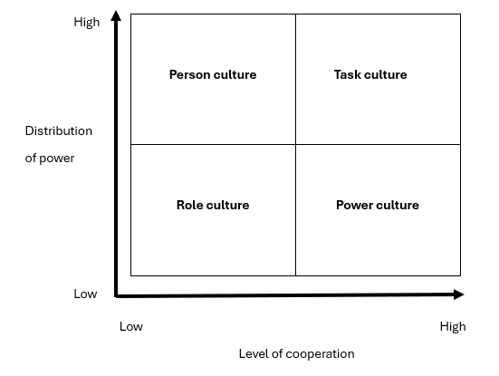

PAI primarily exhibits a power culture, with decision-making centralised among few senior managers. It also includes task aspects, focusing on agility and results in a dynamic market.
Rock’s SCARF Model: Neuroscience-based model helps understand how the brain effects performance (Vato and Sharma 2020). Focusing on reducing perceived threats and maximising rewards across five domains (Rock 2008):
- Status: Involves individuals’ sense of importance within groups. It decreases with public criticism and increases through respect, praise, and job security.

- Certainty: The need for clarity. It diminishes with unpredictable changes and improves with clear communication and consistent policies.

- Autonomy: A sense of control within clear boundaries. It’s reduced by micromanagement and enhanced when individuals are empowered.

- Relatedness: Linked to feeling connected and safe. Increased through strong team collaboration but weakened by social exclusion.

- Fairness: Equity and justice. Improved through greater transparency and clear expectations. Reduced through inconsistent treatment.

Understanding these subconscious drivers fosters positive work environments and greater success by promoting ‘a sense of respect, predictability, control, connection, and fairness’ (Manjaly, Francis and Francis 2024,p.3412). Strengthening manager-employee relationships, increasing engagement, well-being, and capability (Vato and Sharma 2020), underpins change. Threat responses are stronger and longer-lasting than reward responses (Fatol et al 2020).
Leaders also experience SCARF reactions. Their behaviour has an increased impact on the organisation (Rock 2009). Understanding culture and human behaviours is essential. True competitive advantage comes from people’s unique contributions and positive motivation (Crawshaw, Budwer, and Davis 2017).

(AC 2.2) Assess how people practice impact on organisational culture and behaviour. Assess how employee selection or employee development impacts organisational culture and behaviour in your organisation.
Culture has greater influence than strategy (CIPD NDb). Changing organisational culture is seen as ‘almost impossible’ (CIPD 2024b). A positive culture empowers and develops employees when effectively managed. It’s realised by aligning HR and company policies, establishing clear responsibilities, and creating effective communication channels (Waite et al 2021). Engaged employees understand their roles and contribution in achieving broader business objectives (CIPD 2022).
Employee development success has its foundations in recruitment. It’s important people practice employ the right individuals with the necessary skills and fit to the business. Developing employees is vital, as it directly impacts their performance and enhances overall productivity. Effective employee development relies on understanding culture through current employee experiences (Haryadi, Setiawati, and Juhandi 2022).
If employees’ experiences are contrary to expectations set during recruitment, it leads to decreased morale, disengagement, disillusionment, and early exit. HR practices support business objectives by focusing on skill enhancement and continuous learning, increasing motivation, commitment, and engagement. Therefore, improved productivity, quality, customer satisfaction, and financial performance (Appendix 2), as unengaged staff are less likely to innovate (Davies 2024).
At PAI, attempts to create a continuous learning culture (apprenticeships, LMS and skills matrix) have failed. PAI too often redirects resources toward immediate operational needs. Additionally, limited management skills and low employee engagement have impeded success. Leadership plays a critical role in shaping organisational culture (Ostroff, Kinicki and Muhammad 2013), directly influencing both individual behaviour and overall performance (Diana et al 2021).
People practice is the ‘Human Capital Developer’ (Crawshaw, Budwer. and Davis 2017), focusing on developing talent to maintain a competitive advantage (Murtuningsih and dan Bisnis 2019). A consistent appraisal system, alongside motivating staff, is essential. At PAI, there are inconsistent practices, varying line manager approaches with employees encouraged to drive their own development.
Improving communication, ensuring positive reinforcement, and active engagement is key. Regular training feedback and recognition helps reinforce the desired behaviours. An integrated approach aligning development policies with strong management skills and strategic goals is crucial to build a positive learning culture and achieving business goals (CIPD 2021). While improving performance management, career development, and succession planning is challenging for SMEs like PAI, it is achievable with focused effort (Salavou, Baltas and Lioukas 2004).

(AC 2.3) Explain different approaches to managing change. An organisation is planning a change on hybrid working. Many employees moved to home working during the Covid-19 pandemic. Whilst this approach worked well at the time, the organisation now wants all employees to work at least two days a week on site. Explain how Kotter’s approach to managing change could be used to successfully implement this change.
Organisational change is an ongoing process where people professionals are 'stage directors' (CIPD 2024c), guiding initiatives, with employees at the heart of change efforts (Waite et al 2021). It involves introducing new strategies, structures, and processes, prioritising employee support, as their engagement is essential for success (Helmold 2021). Increased hybrid-working from 6% to 28% has had a significant impact (Burton 2024). 56% of hybrid-employees are unwilling to return to in-office, with 39% considering leaving if required to work in-office more than three days a week (Jackson 2024b). Any hybrid-working change must be carefully managed. Resistance to change can disrupt operations and lead to conflict (Schabracq 2007).
Several approaches exist, as ‘even successful change efforts are messy and full of surprises’ (ten Have 2003,p113). Kotter's eight-step model is considered ‘straightforward’ (Laig and Abocejo 2021,p.2), building a readiness for change, creating commitment to deliver and imbed change (Appendix 3).
Kotter’s research revealed three-quarters of change projects fail (Helmold 2021), often at early stages. Applying Kotter's steps avoids common pitfalls (Crawshaw, Budwer, and Davis 2017). Whilst it promotes communication, it lacks guidance on addressing specific challenges (Helmold 2021):
- Urgency: This step focuses on raising awareness and communicating the change reasons, such as improved collaboration or productivity. It fosters a sense of necessity among employees. The organisation can learn from other companies who have implemented similar policies.
- Coalition: Assemble a group of influential leaders and managers to champion change, ensuring consistent support organisation-wide. These must deliver a unified message to the entire company.
- Vision for Change: Develop a clear vision of why more in-office work benefits the organisation and employees, including engagement through in-person interactions (Cholteeva 2023).
- Communicate the Vision: Informing all on reasons, benefits, and timing is essential for a smooth in-office transition, fostering mutual support through genuine two-way consultation.
- Remove Obstacles: Actively listen to concerns, such childcare or commuting. 40% of Londoners expect a pay increase if asked to return to in-office (Jackson 2024b), highlighting the need for research into all concerns.
- Create Short-Term Wins: Celebrate early successes. Enhanced team collaboration or increased productivity demonstrate potential future benefits and create a positive attitude.
- Consolidate: Reinforce practices supporting in-office working, adjusting based on feedback to ensure employees are being listened to and ongoing improvement.
- Anchor the Changes: Embed new working practices into the new culture, illustrating long-term commitment to in-office work publishing its ongoing benefits.
These explain why change is necessary, how to implement it, and the intended outcomes, leading to successful outcomes. 78% of change participants believe this model is crucial for its success (Laig and Abocejo 2021).

(AC 2.4) Discuss models to show how change is experienced. Using the Kubler-Ross change curve, discuss how change is experienced.
While change is essential, it causes employee distress (Elrod II and Tippett 2001). Originating in bereavement research, the Kubler-Ross curve shows how ‘change triggers a sense of loss and consequently grief’ (Petrovic 2023,p.10), offering insight into individuals’ reaction to change across different stages (Helmold 2021) and its impact to self-esteem (Appendix 4).
Recognising these is crucial as hidden resistance, if unaddressed, jeopardises change success. Understanding employees’ position on the curve helps to determine communication methods, timing, additional support, or information requirements (Taylor and Woodhams 2022b). People are central to change, so it’s also important to acknowledge individual responses vary based on personal traits or circumstances (Waite et al 2021).
Ignored emotions during change lead to obstructive behaviours undermining initiatives and cause failure (Elrod II and Tippett 2001). Curve stages are:
- Denial: Individuals try avoiding change by denying its real. A protective mechanism to manage anxiety and maintain control. Extended denial may cause health issues (Chavan and Bhattacharya 2022).
- Anger: Employees become defensive and feel betrayed by the situation, expressing frustration, annoyance, or rage (Gerhardt and Puchkov 2023).
- Bargain: Individuals negotiate to retain control or keep aspects of the status quo. They look at ways to mitigate the change's impact on their role or responsibilities (Cameron and Green 2015).
- Depression: Occurs when change is unexpected and significant, leading to feelings of indecision, low motivation, and difficulty concentrating. Known as ‘death wish stage’ (Gerhardt and Puchkov 2023,p.987), individuals lose hope of moving forward. Progress is only possible when new possibilities become visible.
- Acceptance: In this stage, individuals come to terms with the change. While this does not always mean they have embraced it fully, they begin to adapt to the new circumstances.
Effective communication is vital throughout its stages. Organisations must explain the change, provide regular updates, and organise meetings to distribute information. Acknowledging employees' feelings and providing opportunities for them to voice concerns is essential. Line managers are key in addressing these concerns, listening to feedback, and adjusting plans when needed (Smyrl 2024). Emotional support is crucial throughout the process, with additional training or even counselling (Campbell et al 2023).
Some argue ‘grief isn’t linear’ (Gerhardt and Puchkov 2023,p.983), noting it lacks scientific rigour and cultural variation. It can be confusing, leading to improper application and potential negative outcomes (Simpson 2022). There is no universal approach managing these stages (Gerhardt and Puchkov 2023). Nonetheless it offers valuable insights into individuals' emotional states, reactions, and potential support strategies (O’Brien et al 2023).

(AC 2.5) The CIPD’s Health and wellbeing at work survey 2023 found the percentage of organisations that have a standalone wellbeing strategy has risen from 40% in 2018 to 53% in 2023. Although the percentage has increased, this means that 47% of organisations do not have a standalone wellbeing strategy. Assess the importance of wellbeing at work and assess how good work could impact wellbeing.
Work well-being is crucial for safe and effective business operations plus employers have a legal duty of care (ACAS 2024). It’s a key people practice responsibility and core within CIPD’s professional map (CIPD NDc), especially in VUCA environments which can negatively impact individuals. Healthy employees are more ‘alert, vital, agile, resilient, innovative, collaborative, motivated, engaged, loyal, in attendance and productive’ (Taylor and Woodhams 2022b,p.86). Employees and HR professionals recognise its value building resilience and reducing absenteeism (CIPD 2018), yet in 2022/3, 35.2 million workdays were lost to work-related ill health, with stress, anxiety, and depression accounting for 24 million (CIPD NDa).
Work should benefit all parties, ‘not just businesses and economies but the people that drive them’ (Waite et al 2021,p.10). CIPD government and employers’ recommendations promote a holistic and tailored approach (Appendix 5) to support ‘good work’. Including SSP reform, which is under consultation by the new Labour Government’s employment rights (GOV 2024).
Good work encompasses several areas (Appendix 6) and should provide fair rewards, job security, work-life balance, opportunities for skill development, career growth, and ideally a sense of fulfilment (CIPD 2023a). However, ‘for too long the fight for good work and working conditions has been seen as separate’ (CIPD 2024d). This is despite positive well-being leading to positive business results, which improves morale, loyalty, and engagement (CIPD 2024d). Neglecting wellbeing is a business risk, with lower productivity, higher financial and legal costs, plus talent loss (Woolley 2024). Issues of presenteeism, exhaustion, lack of focus, errors, and legal challenges can all result from a lack of well-being initiatives.
Globally companies will spend $94.6 billion on workplace wellbeing in 2026, often with minimal impact on actual employee well-being (Spicer 2024). Resources sometimes go to well-being at the expense of other critical business priorities. Also ‘wellbeing washing’ accusations involve promoting wellness programs during recruitment without genuinely applying them to individual needs (Mayne 2024a).
Clear communication is essential to overcome resistance and potential disruptions when rolling out a wellness strategy. A comprehensive approach to ‘good work’ should encompass not only physical and mental health but also the overall working environment, effective line-management, balanced work demands, autonomy, change management, employee voice, learning opportunities, financial assistance, and support programs. A complete well-being strategy integrating ‘good work' into core organisational practices ensures a balanced, supportive, and on-going positive work environment (CIPD 2018). It also increases competitive advantage and helps ‘drive the inclusive growth needed to raise living standards for all’ (CIPD 2023a).

(AC 3.1) Discuss the links between the employee lifecycle and different people practice roles. Provide a brief overview of the employee lifecycle and discuss people practice roles at the recruitment, development and separation stages of the lifecycle.
People practice must understand employee lifecycles (Figure 5), recognising its influence on both individual and organisational performance at each stage (Waite et al 2021).
Figure 5: A typical lifecycle model (Taylor and Woodhams 2022b,p.90)

Concern exists over employees following methodical stages or if this theory is tested (Briner 2024a).
It encompasses all employee journey phases, from attraction for both parties, to recruitment and selection for the right skills and cultural fit, then onboarding. It's essential to engage employees, supporting development to meet evolving business needs, which in turn retains talent. If employment ends, minimising disruption and collecting insights for continuous improvement are essential (Taylor and Woodhams 2022b).
Misaligned HR practices in initial stages risk hiring unsuitable candidates or failing to retain best talent. SME line-managers are responsible for HR without expertise, leading to inconsistent approaches and detrimental outcomes as they just ‘muddle through’ (Crawshaw, Budwer and Davis 2017,p337) without best practices.
Validating recruitment needs is vital. Working with line-managers to explore all practical solutions (Armstrong and Taylor 2014) including role redesign, efficiency improvements and secondment opportunities before advertising is commercially important. Aligning recruitment and job descriptions to organisational structures and requirements, ensures new roles support actual business needs. Once approved, job advertisements must reflect role expectations, benefits, and growth opportunities to attract talent. Strong company branding and messaging attracts candidates interested in working for reputable employers (Taylor and Woodhams 2022a).
Robust and consistent recruitment policies support compliance and diversity, ensuring candidates who will positively contribute (Taylor and Woodhams 2022a). Evaluating individual skills and aligning to company needs benefits both organisation and employee, maximising individual potential and shared success (Taylor and Woodhams 2022b). Open conversations and honesty about career opportunities and company objectives will enhance employee loyalty, motivation, and engagement. Establishing this psychological contract reduces barriers and promotes a learning culture (Taylor and Woodhams 2022a).
Tailored development is crucial, especially for an ageing workforce, to enhance employee behaviour and training outcomes (Zacher and Froidevaux 2021). People practice collaborates with management to create effective training frameworks (Armstrong and Taylor 2014). In-house coaching, e-learning, and on-the-job training are vital but can be hard to measure particularly in SMEs (Crawshaw, Budwer, and Davis 2017). Improved feedback mechanisms, such as appraisals and clear career routes are essential. Avoiding unworkable pathway promises is important as unachievable expectations leads to dissatisfaction and exit (Davies 2024).
Staff turnover is inevitable (Waite et al 2021). Companies should aim to retain best talent (Appendix 7). People practices cannot meet all demands but can address key concerns. 90% of separations are preventable, which can harm skills, morale, and incur high replacement costs (Taylor and Woodhams 2022b). If retention fails, exit interviews offer valuable feedback, even when negative, to create targeted action plans (CIPD 2023b). Maintaining positive ex-employee relationships encourages good talent to return.
People practice must ensure all recruitment, development and separation policies are relevant and actively used to enable full effectiveness.
(AC 3.2) Analyse how people practice connects with other areas of an organisation and supports wider people and organisational strategies. Analyse how people practice supports organisational strategy through vertical integration and how people practice supports wider people strategies through horizontal integration.
Through horizontal and vertical integration, people practices contribute significantly to achieving organisational objectives (Taylor and Woodhams 2022a). Employees are ever-present and fundamental throughout working environments (Dewi and Fitrio 2022). Their support and development are critical to commercial success. People practices operate across departments, leading to a unified approach, strengthening shared values, goals and ultimately improved companywide performance (CIPD 2024c).
Human Resource models illustrate people practices wide-ranging interconnections from the fundamental three-stage ‘recruitment, retention, and redeployment’ to the more detailed eight-stage, including ‘job design, selection and placement, organisational design, skill assessment, training and development, performance management, rewards, planning, and career development’ (Davies 2024). Across all these, it directly develops strategies related to organisational development, workforce planning, learning, equality, diversity, and inclusion. Additionally, managing behaviours and performance though processes within recruitment, development, appraisals, and recognition is essential (Jarvalt and Randma-Liiv 2010).
Concerns people practice lacks direct performance impact (Armstrong and Taylor 2014) are overcome with its primary goal supporting organisational plans by aligning strategies, policies, and procedures to business capabilities and needs (Taylor and Woodhams 2022b). People Practice have several strategic and operational roles (Appendix 8). HR is increasingly represented at the board level, extending its responsibilities to governance (Taylor and Woodhams 2022b).
Vertical integration concentrates on the overarching organisational strategies. Operating as a 'Business Partner' collaborating closely with leaders to create positive change. This role builds strong relationships and develops people focused programs linked to business goals (CIPD 2023c). Coordinating across departments, enhancing employee engagement, supporting feedback loops, and ensuring training needs and EDI initiatives are aligned with organisational goals (Crawshaw, Budwer, and Davis 2017). This strategic performance approach is essential, enabling organisational agility (Fatol et al 2020).
Horizontal integration aligns policies to embed employee behaviours, driving productivity. Establishing consistent practices is essential as the foundation for sustained performance (Crawshaw, Budwer and Davis 2017). Without alignment departments work in silos, policies lead to varying interpretations and potentially wrong decisions. The ‘flower-arranging’ concern (Briner 2024b,p35) creates irrelevant or ineffective policies.
People practice contribution increases by driving organisational success through its activities (Appendix 9). No single approach guarantees success (CIPD 2024e). People practice undertake a combination of vertical and horizontal approaches, aligned to overall company goals, managing behaviours through policies, fostering a positive culture, effective line management, and performance management, which are all essential in achieving organisational targets (Taylor and Woodhams 2022a).

(AC 3.3) Discuss processes for consulting and engaging with internal customers to understand their needs. An organisation is planning to introduce a four-day working week. Discuss the processes the people function could use to consult and engage with managers and employees to understand their needs when moving from a five-day to four-day working week.
Managing communication strategically is essential in achieving organisational objectives and supporting key operations (Andersson and Rademacher 2021). Employees in companies with fifty-plus staff can request formal consultation under the Information and Consultation of Employees regulations (ACAS 2022).
As organisations grow focus groups, feedback loops, surveys, and collaborative processes establish a structure for employee engagement (CIPD 2023b). This supports deeper employee-management relationships, improving commitment and engagement (Appendix 10). Employee voice, management’s ‘best friend’ strengthens a positive environment to consult and engage (IPA NDa). Leaders as ‘change agents,’ must avoid unrealistic promises and employ diverse communication tools to involve employees. These will support organisational success (Gilley, Gilley and McMillan 2009).
Effective consultation must be customised to the specific organisation and four-day working issue. Communication strategies should be driven by senior leadership, ensuring two-way interaction, listening, reacting, and regularly reviewed to maintain effectiveness (CIPD 2024f).
A well-designed communication plan is critical (GCS 2021), beginning with understanding the audience and choosing appropriate consultation methods. Utilising line-managers as communicators, involves employees in the process (CIPD 2024f). Four-day weeks benefits of talent retention, trust, engagement, performance, well-being, and competitive advantage (McRae et al 2024), plus reducing absenteeism (Burgess 2023) will need to be fully articulated. However, ASDA reverted to standard hours after trailing a four-day week due to exhaustion concerns (Mayne 2024c).
Four-day week’s has compliance and scheduling challenges, ensuring essential service availability (Moran 2024). Trade unions, staff forums, surveys, and suggestion boxes are vital for examining the complexities of such a change and encourages communication and employee feedback (IPA NDa). Collecting opinions enable more targeted communication strategies (Macey and Fink 2020). While surveys are cost-effective to ‘take the pulse’ of attitudes (Campbell et al 2023), they are only a snapshot and may reflect perceptions rather than objective facts (Solberg et al 2008), reinforcing the need for multiple consultation methods.
Enhanced communication may raise challenging questions and issues. Addressing these help management work with employees to mitigate concerns (IPA NDa). Technology has a crucial role, not only in implementing a four-day work week but also in effective communication (Moran 2024). Group email, although useful for information dissemination, lacks genuine two-way consultation (IPA NDb).
Direct methods including focus groups, employee resource groups (ERGs), and town halls are also effective (IPA NDa). Staff groups function as a ‘critical friend’ to management, facilitating discussions and feedback to ensure a comprehensive understanding of the issues for all (Thomas 2023).

Appendices
Appendix 1 : Charles Handy Culture descriptions representations table (Russo et al 2013,p.15)
God’s Name | Characteristics | Representation
ZEUS  Power culture | Patriarchal, benevolent, impulsive, charismatic, and irrational; few procedures and rules; decisions that seek to strike a balance between influence and logical reasons; structured according to function or product lines; values employees who are within Zeus’s web of influence. | WEB  Power structure concentrated at the centre. To keep his subjects under control, Zeus distributes rewards and compensation according to relationships rather than a formal structure.
APOLLO  Role culture | Order and rules; functions and roles; descriptions and definitions; interaction between top management and the base controlled by procedures for each role; functional division of work. | GREEK TEMPLE  Environment for employees is very safe and predictable, and activities are fixed. Employees who are aligned with the Apollo culture wait in a disciplined manner for opportunities to appear.
ATHENA  Task culture | Focuses on results and organizational effectiveness, on the execution of work using appropriate tools, the right people for the job, and autonomy. | NET  Results take precedence over means. Power is based on expertise, and recognition is afforded to specialists.
DIONYSUS  Person culture | Responsible for our fate, independently of the will of the gods; individuals are attached to their values and constitute the firm’s central point. | STAR  They reject organizational controls and targets, and members of this group are inclined to follow their own paths.

Appendix 2: Impact of HRM on organizational Performance (Armstrong and Taylor 2014,p.57)
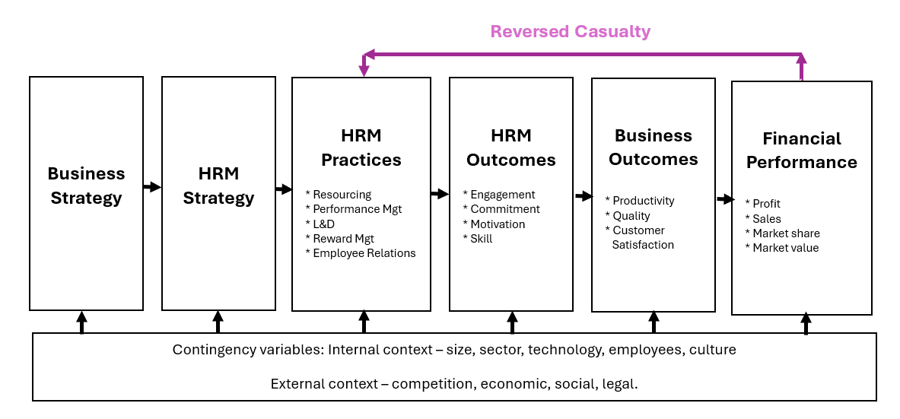

Appendix 3: Kotter’s (2012) 8-Step Change Model (Laig and Abocejo 2021,p.35).
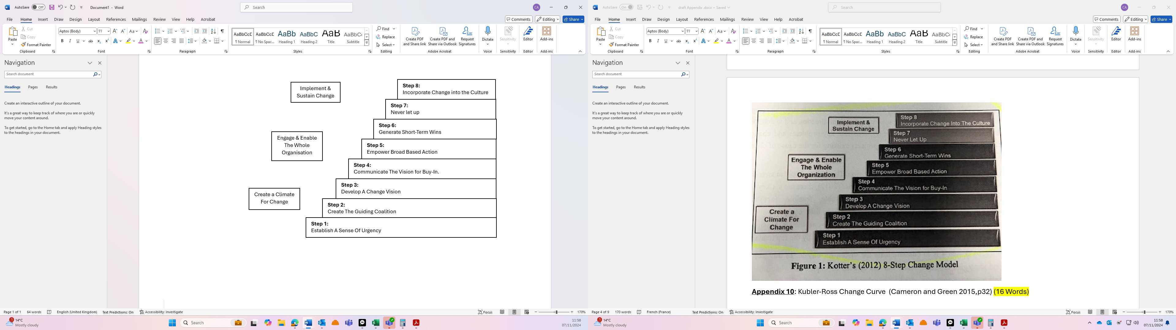

Appendix 4: Kubler-Ross Change Curve (Cameron and Green 2015,p.32)
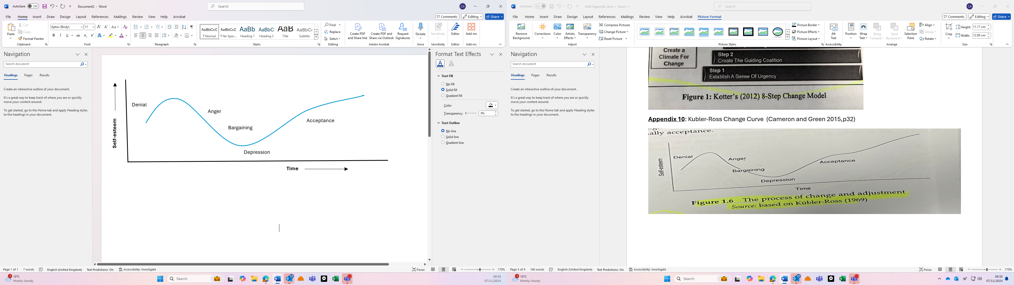
Appendix 5: CIPD Good Work recommendations table (CIPD NDa)
Actions for the UK Government:
- Improve the protection of workers’ health and rights through the creation of a well-resourced single enforcement body.
- Ensure that employers conduct risk assessments for work-related stress by providing the Health and Safety Executive with the resources to promote employer compliance with obligations under existing health and safety law.
- Reform statutory sick pay so its financially adequate, flexible, and can support employees to make more effective and sustainable phased return to work.
- Develop locally delivered access to occupational health provision for employers, which is free for SMEs to support organisations with health advice and return to work.
Recommendations for employers:
- Ensure that senior leaders are aware of the importance of workplace health and wellbeing, and that they embed actions to ensure that it taken seriously across the organisation.
- Train line managers to manage people well. Line managers are key to employee wellbeing and should ensure people’s workloads and deadlines are manageable. They should provide clear objectives and give constructive feedback, as part of a trust-based relationship with employees. They should have the confidence to have sensitive conversations with people and offer support and flexibility if a team member needs adjustments to help manage their health and safety.
- Provide early access to occupational health support and other specialist sources of help, such as counselling or physiotherapy.
- Develop an evidence-based understanding of the causes of absence and unhealthy practices in your organisation, such as ‘presenteeism’ and ‘leaveism.’ Unless the underlying issues prompting people’s attendance and behaviours are addressed, efforts to improve health and wellbeing will be short-lived.
- Tailor policies and practices to organisational and employee needs. There is no ‘one-size-fits-all’ approach to designing an effective employee wellbeing strategy – its content should be based on the organisation’s unique needs and characteristics, and of course those of its employees.
- Build a robust organisational framework to promote good mental wellbeing and foster a culture where people can talk about mental health and seek help where needed.
- Carry out a risk assessment or audit on work-related stress across workforce, as part of a preventive approach to identify its main causes.

Appendix 6: CIPD Good Work recommendations (CIPD NDa)
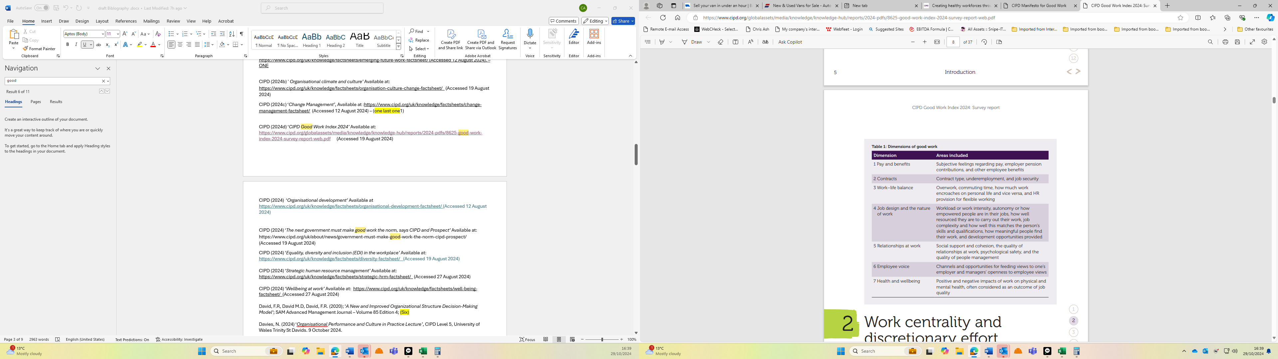
Appendix 7: Table on Retention strategies (Adapted from Taylor and Woodhams 2022b,p.101-2)

Reason for leaving | Retention initiatives
Lack of development opportunities | Regular employee appraisals / Training / Development programs / Emphasising importance of lateral and vertical career development / Development opportunities at little or no cost.
Poor line managers or collegues relationships | Improved feedback and interaction / Management training / Internal mediation schemes / Internal transfer opportunities.
Negative opinion of the company in general | Policies and procedure transparency / Communication, Consultation and involvement initiatives / EDI, CSR, and ethics investment.
Dissatifaction with reward | External benchmarking / Internal job evaluations / Flexible and individualised benefits scheme / Intrinsics rewards such as autonomy and job rotation.
Lack of work-life balance | Flexible working / Homeworking / Assistance for working parents (e.g. creche or vouchers.
Dissatisfaction with working environment | Investment in upkeep and new equipment / Mental health support

Appendix 8: HR Leader Model (Crawshaw, Budwer and Davis (2017,p.16)
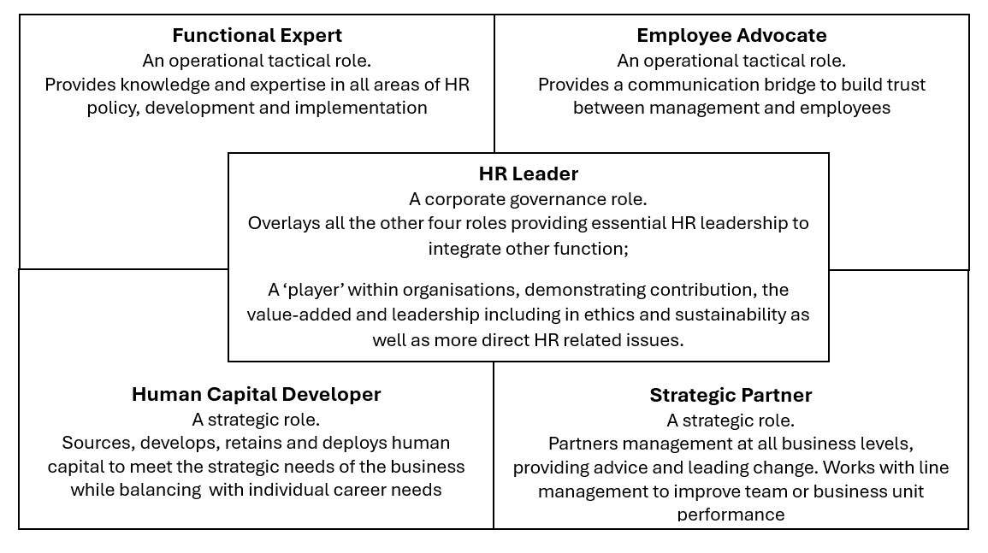

Appendix 9: HR Contribution Continuum (Briner 2024b,p.33)

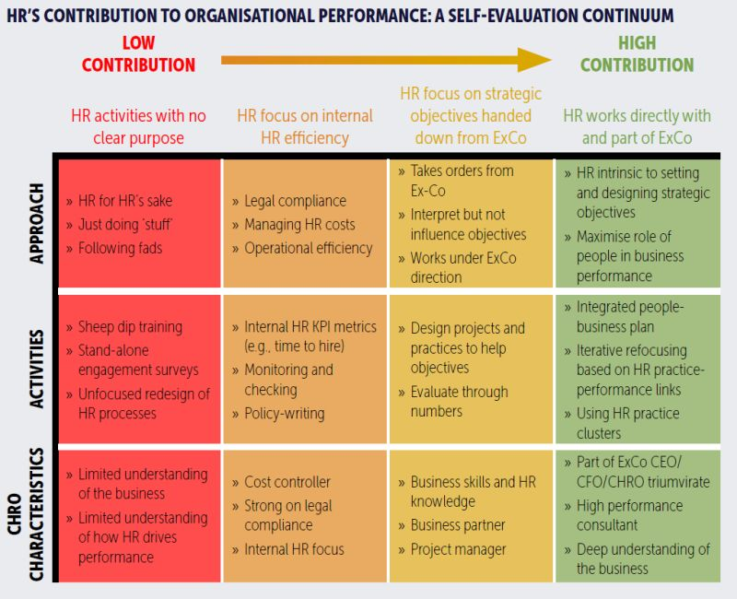

Appendix 10: Employee communication positive effect on commitment and engagement (Walden, Jung, and Westerman 2017,p.74).
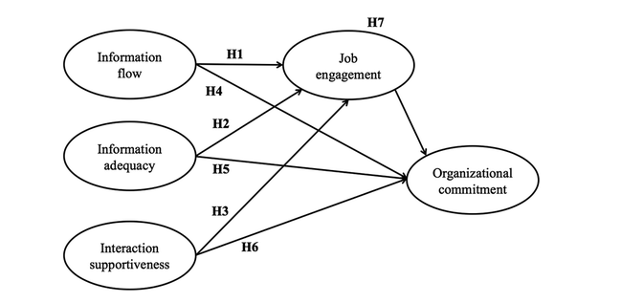

Bibliography
ACAS (2019) ‘New technology and the world of work: the winners and the losers’, Available at: https://www.acas.org.uk/research-and-commentary/new-technology-and-the-world-of-work, (Accessed 12 August 2024).
ACAS (2022) ‘Formal ICE Agreements: Informing and consulting at work’, Available at: https://www.acas.org.uk/formal-ice-agreements (Accessed 12 August 2024).
ACAS (2024) ‘Supporting mental health at Work: Mental health and the law, Available at: https://www.acas.org.uk/supporting-mental-health-workplace (Accessed 12 November 2024).
Aguirre, D. and Alpern, M. (2014) ‘10 principles of leading change management’, Available at https://www.strategy-business.com/article/00255 (Accessed 12 August 2024).
Ajagbe, M. A, et al (2016) ‘Which Precedes the other? Organizational Strategy or Organizational Structure’, HARD International Journal of Economics and Business Management, Vol. 2, No.6, p.50-63.
Akpoviroro, K.S., and Owotutu, S. O. (2018) ‘Impact of external business environment on Organizational Performance’, International Journal of Advanced Research and Innovative Ideas in Education’, Vol.4, Issue 3, p.498-505.
Ambroz, M. and Praprotnik, M. (2008) ‘Organizational Effectiveness and Customer Satisfaction’, Oraganizacija, Vol. 41, No.5, Available at: DOI:10.2478/v10051-008-0018-2 (Accessed 19 August 2024).
Anand, N. and Daft, R.L. (2007) ‘What is the Right Organization Design’, Organizational Dynamics, Vol. 36, No.4, p.329-344.
Anand, N and Barsouux, J.L. (2017) ‘What Everyone Gets Wrong About Change Management’, Available at https://hbr.org/2017/11/what-everyone-gets-wrong-about-change-management (Accessed 12 August 2024).
Andersson, R. and Rademacher, L. (2021) ‘Managing communication’. Handbook of Management Communication, Vol. 16, p.279–293. Available at: https://doi.org/10.1515/9781501508059-015 (Accessed 31 October 2024).
Armstrong, M. and Taylor, S. (2014) ‘Armstrong’s Handbook of Human Resource Management Practice’, 13th Ed; London; Kogan Page.
Aronowitz, S., De Smet, A and McGinty, D. (2015) ‘Getting organizational redesign right’, Available at: https://www.mckinsey.com/capabilities/people-and-organizational-performance/our-insights/getting-organizational-redesign-right#/ (Accessed 12 August 2024).
Baska, M. (2019) ‘Businesses ‘feel free to discriminate’ because equality law is not being enforced ‘ Available at: https://www.peoplemanagement.co.uk/article/1744768/businesses-feel-free-to-discriminate (Accessed 27 August 2024).
Briner, R. (2024a) ‘Is the employee life cycle really a thing’, Available at: https://www.linkedin.com/feed/update/urn:li:activity:7218975122232143872/ (Accessed 27 August 2024).
Briner, R. (2024b) ‘New Report – Driving Organisational Performance: HR’s critical Role’ Available at: https:// https://www.linkedin.com/posts/rob-briner_hr-activity-7245430060084604928-XRZW (Accessed 27 August 2024).
Brown, G. (2018) ‘Six ways to help guide employees through multiple changes’, Available at: https://www.peoplemanagement.co.uk/article/1745940/guide-employees-through-multiple-changes (Accessed 12 August 2024).
BSC (2014) ‘The business benefits of health and safety’, British Safety Council, Available at: https://www.britsafe.org/media/5pgnkhzr/the-business-benefits-health-and-safety-literature-review.pdf (accessed 24 October 2024).
BoE (2024) ’Interest rates and Bank Rate’, Bank of England Available at: https://www.bankofengland.co.uk/monetary-policy/the-interest-rate-bank-rate (Accessed 25 October 2024).
Bozionelos, N. (2022) ‘AI will take our jobs – but it can happen in an orderly fashion’, Available at: https://www.peoplemanagement.co.uk/article/1744127/ai-will-take-our-jobs-but-can-happen-orderly-fashion (Accessed 14 August 2024).
Bucolo, S, and Matthews, J, (2011). ‘A Conceptual Model to Link Deep Customer Insights to both Growth Opportunities and Organisational Strategy in SMEs as part of a Design Led Transformation Journey’, Available at: https://eprints.qut.au/47895/ (Accessed 27 August 2024).
Burgess, G. (2023) ‘Is the four-day week here to stay?‘ Available at : https://www.peoplemanagement.co.uk/article/1848319/four-day-week-stay (Accessed 19 August 2024).
Burnes, B. (2009) ‘Managing Change’, 5th Edition; Essex Person.
Burton, S. L. (2024) ‘Securing Tomorrow: Synergizing Change Management and Cybersecurity in the Digital Era’, Holistica, Vol. 15, Issue 1, p.1-20. Available at: DOI:10.2478/hjbpa-2024-0001 (Accessed 26 August 2024).
BusinessBalls (ND) ‘Introduction to Handy's Model of Organisational Culture’, Available at: https://www.businessballs.com/organisational-culture/introduction-charles-handy-organisational-culture/ (Accessed 27 August 2024).
Cameron, E. and Green, M. (2015) ‘Making Sense of Change Management’, London; Kogan Page.
Campbell, R. et al (2023) ‘Individual voice channels: Guide for people professionals’, CIPD, Available at: https://www.cipd.org/uk/knowledge/guides/employee-voice-individuals-guide/ (Accessed 31 October 2024).
Campbell, S.J, et al. (2022) ‘Examining the engagement of health services staff in change management: modifying the SCARF assessment model’. 25th May 2022. Campbell, S. J. et all. International Practice Development Journal 12 (1) [5].
Carucci, R. and Shappell, J. (2022), ‘Design Your Organisation to Match Your Strategy’, Available at: https://hbr.org/2022/06/design-your-organization-to-match-your-strategy (Accessed 12 August 2024).
Chambers, A. (2023) ‘Why I think artificial intelligence will be the turning point for HR’, Available at: https://www.peoplemanagement.co.uk/article/1846150/why-i-think-artificial-intelligence-will-turning-point-hr (Accessed 19 August 2024).
Chavan, S. and Bhattacharya (2022); ‘Study of employees’ behavior during organizational change: effects of business theatre on Kubler-Ross Model’; Cardiometry Original Research, issue 22 May 2022.
Chi, T. and Nystrom, P. (1998), ‘An Economic Analysis of Matrix Structure, Using Multinational Corporations as an Illustration’, Managerial and Decision Economics, Vol. 19, p.141-156.
Cholteeva, Y. (2023), ‘Is hybrid work good for everyone’s wellbeing?’, Available at: https://www.peoplemanagement.co.uk/article/1826471/hybrid-work-good-everyones-wellbeing. (Accessed 19 August 2024).
Chalk, R. (2024), ‘Divisional Organizational Structure’, Available at: https://www.workamajig.com/blog/divisional-organizational-structure (Accessed 28 October 2024).
CIPD (NDa) ‘Employee health and wellbeing’, Available at: https://www.cipd.org/uk/views-and-insights/cipd-viewpoint/employee-health-wellbeing/ (Accessed 19 October 2024).
CIPD (NDb) ‘ Organisational culture’ Available at : https://www.cipd.org/uk/views-and-insights/cipd-viewpoint/organisational-culture/ (Accessed 19 August 2024).
CIPD (NDc) ‘Wellbeing’ Available at : https://www.cipd.org/uk/the-people-profession/the-profession-map/explore-the-profession-map/specialist-knowledge/wellbeing/ (Accessed 19 August 2024).
CIPD (2018) ‘Creating healthy workforces through ‘good work’ Available at: https://www.cipd.org/uk/knowledge/bitesize-research/creating-healthy-workforces/ (Accessed 27 August 2024).
CIPD (2020a) ‘What lessons can COVID-19 teach us about organisational change?’, Available at: https://www.cipd.org/uk/views-and-insights/thought-leadership/people-profession/lessons-covid-19-organisational-change/ (Accessed 12 August 2024).
CIPD (2020b) ‘Workplace technology: the employee experience’, Available at: https://www.cipd.org/uk/knowledge/reports/workplace-technology-employee/ (Accessed 12 August 2024).
CIPD (2020c) ‘People Profession 2030: a collective view of future trends’ Available at: https://www.cipd.org/uk/knowledge/reports/people-profession-2030-future-trends/ (Accessed 12 August 2024).
CIPD (2021) ‘6 Ways HR Can Influence Organisational Culture’ Available at: https://www.cipd.org/en/about/news/six-ways-hr-influences-organisational-culture/ (Accessed 19 August 2024).
CIPD (2022) ‘Organisational Culture and Climate - An Evidence Review’ Available at: https://www.cipd.org/globalassets/media/knowledge/knowledge-hub/evidence-reviews/2023-pdfs/8263-organisational-culture-and-climate-practice-summary.pdf (Accessed 19 August 2024).
CIPD (2023a) ‘CIPD Manifesto for Good Work’ Available at: https://www.cipd.org/uk/about/public-policy/our-priorities/manifesto-good-work/ (Accessed 19 August 2024).
CIPD (2023b) ‘Organisation design’, Available at: https://www.cipd.org/uk/knowledge/factsheets/organisational-development-design-factsheet/ (Accessed 12 August 2024).
CIPD (2023c) ‘Business partnering’ Available at: https://www.cipd.org/uk/knowledge/factsheets/business-partnering-factsheet/ (Accessed 19 August 2024).
CIPD (2023d) ‘CIPD features on “The Future of Work: People, Culture, Tech” by ITN Business’ Available at: https://www.cipd.org/uk/about/news/cipd-features-the-future-of-work-people-culture-tech-by-itn-business/ (Accessed 19 August 2024).
CIPD (2024a) ‘Technology, AI and the future of work’, Available at: https://www.cipd.org/uk/knowledge/factsheets/emerging-future-work-factsheet/ (Accessed 12 August 2024).
CIPD (2024b) ' Organisational climate and culture’, Available at: https://www.cipd.org/uk/knowledge/factsheets/organisation-culture-change-factsheet/(Accessed 19 August 2024).
CIPD (2024c) ‘Change Management’, Available at :https://www.cipd.org/uk/knowledge/factsheets/change-management-factsheet/ (Accessed 12 August 2024).
CIPD (2024d) ‘CIPD Good Work Index 2024’ Available at: https://www.cipd.org/globalassets/media/knowledge/knowledge-hub/reports/2024-pdfs/8625-good-work-index-2024-survey-report-web.pdf (Accessed 19 August 2024).
CIPD (2024e) ‘Strategic human resource management’ Available at: https://www.cipd.org/uk/knowledge/factsheets/strategic-hrm-factsheet/ (Accessed 27 August 2024).
CIPD (2024f) ‘Employee Communication’ Available at: https://www.cipd.org/uk/knowledge/factsheets/employee-communication/ (Accessed 31 October 2024).
CIPD (2024g) ‘Organisational development’ Available at https://www.cipd.org/uk/knowledge/factsheets/organisational-development-factsheet/ (Accessed 12 August 2024).
CIPD (2024h) ‘The next government must make good work the norm, says CIPD and Prospect’ Available at: https://www.cipd.org/uk/about/news/government-must-make-good-work-the-norm-cipd-prospect/ (Accessed 19 August 2024).
CIPD (2024i) ‘Equality, diversity and inclusion (EDI) in the workplace’ Available at: https://www.cipd.org/uk/knowledge/factsheets/diversity-factsheet/ (Accessed 19 August 2024).
CIPD (2024j) ‘Wellbeing at work’ Available at: https://www.cipd.org/uk/knowledge/factsheets/well-being-factsheet/ (Accessed 27 August 2024).
Crawshaw, J.R., Budwer. P., and Davis, A. (2017) ‘Human Resource Management: Strategic and International perspectives’, Sage; London.
David, F.R, David M.D, David, F.R. (2020) ‘A New and Improved Organizational Structure Decision-Making Model’; SAM Advanced Management Journal, Volume 85, Edition 4.
Davies, N. (2024) ‘Organisational Performance and Culture in Practice Lecture’, CIPD Level 5, University of Wales Trinity St Davids. 9 October 2024.
de Vries, G.J. et all (2020) ‘The rise of robots and the fall of routine jobs’, Labour Economics’; Available at: http://doi.org/10.1016/j.labeco.2020.101885 (Accessed 26 August 2024).
Dewi, P. and Fitrio, T. (2022) ‘The Role of Adaptive Millennial Leadership, Organizational Culture, and Competency as a strategy to Increase Employee Performance’, Journal of Applied Management, Vol. 20, No. 3, p697-708.
Diana, I.N. et al (2021) ‘Factors Influencing Employee Performance: The Role of Organizational Culture’, Journal of Asian Finance, Economics and Business, Vol.8, No.2 (ISSN 2288-4645) Available at: doi:10.13106/jab.2021.vol8.no2.0545 (Accessed 27 August 2024).
Elitamby, A. (2024) ‘How to create a mental health and wellbeing programme that works’ Available at: https://www.peoplemanagement.co.uk/article/1872950/create-mental-health-wellbeing-programme-works (Accessed 27 August 2024).
Elrod II, P.D. and Tippett, D.D. (2001) ‘The “death valley” of change’, Journal of Organizational Change Management; 15, 3, p.273-290.
Everett, J. and Watson, J. (1998) ‘Small Business Failure and External Risk Factors’, Small Business Economics, Vol.11, p.371-390.
Faragher, J. (2020) ‘We need to talk about diversity and inclusion’ Available at: https://www.peoplemanagement.co.uk/article/1746481/we-need-talk-diversity-inclusion (Accessed 27 August 2024).
Fatol, D. et al (2020) ‘A Proposed Framework for Talent Management Development’, Scientific Bulletin of the Politehnica University of Timisoara, Vol 6, No. 2.
FSB (2016) ‘Small firms spend four days per month battling red tape’, National Federation of Self Employed & Small Businesses, Available at: https://www.fsb.org.uk/resources-page/small-firms-spend-four-days-per-month-battling-red-tape.html (Accessed 24 October 2024).

GCS (2021) ‘Developing an internal communication strategy’, Government Communication Service, Available at: https://gcs.civilservice.gov.uk/guidance/internal-communication/developing-an-internal-communication-strategy/#Steps-to--develop-your-strategy (Accessed 31 October 2024).
Gerhardt, T. and Puchkov, R. (2023) ‘Preparing for the future: understanding collective grief through the lens of Kubler-Ross crisis cycle’, Higer Education Kills and Workbased Learning, Vol. 13, No. 5, p.983-1008.
Gilley, A., Gilley, J.W. and McMillan, H.S. (2009) ‘Organizational change: Motivation, communication, and leadership effectiveness’, Performance improvement quarterly, Vol 21, No. 4, p.75–94. Available at: https://doi.org/10.1002/piq.20039.
GOV (2024) ‘Making Work Pay: Strengthening Statutory Sick Pay’, Department of Works and Pension’, Available at: https://www.gov.uk/government/consultations/making-work-pay-strengthening-statutory-sick-pay (Accessed 24 October 2024).
Gutterman, A.S. (2023) ‘Basic Models of Organizational Structure’, Available at: https://ssrn.com/abstratct=4545843 (Accessed 19 August 2024).
Harrison, P. (2013) ‘Study Shows H&S Compliance is Third Largest Cost to Small Businesses’, SGWORLD, Available at: https://blog.sgworld.com/new-study-shows-health-safety-compliance-is-third-largest-cost-to-small-businesses (Accessed 25 October 2024).
Harrison, R. et al (2021) ‘Where Do Models for Change Management, Improvement and Implementation Meet? A Systematic Review of the Applications of Change Management Models in Healthcare, Journal of Healthcare Leadership. Available at: https://doi.org/10.2147/JHL.S289176 (Accessed 19 August 2024).
Haryadi, D., Setiawati, E.T., and Juhandi (2022) ‘The Role of Organizational Culture on improving Employee Performance through work disciple, Jurnal Mantik, Vol 6, No.1 p.686-698.
Helmold, M. (2021) ‘New Work, Transformational and Virtual Leadership, Lessons from COVID-19 and other Crises’, Available at: https://link.springer.com/chapter/10.1007/978-3-030-63315-8_3 (Accessed 24 October 2024).
Horn, R. (2012) ‘The Business Skills Handbook’, London; CIPD.
HSE (ND) ‘Benefits and costs’, Health and Safety Executive, Available at: https://www.hse.gov.uk/leadership/benefits.htm (Accessed 25 October 2024).
IPA (NDa) ‘What is Employee Voice?’, Involvement & Participation Association, Available at: https://www.ipa-involve.com/employee-voice (Accessed 31 October 2024).
IPA (NDb) ‘The ICE Regs Ten Years On’, Involvement & Participation Association, Available at: https://www.ipa-involve.com/News/the-ice-regs-ten-years-on (Accessed 31 October 2024).
Jackson, T. (2024a) ‘How AI could transform the way training is delivered at work’, Available at:
https://www.peoplemanagement.co.uk/article/1887479/ai-transform-training-delivered-work?
(Accessed 27 August 2024).

Jackson, I. (2024b) ‘Fewer than half of employees have flexible working hours, research reveals’, Available at:https://www.peoplemanagement.co.uk/article/1889594/fewer-half-employees-flexible-working-hours-research-reveals (Accessed 19 August 2024).

Jackson, I. (2024c) ‘People managers admit to using AI for performance reviews and feedback, research finds’, Available at: https://www.peoplemanagement.co.uk/article/1875801/people-managers-admit-using-ai-performance-reviews-feedback-research-finds (Accessed 19 August 2024).

Jarvalt, J. and Randma-Liiv, T. (2010) ‘Public sector HRM: the case of no central human resource strategy’, Baltic Journal of Management, Vol.5, No.2, p.242-256.
Jeffery, R. (2018) ‘Naomi Stanford: “We’re just not prepared for automation”’, Available at: https://www.peoplemanagement.co.uk/article/1742116/naomi-stanford-not-prepared-automation (Accessed 12 August 2024).
Jeffery, R. (2020) ‘Why the pandemic has been OD's time to shine‘ Available at: https://www.peoplemanagement.co.uk/article/1746471/why-organisational-development-can-add-even-more-value-post-pandemic (Access 19 August 2024).
Kang, M. and Sung, M. (2017) ‘How symmetrical employee communication leads to employee engagement and positive employee communication behaviors: The mediation of employee-organization relationships’, Journal of Communication Management, Vol. 21 No. 1, p.82-102. Available at: https://doi.org/10.1108/JCOM-04-2016-0026 (Accessed 31 October 2024).
Kang, S. K, et al (2020) ‘Guiding change in higher education: an emergent, iterative application of Kotter’s change model’, Studies In Higer Education, Available at: Http://doi.org/10.1080/03075079.2020.1741540 (Accessed 27 August 2024).
Khatri, N. (1999) ‘Emerging issues in strategic HRM in Singapore’, International Journal of Manpower, Vol. 20, No. 8, p.516-529.
Laig, R.B.D. and Abocejo, F.T. (2021) ‘Change Management Process in a Mining Company: Kotter’s 8-Step Change Model’, Journal of Management, Economics and Industrial Organizations, 5 (3) p.31-50; Available at: http://doi.org/10.31039/jomeino.2021.5.3.3 (Accessed 27 August 2024).
Macey, W.H. and Fink, A.A. (2020) ‘Employee Surveys and Sensing: Challenges and Opportunities’. 1st Edition. New York: Oxford University Press. Available at: https://doi.org/10.1093/oso/9780190939717.001.0001.
Manjaly, N. B., Francis, V. and Francis, D. (2024) ‘Leveraging the SCARF Model for Employee Engagement: An In-Depth Analysis with Special Reference to Government Organisations’, Journal of Economics, Finance and Management Studies, Vol. 07, Issue 06, p.3412-3424.
Mayne, M. (2023) ‘Elon Musk says AI will mean people no longer need to work – do HR experts agree? ‘, Available at : https://www.peoplemanagement.co.uk/article/1846529/elon-musk-says-ai-will-mean-people-no-longer-need-work-%E2%80%93-hr-experts-agree (Accessed 19 August 2024).
Mayne, M. (2024a) ‘Is your firm guilty of ‘wellbeing washing’? ‘, Available at: https://www.peoplemanagement.co.uk/article/1875808/firm-guilty-wellbeing-washing (Accessed 27 August 2024).
Mayne, M. (2024b) ‘Third of workers think AI should be banned in the workplace, report finds’, Available at: https://www.peoplemanagement.co.uk/article/1889593/third-workers-think-ai-banned-workplace-report-finds (Accessed 19 August 2024).
Mayne, M. (2024c) ‘Council’s four-day week trial led to greater retention and productivity – so should the wider public sector follow suit?’, Available at: https://www.peoplemanagement.co.uk/article/1880251/councils-four-day-week-trial-led-greater-retention-productivity-%e2%80%93-so-wider-public-sector-follow-suit (Accessed 19 August 2024).
Mayne, M. (2024d) ‘Employees demand pay rises if forced back to the office full time, report finds.’, Available at: https://www.peoplemanagement.co.uk/article/1888643/employees-demand-pay-rises-forced-back-office-full-time-report-finds (Accessed 27 August 2024).
McCloskey, J. (1996) A. Heaton (ed.), ‘An introduction to Industrial Chemistry’, p.95-96.

McRae, E.R. et al (2024) ‘9 Trends That Will Shape Work in 2024 and Beyond’, Available at: https://hbr.org/2024/01/9-trends-that-will-shape-work-in-2024-and-beyond (Accessed 27 August 2024).
Mindtools (ND) ‘Handy's Four Types of Culture’, Available at: https://www.mindtools.com/ass7geb/handys-four-types-of-culture (Accessed 27 August 2024)
Moran, S. (2024) ‘Four-day working week: compliance challenges and how to overcome them’, Available at:https://www.peoplemanagement.co.uk/article/1857489/four-day-working-week-compliance-challenges-overcome (Accessed 19 August 2024).
Moscatel, R. and Moscatel, A. (2021) ‘Tomorrows Jobs today’, Hampshire; Business Books.
Murtuningsih. R.S., and dan Bisnis, F.E. (2019) ‘The impact of Compensation, Training, and Development and Organizational Culture on Job satisfaction and Retention’, Indonesian Management and Accounting Research, Vol. 19, No. 1, p.33-48.
O’Brien, L. et al (2023) ‘Trees and forests contribution to well-being during the COVID-189 pandemic in England: how did people adapt to change’, Forestry: An international Journal of Forest Research, p.1-12.
ONS (2024) ‘Inflation and price indices’, Office of National Statistics’, Available at: https://www.ons.gov.uk/economy/inflationandpriceindices (Accessed 24 October 2024).
Ostroff, C., Kinicki, A., and Muhammad, R. (2013) ‘Organizational Culture and Climate’, Handbook of Psychology, Second Edition, Edited by Weiner, I.B.
Paigroup.com (ND) Available at: https://www.paigroup.com/about-pai-group/accreditations/ (Accessed 24 October 2024)
Pangestuti, D. C. and Lousia, A, M. (2020) ‘The Influence of Internal and External Factors on Firm Value’, European Journal of Business and Management Research, Vol. 5, No. 5, DOI: Available at: http://dx.doi.org/10.24018/ejbmr.2020.5.5.492 (Accessed 19 August 2024).
People Management (2023) ‘Will artificial intelligence take the 'human' out of human resources?’, Available at: https://www.peoplemanagement.co.uk/article/1845627/will-artificial-intelligence-human-human-resources (Accessed 19 August 2024).
Personneltoday (2023) ‘What are the models of organisational culture?’, Available at: https://www.personneltoday.com/hr/what-are-the-organisational-culture-models/ (Accessed 27 August 2024).
Petrovic, E. K. (2023), ‘Sustainability Transition Framework: An Integrated Conceptualisation of Sustainability Change’, Available at: http://doi.org/10.3390/sul16010217 (Accessed 26 August 2024).
Piwowar-Sulej, K. et al (2024); ‘The impact of digitalization on employees’ future competencies: has human resource development a conditional role here?’, Journal of Organizational Management, Vol. 37, No 8, p.36-52.
QMSUK (ND) ‘Benefits of ISO 9001 for your organisation’, Available at: https://www.qmsuk.com/iso-standards/iso-9001/iso-9001-benefits (Accessed 12 November 2024)
Radoslaw, M. (2017) ‘Organisational structure in the progress of integration’, Minich Personal RePEc Archive, Available at: https://mpra.ub.uni-muenchen.de/81767/ (Accessed 12 August 2024).
Redshaw, K. (2024) ‘How can HR successfully roll out AI? ‘, Available at: https://www.peoplemanagement.co.uk/article/1871602/hr-successfully-roll-ai (Accessed 19 August 2024).
Roberts, M.L., Liu, R.R. and Hazaed, K. (2005) ‘Strategy, technology and organisational alignment: Key components of CRM success’, Database Marketing & Customer Strategy Management, Vol. 12, No. 4, p.315-326.
Robinson, M. M. and Robinson, S. (2021) ‘How AI can help build a diverse workforce’ Available at: https://www.peoplemanagement.co.uk/article/1746276/how-ai-help-build-diverse-workforce (Accessed 12 August 2024).
Rock, D. (2008) ‘SCARF: a brain-based model for collaborating with and influencing others’, NeuroLeadership Journal, Issue One.
Rock, D. (2009) ‘Managing with the Brain in Mind’, Strategy + Business, Issue 56, 27 August 2009.
Rowsell, J. (2023) ‘Daniel Susskind: Why it is unhelpful to think about how AI will affect ‘jobs’ ‘, Available at: https://www.peoplemanagement.co.uk/article/1846881/daniel-susskind-why-unhelpful-think-ai-will-affect-jobs (Accessed 27 August 2024).
Russo, M.R. et al (2013), ‘Correlation between Organizational Culture and Compensation Strategies using Charles Handy’s Typology’, International Society for Performance Improvement, vol.52, no.7. p.13-19.
Salavou, H., Baltas, G. and Lioukas, S. (2004), ‘Organisational Innovation in SME’s’, European Journal of Marketing, Vol. 38, No 9/10, p.1091-1112.
San Cristobal, J.R, Fernandez, V. and Diaz, E. (2018). ‘An analysis of the main project organizational structures: Advantages, disadvantages, and factors affecting their selection’, Procedia Computer Science, Vol. 138, p.791-798.
Schabracq, M. J. (2007) ‘Changing Organisational Culture: The Change Agent’s Guidebook’, John Wiley & Sons Ltd; Chichester.
Serfontein, S. and Hugh, J. (2011) ‘Nature of the relationship between strategic leadership, operational strategy and organisational performance’, South African Journal of Economic and Management Sciences, Vol 14, No.4; Available at: doi: 10.1371/journal.pone.0276622 (Accessed 27 August 2024).
Sequeria, T.N., Garrido, S. and Santos, M. (2021) ‘Robots are not always bad for employment and wages’, International Economics, Vol 167, p.108-119.
Simpson, J. M. (2022) ‘Understanding change in the university workplace: are metaphors of bereavement helpful’, Perspectives: Policy and Practice in Higher Education, Vol.26, no. 3, p.96-101.
Sloan, C. (2023) ‘Can we keep the human in HR? ‘Will artificial intelligence take the 'human' out of human resources?’ Available at: https://www.peoplemanagement.co.uk/article/1848750/keep-human-hr (Accessed 19 August 2024).
Smyrl, N. (2024) ‘The legal side of mental health in the workplace – is your business doing enough?’, Available at: https://www.peoplemanagement.co.uk/article/1892598/legal-side-mental-health-workplace-%E2%80%93-business-doing-enough? (Accessed 18 Oct 2024)
Solberg, L.I. et al. (2008) ‘Measuring an Organization’s Ability to Manage Change: The Change Process Capability Questionnaire and Its Use for Improving Depression Care’, American journal of medical quality, Vol 23, No. 3, p. 193–200. Available at: https://doi.org/10.1177/1062860608314942.
Soomro, S. and Shamsi, A. F. (2018) ‘Measuring SHRM Vertical and Horizontal fit: Scale Development and Validation’; Abasyn Journal of Social Sciences – Vol (11), Issue (1).
Spicer, A. (2024) ‘Work ‘wellness’ programmes don’t make employees happier - but I know what does’ Available at: https://www.theguardian.com/commentisfree/2024/jan/17/work-wellness-programmes-dont-make-employees-happier-but-i-know-what-does (Accessed 27 August 2024)
Suharyanto and Zaki, A. (2021) ‘The Effects of Inflation, Interest Rates, and Exchange Rate on Stock returns in Food and Beverages Companies’, Vol. 19, No. 3, p.616-621.
Tan, G. (2022) ‘The legal pitfalls of using AI in recruitment’, Available at: https://www.peoplemanagement.co.uk/article/1745792/legal-pitfalls-using-artificial-intelligence-recruitment (Accessed 12 August 2024).
Taylor, S. and Woodhams, C. (eds) (2022a) ‘Human Resource Management – People and Organisations’. 3rd Edition, London; Kogan Pages.
Taylor, S. and Woodhams, C. (eds) (2022b) ‘Studying Human Resource Management – A Guide to the Study, Context and Practice of HR’, 3rd Edition, London; Kogan Pages.
ten Have, S. et al (2003) ‘Key Management Models’, London, Pearson.
Thomas, P. (2023) ‘ERGs and staff networks: How to set up and run business groups’, CIPD,
Available at: https://www.cipd.org/uk/knowledge/guides/ergs-staff-networks/ (Accessed 31 October 2024).

Tinline, G. and Crowe, K. (2010) ‘Improving employee engagement and wellbeing in an NHS trust’, Strategic HR review, Vol 9, No. 2, p.19–24. Available at: https://doi.org/10.1108/14754391011022226.

TUC (2018) ‘I'll be watching you - A report on workplace monitoring’, Available at: https://www.tuc.org.uk/research-analysis/reports/ill-be-watching-you (Accessed 12 August 2024).

UK Parliament (2024a) ‘Interest Rates and Monetary Policy: Key Economic Indicators’, Research Briefing, House of Commons Library, Available at: https://commonslibrary.parliament.uk/research-briefings/sn02802/ (Accessed 25 October 2024).

UK Parliament (2024b) ‘Inflation: Key Economic Indicators, Research Briefing, House of Commons Library, Available at: https://commonslibrary.parliament.uk/research-briefings/sn02792/ (Accessed 25 October 2024).

Vato, R. and Sharma, S.K. (2020) ‘The Neuroscience of Employee Engagement’, Contemporary Social Sciences, Vol. 29, No.1., p.146-153.

Walden, J., Jung, E.H. and Westerman, C. Y. K (2017) ‘Employee communication, job engagement and organizational commitment: A study of members of Millennial Generation’ Journal of Public Relations Research, Vol. 29, No’s 2-3, p.73-89 Available at: https://doi.org/10.1080/1062726X.2017.1329737 (Accessed 31 October 2024).

Waite, K. et al (2021) ‘People Practice. A Complete Guide’, London; Kogan Page.

Willis, L. (2024) ‘How can we protect our people when adopting AI into the workplace?’ Available at: https://www.peoplemanagement.co.uk/article/1887656/protect-people-when-adopting-ai-workplace? (Accessed 27 August 2024).

Woolley, F. (2024) ‘Why businesses should cultivate a workplace that promotes good mental wellbeing’ Available at: https://www.peoplemanagement.co.uk/article/1872412/why-businesses-cultivate-workplace-promotes-good-mental-wellbeing (Accessed 27 August 2024).

Zacher, H. and Froidevaux, A. (2021) ‘Life stage, Lifespan, and life course perspective on vocational behaviour and development: A theoretical framework, review and research agenda’ Journal of Vocational Behaviour, Vol 126, Available at: https: doi.org/10.1016/j.jvb.2020.103476 (Accessed 27 August 2024).

Zaki, M.A. et al. (2015) ‘Analyzing Organisational Structure for contracting Firms of Classification “A”, Egypt’; Journal of Engineering Sciences; Assiut University; Faculty of Engineering; Vol. 43, No. 3 May 2015; p.403-428.

