Do the personality characteristics conscientiousness and Agreeableness predict an individual’s levels of intrinsic work motivation?

This paper considers the ability of the personality traits agreeableness and conscientiousness in the prediction of intrinsic work motivation. Many studies have found strong links between conscientiousness and intrinsic motivation, agreeableness has received less support. The study hypothesis: conscientiousness would be a stronger predictor of intrinsic work motivation than agreeableness. Participants completed a personality questionnaire, followed by a work intrinsic and extrinsic questionnaire. A multiple regression analysis was conducted. No significant correlation was identified between either conscientiousness or agreeableness on participants self reported measures of intrinsic motivation. However, a weak negative correlation was found between agreeableness and intrinsic motivation which is in line with previous literature findings.

Introduction
Within the workplace, the nature of motivation is a heavily researched topic. Motivation refers to the driving force of one’s actions, including the factors that push and pull an individual to behave in a certain way (Guillen & Saris, 2013). Considering a mechanical analogy, a machine is started and run by its motive force, if this motion were to stop, the machine would also. Many modern companies acknowledge the importance of a motivated workforce to their success, from reducing staff turnover and absenteeism, achieving company goals and objectives and encouraging creative solutions and new ideas (Ahammad, Lee, Malul & Shoham, 2015). Increasingly, companies are taking less accountability for the development of employee’s, instead simply ensuring opportunity is available for those motivated to take it (Major, Turner & Fletcher, 2006).
Motivation is a complex concept, affected by a multitude of unobservable factors, and highly subjective to the individual, whose motivation can vary not only in amount towards a given task, but also orientation (Ryan & Deci, 2000). Take the example of an entrepreneur raising funds to start a business, this decision could be motivated extrinsically (in terms of the potential financial rewards associated) or intrinsically (in terms of the passion and drive to achieve). Intrinsic and extrinsic motivation can be equally as powerful, simply driven in a differing way.
Research has suggested that personality has influence over an individual’s motivation through the unique interaction of personality characteristics with organisational and situational factors (Rajput & Talan, 2017). O’Reilly et al (1980) suggested that an employee’s personality and motivators will affect the way in which a job role and an organisation is experienced, leading to variances in work behaviour between colleagues. The predictive power of personality characteristics is a heavily considered debate within psychological research, until the early 1990’s through to be a poor predictor of work related behaviours (Bajor & Baltes, 2002). The introduction of the Big Five Index BFI; Costa & McRae, 1985; McRae & Costa, 1987) identifying five key personality types : Conscientiousness, Agreeableness, Extroversion, Openness to experience and Neuroticism, found to be reliable and stable over time (Antonakis, 2011) provided a universal structure acting as a baseline within much personality research.
Conscientiousness has been consistently found to be a strong predictor of job performance and a variety of positive work outcomes (Barrick & Mount, 1991; Hurtz & Donovan, 2000; Bajor & Baltes, 2002). However, the link between conscientiousness and work motivation is not as strongly established. Conscientiousness has been linked to job dedication, as it requires a high level of self discipline and compliance, which are typical traits of a conscientious individual (Witt, Kacmar, Carlson & Zivnuska, 2002). With a highly conscientious individual likely to set themselves challenging goals to which they commit and achieve (Colquitt & Simering, 1998), identified as a strong predictor of intrinsic career success (Bozionelos, 2004; Major, Turner & Fletcher, 2006).
Agreeableness involves being sympathetic, trusting, cooperative and helpful (Costa & McRae, 1985), and is associated with work involvement, and found to be a positive correlate of work performance (Bozienelos, 2004). Komarraju and Karau (2005) found agreeableness to be positively related to persistence and desire for self-improvement. However, Bozonelos (2004) found agreeableness to be negatively associated with intrinsic motivation and career success. Which could, in part to be as a result of the non-competitive altruistic nature associated with agreeable individuals (Komarraju & Karau, 2005).
Hypothesis: Participants scoring highly on measures of conscientiousness will show higher levels of intrinsic motivation than those scoring highly on agreeableness.

Methods
Participants
Twenty two students from the University of Wales Trinity Saint David (16 females, 3 males, mean age 29.89, S.D. 9.27) participated within the study. Three participant’s data was removed due to incomplete questionnaires or failure to meet the study requirements. Recruitment involved opportunity sampling, with the link to complete the online questionnaire entered into the university study platform sona systems.

Design
Data was collected through opportunity sampling through an online link. The data was analysed through multiple regression analysis. The independent variables, conscientiousness and agreeableness were measured as a result of participant scores on the relevant sections of the Big Five Inventory (BFI; John & Srivastava, 1999). The dependent variable was the participant score on the Work Extrinsic and Intrinsic Motivation Scale (WEIMS; Tremblay, Blanchard, Taylor, Pelletier & Villeneuve, 2009), that were further broken down into a total intrinsic and extrinsic score. The BFI was presented to participants first, followed by the WEIMS in order to reduce demand characteristics (see appendix 3 &4).

Materials
The study was designed using the questionnaire building programme, qualtrics, and distributed through the university’s internal experiment management system (EMS). The questionnaire opened to a consent page and exclusion criteria (see appendix 1), presentation of the questionnaires (see appendix 2, 3, &4) and finally a debrief page (appendix. 5).
Big Five Inventory
Levels of personality characteristics were measured through an adapted version of the Big Five Inventory (BFI; John & Srivastava, 1999). The BFI is measured on a 5 point likert-style scale ranging from 1 (strongly disagree) to 5 (strongly agree). As the research study was only considering Conscientiousness and Agreeableness, only the questions relating to these variables were used (Conscientiousness; Q3,8,13,18,23,28,33,38,43, Agreeableness; Q2,7,12,17,22,27,32,37,42). Questions 2,8,12,18,23,27,37 and 43 required reverse scoring. Achieving internal consistency (Chronbach’s alpha = .91).
Work Extrinsic and Intrinsic Motivation Scale
Levels of work motivation (intrinsic and extrinsic) were measured by the Work Extrinsic and Intrinsic Motivation Scale (WEIMS; Tremblay, Blanchard, Taylor, Pelletier & Villeneuve, 2009) which includes 18 questions measured on a 7 point likert-type scale ranging from 1 (Does not correspond at all) to 7 (corresponds exactly). Each question corresponded to one of six motivational variables: intrinsic motivation (IM), integrated regulation (INTEG), Indentified regulation (IDEN), Introjected regulation (INTRO), External regulation (EXT) and Amotivation (AMO). The first three sub groups (IM, INTEG & IDEN) consisted of the intrinsic motivation questions, with the final three sub groups (INTRO, EXT, & AMO) measuring extrinsic motivation. The intrinsic work motivation scale achieved internal consistency (Chronbach’s alpha = .88), however, the extrinsic motivation scale did not achieve internal consistency (Chronbach’s alpha = .11), as such the extrinsic motivation scores were removed from further analysis.

Procedure
The questionnaire was distributed via the university’s EMS to current students, including a brief description of the study. Participation (regardless of completion) was incentivised by awarding a credit. After signing up for the study and following the link to the questionnaire web page a consent form was presented to participants, providing a brief description of what the study would entail, reminding the right to withdraw and establishing the anonymous nature of collected data. After consent was the participant was asked to confirm that they were 18 years of age or above, and that they are currently in paid employment as exclusion criteria. If either of these criteria were not met participants were re-directed to a page thanking them for their time as they were not eligible to participate in the study. If consent was gathered and exclusion criteria were met, demographic data (gender and age) was collected was collected. The BFI questionnaire was presented first alternating between a question measuring conscientiousness and agreeableness (e.g. C,A,C,A), responses were measured on a five point likert-style scale through tick boxes ranging from 1 (strongly disagree) to 5 (strongly agree). 6 questions were presented per page. Once the first questionnaire was completed the WEIMS questionnaire followed, this time measures using a slider for each question on a 7 point likert-style scale ranging from 1 (does not correspond at all) to 7 (corresponds exactly). Upon completion of all questionnaires, a debrief page was presented emphasising anonymity and the time frame for withdrawal, alongside contact details of the researchers and module lead and a description of the study aims.

Results
A multiple regression was conducted to assess whether the personality characteristics, conscientiousness and agreeableness predicted levels of intrinsic and extrinsic work motivation. Table 1 summarises the means and standard deviations for each variable.
Table 1.
Means and standard deviations of all variables included in the analysis

 | M | SD | N
Conscientiousness | 20 | 7.05 | 19
Agreeableness | 18.74 | 5.79 | 19
Intrinsic Motivation | 37.26 | 12.29 | 19

Correlations between the predictor variables and dependent variable are highlighted in table 2. As can be seen, Conscientiousness was not correlated with intrinsic motivation. Agreeableness was weakly negatively correlated with intrinsic motivation. The predictor variables themselves, conscientiousness and agreeableness showed a moderate positive correlation.

Table 2.
Correlations between variables

 | Conscientiousness | Agreeableness | Intrinsic motivation
Conscientiousness | - | .56 | -.01
Agreeableness | .56 | - | -.25
Intrinsic motivation | -.01 | -.25 | -

The regression analysis showed that as an overall model, the set of independent variables (Conscientiousness and agreeableness) were not statistically significant (F(3,16)=0.75, P>0.05) and produced an Adjusted R² value of 0. The combined IV’s therefore explained 0% of the variance in levels of intrinsic motivation.

Table 3 shows the coefficients for the separate IV’s in the analysis. The variables of Conscientiousness and agreeableness were not statistically significant in contributing to the prediction of participants’ intention to binge drink (p>0.05).

Table 3.
Beta coefficients for independent variables on the dependent variable intention.
Variable | Beta Value
Conscientiousness | .19
Agreeableness | -.35

Discussion
This study aimed to identify whether the personality characteristics agreeableness and conscientiousness were predictors of intrinsic motivation at work. The findings did not support the hypothesis with no significant correlations between either personality characteristic and intrinsic work motivation, suggesting that neither conscientiousness or agreeableness are predictors of an individual’s intrinsic work motivation.
A weak negative correlation was found between agreeableness and intrinsic motivation. This finding is somewhat in-line with previous literature (Bozonelos, 2004; Komarraju & Karu, 2005) that suggests as a result of the non-competitive nature of highly agreeable individuals, such individuals would not score highly on measures of intrinsic motivation. Unlike previous literature findings (Bozienelos, 2004, Major, Turner & Fletcher, 2006) conscientiousness did not emerge as a significant predictor of intrinsic motivation within this study demonstrating no correlative strength with intrinsic motivation.
The sample size poses considerable limitations to the findings of this study, as the minimum requirement for the conduction of a multiple regression; (20-30 participants for each predictor variable) were not met. The adjusted R² value demonstrates that the outcome variable (motivation) is not explained by the predictor variables (agreeableness and conscientiousness).
Motivation is a highly complex concept, Rajput and Talan (2017) highlight the way in which personality interacts with and effects the way in which a work environment is experienced. The participant sample was comprised of university students, working alongside study. It is possible that extrinsic motivations (financial gains) are the primary reason for participation in work, as it is a supplementary task to university study. Conscientiousness and Agreeableness have been found to be associated with career success through intrinsic motivation (Bozienelos, 2004; Komarraju & Karau, 2005; Major, Turner & Fletcher, 2006), in the instances of students working to support their studies, the intrinsic motivation driven by the personality factors may be focused on studies rather than paid employment.
Future research, investigating motivational factors and forces within part time workers, or workers with alternative commitments, could be beneficial in identifying and understanding the different motivational needs, and respective predictive values of a more diverse workforce. Considering the increased use of part time employees within many occupational settings, there is an increasing need to understand and adapt the workplace to accommodate the part time workforce.

References
Ahammad, M., Lee, S., Malul, M., & Shoham, A. (2015). Behavioral Ambidexterity: The Impact of Incentive Schemes on Productivity, Motivation, and Performance of Employees in Commercial Banks. Human Resource Management, 54, S45. Doi:10.1002/hrm.21668
Antonakis, J. (2011). Predictors of leadership: The usual suspects and the suspect traits. Sage handbook of leadership, 269-285. ISBN: 978-1-84860-146-8
Bajor, J. K., & Baltes, B. B. (2003). The relationship between selection optimization with compensation, conscientiousness, motivation, and performance. Journal of Vocational Behaviour, 63(3), 347-367. DOI: 10.1016/S0001-8791(02)00035-0
Barrick, M., & Mount, M. (1991). The Big Five Personality Dimensions and Job Performance: A Meta-Analysis. Personnel Psychology, 44(1), 1
Bozionelos, N. (2004). The relationship between disposition and career success: A British study. Journal of Occupational and Organizational Psychology, 77(3), 403-420. DOI: 10.1348/0963179041752682
Bozionelos, N. (2004). RESEARCH NOTE: The big five of personality and work involvement. Journal of Managerial Psychology, 19(1/2), 69-81.
Colquitt, J. A., & Simmering, M. J. (1998). Conscientiousness, goal orientation, and motivation to learn during the learning process: A longitudinal study. Journal of applied psychology, 83(4), 654. http://dx.doi.org/10.1037/0021-9010.83.4.654
Costa, P. T., & McCrae, R. R. (1985). The NEO personality inventory. https://www.researchgate.net/profile/Paul_Costa3/publication/247728869
Judge, T. A., Bono, J. E., Ilies, R., & Gerhardt, M. W. (2002). Personality and leadership: A qualitative and quantitative review. Journal of Applied Psychology, 87, 765–780. doi:10.1037/0021-9010.87.4.765
Komarraju, Meera. (2005). The relationship between the big five personality traits and academic motivation. Personality & Individual Differences, 39(3), 557-568. Doi: 10.1016/j.paid.2005.02.013
Major. D. A., Turner. J. E, & Fletcher. T.D. (2006) Linking Proactive Personality and the Big Five to Motivation to Learn and Development Activity. Journal of Applied Psychology, 91(4), 927-935. DOI: 10.1037/0021-9010.91.4.927
McCrae, R. R., & Costa, P. T. (1987). Validation of the five-factor model of personality across instruments and observers. Journal of Personality and Social Psychology, 52(1), 81-90. http://dx.doi.org/10.1037/0022-3514.52.1.81
Ryan, & Deci. (2000). Intrinsic and Extrinsic Motivations: Classic Definitions and New Directions. Contemporary Educational Psychology, 25(1), 54-67. Doi:10.1006/ceps.1999.1020
Tremblay, M. A., Blanchard, C. M., Taylor, S., Pelletier, L. G., & Villeneuve, M. (2009). Work Extrinsic and Intrinsic Motivation Scale: Its value for organizational psychology research. Canadian Journal of Behavioural Science/Revue canadienne des sciences du comportement, 41(4), 213.
Witt, L. A., Kacmar, K. M., Carlson, D. S., & Zivnuska, S. (2002). Interactive effects of personality and organizational politics on contextual performance. Journal of Organizational Behavior: The International Journal of Industrial, Occupational and Organizational Psychology and Behavior, 23(8), 911-926.
https://doi.org/10.1002/job.172

Appendix
Appendix 1.
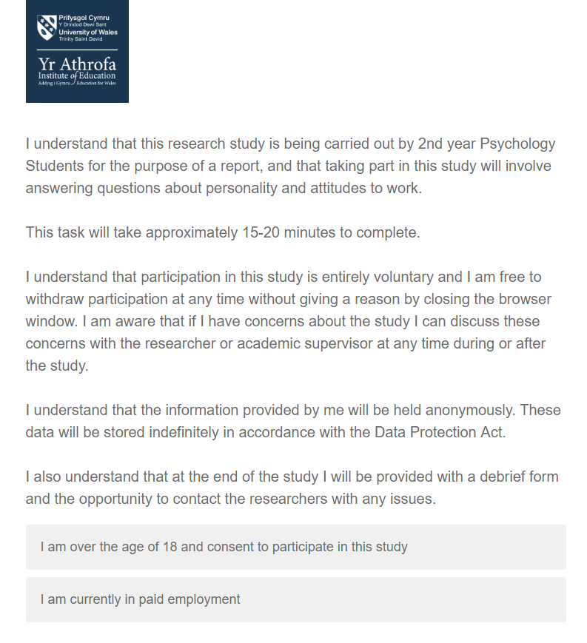
Consent page including exclusion criteria.

Appendix 2.
Demographic Questions




Appendix 3.
Personality Questionnaire

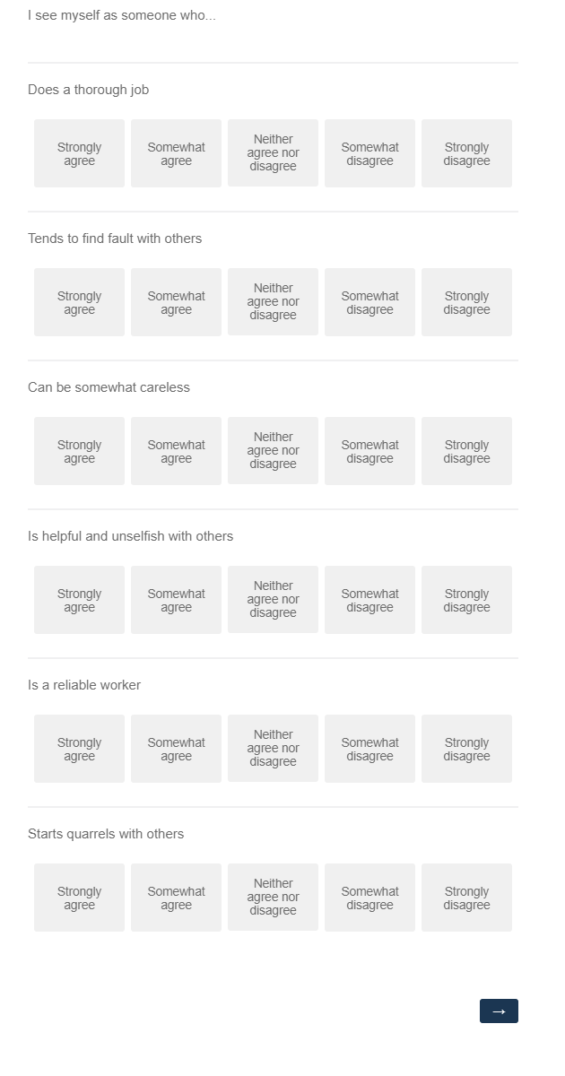




Appendix 4.
WIEMS Questionnaire






Appendix 5.

Debrief information

Appendix 6.
SPSS Output

Descriptive Statistics
 | Mean | Std. Deviation | N
Total Intrinsic Score | 37.2632 | 12.28749 | 19
Total Agreeableness Score | 18.7368 | 5.79120 | 19
Total Conscientiousness Score | 20.0000 | 7.04746 | 19

Correlations
 |  | Total Intrinsic Score | Total Agreeableness Score | Total Conscientiousness Score
Pearson Correlation | Total Intrinsic Score | 1.000 | -.245 | -.005
Pearson Correlation | Total Agreeableness Score | -.245 | 1.000 | .562
Pearson Correlation | Total Conscientiousness Score | -.005 | .562 | 1.000
Sig. (1-tailed) | Total Intrinsic Score | . | .156 | .492
Sig. (1-tailed) | Total Agreeableness Score | .156 | . | .006
Sig. (1-tailed) | Total Conscientiousness Score | .492 | .006 | .
N | Total Intrinsic Score | 19 | 19 | 19
N | Total Agreeableness Score | 19 | 19 | 19
N | Total Conscientiousness Score | 19 | 19 | 19

Variables Entered/Removedª
Model | Variables Entered | Variables Removed | Method
1 | Total Conscientiousness Score, Total Agreeableness Score^{b} | . | Enter
a. Dependent Variable: Total Intrinsic Score
b. All requested variables entered.

Model Summary^{b}
Model | R | R Square | Adjusted R Square | Std. Error of the Estimate
1 | .293ª | .086 | -.029 | 12.46215
a. Predictors: (Constant), Total Conscientiousness Score, Total Agreeableness Score
b. Dependent Variable: Total Intrinsic Score

ANOVAª
Model |  | Sum of Squares | df | Mean Square | F | Sig.
1 | Regression | 232.803 | 2 | 116.402 | .750 | .488^{b}
1 | Residual | 2484.881 | 16 | 155.305
1 | Total | 2717.684 | 18
a. Dependent Variable: Total Intrinsic Score
b. Predictors: (Constant), Total Conscientiousness Score, Total Agreeableness Score

Coefficientsª
Model |  | Unstandardized Coefficients |  | Standardized Coefficients | t | Sig. | 95.0% Confidence Interval for B |  | Correlations |  |  | Collinearity Statistics
 |  | B | Std. Error | Beta | t | Sig. | Lower Bound | Upper Bound | Zero-order | Partial | Part | Tolerance | VIF
1 | (Constant) | 44.573 | 10.564 |  | 4.219 | .001 | 22.179 | 66.966
1 | Total Agreeableness Score | -.751 | .613 | -.354 | -1.224 | .239 | -2.051 | .549 | -.245 | -.293 | -.293 | .684 | 1.462
1 | Total Conscientiousness Score | .338 | .504 | .194 | .670 | .512 | -.730 | 1.406 | -.005 | .165 | .160 | .684 | 1.462
a. Dependent Variable: Total Intrinsic Score

Collinearity Diagnosticsª
Model | Dimension | Eigenvalue | Condition Index | Variance Proportions
 |  |  |  | (Constant) | Total Agreeableness Score | Total Conscientiousness Score
1 | 1 | 2.908 | 1.000 | .01 | .01 | .01
1 | 2 | .054 | 7.332 | .70 | .00 | .64
1 | 3 | .038 | 8.751 | .29 | .99 | .35
a. Dependent Variable: Total Intrinsic Score

Residuals Statisticsª
 | Minimum | Maximum | Mean | Std. Deviation | N
Predicted Value | 28.6571 | 43.2597 | 37.2632 | 3.59632 | 19
Residual | -21.47537 | 20.78441 | .00000 | 11.74942 | 19
Std. Predicted Value | -2.393 | 1.667 | .000 | 1.000 | 19
Std. Residual | -1.723 | 1.668 | .000 | .943 | 19
a. Dependent Variable: Total Intrinsic Score

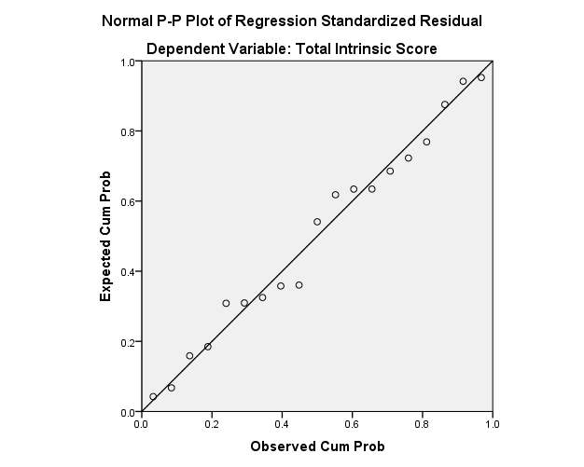
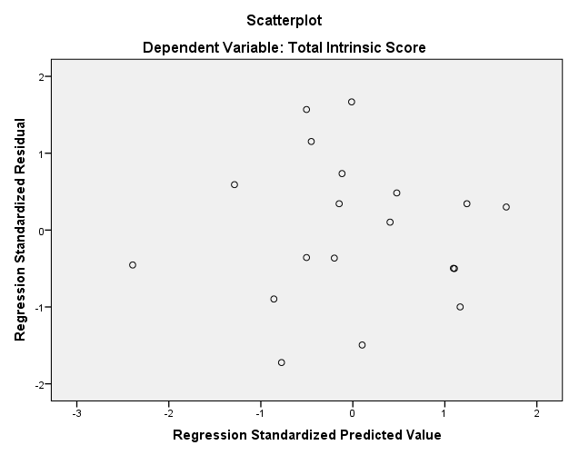

Chronbach’s apha BFI
Reliability Statistics
Cronbach's Alpha | Cronbach's Alpha Based on Standardized Items | N of Items
.898 | .908 | 18

Cronbach’s alpha Intrinsic

Reliability Statistics
Cronbach's Alpha | Cronbach's Alpha Based on Standardized Items | N of Items
.881 | .879 | 9

Cronbach’s alpha extrinsic

Reliability Statistics
Cronbach's Alpha | Cronbach's Alpha Based on Standardized Items | N of Items
.151 | .114 | 9

SPSS output – Extrinsic motivation (removed from results)
Descriptive Statistics
 | Mean | Std. Deviation | N
T_Extrinsic | 40.1579 | 6.03934 | 19
Total Agreeableness Score | 18.7368 | 5.79120 | 19
Total Conscientiousness Score | 20.0000 | 7.04746 | 19

Correlations
 |  | T_Extrinsic | Total Agreeableness Score | Total Conscientiousness Score
Pearson Correlation | T_Extrinsic | 1.000 | .066 | .170
Pearson Correlation | Total Agreeableness Score | .066 | 1.000 | .562
Pearson Correlation | Total Conscientiousness Score | .170 | .562 | 1.000
Sig. (1-tailed) | T_Extrinsic | . | .394 | .244
Sig. (1-tailed) | Total Agreeableness Score | .394 | . | .006
Sig. (1-tailed) | Total Conscientiousness Score | .244 | .006 | .
N | T_Extrinsic | 19 | 19 | 19
N | Total Agreeableness Score | 19 | 19 | 19
N | Total Conscientiousness Score | 19 | 19 | 19

Variables Entered/Removedª
Model | Variables Entered | Variables Removed | Method
1 | Total Conscientiousness Score, Total Agreeableness Score^{b} | . | Enter
a. Dependent Variable: T_Extrinsic
b. All requested variables entered.

Model Summary^{b}
Model | R | R Square | Adjusted R Square | Std. Error of the Estimate
1 | .173ª | .030 | -.091 | 6.30880
a. Predictors: (Constant), Total Conscientiousness Score, Total Agreeableness Score
b. Dependent Variable: T_Extrinsic

ANOVAª
Model |  | Sum of Squares | df | Mean Square | F | Sig.
1 | Regression | 19.712 | 2 | 9.856 | .248 | .784^{b}
1 | Residual | 636.814 | 16 | 39.801
1 | Total | 656.526 | 18
a. Dependent Variable: T_Extrinsic
b. Predictors: (Constant), Total Conscientiousness Score, Total Agreeableness Score

Coefficientsª
Model |  | Unstandardized Coefficients |  | Standardized Coefficients | t | Sig. | 95.0% Confidence Interval for B |  | Correlations |  |  | Collinearity Statistics
 |  | B | Std. Error | Beta | t | Sig. | Lower Bound | Upper Bound | Zero-order | Partial | Part | Tolerance | VIF
1 | (Constant) | 37.670 | 5.348 |  | 7.044 | .000 | 26.333 | 49.006
1 | Total Agreeableness Score | -.044 | .310 | -.042 | -.142 | .888 | -.702 | .614 | .066 | -.036 | -.035 | .684 | 1.462
1 | Total Conscientiousness Score | .166 | .255 | .194 | .650 | .525 | -.375 | .707 | .170 | .160 | .160 | .684 | 1.462
a. Dependent Variable: T_Extrinsic

Collinearity Diagnosticsª
Model | Dimension | Eigenvalue | Condition Index | Variance Proportions
 |  |  |  | (Constant) | Total Agreeableness Score | Total Conscientiousness Score
1 | 1 | 2.908 | 1.000 | .01 | .01 | .01
1 | 2 | .054 | 7.332 | .70 | .00 | .64
1 | 3 | .038 | 8.751 | .29 | .99 | .35
a. Dependent Variable: T_Extrinsic

Residuals Statisticsª
 | Minimum | Maximum | Mean | Std. Deviation | N
Predicted Value | 38.9301 | 42.7556 | 40.1579 | 1.04647 | 19
Residual | -10.02953 | 17.97047 | .00000 | 5.94799 | 19
Std. Predicted Value | -1.173 | 2.482 | .000 | 1.000 | 19
Std. Residual | -1.590 | 2.848 | .000 | .943 | 19
a. Dependent Variable: T_Extrinsic



