

STUDENT NAME: RALUCA IOANA SERBAN
STUDENT ID: 2213917
MODULE CODE: LCBB6015

Table of Contents
Executive Summary 3
Introduction 4
External Environment Analysis Aston Martin 5
Internal Environment Analysis Aston Martin 6
SWOT Analysis for Aston Martin 7
Strategy Formulation for Aston Martin 9
Conclusion and Recommendations 10
References 11

Executive Summary
The report aims to evaluate the strategic position of Aston Martin Lagonda Global Holdings PLC in the modern domestic automotive industry. Also, the report presents strategic recommendations which would support sustainable growth. The automotive industry is changing significantly at present. In particular, the rise of electric vehicles, acceleration of technological development, government regulatory measures, and changing consumer trends are influencing the business environment. Organisations these days are experiencing intense levels of business environment due the level of competition all around us. Thus, these organisations must reconfigure their strategies to avoid losing their competitive advantage. (Armstrong et al. 2018) A detailed study of the surrounding environment of an organization helps it know its standing and plan accordingly. Theories of strategic management are a good tool for the purpose. The Aston Martin Lagonda Global Holdings report discusses different strategic management theories and their application to the company. The internal business environment is where strategic management frameworks can be useful to analyse business risks and business opportunities (Hitt et al. 2018). The PESTLE and Five-Forces Framework help to analyse the external environment of Aston Martin while Value-Chain Analysis along with Resource-Based View and VRIO framework helps to examine the internal environment. According to report, Aston Martin has been protected mostly due to the stringent quality standards for electric cars.

Strategic Management Analysis of Aston Martin Lagonda Global Holdings plc

Introduction
The process of strategic management helps an organization in gaining a competitive edge over its rivals and achieve superior performance. Johnson and others (2020) define strategic management as an analysis of internal and external environment, that is followed up formulation of strategic objectives and making strategic decisions which helps the organisation gain long term results. When a company operates in an industry characterized by intense competition, strategic management enables the company to respond effectively to changes in competitive conditions. Usually, the companies managed to cultivate strategies that would help them prepare in advance for the things like market and technological change and evolving customer needs. The UK automotive sector contributes a lot to growth, jobs and innovation in UK economy. The industry is significantly changing due to environmental regulation, technology improvement, and customer demand for electric vehicles (SMMT, 2024). The automotive manufacturers are facing several challenges and opportunities due to these multiplexing factors. Thus, the business organization must make innovative business strategies and sustainable business strategy.
Lagonda Global Holdings plc is a British car manufacturer famous for its luxury vehicles. Customers admire the luxury car company for its heritage, craftsmanship, high-performance vehicles, and other aspects.
Aston Martin's vision is to become the world’s most desirable British ultra-luxury performance business. According to (Aston Martin Lagonda, 2024), the purpose of the mission will be to ensure engineering excellence application technology will sell great products. As a result, this report examines the internal and external environment of the firm and contains strategic recommendations for the company to enhance its competitiveness and grow in the long run.

External Environment Analysis Aston Martin

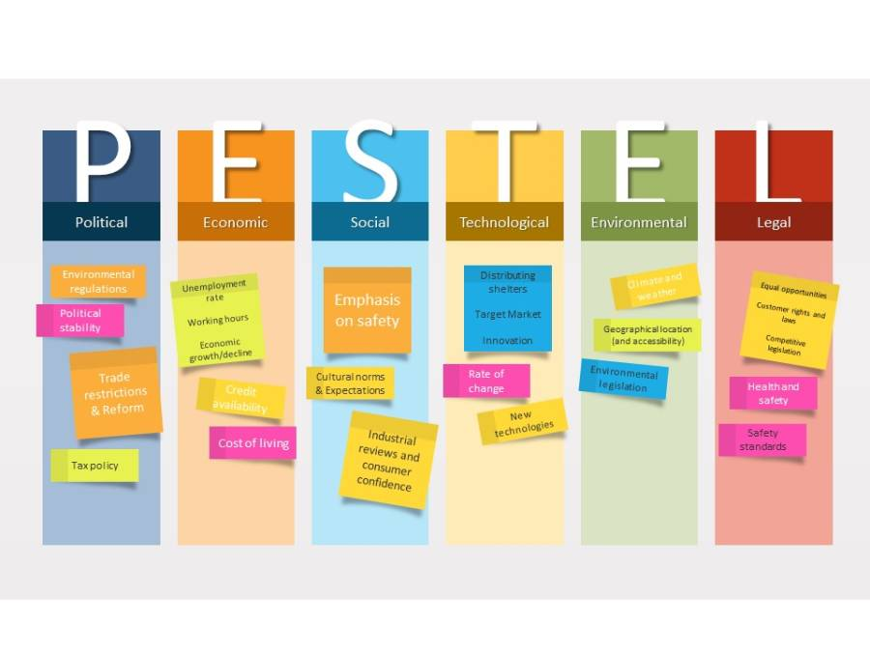
(Source: create by the author)
The external environment plays an important role in determining organisational strategy because firms must always respond to environmental factor that influence the organisation but are beyond its reach. Aston Martin’s competition position can be analysed with the help of PESTLE framework which examines macro environment. The government's increased commitment to net zero caused a political shift that accelerated the transition to electric mobility. There are opportunities available in this place, but premium automotive manufacturers are under significant pressure to invest heavily in electrification technologies and sustainable manufacturing processes (Department for Transport, 2024). The post-Brexit trade arrangements are generating uncertainties relating to trading arrangements, supply chains, availability of labour and access to international markets.
The economic situation offers Aston Martin options and makes them subject to various currencies. The rise in inflation and interest rates and real income and wealth decline of the middle-income earners may dent consumer confidence. The economic conditions may slow down demand for luxuries, but premium vehicles will continue to find a market, says an expert at a premium auto expo. According to (PwC, 2024), high net worth consumers in developed economies are resilient and the rich in emerging economies are becoming more affluent.
The automotive industry is becoming one due to the social and technology trends. Today’s consumers want their luxury vehicles to feature digital technology whilst being eco-friendly. According to (Porter and Heppelmann, 2015), connected technologies are changing the nature of competition and value creation for firms worldwide. It creates a strategic challenge for Aston Martin to maintain a luxury identity and invest in innovating technologies (Electric powertrains, connected vehicle systems) at the same time.
The luxury automobile industry has been analyzed using Porter five forces model. Though the toy industry has a high entry barrier due to high capital requirement and strong brand loyalty, competitive rivalry is high among established players. Moreover, buyer power is robust as they always have the ability to substitute the company’s products with another brand. Just like batteries and other technology depend on a specialist supplier, so does power. Hence, there is a lot of rivalry for Astin Martin.

Internal Environment Analysis Aston Martin

The internal environment of the entity is helpful in creating and sustaining the competitive advantage. As stated by (Porter, 1985), some organisation’s value-creating activities can drive competitive advantage. The Aston Martin value chain highlights that the quality, exclusivity, and particular nature of the product put it in the category of luxury goods. Also, high-quality vendors are important for the company to meet through either engineering skill or high-quality standard.
In addition, Aston Martin’s value chain in terms of operation is not the same as its competitors comprising Ferrari and Porsche whose production is by far more significant in scale compared to that of Aston Martin. In case of Aston Martin, operational costs along with manufacturing or other costs may not qualify for the benefits of economies of scale.

The Resource Based View mentions that monopoly of resources helps firms stay ahead and compete efficiently in the global marketplace. Aston Martin’s most asset is its world-famous brand synonymous with luxury, class and power. With over 100 years in the business, the firm has created a credible brand by association through heritage, innovation and exclusivity. Additionally, owing to this resource, Aston Martin can charge premium prices for its offerings. It also enjoys strong customer brand loyalty. The organization's worldwide brand may not give it a sustainable competitive advantage, (Teece, 2018) stated that competitive advantage is a function of the mechanisms and processes occurring in firms.
The VRIO framework shows whether Aston Martin’s strategic resources are strength or weakness. The company’s brand name and heritage are valuable, rare, costly to imitate and the organisation exploits it (Barney and Hesterly, 2019). Thus, this gives the company a competitive edge. Competencies like engineering skills and technological capabilities are also not very expensive to imitate. In terms of investing and collaborating, the competitor organisation can learn the latter. As a result, the historic strength of the brand will continue to be a cost reason, but the brand evolves in terms of new capabilities (including in electrification and sustainable mobility) that represent worth for the competitive advantage.

SWOT Analysis for Aston Martin

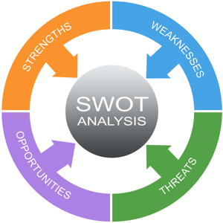

(Source: create by the author)
The SWOT analysis emphasize Aston Martin’s strategic position by merging insights from both external and internal environment analysis section. According to the company’s strengths, the brand reputation is global in nature. For over a hundred years, the company heritage established the brand as exclusive and made by experts. Because Aston Martin is a prestigious brand, it sells premium prices and has loyal customers despite competitive suppliers. Its strategic partnerships and engineering capabilities are further critical strengths.
The weaknesses of the company project its disadvantageous positioning. For example, Aston Martin is much smaller than rivals like Ferrari, Porsche and others in terms of manufacturing size. Many of these players are much bigger than Aston Martin and therefore, they can leverage economies of scale to make cars effectively cheaper. Moreover, the firm has suffered relatively poor financial performance in recent years. This may restrict the company’s ability to invest in R&D (research and development), especially when it requires substantial funds for electrification and digital transformation.
The organization stands to gain substantially from this new development, and the increasing popularity of electric vehicles will be of great use for future advancement. In a similar fashion, increasing popularity of green and sustainable luxury goods can aid growth. Moreover, the increasing affluence in emerging markets such as China and the Middle East can draw in new clientele. Likewise, improved technological capabilities and strategic partnerships may help enhance innovation and efficiency in a business's diverse facets.
Aston Martin competes against various brands and quickly changing regulations that are hazardous to their business. Moreover, competition is made more intense by increased investments by rivals like Porsche, Ferrari, etc., in EVs. In addition to that, supply chain disruptions and inflation may hit profitability. Consequently, Aston Martin should be using its brand heritage i.e. a luxury car maker and positioning for exploiting the opportunity in electrification and emerging markets, as per its SWOT analysis. On the contrary, it must deal with weaknesses relating to scale, financial performance and technological development.

Strategy Formulation for Aston Martin

According to strategic analysis, Aston Martin must adopt an electric strategy, international expansion and tech collaboration as strategy. Through SWOT analysis, PESTLE analysis and Five Forces analysis in the first stage of strategic analysis, opportunities and threats have been profiled, which has resulted in these strategic alternatives.
The priority must be to speed up development of electric vehicle. The external analysis identified increasing regulatory pressure and evolving customer preferences as key forces reshaping the dynamics of the industry. If Aston Martin is unable to respond effectively to changes in market forces, then its competitive position would be weakened significantly. The electric vehicle market will be dominated by all other manufacturers in the next generation. Aston Martin must invest in their technology and processes to appeal to a younger crowd. Furthermore, increased funding towards electrification would enable Aston Martin to compete better with rivals that are quickly escalating their electric vehicle line-up.
Emerging luxury markets to be the second most crucial strategy prioritized. According to the economic analysis, there are rising demand and growing wealth for luxury goods in certain area like China, India and Middle East. By expanding our operations in these markets, the company would be less reliant on the ageing European markets with additional earnings. As competition increases and the traditional automobile markets face economic uncertainties, this is very important.
The focus of the third strategic choice should be the technology partnerships or strategic alliances. Internal analysis shows that Aston Martin has strong brands and engineering capabilities. Nevertheless, the technological capability is the most imitable resource. While the company has an exclusive agreement to supply technology for Mercedes-Benz, a Us Automobile Partners study finds that partnering with technology suppliers and other auto OEMs can boost innovation while also driving development savings. In fact, multiple OEMs demand technology from Daimler AG and BMW AG. Through its existing affinity with Mercedes, Aston Martin has access to cutting-edge technologies. It is also working with partners to build new technology collaboratively. This decision should focus on deepening existing partnerships and developing new ones in the field of Battery, Artificial Intelligence, Connected vehicles and many more. All such partnerships will greatly strengthen Aston Martin’s features. Improvements will be made to the online retail function of JML.

Conclusion and Recommendations

The evaluation of several strategic management frameworks has allowed for the assessment of Aston Martin Lagonda Global Holdings plc’s strategic position. The report states that the environment in which Aston Martin operates is highly competitive and dynamic. Apart from it, the company faced macro challenges also such as technological disruption, sustainability pressures, and changing consumer expectations. The external analysis has identified opportunities regarding the growth of electric vehicles, innovations, and the like. It also indicated threats regarding competitive rivalry, economic uncertainty, and regulatory change among others.
The internal analysis indicates that Aston Martin has valuable resources and capabilities through which it can develop competitive advantages. The organization’s brand has played a really important role in countless opportunities over the last century. In more detail, the considerable history, engineering quality, and luxury status of the company are important competitive advantages. These competitive advantages distinguish the organization in a positive way from several competitors.
To stay competitive in the environment and achieve growth targets, Aston Martin needs to increase its speed of investment in electric vehicle development. The company should also invest in emerging luxury markets and enter technology strategic partnerships. Also, the organization must keep investing in sustainability and operational efficiency to boost long-term profitability. As a result of these recommendations, Aston Martin will be better placed to achieve its strategic objectives and maintain its position as one of the world’s leading luxury automotive manufacturers.

References
Aston Martin Lagonda Global Holdings plc (2024) Annual Report and Accounts 2024. Gaydon: Aston Martin Lagonda Global Holdings plc.
Barney, J. (1991) ‘Firm resources and sustained competitive advantage’, Journal of Management, 17(1), pp. 99–120.
Department for Transport (2024) Transport Decarbonisation Plan. London: Department for Transport.
Deloitte (2024) 2024 Global Automotive Consumer Study. London: Deloitte.
Grant, R.M. (2022) Contemporary Strategy Analysis. 11th edn. Hoboken, NJ: Wiley.
Johnson, G., Whittington, R., Scholes, K., Angwin, D. and Regnér, P. (2020) Exploring Strategy. 12th edn. Harlow: Pearson Education.
Lynch, R. (2021) Strategic Management. 9th edn. Harlow: Pearson Education.
Mintzberg, H., Ahlstrand, B. and Lampel, J. (2009) Strategy Safari: Your Complete Guide Through the Wilds of Strategic Management. 2nd edn. Harlow: Pearson Education.
Porter, M.E. (1980) Competitive Strategy: Techniques for Analysing Industries and Competitors. New York: Free Press.
Porter, M.E. (1985) Competitive Advantage: Creating and Sustaining Superior Performance. New York: Free Press.
Porter, M.E. and Heppelmann, J.E. (2015) ‘How smart, connected products are transforming companies’, Harvard Business Review, 93(10), pp. 96–114.
PwC (2024) Automotive Industry Trends Report 2024. London: PricewaterhouseCoopers.
Society of Motor Manufacturers and Traders (SMMT) (2024) UK Automotive Sustainability Report 2024. London: SMMT.
Teece, D.J. (2018) ‘Business models and dynamic capabilities’, Long Range Planning, 51(1), pp. 40–49.
Wheelen, T.L., Hunger, J.D., Hoffman, A.N. and Bamford, C.E. (2022) Strategic Management and Business Policy: Globalization, Innovation and Sustainability. 16th edn. Harlow: Pearson Education.

