Master of Business Administration
International Business pathway

Contemporary employability skills
Assessment 1: Individual report. Weight: 100%
Module name: Strategic Management
Module code: LCMB7003
Lecturer name: Hoang Nguyen
Student Name: Abdul Hakim
Student ID: 2505488

Word count: 5445
Submission date: 12-08-2026

AI use acknowledgement
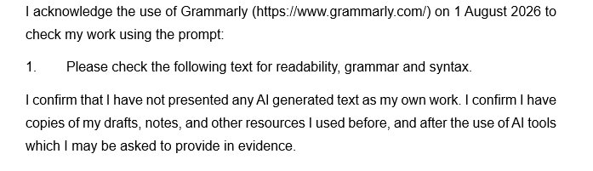

Table of Contents
Section 1 5
Introduction 5
1. Organisational Context and Overview 6
1.1 Background of Tesla 6
1.2 Industry Context and Market Position 8
2. External and Internal Analysis 9
2.1 External Analysis: PESTEL Framework 9
2.2 Internal Analysis: VRIO Framework 12
2.3 SWOT Analysis 14
3. Comprehensive and Holistic View of Tesla 17
3.1 Corporate Social Responsibility (CSR) Strategy and Alignment with Business Objectives 17
3.2 Balanced Scorecard Analysis 18
4. Strategic Choices and Implementation 21
4.1 The strategy of the business 22
4.2 Identification of the Most Appropriate Strategy 23
4.3 Strategic Benefits of the Recommended Strategy 25
4.4 Implementation Challenges and Mitigation Strategies 25
Conclusion 27
Section 2 28
Reflective Account using Gibbs Reflective Cycle 28
References 32

List of Figures
Figure 1: Quarterly Revenues Segment of Tesla 6
Figure 2: Direct to Consumer Business Model 7
Figure 3: Best Selling Cars in the UK Market 8
Figure 4: PESTLE Analysis 9
Figure 5: UK Inflation Rate (2022-2025) 10
Figure 6: VRIO Framework 13
Figure 7: SWOT Analysis 15
Figure 8: Balanced Scorecards 19
Figure 9: Porter's Generic Strategies 22
Figure 10SAFe Framework 24
Figure 11Gibbs Reflective Cycle 28

Section 1

Introduction
Strategic management is a process that helps organisations to analyse their own internal strengths and weaknesses and external opportunities and threats to ensure they are able to gain a sustainable competitive advantage in ever-changing markets (Armstrong, 2021). This report critically analyses the Tesla Model Y in the United Kingdom (UK) electric vehicle market using the framework of academic strategic management tools such as PESTEL, VRIO, SWOT, Corporate Social Responsibility (CSR), the Balanced Scorecard, Porter's Generic Strategies and the SAFe framework. These analyses lead to the formulation of the most suitable strategic direction and the most suitable implementation approach to boost the competitiveness and organisational performance of Tesla in the long term.

1. Organisational Context and Overview

1.1 Background of Tesla
Historical Perspective
Tesla Inc. was established in 2003 in California with the goal of changing the automotive world by creating sustainable mobility (Tesla, 2025). Elon Musk took over the helm in 2008 and led the company to become very successful in moving from high-end electric sports cars to mass-market electric cars (EVs). In 2025, Tesla’s quarterly revenue fluctuated throughout the year, reaching approximately US$18.4 billion in Q1, US$21.6 billion in Q2, US$27.5 billion in Q3 (the highest level), and US$24.0 billion in Q4.
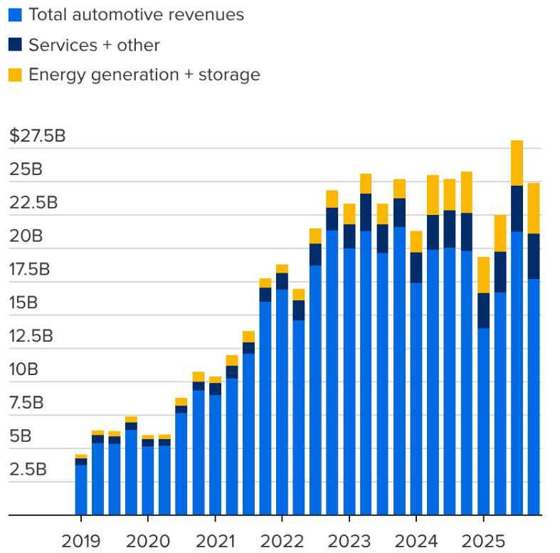
Figure 1: Quarterly Revenues Segment of Tesla
Source: (Kolodny, 2026)

Mission and Vision
Its mission is to "accelerate the world's transition to sustainable energy", and its vision is to usher in a sustainable energy-powered future. These strategic declarations have enabled Tesla to expand its operations beyond its domestic borders to over 40 countries and to become one of the key players in the global electric mobility and clean energy sector.
Business Model
Tesla primarily does not sell its cars through dealers and is known for having a direct-to-consumer approach in which it designs, produces and sells cars in its own stores and online (Quang Hậu, 2021). Automotive operations accounted for around 79% of total revenue in 2025 while the energy generation and storage segment garnered more than US$10 billion, showing revenue diversification. There are also other revenue streams including software services, regulatory credits and Supercharger charging networks.
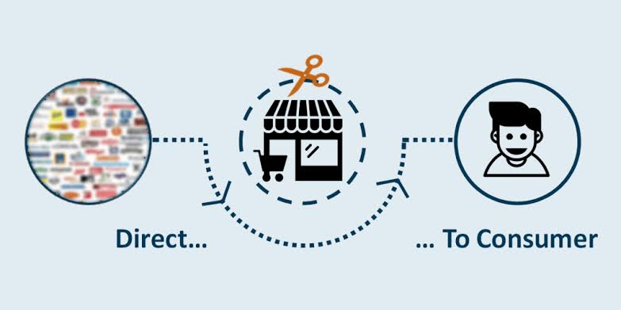
Figure 2: Direct to Consumer Business Model
Source: (Quang Hậu, 2021)

1.2 Industry Context and Market Position
UK Electric Vehicle Industry
Tesla is in the fastest-growing segment of the UK automotive market – the battery electric vehicle segment. The Ford Puma was the top-selling car of 2024, with 48,340 Puma models joining the UK's roads, while the Tesla Model Y was the most popular car sold in December, with 5,165 Model Y cars sold (Electrive, 2025). UK Government targets of 2050 for net-zero and 2030 for the end of new petrol/diesel car sales remains to drive EV demand and charging infrastructure investment.
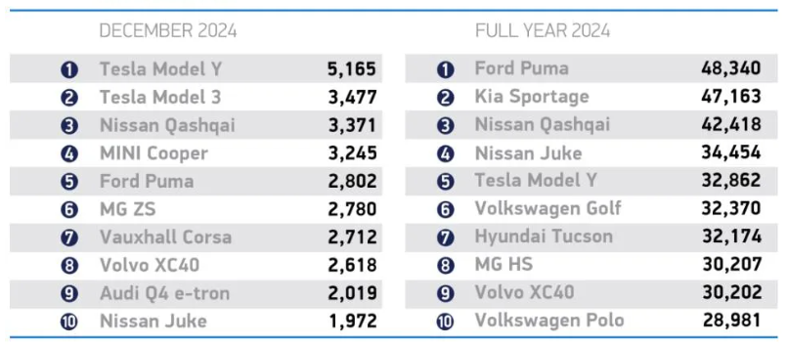
Figure 3: Best Selling Cars in the UK Market
Source: (Electrive, 2025)
Competitors and Market Position
Tesla is rivaled by BYD, BMW Group, Volkswagen Group, Hyundai-Kia, Mercedes-Benz and MG. With greater competition, the Model Y actually stayed in the top five best-selling EVs in the UK in 2025, due to its long-range capabilities, stand-alone battery technology, over-the-air software updates and a nationwide Supercharger network (Tesla, 2025). The features enhance Tesla's upscale market standing and establish a unique value proposition in terms of innovation, performance and customer experience.

2. External and Internal Analysis
The external and internal analysis is a strategic management process that consists of analysing the macro-environment and an organisation's internal resources in order to understand its strategic position and/or competitive advantage (Bailey et al., 2018). This section analyses the Model Y of Tesla in the UK by using PESTLE, VRIO, and SWOT frameworks.

2.1 External Analysis: PESTEL Framework
PESTEL is a tool that can help an organisation assess the external macro environmental influences that can impact strategic decisions and competitive performance (Vecteezy, 2024). The application of this framework is following:
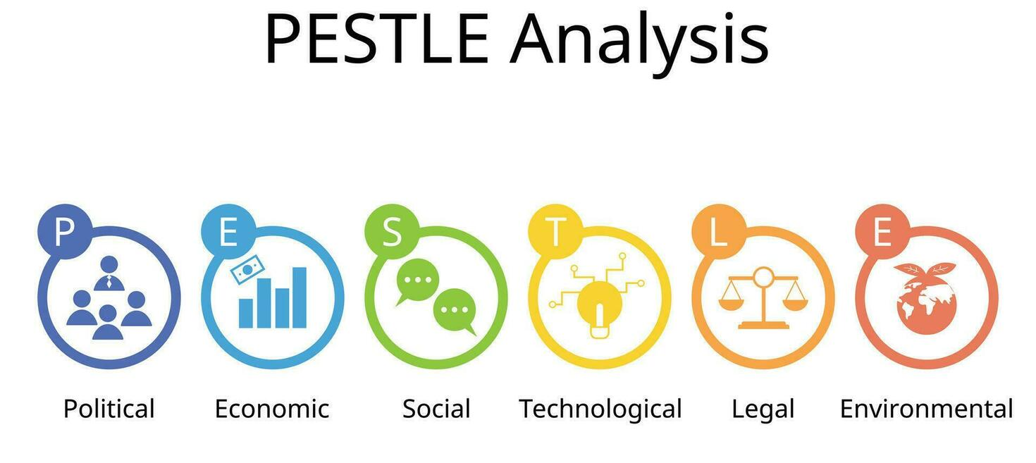
Figure 4: PESTLE Analysis
Source: (Vecteezy, 2024)
Political Factors
- Government Decarbonisation Strategy: The UK Government has pledged that its greenhouse gas emissions by 2050 will be 'Net Zero' Climate Change Act 2008 (2050 Target Amendment Order 2019) (Shahzad et al., 2024). In addition, the sale of new petrol and diesel cars will be phased out by 2030 and all new vehicles by 2035 will be zero-emission vehicles (ZEVs).
- Investment in EV Charging Infrastructure: The Government will continue to promote the roll-out of a national charging network. As of June 2025, more than 82,700 public charging devices have been installed at a little over 39,000 charging sites in the UK, a rate of over 30% every year (Zhang et al., 2025).
Economic Factors
- Expansion of the UK Electric Vehicle Market: In 2025, the UK was a leading market for battery electric vehicles (BEVs) in Europe. The Society of Motor Manufacturers and Traders (SMMT) said a total of 382,000 battery electric vehicles were registered, around 19.6% of all new vehicle registrations of 1.95 million vehicles.
- Inflation, Interest Rates and Consumer Spending: Consumer Price Index (CPI) inflation in the UK jumped to 3.6% in June 2025 from 3.4% the previous month and is expected to stay above the Bank of England's 2% rate of inflation. With more than 80% of all new cars being bought with finance, a higher cost of finance could make it harder for customers to afford to buy more expensive cars like the Tesla Model Y.
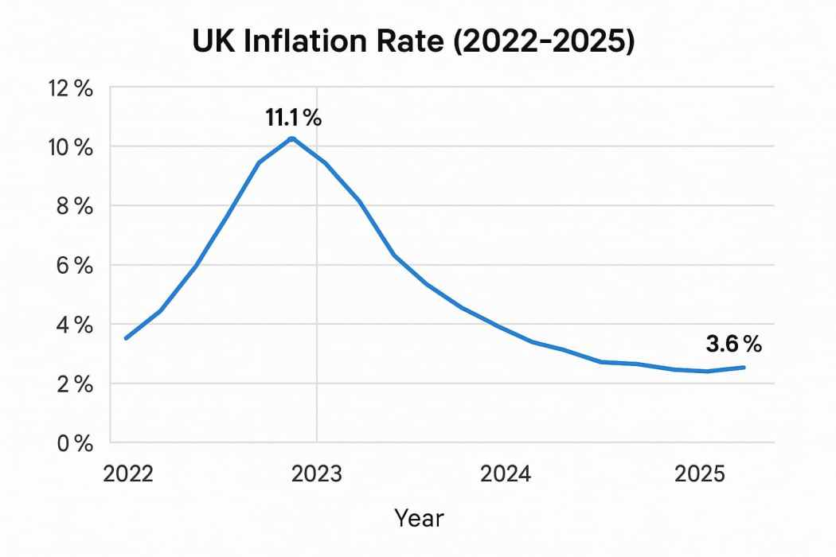
Figure 5: UK Inflation Rate (2022-2025)
Source: (Bull, 2025)
Social Factors
- Rising Consumer Environmental Awareness: People's interest in climate change is still affecting their buying habits. Research shows that about 74% of UK consumers take environmental sustainability into account when buying vehicles, and more than 60% are in favour of swapping internal combustion cars with electric models.
- Brand Recognition and Customer Loyalty: Among all the electric vehicle brands, Tesla is one of the most recognised ones worldwide (Tesla, 2025). The company's brand value in 2025 was greater than US$40 billion and Model Y was among the top-selling passenger vehicles in the world. However, customer expectations around after-sales service and product controversies relating to corporate leadership could impact sales and brand image in the UK market.
Technological Factors
- Research and Development Investment: Among all the things, innovation is still Tesla's number one selling point. In 2025, Tesla spent roughly US$4.5 billion on R&D, which accounted for roughly 4.6% of its revenue (Macrotrends, 2024). The ongoing investment allows for enhancements of the batteries' efficiency, their manufacturing automation, energy management systems, and vehicle performance.
- Charging Infrastructure Leadership: By 2025, Tesla will have over 70,000 Superchargers running all over the world, and has one of the largest proprietary charging networks in the world. In the UK, Tesla's Supercharger network keeps growing alongside the public network, offering users charging speeds that are faster, reliability and less operational inconvenience than many EV brands.
Environmental Factors
- Contribution to Carbon Emission Reduction: Vehicle electrification is key to national environmental policy as the UK accounts for roughly 24% of its total GHG emissions from road transport (Mehlig, ApSimon and Staffell, 2022). The expansion of BEVs directly addresses the UK's decarbonisation goals and establishes a long-term demand for Tesla's zero-emission product line.

- Sustainable Manufacturing and Renewable Energy: Tesla further leverages renewable energy resources during its manufacturing processes and broadens its battery recycling programs and resource-optimised systems (Tesla, 2025). In 2025, the company's energy generation and storage segment contributed more than US$10 billion in revenue, highlighting the business benefits and sustainability efforts of the energy transition.
Legal Factors
- Data Protection and Cybersecurity Compliance: Connected vehicles generate a lot of data relating to the customer, location and driving, requiring Tesla to adhere to the General Data Protection Regulation (UK GDPR) and Data Protection Act 2018 (Shen and Liu, 2025). Data governance is a top priority for many organisations because failure to comply can lead to fines of up to £17.5 million or 4% of the annual turnover of global organisations.
- Product Safety and Consumer Protection: The Road Vehicles (Approval) Regulations 2020, the Consumer Rights Act 2015, and the Automated Vehicles Act 2024 (AV Act) on vehicle safety, product quality, autonomous systems, and consumer rights apply to Tesla. Compliance also helps to build consumer trust, but also raises the costs of research, testing and regulatory compliance, especially with the continued evolution of autonomous driving technology.

2.2 Internal Analysis: VRIO Framework
VRIO is a framework that enables an organisation to determine if it has a sustainable competitive advantage based on its resources and capabilities, by considering the traits of Valuable, Rare, Inimitable and Organised (Watson, 2025).
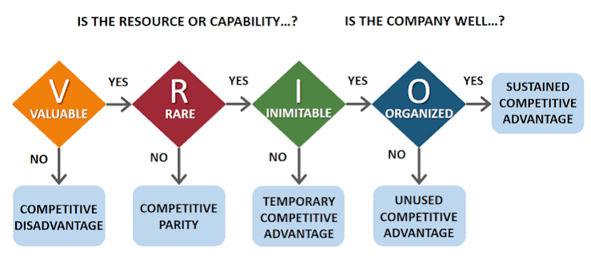
Figure 6: VRIO Framework
Source: (Watson, 2025)
Valuable (V)
- Technological Innovation and Product Performance: Tesla builds a lot of value for customers by innovating new technologies continuously. The company reportedly spent some $4.5 billion on R&D in 2025, and the Model Y reached up to 387 miles (WLTP), one of the longest driving ranges among premium electric SUVs
- Vertically Integrated Business Model: Tesla has a vertically integrated business model, in which it designs the car, develops the battery technology, writes the software, and handles manufacturing and direct sales (Tesla, 2025). In 2025, Tesla's total revenue was estimated to be around US$97.7 billion and they delivered about 1.79 million cars worldwide.
Rare (R)
- Proprietary Supercharger Network: In 2025, over 70,000 Superchargers have deployed worldwide, including one of the world's largest proprietary fast-charging infrastructures, owned by Tesla (Silva, 2026). Tesla owners in the UK have access to a vast national network of charging stations, which few rivals can match, delivering a better driving experience and minimising range anxiety.
- AI and Software Ecosystem: Tesla has proprietary Full Self-Driving (FSD) technology, artificial intelligence, and over-the-air software that is backed by driving data from more than 6 million vehicles worldwide (Tesla, 2025). This level of software integration and real-world data is hard to find in the automotive industry and is a niche capability in the global EV sector.
Inimitable (I)
- Advanced Manufacturing Capability: Over the past 20+ years, Tesla's manufacturing know-how has been is built through technological innovation and investment in Gigafactories. By 2025 the firm had large-scale manufacturing plants in the U.S., Germany and China, which allowed for efficient production and ongoing process improvement.
- Strong Brand Equity: Tesla has built one of the most iconic brands in the world for electric vehicles, and it is doing so with a steady and innovative approach, plus an edge and customer loyalty (Tesla, 2025). Tesla's worth on the worldwide level in 2025 crossed US$40 billion, and the Model Y continued to be one of the most popular cars in the world for passengers.
Organised (O)
- Efficient Resource and Innovation Management: Tesla's innovation commercialisation process is a perfect way to allocate the company's R&D, engineering and manufacturing efforts (Miao, 2025). In 2025, over 125,000 workers were engaged in global operations and helped maintain efficiency in manufacturing and software updates, whilst improving products, thereby providing the company with a competitive edge.
- Integrated Global Operations: Tesla uses direct online sales and company-owned retail stores and digital service platforms to coordinate production under the brand's Gigafactories. This organisational integration allowed the company to ship roughly 1.79 million vehicles in 2025, and it enabled the company to effectively leverage its precious and indescribable assets in such competitive markets.

2.3 SWOT Analysis
SWOT is a framework that incorporates the results of the external (PESTEL) and internal (VRIO) analyses to assess the strategic position of Tesla Model Y in the UK market (Bitesize, 2024). It pinpoints the main strengths and weaknesses inside the organisation and the opportunities and threats outside the organisation that could affect future competitive ability.
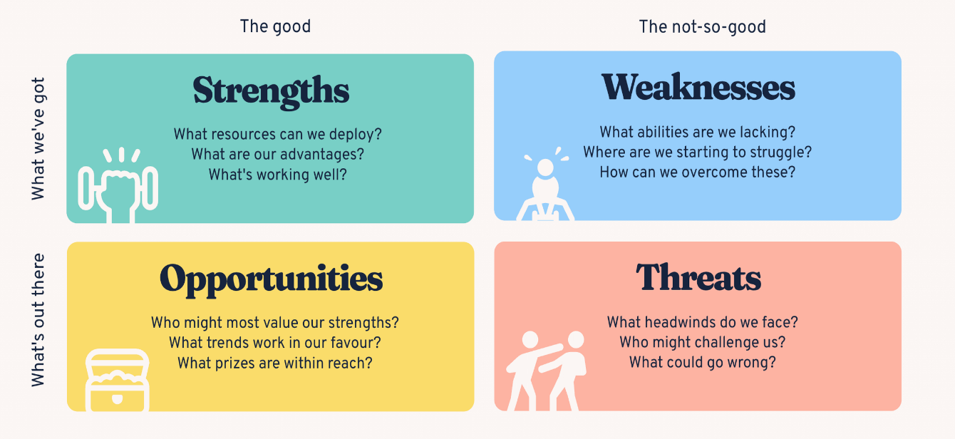
Figure 7: SWOT Analysis
Source: (Bitesize, 2024)
Strengths (S)
- Technological Leadership: Tesla spent around US$4.5 billion on R&D in 2025 to produce a Model Y with a range of up to 387 miles (WLTP) and advanced battery technology and over-the-air software updates, which sets it apart from many UK rivals.
- Strong Brand and Market Position: The global brand value of Tesla stood above US$40 billion in 2025, and the Model Y continued to be one of the world's top-selling passenger vehicles and one of the UK's most popular battery electric vehicles, further fueling consumer confidence and price strength (Ghaffarpasand and Pope, 2025).
- Vertically Integrated Operations: In 2025, Tesla's integrated business model is expected to generate revenue of ~US$97.7 billion, serving to manufacture ~1.79 million vehicles. 100% of sales, proprietary battery production and over 70,000 Superchargers worldwide increase operational efficiency and customer satisfaction.
Weaknesses (W)
- Premium Pricing Strategy: The Model Y is pricier than most of BYD, MG and Hyundai's competing EVs, and that has some price-sensitive UK customers worried, especially with the rising cost of borrowing these days (Ghaffarpasand and Pope, 2025).
- Dependence on Limited Vehicle Models: Automotive sales represented around 79% of Tesla's revenue in 2025, with a significant share of the company's deliveries coming from the Model Y (Eggers, 2023). This is a risk for businesses because if customer preferences or the competition change, it can lead to higher dependence.
- After-Sales Service Constraints: As the UK EV market grows, it is possible that Tesla's maintenance waiting times could be longer than many traditional automotive manufacturers, and this could impact customer satisfaction.
Opportunities (O)
- Expanding UK EV Demand: During 2025, the Model Y saw sales of over 382,000 battery electric vehicles, which accounted for around 19.6% of all new vehicle registrations in the UK.
- Government Decarbonisation Policies: These are key targets that will further drive the growth of EV use in the UK, including the 2030 phase-out of new petrol and diesel vehicle sales, and the 2050 target for net-zero carbon emissions (Brand, Marsden and Anable, 2022).
- Growth of Digital Mobility Services: Higher uptake of connected cars, AI and software-based services opens doors for Tesla to further monetise recurring revenues through enhanced software subscription services, self-driving and energy system usage.
Threats (T)
- Intensifying Industry Competition: The competition is driving down Tesla's share of the UK market, with manufacturers such as BYD, Volkswagen, BMW, Hyundai-Kia and MG continuing to add new EV models (Eggers, 2023).
- Raw Material Price Volatility: Production of batteries is still highly reliant on lithium, nickel and cobalt, and global demand for lithium is expected to grow by more than 400% until 2040, causing cost pressures and uncertainty in the supply chain.
- Regulatory and Economic Risks: Adopting Zero Emission Vehicle (ZEV) Mandate 2024, UK GDPR and the New Autonomous Driving Regulations drive up costs (Nalina Hamsaiyni Venkatesh and Laurencas Raslavičius, 2024). Plus, elevated interest rates and consumer spending uncertainty could impact demand for the high-end EVs like the Model Y.

3. Comprehensive and Holistic View of Tesla
Competitive positioning is not the only key to strategic performance; it is an organisation's ability to deliver long-term benefits to stakeholders while delivering long-term business results (Alkhodary, 2023). This section critically appraises Tesla's Corporate Social Responsibility (CSR) policy and its integration with the corporate goals before analysing organisational performance using the Balanced Scorecard (BSC) to determine the extent to which financial and non-financial scores contribute to the competitive success of the Tesla Model Y in the United Kingdom.

3.1 Corporate Social Responsibility (CSR) Strategy and Alignment with Business Objectives
Corporate Social Responsibility (CSR) is a company's duty to conduct its affairs ethically and to generate economic, environmental and social value for the stakeholders (Ardiansyah and Alnoor, 2024). Tesla's CSR approach is well aligned with the company's core business objective of accelerating the global transition to sustainable energy, ensuring that sustainability is not just a social responsibility but also a source of competitive advantage.
Environmental Responsibility:
The main focuses of Tesla's CSR are its efforts aimed at lowering the global carbon footprint by promoting clean transportation and renewable energy solutions. The company has sold ~1.79 million EVs globally in 2025, which saved millions of tonnes of CO₂ emissions relative to conventional internal combustion engines. In addition, Tesla's Energy Generation and Storage segment earned over US$10 billion in revenue in 2025, highlighting the growing emphasis on solar power and battery storage solutions.
Social and Governance Responsibility
Tesla also models CSR by investing in employee education, safety and technology continually. By 2025, the company has more than 125,000 employees worldwide and invests about US$4.5 billion per year in research and development for safer vehicles, better battery range and autonomous driving solutions (Ardiansyah and Alnoor, 2024). But Tesla has been criticised for its labour relations, workplace practices and corporate governance, meaning that its social responsibility performance is less mature than its environmental performance.
Alignment with Business Objectives
Tesla's CSR approach is well-positioned to support its overall business goals of technological leadership, sustainable growth and global market expansion (K and Lingam, 2025). More than 382,000 battery electric vehicles (BEVs) were registered across the UK in 2025, and sustainability measures can help differentiate brands, appeal to eco-conscious consumers and boost customer loyalty in this growing market. At the same time, the ongoing investment in renewable energy, battery technology and digital solutions paves the way for operational efficiency, product quality and long-term profitability.

3.2 Balanced Scorecard Analysis
The Balanced Scorecard (BSC), developed by Kaplan and Norton (1992), is a strategic performance management tool and is used to convert an organisation's vision and strategy into measurable financial and non-financial goals. The four views for Tesla Model Y in the United Kingdom assess the impact of the operational activities on the mission of the company to accelerate the transition towards sustainable energy and long-term competitive advantage.
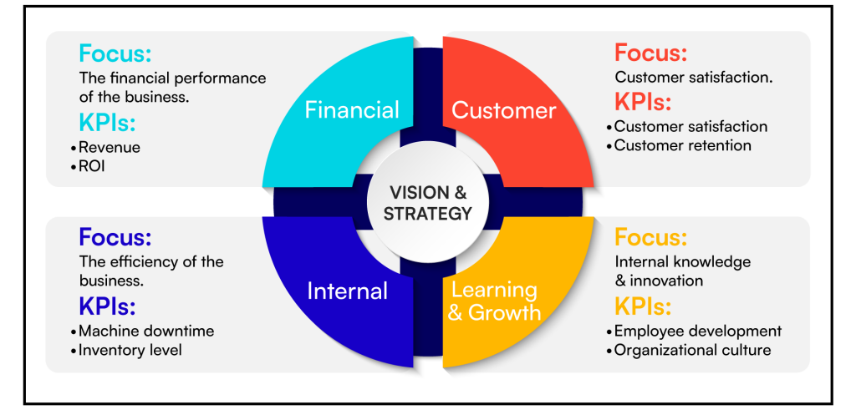
Figure 8: Balanced Scorecards
Source: (Singh, 2024)
1. Financial Perspective
Strategic Objective: Tesla's finances goal is to foster growth that is sustainable and profitable, continuing to sell more Model Y vehicles, using operational efficiencies, and remaining an innovative major player in the UK EV industry (Tesla, 2025).
Key Performance Indicators (KPIs): Metrics that are important include annual vehicle deliveries, automotive revenue, operating margin, return on invested capital (ROIC) and gross profit margin. Yet, despite fierce competition in the marketplace, Tesla managed to rake in some US$97.7 billion in revenues in 2025 and delivered around 1.79 million vehicles worldwide.
Performance Targets: Tesla's goal is to sell more Model Ys in the UK, achieve positive operating margins while cutting prices, and do both by optimising the factory, improving production efficiency, and developing new batteries (Macrotrends, 2024).
Strategic Initiatives: The company is still continuing to invest in advanced manufacturing technologies, cost reduction and optimisation of the battery supply chain. Ongoing price adjustments, software revenue and energy business growth increase financial resilience and contributes to long-term shareholder value.
2. Customer Perspective
Strategic Objective: Tesla aims to give customers the highest satisfaction by offering revolutionary, eco-friendly and technologically advanced cars with a better ownership experience.
Key Performance Indicators (KPIs): Performance is evaluated using customer satisfaction scores, market share, vehicle deliveries, customer retention, charging network availability and brand value (Shbool, Al-Bazi and Al-Hadeethi, 2022). In 2025, Tesla's global brand value is over US$40 billion and the Model Y continues to be one of the world's top-selling passenger vehicles.
Performance Targets: The goal of Tesla is to build customer loyalty through greater charging availability, enhanced after-sales services, and industry-leading vehicle quality and software capabilities.
Strategic Initiatives: The addition of more Superchargers around the UK, frequent over-the-air software updates, artificial intelligence upgrades, and better digital customer service help ensure higher levels of customer satisfaction and continue to strengthen Tesla's premium market presence (Shahzad et al., 2024).
3. Internal Business Process Perspective
Strategic Objective: Tesla aims to enhance manufacturing efficiency, product quality and operational excellence to pave the way for sustainable growth and competitive advantage.
Key Performance Indicators (KPIs): Parameters like production efficiency, manufacturing cost per vehicle, battery performance, quality defect rates, and delivery lead times are important. Tesla has several Gigafactories and a very efficient manufacturing process, with the company producing around 1.79 million vehicles worldwide in 2025 (Tesla, 2025).
Performance Targets: The company's goals are to lower manufacturing expenses, increase battery utilisation, cut production faults, and speed up the delivery of vehicles to satisfy rising demand in the UK.
Strategic Initiatives: Tesla remains committed to investing in Gigafactory automation, AI, battery innovation, and vertically integrated manufacturing. Ongoing process enhancements boost productivity and improve flexibility and reliability of products.
4. Learning and Growth Perspective
Strategic Objective: The goal of Tesla is to continuously innovate by developing employees, building technology leadership and organisational learning for future competitive advantage.
Key Performance Indicators (KPIs): Performance indicators are research and development expenditure, employee productivity, innovation output, software development capability and employee training. Tesla spent about $4.5 billion on R&D during 2025 and had more than 125,000 employees around the world.
Performance Targets: Tesla wants to improve the skills of its workforce, speed up the progress of artificial intelligence, improve battery technology and boost innovation in engineering and manufacturing.
Strategic Initiatives: Continuous investment in employee training, digital technologies, autonomous driving systems and next-generation battery research enables Tesla to maintain technological leadership. These activities are directly aligned to the company's mission to enhance product innovation, organisational capability and sustainable long-term growth in the UK electric vehicle market.

4. Strategic Choices and Implementation
Strategic choices are decisions that guide an organisation to gain competitive advantage in the industry by adopting the most suitable competitive and growth strategies (Ali et al., 2024). This section considers the strategic options that are currently available to Tesla in the UK, the most appropriate business-level strategy selected from those available to them, and its long-term strategic suitability.

4.1 The strategy of the business
Business-level strategy is the strategy that an organisation will pursue in a specific market. Organisations can obtain competitive advantage by aiming for cost leadership, differentiation or a focus strategy. Tesla has the strategic assets to assess all the options available for the UK Model Y market.
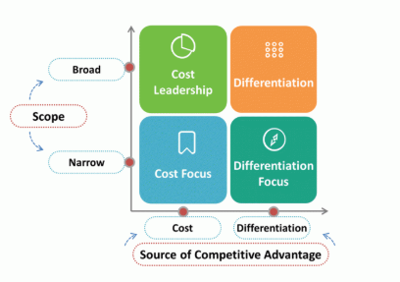
Figure 9: Porter's Generic Strategies
Source: (Wowslides, 2020)
Cost Leadership Strategy: The cost leadership strategy is designed to be the lowest-cost producer in the industry with acceptable product quality (Jerab and Mabrouk, 2023). Tesla has vertically integrated its operations, automated its Gigafactory and innovated battery technology to lower manufacturing costs. In 2025, Tesla sold around 1.79 million cars worldwide, which helped to achieve economies of scale, lowering production costs. The Model Y, though, remains a contender in the mid-range electric SUV market, and budget-friendly rivals like BYD, MG, and Hyundai are increasingly getting into the game of affordability. Thus, selling at a low cost might hurt Tesla's high-end brand image and its profit margins.
Differentiation Strategy: Differentiation is about providing a product that has some sort of distinction (Eikeland and Ohna, 2022). The Model Y is backed by about US$4.5 billion invested in R&D in 2025 and offers up to 387 miles (WLTP) driving range, over-the-air updates, AI features and access to more than 70,000 Superchargers around the world. These technical features set Tesla apart from rivals, support higher price points, and contribute to a loyal customer base in the UK EV market.
Focus Strategy: A focus strategy involves a narrow market targeting using a cost or a differentiation approach. Tesla's focuses mainly on consumers who are green-minded, tech-savvy, and looking for high-performance electric cars. While this strategy helps build brand positioning, it could hinder future growth as mass-market EV adoption gains momentum in the United Kingdom.

4.2 Identification of the Most Appropriate Strategy
Recommended Strategy: Differentiation
The most appropriate strategic choice for Tesla Model Y among Porter's generic strategies is differentiation, since the company's competitive advantage is based on technological innovation, software integration, premium quality and sustainability, not low prices. Differentiation helps Tesla stave off increased competition and secure customer loyalty (Eikeland and Ohna, 2022).
Evaluation Using the SAFe Framework
The SAFe Framework (Suitability, Acceptability and Feasibility) offers a systematic method of assessing strategic alternatives (Klaic et al., 2022). Given this, differentiation is the right business level strategy for Tesla Model Y.

Figure 10SAFe Framework
Source: (Self-Made)
Suitability: Differentiation is related to the external environment identified in the PESTEL analysis (Eikeland and Ohna, 2022). The UK EV market is growing, with environmental awareness, government incentives for ZEVs, and a growing demand for connected technologies making it an ideal environment for Tesla's innovation-driven approach.
Acceptability: The strategy provides value for key stakeholders in terms of support for revenue growth, premium profit margins and strengthening the over US$40 billion global brand value of Tesla. Customers enjoy state-of-the-art technology and investors are assured of long-term competitiveness.
Feasibility: Tesla has the tools it needs to get differentiation done. During 2025, the company generated approximately US$97.7 billion in revenue, employed more than 125,000 people globally and invested US$4.5 billion in research and development (Tesla, 2025).

4.3 Strategic Benefits of the Recommended Strategy
Duration of sustainable competitive advantage is achieved through the recommended differentiation strategy that places Tesla in the customer value arena of delivering superior technology, innovation and customer value, instead of price (Wu et al., 2022). Differentiation is a strategy that provides competitive advantage by providing distinctive products at premium prices, according to Porter (1985). This move is designed to further Tesla's goal of helping to transition to sustainable energy and solidifying the Model Y in the UK.
Competitive Advantage through Innovation
Continuous Product Innovation: In 2025, Tesla spent around US$4.5 billion on research and development, which will allow them to make constant enhancements to battery technology, AI and over-the-air software updates (Tesla, 2025). The Model Y has an extended driving range of up to 387 miles (WLTP), further enhancing product differentiation. The above capabilities are valuable, rare and hard for competitors to imitate thus supporting the VRIO framework.
Enhanced Customer Value: Tesla's offering of electric vehicles, software, and charging infrastructure is a unique proposition. As of 2025, the company had over 70,000 Superchargers worldwide and a global brand value of over US$40 billion. These strategic resources increase customer loyalty, reduce range anxiety and enable Tesla to sustain premium pricing despite increasing competition.
Long-Term Business Performance: The differentiation strategy is based on innovation to achieve sustainable growth, not competition through price (Eikeland and Ohna, 2022). Tesla's revenue in 2025, was around US$97.7 billion, sold around 1.79 million vehicles worldwide. Ongoing investments in renewable energy and digital technologies further boost sustainability and resilience in the organisation and long-term profitability.

4.4 Implementation Challenges and Mitigation Strategies
To implement the differentiation strategy, Tesla will face some operational and competitive hurdles in the fast-growing UK electric vehicle market.
Potential Implementation Challenges
- Increasing Industry Competition: The UK saw over 382,000 battery electric vehicles registered, and other manufacturers such as BYD, BMW, VW, Hyundai and MG are also continuing to build EV ranges (Micucci, 2025). The more competition there is the more pressure, and the more it poses a threat to Tesla's market share.
- Supply Chain and Regulatory Risks: Tesla relies on lithium, nickel and cobalt for battery manufacturing, and is therefore vulnerable to fluctuations in the raw material markets (Jones, Nguyen‐Tien and Elliott, 2022). The operational costs and regulatory complexity are also increased by the Zero Emission Vehicle (ZEV) Mandate 2024, and the Consumer Rights Act 2015, along with the UK GDPR.
Mitigation Strategies
- Strengthening Innovation: Tesla must keep investing in battery development, AI and manufacturing automation, as well as forming strategic partnerships with battery suppliers. These efforts will help to strengthen the technological leadership and enhance cost efficiency.
- Enhancing Customer Experience: Tesla should increase service centers in UK, improve after sales service and keep on adding more Supercharging stations. At the same time, better battery recycling and diversification of the supply chain will minimise operational risks and strengthen sustainability.

Conclusion
Overall, the report reveals that Tesla continues to hold a competitive edge in the UK EV sector due to its technological advancements, reputation, and commitment to sustainable business practices. While competition, regulatory shifts, and supply chain pressures are all potential threats, Tesla can mitigate these risks and continue to build its competitive edge, ensure sustainable growth, and generate long-term value for customers and shareholders by implementing a differentiation strategy that is grounded in constant innovation, operational excellence, and customer-centric initiatives.

Section 2

Reflective Account using Gibbs Reflective Cycle
Reflective practice is a systematic learning process that allows individuals to reflect on experiences and make improvements for subsequent practice (Mohamed, Rashid and Alqaryouti, 2022). Hence, I used Gibbs' Reflective Cycle to reflect on the research, analytical and preparatory process of strategic management report to Tesla Model Y in the United Kingdom.
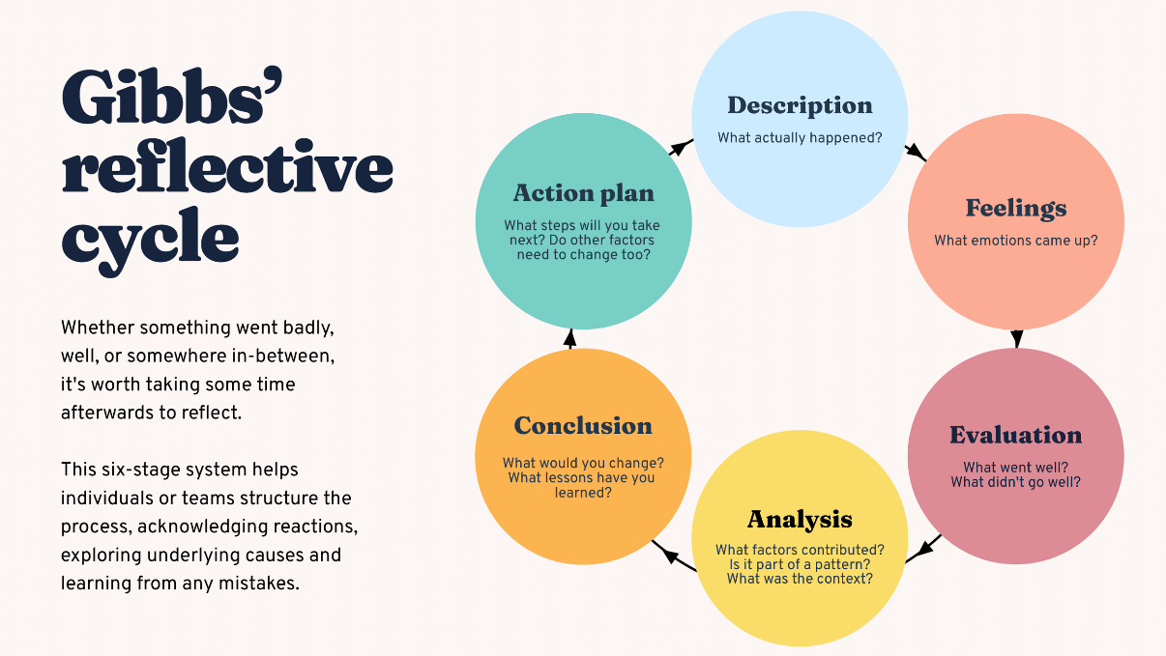
Figure 11Gibbs Reflective Cycle
Source: (BiteSize Learning, 2024)
1. Description
The first step is to objectify the experience (following Gibbs, 1988). To conduct a strategic analysis, I chose Tesla Model Y in the UK market because it had a lot of company information and up-to-date industry data. I took time to read the assessment brief to really get a handle on the learning outcomes and marking criteria of the report. The information was then gathered from the Annual Report of Tesla, publications of the UK Government, the Society of Motor Manufacturers and Traders (SMMT), and peer-reviewed journal articles. The report was structured using strategic management tools that include PESTEL, VRIO, SWOT, CSR, balanced scorecard and Porter's generic strategy. According to Hellberg and Fauskanger (2022), reflective learning is a process of relating theory and experience, which assist me to critically discuss Tesla's positioning instead of merely describing company activities.
2. Feelings
At the beginning of the assignment, I was confused with regard to using a number of models from strategic management; however, I had to keep my word limit in mind. Another issue I had with the selection of evidence was that I wanted to be sure that I was using reliable and current resources from a variety of academic and industry sources. As I carried out the research process though, my confidence grew, as I gained a greater understanding of each framework and how it applied in practice. Korthagen and Nuijten (2022) claims that reflection is a way to improve the work of the professional during and after the completion of tasks. This happened when I did every section of the assignment and it boosted my confidence and analytical skills for the assignment.
3. Evaluation
I think the report has been able to marry up the academic theory with the evidence from the organisation. Company statistics helped to bolster the analysis with up-to-date statistics and factual numbers, and strategic frameworks gave me a logical structure in which to assess Tesla's competitive position. However, I found having to edit the word count and only using the most pertinent information from a lot of academic resources was a problem. According to Marougkas et al. (2023), learning become more efficient when people evaluate their experience into knowledge. In retrospect, these difficulties have helped me to develop my academic writing, research skills and ability to prioritise information.
4. Analysis
This experience made me realise that strategic management is a practice that is dependent on an external and an internal analysis before giving strategic recommendations. Applying PESTEL identified the opportunities and threats within the UK electric vehicle market, whereas VRIO highlighted Tesla's valuable organisational capabilities. These findings were integrated into the SWOT analysis to create more well-balanced strategic recommendations. Amaya et al. (2022) stressed that the key to sustainable competitive advantage for organisations is to match internal capability to external market conditions. This is an aspect that was very relevant to me because Tesla's product differentiation strategy showed that there is a relationship between innovation, competitive advantages and long-term performance of the business.
5. Conclusion
This assessment helped to increase my knowledge and understanding of strategic management and reflective learning. I have enhanced my capacity to undertake academic research, critically analyse business information and to apply theory to real-life organisational issues. Critical reflection allows an individual to question their own assumptions and continually challenge the practice of the profession. I think that this experience has helped me to build my academic self-confidence and preparedness to do more strategic management projects in the future.
6. Action Plan
Development Area | Action Plan | Expected Outcome
Academic research | I will begin searching Google Scholar and university databases earlier to identify high-quality peer-reviewed literature. | Improve the quality and credibility of academic evidence.
Critical analysis | I will compare multiple strategic frameworks before making recommendations. | Produce more balanced and evidence-based strategic evaluations.
Time management | I will prepare a weekly study schedule with clear milestones before starting future assignments. | Complete future assessments more efficiently and reduce time pressure.
Referencing skills | I will improve my Harvard referencing skills by using university guidance and reference management software. | Reduce referencing errors and strengthen academic integrity.
Data analysis | I will continue using current company reports and industry statistics to support strategic recommendations. | Develop stronger evidence-based decision-making skills.
Reflective practice | I will apply Gibbs' Reflective Cycle after completing future academic work. | Promote continuous personal and professional development.
Table 1: My Personal Development Plan

References
Ali, M., Khan, T.I., Khattak, M.N. and ŞENER, İ. (2024). Synergizing AI and business: Maximizing innovation, creativity, decision precision, and operational efficiency in High-Tech enterprises. Journal of Open innovation technology market and complexity, [online] 10(3), pp.100352–100352. https://doi.org/10.1016/j.joitmc.2024.100352
Alkhodary, D. (2023). Integrating sustainability into strategic management: A path towards Long-Term business success. International journal of Professional business review: Int. J. prof.Bus. Rev., [online] 8(4), p.39. https://dialnet.unirioja.es/servlet/articulo?codigo=8956100
Amaya, N., Bernal-Torres, C.A., Nicolás-Rojas, Y.W. and Pando-Ezcurra, T.T. (2022). Role of internal resources on the competitive advantage building in a knowledge-intensive organisation in an emerging market. VINE journal of Information and knowledge management systems, [online] 54(5), pp.1–17. Available at: https://www.emerald.com/insight/content/doi/10.1108/VJIKMS-01-2022-0029/full/html [Accessed 19 July 2026].
Ardiansyah, M. and Alnoor, A. (2024). Integrating corporate social responsibility into business strategy: Creating sustainable value. Involvement international journal of Business, 1(1), pp.28–41. https://doi.org/10.62569/iijb.v1i1.5
Armstrong, M., (2021). Armstrong’s Handbook of Strategic Human Resource Management. 7 ed. London: Kogan Page. https://books.google.com/books?hl=en&lr=&id=FeynCwAAQBAJ&oi=fnd&pg=PP1&dq=Armstrong,+M.,+(2021).+Armstrong%E2%80%99s+Handbook+of+Strategic+Human+Resource+Management.+7+ed.+London:+Kogan+Page.&ots=1oKZA2OgXB&sig=zUWp4JxhgDZ27rFuyUNKNpk6HeY
Bailey, C., Mankin, D., Kelliher, C. & Garavan, T., (2018). Strategic Human Resource Management. 2 ed. Oxford: Oxford University Press. https://books.google.com/books?hl=en&lr=&id=ghFQDwAAQBAJ&oi=fnd&pg=PP1&dq=Bailey,+C.,+Mankin,+D.,+Kelliher,+C.+%26+Garavan,+T.,+(2018).+Strategic+Human+Resource+Management.+2+ed.+Oxford:+Oxford+University+Press.&ots=nTXVNuTQpf&sig=iFyfrsGR2r5mI_rwvL7_Qa4eaEY
Bitesize (2024). How to do a SWOT analysis [with examples & templates]. [online] BiteSize Learning. Available at: https://www.bitesizelearning.co.uk/resources/swot-analysis-explained-examples-templates [Accessed 24 July 2026].
BiteSize Learning (2024). The gibbs reflective cycle, explained. [online] BiteSize Learning. Available at: https://www.bitesizelearning.co.uk/resources/gibbs-reflective-cycle-explained-diagram-examples [Accessed 20 July 2026].
Brand, C., Marsden, G. and Anable, J. (2022). The role of energy demand reduction in achieving net-zero in the UK: Transport and mobility. Proceedings of the eceee summer study 2022. [online] Available at: https://ora.ox.ac.uk/objects/uuid:a1f5ffe1-89d7-47c3-bb9e-9c464bd40bf6 [Accessed 22 July 2026].
Bull, A. (2025). What is the current UK inflation rate (july 2025)? [online] International Payments & Currency Exchange Rates. Available at: https://cambridgecurrencies.com/current-uk-inflation-rate-july-2025/ [Accessed 24 July 2026].
Eggers, N.J. (2023). Tesla - the future largest player in the automotive industry. [online] Run.unl.pt. Available at: https://run.unl.pt/entities/publication/d0e5e163-2e6f-41aa-b13b-3e067d09e16a [Accessed 22 July 2026].
Eikeland, I. and Ohna, S.E. (2022). Differentiation in education: A configurative review. Nordic journal of Studies in Educational policy, [online] 8(3), pp.157–170. https://doi.org/10.1080/20020317.2022.2039351
Electrive (2025). Over 380,000 electric cars registered in the UK in 2024 - electrive.com. [online] electrive.com. Available at: https://www.electrive.com/2025/01/06/over-380000-electric-cars-registered-in-the-uk-in-2024/ [Accessed 22 July 2026].
Ghaffarpasand, O. and Pope, F.D. (2025). Air pollution emissions from vehicles as a function of their current real-world market price. Journal of Cleaner production, [online] https://www.sciencedirect.com/science/article/pii/S0959652625024333.
Hellberg, R. and Fauskanger, E. (2022). Learning of quality improvement theory – experiences with reflective learning from a student perspective. International journal of Lean six sigma. https://doi.org/10.1108/IJLSS-04-2022-0090
Jerab, D. and Mabrouk, T. (2023). Achieving competitive advantage through cost leadership strategy: Strategies for sustainable success. [online] Social Science Research Network. Rochester, NY. https://doi.org/10.2139/ssrn.4574945
Jones, B., Nguyen‐Tien, V. and Elliott, R.J.R. (2022). The electric vehicle revolution: Critical material supply chains, trade and development. The world economy, 46(1). https://onlinelibrary.wiley.com/doi/10.1111/twec.13345
K, R. and Lingam, M.S. (2025). Entrepreneurship for a sustainable world:Innovations leading the WAY toward global sustainability goals. International journal of Advances in Business and management research, [online] 03(02), pp.24–35. https://doi.org/10.62674/IJABMR.2025.V3I02.003
Klaic, M., Kapp, S., Hudson, P., Chapman, W., Denehy, L., Story, D. and Francis, J.J. (2022). Implementability of healthcare interventions: An overview of reviews and development of a conceptual framework. Implementation science, [online] 17(1). https://doi.org/10.1186/s13012-021-01171-7
Kolodny, L. (2026). Tesla tops estimates for quarter, but wraps up first annual revenue drop on record. [online] CNBC. Available at: https://www.cnbc.com/2026/01/28/tesla-tsla-2025-q4-earnings.html [Accessed 27 July 2026].
Korthagen, F. and Nuijten, E., (2022). The power of reflection in teacher education and professional development: Strategies for in-depth teacher learning. Routledge. https://api.taylorfrancis.com/content/books/mono/download?identifierName=doi&identifierValue=10.4324/9781003221470&type=googlepdf
Macrotrends (2024). Tesla research and development expenses 2009-2019 | TSLA. [online] Macrotrends.net. Available at: https://www.macrotrends.net/stocks/charts/TSLA/tesla/research-development-expenses [Accessed 26 July 2026].
Marougkas, A., Troussas, C., Krouska, A. and Sgouropoulou, C. (2023). Virtual reality in education: A review of Learning theories, approaches and methodologies for the last decade. Electronics, [online] 12(13), p.2832. https://doi.org/10.3390/electronics12132832
Mehlig, D., ApSimon, H. and Staffell, I. (2022). Emissions from charging electric vehicles in the UK. Transportation research part d: Transport and environment, [online] 110, p.103430. https://doi.org/10.1016/j.trd.2022.103430
Miao, D. (2025). Tesla’s innovation management strategy and market strategy optimization analysis. SSRN Electronic Journal, [online] pp.224–229. https://doi.org/10.5220/0013988900004916
Micucci, L. (2025). Electric vehicles: Actual market and future prospects , with a focus on battery technology - webthesis. Polito.it. [online] Available at: https://webthesis.biblio.polito.it/35717/ [Accessed 29 July 2026].
Mohamed, M., Rashid, R.A. and Alqaryouti, M.H. (2022). Conceptualizing the complexity of Reflective practice in Education. Frontiers in psychology, [online] 13(1), pp.1–8. https://doi.org/10.3389/fpsyg.2022.1008234
Nalina Hamsaiyni Venkatesh and Laurencas Raslavičius (2024). A national innovation system Concept-Based analysis of Autonomous vehicles’ potential in Reaching Zero-Emission fleets. Technologies, 12(2), pp.26–26. https://doi.org/10.3390/technologies12020026
Quang Hậu, P. (2021). What is direct to Consumer brands? The top D2C brands 2024. [online] Magenest - One-Stop digital transformation solution. Available at: https://magenest.com/en/direct-to-consumer-brands/?srsltid=afmbooqzyablrooc4bnqlwjuovr6de4ggj6u0mk4er-dycch6jxxyftz
[Accessed 27 July 2026].
Shahzad, S., Faheem, M., Muqeet, H.A. and Waseem, M. (2024). Charting the UK’s path to Net zero emissions by 2050: Challenges, strategies, and future directions. IET smart grid, 7(6). https://ietresearch.onlinelibrary.wiley.com/doi/abs/10.1049/stg2.12185
Shbool, M.A., Al-Bazi, A. and Al-Hadeethi, R. (2022). The effect of customer satisfaction on parcel delivery operations using autonomous vehicles: An agent-based simulation study. Heliyon, [online] 8(5), p.e09409. https://doi.org/10.1016/j.heliyon.2022.e09409
Shen, W. and Liu, Y. (2025). Data governance rules in the context of Connected vehicles. SSRN Electronic Journal, pp.173–196. https://doi.org/10.1007/978-981-96-1277-2_8
Silva, D. (2026). Equity research on Tesla Inc. : Distinguishing a good company from a good investment. [online] Repositorio.ucp.pt. Available at: https://repositorio.ucp.pt/entities/publication/72264820-aa3d-456b-bfb3-ddd19ba93c3b [Accessed 28 July 2026].
Singh, D. (2024). Balanced scorecards explained: A guide for HR professionals. [online] peoplestrong. Available at: https://www.peoplestrong.com/blog/balanced-scorecards/ [Accessed 19 July 2026].
Tesla (2025). About tesla. [online] Tesla. Available at: https://www.tesla.com/about [Accessed 25 July 2026].
Vecteezy (2024). Pestel analysis is used to identify threats and weaknesses to examines the political, economic, social, technological, environmental, and legal factors in the external environment. [online] Vecteezy. Available at: https://www.vecteezy.com/vector-art/33238849-pestel-analysis-is-used-to-identify-threats-and-weaknesses-to-examines-the-political-economic-social-technological-environmental-and-legal-factors-in-the-external-environment [Accessed 19 July 2026].
Watson, M. (2025). VRIO framework. [online] The Community. Available at: https://community.montyhalls.co.uk/vrio-framework/ [Accessed 20 July 2026].
Wowslides (2020). Generic competitive advantage template. [online] Free PowerPoint Template. Available at: https://yourfreetemplates.com/generic-competitive-advantage-template/ [Accessed 22 July 2026].
Wu, Z.-Q., Nguyen, P.-Q., Phankasemsan, I. and Wolf, E. (2022). Driving sustainability and electric vehicles evolution: Tesla company’s success strategies. Dspace.fcu.edu.tw. http://dspace.fcu.edu.tw/handle/2376/4771
Zhang, Y., Li, S., Blythe, P., Wardle, J., Herron, C., Edwards, S., Li, D., Ji, Y. and Namdeo, A. (2025). Analysis of electric vehicle charging behaviour in existing regional public and workplace charging infrastructure: A case study in the North-East UK. Transportation engineering, p.100309. https://doi.org/10.1016/j.treng.2025.100309

