

PROGRAMME: MBA – International Business
Term 1

STUDENT NAME: YASHKUMAR DHOLAKIYA
STUDENT ID: 2505243

MODULE: Human Capital Management
MODULE CODE: LCMB7023

Lecturer’s Name: Dr. Gladius Kulothungan
Word Count: 2598/2500

Executive summary
The analysis revealed that human resource management refers to the analysis and development of strategic plans to maximise employee engagement, and employee’s abilities for new skill development. AI and automation has been explored as two major concepts of IHRM initiatives within the modern organisational setup. Moreover, the implication of advanced automation also comes with some of the negative traits like bias decision-making during employee hiring that further reshaping the process of skill hiring practices. Gibbs reflective model is implemented in the study to evaluate strengths and weaknesses in “communication, teamwork, technology, leadership and self-directed learning”. Furthermore, learning experience from performance management and internship is evaluated in the report.

Table of Contents
Introduction: 3
Question 1: Analysis of the impact of technological advancement in reshaping labour markets and its implications in HRM and IHRM strategies 3
Question 2: key demographic and geopolitical factors influencing employment markets today and how they have created challenges for HR professionals? 4
Question 3: Strategy that can used by organisations to address the persistent skills gap and talent shortages in the critical sector through strategic HRM 6
Question 4: Reflective report on my current capabilities, learning activities, and recent working experiences in working within an international context 8
Conclusion: 11
Reference list 12

Introduction:
Technological advancements are rapidly influencing Human resource management processes. In fact. Technologies like AI and ML have considerably influenced the ways employees are been screened, recruited and management within an organization. The following study, will explain in details the ways, technological aspects and embedded within Human resource management.

Question 1: Analysis of the impact of technological advancement in reshaping labour markets and its implications in HRM and IHRM strategies
Claim
Human Resource management refers to the analysis and development of strategic plans to maximise employee engagement, and employee’s abilities for new skill development. As mentioned by Allal-Chérif et al. (2021), successful integration of Artificial Intelligence (AI) allows companies to gain rapid flexibility in employee recruitment and training management process. Moreover, a progress on selecting potential candidates in business has become possible with the integration of AI. As stated by Cramarenco et al. (2023), AI is beneficial for taking online interview of employees that further helps to analyse digital skills of individual employees. Hence, it can be said that AI plays a potential role in organisational context for making transformation in HRM practices by developing practices of IHRM.
Evidence
AI and automation has been explored as two major concepts of IHRM initiatives within the modern organisational setup. As opined by Bayya (2022), automation technologies like big data helps companies to implement ethical process of employee training thorough two way information transaction initiatives. Moreover, digital platforms like Zoom has been explored as beneficial for companies for maintaining employee hiring initiatives in organisational context. For example, IBM employed over 35% of its employee from 2023-2025 thorough digital interview thorough Google Meet platforms (Reuters, 2025). On the other hand, integration of AI has been explored as beneficial for large-scale companies to explore skilful employees for the required industry though digital platforms like Indeed. It further helps to explore involvement of advanced technologies like AI and automation helps companies to improve quality standards of IHRM practices.
The implication of advanced automation also comes with some of the negative traits like bias decision-making during employee hiring that further reshaping the process of skill hiring practices. As stated by Chanana and Sangeeta (2021), online employee hiring process is unable to provide accurate result in the procedure of maintaining employee or labour engagement initiatives. As reported, 50% of the job candidates are facing struggle due to the online biases in the procedure of IHRM in international market (Schellmann, 2022). Based on this challenge companies from large-scale industries are working though the process of both online and offline interview conduction for identifying behavioural traits of candidates.
Interpretation
The above analysis edifies that implication of digital platform based IHRM causes bias employee hiring decisions in the organisational context. Based on these issues, application of contingency theory of employee management can be proven as beneficial for maintaining standardisation program of HRM practices. As mentioned by Donnelly and Johns (2021), contingency theory is beneficial for exploring online and offline employment skills during HRM practices. Thus, the use of contingency theory has been explored as beneficial for developing effective growth of HRM initiatives for reducing biases during labour management initiatives.

Question 2: key demographic and geopolitical factors influencing employment markets today and how they have created challenges for HR professionals?
Claim
The key demographic and geopolitical factors influencing employment markets today are multigenerational workforce, global migration, political instability and trade tension. These factors have created significant challenges for the HR professionals for talent management, resource allocation and fostering inclusive learning environments towards the workplace for improving productivity. Rising migration flow, sanctions and tariffs are creating economic and social disorder that will likely persist for many years (Iclg, 2025). As per the ILO global employment growth forecast global employment growth is downgraded to 1.5% in the year 2025 due to geopolitical tension, trade tension, global immigration and structural changes along with risk of inflation within the country (Iclg, 2025). Meanwhile, key demographic factors such as the aging population, skills gap in the high income countries significantly impacted the HR professional to integrate better talent and skills in the global workforce management.
Evidence
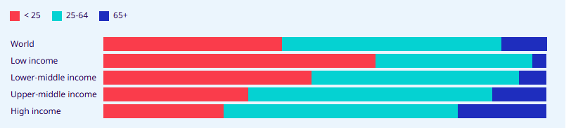
Figure 1: Distribution of population by age group in 2024
(Source: Ilostat, 2024)
The above figure indicates that one fifth of the population in the high income countries are over 65 years of age and only 3% in the low income countries (Ilostat.ilo, 2024). The demographic shift poses challenges for the HR professionals for creating effective pension systems and labour force dynamics. On the other hand, urbanisation is the major demographic trends and geo political factors that have impacted the HR professionals and develops shifts in the employment patterns and creating new job opportunities. As opined by GRENČÍKOVÁ et al. (2022), the labour market has also been transformed by the smart working environment which has changed the operation of the major companies and working environments. Another major challenge faced by HR professionals is the multigenerational workforce that is baby boomers – born after WW II, generation X, generation Y, and generation Z. Each generation has different points of views and working patterns in the global companies which has created major shifts in the labour market and influences employment opportunities. On the other hand, global migration is another geopolitical factor that influences the employment market and can create a negative force in human capital growth. As for example, the share of jobs by non-UK citizens have been increased by 20% in the year 2024 (Migrationobservatory, 2025). London has the highest proportion of jobs held by non-UK citizens that is estimated at 42%. Thus, global migration has created major difficulty for the HR professionals to manage cultural inclusion, diversity in the workforce in the country's organisational workplace.
Interpretation
It can be interpreted that geo-political factors such as tariffs, multigenerational workforce, global migration factors are creating major challenges for the HR professional to integrate talent in the workplace by managing diverse culture, collaboration and integration of labour policy in the cross border. As opined by Ererdi et al. (2022), political circumstances, demographic and HRM practices in the country has impacted the labour source in the global employment market. Lack of implementation of breast HRM practice in the MNC has created major challenges for HR professionals to create an effective talent management strategy in the workplace.

Question 3: Strategy that can used by organisations to address the persistent skills gap and talent shortages in the critical sector through strategic HRM
Claim
Organisations can address the persistent skills gap and talent shortages in the critical sector such as technology, health care and hospitality through developing an effective learning management system. The SHRM intervention focused on the build versus buy talent approach can help to make strategic partnership with the global employees and reduce skills gap through performance evaluation (Kunsman, 2025). Upskilling and reskilling programs through software can help the employees to adapt with the latest technology and integrate better skills in the learning and development (Sap, 2025). The HR and talent management team in the organisation can use AI driven analytics to track workforce data regarding the skills and performance certification required. On the other hand, Borderless hiring and global mobility can help the organisations to adopt better HR strategy in supplying talented workforce and reduce chances of skills gap in the industry. For example, Marriott hotel HR professionals have developed effective leadership capability and innovation through a learning program for front line crew members to reduce the chances of skills gap (Shumway, 2021). Guiding principles and honesty along with transparency in the HR operation can help the organisations to manage the issue of skills gap.
Evidence
Strategic inhuman resource management strategies used by the organisations to manage skills gap issues are international mobility, talent acquisition and performance analysis. For example, GSK has developed an industry led manager training policy that helps to support employees and managers in talent management and skills enhancement in the global workforce (GSK, 2025). A flexible and life-friendly working environment helps employees to increase motivation for work and increase skills in the global workforce. Thus, international talent acquisition programs, training and performance analysis can help HR managers to reduce the skills gap in the global workplace. Organisations can therefore implement strategic HRM products in the way to prioritise upskilling and reskilling prospects, thereby managing an effective learning management system to support AI-driven analytics in future. A focus over strategic partnerships, followed by managing transparency towards HR practices management can be thoroughly recommended for mitigating persistent skill shortage issues.
Interpretation
HR professionals in the critical sector can use credential programs, certifications and internship programs that can help the employees to enhance skills and knowledge for managing issues of skills gap. For example, GE appliances and Unilever have award winning training programs that help the companies to manage the issue of skills gap of the employees (Paycor, 2025). An adoption of built versus buy approach in terms of talent management can help in leveraging global mobility, thereby recognising accessibility towards performance-based training implication. Additionally, the HR group can take positive amplification of relative certifications and internships, thus suggesting a supportive and flexible work environment collectively for managing business goals. Thus, aligning business goals with the SHRM can help the organisations to integrate better growth through talent management.

Question 4: Reflective report on my current capabilities, learning activities, and recent working experiences in working within an international context
Claim
The current globalised workspace has helped me in interpreting my knowledge development as a business management professional, thereby recognising multicultural and global environment amplification. My communication ability has become ideal for strengthening efficient work amplification, thus ensuring possible clarity over professionalism across international teams. On the other hand, a writing approach for amplifying verbal and non-verbal communication can be thoroughly recognised by effective organisational improvement, thereby managing positive relations with customers and staff (Flores et al., 2023). I faced challenges in technology application during my internship that made me realise about importance of improving cognitive skills and self-directed learning.
Evidence
Performance management is one of the most important session for me that help me to realise my strengths and weaknesses required in a globalised workplace. “Flexibility, resilience, leadership, cognitive skill, creative thinking, skill awareness, collaborative work and problem solving” are core skills required in today’s workplace (World Economic Forum, 2025). I have understood that improvement in technology skills is important to manage market trends. I have to utilise my communication and teamwork skills to quickly learn about key HR technology as realised from the weekly sessions and internship. I can say that improvement in cognitive skills and self learning ability can help me in achieving my professional goal of being a business analyst.
Interpretation
Gibbs' Reflective Cycle:
The “Gibbs' Reflective Cycle” is effective for evaluation of an individual’s learning experience throughout six stages. “Description, feelings, evaluation, analysis, conclusion and action plan” are stages of “Gibbs' Reflective Cycle” (Ocampo et al., 2025). I have learnt a lot of things from weekly sessions; however, performance management was part of session 2 of week 8. It helps me to realise my strengths and areas of improvement to achieve my career goal of business analyst in future.
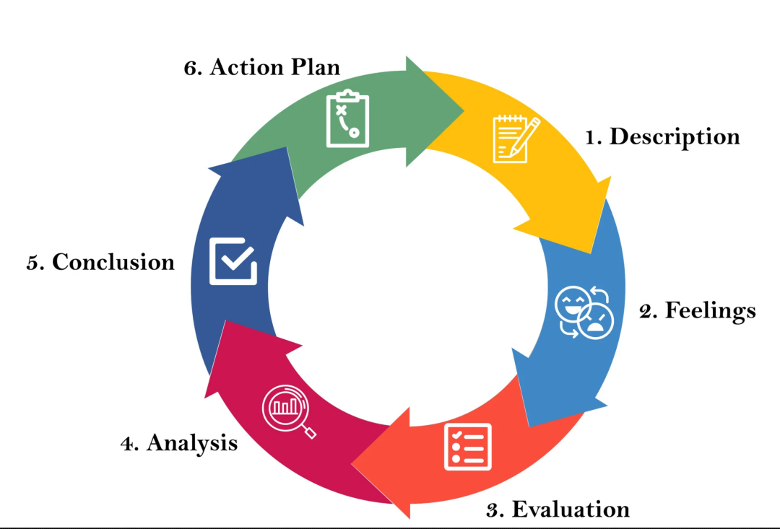
Figure 2: Stages of Gibbs' Reflective Cycle
(Source: Inspired by Ocampo et al., 2025)
- Description
A globalised workplace requires skilled employees to work in an international environment. However, it makes me realise my capabilities in communication, technology, teamwork, self-directed learning, leadership and cognitive skills. “Human Resource Information Systems (HRIS)” integrates key “human resource (HR)” functions such as recruitment, performance management and payroll (Ogbe and Uchechukwu, 2024). I have learnt about HRIS from a performance management session; however, it was quite difficult for me to understand technology application in the HR system. I have also learnt about key HR roles that include managers' training and monitoring outcomes. I have understood that communication and teamwork are essential in HR job roles. Hence, continuous adoption is important in a globalised workplace to achieve emerging opportunities as per my realisation from weekly sessions.
- Feeling
I have mixed feelings in class sessions, as initially learning a lot of new things makes me joyful and fearful. I was happy to learn about “Human Capital Management” from weekly sessions as it is one of my areas of interest. HRIS is important to manage workflow automation, enhance data accuracy and utilise a unified platform for employee data storage (Saha, 2023). I have faced challenges in understanding application of HRIS system in performance management session. It makes me realise about difficulties in understanding technology applications. However, I also faced challenges in quickly learn about technology applications during my internship experience in an international organisation. Moreover, it makes me sad due to my inadequate technological skills and quick learning ability. Apart from technology challenges, I was happy that my communication and teamwork abilities influenced me to seek help from peers and overcome challenges.
- Evaluation
My weekly sessions of “Human Capital Management” and recent internship work experience have helped me learn a lot of things about HR systems and technology applications. Evaluation stage of Gibbs model evaluates the good or bad experience of individuals (Ahmadpour et al., 2025). My current learning activities in the module provide me good experience by knowing HR roles. I have understood that my inappropriate cognitive skills, self-directed learning ability and technology competence made it difficult for me to understand complex topics such as HRIS. My collaboration, leadership teamwork are good as realised from my previous group projects. It helps me to ask for help from the tutor and my friends to create a deep understanding of the performance management system.
- Analysis
I have recognised my areas for improvement or weaknesses in cognitive skills, technology competence and self-directed learning. It creates challenges for me in performance management sessions to understand the application of the HRIS system in international organisations. I also faced challenges during my internship as it was difficult to adopt technology in my work roles. In contrast, effective communication, teamwork and leadership are vital assets for business competencies, administration and knowledge-based society growth (Mercader et al., 2021). My strength in teamwork, communication and leadership skills helps me to increase understanding of HRIS system by discussing with my friends. I have learnt about technology practices in performance management class by communicating with my friends. Hence, I have to improve my cognitive skills, technology and self-directed learning to achieve my career objective of being a business analyst in “Human Capital Management” field.
- Conclusion
Conclusively performance management sessions and internship work experience help me to realise my strengths in teamwork, communication and leadership skills. I have to improve my cognitive skills, technology competence and self-directed learning for better career growth opportunities. It can help me to be a business analyst in future and manage continuous adaptability in a globalised workplace.
- Action plan
Objectives | Actions taken | Resources needed | Time frame
Improvement in technology proficiency | I will enrol in an online course for HRIS and join a webinar to learn HR analytics | Online learning platform access and IT support from the University | 3-6 months
Improvement in cognitive skills | I will participate in a group project and case study analysis to increase problem solving ability | Academic textbook and journals | 6-9 months
Self-directed learning skill development | Structured study schedule development and feedback from lecturers | Planner app and academic advisory support | 9-12 months
Table 1: Action plan
(Source: Self-Developed)

Conclusion:
Conclusively, it can be stated that technological advancements are considerably shaping the labour markets. Consequently, there are certain implications on HRM and IHRM strategies. The study had showcased the ways key demographic and geopolitical factors influence HR markets today. Additionally, strategic measures for dealing with skill gap and talent shortages have also been presented.

Reference list
Ahmadpour, N., Shariati, A. and Moghadam, M.P., (2025) ‘Effect of narrative writing based on Gibbs’ reflective model on the empathy and communication skills of nursing students’. BMC Medical Education, 25(1), p.10. https://link.springer.com/article/10.1186/s12909-024-06593-7
Allal-Chérif, O., Aránega, A.Y. and Sánchez, R.C., (2021) ‘Intelligent recruitment: How to identify, select, and retain talents from around the world using artificial intelligence’, Technological Forecasting and Social Change, 169, p.120822. https://doi.org/10.1016/j.techfore.2021.120822
Bayya, A.K., (2022) ‘Advocating Ethical Data Management and Security’, International Journal of Scientific Research in Computer Science, Engineering and Information Technology (IJSRCSEIT) Volume, 8, pp.396-417. https://link.springer.com/article/10.1007/s10551-022-05240-9
Chanana, N. and Sangeeta, (2021) ‘Employee engagement practices during COVID‐19 lockdown’, Journal of public affairs, 21(4), p.e2508. https://doi.org/10.1002/pa.2508
Cramarenco, R.E., Burcă-Voicu, M.I. and Dabija, D.C., (2023) ‘The impact of artificial intelligence (AI) on employees’ skills and well-being in global labor markets: A systematic review’, Oeconomia Copernicana, 14(3), pp.731-767. https://urn.fi/URN:NBN:fi-fe2025060358297
Donnelly, R. and Johns, J., (2021) ‘Recontextualising remote working and its HRM in the digital economy: An integrated framework for theory and practice’, The International Journal of Human Resource Management, 32(1), pp.84-105. https://doi.org/10.1108/IJCHM-06-2022-0793
Ererdi, C., Nurgabdeshov, A., Kozhakhmet, S., Rofcanin, Y. and Demirbag, M., (2022). ‘International HRM in the context of uncertainty and crisis: A systematic review of literature’ (2000–2018). The International Journal of Human Resource Management, 33(12), pp.2503-2540. Available at: https://repository.essex.ac.uk/29323/1/IJHRM%20-%204th%20Revision-Final-Repository.pdf
Flores, J.L., Kilag, O.K., Tiu, J., Groenewald, E., Balicoco, R. and Rabi, J.I. (2023) ‘TED Talks as Pedagogical Tools: Fostering Effective Oral Communication and Lexical Mastery’. Excellencia: International Multi-disciplinary Journal of Education (2994-9521), 1(6), pp.322-333. https://www.researchgate.net/profile/Elma-Groenewald-2/publication/376643347_TED_Talks_as_Pedagogical_Tools_Fostering_Effective_Oral_Communication_and_Lexical_Mastery/links/65d5a706e7670d36abcacf47/TED-Talks-as-Pedagogical-Tools-Fostering-Effective-Oral-Communication-and-Lexical-Mastery.pdf
GRENČÍKOVÁ, A., HABÁNIK, J., ŠPANKOVÁ, J., HÚŽEVKA, M. and ŠRÁMKA, M., (2022). ‘Current Labour Market Challenges in the Light of Future Economic and Demographic Developments’. European Journal of Interdisciplinary Studies, 14(1). Available at: http://doi.org/10.24818/ejis.2022.07
GSK (2025) ‘Life at GSK’. Available at: https://www.gsk.com/en-gb/careers/life-at-gsk/ (Accessed: 08 November 2025)
Iclg (2025) ‘IBA highlights geopolitical impact on global employment’. Available at: https://iclg.com/news/22917-iba-highlights-geopolitical-impact-on-global-employment#:~:text=Rising%20migration%20flows%2C%20sanctions%20and,in%20ways%20previously%20unheard%20of (Accessed: 08 November 2025)
Ilostat (2024) ‘How population trends shape our workforce’. Available at: https://ilostat.ilo.org/how-population-trends-shape-our-workforce/#:~:text=Get%20the%20data-,International%20migration,million%20international%20migrant%20workers%20globally (Accessed: 08 November 2025)
Kunsman (2025) ‘Smart Strategies for HR Leaders Facing Labor Shortages’. Available at: https://www.remofirst.com/post/hr-leaders-labor-shortages#:~:text=Continuous%20(Re/Up)%2DSkilling,buy%E2%80%9D%20talent (Accessed: 08 November 2025)
Mercader, V., Galván-Vela, E., Ravina-Ripoll, R. and Popescu, C.R.G., (2021) ‘A focus on ethical value under the vision of leadership, teamwork, effective communication and productivity’. Journal of Risk and Financial Management, 14(11), p.522. https://doi.org/10.3390/jrfm14110522
Migrationobservatory (2025) ‘Migrants in the UK labour market: an overview’. Available at: https://migrationobservatory.ox.ac.uk/resources/briefings/migrants-in-the-uk-labour-market-an-overview/ (Accessed: 08 November 2025)
Ocampo, F.A., McIntyre, B.G., Massey, D. and Saunders, R., (2025) ‘Nursing student reflections on a research internship: A reflective discussion following the Gibbs' reflective cycle’. Nurse Education Today, 145, p.106481. https://doi.org/10.1016/j.nedt.2024.106481
Ogbe, O. and Uchechukwu, J., (2024) ‘Cloud-based HRIS solutions: Transforming human resource management in a hybrid workforce era’. International Journal of Research Publication and Reviews, 5(11), pp.5500-5515. https://doi.org/10.55248/gengpi.5.1124.3342
Paycor (2025) ‘Top Strategies and Solutions to Overcome a Talent Shortage’. Available at: https://www.paycor.com/resource-center/articles/talent-shortage/ (Accessed: 08 November 2025)
Reuters, (2025) ‘IBM to cut thousands of jobs in fourth quarter amid software focus’, Reuters, 5 November. Available at: https://www.reuters.com/business/world-at-work/ibm-cut-thousands-roles-focus-software-growth-bloomberg-news-reports-2025-11-04/ (Accessed 6 November 2025)
Saha, B., (2023) ‘Robotic Process Automation (RPA) in onboarding and offboarding: Impact on payroll accuracy’. IJCSPUB, 13(2), pp.237-256. https://d1wqtxts1xzle7.cloudfront.net/121293321/IJCSP23B1502-libre.pdf?1739265999=&response-content-disposition=inline%3B+filename%3DRobotic_Process_Automation_RPA_In_Onboar.pdf&Expires=1762609269&Signature=JWZWkLKz1pcQn2~kX4AVy-ijylvYDI0awHTQGI0fmSlhKjiBpKyHrEYkJ7haXD9mqs600PaLvwcweAOH1Rbj8qD9zjdnYGwaUySpqpBdsEGdaJkymnW2a721IQCEFL66kpqSMVr68j-ad7So-bq2pwS6zr3tJ0nt4XKlwiX7~aMgvurH2zM1dKhF-wvANM~tsXA1xmovRJZKueFkE19zxIbN5K4tMUMtgl4sqQUMmBhlJ0hbzZnhQj7alypVfRIac6kEcOyqu89DcWB1Gwfe3U42EsZkzIwG7WfVr2vs53-Y118yoxamnpigOa2p8cCpr6b8nITeAFQc9R3XDWA69A__&Key-Pair-Id=APKAJLOHF5GGSLRBV4ZA
Sap (2025) Close the workforce skills gap with upskilling and reskilling. Available at: https://www.sap.com/latinamerica/resources/upskilling-and-reskilling-the-workforce (Accessed: 08 November 2025)
Schellmann, H. (2022) ‘Finding it hard to get a new job? Robot recruiters might be to blame’, The guardian, 11 May. Available at: https://www.theguardian.com/us-news/2022/may/11/artitifical-intelligence-job-applications-screen-robot-recruiters (Accessed 6 November 2025)
Shumway (2021) 4 strategies that helped a Marriott HR exec weather ‘the most challenging year’. Available at: https://www.hrdive.com/news/4-strategies-that-helped-a-marriott-hr-exec-weather-the-most-challenging-y/598648/ (Accessed: 08 November 2025)
World Economic Forum (2025) ‘The Future of Jobs Report 2025’. Available at: https://www.weforum.org/publications/the-future-of-jobs-report-2025/in-full/3-skills-outlook/ (Accessed: 07 November 2025)

