

Program Name: | Master of Business Administration in International Business
Module Name: | Dissertation
Module Code: | LCMB7035
Report Title: | “Customer trust and its impact on usage of fintech services in the UK”
Student Name: | Masum Patel Harishbhai
Student ID: | 2430264
Supervisor: | Dr Andry Rakotovololona
Date of Submission: | 03 June 2026

Abstract
This paper investigates the role of customer trust in incorporating, maintenance, and behaviour priority of using FinTech services in the regulated digital financial ecosystem of the United Kingdom. Although the UK FinTech market has reached an approximate of 14.74 billion in 2025, structural obstacles related to trust tend to slow down consumer penetration due to data insecurity, privacy issues, and financial risk. Based on the Perceived Risk Theory, and backed by the Technology Acceptance Model and the Unified Theory of Acceptance and Use of Technology, the study has a quantitative survey design based on receiving responses to 114 FinTech users located in the UK, which is analysed by the regression, correlation, and reliability by using SPSS.
There were three hypotheses that were tested. Customer trust was found to be an important positive predictor of FinTech usage intention (H1 was accepted). The strongest antecedents of trust were found to be perceived security and regulatory assurance (H2 supported). Surprisingly, the perceived risk showed a positive correlation with the intention to use (H3 was rejected), indicating that under a high-regulation situation, experienced users incorporate risk awareness when continuing their use instead of avoiding it.
The study also fills a gap in the empirical literature on UK-specific digital trust, providing contextually-specific theoretical inputs and practical advice to FinTech providers, regulators, and policymakers to increase consumer trust in digital financial services.

Table of Contents
Chapter 1: Introduction 7
1.1 Background and Context 7
1.2 Research Problem 8
1.3 Research Aim 8
1.4 Research Objectives 9
1.5 Research Questions and Hypotheses 9
1.6 Significance and Contribution of the Study 10
1.7 Scope of the Study 10
1.8 Theoretical Framework 10
1.9 Structure of the Dissertation 11
Chapter 2: Literature Review 12
2.1 Introduction 12
2.2 Empirical Analysis 12
2.3 Theories and Models 23
2.3.1. Technology Acceptance Model (TAM) 23
2.3.2 Unified Theory of Acceptance and Use of Technology (UTAUT) 24
2.3.3 Perceived Risk Theory 25
2.3.4 Most useful theory 26
2.5 Summary 27
Chapter 3: Methodology 28
3.1 Introduction 28
3.2 Research Onion 29
3.3 Research Philosophy 29
3.4 Research Approach 30
3.5 Research Strategy 30
3.6 Data Collection Method 31
3.6.1 Sampling Procedure 31
3.6.2 Survey Design 31
3.6.3 Survey Distribution and Storage 32
3.6.4 Operationalization Table 33
3.7 Data Analysis Method 34
3.7.1 Software Used 34
3.7.2 Validity and Reliability 34
3.7.3 Tests Used 34
3.8 Ethical Considerations 35
3.9 Methodological Limitation 35
Chapter 4: Data Analysis 36
4.1 Introduction 36
4.2 Reliability Analysis 36
4.3 Key Findings 38
4.3.1 Impact of Customer Trust on FinTech Usage Intention (H1) 38
4.3.2 Influence of Perceived Security on Customer Trust (H2) 40
4.3.3 Effect of Perceived Risk on FinTech Usage Intention (H3) 42
4.3 Summary 43
Chapter 5: Discussion 45
5.1 The Role of Customer Trust in FinTech Usage Intention 45
5.2 Perceived Security as a Determinant of Customer Trust 46
5.3 The Counterintuitive Role of Perceived Risk in FinTech Adoption 47
5.4 Addressing the Research Gap 49
Chapter 6: Conclusion 51
6.1 Revisiting the Research Aim and Questions 51
6.2 Summary of Key Findings 51
6.3 Addressing the Literature Gap 52
6.4 Contributions to Theory and Practice 52
6.4.1 Theoretical Contributions 52
6.4.2 Practical Recommendations 52
6.5 Limitations 53
6.6 Directions for Future Research 53
Reference List 54
Appendices 65
Appendix 1: Google Form 65
Appendix 2: Survey Raw Data 67
Appendix 3: Survey responses 71
72

List of Figures
Figure 1: UK Fintech Market Size 7
Figure 2: Technology Acceptance Model 23
Figure 3: Unified Theory of Acceptance and Use of Technology (UTAUT 24
Figure 3: Perceived Risk Theory 26
Figure 4: Research Onion 29
Figure 5: Reliability Analysis of the variables 39
Figure 6: Regression analysis for the Customer Trust on FinTech Usage Intention 40
Figure 7: Independent T Test for Influence of Perceived Security on Customer Trust 42
Figure 8: Correlation analysis for Effect of Perceived Risk on FinTech Usage Intention 43

Chapter 1: Introduction

1.1 Background and Context
Financial services have been experiencing a fast digital shift in the last ten years, most of which came as a result of the implementation of financial technology (FinTech). FinTech is the adoption and implementation of new methods of digital technologies in financial services to increase its efficiency, accessibility, and customer experience. The United Kingdom has become one of the most innovative regions in FinTech with extensive regulatory, technological, and digital-adoption bases.
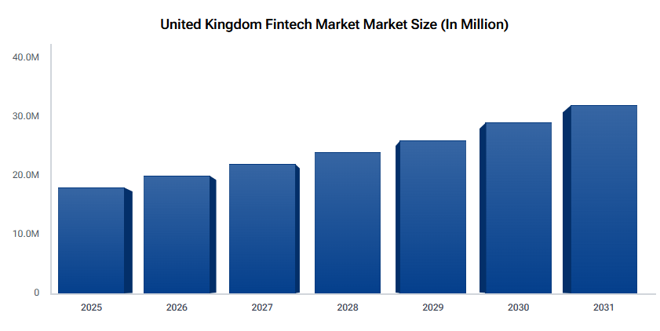

Figure 1: UK Fintech Market Size
(Source: Datainsightsmarket.com, 2025)
More recent statistics point to the magnitude of this change. The UK FinTech market is estimated to have a total value of around £14.74 billion in 2025 with an estimated increase of about 10% per year. Moreover, the proportion of UK adults that access online banking services is close to 88% or approximately 47 million people and more than 57% of the population applies mobile wallets (Datainsightsmarket.com, 2025). The adoption of open banking has also grown considerably and now serves over 16 million users, and the number of transactions is growing more than 50% with each annual growth. These statistics indicate that digital financial services have been accepted and are integrated into daily life (Ramirez and Lee, 2025).
Nevertheless, in spite of this development, trust is a decisive factor that determines the involvement of customers in FinTech platforms. The security, privacy and reliability issues are still influencing the user behaviour as financial services deal with sensitive personal and financial information. In this way, the current digital economy needs to study the impact of trust on adopting and utilizing FinTech services (Pillai and Hu, 2024).

1.2 Research Problem
In spite of the fact that the level of FinTech usage is very high in the UK, a certain percentage of users still feel hesitant about the idea because of doubts about information insecurity, privacy invasion, and financial losses. According to studies that were carried out by Aracil et al. (2025), the perceived risk and the absence of institutional trust are one of the key obstacles to the deeper involvement with digital financial platforms.
Also, there are differences in the degree of trust among the demographic groups, which is affected by age, digital literacy, and previous experiences in the sphere of financial services. Although consumer protection occurs through regulatory agencies like the Financial Conduct Authority (FCA) has been trying to improve the issue, there still exist gaps in the knowledge of how trust combines with perceived security and risk to drive behavioural intentions (Gaviyau and Godi, 2025).
Thus, the limited empirical knowledge about the influence of customer trust on the usage and adoption of FinTech services under a regulated financial environment in the UK is the main issue of the examined study.

1.3 Research Aim
The aim of this study is to examine how customer trust influences the adoption, continued usage, and behavioural intention toward FinTech services within the United Kingdom’s regulated digital financial ecosystem.

1.4 Research Objectives
To achieve the research aim, the following objectives are established:
- To examine the determinants of customer trust in UK FinTech services
- To analyse the relationship between trust and user adoption/usage intention
- To evaluate the role of perceived risk and security concerns

1.5 Research Questions and Hypotheses
Research Questions
- What factors influence customer trust in FinTech services in the UK?
- How does trust affect customer adoption and continued usage of FinTech platforms?
- What is the role of perceived security and perceived risk in shaping trust?
Research Hypotheses
- H1: Customer trust has a positive and significant effect on FinTech usage intention.
- H2: Perceived security positively influences customer trust.
- H3: Perceived risk negatively influences FinTech usage intention.
These hypotheses give the research the focus a specific and measurable hypothesis so that it does not take an excessively broad or narrow scope.

1.6 Significance and Contribution of the Study
This study has academic and practical implications. Academically, it adds to the existing knowledge on the topic of digital trust and technology acceptance by incorporating trust into conceptualized frameworks like the Technology Acceptance Model (TAM) and the Unified Theory of Acceptance and Use of Technology (UTAUT). Although past researchers have investigated the use of FinTech in the global context, scanty context-sensitive research has been done on the mature and well-regulated financial landscape of the UK (Lee, Ramasamy and Subbarao, 2025).
Practically, the research has a lot of value to Fintech companies, policymakers, and regulators. Knowledge of the importance of trust can assist organisations to develop safer, open and friendly platforms to improve customer interaction. As well, the results can guide policy-making that would enhance consumer trust in online financial systems.
More recent studies suggest that more than 62% of consumers in the UK regard the issue of data privacy to be a key concern in the use of digital financial services in the year 2026. The proper response to such fears using a system of trust-building can go a long way in enhancing rates of adoption and continued use (Blythe, 2026).

1.7 Scope of the Study
The research is specifically on FinTech clients in the United Kingdom, how they trust, feel secure and at risk with digital financial services like mobile banking, digital wallets, and web-based investment platforms. The study takes a quantitative design, where the results are derived out of measurable and statistically tested relationships (Jafri et al., 2024).
The scope is so specified that it is not overly generalised and at the same time is deep enough to bring valuable insights. It is not applicable to other nations or conventional banking systems which are not in the FinTech arena.

1.8 Theoretical Framework
This study is grounded in three key theoretical perspectives:
- Technology Acceptance Model (TAM): This model is the way in which paradigms of perceived usefulness and ease of use affect the uptake of technology. Trust was also used in this study as one of the factors affecting behavioural intention (Asif and Sarwar, 2025).
- Unified Theory of Acceptance and Use of Technology (UTAUT): UTAUT builds upon TAM by incorporating performance expectancy, effort expectancy, social influence as well as facilitating conditions. It is postulated that trust is a significant prerequisite construct which improves these constructs within the financial Cases (Amnas et al., 2023).
- Perceived Risk Theory: According to this theory, users are likely to evaluate the risk posed by the new technologies which may be financial risks, privacy, and performance-related risks, and adopt them. When risk is perceived to be high, it has negative effects on trust and adoption behaviour (Appiah and Agblewornu, 2025).

1.9 Structure of the Dissertation
In the next chapter, literature review and critical analysis of previous literature has been carried out to provide a theoretical basis for the study. The proceeding section presents the research methodology which includes the research philosophy, research design, data collection methods and analysis methods. The next chapter will give the research findings of statistical analysis and the discussion will give the interpretation of the findings regarding the available literature. Lastly, the conclusion will summarise the major findings made, point out implications, limitations and give the recommendations on future research.

Chapter 2: Literature Review

2.1 Introduction
The concept of customer trust has turned out to be a key construct in the interpretation of adoption and persistence of the use of fintech services in the UK. As conventional banking turns into digital versions due to mobile technologies, peer-to-peer lending, and digital payments, users are forced to use much more or more frequent intangible systems that are not as human-oriented. The alteration raises the concerns of data privacy, cybersecurity, transparency and regulatory protection. As the existing literature shows, trust can not only result in the perceived reduction of risk but enhance user confidence and engagement with fintech platforms. An appropriately monitored financial atmosphere and presence of a financial regulator such as the financial conduct authority in the UK setting are imperative in shaping consumer perceptions. Thus, to analyse fintech adoption and continued use behaviour, the concept of trust as a multidimensional concept is vital.

2.2 Empirical Analysis
Devlin, J., Ashta, A. and Wood, S. (2022) in Electronic Markets. The assessment of how classical trust approaches can be applied to the environments of algorithmic and platform-based financial services will be needed to survey trust literature in FinTech and formulate a research agenda in the future. The classical trust conceptualisations have been developed to connect interpersonal and institutional relationships, which happened before the development of algorithms and AI-based financial services. Those older models do not take into consideration the problems of explicability of algorithms, responsibility in governance. The systematic and conceptual use of literature was employed i.e. synthesising past empirical and theoretical studies about trust in the context of financial services and digital platforms. A review of the body of work was performed through thematic analysis to discover the patterns, contradictions, gaps. As it turned out, classical trust structures are rather broadly applicable to FinTech but require significant theoretical translation in order to become applicable to the realities of the digital era. The found FinTech trust pillars are algorithmic transparency, system governance and explainable AI.
Aldboush, M.H.H., Ferdous, H.H.H.(2023) in International Journal of Financial Studies. To delve into the ethical and privacy-related issues of customer trust in FinTech, one can further reduce the issue to the point where big data analytics, artificial intelligence, and data governance interact to change user trust perceptions. The existing body of trust literature on FinTech does not discuss enough the ethical dimensions of algorithmic bias and discriminatory usage of information and unclear AI decision-making. The available models of trust have not been designed to accommodate the data-intensive, AI-mediated world of current FinTech and are, therefore, unable to help determine the effect of the latter on consumer trust. This study applied a conceptual and systematic review of the literature concerning the governance of ethical and privacy in FinTech platforms. It applied the scholarly sources about data governance, corporate data responsibility, and data privacy to design a normative framework of trust-building. The risk of losing customer trust is a serious problem facing FinTech because such aspects as algorithmic biases, lack of transparency in data, and low-quality disclosure procedures are all threat factors that influence the degree of trust. The authors propose that the bare minimum of actions to rebuild the trust in the system is encryption, a clear policy of data collection, the clause of opt-out and educating employees.
Jafri, J.A., Amin, S.I.M., Rahman, A.A. and Nor, S.M.(2024) in Heliyon. In order to carry out a systematic review of the contribution of trust and security to adopting FinTech in the banking sector, uncover the theoretical framework that is primarily used in it, and synthesise thematic clusters of the existing empirical literature. Despite the accumulating body of empirical research, a synthesis of the different methodological strategies is yet to be conducted in a systematic manner and hence it is difficult to come up with common conclusions. The literature on trust is still debated and diffracted in terms of its dimensionality and its relation to constructs of security, which limits the accrual of theoretical development. A systematic evidence review and synthesis with the ROSES framework was used to conduct a systematic review of the literature and 26 peer-reviewed articles were analyzed. The relative importance of constructs in the studies was identified by the thematic weight analysis in order to enable the thematic prevalence to be measured. They have determined that there exist five thematic clusters UTAUT2 variables, perceived risk, trust, service quality, and other constructs. Trust and security in various geographic, demographic and methodological settings were always discovered to be the strongest predictors of the intention to use FinTech.
Okat, D., Paaso, M. and Pursiainen, V.(2025) in Corporate Finance Rev. Studies. To empirically test the general assumption that the degree of consumer trust toward traditional financial institutions serves as a valid predictor of using FinTech products, such as robo-advisor, peer-to-peer lending sites, and electronic payment services. Among the assumptions that the research of FinTech adoption is based on, one of the most widespread and unproven assumptions is that the trust developed in the traditional banking relationship can be applied to the FinTech situation with no concerns. However, this was not a supposition that had been directly investigated using control and representative empirical data in a consumer market that was predominantly of the West and this created a critical theoretical vacuum that was yet to be filled. The research design entailed application of mixed method research design, which entailed gathering of information that was founded on an experiment and a large scale household survey on Dutch consumers. Structural analysis was done to test the hypothesised predictive relationships between institutional trust in traditional banks and actual FinTech adoption behaviour. The use of FinTech products and the trust to conventional banks were not significant or reasonable in the experiment. The findings point to the fact that FinTech trust is an operationally distinct dimension, which is also formed under platform-specific digital engagements, algorithmic experiences and interface design as compared to being passed through the established banking ties.
Amnas, M.B., Selvam, M., Raja, M., Santhoshkumar, S. and Parayitam, S.(2023) on Journal of risk and financial management. In order to examine the determinants of the adoption of FinTech by integrating the UTAUT2 model with the Trust Theoretic Model (TTM) i.e. testing the role of trust as a contributing factor and a mediating variable in the adoption process. Past researchers have inadequately applied the UTAUT2 framework to FinTech circumstances to determine the independent explanatory power of trust, as compared to the pre-established constructs such as performance expectancy, effort expectancy, and social influence. The absence of trust as a constructive unit with a theoretical character leaves a huge gap in the explanations according to the existing models of adoptions. The survey (quantitative) was carried out among 399 users of FinTech services. Structural equation modelling (SEM) was used to test integrated UTAUT2-TTM framework with a direct and mediation relationship and trust was a dependent and independent variable in the model. The impact of all UTAUT2 constructs on intention to adopt was great. However, trust did elaborate on certain more variance that is relevant to other constructs after taking into account all the typical predictors of UTAUT2, which validates its dual nature of being a direct predictor and an intervening variable.
Zhao, H. and Khaliq, N. (2024) in Heliyon. To explore the most significant aspects that impact the customer confidence in FinTech services and examine the trust as the primary predictor of the intention to use it with a structural equation modelling within a Pakistani consumer population. Technology-oriented models of adoption, such as Technology Acceptance Model (TAM) give priority to perceived usefulness and ease of use, and thus do not give sufficient focus to the importance of trust which is the driving force that propels the adoption process. This is particularly broad in the emerging markets where regulation uncertainty is also a characteristic in addition to reduced minimum institutional confidence. They had surveyed 275 FinTech users in Pakistan and therefore, it was a quantitative survey. The hypothesised relationships between the determinants of trust, overall trust and adoption intention and security, transparency and reputation as the independent construct have been tested using partial least squares structural equation modelling (PLS-SEM). Individually, customer trust emerged as the strongest predictor of FinTech adoption intention, and it has a larger predictory power than perceived usefulness. Security assurance, transparency of services and reputation of the firm were found to be the strongest antecedents in the development of trust.
Jahromi, A T., Nazari, M. and Rohani, M. (2023) in International Journal of Human Computer Interaction. Use Necessary Condition Analysis and Mobile Technology Acceptance Model (MTAM) to identify what factors are necessary conditions and not just sufficient conditions required to get users to trust the mobile payment gateways. In most of the studies of FinTech adoption, it emerges that most factors seem to be correlated to trust but may not be able to differentiate between necessary conditions - factors that do not cause trust not to emerge but rather contribute to development of trust - and sufficient conditions that only encourage trust development. This disparity directly can be applied to the prioritisation of system design but has not been methodologically considered. Among 218 mobile payment users, Iranian people were surveyed. Necessary and sufficient conditions were distinguished with the help of the Mobile Technology Acceptance Model and the Necessary Condition Analysis (NCA). Quantitative regression techniques and NCA outputs were used to facilitate the triangulated interpretation. The perceived security and ease of use were identified as pre-requisite to trust mobile FinTech platforms i.e. one cannot develop trust in them without having other positive factors. The perceived ease of use in different studies on adoption have not achieved the criteria of necessity meaning that it is a supportive, rather than a pillar construct, to mobile payment trust.
Mateus-Berr, R., Obando, D. and Morales, M. (2021) in FinTech. To complete a systematic review of the enablers and barriers to FinTech adoption and put these into cumulative effect on bank performance, one will find institutional level and individual level enablers of adoption, which will be important. The body of knowledge on enabler-barrier models of the FinTech adoption is scattered across geographic and sectoral contexts. There is slight, but systematic consideration of the role of institutional support frameworks and regulatory settings, particularly in the Western regulated market contexts wherein both variables are likely to play important roles. The systematic review of the 109 peer-reviewed articles was conducted and studies were coded thematically in accordance with the type of enablers and barriers. The repetitive patterns were found with the methods of the narrative synthesis. The strongest facilitators of FinTech adoption were most often found to be individualised services and institutional support systems, and perceived risk and regulatory uncertainty, and perceived barriers to contexts were often recurrent. The researchers made an inference that the institutional trust, trust in the broader regulatory ecosystem, constitutes one of the components of the overall consumer trust.
Bajunaied, K., Hussin, N. and Kamarudin, S. (2023) on Journal of Open innovation. Technology, Market and complexity. To test the behavioural intention of consumers that would lead to the FinTech services in Saudi Arabia through conceptualising and operationalising the concept of UTAUT in the presence of privacy enablers and privacy inhibitors as conceptually different constructs. Previously, to the best of my knowledge, UTAUT applications in the FinTech adoption literature have not explicitly modelled privacy enablers (such as trust and information richness) and privacy inhibitors (such as privacy concerns and perceived risk) as independent constructs in the same framework. The survey was a quantitative survey, which was done among 361 users of FinTech in Jeddah, Saudi Arabia. The hypothesised links among the extended UTAUT constructs, privacy enabler and inhibitor variables and the behavioural intention to use FinTech services were analysed with the partial least squares structural equation modelling (PLS-SEM). A positive and significant influence on the intention to adopt was observed on all the performance expectancy, effort expectancy, facilitating conditions and privacy enablers. The imbalanced impact of the two privacy dimensions was that the issues of privacy and perceived risk were salient in suppressing behavioural intention which are the privacy inhibitors.
Zhao, Y., Chen, L. and Song, Z. (2024) in Humanities and Social Sciences Communications. To investigate how mobile FinTech is adopted in a dual perspective of perceived value and perceived risk, one should be willing to adopt a mechanism that allows the risk to be rendered to work through trust and how facilitating and deterring elements interact to impact the adoption behaviour. Most of the studies on FinTech adoption focus a lot on the positive aspects that dictate acceptance that lacks sufficient theoretical exposition to the constitutive character of perceived risk as acting on and through trust. Specific mechanisms by which risk can impact trust not as an attitudinal leftover but as an obstacle to struggle with had not been theorised and empirically tested in the mobile FinTech space. This paper assumed a quantitative research design which involved the application of both PLS-SEM and fuzzy-set Qualitative Comparative Analysis (fsQCA) to test both symmetric and asymmetric relationships between the perceived value, perceived risk, trust and adoption intention. This two-fold methodology enabled causal configurations to be discovered that would not have been discovered under symmetrical analysis. The perceived risk of mobile FinTech adoption choices is an active constitutive mechanism with trust rather than an attitudinal barrier in the background. In the case of effectively managing risk through the aid of trust, perceived value was positively moderating the adoption.
Zhao, H., Tariq, M.Z. and others (2024) in Technology Forecasting and Social Change. The research questions are to establish which specific dimensions of perceived risk have the most negative impact on the adoption of FinTech and to establish whether situational factors such as time pressure, and experience with previous technologies mediate the relationship between risk perceptions and intention to use. In prior adoption models, perceived risk is treated as a compound or residual variable, and compresses the various dimensions of risk to one non-distinct measure. This renders it unattainable to possess any grainy understanding of what kind of risk, financial, security, social, temporal or performance-related risks are likely to have the most significant influence on adoption intention and limit the particularity of practical advice. It was a quantitative survey based research in which structural equation modelling was conducted, in order to test the multi dimensional risk constructs and their effects on adoption intention. The assessment of the boundary conditions occurred based on the structural model and involved the use of situational moderator variables, including time pressure and prior experience of FinTech. Time risk had the highest influential individual risk dimension with the standardised coefficient, 0.274 and the other three, financial risk, security risk and social risk followed by performance risk. The perceived risk magnitude had a statistically significant negative effect on the adoption intention of statistically significant -0.284 which is large and indicates a constitutive not a marginal effect of attitudinal noise.
Zhang, W., Siyal, S., Riaz, S., Ahmad, R., Hilmi, M.F. and Li, Z. (2023) in SAGE Open. To empirically explore the hypothesis of how perception of data security influences customer trust and intention to use the FinTechs among users of commercial banks where the perceived ease of use and the perceived usefulness are indirect antecedents. TAM-based models pay little attention to the mediating role of data security in the pathway between the perceived usefulness and ease of use to trust and, therefore, an important indirect path has been under-theoreticalized. The specific understanding of how the feeling of security transforms to trust and subsequently, to adoption intention was not empirically tracked. It was carried out in Pakistan through customers in commercial banks in the form of a quantitative survey. The direct and mediated impact of perceived usefulness and ease of use on trust in terms of data security perceptions were experimented using structural equation modelling (SEM). The data security perception was shown to have a positive and direct effect on customer trust and desire to use FinTech. Both perceived easy use and perceived usefulness had significant indirect impacts on trust mediated by data security perceptions, an observation that confirms a mediation role in the TAM models that none of the traditional TAM models have been able to take into account previously.
Zarifis, A. and Cheng, X. (2022) on Journal of Behavioral and Experimental Finance. To develop a model of trust in Fintech and Insurtech and how trust is affected by use of AI and the technology context. While earlier research looked at trust in mobile banking and e-commerce, there was no modelling of the role of AI (and more broadly, the technology) in trust for FinTech and the relative role of trust in Insurtech and so comparative trust mechanisms were not well-developed. A quantitative online survey was used, with data analysed using Multigroup Structural Equation Modelling (SEM) to compare trust formation in FinTech and Insurtech. Four factors form the basis of trust in FinTech and Insurtech: psychological propensity to trust, sociological factors, trust in the financial or insurance company, and trust in AI (and other technologies). The trust pathways are comparable, but there is still a need for transparency in AI.
Zarifis, A. and Cheng, X. (2022) on Journal of Behavioral and Experimental Finance. To develop a model of trust in Fintech and Insurtech and how trust is affected by use of AI and the technology context. While earlier research looked at trust in mobile banking and e-commerce, there was no modelling of the role of AI (and more broadly, the technology) in trust for FinTech and the relative role of trust in Insurtech and so comparative trust mechanisms were not well-developed. A quantitative online survey was used, with data analysed using Multigroup Structural Equation Modelling (SEM) to compare trust formation in FinTech and Insurtech. Four factors form the basis of trust in FinTech and Insurtech: psychological propensity to trust, sociological factors, trust in the financial or insurance company, and trust in AI (and other technologies). The trust pathways are comparable, but there is still a need for transparency in AI.
Dawood, H.M., Liew, C.Y. and Lau, T.C. (2022) in F1000 Research. To examine the mediating role of Mobile Perceived Trust (MPT) in FinTech innovation intention and use through mobile technologies. Most of the earlier studies treated trust as a predictor, not a mediator, of behavioural intention and use. There were only a few studies in Q1/Q2 journals exploring the mediation effect of trust in mobile FinTech. Systematic Literature Review (SLR) using PRISMA; Q1 and Q2 journals in 2016-2021; four empirical studies that considered MPT as a mediator. MPT can mediate the relationship between the trust antecedents (such as usefulness, ease of use, security and privacy) and FinTech adoption intentions. The review demonstrates trust cannot be treated as an independent variable, and suggests future research should investigate trust mediation in various FinTech products and geographical regions (such as the UK).
Sampat, B., Mogaji, E. and Nguyen, N.P. (2024) in International Journal of Bank Marketing. To map out the "dark side" of FinTech, and its risks for individuals, organisations and society from the eyes of FinTech developers, rather than consumers. Most FinTech research was either positive or customer-oriented. Managerial and regulatory knowledge of the "inside view" of FinTech developers on the dark side of systemic risks to consumer safety and trust had been overlooked. Qualitative; exploratory and inductive study using semi-structured interviews with 23 FinTech developers; interviews transcribed and analysed using NVivo software. Three key themes were identified: customer vulnerability (risk of fraud, loss of money), technical incompetence (vulnerability to security attacks, service failure) and regulatory irresponsibility (non-compliance, weak governance). These result in trust issues and highlight potential risks that platforms in the UK and globally must address to achieve trust and stability.
Fatorachian, H., Brooks, M., O'Higgins, B., Maldonado, A., Lyons, C. (2024) in Cogent Business & Management. To understand the challenges faced by FinTech startups in the B2C market in the UK, especially regulatory and product-market fit problems, and the need to win consumer trust. While there is literature on barriers to FinTech adoption, there is a lack of empirical literature on the issues faced by UK FinTech startups in meeting the regulations of the Financial Conduct Authority (FCA) and in gaining consumer trust in a competitive B2C market. Mixed-methods; surveys and interviews with FinTech and consumers, and a case study for a UK FinTech startup ('Company A'). Themes and Porter's Five Forces were used to analyse data. FCA authorisation and compliance are important for UK FinTech consumer trust. Consumers are also concerned about online data security and payment security. The positive effect of innovation on adoption was also shown to be moderated by trust, suggesting that innovative FinTech features can only lead to the increase in adoption with high consumer trust.
Apau, R., Titis, E. and Lallie, H.S. (2025) in Computers. To extend the UTAUT2 model with the inclusion of constructs of perceived security, perceived risk, institutional trust and technology trust, and to explore the moderating influences of demographics on these factors and mobile banking adoption. Although UTAUT2 has been used to study mobile banking, it does not consider factors specific to mobile banking in a risky environment; little has been done to investigate the moderating effects of demographic variables (age, gender, income, education) on trust and security constructs in the UK mobile banking market. Quantitative; survey of mobile banking customers (n=315) in the UK using an online questionnaire; analysed using Covariance-Based Structural Equation Modelling (CB-SEM), including testing of moderating effects of demographics. The model explained 79% of the variance of intention to use mobile banking, and 54.7% of variance of use behaviour, compared to the original UTAUT2. Institutional trust and technology trust were significant predictors of intention. Perceived risk was not significant, as expected.
Yang, K. (2025) on Journal of Financial Economics. To identify the causal role of eroded trust in traditional banks (traditional finance) and whether it is a barrier to FinTech in credit markets. Previous research found a positive association between trust in traditional banks and FinTech uptake, but not causality due to endogeneity and reverse causality. Lack of a natural experiment to determine the causal effect of lost trust on FinTech adoption. Quantitative; difference-in-differences (DiD) econometric model where the Wells Fargo fake accounts scandal was used as a natural experiment that caused exogenous variation in trust; also triple-differences analysis and machine learning inference to model the treatment effect; data on US residential mortgage loans. Erosion of trust in traditional banks leads to an increase in FinTech mortgages. Counties in which trust was more eroded in the post-scandal period adopted FinTech more than other counties. This finding was confirmed by using a dummy for political affiliation.
Clarke, C. and Macartney, H. (2025) in Competition & Change. To explain why UK open banking reform - hailed as a competition-enhancing FinTech revolution - failed to bring consumer and competition benefits. Much has been written about UK open banking policy, but little has been written about its political economy and why incumbent bank power is resurgent in the face of open banking, at the cost of trust in consumer payments and FinTech markets. Qualitative political economy; analysis of policy reports, CMA papers and Parliamentary documents (2015-2024); interviews with stakeholders, insights from Culpepper's (2010) theory of "noisy" and "quiet" politics. Open banking's design phase (2015-18) was successful as consumer trust in banks was undermined, allowing pro-reform statecraft. But its subsequent return to "quiet politics", since the UK voted to exit the EU - coupled with weak CMA regulation and OBIE governance issues.

2.3 Theories and Models

2.3.1. Technology Acceptance Model (TAM)
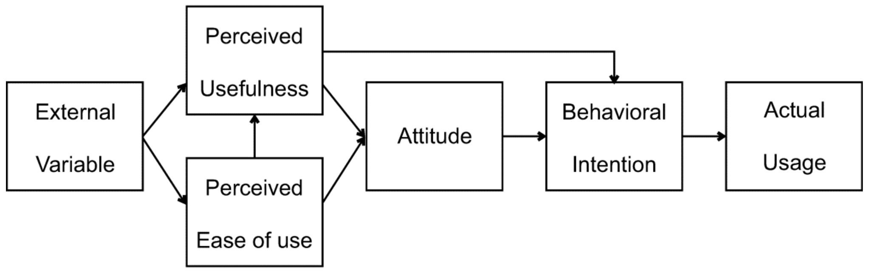

Figure 2: Technology Acceptance Model
(Source: Park and Park, 2020)
Technology Acceptance Model by Davis (1989) is a model of user learning to accept and use new technology based on two principle constructs; perceived usefulness, and perceived ease of use. The usefulness is the degree of perceived usefulness of using the system by the user and the ease of use is the degree of effort that one perceives needed to use the system. This has been the case with TAM over time whereby more variables such as trust and perceived risk have been added and as such, it can be applied very well in research on the topic of fintech (Legramante, Azevedo and Lopes, 2023).
TAM can provide a useful framework to examine how the customer trust influences the adoption and utilisation of the UK fintech services. This element of trust can be added as an extrinsic factor that has an impact on perceived usefulness and ease of use. One example is that users who have trust in the reliability and safety of the system will be more likely to perceive the fintech platforms as useful and user-friendly (Kansal and Saha, 2023). This is even greater in the digital financial services where intangible interactions are the order of the day.
TAM has its limitations, however. It makes the assumption of rational choice and does not entirely reflect emotional or social factors of trust. Also, it does not take into account the importance of regulatory frameworks and security issues, which are essential in fintech (Lee, Ramasamy and Subbarao, 2025). Therefore, whereas TAM is an impressive framework, it should be further developed to explain comprehensively the processes of trust in fintech situations.

2.3.2 Unified Theory of Acceptance and Use of Technology (UTAUT)
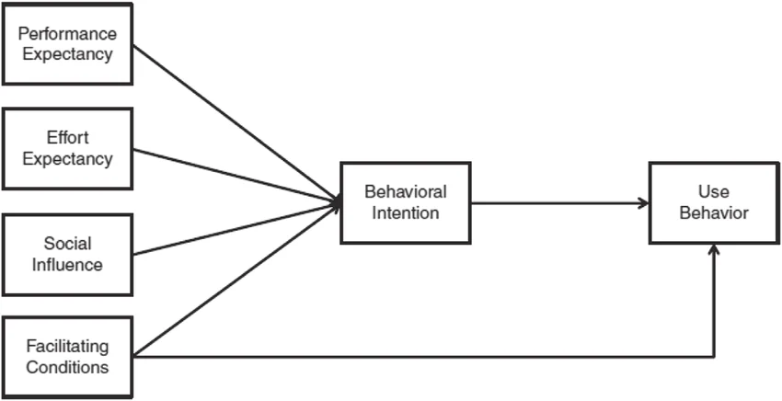

Figure 3: Unified Theory of Acceptance and Use of Technology (UTAUT
(Suki, 2017)
The four determinants as performance expectancy, effort expectancy, social influence and facilitating conditions are extensions of the models that have already been developed such as TAM. Unified Theory of Acceptance and Use of Technology considers the moderating factors such as age, sex and experience and thus is more exhaustive in explaining the adoption behaviour of technology (Terblanche and Kidd, 2022).
UTAUT is particularly relevant in this research when it comes to the understanding of the interplay between trust and social and institutional challenges in the fintech adoption in the UK. Performance expectancy (belief in system performance) and facilitating conditions (accessible secure infrastructure and regulatory security) can be instilled with trust. Social pressure can also be a significant factor, and the users may use peer-to-peer recommendations or social standards to decide to use fintech services (Sharma and Mittal, 2025).
The UTAUT, although having its advantages, has been criticised due to its complexity and failure to emphasize on psychological constructs such as trust and perceived risk. Even though it provides a more in depth observation compared to TAM, it does not address itself directly to the creation or depletion of trust. In addition, its generalised nature may fail to put into consideration context-specific challenges, such as, the regulatory implications on the UK fintech sector (Pande Nyoman Yuliani et al., 2024). Therefore, UTAUT ought to be accompanied with frameworks pertaining to trust to gain more profound insights.

2.3.3 Perceived Risk Theory
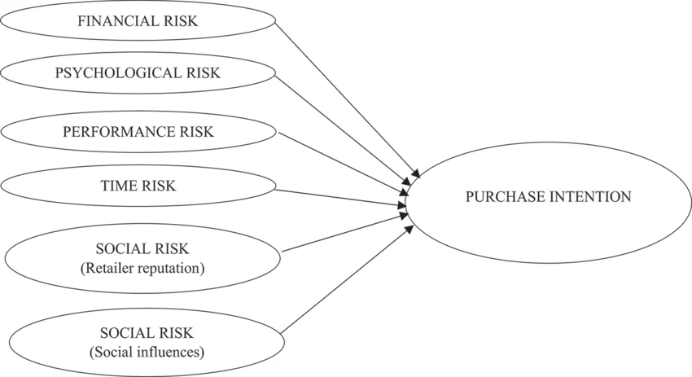

Figure 3: Perceived Risk Theory
(Source: Pentz, du Preez and Swiegers, 2020)
Perceived Risk Theory has its foundation on consumer behaviour literature and is purported to explain how individuals take into account the potential losses during making decisions in an uncertain situation. Fintech Perceived risk can be broken down into financial, security, privacy, and performance risks. These risks affect the user attitudes and can act as a hindrance to the use of technology (Li et al., 2023).
Perceived risk theory is essential in the study in terms of how security and privacy issues influence the level of trust of customers towards UK fintech services. The level of perceived risk has been regarded to be high, and can erode the intentions of trust and adoption particularly where the service provider is handling sensitive financial information. Conversely, perceived risk can be minimized by implementing adequate risk mitigation strategies such as encryption, authentication and adherence to regulation, which leads to an increased trust. This emphasizes the two-sidedness of risk as a hindrance and a possible source of trust in its undertaking (Mohammed Amin Almaiah et al., 2023).
But there are limitations in the perceived risk theory. It is mainly negative oriented and fails to take into consideration the positive reasons like convenience or innovation. It also makes the assumption that the perception of risk is a static view however the reality is that the user perception of risk varies over time (Appiah and Agblewornu, 2025).

2.3.4 Most useful theory
Analyzing the theoretical frameworks of the present research, it is possible to mention the Perceived Risk Theory that will be the most significant framework which will be used in the next stages of the research. To the extent that the Technology Acceptance Model (TAM) as well as the UTAUT can potentially provide the required frameworks to digital adoption in general, either approach is predisposed to fail on its ability to understand the underlying psychological barriers that accompany financial services. Since the primary research issue will be user hesitation due to information insecurity and financial loss, Perceived Risk Theory may be used to give a fine-tuned solution to the analysis of these specific barriers (Mohammed Amin Almaiah et al., 2023).The research can directly measure the effect of the financial, privacy and performance risks by defining the character of the risk as it lowers customer trust and use of the UK FinTech.

2.5 Summary
The chapter has critically reviewed the available literature on the topic of customer trust and the significance of this aspect in the process of adopting and using fintech services. It started by defining trust as a multidimensional phenomenon that can be influenced by technological trustworthiness, moral and algorithmic clarity and has become more complex than within the very traditional financial frameworks. This discussion has gone ahead to discuss the most powerful determinants of trust which include behavioural, technological and institutional determinants and observed narrow focus on situations in the United Kingdom.
In providing the background theoretical information, the key theoretical frameworks like the Technology Acceptance Model, the Unified Theory of Acceptance and Use of Technology, and Perceived Risk Theory were addressed. Overall, the chapter is discovered to have significant Research Gap, in particular, the lack of single, UK-specific, and longitudinal research, therefore, the need to conduct such a research.

Chapter 3: Methodology

3.1 Introduction
This chapter shows the approach the study used to test the relationship between customer trust and the utilization of fintech services in the United Kingdom. It explains the philosophical site, research strategy, research approach as well as the method of collecting data applied in responding to the research objectives. Since the study aims at analysing quantifiable constructs of perceived security, perceived risk, trust, and behavioural intention, a quantitative study approach is used. The chapter also covers other topics of research like sampling methods, survey design, data analysis methods and ethical issues so as to have a reliable and valid outcome. Finally, the last methodological problems are identified to provide the clarity and critical evaluation of the research design.

3.2 Research Onion


Figure 4: Research Onion
(Source: Saunders et al. 2019)

3.3 Research Philosophy
The philosophy of research could be defined as the beliefs that regard what knowledge is and how it may be obtained. The philosophy of this paper is positivism, which assumes that reality is objective, and can be measured using observable and measurable data. The method of positivism can be particularly used when one is doing a study to test the relationships between variables using statistical methods. This study will test the impact of customer trust on fintech service use in the UK as part of this research (Park, Konge and Artino, 2020). This will involve measurement of perceived risk, perceived security and behavioural intention through structured measures. However, the fact that positivism may miss on finer contextual and behavioural details can not be overridden when dealing with subjective opinions as to trust. However, it can be applied to this study due to its emphasis on statistical testing and validation of hypotheses (Williamson and Johanson, 2022, p.430).

3.4 Research Approach
In this research, the research approach is deductive research approach which entails formulation of hypotheses entirely based on the known theories and subsequently testing the hypotheses through empirical data. Deductive reasoning starts with general theoretical concepts and proceeds to particular observations. The research also uses existing theories, such as the Technology Acceptance Model and the Perceived Risk Theory to come up with the hypotheses of how trust and perceived risk, and perceived security and fintech usage intention relate (Casula, Rangarajan and Shields, 2021). These theories provide a logical direction of identifying the important variables and expected relationships. The deductive approach is correct as it ensures that there is consistency in theory and that relationships between constructs can be systematically tested.
The data gathered from the respondents is analysed and the answers to the proposed hypotheses are detected as accepted or rejected. This method enhances the validity and reproducibility of the study since there is a clear and systematic process (Dudovskiy, 2025).

3.5 Research Strategy
The study method that is taken in the research is a quantitative survey strategy. The application of survey has taken root in the behaviour and social science research to be able to acquire a considerable amount of data in a rather limited time frame. The need to create the same response in the form of a standardised data concerning the perception of trust, risk, and security among the users of fintechs indicates the choice of a survey strategy. Structured questionnaires can be used with surveys, which means that they can be measured consistently with everyone (Salvatori, 2023). The study is suitable in capturing the existing perceptions and behavioural intentions of users of fintech in the UK. It is also cost effective and time efficient as compared to the longitudinal studies (Sultana, Chowdhury and Haque, 2023).

3.6 Data Collection Method

3.6.1 Sampling Procedure
This research has used a non-probability sampling method that is both snowball sampling and convenience sampling. In the case of convenience sampling, respondents are sampled based on their proximity to the researcher whereas in snowball sampling, the first respondents are free to consult others who qualify to be included in the study. The target population is people who live in the UK and use at least one FinTech product, which can be mobile banking applications, an online investment platform, or a mobile wallet. The sample size of 114 respondents is chosen, as it can be said that it is sufficient to perform regression analysis and investigate the correlation between variables (Qualtrics, 2021). The sample is evenly split between 57 respondents with a background in a relevant field (FinTech) and 57 respondents who are merely people familiar with the subject and have knowledge about the field merely as a result of their acquaintance. The first interviewee is an acquaintance of the family who is working in the HSBC Bank and gave his insights into FinTech sphere.

3.6.2 Survey Design
The research takes the quantitative survey design with structured questions composed of a 5-point Likert scale (1 = Strongly Disagree to 5= Strongly Agree) to examine the perceptions of users towards the FinTech services. The main constructs assessed by the questionnaire include trust, reliability, security, perceived risk and behavioural intention.Both positively-framed and reverse-coded statements are used in the survey to reduce bias in responses and maximise reliability. The main survey Question in Google Form are:
- I trust FinTech applications (e.g., mobile banking, digital wallets) to handle my financial transactions securely.
- I believe FinTech services are reliable and perform transactions accurately.
- I feel confident sharing my personal and financial information on FinTech platforms.
- The security features (e.g., OTP, encryption) of FinTech services increase my trust.
- I believe FinTech companies comply with regulations and protect customer data.
- I am concerned about the risk of fraud or data breaches when using FinTech services. (Reverse-coded)
- I feel that using FinTech services involves financial risk.
- I am willing to continue using FinTech services in the future.
- My level of trust influences my decision to use FinTech services regularly.
Additionally, the survey incorporates an open-ended question:
- "What factors would increase your trust in FinTech services?"
This mixed-method approach enables both quantitative measurement and qualitative insights, allowing for a more comprehensive understanding of user attitudes (Koo and Yang, 2025).

3.6.3 Survey Distribution and Storage
The Survey will be sent online using email and social media. The subjects will be given a short description of the purpose of the study and informed consent will have to be granted. The survey data that is collected in all surveys is entered in a secure password controlled system to ensure confidentiality (Mondal, Mondal and Soni, 2023). The researcher can only access the data and all the responses have been anonymised in order to maintain the identity of the participants. The first respondent will be a family friend who works in the HSBC bank. He was also quite helpful in order to provide the chances to have better knowledge regarding this fintech field.

3.6.4 Operationalization Table
Variable Type | Variable | Dimension | Question | Scale
 | Customer Trust | Security Trust | I trust FinTech applications (e.g., mobile banking, digital wallets) to handle my financial transactions securely. | 5-point Likert Scale
  Independent Variable
 | Perceived Reliability | Information Security | I believe FinTech services are reliable and perform transactions accurately.
 | Perceived Security | Security Features | I feel confident sharing my personal and financial information on FinTech platforms.
 |  | Compliance & Protection | The security features (e.g., OTP, encryption) of FinTech services increase my trust.
 | Regulatory Assurance | Security Risk | I believe FinTech companies comply with regulations and protect customer data.
 | Perceived Risk | Financial Risk | I am concerned about the risk of fraud or data breaches when using FinTech services. (Reverse-coded)
 |  | Continuance Intention | I feel that using FinTech services involves financial risk.
Dependent Variable | Behavioural Intention | Trust-driven Usage | I am willing to continue using FinTech services in the future.
Dependent Variable | Usage Behaviour | Trust Enhancement Factors | My level of trust influences my decision to use FinTech services regularly.
Qualitative variable | Customer Trust |  | What factors would increase your trust in FinTech services? | Open-ended

3.7 Data Analysis Method

3.7.1 Software Used
The use of SPSS (Statistical Package for the Social Sciences) assists in achieving the statistical work. The key benefit of the SPSS use in academic studies is the ability to process big data and perform a series of statistical tests. The software is simple to use and aids in data entry, cleaning and analysis making it precise and effective. It can also provide visual results such as charts and tables that help in the interpretation of the results (Rahman and Muktadir, 2021).

3.7.2 Validity and Reliability
It is important in quantitative research to ensure validity and reliability. Validity is the extent to which the instrument measures what it is designed to measure and reliability is the consistency of the measurement. The adapted measurement scales considering the existing research supported by the body of research regarding fintech and technology adoption can guarantee content validity (Andersson, Boateng and Abos, 2024). This is to make sure that the questionnaire is able to measure the constructs of interest. The reliability is determined by the Cronbach alpha which helps in measuring internal consistency. Values above 0.7 can be said to be acceptable which denotes that the items under each construct are consistent (Bujang et al., 2024).

3.7.3 Tests Used
Various statistical tests are used to analyse the data. Correlation analysis is used to establish the relationships among variables and the multiple regression analysis is used to find out the level to which the independent variables influence fintech usage intention. Besides, the Cronbach alpha based reliability test, tests measurement scales consistency. These tests are an overall image of the data and may be applied to prove hypotheses of research.

3.8 Ethical Considerations
In this study, the ethical code is upheld during the research. Prior to participation, all participants receive full disclosure of the purposes of the study, and their rights. The consent is informed and participation is made completely voluntary. Anonymity and confidentiality are ensured, no personal identifying information is gathered and the data is only used academically. The storage of data is in accordance with the requirements of the GDPR, so there are secure systems and only authorized persons can gain access to them (GDPR, 2025). The subjects are also free to drop out of study without any punishment. The University of Wales Trinity saint David has granted an ethics committee and the supervisor has given ethical approval to this research.

3.9 Methodological Limitation
The study has various limitations although it is carefully designed. First, a cross-sectional design does not enable exploring how trust and change of behaviour changes with time. Longitudinal studies would provide more detailed data on the change in trust according to the further use of fintech (Tuthill et al., 2020).
Second, convenience and snowball sampling can lead to bias since the sample might not be a complete picture of the whole population of fintech users in the UK. This makes the generalisability of the results less (Cabanelas et al., 2024).
Third, self-reported data might cause the bias of response since individuals tend to give the answers that are socially desirable, instead of those that represent their actual perceptions (Lavidas et al., 2022).

Chapter 4: Data Analysis

4.1 Introduction
Chapter 4 introduces the results and data analysis of the collected information aimed to investigate the effects of customer trust on the use of FinTech services in the UK. The chapter is dedicated to the perception of the respondents in relation to trust, perceived security, perceived risk, and behavioural intention towards the FinTech platforms. The collected survey data are interpreted using statistical methods such as descriptive analysis, correlation analysis, reliability test, and regression analysis to assess the research hypotheses proposed. The conclusions offer knowledge regarding the connection between customer confidence and further adoption and usage of the FinTech services in the controlled UK financial sector. Moreover, the chapter outlines the major behavioural trends and user attitudes to digital financial technologies. The analysis results are the foundation of the following discussion chapter whereby the findings are contrasted with available literature and theoretical basis.

4.2 Reliability Analysis
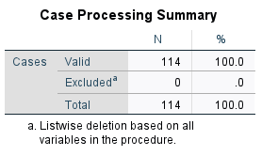
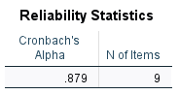
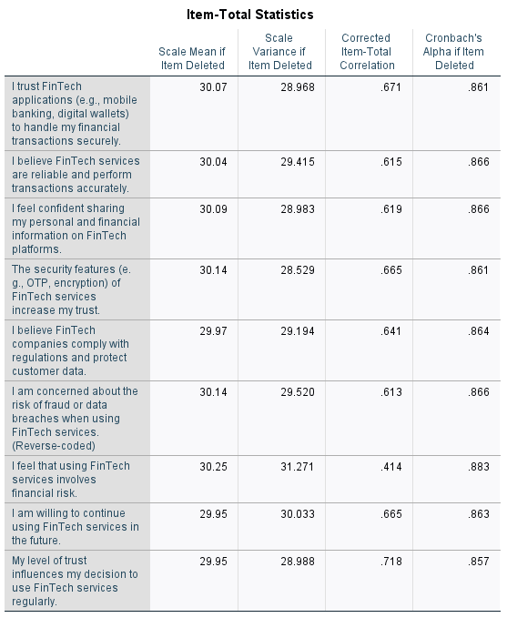
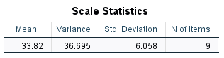

Figure 5: Reliability Analysis of the variables
(Source: Author)
Cronbach Alpha (alpha) was employed to examine the internal consistency of the 9 questions in the questionnaire to determine the reliability. According to the Case Processing Summary all the 114 responses were not eliminated as a result of list wise elimination. The total scale Cronbach Alpha was 0.879 of the scale using a scale of 9 items. The mean of the scales was 33.82, variance 36.695 and standard deviation of 6.058. The values of the item-total correlations were fixed to their corrected values, which were between 0.414 and 0.718. The highest item-total corrected correlation was 0.718 when the item was My level of trust influences my decision to use FinTech services regularly, and the lowest resulted in 0.414 with the item I feel that using FinTech services involves financial risk. The Cronbach's Alpha, in case of an item deleted, was between 0.883 and 0.857. The item that corresponded to the highest alpha when deleted was the financial risk item and the lowest alpha was with the usage item that was based on trust.

4.3 Key Findings

4.3.1 Impact of Customer Trust on FinTech Usage Intention (H1)
H0: (Null Hypothesis)
There is no significant relationship between customer trust and FinTech usage intention in the UK.
H1: (Alternative Hypothesis)
There is a significant positive relationship between customer trust and FinTech usage intention in the UK.
Result: H1 Accepted
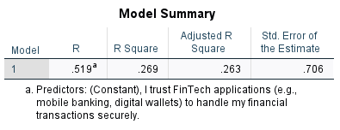
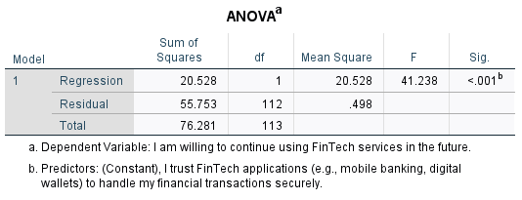
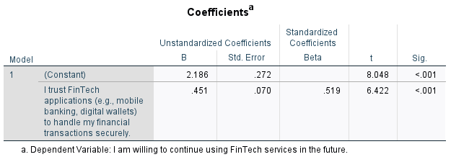

Figure 6: Regression analysis for the Customer Trust on FinTech Usage Intention
(Source: Author)
The regression model was run to investigate whether customer trust had an impact on FinTech usage intention. According to the Model Summary, the R value is 0.519, and the R Square is 0.269, which means that a level of customer trust can be used to explain 26.9% of the variation in the intention of users to further use FinTech services. The adjusted R Square was 0.263 with the standard error of estimate being 0.706. The ANOVA table indicates that the regression model was statistically significant F = 41.238 and a significant value of 0.000, which demonstrates that the regression model was appropriate to predict FinTech usage intention. According to the coefficients table, customer trust showed that it had a positive regression coefficient (B = 0.451) and standardized beta value of 0.519. The t-value was 6.422 and the level of significance was 0.000 indicating, statistically significant positive association between customer trust and FinTech usage intention. Thus, hypothesis H1 was confirmed.

4.3.2 Influence of Perceived Security on Customer Trust (H2)
H0: (Null Hypothesis)
Perceived security has no significant influence on customer trust toward FinTech services.
H2: (Alternative Hypothesis)
Perceived security has a significant positive influence on customer trust toward FinTech services.
Result: H2 Accepted
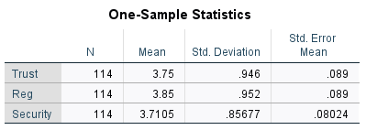
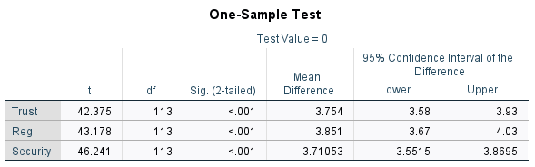
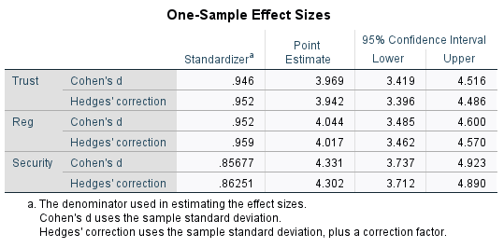

Figure 7: Independent T Test for Influence of Perceived Security on Customer Trust
(Source: Author)
The one-sample statistics showed that Trust had a mean of 3.75 with standard deviation of 0.946 whereas Regulatory Assurance (Reg) had a mean of 3.85 and standard deviation of 0.952. The security variable gave a mean of 3.71 with a standard deviation of 0.857. The number of responses was 114, and this number was utilized as the basis of all the variables. Results obtained on one-sample test reveal that the t-value of Trust is 42.375 with a uniqueness level of 0.000. The highest t-value of 46.241 with a significance value of 0.000 was observed in Security and the t-value of Regulatory Assurance was 43.178 with a significance value of 0.000. All the confidence intervals of the variables were positive. Analysis of effect size revealed Cohen’s d values of 3.969 for Trust, 4.044 for Regulatory Assurance, and 4.331 for Security. These values indicate extremely large effect sizes. This means perceived security factors have a very strong positive influence on customer trust toward FinTech services in the UK. Therefore, hypothesis H2 was supported.

4.3.3 Effect of Perceived Risk on FinTech Usage Intention (H3)
H0: (Null Hypothesis)
Perceived risk has no significant effect on FinTech usage intention.
H3: (Alternative Hypothesis)
Perceived risk has a significant negative effect on FinTech usage intention.
Result: H3 Rejected because the relationship was positive instead of negative.
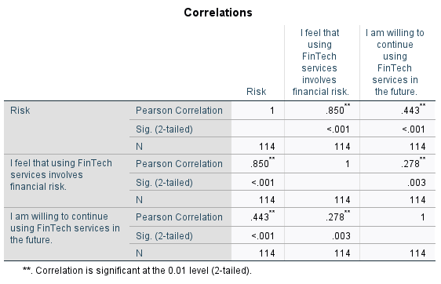

Figure 8: Correlation analysis for Effect of Perceived Risk on FinTech Usage Intention
(Source: Author)
Correlation analysis was carried out to identify the correlation between perceived risk and intent to use FinTech. The results show that the variable “I feel that using FinTech services involves financial risk” had a Pearson correlation value of 0.278 with the variable “I am willing to continue using FinTech services in the future.” The value of significance of this relationship was 0.003 thus less than the significance level of 0.01 and therefore significantly related.
The wider Risk variable, too, had the Pearson correlation coefficient of 0.443 with FinTech usage intention and the significance value of less than 0.001. Also, the overall Risk variable and financial risk perception showed a great correlation of 0.850, which had a significance value of less than 0.001, thus establishing a strong relationship between the two variables related to risk.
The results present an indication that perceived risk significantly correlated with the intention of FinTech usage. So, hypothesis H3 was not accepted as the relationship was positive rather than negative.

4.3 Summary
This chapter came forward with the statistical results referring to customer trust and customer utilization of FinTech services in the UK. The results of the reliability analysis showed that the questionnaire items have a good internal consistency, as indicated by Cronbach Alpha. Regression analysis revealed that customer trust significantly (and positively) affects FinTech usage intention, based on hypothesis H1. It was also found that perceived security and regulatory assurance that had been established were significantly positively associated with the customer trust and thus, hypothesis H2 was accepted. Moreover, the correlation analysis found that there was a statistically significant association between perceived risk and the intention to use FinTech. But the correlation was not negative, but positive and thus hypothesis H3 was rejected. In general, the chapter has shown that the factors that impact user behaviour to FinTech services are trust, security, and perceived risk. This is the basis of discussion and interpretation in the following chapter.

Chapter 5: Discussion

5.1 The Role of Customer Trust in FinTech Usage Intention
The initial research question was which determinants influence the customer trust in services provided by FinTech in the UK. The analysis of the data proved the statistically significant and positive impact of customer trust on intention to use FinTech using regression coefficient B = 0.451 and standardised beta = 0.519, thus, confirming hypothesis H1. The literature is in full support of such findings. Zhao and Khaliq (2024) also achieved the same outcomes when they tested PLS-SEM with FinTech users by finding that the level of customer trust was the most active single predictor of the intention to adopt and a superior predictor of engagement than the perceived usefulness. A similar pattern was echoed by Amnas et al. (2023), who, in an integrated UTAUT2-Trust Theoretic Model, showed that trust directly predicts adoption intention, as well as mediating variables enhancing the explanatory capacity of the constructs of performance and effort expectancy.
These observations are particularly an eye opener when viewed through the Perceived Risk Theory understanding. Perceived Risk Theory is a theory suggesting that users consider the loss that they could face by adopting a particular technology, prior to adoption. Trust is the main process by which risk is cognitively minimized (Jangir et al., 2022). Choosing to have a FinTech platform appears responsible, users effectively lower their threshold level of intra-risk in such a way that its acquisition and utilization is more likely to take place (Mohammed Amin Almaiah et al., 2023). The regression model applied in the study could explain the usage intention (R 2 = 0.269) of 26.9% which is statistically significant, but at the same time, it is also shown that there are other constructs, such as trust, that ought to be investigated in future researches and these are perceived value, reputation of the platform, and regulatory confidence. This compares with the study of Zhao et al. (2024) in which perceived value mediates the relationship between risk management and adoption in the examples of successful adoption of risk through trust.
Placing these findings in the context of a regulated FinTech environment of the UK, Fatorachian et al. (2024) noticed that innovative FinTech features only owing to trust into other products lead to increased adoption rates, and trust cannot be regarded as an attitudinal variable by itself but instead a structural precondition of successful digital financial products in the market. The validated H1 finding therefore carries gigantic practical implications on providers of FinTech in the UK: product design, and marketing strategies should prioritize the creation of trust-building elements as the initial step, then other motivation elements can perform effectively (Savitha, Hawaldar and Kumar K, 2022).

5.2 Perceived Security as a Determinant of Customer Trust
The second research question was how trust influences customer adoption and further usage particularly regarding the size of the perceived security. The given data of one sample t-test has returned the values of Cohen d of 4.331 of security, 4.044 of regulatory assurance and 3.969 of trust, at the significance level of 0.000 and as such the H2 hypothesis that, there is a positive correlation between the perceptions of security and customer trust is supported. The consequent effect sizes are large under usual criteria meaning that security and regulatory assurance, not the fringe factors, which influence trust but the simplest antecedents of trust in the UK FinTech context (Hassan et al., 2025).
These findings are more directly applicable to the results of Zhang et al. (2023) which, in an SEM-based study, found that the role of data security was directly significant and positively correlated to customer trust and intention to use FinTech; that the perceived ease of use, but not the perceived usefulness negotiated the relationship between customer trust and perceptions of levels of security - a mediation which conventional TAM models cannot capture. Similarly, Jahromi et al. (2023) have been able to identify perceived security as a necessary condition to establish trust between mobile payment platforms, using Necessary Condition Analysis in order to discriminate between the factors that that establishes trust and those that do not, finding out that without the latter no trust at all could be built. The findings of the present study support this high-ranking significance of security in the process of forming trust amongst the UK consumers.
The inclusion, being a regulated assurance, was also a measured construct producing good results (mean = 3.85; Cohen's d = 4.044). It is analytically significant because it concludes that trust between the users of FinTech in the UK, is formed by the security features provided on the platform not only to an analytic degree but also to a significant degree because of perceived institutional legitimacy (Nayak, Singh and Dave, 2021). Based on a systematic review of 109 studies, Mateus-Berr et al. (2021) observed that institutional trust, which refers to relying on the greater regulatory ecosystem, is a key aspect of general trust of consumers in FinTech. The structural element of trust created by the presence of the Financial Conduct Authority (FCA) in the UK as part of the authorisation and supervision is another structural element of trust that fits with the direct security properties of platforms and supported by Fatorachian et al. (2024), who found that FCA compliance on FinTech startups in the UK was the subject of consumer trust development.
Security and regulatory assurance outcomes show the path of risk-reduction in this theoretical framework in the Perceived Risk Theory. Aldboush and Ferdous (2023) believe that encryption and clarity of data collection practices and open opt-out are the only features capable of handling the three aspects of risk they believe present in AI-mediated FinTech settings which will instill trust in consumers the most: algorithmic bias, data inscrutability and governance failures. Results at hand affirm the same position in a quantitative vein within the UK context, and build on previous studies that had been done in mostly emergent markets (G. Yamuna, 2024).

5.3 The Counterintuitive Role of Perceived Risk in FinTech Adoption
The third research question was: how perceived security and perceived risk, influence development of trust and hypothesis H3 was: perceived risk had negative effect on intention to use FinTech. The correlation analysis above however, found correlation coefficient of 0.443 between the overall risk variable and the FinTech usage intention which were significant at the p= 0.001 level and 0.27 between the financial risk perception variable and the continuance intention (p=0.033). The correlation between the two was unreliable but good and hence H3 was rejected. It is the most analytically surprising outcome of the study (Hosmani and Raghukant, 2025).
The failure to reject H3 does not necessarily mean that there does not exist inconsistency with the Perceived Risk Theory. Rather, it might be a more flexible process that is characterized by Zhao et al. (2024), who considered perceived risk to be an active process of constitutions that occurs via trust, rather than a simple protective barrier of attitudinal conditioning that does not interact with it. In their mobile FinTech adoption study in both PLS-SEM and fsQCA, they found a positive mediating impact of perceived value on adoption in the presence of trust to utilize the perceived value to manage risk effectively. It can even be imagined that the UK participants of this study who were already active users of FinTech had already manoeuvred their views regarding risks and fitted risk awareness in a broader assessment framework which eventually had legitimized continuing usage (Arun Adwani, 2025). That is, risk awareness amongst more frequent users might also be a form of informed activity as opposed to deterrence.
Zhao et al. (2024) also additionally subdivide the perceived risk into the dimensions, where the time risk (0.274) is the most standardised and the rest of the perceived risk includes the following negative composite contribution, performance risk, financial risk, security risk, and social risk (composite negative effect = -0.284). This dimensional heterogeneity may have been covered by the composite risk variable used in the present study. The users who suspect that there is a security risk, might react in very different ways with the users who perceive that there is a financial risk or a performance failure and with the reported aggregate positive correlation can be a composition effect due to users whose risk concern may be more informational than behavioural (Ainslie et al., 2023). Apau et al. (2025) also discovered that perceived risk in a longitudinal study of UTAUT2 in the UK between the customers that were using mobile banking that included institutional trust and technology trust in the model, could not be a negative predictor of the intention to use because the risk perceptions might be counterbalanced by institutional trust.
The results presented by Yang (2025) who through a difference-in-differences econometric model that leverages the Wells Fargo fake accounts scandal as a natural experiment in order to demonstrate that the credibility of using traditional bank was undermined had an inverse impact on appointment of FinTech support the existence of positive correlation between perceived risk and usage intention in this study. This implies that knowing that using the conventional financial services can be risky could increase some levels of trust among some users using the FinTech options. In relation to the Perceived Risk Theory the theoretical limitation to be identified in the literature review (Appiah and Agblewornu, 2025). The theory is more negativistic and not dynamically risk perception oriented, yet the empirical reality of user risk perception has shown to be dynamically implemented, as a function of experience and institutional background (Appiah and Agblewornu, 2025).

5.4 Addressing the Research Gap
A significant knowledge gap was identified: no single, UK-based, empirically grounded study was found, which empirically follows the correlation between customer trust and FinTech adoption and use in a proactively governed financial context. Although Jafri et al. (2024), Amnas et al. (2023), and Zhao and Khaliq (2024) offered rigorous empirical data, they were carried out in the context of Pakistan and Saudi Arabia and other countries not in the UK. Apau et al. (2025) have the nearest gap in their approach to filling the gap in the UK, yet they narrowed down their analysis to mobile banking as opposed to the FinTech ecosystem.
This work adds empirical data of 114 UK-based FinTech users, which hypothesizes testing is in the UK market context of a specific regulatory and online infrastructure. Acceptance of H1 and H2 offers validation of H1 and H2 specific to the UK and the surprising development of H3 negative represents a significant theoretical twist, namely that, in high-regulation and high-trust situations, the negative relationship between perceived risk and usage intention, which represents emerging market situations, might be invalid. It is an original observation which adds to the body of literature by indicating that basically, geographically-differentiated applications of Perceived Risk Theory have to be made. The article by Dawood et al. (2022) emphasized the necessity to explore the mediation of trust in different products of FinTech and in different geographic areas (such as UK); this study responds directly to this call and gives the necessary empirical basis to further theoretical enhancement.
Besides, the paper also brushes upon the fact that Sampat et al. (2024) also indicate the vulnerability of customers, the lack of technical competence, and the irresponsibility of regulatory bodies as the most significant systemic trust risks exposed in FinTech. This research adds to the empirical foundation of ways of developing trust through governance, participants in the UK digital finance sector including regulators and researchers can count on by demonstrating quantitatively that regulatory assurance and security features are the strongest trust antecedents among the UK users. The restrictive nature of generalisability as seen in Chapter 3 because of the cross-sectionality and use of convenience sampling method limits the statistical power of results, as a Cronbach's Alpha of 0.879 and high regression and correlation scores report, puts such a foundation as the basis of an evidential foundation upon which the conclusions are derived.

Chapter 6: Conclusion

6.1 Revisiting the Research Aim and Questions
The aim of the dissertation was to explore the role of customer trust on adoption, continued usage and behavioural intention towards FinTech services in the regulated digital financial ecosystem in the United Kingdom. Having three research questions namely the determinants of trust, the relationship between trust and usage, and the role of perceived security as well as perceived risk, the research hypothesised three hypotheses which are measured based on survey quantifiable data, analysed using SPSS with 114 surveyed UK-based users of FinTech. The primary theoretical model of the research was Perceived Risk Theory with the help of the Technology Acceptance Model (TAM) and the Unified Theory of Acceptance and Use of Technology (UTAUT).

6.2 Summary of Key Findings
Three key findings were made during the data analysis. First, the use of customer trust was found to be a statistically significant and positive predictor of FinTech use intention, which validated H1 and directly answered the second research question. This conclusion contributes to the assumption of the absence of trust as an attitudinal variable, but as a structural pre-condition towards additional digital financial activity in the UK (Ferilli et al., 2024). Second, the perceived security and regulatory assurance were the strongest antecedent of customer trust with Cohen d 4.331 and 4.044 respectively, testing H2 and responding to the third research question. These findings confirm that the consumers of FinTech in the UK are not only likely to develop trust in the security advantages of the platforms themselves but also with the institutional and regulatory environment. Third, H3 was rejected: more expectedly negatively, perceived risk had a statistically significant positive correlation with usage intention (r = 0.443, p < 0.001), which indicates that in the high-trust and high-regulation setting of the UK perceived risk is an ingredient that is integrated in a wider evaluation mechanism that in fact encourages further use, but not discourages it (Wang et al., 2023).

6.3 Addressing the Literature Gap
In the literature review, there was a significant gap in the literature that there is no UK-specific, empirically-grounded research on mapping the relationship between customer trust and the use of FinTech in a regulated financial ecosystem. These research findings can only be universally applied to the UK because previous studies were conducted in Pakistan, Saudi Arabia, and Amnas et al. (2023), Zhao and Khaliq (2024) and Bajunaied et al. (2023). The current paper directly addresses this gap by providing original yet quantitative data of UK users and by demonstrating that the trust-adoption relationship is valid in a well-developed regulatory environment as well as demonstrating that the risk-deterrence assumption underlying Perceived Risk Theory is contextually contingent in highly-regulated markets. The study thus empirically and theoretically contributes to the literature regarding digital trust in FinTech.

6.4 Contributions to Theory and Practice

6.4.1 Theoretical Contributions
The paper builds on the Perceived Risk Theory in that it verifies the fact that its hypothesis of a constant, negative association of risk-adoption is not necessarily the case at all. The perceived risk is counterbalanced by the institutional confidence act that is implemented as a result of the FCA regulation and adherence to the GDPR in the UK regulated FinTech environment (Bland et al., 2024). The Perceived risk Theory based on its operationalisation in developed market setup has broader implications on how the theory ought to be contextualised. The paper also validates the presence of intervention conclusions of the trust between security perceptions and adoption intention that can be considered a subset of the TAM-trust integration literature with emphasis (Wijaya et al., 2024).

6.4.2 Practical Recommendations
Similar to FinTech providers, the findings indicate that visible security measures such as multi-factor authentication, and encryption disclosures and fraud alerts in real-time do not only constitute a compliance concern but an explicit trust-forming mechanism that translates into adoption (Zamil and Faruq, 2022). The regulatory bodies, like the FCA, should also continue to publish information on authorisation and compliance practices to the consumers since frameworks prepared by the institutions not only fulfill an important role in the establishment of trust. The policymakers may improve the interaction between the implementation of GDPR and privacy focused communication so that the rights of data protection can be adequately understood by users and it will aid the regulatory assurance aspect, which the given study has found to be at the core of UK FinTech trust (Zaguir, Guilherme and Mauro, 2024).

6.5 Limitations
There are a number of limitations to take into consideration. The research design is cross-sectional and comprises any measured perceptions as such could only be the perceptions at that particular moment and not the effects of trust with longer usage of FinTech (Abdullah et al., 2025). The 114 respondents, who were chosen by convenience sampling and snowball sampling, may not be sufficiently representative of the diversity of relevant terms of UK FinTech users, such as age, income and digital literacy, and this poses a threat of generalisability. Self-reported Lickert-scale data have a social desirability bias.

6.6 Directions for Future Research
The following phase of conducting research should be based on longitudinal research designs to track the change in the trust and risks perception through the lives of the users. Greater, representative samples on the national level would increase the generalisability and a subgroup of demographic variables could be assessed, in particular, age and digital literacy since both age and digital literacy have been known to moderate the effect of trust formation (Apau et al., 2025). The qualitative or mixed-methods could provide further insight into how and why regulatory assurance impacts consumer trust. Breaking down perceived risk, its dimensional aspects, and analyzing their individual effects in the context of the UK FinTech can also be done with the help of the multi-dimensional risk framework proposed by Zhao et al. (2024).

Reference List
Abdullah, M., Tipon Tanchangya, Rahman, M.A., Hasan, M.M., Islam, N. and Bony Yeamin (2025). Measuring the Influence of FinTech Innovation Towards Consumers’ Attitude: Moderating Role of Perceived Usefulness. Sustainable Futures, [online] pp.100885–100885. doi:https://doi.org/10.1016/j.sftr.2025.100885.
Aldboush, H.H.H. and Ferdous, M. (2023) 'Building trust in Fintech: an analysis of ethical and privacy considerations in the intersection of big data, AI, and customer trust', International Journal of Financial Studies, 11(3), p.90. Available at: https://doi.org/10.3390/ijfs11030090
Aldboush, H.H.H. and Ferdous, M. (2023). Building Trust in Fintech: an Analysis of Ethical and Privacy Considerations in the Intersection of Big Data, AI, and Customer Trust. International Journal of Financial Studies, [online] 11(3). doi:https://doi.org/10.3390/ijfs11030090.
Amnas, M.B., Selvam, M., Raja, M., Santhoshkumar, S. and Parayitam, S. (2023). Understanding the Determinants of FinTech Adoption: Integrating UTAUT2 with Trust Theoretic Model. Journal of Risk and Financial Management, [online] 16(12), p.505. doi:https://doi.org/10.3390/jrfm16120505.
Amnas, M.B., Selvam, M., Raja, M., Santhoshkumar, S. and Parayitam, S. (2023) 'Understanding the determinants of FinTech adoption: integrating UTAUT2 with trust theoretic model', Journal of Risk and Financial Management, 16(12), p.505. Available at: https://doi.org/10.3390/jrfm16120505
Andersson, M., Boateng, K. and Abos, P. (2024). Validity and reliability: The extent to which your research findings are accurate and consistent. [online] ResearchGate. Available at: https://www.researchgate.net/publication/384402476_Validity_and_Reliability_The_extent_to_which_your_research_findings_are_accurate_and_consistent.
Apau, R., Titis, E. and Lallie, H.S. (2025). Towards a Better Understanding of Mobile Banking App Adoption and Use: Integrating Security, Risk, and Trust into UTAUT2. Computers, 14(4), p.144. doi:https://doi.org/10.3390/computers14040144.
Appiah, T. and Agblewornu, V.V. (2025). The interplay of perceived benefit, perceived risk, and trust in Fintech adoption: Insights from Sub-Saharan Africa. Heliyon, 11(2), p.e41992. doi:https://doi.org/10.1016/j.heliyon.2025.e41992.
Appiah, T. and Agblewornu, V.V. (2025). The interplay of perceived benefit, perceived risk, and trust in Fintech adoption: Insights from Sub-Saharan Africa. Heliyon, 11(2), p.e41992. doi:https://doi.org/10.1016/j.heliyon.2025.e41992.
Aracil, E., Fernández-Méndez, L., Roch-Dupré, D. and Fuertes, F.J. (2025). Trust and financial inclusion: A literature review with reference to the digital transformation. Heliyon, 11(16), p.e44128. doi:https://doi.org/10.1016/j.heliyon.2025.e44128.
Asif, M. and Sarwar, F. (2025). The essential position of trust in the technology acceptance model: a comprehensive review and bibliometric analysis in management studies. Journal of Modelling in Management. doi:https://doi.org/10.1108/jm2-12-2023-0282.
Bajunaied, K., Hussin, N. and Kamarudin, S. (2023) 'Behavioral intention to adopt FinTech services: an extension of unified theory of acceptance and use of technology', Journal of Open Innovation: Technology, Market, and Complexity, 9(3), p.100125. Available at: https://doi.org/10.1016/j.joitmc.2023.100125
Birati, Y. and Tzemah-Shahar, R. (2026). Barriers to Digital Health Adoption in Older Adults: Scoping Review Informed by Innovation Resistance Theory. Journal of Medical Internet Research, 28, pp.e75591–e75591. doi:https://doi.org/10.2196/75591.
Blythe, F. (2026). UK Data Privacy and Cybersecurity Outlook for 2026: What Financial Services Firms Need To Know | Data Matters Privacy Blog. [online] Data Matters Privacy Blog. Available at: https://datamatters.sidley.com/2026/02/19/uk-data-privacy-and-cybersecurity-outlook-for-2026-what-financial-services-firms-need-to-know/
Bujang, M.A., Omar, E.D., Foo, D.H.P. and Hon, Y.K. (2024). S ample size determination for conducting a pilot study to assess reliability of a questionnaire. Restorative Dentistry and Endodontics, [online] 49(1). doi:https://doi.org/10.5395/rde.2024.49.e3.
Cabanelas, P., Cortez, R.M., Pérez-Moure, H. and Lampón, J.F. (2024). Sampling and sample size in B2B marketing: Current practices and recommendations. Industrial Marketing Management, 125, pp.71–86. doi:https://doi.org/10.1016/j.indmarman.2024.12.014.
Casula, M., Rangarajan, N. and Shields, P. (2021). The Potential of Working Hypotheses for Deductive Exploratory Research. Quality & Quantity, 55(1), pp.1703–1725. doi:https://doi.org/10.1007/s11135-020-01072-9.
Clarke, C. and Macartney, H. (2025). The second financial services revolution? The quiet politics of open banking reform in the UK. Competition & Change. doi:https://doi.org/10.1177/10245294251320569.
Datainsightsmarket.com. (2025). United Kingdom Fintech Market Insightful Analysis: Trends, Competitor Dynamics, and Opportunities 2025-2033. [online] Available at: https://www.datainsightsmarket.com/reports/united-kingdom-fintech-market-19706.
Dawood, H.M., Liew, C.Y. and Lau, T.C. (2022). Mobile perceived trust mediation on the intention and adoption of FinTech innovations using mobile technology: A systematic literature review. F1000Research, 10, p.1252. doi:https://doi.org/10.12688/f1000research.74656.2.
Deák, Z. and Horváth, Á.B. (2026). Institutional Trust, Risk-Taking, and FinTech Adoption: Evidence from an Emerging Economy. FinTech, [online] 5(2), p.27. doi:https://doi.org/10.3390/fintech5020027.
Devlin, J., Ashta, A. and Wood, S. (2025) 'Trust and FinTech: a review and research agenda', Electronic Markets, 35. Available at: https://doi.org/10.1007/s12525-025-00803-w
Dudovskiy, J. (2025). Deductive Approach (Deductive Reasoning). [online] Business Research Methodology. Available at: https://research-methodology.net/research-methodology/research-approach/deductive-approach-2/.
Fatorachian, H., O’Higgins, B., Maldonado, A., Lyons, C., Willis, H., Abbott, L. and Brooks, M. (2024). Navigating the challenges of FinTech startups in the B2C market. Cogent Business & Management, 12(1). doi:https://doi.org/10.1080/23311975.2024.2446696.
Gaviyau, W. and Godi, J. (2025). Banking Sector Transformation: Disruptions, Challenges and Opportunities. FinTech, 4(3), pp.48–48. doi:https://doi.org/10.3390/fintech4030048.
GDPR (2025). Personal Data | General Data Protection Regulation (GDPR). [online] General Data Protection Regulation (GDPR). Available at: https://gdpr-info.eu/issues/personal-data/.
Iddrisu, I. (2025). Understanding the Nexus Between Organizational Culture and Trust: The Mediating Roles of Communication, Leadership, and Employee Relationships. Sustainable Futures, 9, p.100555. doi:https://doi.org/10.1016/j.sftr.2025.100555.
Jafri, J.A., Amin, S.I.M., Rahman, A.A. and Nor, S.M. (2024). A systematic literature review of the role of trust and security on Fintech adoption in banking. Heliyon, [online] 10(1), p.e22980. doi:https://doi.org/10.1016/j.heliyon.2023.e22980.
Jafri, J.A., Mohd Amin, S.I., Abdul Rahman, A. and Mohd Nor, S. (2024) 'A systematic literature review of the role of trust and security on Fintech adoption in banking', Heliyon, 10(1), e22980. Available at: https://doi.org/10.1016/j.heliyon.2023.e22980
Jahromi, A.T., Nazari, M. and Rohani, M. (2024) 'Navigating trust in mobile payments: using necessary condition analysis to identify must-have factors for user acceptance', International Journal of Human-Computer Interaction, pp.3325–3339. Available at: https://doi.org/10.1080/10447318.2024.2338319
Kansal, A. and Saha, S. (2023). The intention of Fintech adoption in TAM perspective: A SEM approach. Journal of Statistics and Management Systems, [online] 26(3), pp.505–514. doi:https://doi.org/10.47974/JSMS-1043.
Koo, M. and Yang, S.-W. (2025). Likert-Type Scale. Encyclopedia, 5(1), pp.18–18. doi:https://doi.org/10.3390/encyclopedia5010018.
Lavidas, K., Papadakis, S., Manesis, D., Grigoriadou, A.S. and Gialamas, V. (2022). The Effects of Social Desirability on Students’ Self-Reports in Two Social Contexts: Lectures vs. Lectures and Lab Classes. Information, 13(10), p.491. doi:https://doi.org/10.3390/info13100491.
Lee, A.T., Ramasamy, R.K. and Subbarao, A. (2025). Understanding Psychosocial Barriers to Healthcare Technology Adoption: A Review of TAM Technology Acceptance Model and Unified Theory of Acceptance and Use of Technology and UTAUT Frameworks. Healthcare, 13(3), p.250. doi:https://doi.org/10.3390/healthcare13030250.
Lee, A.T., Ramasamy, R.K. and Subbarao, A. (2025). Understanding Psychosocial Barriers to Healthcare Technology Adoption: A Review of TAM Technology Acceptance Model and Unified Theory of Acceptance and Use of Technology and UTAUT Frameworks. Healthcare, 13(3), p.250. doi:https://doi.org/10.3390/healthcare13030250.
Legramante, D., Azevedo, A. and Lopes, I.C. (2023). Integration of the technology acceptance model and the information systems success model in the analysis of Moodle’s satisfaction and continuity of use. Campus-wide Information Systems, 40(5). doi:https://doi.org/10.1108/ijilt-12-2022-0231.
Li, C., Khaliq, N., Chinove, L., Khaliq, U. and Judit Oláh (2023). Consumers’ Perception of Risk Facets Associated With Fintech Use: Evidence From Pakistan. SAGE Open, 13(4). doi:https://doi.org/10.1177/21582440231200199.
Mateus-Berr, R., Obando, D. and Morales, M. (2025) 'Enablers and barriers in FinTech adoption: a systematic literature review of customer adoption and its impact on bank performance', FinTech, 4(3), p.49. Available at: https://doi.org/10.3390/fintech4030049
Mohammed Amin Almaiah, Shaha Al-Otaibi, Shishakly, R., Hassan, L., Lutfi, A., Mahmaod Alrawad, Qatawneh, M. and Orieb Abu Alghanam (2023). Investigating the Role of Perceived Risk, Perceived Security and Perceived Trust on Smart m-Banking Application Using SEM. Investigating the Role of Perceived Risk, Perceived Security and Perceived Trust on Smart m-Banking Application Using SEM, 15(13), pp.9908–9908. doi:https://doi.org/10.3390/su15139908.
Mondal, H., Mondal, S. and Soni, S. (2023). A cross-sectional audit of informed consent of online survey: Characteristics and adherence to prevalent guidelines. Perspectives in Clinical Research, [online] 14(3), p.123. doi:https://doi.org/10.4103/picr.picr_175_22.
Okat, D., Paaso, M. and Pursiainen, V. (2024) 'Trust in traditional finance and consumer FinTech adoption', The Review of Corporate Finance Studies, 14(2), pp.408–438. Available at: https://doi.org/10.1093/rcfs/cfae011
Pande Nyoman Yuliani, Ni, Jaya, G. and Putu Saroyini Piartrini (2024). The Literature Review on UTAUT 2: Understanding Behavioral Intention and Use Behavior of Technology in the Digital Era. International Journal of Social Science and Business, 8(2), pp.208–222. doi:https://doi.org/10.23887/ijssb.v8i2.77311.
Park, E.S. and Park, M.S. (2020). Factors of the Technology Acceptance Model for Construction IT. Applied Sciences, [online] 10(22), pp.1–15. doi:https://doi.org/10.3390/app10228299.
Park, Y.S., Konge, L. and Artino, A.R. (2020). The Positivism Paradigm of Research. Academic Medicine, [online] 95(5), pp.690–694. doi:https://doi.org/10.1097/ACM.0000000000003093.
Patrick, B. and Patrick, B. (2025). The Role of the Financial Conduct Authority (FCA) in Regulating FinTech in the UK. [online] Available at: https://www.researchgate.net/publication/391497304_The_Role_of_the_Financial_Conduct_Authority_FCA_in_Regulating_FinTech_in_the_UK.
Pentz, C.D., du Preez, R. and Swiegers, L. (2020). To bu(Y) or not to bu(Y): Perceived risk barriers to online shopping among South African generation Y consumers. Cogent Business & Management, 7(1). doi:https://doi.org/10.1080/23311975.2020.1827813.
Pillai, S. and Hu, W.-C. (2024). Security and Privacy Challenges and Opportunities in FinTech. [online] pp.1–6. doi:https://doi.org/10.1109/cars61786.2024.10778753.
Qualtrics. (2021). What is Non-Probability Sampling? Everything You Need to Know. [online] Available at: https://www.qualtrics.com/articles/strategy-research/non-probability-sampling/.
Raddatz, N., Coyne, J. and Menard, P. (2025) 'Measuring perceived security in FinTech services: developing a dynamic scale', European Journal of Information Systems, pp.1003–1023. Available at: https://doi.org/10.1080/0960085X.2025.2491449
Rahman, A. and Muktadir, G. (2021). SPSS: An Imperative Quantitative Data Analysis Tool for Social Science Research. [online] ResearchGate. doi:https://doi.org/10.47772/IJRISS.2021.51012.
Ramirez, S. and Lee, R.A. (2025). Open Banking Adoption Statistics 2026: Who Leads Now. [online] Sqmagazine.co.uk. Available at: https://sqmagazine.co.uk/open-banking-adoption-statistics/.
Salvatori, H. (2023). Structured vs. Unstructured Questions | Cvent Blog. [online] Cvent.com. Available at: https://www.cvent.com/en/blog/events/structured-vs-unstructured-questions.
Sampat, B., Mogaji, E. and Nguyen, N.P. (2023). The Dark Side of FinTech in Financial Services: A Qualitative Inquiry into FinTech Developers’ Perspective. The dark side of FinTech in financial services: a qualitative enquiry into FinTech developers’ perspective, 42(1). doi:https://doi.org/10.1108/ijbm-07-2022-0328.
Saunders, M.N.K., Lewis, P. and Thornhill, A. (2019) Research Methods for Business Students. 8th Edition, Pearson, New York.
Sharma, N. and Mittal, R. (2025). Trust-Driven Adoption of FinTech Digital Payments via using Structural Equation Modelling. ResearchGate, [online] 1(1), pp.26–36. Available at: https://www.researchgate.net/publication/395187764_Trust-Driven_Adoption_of_FinTech_Digital_Payments_via_using_Structural_Equation_Modelling.
Suki, N.M. (2017). Determining students’ behavioural intention to use animation and storytelling applying the UTAUT model: The moderating roles of gender and experience level. The International Journal of Management Education, 15(3), pp.528–538. doi:https://doi.org/10.1016/j.ijme.2017.10.002.
Sultana, N., Chowdhury, R.S. and Haque, A. (2023). Gravitating towards fintech: A study on undergraduates using the extended UTAUT model. Heliyon, 9(10), pp.e20731–e20731. doi:https://doi.org/10.1016/j.heliyon.2023.e20731.
Terblanche, N. and Kidd, M. (2022). Adoption Factors and Moderating Effects of Age and Gender That Influence the Intention to Use a Non-Directive Reflective Coaching Chatbot. SAGE Open, 12(2), p.215824402210961. doi:https://doi.org/10.1177/21582440221096136.
Tuthill, E.L., Maltby, A.E., DiClemente, K. and Pellowski, J.A. (2020). Longitudinal Qualitative Methods in Health Behavior and Nursing Research: Assumptions, Design, Analysis and Lessons Learned. International Journal of Qualitative Methods, [online] 19(10), pp.1–21. doi:https://doi.org/10.1177/1609406920965799.
Williamson, K. and Johanson, G. (2022). Research methods: Information, systems, and contexts. 2nd ed. Cambridge, Ma Chandos Publishing, p.430.
Yang, K. (2025). Trust as an entry barrier: Evidence from FinTech adoption. Journal of Financial Economics, 169, p.104062. doi:https://doi.org/10.1016/j.jfineco.2025.104062.
Zarifis, A. and Cheng, X. (2022). A model of trust in Fintech and trust in Insurtech: How Artificial Intelligence and the context influence it. Journal of Behavioral and Experimental Finance, 36, p.100739. doi:https://doi.org/10.1016/j.jbef.2022.100739.
Zhang, W., Siyal, S., Riaz, S., Ahmad, R., Hilmi, M.F. and Li, Z. (2023) 'Data security, customer trust and intention for adoption of Fintech services: an empirical analysis from commercial bank users in Pakistan', SAGE Open, 13(2). Available at: https://doi.org/10.1177/21582440231181388
Zhao, H. and Khaliq, N. (2024) 'Exploring trust determinants influencing the intention to use FinTech via SEM approach: evidence from Pakistan', Heliyon, 10(8), e29716. Available at: https://doi.org/10.1016/j.heliyon.2024.e29716
Zhao, H., Tariq, M.Z. and colleagues (2024) 'In quest of perceived risk determinants affecting intention to use FinTech: moderating effects of situational factors', Technological Forecasting and Social Change. Available at: https://doi.org/10.1016/j.techfore.2024.103397
Zhao, Y., Chen, L. and Song, Z. (2025) 'Analysis of mobile fintech adoption based on perceived value and risk theory: findings from PLS-SEM and fsQCA', Humanities and Social Sciences Communications, 12. Available at: https://doi.org/10.1057/s41599-025-05142-x
Abdullah, M., Tipon Tanchangya, Rahman, M.A., Hasan, M.M., Islam, N. and Bony Yeamin (2025). Measuring the Influence of FinTech Innovation Towards Consumers’ Attitude: Moderating Role of Perceived Usefulness. Sustainable Futures, [online] pp.100885–100885. doi:https://doi.org/10.1016/j.sftr.2025.100885.
Ainslie, S., Thompson, D., Maynard, S. and Ahmad, A. (2023). Cyber-threat intelligence for security decision-making: A review and research agenda for practice. Computers & Security, [online] 132(132), p.103352. doi:https://doi.org/10.1016/j.cose.2023.103352.
Appiah, T. and Agblewornu, V.V. (2025). The interplay of perceived benefit, perceived risk, and trust in Fintech adoption: Insights from Sub-Saharan Africa. Heliyon, 11(2), p.e41992. doi:https://doi.org/10.1016/j.heliyon.2025.e41992.
Arun Adwani (2025). foundations of fintech: navigating the digital financial revolution. ResearchGate. [online] doi:https://doi.org/10.25215/9358096292.
Bland, E., Changchit, C., Changchit, C., Cutshall, R. and Pham, L. (2024). Investigating the Components of Perceived Risk Factors Affecting Mobile Payment Adoption. Journal of Risk and Financial Management, [online] 17(6), p.216. doi:https://doi.org/10.3390/jrfm17060216.
Ferilli, G.B., Palmieri, E., Miani, S. and Stefanelli, V. (2024). The Impact of FinTech Innovation on Digital Financial Literacy in Europe: Insights from the Banking Industry. Research in International Business and Finance, 69, pp.102218–102218. doi:https://doi.org/10.1016/j.ribaf.2024.102218.
G. Yamuna (2024). Building trust and ensuring privacy in ai-driven fintech: a study of user perceptions. Journal of management and entrepreneurship, [online] 18(4), pp.35–41. Available at: https://www.researchgate.net/publication/392658379_BUILDING_TRUST_AND_ENSURING_PRIVACY_IN_AI-DRIVEN_FINTECH_A_STUDY_OF_USER_PERCEPTIONS.
Hassan, M.S., Mai, N.H., Wahab, N.S.A., Amin, M.B., Hassan, M.M. and Oláh, J. (2025). Decentralized fintech platforms adoption intention in cyber risk environment among GenZ: A dual-method approach using PLS-SEM and necessary condition analysis. Computers in Human Behavior Reports, [online] 18, p.100687. doi:https://doi.org/10.1016/j.chbr.2025.100687.
Hosmani, D.A.P. and Raghukant, P.S. (2025). Decoding Fintech Adoption: The Role of Trust, Risks and Perceived Benefits. International Journal of Research and Scientific Innovation, 12(9), pp.4610–4619. doi:https://doi.org/10.51244/ijrsi.2025.120800419.
Jangir, K., Sharma, V., Taneja, S. and Rupeika-Apoga, R. (2022). The Moderating Effect of Perceived Risk on Users’ Continuance Intention for FinTech Services. Journal of Risk and Financial Management, 16(1), p.21. doi:https://doi.org/10.3390/jrfm16010021.
Nayak, K., Singh, P. and Dave, P. (2021). Article ID: IJM_12_01_016 Cite this Article: Keyurkumar Nayak, Priyanshu Singh and Priyal Dave, Does Data Security and Trust Affect he Users o Fintech?, f. International Journal of Management (IJM), [online] 12(1), pp.191–206. doi:https://doi.org/10.34218/IJM.12.1.2021.016.
Savitha, B., Hawaldar, I.T. and Kumar K, N. (2022). Continuance intentions to use FinTech peer-to-peer payments apps in India. Heliyon, 8(11), p.e11654. doi:https://doi.org/10.1016/j.heliyon.2022.e11654.
Wang, C., Liu, T., Zhu, Y., Wang, H., Wang, X. and Zhao, S. (2023). The Influence of Consumer Perception on Purchase intention: Evidence from cross-border E-commerce Platforms. Heliyon, [online] 9(11), p.e21617. doi:https://doi.org/10.1016/j.heliyon.2023.e21617.
Wijaya, I.D., Astuti, E.S., Yulianto, E. and Abdillah, Y. (2024). The Mediation Role of Perceived Risk, Trust, and Perceived Security Toward Intention to Use in the Model of Fintech Application Adoption: An Extension of TAM. KnE Social Sciences, [online] pp.324–335. doi:https://doi.org/10.18502/kss.v9i11.15804.
Zaguir, N.A., Guilherme and Mauro (2024). Challenges and enablers for GDPR compliance: systematic literature review and future research directions. IEEE access, 12, pp.81608–81630. doi:https://doi.org/10.1109/access.2024.3406724.
zamil, m.h. and faruq, m.o. (2022). cybersecurity and data integrity in financial systems: a review of risk mitigation and compliance models. International Journal of Scientific Interdisciplinary Research, 01(01), pp.27–61. doi:https://doi.org/10.63125/azwznv07.

Appendices

Appendix 1: Google Form
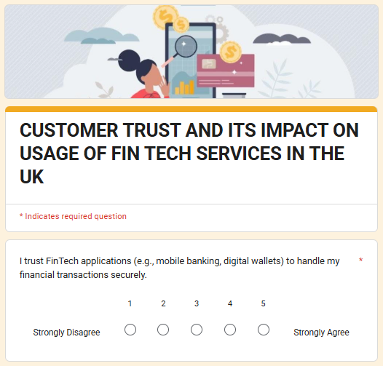
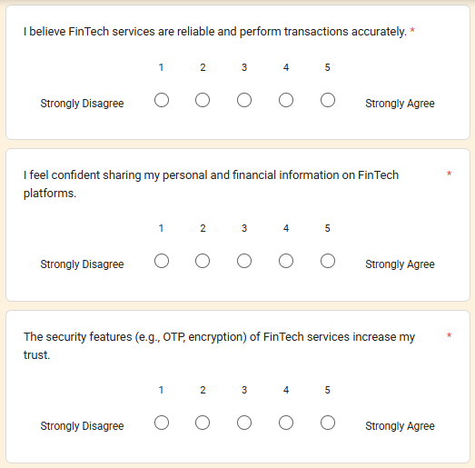
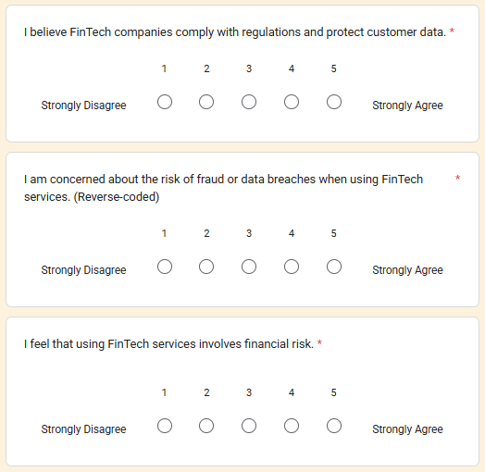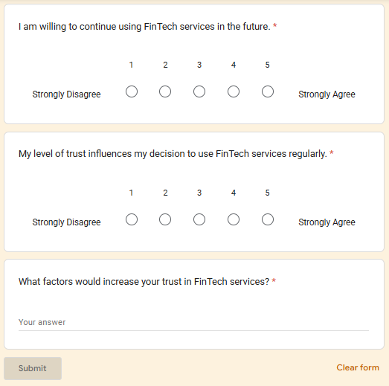

Appendix 2: Survey Raw Data

Sr. | Timestamp | Score | I trust FinTech applications (e.g., mobile banking, digital wallets) to handle my financial transactions securely. | I believe FinTech services are reliable and perform transactions accurately. | I feel confident sharing my personal and financial information on FinTech platforms. | The security  features (e.g., OTP,  encryption) of FinTech services increase my trust. | I believe FinTech companies comply with regulations and protect customer data. | I am  concerned about the risk of fraud or data breaches when using FinTech services. (Reverse-code d) | I feel that using FinTech services involves financial risk. | I am willing to continue using FinTech services in the future. | My level of trust influences my decision to use FinTech services regularly. | What factors would increase your trust in FinTech services?
1 | 22/04/2026 13:31:07 |  | 4 | 4 | 3 | 2 | 3 | 3 | 4 | 4 | 4 | Personal data protection
2 | 22/04/2026 13:44:56 |  | 5 | 2 | 1 | 3 | 2 | 3 | 3 | 3 | 3 | Rules & regulations data protect
3 | 22/04/2026 13:48:29 |  | 5 | 5 | 5 | 5 | 5 | 5 | 4 | 5 | 5 | Trust in FinTech services increases when platforms ensure strong security and protect user data. Transparency about fees and policies builds confidence. Following government regulations also makes services more reliable. Positive reviews and a good reputation further strengthen user trust. Easy-to-use and dependable apps add to overall confidence.
4 | 22/04/2026 14:42:29 |  | 5 | 5 | 5 | 3 | 4 | 5 | 3 | 5 | 5 | Data protection
5 | 22/04/2026 15:04:23 |  | 5 | 5 | 5 | 5 | 5 | 5 | 5 | 5 | 5 | Everything is perfect
6 | 22/04/2026 15:25:04 |  | 4 | 4 | 3 | 5 | 4 | 4 | 3 | 5 | 5 | Stronger security, clear privacy policies, reliable performance, and proper regulation would increase my trust in FinTech services.
7 | 22/04/2026 15:26:19 |  | 3 | 3 | 3 | 3 | 3 | 3 | 3 | 3 | 3 | I never used it
8 | 22/04/2026 16:04:36 |  | 4 | 4 | 4 | 4 | 4 | 2 | 2 | 4 | 4 | OTP
9 | 22/04/2026 16:24:37 |  | 5 | 5 | 5 | 5 | 5 | 5 | 5 | 5 | 5 | Trust in FinTech services increases when they offer strong security features like encryption and 2FA. Regulatory compliance and partnerships with trusted banks also build credibility.  Clear transparency about fees and policies is essential.  Reliable performance and responsive customer support add confidence. Positive user reviews and a good reputation further strengthen trust.
10 | 22/04/2026 16:25:01 |  | 5 | 5 | 5 | 5 | 5 | 5 | 5 | 5 | 5 | Stronger anti-hacking technologies
11 | 22/04/2026 17:03:43 |  | 4 | 4 | 5 | 4 | 4 | 5 | 5 | 5 | 4 | About Security
12 | 22/04/2026 17:05:03 |  | 4 | 3 | 5 | 5 | 3 | 4 | 4 | 5 | 5 | About reduce financial risk and make a transaction safe
13 | 22/04/2026 17:09:34 |  | 4 | 3 | 4 | 5 | 4 | 2 | 3 | 4 | 4 | Better security walls and fater server speeds by which probability of transaction failures , slow speed transactions and frauds would decrease upto a higher level
14 | 22/04/2026 17:14:41 |  | 4 | 3 | 4 | 3 | 4 | 2 | 1 | 4 | 4 | Better features,more transaction amount limits, wider adaptibilities such as better interfaces, better server speeds, better security barriers, etc by which people will trust and use more on FinTech services than traditional methods . Also more verification options and steps can be helpful for building a reliable service and a strong trust between user and service provider
15 | 22/04/2026 18:31:21 |  | 3 | 3 | 3 | 2 | 3 | 3 | 3 | 3 | 3 | Confidence that my financial and personal information is fully protected
16 | 23/04/2026 10:15:48 |  | 4 | 4 | 3 | 5 | 4 | 4 | 4 | 5 | 5 | Secure payment methods (such as OTP and biometric authentication), trusted and well-known apps, strong data privacy and protection, reliable customer support, and a good track record with no fraud experience.
17 | 23/04/2026 10:50:43 |  | 5 | 5 | 4 | 4 | 5 | 4 | 4 | 4 | 4 | Strong data security and privacy protection, clear and transparent policies, regulatory compliance, positive user reviews, reliable customer support, and a user-friendly interface would increase my trust in FinTech services.
18 | 23/04/2026 14:58:21 |  | 3 | 3 | 3 | 3 | 3 | 3 | 3 | 3 | 3 | Stronger security systems and fraud protection
19 | 25/04/2026 08:10:07 |  | 5 | 5 | 5 | 5 | 5 | 5 | 5 | 5 | 5 | Not Now
20 | 25/04/2026 08:22:41 |  | 5 | 5 | 5 | 5 | 5 | 5 | 5 | 5 | 5 | Better customer support available 24/7.
21 | 25/04/2026 09:22:30 |  | 5 | 5 | 5 | 4 | 5 | 5 | 5 | 5 | 5 | Clear information about how my data is used
22 | 25/04/2026 09:22:32 |  | 5 | 5 | 4 | 4 | 5 | 5 | 5 | 5 | 4 | My Financial Transactions
23 | 25/04/2026 09:23:10 |  | 5 | 4 | 5 | 5 | 5 | 5 | 4 | 4 | 5 | perceived reliability. Key factors that increase trust include visible security measures like encryption and biometric logins
24 | 25/04/2026 09:23:48 |  | 5 | 5 | 4 | 4 | 3 | 4 | 3 | 4 | 4 | Faster resolution of payment issues
25 | 25/04/2026 09:27:26 |  | 5 | 5 | 5 | 5 | 5 | 5 | 4 | 5 | 5 | Government regulation and compliance
26 | 25/04/2026 09:28:50 |  | 4 | 4 | 3 | 4 | 5 | 4 | 3 | 4 | 4 | Two-factor authentication for every transaction
27 | 25/04/2026 23:28:22 |  | 5 | 5 | 5 | 4 | 4 | 3 | 3 | 4 | 4 | Multi-Factor Authentication (MFA): Requiring more than just a password for access.
28 | 28/04/2026 17:05:48 |  | 4 | 4 | 3 | 3 | 3 | 4 | 4 | 4 | 2 | Data protection policy
29 | 28/04/2026 17:17:49 |  | 5 | 5 | 5 | 5 | 5 | 5 | 1 | 5 | 5 | Amazing service
30 | 28/04/2026 17:31:25 |  | 5 | 5 | 5 | 5 | 5 | 5 | 5 | 5 | 5 | Transparent transaction records.
31 | 28/04/2026 17:45:35 |  | 4 | 4 | 4 | 4 | 4 | 4 | 4 | 4 | 4 | Positive reviews from other users.
32 | 28/04/2026 17:50:42 |  | 3 | 3 | 4 | 4 | 3 | 4 | 3 | 4 | 3 | Guarantees against financial loss from fraud
33 | 28/04/2026 18:37:21 |  | 3 | 4 | 3 | 4 | 3 | 4 | 3 | 4 | 3 | Data security and privacy
34 | 28/04/2026 20:30:55 |  | 5 | 5 | 5 | 5 | 5 | 5 | 5 | 5 | 5 | Secure encryption of personal information
35 | 29/04/2026 01:57:55 |  | 5 | 4 | 4 | 5 | 4 | 5 | 2 | 4 | 4 | Strong security, transparent policies, regulatory compliance, reliable customer support, and positive user reviews increase my trust in FinTech services.
36 | 29/04/2026 03:53:59 |  | 4 | 4 | 3 | 4 | 4 | 4 | 3 | 4 | 5 | Trust in FinTech services increases with strong security measures, transparency and regulatory compliance
37 | 29/04/2026 13:05:03 |  | 5 | 4 | 4 | 5 | 4 | 3 | 3 | 4 | 4 | Transparancy and good customer care service which solved problem in less time
38 | 29/04/2026 15:23:43 |  | 3 | 4 | 4 | 3 | 4 | 4 | 3 | 4 | 4 | Reliable mobile applications with fewer technical issues.

39 | 29/04/2026 15:26:06 |  | 4 | 5 | 4 | 4 | 5 | 4 | 4 | 4 | 4 | Better privacy protection policies.
40 | 29/04/2026 15:28:47 | 3 |  | 4 | 4 | 3 | 4 | 4 | 3 | 4 | 3 | Clear communication during system maintenance or outages
41 | 29/04/2026 15:33:45 | 5 |  | 5 | 3 | 4 | 4 | 4 | 4 | 3 | 3 | Trust in FinTech services increases with strong security, clear fees, regulatory compliance (guidelines from the Bank), reliable performance, good customer support, and a positive reputation.
42 | 29/04/2026 15:34:57 | 5 |  | 5 | 5 | 5 | 5 | 5 | 5 | 5 | 5 | Strong authentication methods like biometrics.
43 | 29/04/2026 15:35:26 | 5 |  | 5 | 5 | 3 | 4 | 3 | 3 | 2 | 3 | Recommendations from friends and family
44 | 29/04/2026 16:03:15 | 5 |  | 5 | 5 | 4 | 5 | 4 | 4 | 4 | 5 | Trust in FinTech services would increase with strong data security and privacy protection. Clear policies and transparency in fees and transactions also help. Government regulation and proper customer support build confidence. Positive reviews and reliable performance over time make users feel safer.
45 | 29/04/2026 16:48:17 | 4 |  | 4 | 3 | 5 | 3 | 4 | 3 | 5 | 5 | Strong security, quick customer support, fraud protection, transparent policies, government regulation, and positive user reviews.
46 | 29/04/2026 19:30:16 | 5 |  | 5 | 4 | 3 | 2 | 2 | 3 | 4 | 3 | Customer data protection
47 | 29/04/2026 22:21:21 | 5 |  | 5 | 5 | 5 | 5 | 1 | 1 | 5 | 5 | FinTech services are perfect.
48 | 30/04/2026 10:53:31 | 4 |  | 3 | 4 | 4 | 4 | 3 | 4 | 4 | 3 | Easy-to-understand terms and conditions.
49 | 02/05/2026 05:08:02 | 4 |  | 4 | 3 | 4 | 4 | 4 | 3 | 3 | 3 | Insurance coverage for online fraud.
50 | 02/05/2026 06:18:31 | 3 |  | 2 | 3 | 4 | 2 | 2 | 3 | 3 | 2 | More transparency about fees and charges.
51 | 09/05/2026 14:20:06 | 2 |  | 3 | 4 | 2 | 3 | 4 | 2 | 3 | 4 | Consistent app performance without downtime.
52 | 09/05/2026 14:37:59 | 2 |  | 3 | 4 | 2 | 2 | 3 | 3 | 4 | 2 | Strong legal protection for consumers
53 | 09/05/2026 14:40:31 | 3 |  | 2 | 2 | 1 | 2 | 3 | 3 | 2 | 3 | Accurate and error free transaction
54 | 09/05/2026 14:42:12 | 3 |  | 2 | 3 | 1 | 3 | 2 | 1 | 3 | 2 | Verified customer reviews and rating
55 | 09/05/2026 23:30:41 | 2 |  | 3 | 4 | 1 | 3 | 2 | 3 | 1 | 2 | Transfer personnel data
56 | 10/05/2026 15:35:11 | 2 |  | 3 | 1 | 3 | 3 | 2 | 2 | 3 | 1 | OTP fraud protect
57 | 10/05/2026 15:56:32 | 3 |  | 2 | 3 | 5 | 4 | 5 | 4 | 4 | 5 | Transparent company policies and practices
58 | 10/05/2026 21:39:49 | 3 |  | 3 | 2 | 3 | 2 | 3 | 4 | 4 | 4 | Regularly transaction safety
59 | 11/05/2026 10:40:37 | 3 |  | 4 | 3 | 3 | 4 | 2 | 4 | 4 | 3 | Application system easy to use
60 | 11/05/2026 18:32:11 | 3 |  | 4 | 2 | 3 | 3 | 4 | 3 | 4 | 4 | Accurate and secure data protection
61 | 12/05/2026 12:12:39 | 3 |  | 2 | 2 | 2 | 5 | 4 | 4 | 4 | 4 | Customer service increase
62 | 13/05/2026 14:24:49 | 3 |  | 4 | 3 | 2 | 4 | 3 | 4 | 3 | 3 | Easy and free to transfer more money
63 | 14/05/2026 13:54:31 | 3 |  | 2 | 4 | 3 | 4 | 4 | 4 | 3 | 3 | Regulatory Assurance
64 | 14/05/2026 19:49:53 | 4 |  | 3 | 5 | 4 | 3 | 4 | 5 | 4 | 3 | Strongly legal protection for customer
65 | 14/05/2026 19:51:05 | 3 |  | 4 | 5 | 4 | 4 | 3 | 4 | 4 | 5 | Availability of human customer representatives
66 | 14/05/2026 19:51:33 | 3 |  | 2 | 4 | 3 | 3 | 4 | 2 | 4 | 3 | Secure password recovery options.
67 | 14/05/2026 19:52:07 | 3 |  | 4 | 2 | 4 | 4 | 3 | 4 | 3 | 3 | More public awareness campaigns about FinTech safety
68 | 15/05/2026 23:11:00 | 3 |  | 4 | 3 | 4 | 5 | 3 | 4 | 3 | 4 | Continuous monitoring against cyber threats
69 | 15/05/2026 23:11:28 | 4 |  | 3 | 4 | 4 | 4 | 4 | 4 | 4 | 4 | Faster transaction processing
70 | 15/05/2026 23:12:03 | 3 |  | 4 | 3 | 4 | 5 | 3 | 4 | 5 | 3 | Transparent company policies and practices.
71 | 15/05/2026 23:12:36 | 3 |  | 3 | 4 | 3 | 3 | 2 | 3 | 4 | 3 | Verified customer reviews and ratings.
72 | 15/05/2026 23:24:05 | 4 |  | 3 | 5 | 3 | 4 | 4 | 3 | 4 | 4 | Better communication between FinTech firms and users
73 | 15/05/2026 23:24:38 | 3 |  | 4 | 3 | 3 | 4 | 4 | 3 | 4 | 4 | Continuous improvement in app security features
74 | 16/05/2026 00:01:14 | 4 |  | 4 | 5 | 4 | 3 | 4 | 4 | 3 | 5 | More public trust in FinTech companie
75 | 16/05/2026 00:02:08 | 3 |  | 4 | 3 | 3 | 3 | 4 | 3 | 3 | 4 | Better digital literacy support for users
76 | 16/05/2026 01:31:22 | 4 |  | 5 | 4 | 5 | 3 | 4 | 5 | 4 | 4 | More responsive mobile applications
77 | 16/05/2026 01:31:53 | 3 |  | 4 | 5 | 4 | 5 | 4 | 3 | 5 | 4 | Independent verification of security standards
78 | 16/05/2026 09:39:01 | 3 |  | 3 | 4 | 4 | 5 | 4 | 4 | 4 | 5 | Simpler processes for reporting fraud
79 | 16/05/2026 09:39:49 | 5 |  | 4 | 5 | 4 | 4 | 4 | 5 | 4 | 4 | Availability of secure offline support option
80 | 16/05/2026 09:40:36 | 3 |  | 3 | 4 | 4 | 3 | 4 | 4 | 3 | 4 | cybersecurity
81 | 16/05/2026 11:10:16 | 4 |  | 4 | 4 | 4 | 4 | 4 | 4 | 4 | 4 | Increased trust through long-term reliability
82 | 16/05/2026 11:10:42 | 3 |  | 3 | 4 | 4 | 3 | 2 | 3 | 3 | 4 | emergency situations
83 | 16/05/2026 11:29:47 | 5 |  | 5 | 5 | 5 | 5 | 5 | 5 | 5 | 5 | .
84 | 16/05/2026 11:30:55 | 4 |  | 3 | 3 | 4 | 3 | 4 | 3 | 3 | 3 | government financial systems
85 | 16/05/2026 11:31:34 | 2 |  | 4 | 3 | 3 | 2 | 4 | 2 | 3 | 4 | Better customer feedback systems
86 | 16/05/2026 11:47:47 | 1 |  | 2 | 2 | 3 | 2 | 3 | 3 | 3 | 2 | Reduced hidden charges
87 | 16/05/2026 11:48:25 | 3 |  | 3 | 2 | 4 | 3 | 4 | 4 | 3 | 4 | More ethical handling of customer data
88 | 16/05/2026 13:36:08 | 4 |  | 3 | 3 | 2 | 3 | 4 | 3 | 2 | 4 | privacy settings
89 | 16/05/2026 13:36:38 | 3 |  | 2 | 3 | 4 | 5 | 3 | 5 | 4 | 5 | Public disclosure of security certifications
90 | 16/05/2026 13:37:29 | 5 |  | 5 | 5 | 5 | 5 | 5 | 5 | 5 | 5 | Availability of multilingual customer support
91 | 16/05/2026 13:59:22 | 3 |  | 4 | 4 | 3 | 5 | 4 | 4 | 3 | 4 | Transparent explanations of app permissions
92 | 16/05/2026 14:00:34 | 4 |  | 4 | 4 | 4 | 4 | 3 | 5 | 4 | 4 | financial losses awareness
93 | 16/05/2026 14:12:38 | 4 |  | 3 | 4 | 3 | 3 | 4 | 3 | 4 | 4 | Secure international transaction facilitie
94 | 16/05/2026 14:13:06 | 4 |  | 4 | 3 | 3 | 2 | 4 | 3 | 4 | 4 | More reliable internet payment systems
95 | 16/05/2026 14:13:35 | 3 |  | 5 | 4 | 2 | 4 | 3 | 4 | 3 | 3 | Notifications for every login attempt
96 | 16/05/2026 14:14:05 | 4 |  | 3 | 5 | 5 | 5 | 5 | 5 | 4 | 4 | Easy-to-contact
97 | 16/05/2026 14:30:48 | 3 |  | 4 | 3 | 2 | 4 | 3 | 5 | 3 | 4 | cybercrime and online fraud
98 | 16/05/2026 14:31:25 | 4 |  | 2 | 4 | 3 | 5 | 4 | 3 | 4 | 4 | Assurance that my information will not be shared with third parties
99 | 16/05/2026 14:31:46 | 2 |  | 4 | 3 | 4 | 4 | 4 | 4 | 3 | 4 | Bank
100 | 16/05/2026 14:44:17 | 3 |  | 4 | 2 | 3 | 2 | 3 | 4 | 3 | 3 | Fast international money transfer

101 | 16/05/2026 14:46:57 |  | 4 | 4 | 4 | 3 | 4 | 4 | 3 | 5 | 4 | Application interface
102 | 16/05/2026 14:48:03 | 3 |  | 4 | 4 | 3 | 5 | 4 | 3 | 3 | 4 | personal data protection
103 | 16/05/2026 17:27:16 | 4 |  | 5 | 4 | 3 | 4 | 5 | 4 | 5 | 5 | Lower chances of transaction failures
104 | 16/05/2026 17:27:43 | 3 |  | 2 | 3 | 4 | 3 | 2 | 4 | 3 | 3 | More educational campaigns about safe online banking
105 | 16/05/2026 17:40:31 | 3 |  | 3 | 2 | 4 | 4 | 3 | 4 | 4 | 3 | Improved protection against unauthorized access
106 | 16/05/2026 17:41:15 | 3 |  | 5 | 3 | 4 | 5 | 3 | 4 | 3 | 4 | Access to transaction history at all times faster
107 | 16/05/2026 17:57:49 | 4 |  | 3 | 3 | 4 | 5 | 3 | 3 | 4 | 3 | Fintech service
108 | 16/05/2026 17:58:28 | 2 |  | 3 | 4 | 3 | 3 | 4 | 4 | 4 | 3 | Data protection
109 | 16/05/2026 18:15:06 | 3 |  | 4 | 3 | 4 | 4 | 4 | 3 | 4 | 5 | Faster verification processes
110 | 16/05/2026 18:16:11 | 4 |  | 3 | 2 | 2 | 4 | 3 | 4 | 4 | 4 | Stronger anti-hacking technologies
111 | 16/05/2026 18:31:07 | 4 |  | 4 | 3 | 3 | 4 | 3 | 3 | 4 | 4 | Customer support
112 | 16/05/2026 18:31:55 | 5 |  | 5 | 5 | 5 | 5 | 4 | 3 | 3 | 4 | 24 × 7 support
113 | 16/05/2026 18:43:03 | 4 |  | 3 | 4 | 3 | 3 | 3 | 2 | 4 | 4 | Better integration with traditional banking systems
114 | 16/05/2026 18:43:40 | 3 |  | 4 | 4 | 4 | 3 | 2 | 4 | 4 | 3 | Regular updates about account activity

Appendix 3: Survey responses


