
Skills for the Workplace
Module Assignment Submission
Student Name: | Laura Williams
Student Number: | 1815022
Module No: | BMSK6007
Module Title: | Independent Project

Statement of Confirmation of Authenticity
By the act of making this submission, the student declares that this is the work of the student named above. The work has not, in whole or in part, been knowingly presented elsewhere for assessment, or where assessment has been built on a previous assessment, this has been identified. Where materials have been used from other sources it has been properly acknowledged. If this statement is untrue, the student acknowledges that an assessment offence has been committed.
Attention is drawn to the plagiarism and unfair practice policies of both the University and of ILM.
Permission for ILM to use this script
ILM uses learners’ submissions – on an anonymous basis – for assessment standardisation. By submitting, both the centre and the learner agree that ILM may use this script on condition that identifying information is removed. However, if you are unwilling to allow ILM use this script, please refuse by ticking the box: □

Investigating effective ways to keep employees engaged and motivated, while Hybrid working, in an organisational change.

Laura Williams - 1815022
BMSK6007
November 2022

AKNOWLEDGEMENTS
I would like to thank the universe for helping me find the strength and courage to work toward a degree in my thirties. I would like to thank the tutors of the university; Michaela and Gavin in level 4, Brian in level 5, for supporting me through the pandemic and keeping me engaged in my studies. Lastly, a huge shout out to Paul in level 6, the final year, who has been very patient with me and made himself available at short notice, at all hours, to guide me through my insanity! I would especially like to thank my peers and best friends Lianne and Lucy for the study dates and Teams calls, providing the motivation, to push each other through our darkest most stressful nights in the lead up to submitting every assignment.

Abstract
Background
With Alcumus being a private equity business, the fundamental organisation goal is to gain maximum profits. To be successful, continuous change in the way the organisation operates is essential. The organisational culture in Alcumus includes finding ways for employees to collaborate and be innovative when implementing a change.
Aims and objectives.
This report aims to investigate the relationship between transformational leadership, job satisfaction and employee motivation through organisational change, to identify ways on how to improve employee engagement and innovation, when implementing a change in Alcumus.
Research findings
From the literature review from various published articles, journals, and books on the effect of leadership styles used and their effect on organisational performance, it was found that effective leadership positively influences the behaviour and attitudes of employees to be motivated and engaged in a change process. Empirical evidence concluded that the behaviour in an organisation is formed by the styles of communication by the leadership to the employees within of the strategic plans and programmes for the organisational objective. As employees / leaders may come and go within an organisation, further research needs to be conducted to find how to ensure positive behaviours continue within an organisation when faced with changes in leadership roles.

TABLE OF CONTENTS
AKNOWLEDGEMENTS 3
Abstract 4
1. Intro 6
2. LITERATURE REVIEW 7
2.1 ORGANISATIONAL CULTURE AND CHANGE 7
2.2 CHALLENGE OF THE PANDEMIC ON CALL CENTRE BASED ORGANISATIONS. 9
2.3 RESISTANCE TO CHANGE 10
2.4 EMOTIONAL INTELLIGENCE 13
2.5 TRANSFORMATIONAL LEADERSHIP 14
2.6 COMMUNICATION WITHIN AN ORGANISATION 17
2.7 HYBRID WORKING 18
2.8 SUMMARY 20
3. MATERIALS AND METHODS 20
3.1 QUESTIONNAIRE / SURVEYS 21
4. Analysis 22
5. CONCLUSION 23
6. FUTURE RECOMMENDATIONS 24
REFERENCES 25
APPENDIX A 33
APPENDIX B 34
APPENDIX C 35
APPENDIX D 39
APPENDIX E 40
APPENDIX F 41
APPENDIX G 46
APPENDIX H 47
APPENDIX I 48
APPENDIX J 49
APPENDIX K 50
APPENDIX L 51
APPENDIX M 53
APPENDIX N 54
APPENDIX O 55

1. Intro

With the rapid changes in technologies, opportunities available to key talent and market changes, organizations need to motivate employees to engage in the change process. Now more than ever, these changes have forced organizations to re-assess the connections between performance, leadership, and employee satisfaction according to Leimbach (2020). This report will investigate research studies in an organisational context with hybrid working within their business model, to search for effective ways to improve employee’s engagement and motivation in a change process, concentrating on the leadership styles and ways of communication within Alcumus.
Focusing on the retentions team of eighteen employees and one department leader, this report will detail a study using qualitative and quantitative data, collected from a satisfaction survey and interview questions, to understand employees needs and wants, in the hope to help identify what can be implemented to overcome resistance to change, earlier on in the change process, as the organisation believes it loses productivity, sees a drop in morale and motivation levels and have seen an increase in absenteeism during this stage.
Quantitative and qualitative methods will be combined to see if there is a statistically significant relationship between the methods used to engage and motivate employees through a workplace change. Quantitative research will involve running analysis in job satisfaction with leadership styles using the results of employee surveys. While qualitative research will focus on the likelihood that the interviewed participants are open and honest about any issues in the hope to identify their resistance to change. The aim of this study is to help understand the employees’ perceptions and motivations to see if different approaches to leading stakeholders through change can be adapted, from the literature that will be reviewed.
The findings from the data that was analysed for the productivity and growth in Alcumus since 2019 - 2022 reports an increase in productivity and profits while hybrid working. It seems that communication and knowledge sharing, empowers employees to be more productive and motivated while at work. Resisting to change earlier on in the change process is crucial to encourage employees to get on board and be involved in the success of the business objectives.
The limitations of conducting a full analysis on the employees within Alcumus, Further studies can be conducted to gather more qualitative and quantitative data, in the aim to understand how to improve the communication and collaboration within Alcumus while going through a change process.

2. LITERATURE REVIEW

This section will use a mixture of resources including articles, textbooks, and peer reviewed journals to get a better understanding of what factors may affect employee’s willingness to engage with change. Firstly, it will be looking at organisational culture and at the fundamental purpose of organisational change from external and internal forces such as the impact of the recent pandemic on organisations as Li et al. (2022) argues, with organisations facing a crisis like the pandemic, the typical change process of many organisations may no longer be applicable. It will critically analyse academic literature to identify leadership styles used for successful change and how the styles can impact how communication is delivered to stakeholders throughout the change. A study by Whillans et al. (2021) examined how teams adapted to their roles in the pandemic when working virtually and found that core activities such as relationship interactions, required additional adjustments for the employees to work effectively in a virtual environment. The report will examine the importance of emotional intelligence (EI) skills within a workforce to determine if high EI helps to understand others on a deeper level to overcome barriers to change sooner, for the employees to commonly share the same organisational objective goals. The change curve (see section 2.3) is a recognised theory for leaders to identify ways they can have an impact on resistance to change earlier on in the process.
Finally, this section will discuss how to develop emotional intelligence within a workforce helping to understand others on a deeper lever to overcome barriers to change working together to share the same organisational objective goals.

2.1 ORGANISATIONAL CULTURE AND CHANGE

“Change is a constant; has always been with us and will continue to dictate reality. In fact, change is reality.” (Beerel, 2009, p.6). According to O’Reilly & Chatman (1996), organisational culture can define the importance in an organisation and may affect how employees behave and feel, suggesting it can help to shape their behavioural responses to the required performance outcomes, depending on the individuals’ own beliefs and values. A reason why shared values are so often discussed when organisations look to achieve a culture change. In addition to this, in a later study Carlstrom & Ekman (2012) state that the culture in an organisation is based on a set of values, beliefs and behaviours that may vary in organisations and suggest that this is collectively involved in the change, employees and performance in the organisation.
Beerel (2009) states the main purpose for an organisational change is to align to new realities that are continuously presenting themselves and the sooner an organisation can recognise new realities, the more time it allows to plan and make strategic decisions in response to the change that needs to be made. In line with this, Riley (2015) argues there are four elements to change. Firstly, there needs to be a reason for the change, such as a dissatisfaction with the current strategies or position, or a change in external environment that an organisation must respond to, to be successful. Secondly, it is essential for the leader to paint the vision to show there is a better alternative. Thirdly, it is necessary to develop the strategy to implement the change and finally to be ready for the fact that with any kind of step change process there will inevitably be some form of resistance. For any change in an organisation to be successful, research suggests that the organisations are not only increasingly relying on the strengths and skills of their employees and to remain competitive, but also employees need to be engaged and motivated to implement the change successfully (Gilly et al. 2009, Bakker, 2017, Taylor, 2018). Thus, Chanana (2021) agrees that Employee engagement is crucial for an organisation to keep their skilled employees and without employee engagement, an organisation won’t be successful. From these studies, it seems logical to suggest that it is fundamental to get employees onboard earlier on in the change process for the change process to be successful.
The culture in an organisation can help and hinder the transition process, meaning it may have a positive or negative impact when it comes to ensuring the change is successful (Taylor, 2014, Hammood et al., 2020). This research suggests that the implications of employees not being engaged and motivated in a change can have a detrimental effect on the morale of the team and have a negative effect on the change process being successful. Lashitew et al. (2020) argues that individuals in the organisation may continue to work against a change process if they feel they have no say in the change process, resist taking on the extra work.
Alcumus showcase that their organisational culture is an integral part of who they are, and their core values are being open, collaborative, and caring (See Appendix A). It would be logical to assume that it is crucial for the stakeholders within the organisation to understand the reasons for change and communicating openly and honestly would be key to align with their values. The benefits of authentic leadership and the need to build trust will be discussed further in section 2.2. There seems to be many factors that would require an organisation to implement change. Whether it be incremental change where change occurs over a period in small stages, or Step change which occurs rapidly. According to Riley (2015) the step change is a significant challenge to change management. A significant change that forced organisations to make a step change globally, was the pandemic. The next section will investigate external forces, such as the pandemic and how organisations were faced with internal forces such as employees adjusting to the dramatic change, of working from home and looking into this into more detail when Alcumus introduced hybrid working into their business model which is discussed in more detail in section 2.7.

2.2 CHALLENGE OF THE PANDEMIC ON CALL CENTRE BASED ORGANISATIONS.

The shift for organisations to work from home, provided contact centres the opportunity to implement flexible shift patterns, however, working remotely works for some employees but not for others. Mutebi & Hobbs (2022) suggest that remote and hybrid working can negatively impact employees as working from home may cause a blurred effect on work-life balance as the “use of information and communication technologies to engage in work-related tasks outside of work time can make it difficult for workers to ‘switch off’.” According to the ONS (2022) Information and communication organisations reported the biggest increase in using homeworking in their business model, while other industries such as Construction and Hospitality reported the lowest score of implementing working from home as it does not suit the way that they can work (See Appendix B). In a study by Xiong et al. (2016) it was found that trust plays an important part between leadership and employees forming their perceptions, attitudes, and behaviours towards the organisational commitment. In line with this, Leimbach (2020) suggests that if there is not open trust and support from the leadership it is difficult for employees to feel satisfied and fulfilled in their role. He argues that having open trust and support from your leader can create an environment in the team where employees feel empowered and willing to engage in their role. Everett (2020) suggests that leaders and managers are required to have increased emotional intelligence skills to support remote workers to enable them to lead and motivate employees virtually. The importance of emotional intelligence will be discussed further in section 2.4. With incremental and radical changes in a call centre environment, is would seem that trust plays an important role between management and leadership with employees when working from home and it is logical to suggest that is would be useful to find ways of improving forms of communication and collaboration virtually. The Covid-19 pandemic accelerated the transition from the traditional working model of being in the office 5 days a week to the hybrid working model combining working remotely and in the office. According to Nyktarakis (2022) collaboration being a crucial factor for team members while hybrid working and this can be achieved using Microsoft Teams and if used properly by everyone, can overcome challenges that may arise in the collaboration among the team. Anyone who applies for a new job at Alcumus, are invited for their first interview via Microsoft teams (See Appendix O) which demonstrates that the use of Microsoft Teams is part of the normal procedure while working at Alcumus. This suggests that Alcumus can investigate more efficient ways for the team to collaborate and be involved in any team activity, while working from home and shows that with the use of this platform, employees have adapted to the new way of working while they are not in the office. Ensuring employees are engaged with their camera on while in a virtual meeting can be a way for employees to feel seen and heard in meetings. Unforeseen circumstances forcing change within organisations comes resistance (Riley 2015). The next section will investigate an individual’s perspective to change in more detail.

2.3 RESISTANCE TO CHANGE

“In general, individuals focus more on what is that they have to give up when change occurs and not on what they could gain.” (Bejinaru & Baesu, 2013 Pg. 146). Fear, anxiety, and other negative thoughts are the reasons behind most resistance to change, and individuals have an instinct to resist changes (Readon et al. 1998, Oreg 2003, Kotter & Cohen 2012). However, Dent & Goldberg (1999) argues that people may resist the loss they experience such as loss of pay, status, or comfort but these are not the same as resisting to change, in line with this, Loo et al. (2017) suggest that change creates uncertainty in individuals and the tension that brings can have an impact on their perception to change. However, Riley (2015) argues that a degree of resistance is normal as its disruptive and stressful, but a degree of skepticism can be healthy especially where there may be weaknesses in the proposed changes. Lewins force field analysis considered the forces that are pushing for change and the forces that resist change and suggests that for the step change to be possible, the driving force must exceed the restraining force (Riley, 2015). Lewins force field analysis (Lewin 1997) considered the forces that are pushing for change and the forces that resist change. It would be logical to suggest that if a leader can have a better understanding of why individuals are resisting the change, they could adjust the approach they use when dealing with the employees to guide them through the change process more productively. Understanding where an individual is on the change curve will enable the leader to adapt their leadership style to help the individual overcome their sense of loss in other ways. Ignoring resistance to change could have a negative impact on meeting business objectives as stated by Florea (2021). Thus, investigating ways to keep employees motivated and engaged in their roles needs to be addressed, to identify effective ways to overcome resistance to change earlier on in the change process. It would be logical to suggest that a leader should always seek to find ways to understand employees on a personal level to better understand how to approach resistance to change. A tool that can be used to help understand someone’s emotional state while in a change process is the change curve.
The Change curve model is a useful theory to use, to help identify the stages employees may be placed while going through change.
Transition Curve
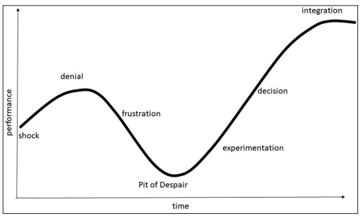
(Malone, 2018, P.37)
The Kubler-ross change curve is known for the five stages of grief:
- Denial
- Anger
- Bargaining
- Depression
- Acceptance.
As stated by Kubler-Ross & Kessler (2014) not everyone goes through all the stages, or even in a prescribed order, but this model aims to make us better equipped to cope with life and loss using this tool to help us to identify how we are feeling. According to Malone (2018), the change curve illustrates the stages of personal change and believes if left to unfold naturally, even though the time it takes to progress through the stages, individuals will progress from denial to acceptance overtime. This would suggest that if individuals are left to deal with the change naturally, without the encouragement or support from their leader, it could hinder the change process in a negative way, as the individual may affect the outcome of the change process by resisting the change for longer.
In Alcumus, when the two leaders of the retentions team were made redundant (See section 2.8) the head of retentions called a mandatory meeting for all of the team to communicate the news with them and provided a space for the team to speak about their concerns on a one-to-one basis and provided follow up meetings to keep the team up to date with the change process, backing the meetings up with email confirmation. This suggests that in communicating each step and being open and honest with the team, the head of retention leader reacted in an empathetic way, which could generate a deeper trusting relationship within the team, thus, making them feel more engaged and part of the change process.
While is seems from the research conducted so far, that leadership styles may seem to have a high impact on leading employees through change, other factors such as dealing with resistance to change early on, is a way to contribute to the success of the change process (Malone 2018, Florea 2021). On the other hand, to successfully lead employees through change, the leadership may utilise other resources such as coaching, to empower employees to be motivated and engaged to utilise their skills to help the change process be successful. (Stankovic & Radojevic, 2022)
Kotter & Schlesinger (2008) suggest that there are four main reasons why individuals resist to change: Parochial self-interest, misunderstanding of employees not being aware why the change needs to happen, Low tolerance with a sense of insecurity of change and different assessment of the situation not agreeing with the need for change.
In line with this in a later study, Shapiro (2010, Pg. 47) argues that individuals’ attitudes towards a particular change initiative fall into one of four categories.
- Apathetic individuals tend not to care about change as it makes no difference to them.
- Incubators tend to think about it first. If they think positively towards the change, resistance is minimal, in contrast, if they think negatively about the change, this could cause problems.
- Resisters oppose the change openly.
- Advocate individuals welcome change.
The aim for an organisation to be successful through a change process would be to keep advocates motivated and to grow advocates within the team, to positively enable the change process to implemented sooner. Shapiro (2010 Pg, 128) suggests that if the environmental support is high in an organization, more people will flow out of apathetic to incubators and from incubators to advocates sooner. Riley (2015) argues that employees may welcome change as it could provide opportunities for personal development, new challenges reducing boredom of work and create opportunities to participate and shape the outcome of the change.
In a recent article, Watkins (2023) states the importance of recognising opportunity focused or obstacle focused individuals to understand why some people react differently to change. Research shows that for a leader to have a level of understanding to identify how to support their followers though a change, emotional intelligence is one of the fundamental skills that are required. The next section will investigate the effects of emotional intelligence in leadership styles further.

2.4 EMOTIONAL INTELLIGENCE

“Ability to perceive accurately, appraise, and express emotion; the ability to access and/or generate feelings when they facilitate thought; the ability to understand emotion and emotional knowledge; and the ability to regulate emotions to promote emotional and intellectual growth” (Mayer and Salovey, 1997, P10). In the ability model of Emotional Intelligence (EI) proposed by Salovey, Mayer (1990) it is suggested that EI is composed into four hierarchical branches that outlines that some abilities of EI are more psychologically complex than others. The four-branch model (Mayer & Salovey, 1997) distinguished four areas of problem solving that is necessary to carry out emotional reasoning:
- The ability to perceive emotions.
- The ability to facilitate thoughts by using emotions.
- The ability to understand emotions.
- The ability to manage emotions in oneself and others to promote personal growth.
In a later study by Caruso (2003) suggested that the ability model, is ‘focussed and narrow in scope’, leaving room for other approaches, whether trait / competency based or to better understand and develop people. Alcumus have taken most of the employees through the insight’s discovery questionnaire (see section 3) to help them understand each individual personalities and traits. This would suggest that this is another approach that has been adopted into their culture to help understand and develop their employees. As explained by Goleman (1996) it is crucial for a leader to have high EI in their leadership role. According to Balestracci (2003) a leader requires five essential skills to respond to resistance to change appropriately which include being self-aware, emotional maturity, self-motivation, ability to show empathy and the ability to maintain and develop relationships positively. According to Srivasta (2013), EI is a crucial skill for a leader to effectively deal with employees when going through a change and Bejinaru, Baesu (2013) agrees that for the leader to be effective, they need the capability to manage employee’s resistance to change to help mould their behaviour towards implementing the change successfully. In research from Grout (2007) a leader that has high EI, can adapt an appropriate style of how they lead in various situations. In a later study Ehrlich (2017) suggested that the heart of leadership involves actively paying attention and helping to build self-awareness within their followers. This would suggest it is crucial for a leader to have high levels of emotional intelligence to adapt to resistance to change early on to help employees engage and be motivated to adapt to the change process. It would be logical to assume that if employee’s complete Goleman’s EI questionnaire (See Appendix C), leaders can utilise this as a reference point, allowing them to engage with employees on a deeper level, as it would be a way to increase the employees’ self-awareness, self-regulation, internal motivation, empathy, and social skills. In line with this, Prince2 (2019) states that EI is an essential skill for a leader to have to establish a deeper connection with employees which improves their ability to motivate and communicate with their followers. The research suggests that individuals may respond in a positive way when going through change if they feel heard and understood. It would be logical to assume that for a leader to build trust with their followers, they need to understand employees on an individual basis to find ways on how to communicate effectively to help them overcome resistance to change earlier on in the change process. The insights discovery questionnaire (section 3) helps Alcumus to understand their employee’s personality traits, however, to help their employees become more self-aware and practice their EI, Alcumus could consider introducing time for their employees to take part in the EI questionnaire to improve the awareness of their own emotions as well as others in the team. The next section will look further into leadership styles and look to identify if the leadership styles used in Alcumus.

2.5 TRANSFORMATIONAL LEADERSHIP

“Leadership is a process of generating change, not maintaining the status quo.” (Bejinaru & Baesu, 2013 Pg. 147). Burns (1978) describes the role that a leader takes in the transactional leadership style is to support the employees through procedures of fundamental changes that improve productivity, and the traits of transformational leadership style empowers employees to engage in the organization’s vision which increases productivity, employees’ motivation, work satisfaction and individual performance. In a later study Bass (1985) stated that transformational leadership styles, require essential abilities such as charisma, inspiration, intellectual stimulation, and individual appreciation to be successful. This would assume that for a change process to be successful, a transformational leadership style is well suited within Alcumus.
Riley (2015) suggests that there is a clear relationship with the process of change and the leadership styles. He stated that for a step change to be successful the organisation needs strong leadership. In line with this, Florea (2021) argues that transformational leadership can only appear in organisations that hold leaders with these abilities. Leadership seems to be a critical factor to manage change in an organisation, and the quality of the leadership during a change process to create a strong vision of the driving forces for the change to get individual on board. Derman (2019) stated a good leader not only guides their followers in achieving professional success, but also reassures them and often motivates them. Adapting to change requires transformation, and according to Beerel (2009), although learning is not always easy, transformative change requires learning to become adaptive and that adaptation means being creative and active in the face of change. As Peter Senge (1990) suggests that learning organisations are possible, as its in people’s nature to learn and they love to learn and argues that “team learning is vital because teams, not individuals, are the fundamental learning unit in modern organisations and unless teams can learn, the organisation cannot learn” (Senge, 1990, Pg. 10).
Creating readiness to change environment within the workplace is the leader’s role according to Bejinaru, Baesau (2013) and state that the employee’s readiness to accept change and embrace in the change is crucial for the change process to be successful. Research has consistently shown that leadership styles have a significant impact on keeping employees motivated through a change process, and that the success of change, depends on how the leaders stimulate employees to engage with the change process. (Bejinaru, Baesu, 2013, Appelbaum et al., 2015).
According to Bass (1985) Transformational leaders motivate employees to exceed their personal orientations at work. In line with this, Oreg & Berson (2011) theorizes that a transformational leader provides strong situational cues, which reduces the effects of employees’ traits on their specific reactions to the change in the organisation.
According to Reardon et al. (1998) leaders need to be aware of their own strengths and weaknesses and understand the extent of how their leadership styles are suited to the demands they face, and this is crucial when organisations are going through radical change. Rowe et al. (1995) developed the Leadership Style Inventory (LSI) (See Appendix D) to identify differences in styles that leaders use, which was created by researching how adaptive leaders are in the demands they are faced with, and how they communicate with the employees and how they can persuade and motivate employees in the change process, using four basic styles.
- The Commanding style who are highly productive and results orientated, focusing on short term goals making changes rapidly.
- The Logical style who covers all alternatives using analysis and questioning and learn by reasoning making changes carefully.
- The Inspirational style who are inquisitive and encourage other to follow the vision in a radical change.
- The Supportive style who emphasizes openness and operate more as facilitators / mentors making changes slowly.
In a later study, Reardon et al. (1998) concluded the most effective leadership styles that are required for the five phases of radical change (See Appendix E) The five stages of radical change are:
- Planning – Charting the course for change.
- Enabling – Discussing with the stakeholders involved in the change through enabling and empowering them to prepare for change.
- Launching – Commencing the change and dealing with resistance to change early on
- Catalysing – Focusing on the employees by involving, encouraging, and motivating them.
- Maintaining – Guiding the stakeholders involved in the change to continue their efforts providing them with motivation and guidance to do so.
They concluded that linking the LSI with the Five-stage Radical Change Model helps leaders can identify where their followers and their own strengths and challenges lie and knowing this will determine what style is more effective to achieve success in a radical change. It would be logical to assume this would be useful to refer to for an organisation looking to implement a change successfully as it would be a way to keep on track of the organisational objective, while choosing the right leadership skills which are needed in each stage, to keep the employees engaged through the change process.
In a systematic review by Lines (2004), quantitative data from a major strategic reorientation of a national telecommunications company was used to assess the outcome of participation in strategic change. It indicated that a collaboration culture, is generated by the leader’s invitation for employees to participate in making tactical decisions for the change process and that it is a key factor, that links participation to organisational change success. In line with this, Beerel (2009) emphasize that leaders must understand that ‘defining a new reality requires the collaboration of others’ and argues a key factor for the leadership is to identify new realities for change, and help build the organisations adaptive capacity, for employees to remain engaged in a change process. As stated by Beerel (2009), there is no one blueprint model or theory for leadership. Throughout the literature there seems to be a pattern which conclude that leadership styles can influence employee’s motivation and empowerment not by transformational leadership in general, but by enforcing collaboration within the team and creating stronger workplace relationships to share the same goal and vision for the organisational mission. It would be logical to assume that if organisations can identify effective ways to communicate openly and honestly, employees would be more inclined to be collaborate and engaged in finding innovative ways to help implement the change. When Alcumus employees are working from home, any meetings are conducted in meeting rooms with a large screen, this allows employees that chose to work from home that day can be part of the meeting with the full team. This is to ensure that the information shared is not missed by anybody. They follow up meetings with emails confirming the key points discussed and are open for any new ideas to ways of improving the process. This would suggest that the collaboration and innovation within the organisation is increased within their culture. The next section will be looking into communication within an organization, to identify methods that can be utilised to engage and motivate individuals while working from home.

2.6 COMMUNICATION WITHIN AN ORGANISATION

Tacit = Explicit - knowledge sharing.
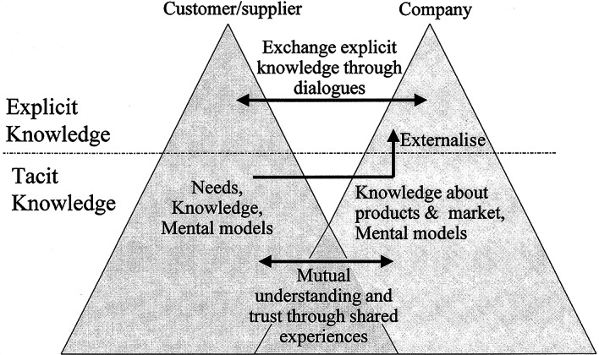
(Nonaka et al. 2020 Pg.13)

Nonaka et al. (2020) suggest the leadership role plays a significant part in creating and understanding the knowledge vision of an organisation. The purpose of the SECI model by Nonaka (1994) is that new knowledge is created through the conversations of tacit and explicit knowledge. As stated by Janekova (2022) the purpose of the model, is to illustrate the process of creating and managing knowledge inside the organisation. According to Farnese et al. (2019) this model focuses on a holistic process, that the conversation of knowledge from one person to another, can generate a new quality of knowledge. However, Janeckova (2022) argues that the pandemic influenced the knowledge conversion in the shifting of communication towards a virtual approach, as the socialisation process, the first phase of the SECI model where tacit knowledge is shared to convert to other tacit knowledge in others, usually consists of sharing experience and knowledge in physical proximity. This would suggest that since the pandemic forcing organisations to implement a complex change, such as introducing home working into their business model, due to lockdown restrictions preventing the office being available to work in, the findings of older studies may not be relevant to keeping employees engaged while working from home using a digital approach with communication. Considering this, researchers have become increasingly interested in finding new ways to keep employees engaged and motivated while going through a change while working from home. (Chanana, 2021, Sultana et al. 2021). According to Bloom et al. (2022) in a study of 1612 employees in a large technology firm, working from home employees, increased messaging, and group video call communication methods. It was evident that individual became accustomed to a more electronic communication even while at the office. Alcumus have daily ‘huddles’ set as a regular occurrence on Mondays Wednesdays and Fridays for a ten minute ‘catch-up’ to confirm the plan for the day. Recently, the renewals team agreed to commit to coming into the office on Tuesdays and Thursdays together, to improve collaboration and innovation within the team and help the new team members understand the culture and shared goals as a team, to meet the organisational objectives. The reason for this is because it was identified that the team members felt more productive and motivated when they came into the office together with over 77% saying they very satisfied with their visit to the office (See Appendix F). This brings us to the next section looking into Hybrid working in more detail with the aim to investigate how to empower employees to feel engaged and motivated, though communication methods while working from home.

2.7 HYBRID WORKING

While the COVID-19 pandemic effected all businesses and how they were able to continue to operate with the lockdown restrictions forcing workplaces to remain closed, organisations had to rapidly react to introducing homeworking effectively. This situation triggered changes in the ways that customer behaved, the market balance and supply chains (Carvalho, Bonzo, & Zenaide, 2020, Ceylan et al. 2020) and according to Klein & Todesco (2021) digital technologies enabled organisations to take advantage of this opportunity. The pandemic caused an increased demand for call centre services according to Catal (2021). Thus, Vyas & Butakhieo (2020) agrees that allowing employees to work from home has become favourable in digital technologies enabled organisations. Alcumus being a digital company, reacted efficiently to implement homeworking effectively, which had a positive effect of their profit growth seeing an increase in volume retention of more than 3% increase from the previous year, in March 2019 being 84.6% volume retention compared to March 2020 being 87.6%. The following year in 2021 (See Appendix G). When lockdown restrictions lifted, Alcumus implemented the hybrid working into their business model to help improve employee’s productivity and collaboration within the workplace. The outcome was successful on the organisational profits and productivity in employees achieving the organisational objectives showing an increase in 2021 and even more in 2022.
The purpose of this study is to investigate ways to increase employee engagement and motivation in a change process, and how to effectively communicate with employees in Alcumus. There are various factors that can impact a change process in a positive or negative way. In a recent study, Murray (2020) suggests working from home increases trust between leaders and employees which can create autonomy and increase wellbeing and in line with a study conducted by ONS (2022) showed that 60% reported increase well-being and enhanced productivity by 41% (See Appendix H). Organisations are increasingly implementing homeworking / hybrid working approach into their business model. In a report by Nolan et al. (2022) working from home has more than doubled based on data between October to December 2019 compared to January to March 2022 (See Appendix I). Sultana et al. (2021) argues that the freedom to work from home helps to empower employees to be more efficient, and that employees who are motivated to help an organisation to reach its goals, are more productive. Pink’s Theory of Motivation consist of three elements for intrinsically motivation employees:
- Autonomy
- Mastery
- Purpose
According to Nasrudin (2022) all three elements have in important roles in driving an individual’s satisfaction and motivation. “Human beings have an innate inner drive to be autonomous, self-determined, and connected to one another. And when that drive is liberated, people achieve more and live richer lives” (Pink, 2011, Pg.73). This would suggest that a leader can look to meet their internal drivers to encourage employees to perform.

2.8 SUMMARY

Alcumus is a private equity company. In February 2022, APAX acquired a controlling stake in Alcumus Group Ltd (See Appendix J). Since then, there has been dramatic changes within the structure of leadership and management roles. Two new leaders were brought in under the head of retentions, to lead the retentions team. In October 2022, survey results from the retentions team showed that there was a negative impact on job satisfaction, and from the target reports not being met, it was decided that this change was not suitable for the business model and the two leaders were made redundant. The head of retentions became solely responsible for the retentions team. According to Korngold (2019) it is imperative for private equity firms to have a better understanding on how to manage and disclose climate risks and opportunities in their investments. This suggests that responding to climate change in private equity firms, radical change is inevitable. With the dramatic changes within Alcumus, the next part of the report will investigate how employees feel towards how they are being led through a change and look for recommendations on how to improve employee’s motivation and engagement while going through future changes and help them to be more autonomous and motivated in meeting the business objectives.

3. MATERIALS AND METHODS

This study aims to determine the possible effect of the leadership styles used, to keep employees engaged and motivated through a change process, by using a mixed method approach to collect data, focusing on the retentions team within Alcumus. Smith (2000) suggests that a great asset to the leadership team is understanding the level of influence the stakeholders have in the change process. In line with this, Hayes (2022) suggested that the stakeholders in an organisation can have a major impact on the change process. It would be a fair analysis to assume that the leadership would need to identify the advocates and the opposition and understand their levels of needs and influence that they hold, to effectively lead them through the change process. Alcumus must meet the needs of their many stakeholders, to deliver their respective objectives (See Appendix K). This helps them to understand their level of influence and importance to communicate effectively.
The retentions team consists of eighteen employees, and the head of the retentions department. The scope of the research will be made up of quantitative research in the form of an online questionnaire and qualitative research using WhatsApp to gather the responses in the investigation, because according to Fei et al. (2020) this is a practical alternative for surveying and data collection. The eighteen employees were asked to complete the insights discovery questionnaire (See Appendix L) to see what personality traits the team members have. This data will allow the student to investigate how the leadership style effected each employee, using their feedback in the survey and interviews. The questions will focus on what motivates them or what makes them resistant to change and their satisfaction of their role. This will aim to see which leadership style has the most effective outcome in the change process. The research conducted in the literature will then be used to recommend ways to improve the employee engagement and motivation in future change processes in various ways while employees are working from home and in the office.

3.1 QUESTIONNAIRE / SURVEYS

The concept of job satisfaction can be defined by using the Human needs Hierarchy by Maslow (1954) the Double Factor theory by Herzberg et al. (1959) and Vroom (1964) to determine the emotional responses of employees to their jobs, positions, and responsibilities. As stated by Aslan et al. (2022) job satisfaction is essential for organisations due to the link between employees’ attitudes, behaviours, and relationships they build and their performance in work. It would seem a useful tool for a leader to implement when trying to understand their employees / followers on a deeper level. There are various ways to find out how employees feel in their current role via questionnaires and surveys. According to Wilson (2010), quantitative research includes questionnaires, as they are designed to collect data that is suitable to achieve the research objectives. By using an online questionnaire, the student can determine if there are certain factors such as hybrid working or leadership styles and how they may influence how the employees perceive the change process and how they may behave. Firstly, the student chose to use survey monkey as according to Survey Monkey (2019), their online platform, helps to provide an analysis of the findings, once the results are gathered. They also explain how questionnaires that are completed in the physical form, allows the researcher to export the data from the results. It would seem logical for this report to utilize this data to help the decision process for the questions wanting answered in an interview style with the retentions team in Alcumus in future research. The data from the insight’s discovery questionnaire completed by the retentions team in Alcumus (See appendix L), show that 63% of the team lead with the colour Yellow which has a higher energy mix of being enthusiastic, persuasive, sociable and dynamic. 33% of the team leads with the colour Red which has a higher energy mix of being purposeful, competitive, determined, and strong willed. Leaving 5% of the team to lead with the colour blue which leads with an energy mix of being formal, precise, deliberate and questioning on a good day (See Appendix M). This would suggest that on a good day the renewals team can be encouraged to be innovative and collaborative to hit their goals and improve the process of their roles. On the other hand, on a bad day (See Appendix N) the yellow would have a higher energy mix of being flamboyant, indiscreet, and hasty, the red would have a higher energy mix of being aggressive, controlling, intolerant and overbearing and the blue would have a high energy mix of being cold, indecisive, suspicious, and reserved. It would be logical to suggest that the leader could intervene to guide the team to pull from other colours to balance the energy mix into a positive state.

4. Analysis

Out of the eighteen employees, only ten employees completed the survey. Eight employees chose not to complete the survey for unknown reasons. This created limitations on analysing the data for the whole team. From the survey results (See Appendix F) 50% of the participants reported their leader motivates them well to do their best work, 40% reported their leader somewhat motivated them and 10% reported the leader does not motivate them well. From the data collected in the survey, half of the team said the leadership incorporated feedback from the members of the team very well and the other half reported somewhat well. It would be logical to suggest that the leadership would need to improve how they understand employees needs to incorporate their feedback into the department to keep them engaged and motivate in future changes.
Zhang & Bartol (2010) suggests that there is a significant and positive relationship between employee creativity and intrinsic motivation. According to Fishback & Woolley (2022) Intrinsic motivation is key for persistence at work increasing interest and enjoyment of work activities. From the research conducted for this report, it was difficult to find evidence to counteract this argument. Therefore, future research would need to be conducted by the student to identify ways to increase employee’s intrinsic motivation within Alcumus, to recommend new ways to increase employees job satisfaction.
In a study by Woodward & Shaffakat (2017) it was suggested that leadership must practice employee empowerment to boost trust in an organisation and argue the promotion of knowledge sharing should be part of this effort. In line with this, Khassawneh et al. (2022) in their study found that Knowledge sharing has a substantial and positive effect on the creativity of employees. When new employees complete their onboarding training in Alcumus, they join the retentions team in a ‘buddy’ system. They spend two weeks working side-by-side with each member of the team in a mentoring knowledge sharing process. The team members have regular meetings to share any new knowledge or procedures that they have found to be more efficient. Thus, it would be logical to assume that Alcumus promote knowledge sharing to empower their employees to be motivated to achieve their targets.

5. CONCLUSION

From the research conducted in this report, it was found that many factors can have a negative or positive impact on motivating and engaging employees through a workplace change. Although it was identified that Alcumus have high levels of emotional intelligence within their transformational leaders, the limitations of employees taking part in the study needs to be addressed to find effective ways to increase their motivation and engagement through a workplace change.
Firstly, this report found that leadership requires transparency with employees to maintain trust and understanding while going through a change. If employees do not have the encouragement or feel supported by their leader when they are reacting negatively to the change process, it could slow down or affect the change process in a negative way.
Secondly, it was found that Knowledge sharing is a crucial factor for organisations. For Alcumus employees to remain innovative and collaborative within the retentions team and encourage new employees to be involved earlier on in their roles, knowledge sharing is critical. It is clear that, an organisation should find ways of improving forms of communication and collaboration virtually to keep employees engaged and motivated through any type of change while working from home. If organisations can identify effective ways to communicate openly and honestly, it is fair to say that this would build a deeper trust with employees and encourage them to be more involved, collaborate and engaged in finding innovative ways to help implement the change.
For an organisation to remain a competitive and compelling place to work, thirdly, emotional intelligence must be present within an organisation as it seems fundamental to understand their employees on a deeper level to empower them to be more creative, will encourage them to effectively find ways of working to reach the organisational objectives, and be more motivated to get on board sooner with the workplace change. From the research conducted for this study, it seems that a crucial factor to consider it to to get employees onboard earlier on in the change process for the change process to be successful and to do that, the leadership plays an important role to identify any resistance and find ways to deal with it accordingly to encourage a positive outcome.
It would be logical to assume that collaboration amongst employees is key to empower other employees to remain motivated and share organisational goals and share the same vision and mission to meet the organisational objectives.

6. FUTURE RECOMMENDATIONS

It would be fair to suggest that interviews could be conducted using questions that are selected to gain a deeper understanding of how the employees currently feel with the leadership styles and any issues they may have. This data will allow further investigation into how the leadership style affects each employee, using their feedback from the interviews. The questions should focus on what motivates them or what makes them resistant to change and their satisfaction of their role. This will aim to see which leadership style has the most effective outcome in the change process to implement new ways of communicating within the organisation.
It is also fair to suggest with the rapid changes with technology, organisations should continually find more efficient and effective ways to involve employees in meetings while they are working remotely to improve collaboration, innovation, and motivation to keep employees engaged and involved in the change process.

REFERENCES

Appelbaum, S. H., Degbe, M. C., MacDonald, O., & NGUYEN-QUANG, T. S. (2015, March 2). Organizational outcomes of leadership style and resistance to change (Part One). Industrial and Commercial Training, 47(2), 73–80. https://doi.org/10.1108/ict-07-2013-0044

Aslan, M., Yaman, F., Aksu, A., & Gungor, H. (2022). Task performance and job satisfaction under the effect of remote working: call center evidence. Economics & Sociology, 15(1). 10.14254/2071-789x.2022/15-1/18

Bakker, A. B. (2017). Strategic and proactive approaches to work engagement. Organizational Dynamics, 46(2), 67–75. https://doi.org/10.1016/j.orgdyn.2017.04.002

Balestracci, D. (2003) Handling the human side of change, Quality Progress, vol. 36(11), pp.38-45. https://www.proquest.com/openview/3f1cbd2fe46044eb91ea697a85b8ed1b/1?pq-origsite=gscholar&cbl=34671

Bass BM. (1985). Leadership and performance beyond expectations. New York, London: Free Press; Collier Macmillan. https://d1wqtxts1xzle7.cloudfront.net/70684182/3c08a7312f01048b773d002f68e1d589a38a-libre.pdf?1636049225=&response-content-disposition=inline%3B+filename%3DLeadership_and_performance_beyond_expect.pdf&Expires=1678241028&Signature=BNgc2g44dCrwzBVVs-tpJTrNbuj1qFGvlTmPL-kMtV6Qkb~VD~p0lOuYA4md5DI6JxVDr0Kppnz4J62Ty4~OjcFWhENc8P~aBzF0thvFpSFP~ikdFu4fBCtM5GNE19aYEvWpgvSQTdNmdmbl2ugU3aO5z1TvV3o6esku0ONneL3P78BNX5LGO-gatGfj3~MDxeO34b01dLOuejG7szIsRfTzhvKkBF6BInNb3LFJgJOMnJLFpEnv7CWKHmqrMCXTEC28mMzfZ-uAqCHkt06yKcd-52U34GX-5AbuspQSqAQyBH2-bWaKyYQgGeZLi5GjB9uj1bE4fkyeeuWsn7MxGQ__&Key-Pair-Id=APKAJLOHF5GGSLRBV4ZA

Bass, B. M., & Avolio, B. J. (1990) Training and development of transformational leadership for individual, team, and organizational development. In R. W. Woodman & W. A. Passmore (Eds.), Research in organizational change and development. Greenwich, CT: JAI Press

Beerel, A. (2009, June 4). Leadership and Change Management (1st ed.). SAGE Publications Ltd.

Bejinaru, R., Băeşu, C. (2013) Approaches to organizational change within modern companies, The USV Annals of Economics and Public Administration, Volume 13, Issue 1(17)

Bloom, N., Han, R., & Liang, J. (2022). How hybrid working from homework out (No. w30292). National Bureau of Economic Research. https://www.nber.org/system/files/working_papers/w30292/w30292.pdf

Burns, J.M. (1978) Leadership, New York: Harper and Row

Caruso, D. (2003). Defining the Inkblot Called Emotional Intelligence. Online http://www.eiconsortium.org/reprints/ei_issues_and_common_misunderstandings_caruso_comment.html

Carvalho, M., Bonzo, M., & Zenaide, V. (2020). Coronavirus: The world will never be the same. [White Report]. Google Integrated Analytical Team. Retrieved from https://www.sincovaga.com.br/wp-content/uploads/2020/05/1_5017503098675921079.pdf

Ceylan, R. F., Ozkan, B., & Mulazimogullari, E. (2020). Historical evidence for economic effects of COVID-19. The European Journal of Health Economics, 21, 817-823. Historical evidence for economic effects of COVID-19 | SpringerLink

Chanana, N. (2021). Employee engagement practices during COVID‐19 lockdown. Journal of public affairs, 21(4), e2508. https://www.ncbi.nlm.nih.gov/pmc/articles/PMC7536939/

Dent, E. B., & Goldberg, S. G. (1999). Challenging “Resistance to Change.” The Journal of Applied Behavioral Science, 35(1), 25–41. https://doi.org/10.1177/0021886399351003

Ehrlich, J. (2017). Mindful leadership. Organizational Dynamics, 4(46), 233-243. 10.1016/j.orgdyn.2017.05.002

Everett, C. (2020, December 1). Covid-19 crisis has speeded up contact centre digital transformation. ComputerWeekly.com. https://www.computerweekly.com/feature/Covid-19-crisis-has-speeded-up-contact-centre-digital-transformation

Farnese, M. L., Barbieri, B., Chirumbolo, A., & Patriotta, G. (2019). Managing knowledge in organizations: A Nonaka’s SECI model operationalization. Frontiers in psychology, 10, 2730. https://www.frontiersin.org/articles/10.3389/fpsyg.2019.02730/full

Fishbach, A., & Woolley, K. (2022). The structure of intrinsic motivation. Annual Review of Organizational Psychology and Organizational Behavior, 9, 339-363. https://www.annualreviews.org/doi/full/10.1146/annurev-orgpsych-012420-091122

Florea, R. (2021). Change management and the role of leadership in facilitating organizational change in corporate takeovers. https://doi.org/10.26417/ejes.v4i1.p68-72

Gilley, A., Gilley, J. W., & McMillan, H. S. (2009). Organizational change: Motivation, communication, and leadership effectiveness. Performance improvement quarterly, 21(4), 75-94.
10.1002/piq.20039

Goleman, D. (1996). Emotional intelligence: Why it can matter more than IQ. Bloomsbury Publishing.
LEADERSHIP QUALITIES AND THEIR CONSEQUENCES IN AN ORGANIZATIONAL CONTEXT: LITERATURE REVIEW | American Journal of Leadership and Governance (ajpojournals.org)

Grout, J. (2007). What Do Leaders Really Do? Getting Under the Skin of What Makes a Great Leader Tick. Capstone.

Hammood, W. A., @Asmara, S. M., Arshah, R. A., Hammood, O. A., Halbusi, H. A., & Al-Sharafi, M. A. (2020). Factors influencing the success of information systems in flood early warning and response systems context. TELKOMNIKA (Telecommunication Computing Electronics and Control), 18(6), 2956. https://doi.org/10.12928/telkomnika.v18i6.14666
Hayes, J. (2022). The theory and practice of change management. Bloomsbury Publishing. Pg. 265-336

Herzberg, F., Mausner, B., & Snydermann B. (1959). The motivation to work. New York: Wiley.

Janečková, M. (2022). COVID-19 and its Influence on Knowledge Conversion within an Organization. https://digilib.uhk.cz/bitstream/handle/20.500.12603/642/27_JANECKOVA.pdf?sequence=1

Khassawneh, O., Mohammad, T., & Ben-Abdallah, R. (2022). The Impact of Leadership on Boosting Employee Creativity: The Role of Knowledge Sharing as a Mediator. Administrative Sciences, 12(4), 175. https://doi.org/10.3390/admsci12040175

Klein, V. B., & Todesco, J. L. (2021). COVID‐19 crisis and SMEs responses: The role of digital transformation. Knowledge and Process Management, 28(2), 117–133. https://doi.org/10.1002/kpm.1660

Korngold, D. (n.d.). How Private Equity Can Address TCFD and Climate Change | Blog | Sustainable Business Network and Consultancy | BSR. https://www.bsr.org/en/blog/how-private-equity-can-address-tcfd-and-climate-change

Kotter, J. P., & Cohen, D. S. (2012). The heart of change: Real-life stories of how people change their organizations. Harvard Business Press. https://books.google.co.uk/books?hl=en&lr=&id=cYJnCQURJ5gC&oi=fnd&pg=PR11&dq=The+heart+of+change:+Real-life+stories+of+how+people+change+their+organizations.&ots=P4n48CBg5f&sig=iw3nJ7Zw_1oVk6Lpu9IaQJOPl9c#v=onepage&q=The%20heart%20of%20change%3A%20Real-life%20stories%20of%20how%20people%20change%20their%20organizations.&f=false

Kübler-Ross, E., & Kessler, D. (2009). The five stages of grief. In Library of Congress Catalogin in Publication Data (Ed.), On grief and grieving (pp. 7-30). http://www.davidkessler.org/ (grief.com)

Leimbach, M. (2020, September 11). Redefining Employee Satisfaction. Wilson Learning Worldwide. https://global.wilsonlearning.com/resources/employee-satisfaction/

Lewin, K. (1997). Resolving social conflicts and field theory in social science. American Psychological Association. https://doi.org/10.1037/10269-000

Li, X., Voorneveld, M., & de Koster, R. (2022). Business transformation in an age of turbulence–lessons learned from COVID-19. Technological Forecasting and Social Change, 176, 121452. Doi: 10.1016/j.techfore.2021.121452

Lines, R. (2004, September). Influence of participation in strategic change: resistance, organizational commitment, and change goal achievement. Journal of Change Management, 4(3), 193–215. https://doi.org/10.1080/1469701042000221696

Loo, J. T. K. Lee, P. H. & Low, A. L. (2017). Impact of Transformational Leadership and the Mediating Effect of Employees' Perception of Organizational Change on Affective, Normative and Continuance Commitment. Journal of Business and Social Review in Emerging Economies, 3(2), 185-198.
https://publishing.globalcsrc.org/ojs/index.php/jbsee/article/view/99/324

Kotter John P. and Schlesinger Leonard A. (2008) Choosing strategies for change: Harvard Business Review, 130, July-August.
Retrieved from https://hbr.org/2008/07/choosing-strategies-for-change on 01 November 2022

Malone, E. D. (2018). The Kubler‑Ross change curve and the flipped classroom: Moving students past the pit of despair. https://conservancy.umn.edu/handle/11299/201619 doi:10.4103/EHP.EHP_26_18

Maslow, A. H. (1954). The instinctoid nature of basic needs. Journal of personality.

Mayer, J. D., & Salovey, P. (1997). What is emotional intelligence? In D. J. Sluyter (Ed.), Emotional development and emotional intelligence: educational implications. (pp. 3-34).

Murray, M. (2020) The Lockdown has Shown Employers There are Benefits to Remote Working. Available at: https://www.irishtimes.com/special-reports/new-future-of-work/the-lockdown-has-sho wn-employers-there-are-benefits-to-remote-working-1.4279631

Mutebi, N., & Hobbs, A. (2022). The impact of remote and hybrid working on workers and organisations. UK Parliament. Available at: https://post.parliament.uk/research-briefings/post-pb-0049/

Nasrudin, A. (2022, April 17). Pink’s Theory of Motivation: Elements and A Brief Explanation. Penpoin. https://penpoin.com/pinks-theory-of-motivation/

Nolan, O., Probert, J., Chapman, N., Hendry, C., & Knight, A. (2022). Homeworking in the UK – regional patterns - Office for National Statistics. Www.ons.gov.uk. https://www.ons.gov.uk/employmentandlabourmarket/peopleinwork/employmentandemployeetypes/datasets/homeworkingintheukregionalpatterns

Nonaka, I. (1994). A dynamic theory of organizational knowledge creation. Organization science, 5(1), 14-37. https://doi.org/10.1287/orsc.5.1.14

Nonaka, I., Toyama, R., & Konno, N. (2000). SECI, Ba and leadership: a unified model of dynamic knowledge creation. Long range planning, 33(1), 5-34. https://doi.org/10.1016/S0024-6301(99)00115-6

Office for National Statistics. (2022). Is hybrid working here to stay? - Office for National Statistics. Www.ons.gov.uk. https://www.ons.gov.uk/employmentandlabourmarket/peopleinwork/employmentandemployeetypes/articles/ishybridworkingheretostay/2022-05-23

O'Reilly, C. A., & Chatman, J. A. (1996). Culture as social control: Corporations, cults, and commitment. In B. M. Staw & L. L. Cummings (Eds.), Research in organizational behavior: An annual series of analytical essays and critical reviews, Vol. 18, pp. 157–200). Elsevier Science/JAI Press.

Oreg, S. (2003). Resistance to change: Developing an individual differences measure. Journal of applied psychology, 88(4), 680. https://pluto.huji.ac.il/~oreg/files/jap_2003.pdf

Oreg, S., & Berson, Y. (2011, august 22). Leadership and employees’ reactions to change: the role of leaders’ personal attributes and transformational leadership style. Personnel Psychology, 64(3), 627–659. https://doi.org/10.1111/j.1744-6570.2011.01221.x

Prince2. (2019, January 21). Understanding emotional intelligence in leadership. https://www.prince2.com/uk/blog/emotional-intelligence

Reardon, K.K, Reardon, K.J & Rowe, A.J. (1998) Leadership styles for five stages of radical change inventory, pp129-146. https://apps.dtic.mil/sti/pdfs/AD1024285.pdf

Riley, J., [tutor2u]. (2015, June 3). Change Management (Overview) [Video]. YouTube. https://www.youtube.com/watch?v=9yysOwXbzRA

Salovey, P., & Mayer, J. D. (1990). Emotional Intelligence. Imagination, Cognition and Personality, 9(3), 185–211. https://doi.org/10.2190/dugg-p24e-52wk-6cdg

Shapiro, A. (2010). Creating contagious commitment: Applying the tipping point to organizational change. Strategy Perspective.

Smith, L. W. (2000). Stakeholder analysis: a pivotal practice of successful projects. Project Management Institute. https://www.pmi.org/learning/library/stakeholder-analysis-pivotal-practice-projects-8905

Srivastava, K. (2013). Emotional intelligence and organizational effectiveness. Industrial Psychiatry Journal, 22(2), 97–99. NCBI. https://doi.org/10.4103/0972-6748.132912

Stanković, T., & Radojević, T. (2022). Employees motivation and managerial coaching during the pandemic COVID-19 at the research institute. The European Journal of Applied Economics, 19(1), 16-29. https://scindeks-clanci.ceon.rs/data/pdf/2406-2588/2022/2406-25882201016S.pdf

Sultana, U. S., Abdullah, N. A., Mok, E. T., Hossain, J., Sherief, S. R., Iskandar, M. L., & Andalib, T. W. (2021). Exploring Motivation and commitment on job satisfaction and employee performance in Work from Home (WFH) perspective. Psychology and Education, 58(3), 2411-2424.
https://www.researchgate.net/profile/Jennifer-Hossain-3/publication/350530765_Exploring_Motivation_and_Commitment_on_Job_Satisfaction_and_Employee_Performance_in_Work_From_Home_WFH/links/60c2e77e299bf1949f498ee2/Exploring-Motivation-and-Commitment-on-Job-Satisfaction-and-Employee-Performance-in-Work-From-Home-WFH.pdf

Survey-Monkey (2019). Survey Monkey. [Online]
Available at: https://www.surveymonkey.com/dashboard/
[Accessed 09th November 2022].

Taylor, J. (2014). Organizational Culture and the Paradox of Performance Management. Public Performance &Amp; Management Review, 38(1), 7–22. https://doi.org/10.2753/pmr1530-9576380101

Taylor, S. (2018). (PDF) Organisational Behaviour, Leadership and Change. ResearchGate. https://www.researchgate.net/publication/324501008_Organisational_Behaviour_Leadership_and_Change

Vroom, V. H. (1964). Work and motivation. Wliey

Watkins, J. (2023, January 23). Responding To Change | Resilience Development Company. Resilience Development Company. https://www.resiliencetraining.co.uk/how-people-respond-to-change/#:~:text=We%20all%20interpret%20and%20respond%20to%20change%20differently.,people%20feel%20understood%20and%20builds%20energy%20for%20change.

Whillans, A., Perlow, L., & Turek, A. (2021). Experimenting during the shift to virtual teamwork: Learnings from how teams adapted their activities during the COVID-19 pandemic. Information and Organization, 31(1), 100343. https://www.hbs.edu/ris/Publication%20Files/Experimenting%20during%20the%20shift_7e807a17-25c0-426b-bcc6-130b81523b70.pdf

Wilson, J., 2010. Essentials of Business Research: a guide to doing your research project.. London : SAGE publications Ltd .

Woodward, I. C., & Shaffakat, S. (2017). Innovation, leadership, and communication intelligence. Strategy and communication for innovation: integrative perspectives on innovation in the digital economy, 245-264. DOI: 10.1007/978-3-319-49542-2_15

Work from Home (WFH) perspective. Psychology and Education, 58(3), 2411-2424. https://www.researchgate.net/profile/Jennifer-Hossain-3/publication/350530765_Exploring_Motivation_and_Commitment_on_Job_Satisfaction_and_Employee_Performance_in_Work_From_Home_WFH/links/60c2e77e299bf1949f498ee2/Exploring-Motivation-and-Commitment-on-Job-Satisfaction-and-Employee-Performance-in-Work-From-Home-WFH.pdf

Xiong, K., Lin, W., Li, J. C., & Wang, L. (2016). Employee trust in supervisors and affective commitment: The moderating role of authentic leadership. Psychological reports, 118(3), 829-848. https://doi.org/10.1177/0033294116644370

Zhang, X., & Bartol, K. M. (2010). Linking empowering leadership and employee creativity: The influence of psychological empowerment, intrinsic motivation, and creative process engagement. Academy of Management Journal, 53(1), 107–128. https://journals.aom.org/doi/10.5465/amj.2010.48037118

APPENDIX A

Alcumus Culture Vision
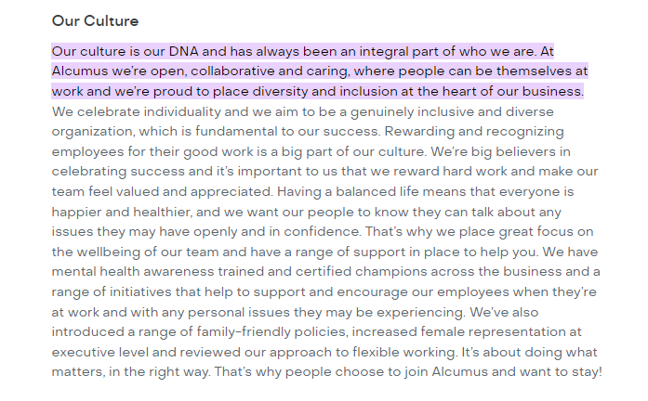
Sourced; https://alcumus.pinpointhq.com/

APPENDIX B

Organisations that Implemented Homeworking Permanently
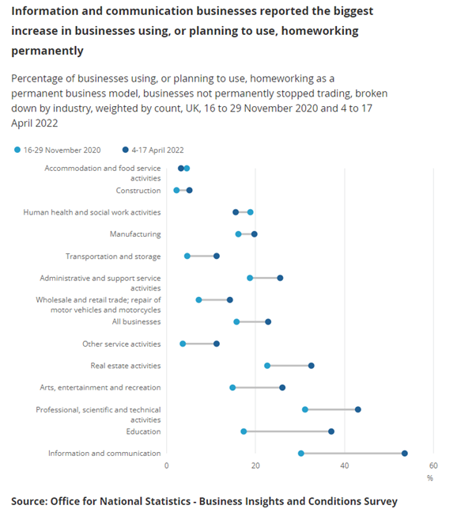

APPENDIX C

Emotional Intelligence Questionnaire

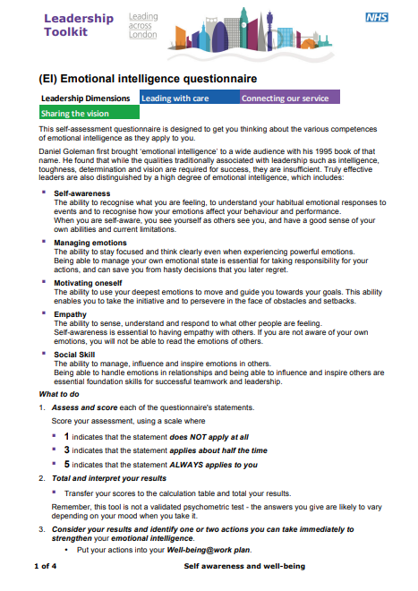
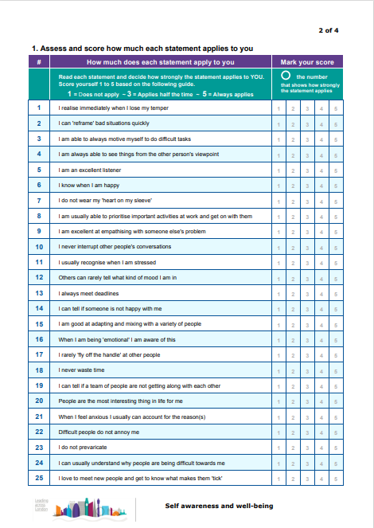
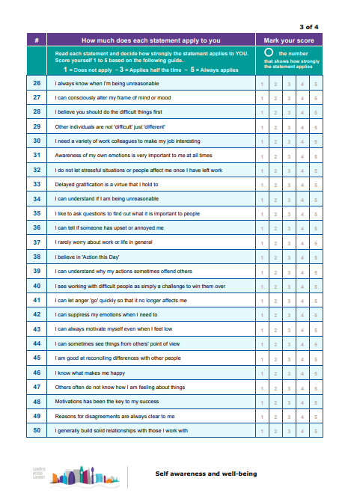
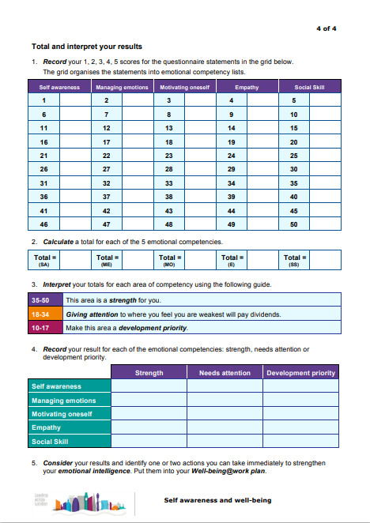

Source: https://expydoc.com/doc/5072112/leadership-toolkit--ei--emotional-intelligence-questionnaire

APPENDIX D

Leadership Style Inventory (LSI) 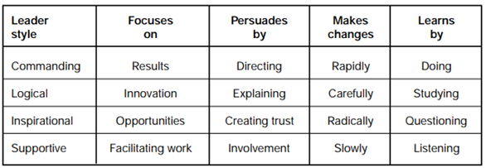

(Reardon, K. K, Reardon, K. J, Rowe, 1998, P.132)

APPENDIX E

The Five Stages of Radical Change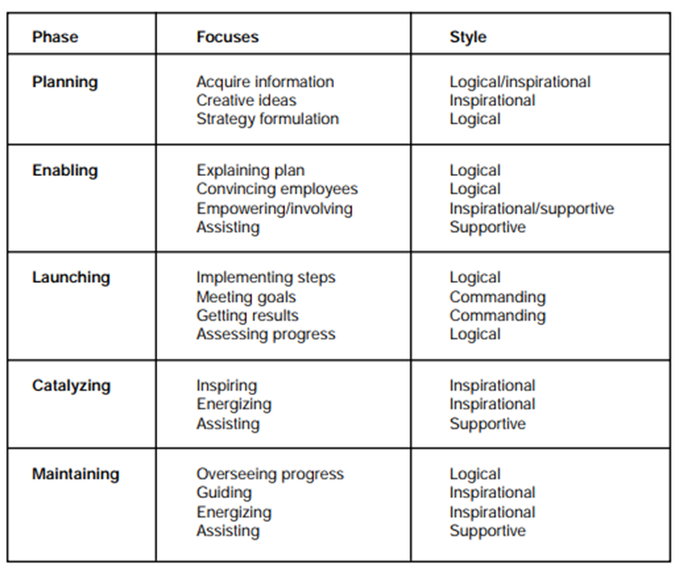
(Reardon, K. K, Rowe, 1998, P.134)

APPENDIX F

Retentions team survey results
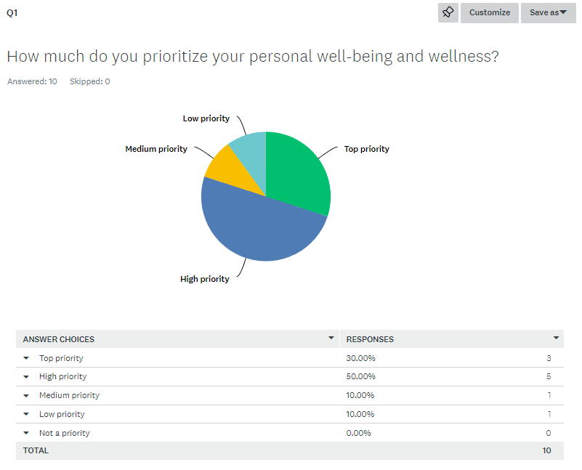
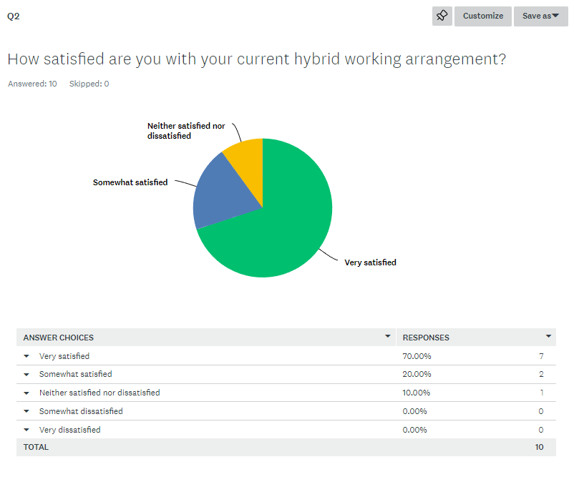
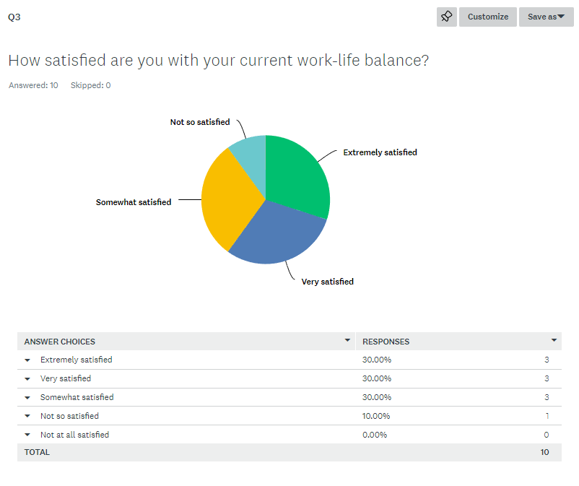
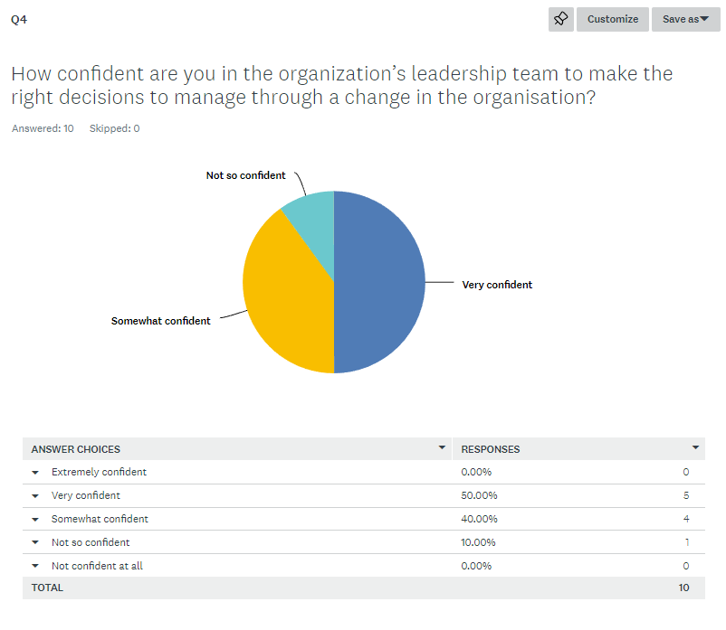
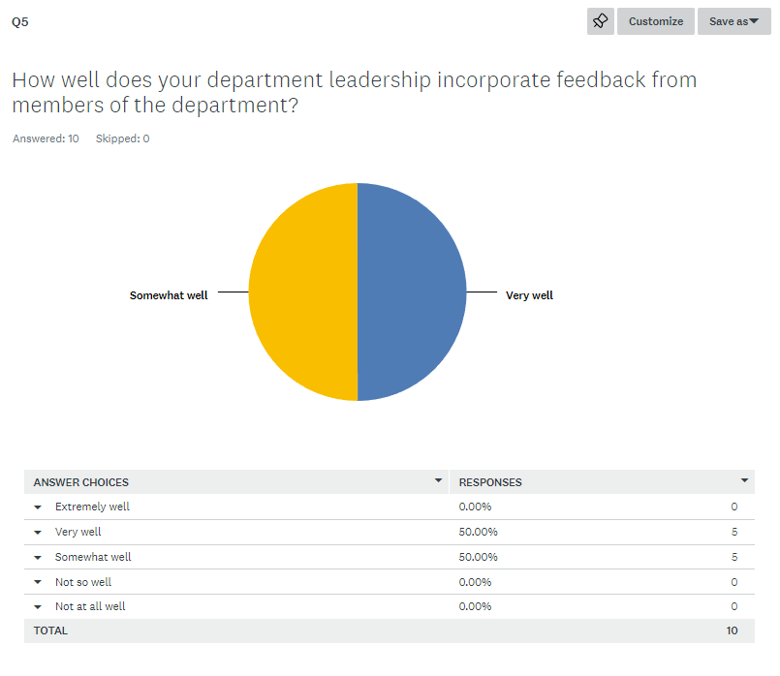
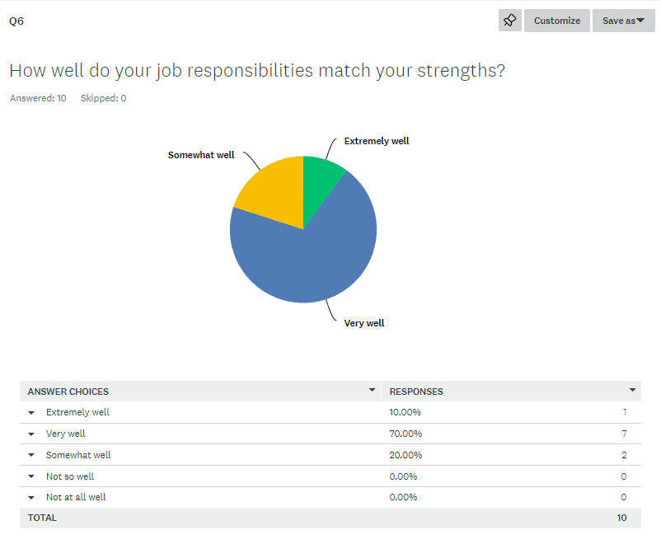
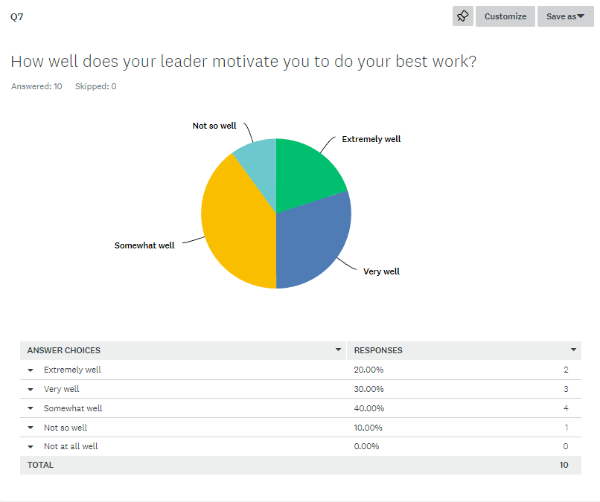
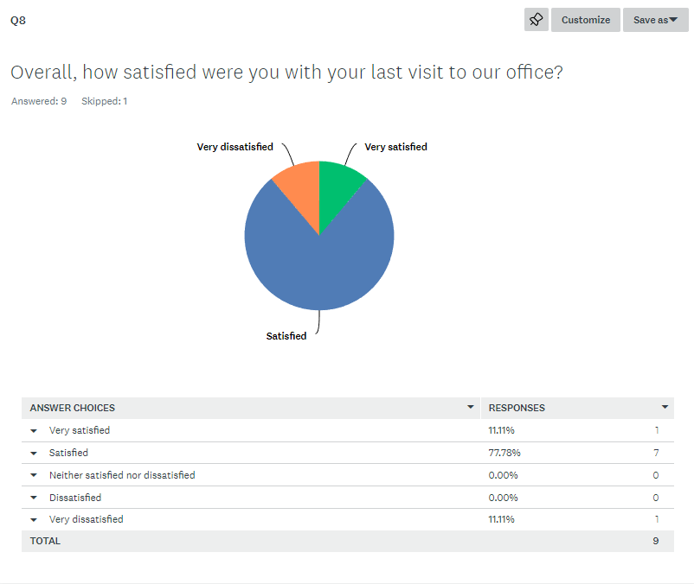
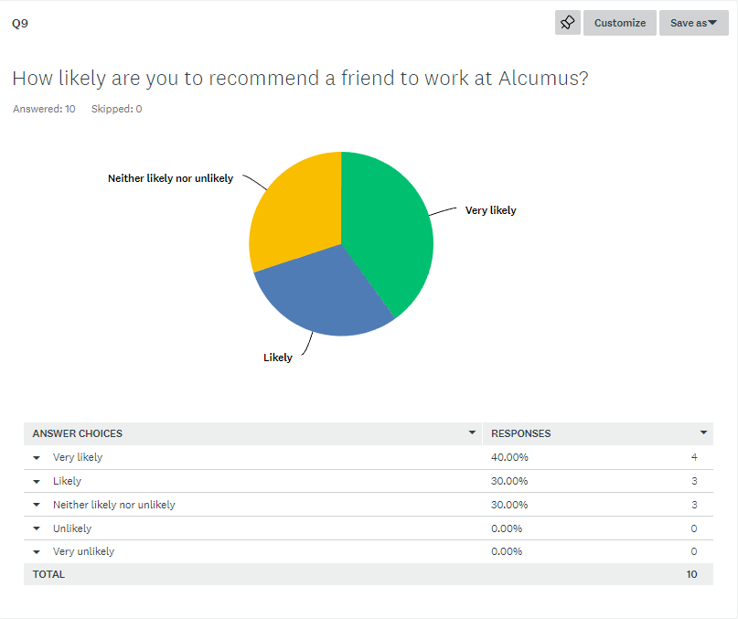
https://www.surveymonkey.com/analyze/QJCB3Afcs3EpjxIMG8tgVxxOPAqnuiP3uNHSbLOSrzI_3D
Source: SurveyMonkey.com

APPENDIX G

Renewals Team Volume Retention in Alcumus
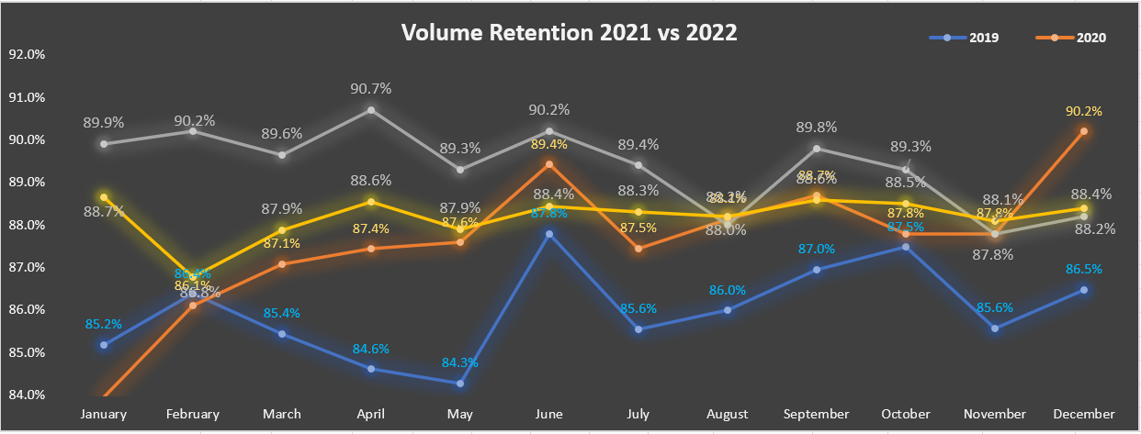

Blue – 2019
Orange 2020
Yellow – 2021
White – 2022
Source – (Alcumus internal use only 2023)

APPENDIX H

Job Satisfaction with Homeworking
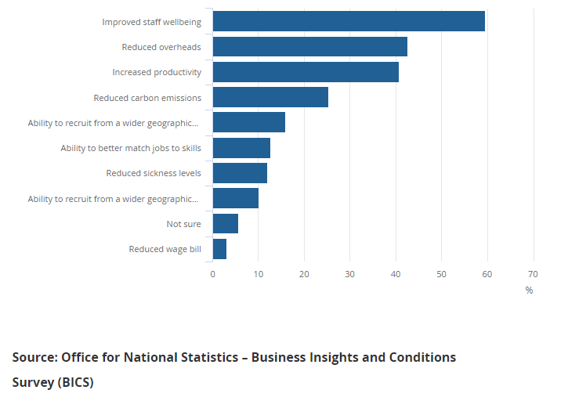

APPENDIX I

Organisations with Homeworking



Source (Nolan et al. 2022) Homeworking in the UK – regional patterns - Office for National Statistics (ons.gov.uk)

APPENDIX J
Apax Acquired Alcumus
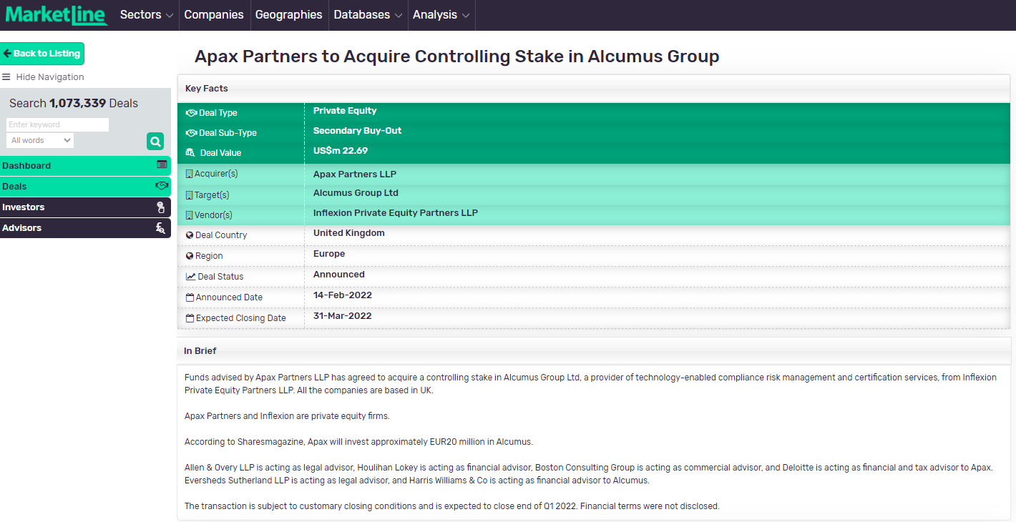
https://advantage-marketline-com.ezproxy.uwtsd.ac.uk/Deals/Facts/apex-global-alpha-to-acquire-alcumus_3799448
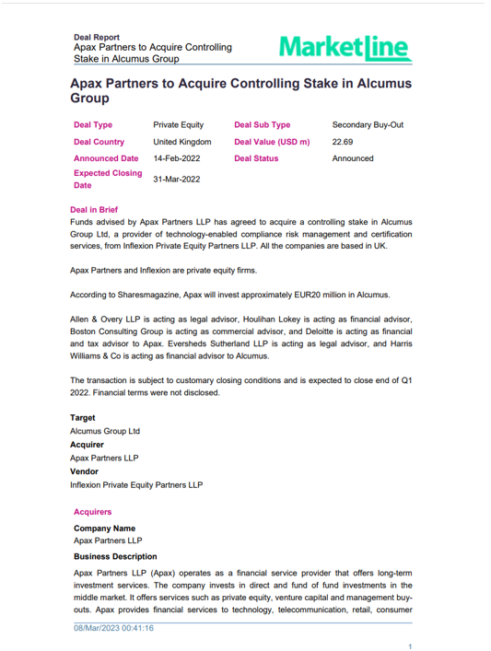
MarketLine.com

APPENDIX K

Alcumus Stakeholders
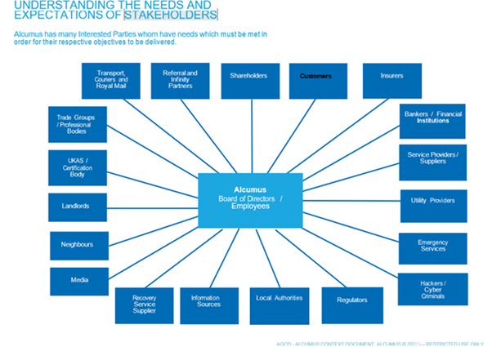
Alcumus (Internal Use only 2022)

APPENDIX L

Retentions Team Data Results from the Insights Questionnaire
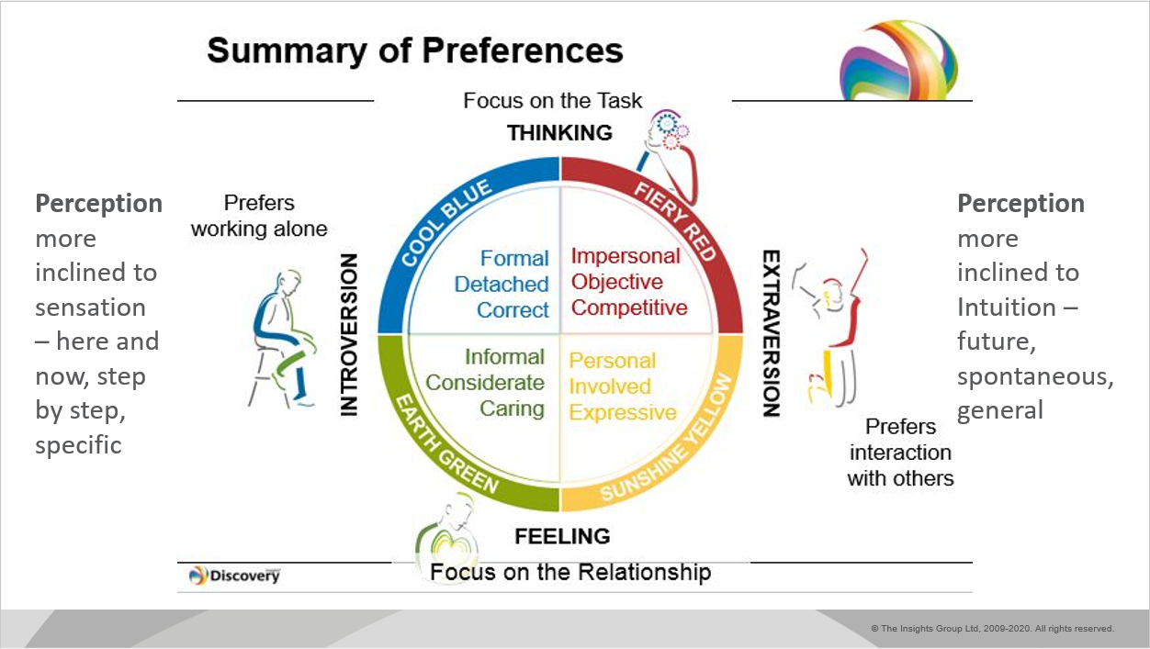
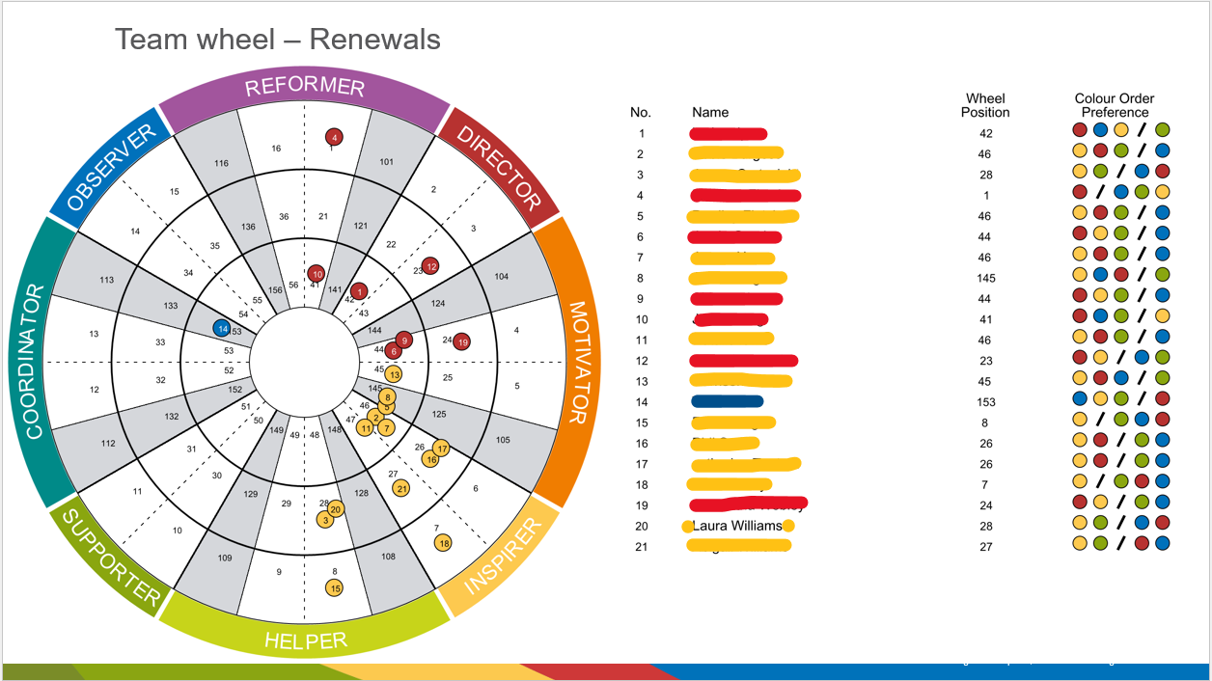

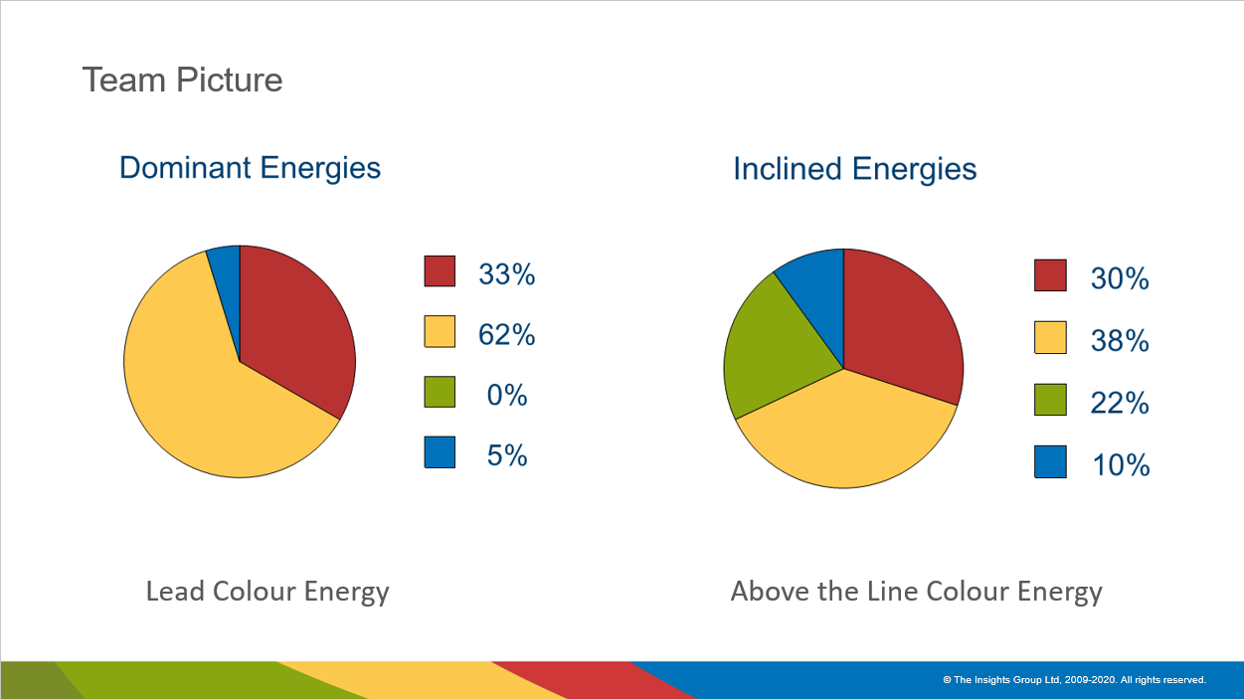

Alcumus (Internal Use only 2022)

APPENDIX M

Insight Discovery Personalities
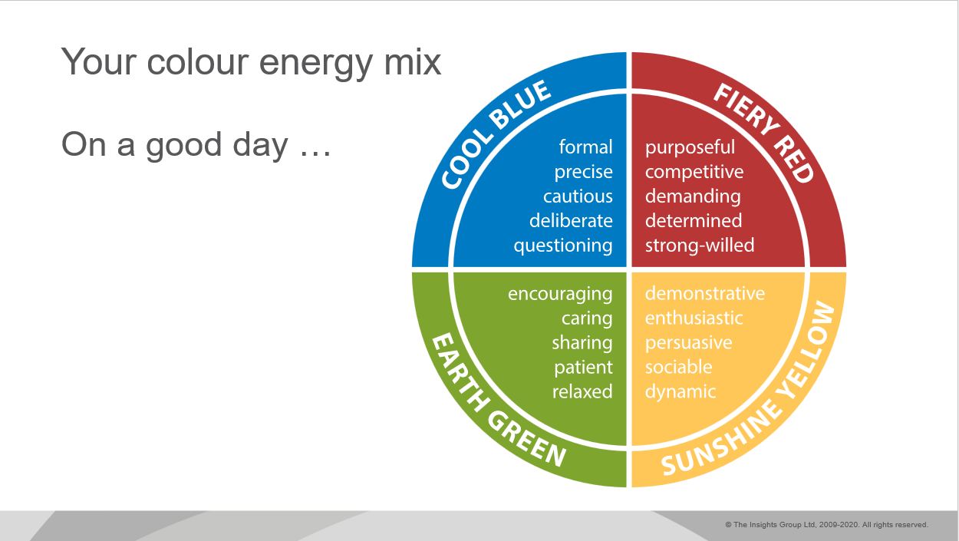

Alcumus (Internal Use only 2022)

APPENDIX N

Insight Discovery Personalities
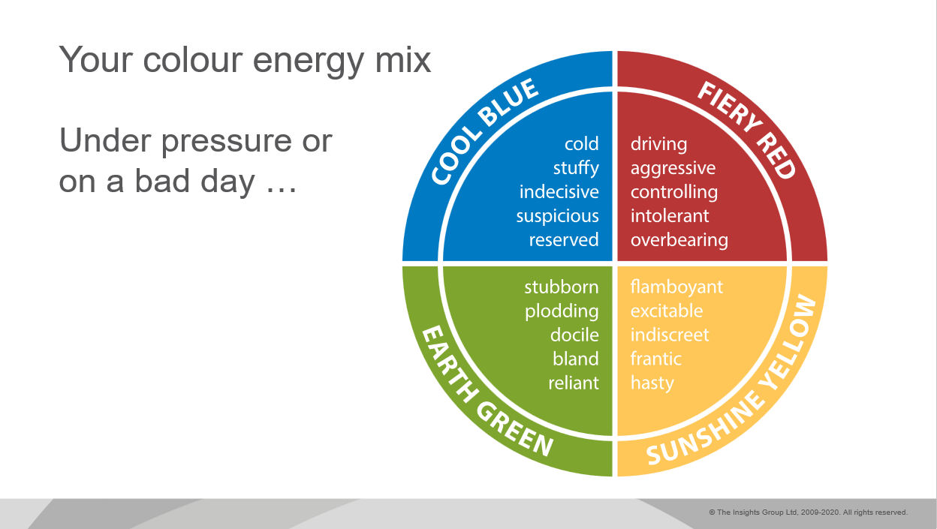

Alcumus (Internal Use only 2022)

APPENDIX O

Microsoft Teams Interview
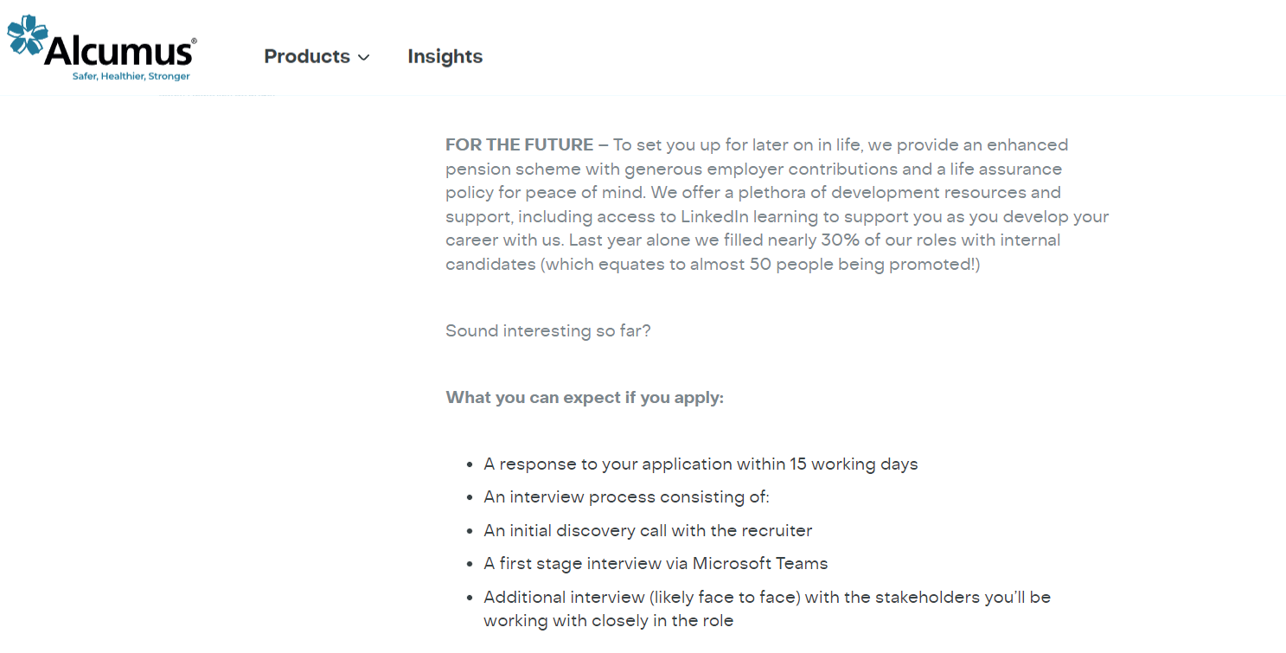
https://www.alcumus.com/en-gb/careers/vacancy/account-executive-93277/

