

BSc (Hons) Ordnance, Munitions & Explosives – Scientific Principles of OME

Fuel-Air Explosions

Thomas Beswick – 1910566
25/10/2022

Contents
Executive Summary 3
1 Introduction 4
2 Fuel Dispersion 5
2.1 Spreading the Fuel Cloud 5
2.2 Creating the Ideal Fuel Cloud 5
2.3 Delivery Systems 7
3 Ignition 8
3.1 Fuel to Air Ratio 8
3.2 Fusing for Ignition 9
4 Targetting 10
4.1 Damage to Target 10
4.2 Post-Detonation Effects 11
4.3 Comparison to High Explosives 11
5 Conclusion 11
6 Bibliography 12

Executive Summary
Fuel-air explosives have recently been reported on in world news due to their supposed use in the on-going Ukraine conflict. This report researches and discusses the scientific principles behind the fuel-air explosive warheads, the requirements for them working and discoveries made within the defence industry. The research shows that some of the critical aspects include the fuel to air ratio and shape of the fuel cloud, while also discussing the fusing mechanisms required to ignite the fuel at the optimum time within the dispersion.
They are also compared the conventional high explosive warheads common across various weapon platforms. Comparisons between their explosive effectiveness and the damage cause to the target are drawn and discussed. Showing that within the same mass, fuel-air explosives carry upwards of 2 times the explosive power results in a conclusion that while they may sit in a lawful grey area the damage they can deliver to a target is difficult to match with a standard high explosive munition.

Introduction

Fuel-air explosives (FAE) have been gaining attention within the world news in recent months due to their use in the Russian invasion of Ukraine [1]. Fuel-air explosives have been in development in many countries since the 1960’s and were initially developed as a method to clear minefields [2]. Once it was discovered that their explosive power is between 2 to 5 times that of TNT, FAE started a new use as a replacement for nuclear weapons. The use of fuel-air explosives in warfare tends to be a bit of a grey area. The Convention on Certain Conventional Weapons (CCW) states that FAE is a legal weapon to use, but has various restrictions on their use, particularly around their use in areas with a civilian population [3].

The term fuel-air explosives is often used interchangeably with thermobaric, and while they both utilise similar scientific principles there are differences between the materials, systems and damage imparted that warrant the distinction between the two [4]. This report will primarily focus on fuel-air explosions and the principles behind how they work, effective targets, and examples of their use, however understanding the differences between FAE and Thermobaric is critical to allow research to focus upon the intended topic and to remain on task. Therefore, below are the main differences between FAE and Thermobaric;
- The fuel used within thermobaric explosives provide their own oxygen, or at the very least contain an oxidant to provide the oxygen to the reaction. In contact, FAE require oxygen in the air to allow for combustion with a fuel to air ratio being critically important to the effectiveness of the explosion.
- Thermobaric explosives don’t require a fusing system to ignite the explosives as the fuel used will be pyrophoric or hypergolic – a technique often used in rocket engines [5]. This means that the fuel will ignite spontaneously on contact with air, or upon mixing with another fuel. FAE require a fusing system to ignite the fuel when an appropriate fuel to air ratio is achieved.
- Thermobaric explosives are often initiated by a central high explosive charge, with the external fuel cloud providing a secondary effect. FAE relies on a single small ignition source, which would provide little damage on its own, to provide enough activation energy to ignite the fuel cloud to create a shockwave.

Fuel Dispersion

The controlled dispersion of the fuel within an FAE is extremely important in order to create an optimal fuel-to-air ratio to allow the ignition to create a shockwave within the dispersed fuel. This section will discuss the principles behind this fuel dispersion.

Spreading the Fuel Cloud
Fuel-air explosives require a multi-stage process to setup the ideal conditions for ignition and damage. The first of these is the rupturing of the fuel container, to allow for the fuel to spread. The method of achieving this is often done through the use of an ignition fuse followed by a booster charge and high explosive, as can be seen in Figure 1. The fuze can be used via proximity, altitude or time depending on the desired target. Once the fuzing conditions have been met, the inition train begins with a primary explosive from the fuse igniting the booster charge, followed by the takeover of the high explosive. This reaction will burst open the container of the fuel and spread it throughout the target area. This design relies on the fuel-to-air ratio principle not allowing the combustible fuel to ignite immediately, due to a lack of oxygen to sustain a reaction during the high explosive spreading the fuel. This is also referred to as the lower explosive limit of the fuel.
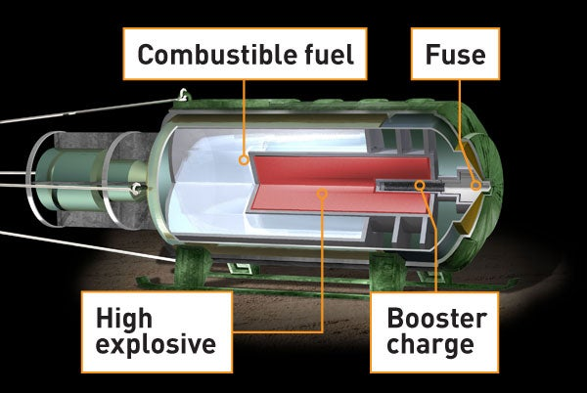
Figure 1 - Sectioned Example of FAE Bomb [6]

Creating the Ideal Fuel Cloud

The fuel used to create the cloud required can vary greatly, and each requires difference properties to obtain an optimal explosive reaction. The fuel is usually made up of ether and isopropyl nitrate, however recent developments have tested the effect of metal powders (primarily aluminium) being mixed into the fuel to improve the energy levels [7]. The addition of these metal powders were seen to increase the overpressure measured during the experiments when compared to pure liquid fuel.

Wang et al. found that the shape of the fuel cloud also has a significant effect on the overpressure values of the explosive mix [8]. The study concludes that a diameter-to-height ratio of 5.7 provides an optimal peak overpressure when measured between 5 to 50 meters. The comparison of diameter-to-height ratios are various distances is illustrated in Table 1. In order to achieve this ratio, the shape of the warhead or high explosive charge can be changed to produce the necessary cloud. However, difficulty could arise when attempting to orientate the cloud to the target. The study conducted by Wang et al. only measured overpressure perpendicular to the central initiation of the cloud. If the warhead approaches at an angle to the target, this increased the difficult in accurately providing this maximum overpressure to the target.
Table 1 - Peak Overpressure, with Diameter-to-height ratio at fixed distance [8]

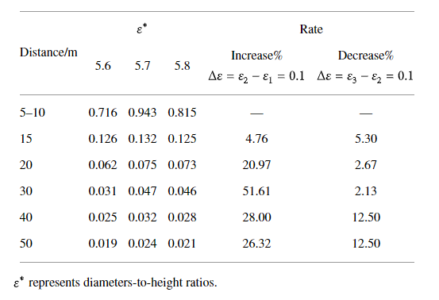

This study also provided a graph of time versus diameter-to-height ratios, as seen in Figure 2. From this graph, the ideal cloud ignition time can be derived. Based on the ratio of 5.7, this is likely to occur once at 30ms after dispersion of the cloud and again at 70ms. These times are the ideal times to ignite the cloud to provide maximum overpressure.

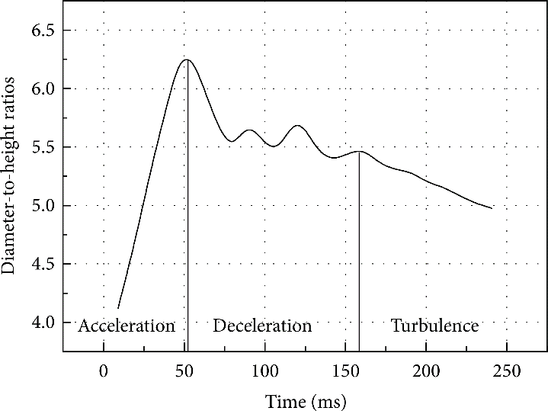
Figure 2 - Diameter-to-height ration of cylinder cloud versus time [8]

Studies conducted by Bull et al. show that a small droplet size of liquid fuel results in a more sensitive explosive mix, while also producing an increased velocity [9]. Benedick et al. follows up these studies and describes the difficulty in accurately recreating droplet sizes for testing of the effectiveness of various fuel droplet sizes within the fuel cloud, however concludes that liquid fuels become easier to ignite when in smaller droplets due to the vapour pressure of the fuel and the increased surface area in contact with oxygen [10].

The three properties discussed in this section allow for an ideal fuel cloud to be created with the following conditions:
- A solid-fuel mixture with an aluminium powder addition to increase the temperature of the fireball produced and an increased peak overpressure.
- A fuel cloud shape that has a diameter-to-height ratio of 5.7 where the target of the system is perpendicular to the diameter of the cloud between 5 and 50m. This property also determines the ideal initiation point of the fuel cloud, between 30ms and 70ms.
- The fuel droplet size of the fuel cloud is as small as possible. This property has been found to be difficult replicate and test and therefore has potential for future performance increases if a method is developed of reliably creating the smallest droplets possible.

Delivery Systems

The most common delivery system of a FAE, is through a standard warhead design, which can be seen in Figure 1. This design will allow for the warhead to be delivered to the target via ground launched systems or air launched systems. For example, the Russian forces have been reported to have used the TOS-1 heavy flamethrower to deliver FAE to the target [11]. This issue this style of delivery system encounters is control of the fuel cloud. Due to the momentum in the warhead at the point of dispersion, the cloud with not spread uniformly and will instead continue in the direction of the travelling warhead with the conserved momentum.

Overcoming this can often be done by using an air deployed system, which allows gravity to do the work. The fusing in the warhead will be set to an altitude, and due to the reduced speed of descent when compared to a propelled warhead, this allows for a more consistent cloud to be created. An example of this in use would be the BLU-72 bomb, an 1130kg FAE warhead delivered via the A-1E Skyraider, as shown in Figure 3

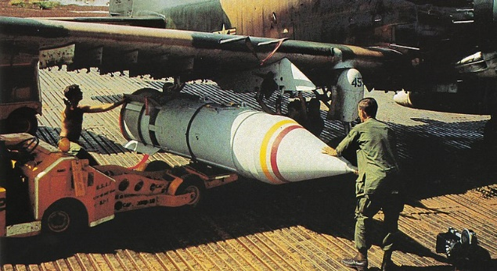
Figure 3 - BLU-72 FAE bomb mounted to a Douglas A-1E Skyraider [12]

Ignition

Fuel to Air Ratio

The fuel to air ratio of an FAE is critical to achieving the desired effect at the target. Before optimising this ratio, an understanding of the upper and lower explosive limits is required, as these determine if and when the fuel will be able to ignite and explode.

Lower explosive limit is defined as the lowest concentration of gas/vapour that will burn or explode if ignited, similarly the upper explosive limit is defined as the highest concentration of gas/vapour that will burn or explode if ignited [13]. These limits are key in ensuring the fuel does not ignite during dispersion as the concentration of fuel within the warhead will be far in excess of the upper explosive limit and therefore be unable to ignite until the cloud has been dispersed.

Some commonly used fuels within FAE warheads are listed in Table 2 with their upper and lower explosive limits defined within.
Table 2 - UEL and LEL of common FAE fuels [14]
Fuel | UEL (% by volume of air) | LEL (% by volume of air)
Diethyl ether | 1.9 | 36
Gasoline | 1.4 | 7.6
Oxirane | 3 | 100
Propylene oxide | 3 | 27.5

The second key feature in obtains the highest overpressure possible if the fuel to air ratio of the cloud fuel. As Zhang and Ng report, the behaviour of this ratio is often seen to be in a reverse “U” shaped curve [15]. This is where the ratio of fuel to air provides the highest peak overpressure approximately in the middle of the UEL and LEL. While in an experimental setup, obtaining the ideal fuel to air ratio is relatively simple and the introduction of the fuel into an explosion spherical vessel allows for the control of the ratio. However, when the cloud is formed in standard use this ratio is increasingly difficult to control and further relies of the second ignition fuse to ignite the fuel at the correct time.

In addition to achieving the correct fuel to air ratio, the detonation parameter of the fuels also factor in the effect on the target. For example, if Methane was used as the fuel the detonation pressure would be in the range of 1.742 MPa, whereas Propylene oxide is significantly higher at 1.98 MPa [2]. When considering the reverse “U” shape of the ratio, demonstrated in Figure 4, the ideal mix can often be 5-8 time more pressure than those at the extremes of the LEL and UEL [16], meaning if Propylene oxide is at a suboptimal ratio while Methane is optimal, the pressure and velocity of the shockwave will be greater in the methane cloud due to the ratio rather than the power of the fuel.

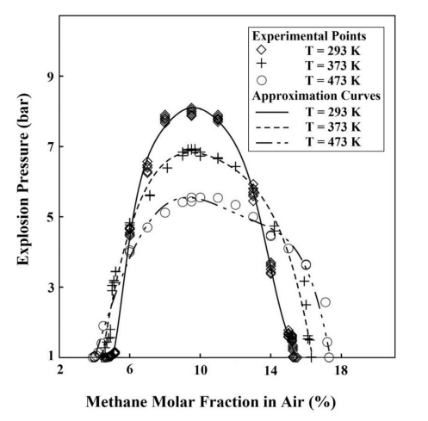
Figure 4 - Explosive Pressure plotted versus Methane % in Air [16]

The final point to consider in the fuel air ratio is that this can be calculated by stoichiometry. As Kosky states, a reactions stoichiometric equation allows the possibility to determine the ideal fuel to air ratio in both molar fraction and mass fraction [17]. The further a reaction moves away from this ideal stoichiometric value, less explosive pressure is created until eventually the UEL and LEL are met.

Fusing for Ignition

There are two common initiation methods within FAE warheads, these are self-initiation and direct initiation [2]. These occur after the fuel cloud has been dispersed. Self-initiation is started in a similar explosive train as a high explosive warhead, starting with a spark or heat to ignite the fuel which pressure and heat increase the speed of the burn past the point of detonation where the detonation wave continues the reaction through the whole cloud. On the other hand, direct ignition is started via a shock wave generated by the ignition source. This method instantly starts the detonation process that have no ramp up time with the shockwave travelling through the fuel cloud above the speed of sound.

The critical operation for this fusing system is the timing of the ignition. As previously discussed, the shape of the fuel cloud and the fuel to air ratio have a large impact over the effectiveness of the explosive reaction. Igniting the cloud and starting the detonation shockwave at the correct time will allow the pressure to build to a maximum with the optimal oxygen in the area of the cloud. Through testing, this could be setup with a timing fuse. Using a high-speed camera, Wang et al. captured the stills found Figure 5. During this testing it shows that the cloud shape is optimal between 30 and 70ms. It is assumed that at this point, is also the optimal fuel to air ratio as this timing provided the highest explosive pressure. Fusing could then be set to initiate 30 to 70ms after the dispersion charge are initiated.

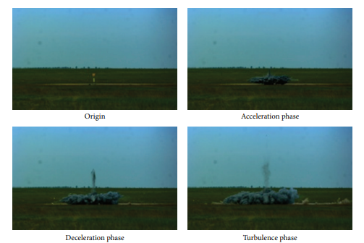
Figure 5 - High speed camera stills of fuel cloud dispersion [8]

Targetting

Damage to Target

When compared to conventional high explosive ammunition of similar mass, FAE are understood to have larger damage area with increased effect on the target [18]. This is due to the ability to penetrate any vehicle, bunker or building that is not completely air tight. The fuel cloud formed will work into the cracks or gaps in the armour of any target and then, upon ignition, transfer the detonation shockwave through the target material.

While the underlying principle of blast damage is the same as that sound during a high explosive shockwave, FAE has a significant advantage in the fact that the blast impulse has a longer duration. This longer impulse increases the area under the curve, shown in Figure 5, which results in a blast wave with more energy to transfer into the target.

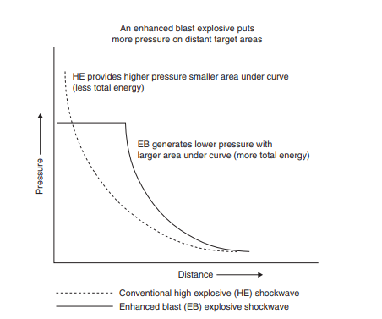
Figure 6 - Characterisation of Explosive Effect Shockwave [19]

The second damaging effect of the FAE is the heat and fireball produced by the fuel cloud. While the ignition created a shock wave for blast, this is then followed by a ball of fuel that has heated to upward of 2800°K [2], depending on the fuel used.

Due to a FAE being able to penetrate in between gaps that are not sealed, they are extremely useful in attacks on vehicles and buildings. Being used to destroy buildings are a further common use for the warheads as they are able to easily spread throughout any given shape. While obstacles in the way of a conventional HE can absorb and block the blast, FAE fuel clouds will penetrate the gaps or flood the whole area surround the obstacle to deliver an increased effect on the intended target. Couples with the increase shockwave duration results in a more devastating effect.

Post-Detonation Effects

While a thermobaric reaction will provide oxygen within the fuel for the reaction, a FAE requires the majority of its oxygen to be taken from the natural air. The effect of this causes a vacuum to be created in the wake of the shockwave, demonstrated in Figure 5 by the negative impulse. In a conventional HE blast, the negative pressure follows behind the blast wave and will often pull debris into this path. When compared to a FAE, the negative pressure is caused by the removal of air surrounding the fuel cloud creating a vacuum in the space this air once occupied, this vacuum is then rapidly filled with air once again pulling debris towards the original blast origination point.

Comparison to High Explosives

At similar distances, a conventional HE explosive is said to product approximately 200KPa, whereas an equivalent FAE would likely product 2MPa [20]. The result from this blast wave would cause casualties with burns, fragmentation injuries and associated blast injuries. Blast injuries would likely include blast lung, burst ear drums, abdominal haemorrhages and concussions if the unprotected targets survived [21].

In addition to the increased impulse, the burn related injuries sustained from a FAE would likely be upwards of 30% according to Baskin and Holcomb [20]. This would be understandable due to the extremely hot fireball created with a FAE. This fireball is both hotter and longer lasting than any seen in conventional HE munitions. Due to this sustained fireball, the risk of inhalation injuries also increases. Inhalation of the hot gases expanding outward and the toxic substances spread within the fuel cloud are highly likely to cause internal and respiratory damage to targets in the affected area increasing the effectiveness of FAE.

Conclusion

Overall, while FAE tend to sit in a moral and lawful grey zone, there is no argument that the destructive power they bring to the battlefield is unmatched. By increasing the impulse duration of the detonation, the FAE will cause harder hitting damage to structures while also being able to penetrate the cracks in the target. Damage to unprotected targets is increased over conventional HE due to the addition fireball and toxic heated gases in the area.

While also having this increased effect, the FAE achieves this in a smaller package. With a similar payload mass, the FAE will often be 2 to 5 times more powerful than an equivalent conventional HE warhead. This will allow for a greater range of delivery systems to be used in ensuring the warhead arrives at the target.

The complexity in FAE comes from the delay between the dispersion charge and the ignition charge – allowing time for the ideal cloud shape and fuel to air ratio to form is critical in delivering the highest impact to the target and still requires further optimisation within the industry to improve on measuring the fuel to air ratio during dispersion.

Bibliography

[1] | “What is a thermobaric of vacuum bomb?,” BBC News, 10 March 2022. [Online]. Available: https://www.bbc.co.uk/news/business-60571395. [Accessed 10 October 2022].
[2] | A. A. Rao, “Fuel Air Explosives,” Defence Science, vol. 37, no. 1, pp. 23-28, 1987.
[3] | J. C. Dunlap, “The Ukraine crisis and the international law of armed conflict (LOAC),” Lawfire, 27 February 2022. [Online]. Available: https://sites.duke.edu/lawfire/2022/02/27/the-ukraine-crisis-and-the-international-law-of-armed-conflict-loac-some-q-a/. [Accessed 25 October 2022].
[4] | L. Türker, “Thermobaric and enhanced blast explosives (TBX and EBX),” Defence Technology, vol. 12, no. 6, pp. 423-445, 2016.
[5] | B. Nufer, “Hyperfolic Propellants: The Handling Hazards and Lessons Learned From Use,” NASA Kennedy Space Center.
[6] | S. Berhie, “Dropping the Big One,” Popular Science, 7 November 2007. [Online]. Available: https://www.popsci.com/bombtech/. [Accessed 24 October 2022].
[7] | Y.-x. Wang, L. Liu, Q.-m. Xu, B. Li and L.-f. Xie , “Effect of metal powders on explosion of fuel-air explosives with delayed secondary igniters,” Defence Technology, vol. 17, no. 3, pp. 785-791, 2021.
[8] | C. Bai, Y. Wang, J. Li and M. Chen, “Influence of the cloud shape of fuel-air mixtures on the overpressure field,” Shock and Vibration, 2016.
[9] | D. a. Bull, “Detonation of unconfined fuel aerosols in 'Gas Dynamics of,” American Institute of Aeronautics and Astronautics, pp. 48-60, 1981.
[10] | W. B. Benedick, S. R. Tieszen, R. Knystautas and J. H. S. Lee, “Detonation of Unconfined Large-scale Fuel Spray-Air Clouds,” Dynamics of Detonations and Explosions, pp. 298-308, 1991.
[11] | J. Zitser, “Russian army deploys its TOS-1 heavy flamethrower, capable of vaporizing human bodies, near Ukrainian border, footage shows,” Insider, 26 February 2022. [Online]. Available: https://www.businessinsider.com/russia-deploys-feared-tos-1-heavy-flamethrower-near-ukraine-cnn-2022-2?r=US&IR=T. [Accessed 25 October 2022].
[12] | U.S. Air Force, “U.S. Air Force photo scanned from Dana Bell,” Air War over Vietnam, vol. 4, p. 43, 1968.
[13] | ChemSafetyPro, “Explosive Limits,” 13 January 2016. [Online]. Available: https://www.chemsafetypro.com/Topics/CRA/Explosive_Limits.html. [Accessed 25 October 2022].
[14] | Engineering Toolbox, “Gases - Explosion and Flammability Concentration Limits,” 2003. [Online]. Available: https://www.engineeringtoolbox.com/explosive-concentration-limits-d_423.html. [Accessed 25 October 2022].
[15] | B. Zhang and H. D. Ng, “An experimental investigation of the explosion characterisitic of dimethyl ether-air mixtures”.
[16] | S. Kundu, J. Zanganeh and B. Moghtaderi, “A review on understanding explosions from methan-air mixture,” Loss Prevention in the Process Industries, vol. 40, pp. 507-523, 2016.
[17] | P. Kosky and G. Wise, “Chemical Engineering,” Exploring Engineering, vol. 5, pp. 129-145, 2021.
[18] | Z. Xiaonan, H. Qiang, B. Zueyang, L. Yexin, G. Li and S. Zhidan, “Establishment and analysis of damage calculation model under fuel air explosion effect,” Earth and Environmental Science, vol. 446, 2019.
[19] | C. Bed, C. Haberacker, G. Husken and e. al., “Recommendations for the improvement of existing European norms for testing the resistance of windows and glazed façades to explosive effects,” 2015.
[20] | T. W. Baskin and J. B. Hocomb, “Bombs, Mines, Blast, Fragmentation and Thermobaric Mechanisms of Injury”.
[21] | CDC, “Explosions and Blast Injuries,” A Primer for Clinicians.

