

University of Wales Trinity Saint David
School of Engineering - Logistics and Supply Chain Management

Module: Warehouse Management
M4X02298
The Key Role of Warehousing in achieving Competitive Advantage

Student: Georgiana Florina Cune

Introduction
In the past, warehouses were seen as cost centre for organizations, without adding value to the business. This concept has changed over the last decades, as many warehouses and distribution centres can make significant competitive differentiation and increase business profits. Effective and efficient warehouses and operation centres can reduce the costs of service and storage which can be considerably high and minimising the costs of warehousing operations makes companies more profitable. An efficient warehouse, adopting a flexible and cost-effective strategy can obtain a remarkable and competitive advantage in the logistics business sector.
The purpose the logistics system is to reduce operations costs, inventories and cycle times, and to improve customer service. According to Richards (2018), today, warehouses represent a ‘vital link’ within supply chains, primarily because of the continuously growth of e-commerce, customers demand and the movement of production to countries with lower manufacturing and labour costs.
Richards (2018, p.7) views the warehouse as ‘…a temporary place to store inventory and trans-shipment point where all the goods received are dispatched as quickly, effectively and efficiently as possible’.
With the increasing operations of movement of goods within supply chains, the warehouse has adopted different operational roles, besides its initial role to hold inventory. Rushton et al. (2017) addresses the common roles performed by a warehouse as follows:
- Inventory holding point. Keeping substantial inventory and critical components if a breakdown happens (repository). Figure 1. presents an example of a normal warehouse function and material flow from an inventory holding point.
- Consolidation centre. Gathering a number of products lines from which are normally delivered together to the customer.
- Cross-dock centre. Goods from other warehouses or direct from production plants are transferred, without being stored, between the incoming vehicle at a cross-docking point to the outgoing vehicle.
- Sortation centre. Goods are sorted into vehicle loads according to region or consumer markets.
- Assembly facility. Warehouses are used as the final assembly point for the manufactured products.
- Trans-shipment point. Warehouses are used for sorting goods to small vehicle load which can directly be transferred to the customer.
- Returned goods centre. These warehouses are an important operation centre because of the increased internet shopping and competitive market, where customers can easily return their goods.
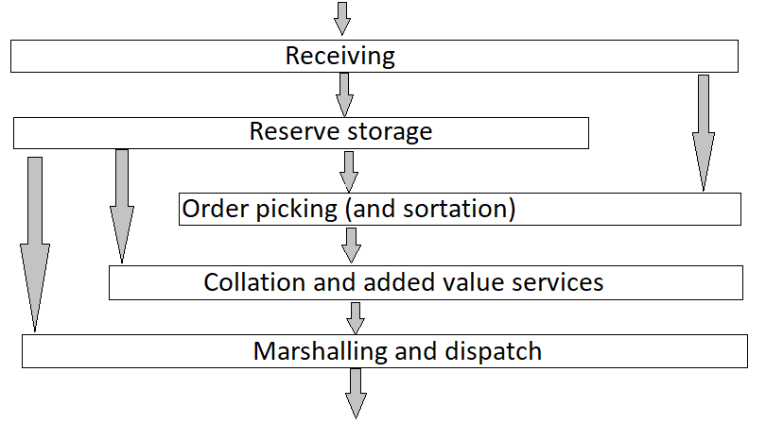
Figure 1. Typical warehouse functions in a stockholding warehouse (Rushton et al., 2017)
With retail e-commerce growing, retailers and manufacturers selling online products, need to adapt existing logistics systems and facilities to meet the market demands or to create new ones in order to adapt to the multichannel retailing movement (Richards, 2018). Although warehousing is a ‘vital link’ and an important operation point in the supply chains, warehouse managers are facing big challenges when handling an e-fulfilment centre. Some of these challenges are argued by Richards (2018, p.32). First, seasonality has a significant impact on the warehouses, on handling and storage equipment (for example, winter clothes are much more voluminous than summer clothes). Secondly, processing low-value and single-item order. Those orders require the same quantity of labour and equipment as for high-cost products, but the margin it will significantly be different. Thirdly, on-time delivery and accuracy are the most important operation for companies towards their customers. With the market competition amongst e-retailers, companies must maintain the loyalty of the customers. Fourthly, increased inventory. Inventory management is a challenge for today’s warehouse managers who must release essential space for the warehouse operations, handle properly the returned stock and to make quick decisions regarding the process of non-moving stock.
Warehouse automation
Because of the increased e-commerce shopping, manufactures and retailers adapt their fulfilments to keep up with customers’ demands and the advancement of nowadays technology. With automation implemented in the warehouses and distribution centres, products are efficiently operated and effectively moved throughout the systems (Alesci and Pollard, 2016).
Today’s fast-moving technological world has determined the real time communication to be an essential factor for businesses to operate efficiently and effectively. The introduction of a real-time warehouse management system can become a serious advantage if a company is going to compete effectively.
Automation within a warehouse allows operations to be more efficient by increasing productivity, space maximization, faster growth, helps reduce inefficient labour and improves sustainability. Automatic guided vehicles, automated storage and recovery, software managed inventory and voice-recognition picking and goods-to-person picking systems are improving the efficiency of operations within a warehouse (Maras, 2015).
Richards (2018) states that the technology used within a warehouse can reduce costs, improve warehouse productivity and increase utilization and customer satisfaction. It is important that warehouses are designated and managed in accordance with the specific obligations of the supply chain as whole (Rushton et al., 2017).
Amazon, the biggest online retailer, has acquisitioned back in 2012 the Kiva Systems (figure 2) for $775 million, a robotic initiative used to make the inventory products come to the warehouse workers rather than the worker traditionally pick the items from the shelves. This robotic operation helps fulfil orders faster. The movement of the robots is managed by resource-allocation algorithms and a computer cluster tracks all the robots and racks on the floor (Guizzo, 2008). In 2018 the retail company had globally more than 100,000 drive units, including 30 palletizer systems and a 6-ton robot (RoboStow) that can move pallets of goods up to 7.5 meters high and stow them onto the larger drive units (Ackerman, 2018). Evidently, not all the warehouses use each type of automation, either the company cannot afford it or just simply doesn’t need an entirely automated warehouse. Amazon has developed and adopted individual systems that are able of handling extremely large volume quantities of products, but ‘different retailers adopt very different strategies’ (Richards, 2018, p. 33).
Kamali (2019, p.14) states that automated technologies implemented by warehouses can attain 24 hours of continuously work, being 3-4 times more efficient than the manual work performed by a warehouse operator.
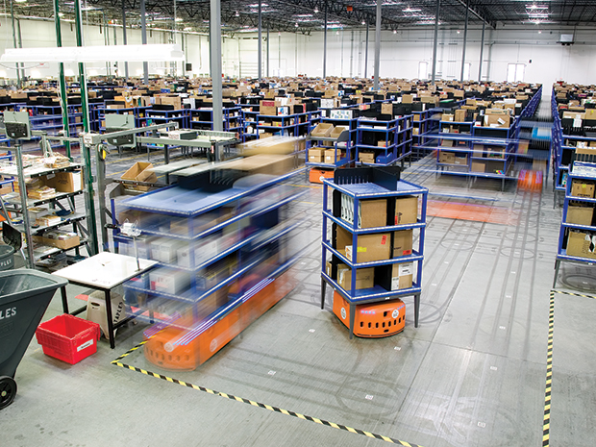
Figure 2. Kiva Systems operating within an Amazon fulfilment centre (Source in Guizzo, 2008)
Warehouse management systems (WMS) have been introduced by companies to enhance productivity and manage warehouse operations and resources, as well as to reduce the overall operational costs. According to Suittawat (2017), WMS integrate data from multiple sources and have been developed to share data information for managers and workers in order to adopt strategic decisions.
In order to ensure on-time delivery, without damage and other aspects to keep the customers loyalty, companies are building warehouses and distribution centres closer to market point of need. For example, in the UK, Amazon has strategically placed its 17 fulfilment centres (Amazon, 2018) close to the major road links.
Warehousing investment allows the storage, shipment and distribution of products more effectively. Therefore, warehouses give better control over managing inventory and ensure that customers will receive their orders on time. The warehouse trade-offs are presented in figure 3.
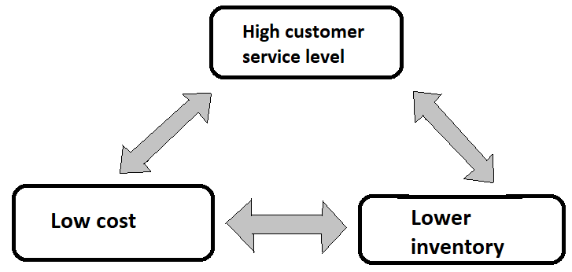
Figure 3. Warehouse trade-offs (Richards, 2018)
RFID (radio frequency identification) is used as a principal automated system in warehouses to identify cartons from retailers and parcel carriers, track unit loads and transmit information about the goods (Rushton et al., 2017).
In developed countries, many companies have already replaced the traditional warehouse with the smart automated ones and are constantly researching for new options and designs based on the new technology in the logistics and supply chains. The fundamental factors that determine companies to implement automated warehousing are ‘… the margin and service expansion that could be obtained in a new competitive market’ (Kamali, 2019).
Conclusion
Although warehouses represented a cost centre for most organizations in the past, today the warehouse is seen as an adding value asset for the business. Warehouses represent key part of many supply chains and they automatically integrate with other components in the supply chains.
Because of the lower transportation costs, reduced inventory and increased delivery accuracy between suppliers and customers, cross-docking centres are being accepted by many companies which want to minimise the product handling and storage within their fulfilment centres and warehouses. The material consolidation reduces the transportation costs and accurate distribution networks minimise the inventory within warehouses at a cross-docking point (Suvittawat, 2017).
Today the warehouses perform different roles in the supply chain, such as inventory holding point, consolidation centre, cross-dock centre, sortation centre, assembly facility, returned goods centre or trans-shipment point. The warehouses usually perform a mix of these roles and should be designated to accommodate the specific requirements of the supply chain of which it is representative of.
A warehouse is an expensive asset for a company and therefore it should be properly designed and efficiently managed, as the operations system has an immediate impact on both customer service and costs.
E-commerce is the factor which drives manufacturers and e-retailers to adapt their fulfilments to respond to customers’ demands and the technology advancements. The efficiency and effectivity of operations within a warehouse is improved by implementing automation in the operations systems, such as automatic guided vehicles, automated storage and recovery, software managed inventory, RFID and voice-recognition systems. Those are just some of the world-wide adopted technologies to reduce costs, improve productivity and customer satisfaction.
The key elements that determine businesses to consider implementing automated technologies within their warehouses are the margins that could be acquired in an existing and new competitive market.

References
Ackerman E. (2018) Brad Porter, VP of Robotics at Amazon, on Warehouse Automation, Machine Learning, and His First Robot. Available at: https://spectrum.ieee.org/automaton/robotics/industrial-robots/interview-brad-porter-vp-of-robotics-at-amazon (Accessed: 29 April 2019).
Alesci, Greg and Tom Pollard. "Warehouse Automation: Five Emerging Trends." Plant Engineering 70.8 (2016): 9. Web.
Amazon (2018), About our Fulfilment Centres. Available at https://www.aboutamazon.co.uk/working-at-amazon/about-our-fulfilment-centres (Accessed: 30 April 2019).
Guizzo E. (2008) Kiva Systems: Three Engineers, Hundreds of Robots, One Warehouse. Available at: https://spectrum.ieee.org/robotics/robotics-software/three-engineers-hundreds-of-robots-one-warehouse (Accessed: 29 April 2019).
Kamali A., ‘Smart Warehouse vs. Traditional Warehouse – Review’. Ciit International Journal of Automation and Autonomous System. Vol. 11, No 1, January 2019.
Maras, Elliot. "The warehouse as a competitive advantage." Food Logistics 163 (2015): 18-26. Web.
Richards, G. Warehouse Management: A Complete Guide to Improving Efficiency and Minimizing Costs in the Modern Warehouse. 3rd ed. 2018. London: KoganPage.
Rushton, A., Croucher, P., and Baker, P. The Handbook of Logistics and Distribution Management. Sixth ed. 2017. London: KoganPage.
Suvittawat, A. "Warehouse and distribution operations for competitive advantage: Eastern Thailand perspective" Aktual'ni Problemy Ekonomiky = Actual Problems in Economics 191 (2017): 138-43.

