‘A Report into the Effectiveness of the
Current Structure of the NHS in Wales’
Tania Davies

Produced by: Maria Crick (1804032)

Abstract

This thesis will investigate into the effectiveness of the NHS structure in Wales, it will be structured as a report an overview of the NHS Wales will be provided and the seven health boards will be explored into by researching how the management structures influences each of the following health boards. Funding will be considered by researching what influences it and where it comes from. An evaluation will be drawn up based on any personal and relevant concerns and issues surrounding the report. Finally, three logical recommendations for usefulness and efficiency of the current system will be provided and supported by relevant references about the current issue.

Contents

Introduction…………………………………………………………………………………………………………. 4

Information/Statistics/Guides……………………………………………………………………………….5-7

Evaluation of Current Structure…………………………………………………………………………….8-9

Conclusion…………………………………………………………………………………………………………….10

Recommendations……………………………………………………………………………………………....11

Reference List……………………………………………………………………………………………………….12-15

Introduction

According to the Healthcare Financial Management Association (HFMA, 2018) the NHS was founded in 1948, by Health Minister Aneurin Bevan. Throughout the years the NHS in Wales has developed significantly and been able to provide adequate healthcare to many people. For example, in 1948 only 9,900 medical staff were employed by the NHS and now there are over 35,845. The structure of the NHS in 1948 consisted of a tripartite system and now, as a consequence of its substantial growth there are seven Health Boards across Wales.

According to NHS Wales (2009) the Health Boards within Wales focus on the following: shifting behavior, collaboration, working as a partnership, wellbeing, developing a whole system and clinical involvement. Hywel Dda Health board is one of the largest, with a population coverage of ‘384,000’ and a budget of ‘£743.95m’ (BBC 2018). However, the Betsi Cadwaladr University Health Board is the largest providing for a population of ‘678,000’ people in North Wales (NHS Wales 2019). They cover three main hospitals and provide a range of primary health services, units in mental health, healthcare centers and many more as well as working alongside ‘109’ GP practices in the area. Another large health board is Powys Teaching Health Board this according to NHS Wales (2019) covers ‘133,000’ people living in mid Wales by providing as many health services within the rural area. There is no General Hospital within the district therefore, healthcare is provided through primary healthcare services as well as community hospitals. Other health boards include ABMU this according to the NHS Wales (2019) covers Swansea, Neath Port Talbot and Bridgend. Their Values includes ‘caring’ ‘working together’ and ‘always improving’. the Aneurin Bevan health board according to BBC (2018) employs,’11,025’ NHS Staff and had a budget of ‘£1.1133bn’. Cwym Taf health Board according to NHS Wales (2019) is responsible for providing healthcare to ‘450,000’ people, with being the largest employment in the area, dedicated to building relationships between community and staff. The remaining health boards includes Cardiff University health board, which provides unique specialist services across Cardiff area, according to NHS (2019) it has a population of ‘472,400’ and a budget of ‘£1.4’. According to NHS Wales (2019) there are also three NHS trusts which include, the Welsh Ambulance Services Trust this is just an emergency service only, there is Velindre NHS Trust this service offers specialist care and finally Public Health Wales.

Information/Statistics/Guides

How management structures generally work within each Health Board

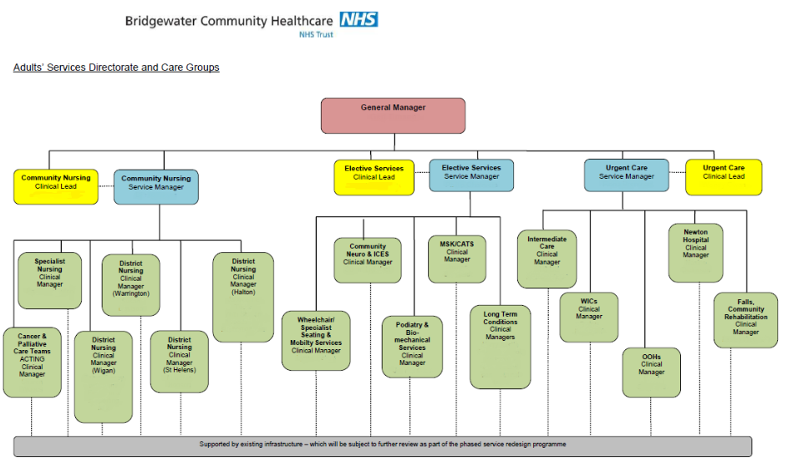
Figure 1: Structure of NHS General Management in Bridgewater Community Healthcare (2019)

Figure 1 was provided by the Bridgewater community healthcare (2019) and although it is from an NHS Trust in England, it is likely to resemble the structure of general management of the NHS in Wales. This Figure presents the hierarchy of staff working within the NHS. The General Manager at the top of this hierarchy is responsible for staff as well as ensuring the NHS runs effectively and efficiently (National Careers Service 2019). The Second row consists of ‘Clinical leads’, who are the heads of their respective departments and hold overall responsibility in event of any failure (Free Dictionary 2019). The Clinical Lead works alongside a Service Manager within their specific department and the Service Manager is responsible for managing general Healthcare Services such as Hospitals and General Practitioners (National Careers Service 2019). The Service Manager also has responsibility over staff within specific sectors. The Figure above shows this: a ‘community nursing service manager’ oversees ‘district nurses’, ‘specialized nurses’ and ‘Cancer & Palliative care teams.’ The other Service Mangers are responsible for other specific departments as further illustrated.

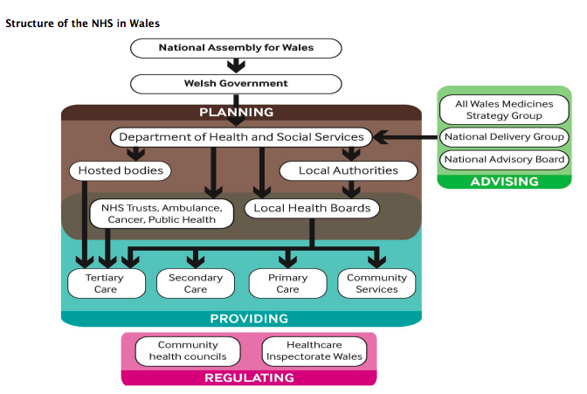
Figure 2: Flow Chart provided by Doheny (2015)
The Figure above was provided by Doheny (2015) and it represents the overall ‘structure of the NHS in Wales’. According to Simpson (2016), the Department of Health and Social Services takes responsibility for health as well as social care and setting out NHS expectations through devising timelines. The seven health boards take on the responsibility of providing community services, primary and secondary services and specialized care. Tertiary care is the sole responsibility of the NHS Trusts.

Where funding comes from and what influences it?

According to GPone (2019) the NHS Wales funds are paid from general taxations, the Welsh Government finances ‘£6bn’ per year into health and social care services, these funds are mostly allocated into Trusts and the seven Health Boards. Roberts and Munday (2018) estimated that the NHS Wales received ‘£7.7bn’ and this was all spent during the period of 2016-17. The largest amount of was spent was on direct NHS staff wages, totalling around ‘£3.5bn’. These salaries linked to approximately ‘76,600’ direct NHS staff. ‘£1.39bn’ was also spent in services for primary healthcare.

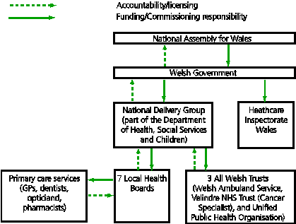
Figure 3: Flow Chart Provided by Parliament.Uk (2015)

Figure 3 is provided by Parliament UK (2015). This diagram represents the distribution of funding amongst the health care departments within the UK. Parliament.UK (2015) discusses the allocation of funding within the Welsh NHS services. The National Assembly for Wales is responsible for commissioning/funding responsibilities and provides NHS funding to general Welsh Government. The Welsh Government then allocates money to both the ‘Healthcare Inspectorate Wales’ and the ‘National Delivery Group’. The National Delivery Group provides funding to all Welsh Trusts and the seven local Health Boards. For example, ABMU has a budget of ‘£1.3 billion’ per year. The Health Boards provide funding to primary care services such as dentists and pharmacists.

There are many factors that influence funding within the NHS in Wales. Developments in technology can be costly. The guardian (2019) reported that it costs the NHS ‘£130’ for a Magnetic resonance imaging scan (MRI) per person and ‘£340’ per person for follow-up or special screening. Another factor affecting NHS spending is the ageing population. According to BBC (2017), statistics show that by 2039, there will be a ‘44%’ increase of people over the age of 65. Due to the advancements in healthcare life expectancy has increased. To Robineau (2016) around two-fifths of national health expenses is spent within the NHS for those 65 and over. Recruitment and retention challenges are a major concern within the NHS in Wales and put a strain on funding. According to The British Medical Association (BMA) (2015), there are not enough GPs to take the place of current GPs who are reaching retirement age within the next couple of years.

Evaluation of Current Structure

There are many positives and negatives to the current structure of the NHS in Wales.
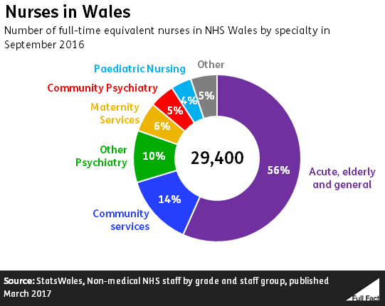
Figure 4: pie chart provided by the UKs Independent Charity (2018)

According to The UK’s Independent Factchecking Charity (2017) there are approximately ‘89,000’ staff working in the NHS in Wales. The NHS in Wales evidently creates a large number of job opportunities for those working within healthcare. As shown by Figure 4, employment within this sector isn’t evenly distributed. Figure 4 shows that in 2016, ‘4%’ of ‘29,400’ staff were pediatric nurses- the lowest number within the nursing employment sector. Reinforcing this, Ford (2018) reports that there is a shortage of pediatric nurses. ‘15% of hospitals’ in Wales are backed up by full time health care community services within children’s services.

One positive attribute of the NHS Current system within the UK is despite being funded by taxations it provides free healthcare, unlike the healthcare system in the US. Kotecha (2010) supports this by affirming that healthcare such as treatment has to be paid by the individual if they are ill. The cost of treatment is paid through individual healthcare insurance and according to Dalen (2009), is the most frequent cause of bankruptcy within the US. Providing free healthcare in Wales (and the UK as a whole) helps support those who cannot afford to pay for treatment, such as people who are homeless.Homeless.org (2019) statistics show that in 2014, ‘73%’ of individuals experiencing homelessness have a physical health problem and ‘80%’ have a mental health issue. Consequently, people who are homeless are shown to make A&E visits four times more often than people who aren’t homeless.

According to NHS Wales (2019), the Abertawe Bro Morgannwg Health Board has a budget of ‘£1.3’ billion and has a population coverage of ‘500,000’ people whereas, according to NHS Wales (2019) the Cardiff Vale University Health Board has a budget of ‘£1.4’ billion and a population coverage of ‘472,400’ people. Less money is funded into ABMU Health Board despite it having to provide services to a wider population. This could be due to several factors but might suggest a re-evaluation of funding could be necessary with the changing populations over time.

According to Gralton (2017), in 2007 the NHS in Wales stopped prescription charges. NHS Wales was the first healthcare service within the UK to do this, ensuring improvements for peoples wellbeing and health. However, providing free prescriptions is certainly costly for the Welsh Government. Williamson (2018) reports that the cost of prescribed medication has increased significantly from ‘410.4m’ in the year 2000, to ‘£578.1m’ in 2017. According to BBC (2017), many patients are denied the opportunity of cancer medication due to its high costs whereas, in 2017 ‘£5.1m’ was spent on Paracetamol. The funding could have been used to provide these life-saving medications and not allocated to store-bought medication through prescriptions.

A&N Services are in high demand and this is causing a major concern for NHS Wales. According to Clarke (2019), figures show that the waiting times in Welsh A&N departments has risen. ‘3,900’patients waited 12 hours to be seen by A&E in hospitals such as Glan Clwyd and Wrexham Maelor despite the standard target time being four hours. According to Kendall-Raynor (2009), the Royal College of Nurses suggest that more beds for admissions should be provided, more primary healthcare nurses are required to see patients who may not need to visit A&E and at least three nurses should be allocated to prescribing into the A&N department for each shift.

In conclusion, the NHS Wales functions efficiently to an extent. Taking into consideration of funding allocated from the Welsh Government, the NHS Wales tries to utilise its resources to provide the best possible care they can. However, there are many issues that have a negative effect on provision of care and on the NHS as a whole. For example, recruitment and retention is a cause for concern and the cost of medical facilities in combination with high demand for the service, gives the NHS a lack of stability for providing the best healthcare service possible.

Conclusion

This report has looked into the current structure of the NHS in Wales by exploring the seven Health Boards and the NHS Trusts. How general management structures work within these health boards and where funding comes from and what influences it were then discussed and evaluated by providing sufficient and appropriate statistics and facts. The report also evaluated the current system by highlighting its pros and cons.

Recommendations

Coping with the increase in Sexually transmitted Infection (STI) cases

According to StatsWales (2018) the lowest amount of funding went towards Sexually transmitted diseases (STIs) with only ‘0.1 %’ of NHS expenditure. According to According to FPA (2016) Chlamydia is the most common STI diagnosis in Wales and this continues to rise. In 2014 there were over ‘5,452’ cases. The Communicable Disease Surveillance Centre (2018) reports that syphilis diagnosis has risen between 2016-17 by ‘53%’. A report from BBC (2018) indicates that attendance to sexual health clinics have doubled from’86,000’ in 2011 to ‘176,000’ in 2016.These clinics in Wales are struggling to deal with the increase in cases. A recommendation would be to introduce diagnostic testing kits via the NHS in local pharmacies and make them available online. These kits would be returnable to the clinics through post for testing. This system would make people feel more comfortable, as people can develop an anxiety to entering clinics and ease waiting time at these establishments.

Increased funding for training for healthcare workers in Wales

A major issue for the NHS Wales is the shortage of nurses. RN (2018) suggests that by 2024 an additional ’21,500’ nurses will be needed due to the high demand. Referring back to Ford (2018), healthcare assistances are taking over the lack of pediatric nurses. Retention is a major concern for the NHS Wales. As shown by a report from Assembly Wales (2018), ‘8%’ of nurses and midwives join and around ‘6.8%’ leave. Providing more training for healthcare assistances to uphold some nursing duties would ease the pressure on nurses due to their insufficient numbers.

Promoting healthcare through Education

Promoting healthcare is highly important in prevention of several conditions that drain NHS funds, such as obesity, smoking and excess intake of alcohol. For example, obesity amongst children is a major concern for the NHS in Wales. According to Wales online (2019), figures show that 26.4% primary school children of age four to five were obese during 2017-18. This was described as an ‘national scandal’. BBC (2011) reports that obesity, alongside excessive drinking costs the NHS in Wales ‘£140m’ per year. Allocating funding for the promotion of a healthy lifestyle promotion in schools or community centers would be the first call to prevent future cases and ease the pressure on the NHS.

References:

BBC (2011) Obesity and alcohol misuse costs NHS £140m in Wales. Available at: https://www.bbc.co.uk/news/uk-wales-12913791 (Accessed 19th April 2019)

BBC (2017) Free prescriptions 'saving Welsh NHS money for 10 years' Available at: https://www.bbc.co.uk/news/uk-wales-politics-39457033 (Assessed 13th April 2019)

BBC (2017) Social care cost inquiry for ageing population in wales. Available at: https://www.bbc.co.uk/news/uk-wales-politics-41471310 (Assessed 5th April 2019)

BBC (2018) How is your health board doing financially? Available at: https://www.bbc.co.uk/news/uk-wales-43543150 (Assessed 15th April 2019)

BBC (2018) Sexual health clinics 'struggling' with big STI rise. Available at: https://www.bbc.co.uk/news/uk-wales-45723960 (Accessed 19th April 2019)

British Medical Association (BMA) (2015). Available at: file:///Users/mariacrick/Downloads/PA-WalesGPWorkforceResponse-19-01-2015%20(1).pdf (Assessed 17th April 2019)

Clarke, O. (2019) A&E target times in Wales worse than last winter. Available at: https://www.bbc.co.uk/news/uk-wales-46976137 (Assessed 17th April 2019)

Dalen, J. (2009) Only in America: Bankruptcy Due to Health Care Costs. The American Journal of Medicine. 112 (8) pp. 699. Available at: https://www.amjmed.com/article/S0002-9343(09)00525-7/fulltext (Assessed 14th April 2019)

Doheny, S. (2015) The Organisation of the NHS in the UK: comparing structures in the four countries. National Assembly for Wales. Available at: http://www.assembly.wales/research%20documents/15-020%20-%20the%20organisation%20of%20the%20nhs%20in%20the%20uk%20comparing%20structures%20in%20the%20four%20countries/15-020.pdf (Assessed 7th April 2019)

Ford, S. (2018) Audit sheds light on impact of shortage of children’s nurses. Available at: https://www.nursingtimes.net/news/workforce/audit-sheds-light-on-impact-of-shortage-of-childrens-nurses/7024279.article (Assessed 14th April 2019)

FPA (2016) SEXUALLY TRANSMITTED INFECTIONS FACTSHEET. Available at: https://www.fpa.org.uk/factsheets/sexually-transmitted-infections#wales (Assessed 19th April 2019)

Gralton, J. (2017) First Ten Years of Free Prescriptions in Wales. Available at: https://www.sochealth.co.uk/2017/04/20/first-ten-years-free-prescriptions-wales/

Healthcare Financial Management Association (HFMA) (2018) 70 years of the NHS in Wales: the changing role of the NHS finance function. Available at: https://www.hfma.org.uk/docs/default-source/publications/Briefings/70-years-of-the-nhs-in-wales.pdf?sfvrsn=0 (Assessed 15th April 2019)

Homeless.org (2019) Homelessness and health campaign. Available at: https://www.homeless.org.uk/our-work/campaigns/policy-and-lobbying-priorities/homelessness-and-health-campaign (Accessed 17th April 2019)

Kendall-Raynor, P. (2013) RCN Wales hatches rescue plan for troubles A&E department. Nursing Standard (through 2013). 23 (33) pp.9. Available at:https://search-proquest-com.ezproxy.uwtsd.ac.uk/docview/219854697?accountid=130472&rfr_id=info%3Axri%2Fsid%3Aprimo (Assessed 19th April 2019)

Kotecha, S. (2010) How does UK healthcare Work? Available at: http://www.bbc.co.uk/newsbeat/article/10067521/how-does-us-healthcare-work (Assessed 13th April 2019)

National assembly of Wales (2007) Inquiry into Workforce Planning in Health and Social Care. Available at: http://www.assembly.wales/NAfW%20Documents/hwlg3_wpinq_3_rcn_workforce_planning_evidence.pdf%20-%2011012008/hwlg3_wpinq_3_rcn_workforce_planning_evidence-English.pdf (Assessed April 19th 2019)

National Careers Service (2019) General management. Available at: https://www.healthcareers.nhs.uk/explore-roles/management/roles-management/general-management (Accessed 8th April 2019)

National Careers Service (2019) Health Service Manager. Available at: https://nationalcareers.service.gov.uk/job-profiles/health-service-manager (Assessed 8th April 2019)

NHS Wales (2009) NHS in Wales; why we are changing the structure. Available at: http://www.wales.nhs.uk/documents/NHS%20Reform%20leaflet_October%202009.pdf (Assessed 15th April 2019)

NHS Wales (2019) Abertawe Bro Morgannwg University Heath Board. About us Available at: http://www.wales.nhs.uk/sitesplus/863/page/41169 (Assessed 10th April) 2019)

NHS Wales (2019) Bridgewater Community Healthcare. Available at: http://www.bridgewater.nhs.uk/ (Accessed 7th April 2019)

NHS Wales (2019) Cardiff and Vale University Health Board. Our Services. Available at: http://www.cardiffandvaleuhb.wales.nhs.uk/Promoting-Health (Assessed 15th April 2019)

NHS Wales (2019) Cwm Taf Morgannwg University Health Board (2019) About us. Available at: https://cwmtaf.wales/we-are-cwm-tafmorgannwg/ (Assessed 15th April 2019)

NHS Wales (2019) Powys Teaching Health Board Home. Available at: http://www.powysthb.wales.nhs.uk/home (Assessed 15th April 2019)

NHS Wales (2019) Structure. Available at: http://www.wales.nhs.uk/nhswalesaboutus/structure (Assessed 19th April 2019)

NHS Wales (2019) The Betsi Cadwaladr University Health Board. About us. Available at: http://www.wales.nhs.uk/sitesplus/861/page/84723 (Assessed 15th April 2019)

Parliament.Uk (2015) Cross-border health arrangements between England and Wales- Welsh Affairs. Available at: https://publications.parliament.uk/pa/cm201415/cmselect/cmwelaf/404/40406.htm (Assessed 5th April 2019)

Richmond Nursing (RN) (2018) The future of nursing in Wales – what will it look like in 2024?. Available at: https://www.richmondnursing.co.uk/2018/08/31/the-future-of-nursing-in-wales-what-will-it-look-like-in-2024/ (Assessed 19th April 2019)

Robineau, D.(2016) Ageing Britain: two-fifths of NHS budget is spent on over-65s. Available at: https://www.theguardian.com/society/2016/feb/01/ageing-britain-two-fifths-nhs-budget-spent-over-65s (Assessed 4th April 2019)

Simpson, M. (2016) How is healthcare in Wales structured? Available at: file:///Users/mariacrick/Downloads/Brief%20how%20is%20healthcare%20in%20Wales%20structured%20(1).pdf (Assessed 2nd April 2019)

StatsWales (2019) NHS expenditure by budget category and year. Available at: https://statswales.gov.wales/Catalogue/Health-and-Social-Care/Health-Finance/NHS-Programme-Budget/nhsexpenditure-by-budgetcategory-year (Assessed 18th April 2019)

The free dictionary (2019) Medical Dictionary. Available at: https://medical-dictionary.thefreedictionary.com/clinical+lead (Assessed 8th April 2019)

The Guardian (2019) How much have I cost the NHS? Available at: https://www.theguardian.com/society/ng-interactive/2016/feb/08/how-much-have-i-cost-the-nhs (Assessed 2nd April 2019)

The UK’s Independent Factchecking Charity (2017) How many NHS employees are there? Available at: https://fullfact.org/health/how-many-nhs-employees-are-there/ (Assessed 2nd April 2019)

The UK’s Independent Factchecking Charity (2018) The number of nurses and midwives in the UK. Available at: https://fullfact.org/health/number-nurses-midwives-uk/ (Assessed 14th April 2019)

Wales Online (2019) Wales has the UK’s biggest childhood obesity problem - and here are the worst areas. Available at: https://www.walesonline.co.uk/news/health/childhood-obesity-wales-worst-uk-15934926 (Assessed 19th April 2019)

Williamson, D. (2018) Strepsils on the NHS? Free prescriptions for everyone in Wales should end, say Tories. Available at: https://www.walesonline.co.uk/news/politics/strepsils-nhs-free-prescriptions-everyone-14712980 (Assessed 14th April 2019)

