2024
Liam Miles
UWTSD
02/05/2024
2600 words
Miss A Client Proposed Housing Development- Technical Report
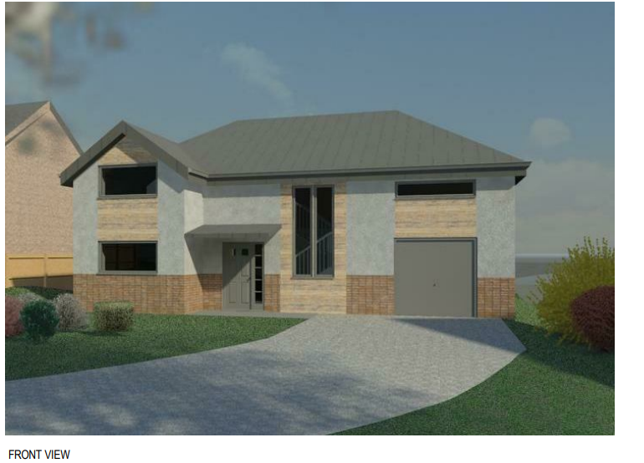
Contents

1. Introduction 4
2. Offsite Construction 4
2.1 What is it? 4
2.2 Panelised Systems 4
2.3 Volumetric Systems 5
2.4 Sub-assemblies and components 5
2.5 Hybrid Systems 5
3. Construction Detailing 6
3.1 Ground Floor Construction 6
3.2 External Wall Construction 8
3.3 Opening Detail 10
3.4 Roof Construction and Eaves Detail 11
4. Proposed Construction vs Brick and Block Construction 13
4.1 Thickness 13
4.2 Thermal Performance 14
4.3 Other Important Factors 15
5. Conclusion 16
6. References 17

Figures List

Figure 1- Wall to Floor Junction 7

Figure 2- Detailing showing the proposed render transition from brick slips to a smooth render on a calcium silicate board. 8

Figure 3- Cut Section of the window opening. 10

Figure 4- Window Sill Detail 10

Figure 5- Raised Tie Truss Roof Structure Detail (please note that the detail does not include renders, internals etc). 11

Figure 6- Proposed Eaves Detail 12

Figure 7- Comparison between proposed external wall construction vs Brick and Block construction (adapted using Surecav, n.d.) 13

Introduction

This report aims to address Miss A Client’s proposed two-storey detached housing project. Originally, the house was proposed as a brick and block structure, however, Miss A Client would like to change this design to feature a factory-made timber panel system with wood fibre blown insulation. The report aims to tackle some of the most important construction details offering advice, whilst addressing key elements such as thermal performance and the necessary regulations. the proposed construction will then be analysed against the original construction method and comparisons will be made.

Offsite Construction

2.1 What is it?

Offsite Construction (OSC), as described in the name, involves the manufacture of elements or modules in a factory before pre-assembly and installation on a designated construction site (CITB, 2017). Often confused with Modern Methods of Construction (MMC), which details the new and innovative approaches to optimise the construction process, offsite construction is a type of MMC which solely focuses on the prefabrication of buildings/components of a building. OSC is becoming increasingly popular and with the aid of this it can help to improve efficiency, accuracy, and better manage costs within the construction industry and to this proposed development.
There are four main categories of offsite construction.

2.2 Panelised Systems

Firstly, panelised systems involve the construction of building panels off-site such as wall, floor, or roof panels, and these are then transported to and installed on-site. There are typically three types of panelised systems. Open systems are usually non-insulated with only the structural elements on one side. Closed systems include insulation, sheeting on both sides and a service zone, there is also the potential to include cladding, windows, and doors. Finally, there are structural insulated panels (SIPs), a variation of closed panels which includes insulation between two layers of oriented strand board (OSB). As specified within the proposed construction, a timber panelised system is to be used with wood fibre-blown insulation prepared offsite. This is a type of closed system, and this will be detailed later in the report.

2.3 Volumetric Systems

Secondly, volumetric construction is where entire rooms or sections of a building are constructed offsite and then similarly transported to and assembled on-site. In this proposed development, volumetric construction of sections such as the bathroom or kitchen could be used. Therefore, the bathroom, for example, would be entirely constructed offsite in a factory and then assembled on-site.

2.4 Sub-assemblies and components

Sub-assembly construction includes the construction of smaller building components in a factory, For the proposed development, key components include timber triple-glazed windows and doors, and roof trusses, therefore this is included as sub-assembly construction. These may either be integrated into the panels or pre-manufactured off-site and then assembled on site.

2.5 Hybrid Systems

Lastly, hybrid systems are where more than one of these methods are used in combination. This method will likely be used in the proposed development. With the use of offsite proposed timber panels already, there is a chance that some components such as windows/doors may be integrated into these panels or premanufactured off-site and then assembled on-site. Additionally, volumetric construction could be used with bathrooms or kitchens potentially arriving as a ‘pod’ on-site to be assembled on site. The combination of these methods creates a hybrid system in which more than one type of offsite construction is used to create the best solution.
Taking advantage of these offsite construction solutions will lead to improved quality control, faster construction, and reduced waste. The background knowledge of this type of construction is important to understand the potential benefits of this construction and the correct terminology to be used.

Construction Detailing

There are 4 main key elements which play a massive role in the overall thermal performance of a dwelling. These are the roof, external walls, openings, and ground floors. These areas will be analysed, and feedback will be given to help achieve the thermal performance which is regulated in Part L of the building regulations in Wales. It is estimated that in poorly insulated buildings around 25% of heat is lost through the roof, 35% through external walls, 25% through doors and windows and finally 15% through ground floors. Therefore, it is crucial to get these construction details right to ensure compliance (Designing Buildings, 2022).

3.1 Ground Floor Construction

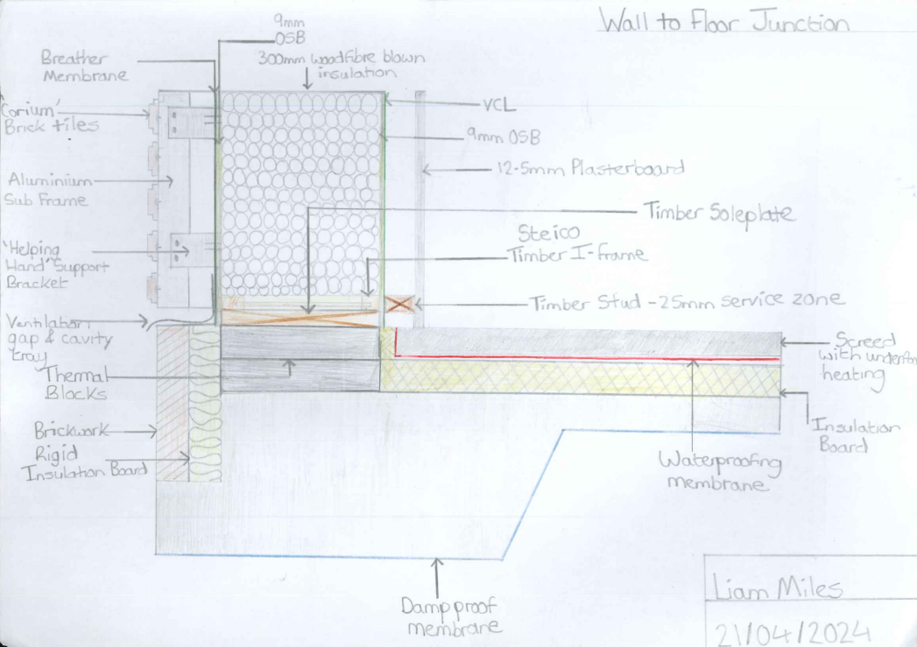
Figure 1- Wall to Floor Junction

As determined by the Ground Investigation Report there is to be a suitable raft foundation built. The proposed construction will feature an insulated ground floor, including underfloor heating in the screed which will improve the thermal performance efficiency and help to improve the overall internal comfort. To achieve compliance, the U-value of the ground floor must be no higher than 0.25W/m2K (Welsh Government, 2020). Using guidance from the LABC, the raft foundation is to be built on a hardcore sub-base (not shown on the diagram) which is used to level the ground. Insulation is recommended above the raft as guided by the NHBC and this will be on top of the Damp Proof Membrane (DPM) which shall be taken up to the edges of the floor with the insulation. Thermal blocks have been detailed as guided by HouseBuild which can help improve thermal performance and achieve the required 0.25 U-value. Below the external wall insulation, brickwork has been advised to improve structural performance and reduce thermal bridging. The Damp Proof Course (DPC) shall be placed at a minimum of 150mm above ground level, with weep holes at 900mm centres (NHBC, 2022). Further analysis shall be conducted by a structural engineer to assess the structural performance.

3.2 External Wall Construction

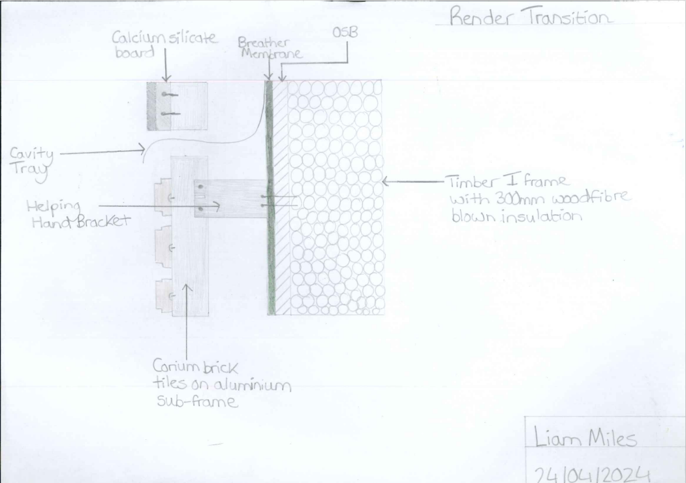
Figure 2- Detailing showing the proposed render transition from brick slips to a smooth render on a calcium silicate board.

Please refer to Figures 1 and 2 for the supporting diagrams illustrating the materials and methods chosen for the proposed external wall construction. As mentioned, external walls play the most important role in a building’s thermal performance. For compliance, Part L of the Building Regulations now requires external walls to have a U-value no higher than 0.18W/m2K. The proposed construction features a 300mm panelised frame with finishes transitioning from vented brick slips to a smooth render on a calcium silicate board. With this specification, a 300mm Steico I Joist has been selected as the appropriate option along with filled wood fibre blown insulation. Following guidance from Steico, this sits on a timber soleplate which is anchored to the foundations for stability. The I Joist is ideal as it can accommodate blown insulation easily, whilst being lightweight compared to solid timber, however still able to provide a vast amount of strength. Additionally, the panels can be premanufactured off-site, and this allows for consistent dimensions and accuracy. This proposed wall construction also offers great thermal performance. As guided by a report from TRADA, the wall structure detailed will achieve a superb U-value of 0.14W/m2K which exceeds the necessary building regulations in Wales. Figure 2 highlights the render transition between the brick slips and the smooth render. At all interruptions to the cavity, cavity trays should be provided to ensure compliance with the BS EN 14909 (NHBC, 2024), this will ensure the necessary waterproofing. The breather membrane is to be a Dupont Tyvek Firecurb which will add flame retardancy properties which is becoming an increasingly important area in modern buildings and now mandated in regulations.

3.3 Opening Detail
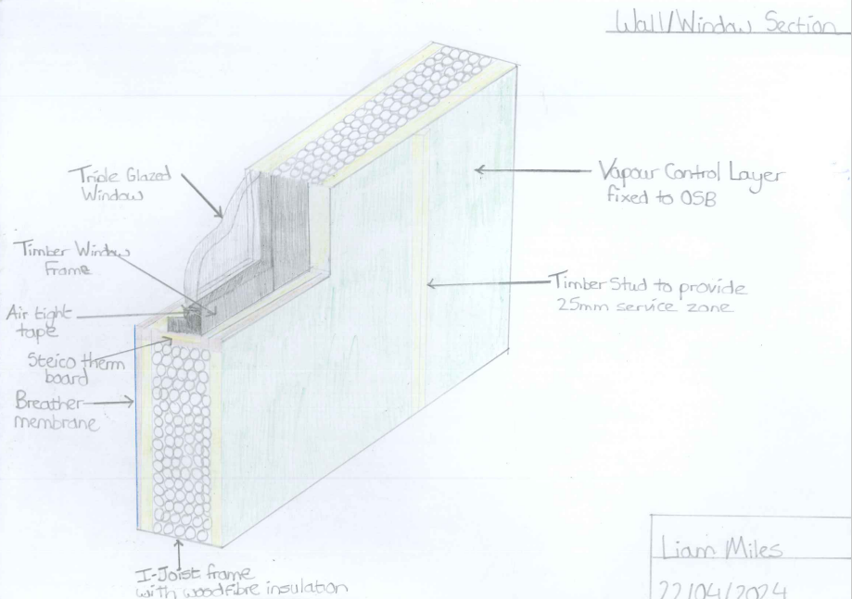
Figure 3- Cut Section of the window opening.
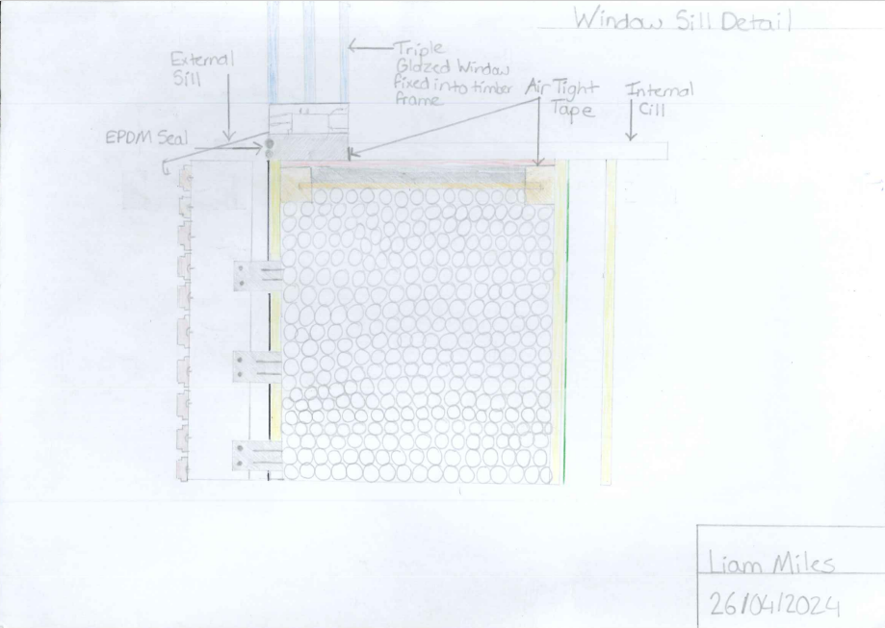
Figure 4- Window Sill Detail

Referring to Figures 3 and 4, the plan and detailing to achieve the necessary thermal performance at a window opening can be seen. These openings are big contributors to heat loss through a building and measures must be in place to ensure the appropriate waterproofing, thermal performance, and ventilation with the added responsibility of the building being timber frame. As specified, triple-glazed windows and doors are to be used to maximise performance as they will improve thermal insulation and enhance sound insulation. As detailed in Figure 4, all joints and openings must be fully sealed. The Steico Therm Board should be used to ensure rigid insulation below the sill to enhance the insulation and reduce condensation. To achieve compliance windows and doors installed in dwellings must be installed with a maximum U-value of 1.4W/m2K (Welsh Government, 2022). With the proposed detail a U-value as low as 0.8W/m2K can be achieved. Additionally, with this proposed construction there is an option to assemble the window/door openings in a factory which may improve installation times and further improve accuracy and coordination.

3.4 Roof Construction and Eaves Detail
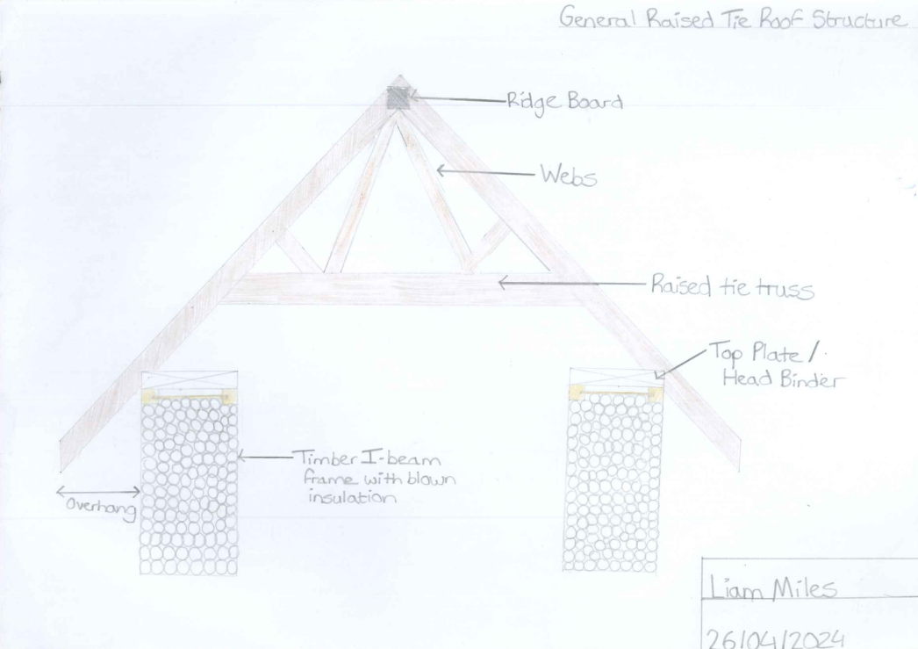
Figure 5- Raised Tie Truss Roof Structure Detail (please note that the detail does not include renders, internals etc).
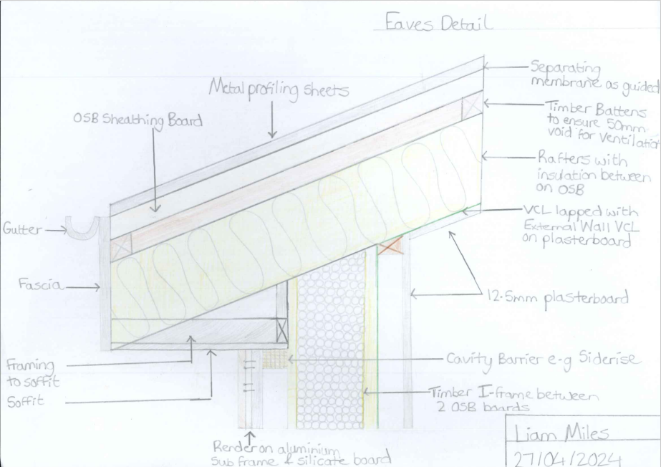
Figure 6- Proposed Eaves Detail

Figure 5 displays the general raised tie structure of the proposed construction, please note that rendering, internals etc are not shown and further detailing can be seen in Figure 6. The raised tie trusses enable the structure to have more headroom by raising the tie beam as shown, which therefore maximises the space to the upper floor in the proposed housing development. This design also enhances the aesthetics internally, adding style and character to the building. The webs have been detailed as shown to transmit the loads of the trusses evenly (TRA, n.d.).
In addition, roofs must now comply with a maximum U-value of 0.13 to comply with building regulations in Wales. To comply with this, thick insulation has been recommended in between the rafters. Additional insulation not shown in Figure 6 may also be recommended below rafters and above the service zone of plasterboard or a double-skinned metal profiling sheet system may be used with insulation between to help achieve the required thermal performance. Cavity barriers have been added as guided by Part B of the building regulations which advise measures to be in place to control the spread of flames (Welsh Government, 2020).

Proposed Construction vs Brick and Block Construction

Here the proposed wall construction will be analysed against the original wall construction of brick and block. There are many areas where each type of construction has its benefits, and these will be analysed in further detail. In specific, the thermal performance, thicknesses, and structure will be critiqued, however, relevant comments will be made regarding sound performance, weight, durability etc.

4.1 Thickness

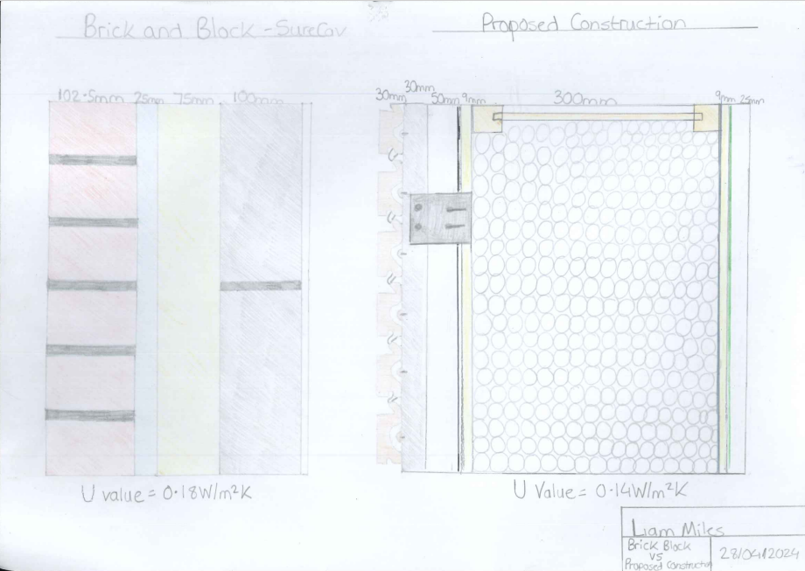
Figure 7- Comparison between the proposed external wall construction vs Brick and Block construction (adapted using Surecav, n.d.)
The brick and block wall construction shown in Figure 7 features 102.5mm wide clay bricks, 25mm SureCav cavity board, 75mm insulation and 100mm wide lightweight blockwork. This creates an overall thickness of around 300mm (excluding internals). This is a highly efficient brick and block construction with the aid of the 25mm SureCav Cavity Board being able to reduce the wall cavity by 50mm to ensure the same thermal performance. Typical brick and block constructions with thicker cavities and thicker insulation may generally be used which places the construction at 300-350mm thick. Comparing this to the proposed construction in Figure 8, the overall thickness of the I joist alone is 300mm thick, however, this comes with the added benefit of wood fibre blown insulation already added to the panels. Therefore, once including the externals the overall thickness of the wall is roughly 400mm thick as opposed to the brick and block construction of 300-350mm. However, with the proposed construction this is typically one of the thicker of the timber frame panelised options, but this is rewarded with much increased thermal performance. Additionally, with the increased thickness and a larger cavity like the I joist construction sound performance will be beneficial as sound will be absorbed within the cavity and the thicker layers of material (National Gypsum, 2023)

4.2 Thermal Performance

As seen in Figure 7, both construction methods comply with the Welsh Building regulations which require a maximum U-value of 0.18 for the external wall. However, the U-value is lower at 0.14 for the proposed construction vs 0.18 for the brick and block construction hence the thermal performance is better. This is mainly due to the nature of the materials of brick and block. Both materials are denser than timber and due to their density, this allows heat to pass more easily through them, therefore, the thermal conductivities of their materials are higher, and this increases the U-value. Additionally, the proposed I-joist significantly reduces thermal bridges due to its slender cross-section along with a big increase in the amount of insulation that can be achieved within the joist itself compared to the brick and block construction (Steico, n.d.). Therefore, the overall thermal performance within the proposed I joist construction is much better than the also efficiently proposed brick and block external wall.

4.3 Other Important Factors

There are also other factors which need to be considered between the two methods to gain an overall judgement.
Firstly, in terms of flexibility the timber I joist frame has added benefits due to its structure. This is because it is a lighter construction which therefore reduces the load on the foundations and will allow for more flexibility in design.
However, brick and block construction have their advantages, one being its longevity, as they are commonly known for their durability and resistance to weathering. Additionally, due to its structure, minimal maintenance is required but they may be prone to cracking and moisture intrusion through mortar joints, but remedies are generally not too strenuous. Whereas, in the I joist frame, there are greater concerns about moisture management and fire performance etc as once damage occurs this can become a serious problem. However, with the correct design the moisture management and fire performance can be easily mitigated and the same durable performance as brick and block can be achieved.
Sustainability is another key factor which must be considered. The materials of both structures are typically from natural materials. However, the brick and block manufacturing process can be energy demanding and involve emissions. Timber materials also involve energy demands due to the deforestation process, but this is seen as lower and there are regulations in place such as the UK Timber regulations to mitigate this issue and it is a renewable product.
There are also improvements to the speed of construction and accuracy benefits with the proposed construction lowering the amount of work required on site which can instead be controlled in a factory.

Conclusion

In conclusion, the proposed shift from traditional brick and block construction to a factory-made timber panelised system offers a promising alternative for this housing project. The report explored offsite construction methods providing clear definitions and suggesting potential benefits and areas where the methods could be incorporated into this construction.
The construction detailing focused on the 4 key areas in which heat is lost throughout the building. The detailing included methods to achieve the required thermal performance of the structure and compliance with building regulations. Including approaches such as insulated ground floors, deep panelised frame walls, and triple-glazed windows and doors to achieve the best efficiency.
Through the comparison of the proposed construction to the original brick and block method clear advantages were outlined for the panelised frame for its thermal performance, sustainability, efficiency, and structure. Although durability, moisture management and fire performance were discussed as problem areas for the construction, however, the relevant detailing suggests methods in which this can be dealt with and how this can be managed through careful design.
Fundamentally, this transition to a factory-made timber panelised system represents an innovative and modern approach to construction which offers a solution that not only can comply with the necessary building regulations but also prioritises energy efficiency and sustainability embracing the change in modern construction.

References

Chudley R. et al. (2014). Building construction handbook. 10th edn. Oxfordshire: Routledge.
CITB. (2017). Faster, Smarter, More Efficient: Building Skills for Offsite Construction. Available at offsite_construction_full_report_20170410.pdf (citb.co.uk). (Accessed 27th March 2024)
Designing Buildings. (2022) Heat Loss https://www.designingbuildings.co.uk/Heat_loss (Accessed 7th April 2024)
Dupont. (n.d). Tyvek Firecurb Breather Membrane. Available at Tyvek® FireCurb® breather membrane (formerly called Tyvek® FireCurb® Housewrap, only a name change) (dupont.co.uk) (Accessed 15th April 2024)
HouseBuild. (n.d). Raft Foundation. Available at Building Guidelines | Standard Construction Drawings - Dwellings | Raft Foundation (housebuild.com) (Accessed 11th April 2024)
James Spraget. (2019). What U Value Should your Timber Windows Have? Available at What U-Value Should your Timber Windows Have? - Timber Windows Direct (timberwindows-direct.co.uk). (Accessed 16th April 2024)
Lancashire R. and Taylor L. (2011). Timber Frame Construction. 5th edn. Buckinghamshire: TRADA Technology Ltd.
Local Authority Building Control (LABC). (2018). Raft Foundations Basics. Available at https://www.labc.co.uk/news/raft-foundation-basics#:~:text=A%20raft%20foundation%20is%20a%20reinforced%20concrete%20slab,other%20foundations%2C%20lowering%20the%20pressure%20on%20the%20ground. (12th April 2024)
Local Authority Building Control (LABC). (2022). Fully supported single skin metal roofs. Available at https://www.labcwarranty.co.uk/technical-blog/fully-supported-single-skin-metal-roofs. (Accessed 20th April 2024)
National Gypsum. (2023). 6 Variables that affect STC ratings. Available at https://www.nationalgypsum.com/who-we-are/blog/acoustics/understanding-acoustical-wall-designs-variables-affect-stc-ratings. (Accessed 28th April 2024)
NHBC. (2022). Raft Foundations- edge detail. Available at https://www.nhbc.co.uk/binaries/content/assets/nhbc/tech-zone/nhbc-standards/tech-guidance/4.4/raft-foundations---edge-detail.pdf. (Accessed 11th April 2024)
Steico (n.d) I Joists. Available at https://www.steico.com/en/solutions/product-advantages/i-joists. (Accessed 16th April 2024)
SureCav (n.d.) SureCav 25 The Future In Cavity Walls Surecav25 Product Details | Innovative Cavity Wall Solutions. (Accessed 28th April 2024)
Trussed Rafter Association (TRA). (2019). The Buyers Guide to Trussed Rafters. Available at https://www.tra.org.uk/wp-content/uploads/tra_buyers_guide_online_29.05.19.pdf (Accessed 20th April 2024)
Warmcel (n.d) Technical Details. Available at https://www.warmcel.co.uk/warmcel/technical/. (Accessed 16th April 2024)
Welsh Government. (2020). Building Regulations Part B: Fire Safety. Available at https://www.gov.wales/sites/default/files/publications/2021-12/building-regulations-guidance-part-b-fire-safety-volume-1-dwellinghouses.pdf. (Accessed 30th March 2024)
Welsh Government. (2020). Building Regulations Part L: Conservation of fuel and power in Wales. Available at https://www.gov.wales/building-regulations-guidance-part-l-conservation-fuel-and-power. (Accessed 30th March 2024)
Wienerberger. (n.d). Corium Technical Documents.
Available at https://www.wienerberger.co.uk/content/dam/wienerberger/united-kingdom/marketing/documents-magazines/technical/corium-technical-documents/UK_MKT_DOC_TEC_FAC_FOR_Corium%20Technical%20Guide.pdf (Accessed 14th April 2024)
Please see attached link for full size completed drawings.

