WEB DEVELOPMENT

Lecturer: Suneth Fernando
Student Name:Liliana Guraliuc
Student ID: 1811989

Table of Contents
Research 3
Introduction 6
Testing 7
Evaluation 10
References 11
Appendix 12

Research
There are a number of PHP programming models and frameworks available for making high performance and robust web applications. Though the new emerging server-side technologies are becoming more popular, PHP still manages to hold 79% of the total share on the technologies used for building web applications. In this section, we present the research and the critical evaluation of some of the most widely used PHP frameworks for building web applications.
1. Laravel PHP Framework:
The Laravel framework of the PHP language is best suited for implementing the Model View Controller(MVC) pattern for developing complex web applications. The framework allows the developers to easily manage the code for complex applications(Yadav, Rajpoot and Dhakad, 2019). The data manipulation and the data controlling of the web applications can be better implemented with the MVC pattern of development. The framework enables the developers to maintain a clean and clear code that has very less chances of bugs. It is focused on handling repetitive tasks more efficiently and faster. The codebase is easily handled in the Laravel framework. It is very efficient in handling complex web applications and also provide security and high performance. It’s widely used as it implements object-oriented approaches. It can help the developers to simplify the code automatically by arranging them in a proper structure. Apart from all these, the framework has large community support, online tutorials, and documentation.
2. Yii – Yes, It is! PHP Framework:
This PHP framework is focused on Object-Oriented concepts and implements them to build web applications. The framework is suited for all kinds and nature(Hryshko, 2016) of web applications and has great support for security and performance. Yii is used for building web applications that need high security such as e-commerce web applications, CMS, portals, etc. The framework allows the developers to avoid implementing repetitive SQL statements. It is a component-based web application development framework that harnesses reusability and helps develop the web application at a faster pace. It is easy to install, configure, and use to develop complex and large scale web applications. It comes with a powerful tool called Gii, which automatically generates the code. It also implements the Model View Controller architecture for developing web applications. It also has great support in the open-source community. The GitHub page of the framework provides much support.
3. Symfony:
The Symfony implements the Object Relational Mapping, i.e., the ORM approach for making web applications. It is a high performance and powerful PHP framework that is used to make complex and large PHP web applications(Han-Nguyen, 2016). It provides high flexibility in developing web applications, by providing a selection of unique PHP functions that are pre-made and come in handy in developing web applications. It comes with built-in testing features that make the testing of the web applications easy as it is integrated into the framework itself. This enables the developers to test the web applications as they are being developed simultaneously. The only drawback is that it can be sometimes low in performance for PHP web applications as compared to the other PHP frameworks that are used to build the web applications. On the plus point, Symfony gives high support for modularity in web application development. It can be used to make modular PHP web applications. The framework provides support for choosing the components instead of the full library for the functionalities. This makes it a sweet framework that is focused on the modularity of the web application.
4. CodeIgniter:
The CodeIgniter PHP framework focuses on the MVC, i.e. the model-view-controller architecture for building the web applications. The framework is widely used(Li, Karnan and Chishti, 2017) as it has a very small footprint and allows the developers to build powerful web applications. The web applications made with CodeIgniter can easily be scaled. The framework is easy to learn, configure, and use as compared to the other PHP frameworks. The performance factor of the CodeIgniter is very high since it has a small footprint and can be used to make scalable web applications, the performance is high. It is the most used framework for its simplicity and high performance to make web applications. The only drawback is that it has very irregular updates and releases. It has great support for libraries and components. The web application development is very rapid using the CodeIgniter framework.
5. CakePHP:
The CakePHP framework is a PHP framework that implements the MVC model to build web applications. The framework has improved performance(Solanki, Shah and Shah, 2017) and have many components that are hard to find in other PHP frameworks. The best feature of the framework includes better and efficient code handling and maintenance. It uses very simple and powerful coding conventions that allow the developers to focus on the development process to build web applications in a rapid manner. The framework has a great feature of large libraries and components that make the complex implementations of web applications easy. It has built-in features that enhance the security of web applications such as the input validations and the anti-csrf, SQL injections, etc. The drawback of the framework is the very strong point that is the coding convention, which allows less customization in the implementation process. It makes sure that the developers follow certain criteria while building a web application that restricts the creativeness.

Introduction
This assignment is based on a website development related to Student Course Registration Management that supports dynamic content with the use of server-side based programing language. This student course management system website is designed and implemented by a university and various services are implemented on this website. On the website, students can register for two courses that are related to the level four CertHE course in which students are involved in the CertHE course in capabilities for the health, workplace as well as social care. Eight modules are considered and included in each course. Students can also register only for a single course. When the student is enrolled for the course then the admin of the website validates and verifies the application. Students must pass the assignment regarding grades and result with regard to each module. With the use of this website, students can re-sit failed modules up to two times at most. Once the entire module related to the course is completed then the student can demand the certificate.
The Student Course Registration Management website is developed using some web technologies and tools including HTML, CSS, PHP, MySQL. This website is fulfilled with some requirements such as logo bar, the navigation bar (including home, course details, register for course, login and contact us), university name, slide show screen, footer section, and about the university. The website is also included more requirements such as information should be kept in a suitable normalized database. In order to access content as well as show it on the webpages, the website should link to the database. On the course page, the details related to the module and course are displayed. On the home page, the university name, logo, navigation bar, slide show, about the university regarding information is displayed.
Admin and students can log in to the website. On the login page, a form is displayed and this can be achieved by setting up the user login screen. It is important to validate and verify user levels as well as details of login and allow the user to transfer the respective page (student page and admin page). On the student page, students can change their personal information and retrieve information regarding the course in which they have registered. On the admin page, the admin can edit, delete and add details related to the course and validate the application regarding students.

Testing
Testing is the most crucial part of the development cycle. Testing is the phase in which all the parameters and requirements are checked to test if all the functionalities of the website are working properly or not. Testing identifies the bugs and errors which are then further handled so that the end-user should not face any problem while working on the website and performing various tasks. For further understanding of how web processes are validated, various examples are presented below.
1st case
To remove any login issues and errors, the login form is also validated properly. If the user enters the wrong credentials, it alerts the user and denies authorization.
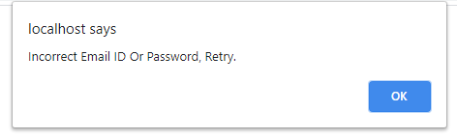
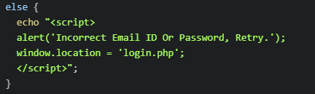
If-else conditional statements are used for logging in and if the credentials don’t match with any records in the database, this else part is run and the user receives an alert message and the authorization is denied.

2nd case
The most common form of errors comes when a user uses forms. If the form is not validated, null values or incorrect values are submitted to the database, which is unacceptable. To overcome this problem, the required attribute is used in all the input fields so that the inputs will be validated before submission.
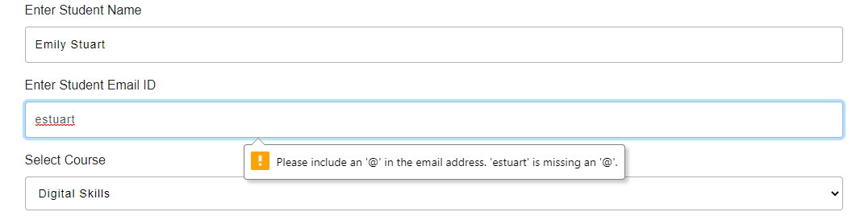
The required attribute alerts the user to fill in the information correctly as seen above. It also prompts the user if the input field is left empty.


3rd case
To avoid multiple similar entries of email addresses in the registration process, a validation process is created which alerts the user if the email address submitted matches any record which is preexisting in the database and also denies the insertion/registration request.

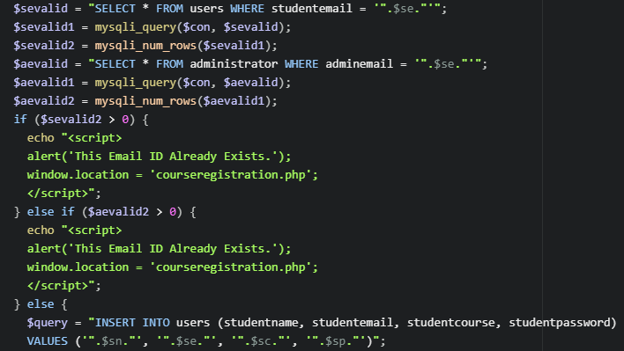
Two different queries for two different tables are run with the purpose of finding any records which matched the submitted email address, if found, an alert message is shown and the insertion process is denied.

Evaluation
The web application is a complete solution for student course enrolment and selection. It has a great design and functionalities implementation that fulfills the requirements. The website has very high performance and great potential. It has all the features and the functionalities with the qualities of an industry-grade web application that can be deployed on a webserver to use it. Though it has been made as a project, it has great potential for deployment in the real world for better understanding and measuring the capacities of the web application. It has implemented all the functions that are secure and apt in performance and the functionality requirements. The qualities of any web application can be determined well by deploying it in the real world and see the performance and the functionalities of the web application, how it behaves when the real-world interaction is done and how does it deliver the required specifications and functionalities for which it was built.
The future improvements would be to enhance the user interface and the user experience of the web application. The signup and the login process can be improved and made more secure by adding 2-factor authentication to secure the user data. The website application can be improved a lot. The design and the functionalities can be changed the way they are currently presented. It can be made more user interactive by implementing new layouts and user interfaces. The functionalities implementation can be altered to make it more fast and efficient. The design of the web application can be made modular in order to make it more high performance.

References
Ibrahim, A.F., Jamaludin, M.N.F. and Musa, N., 2018. Internship Application System (IAS) for University Students using Laravel. Journal of Computing Research and Innovation, 3(4), pp.12-18.
Hryshko, A., 2016. Yii as a modern application framework. Prospects for the development of professionally oriented language competencies in modern science: a collection of materials of the International scientific-practical conference for students of non-language specialties: Zhytomyr, April 13, 2016 / for general. ed. NM Andriychuk, pp.45-46.
Han-Nguyen, J.K.B., 2016. DEVELOPING A CMS PHP FRAMEWORK WITH SYMFONY (Doctoral dissertation, CALIFORNIA STATE UNIVERSITY, NORTHRIDGE).
Arrhioui, K., Mbarki, S., Betari, O., Roubi, S. and Erramdani, M., 2017. A Model Driven Approach for Modeling and Generating PHP CodeIgniter based Applications. Transactions on Machine Learning and Artificial Intelligence, 5(4).
Solanki, N., Shah, D. and Shah, A., 2017. A Survey on different Framework of PHP. International Journal of Latest Technology in Engineering, Management & Applied Science (IJLTEMAS), 6(6), pp.155-158.
Li, X., Karnan, S. and Chishti, J.A., 2017, November. An empirical study of three PHP frameworks. In 2017 4th International Conference on Systems and Informatics (ICSAI) (pp. 1636-1640). IEEE.
Yadav, N., Rajpoot, D.S. and Dhakad, S.K., 2019, November. LARAVEL: A PHP Framework for E-Commerce Website. In 2019 Fifth International Conference on Image Information Processing (ICIIP) (pp. 503-508). IEEE.
Dāsa, R., 2016. What Is CakePHP?. In Learn CakePHP (pp. 2-6). Apress, Berkeley, CA.

Appendix
Home
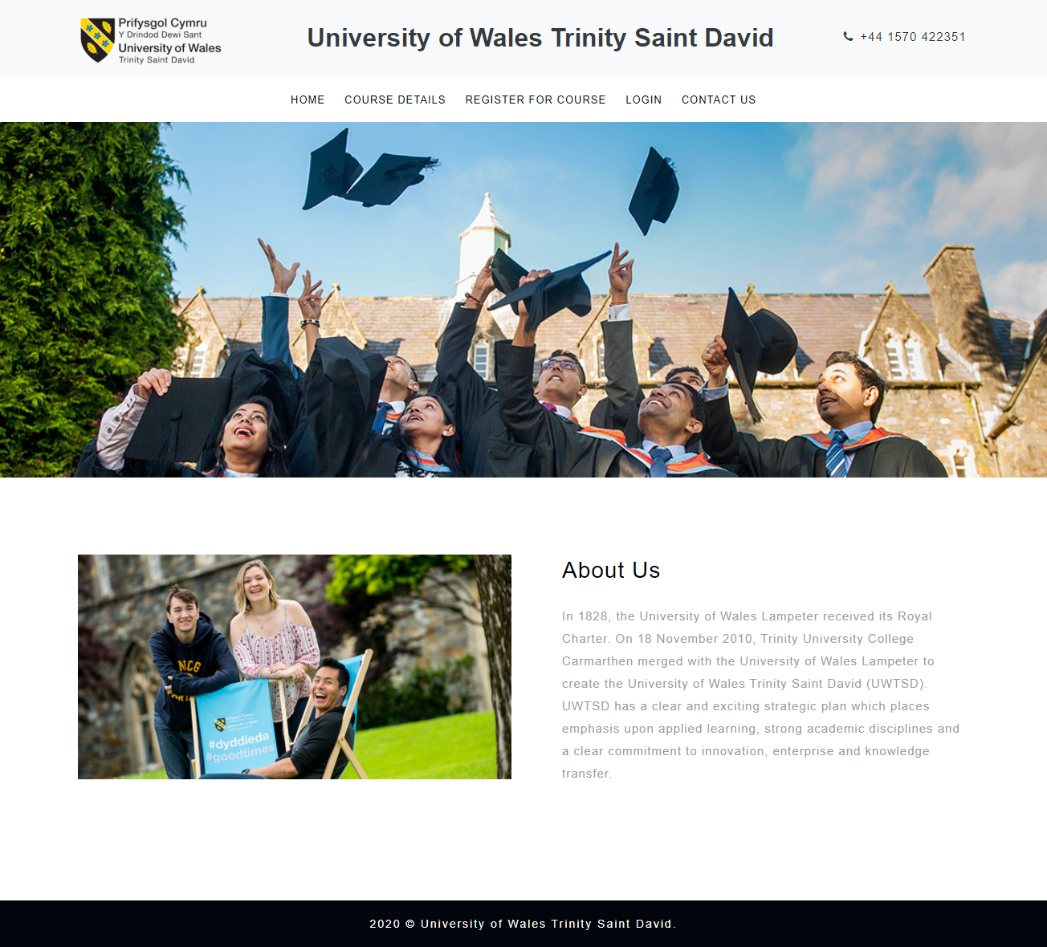

Course details


Course registration
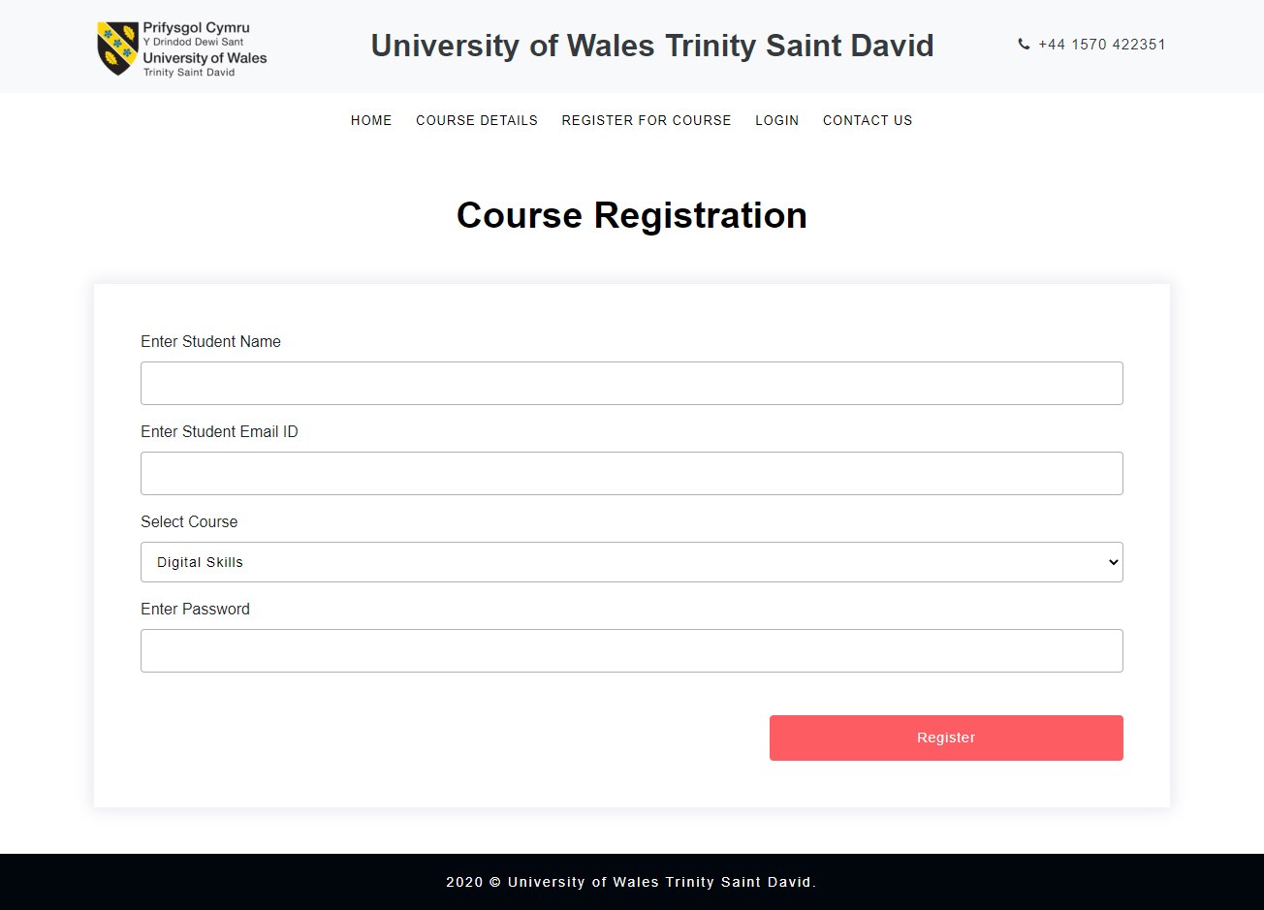

Login
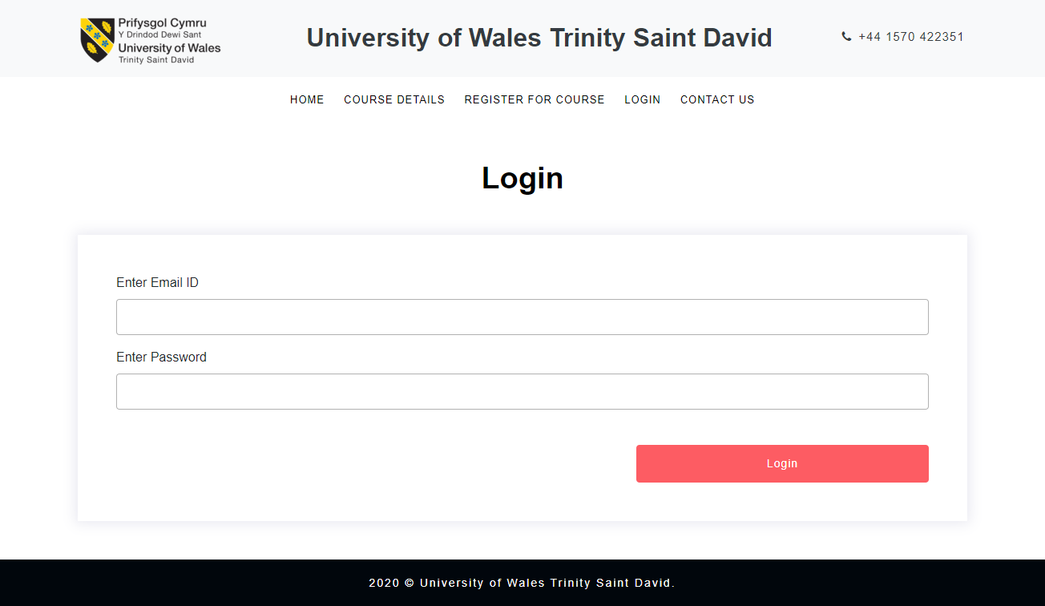
Contact us
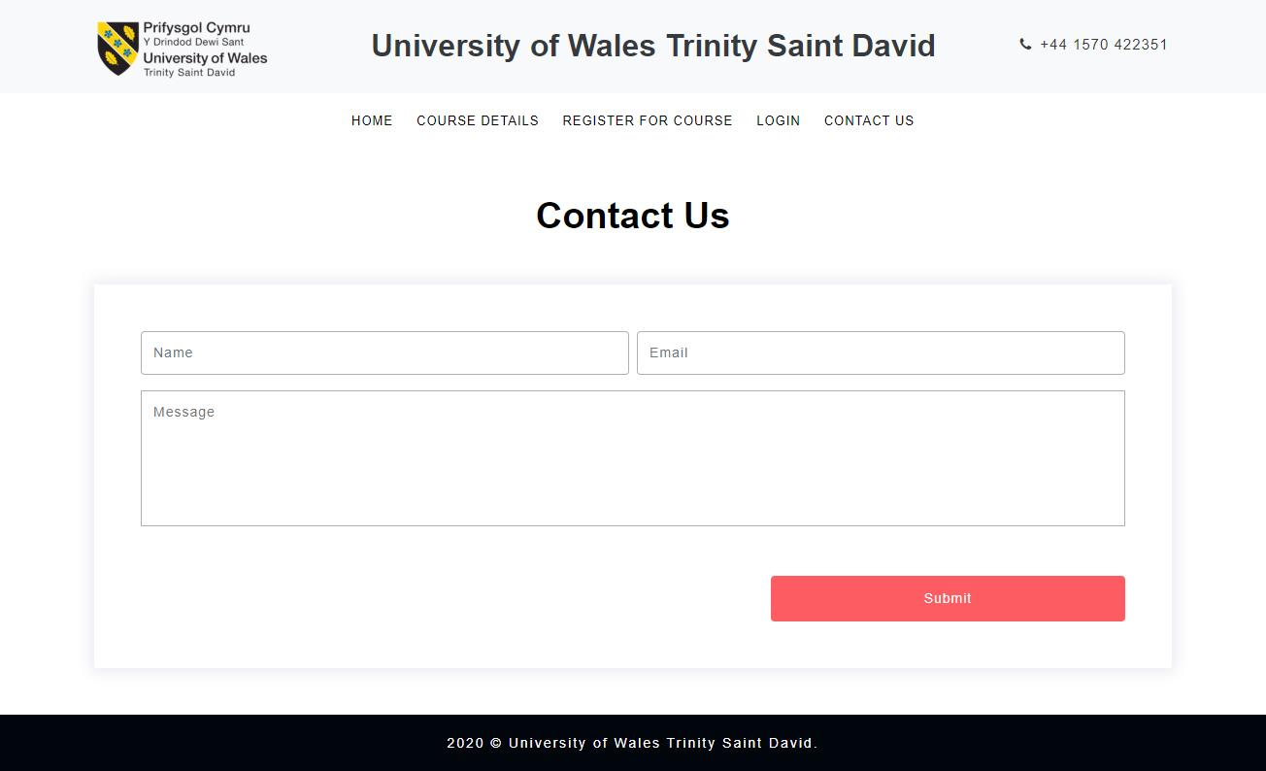
Administrator
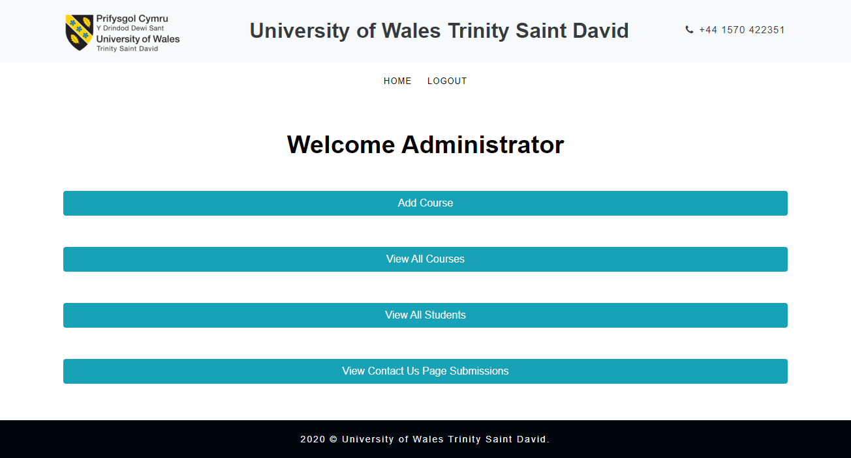

Administrator: Add course
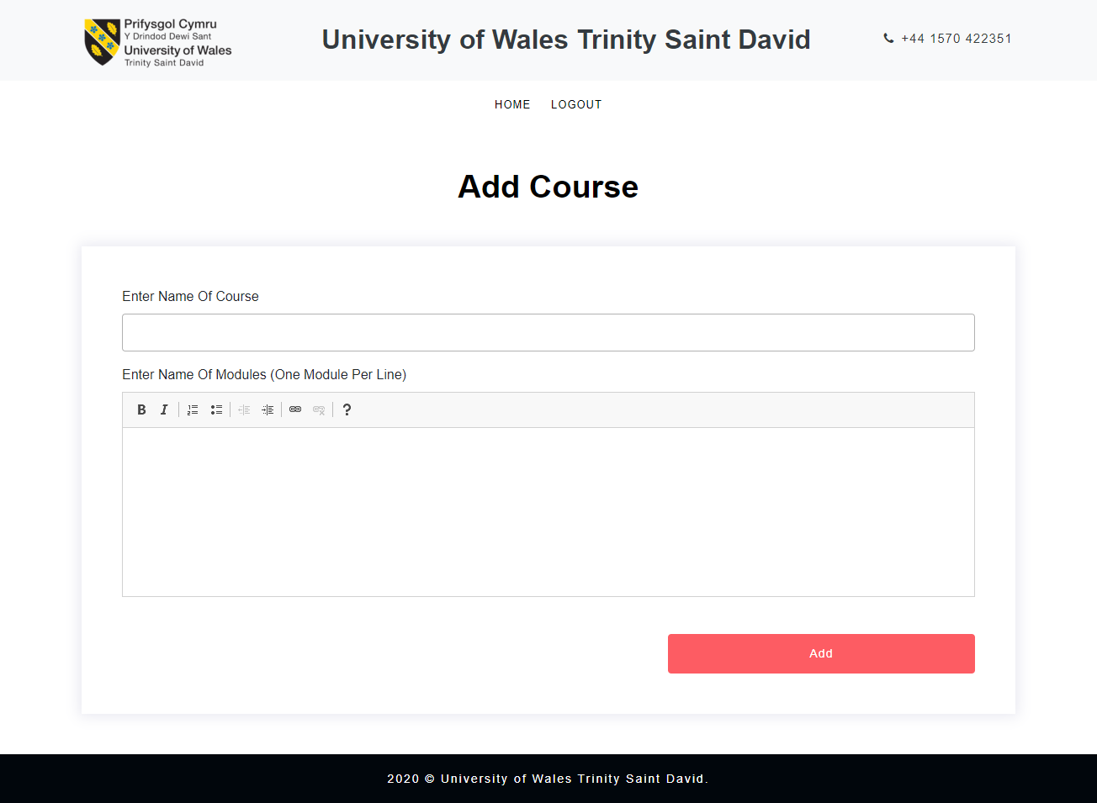

Administrator: Courses data
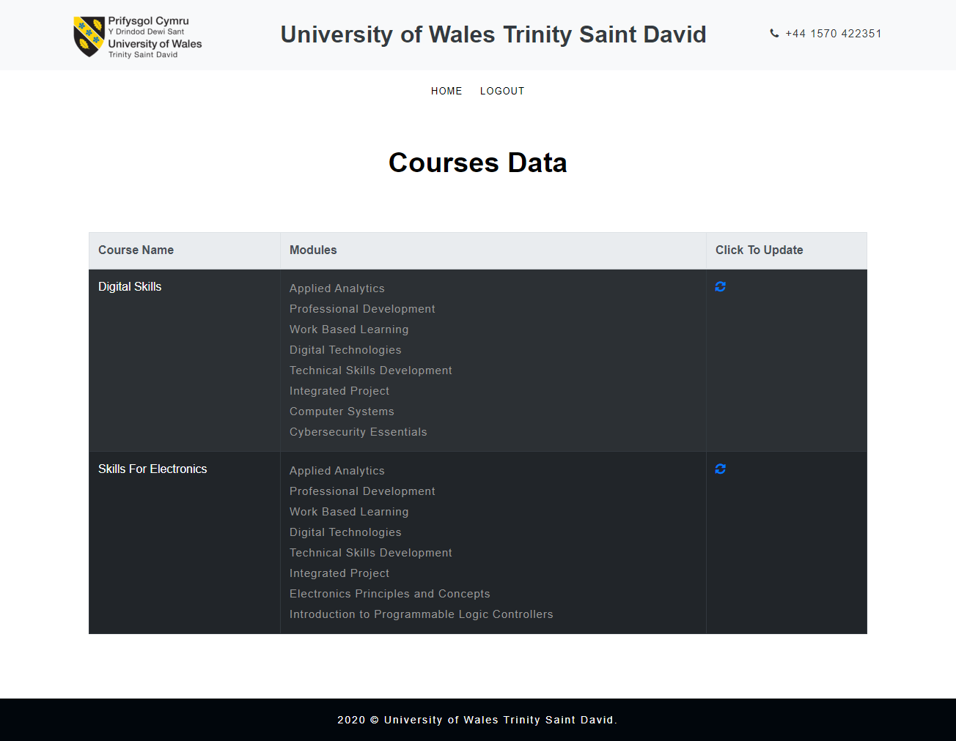

Administrator: Update course
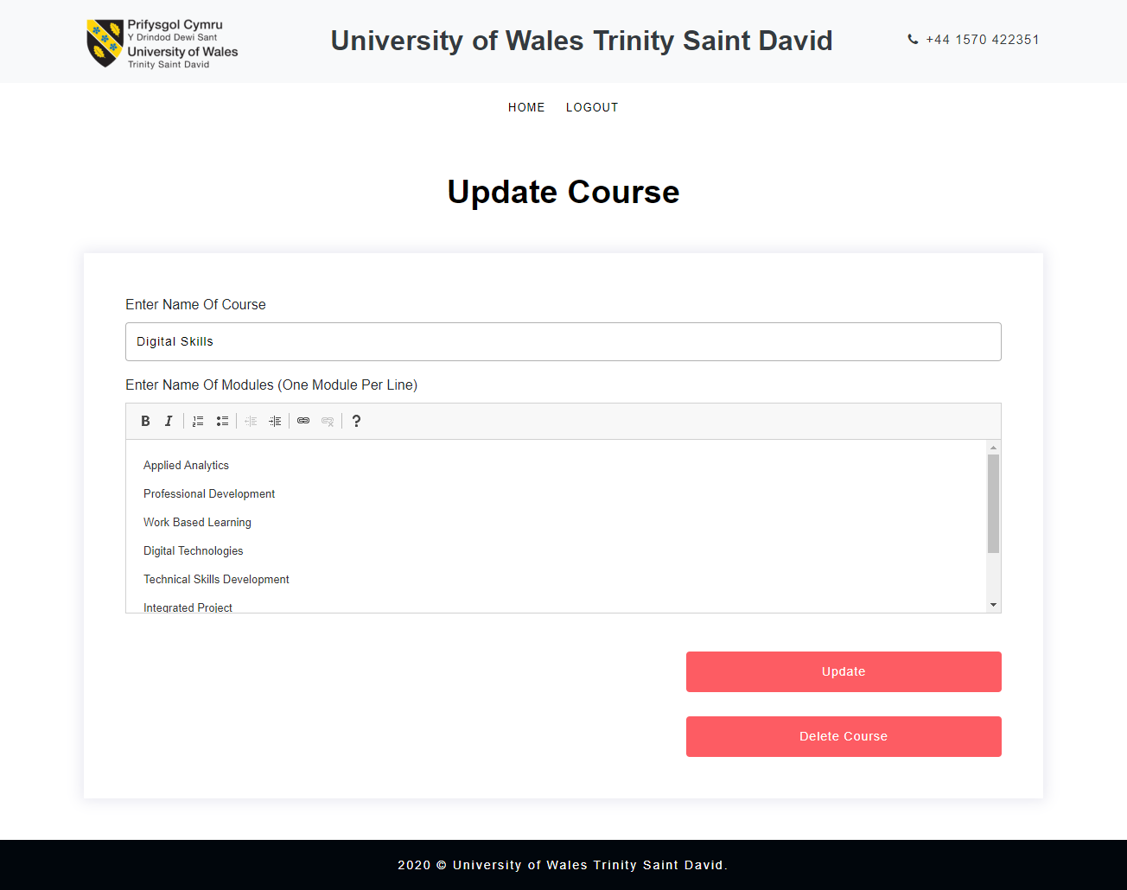

Administrator: Students data
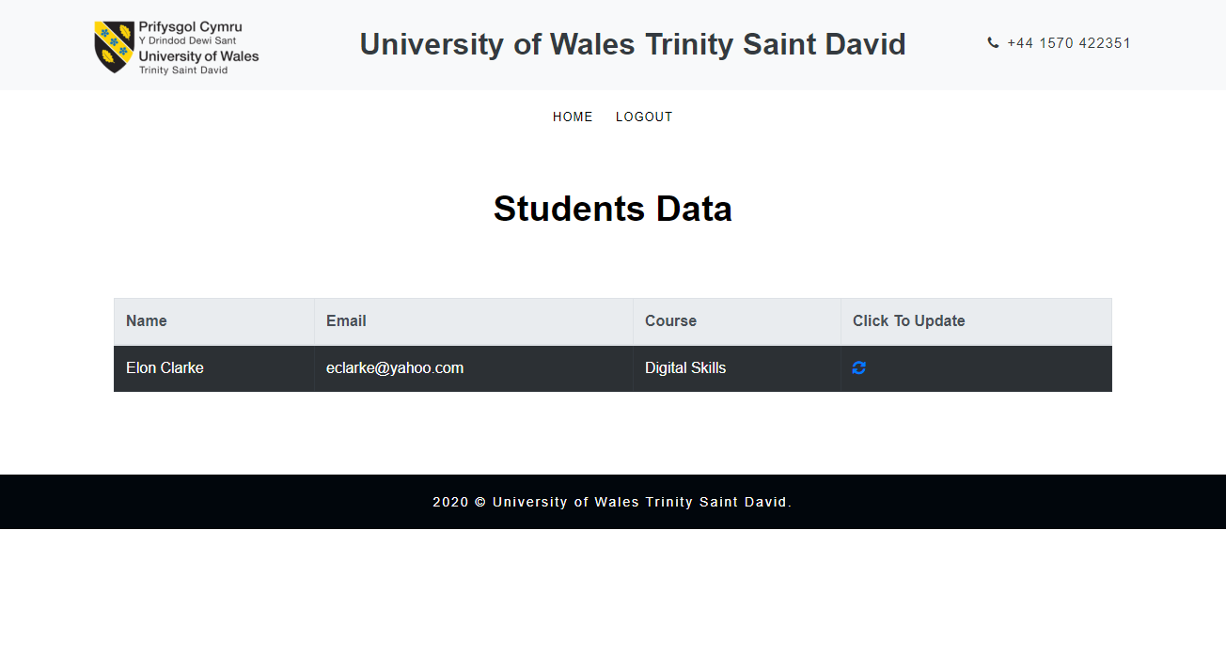

Administrator: Update student data
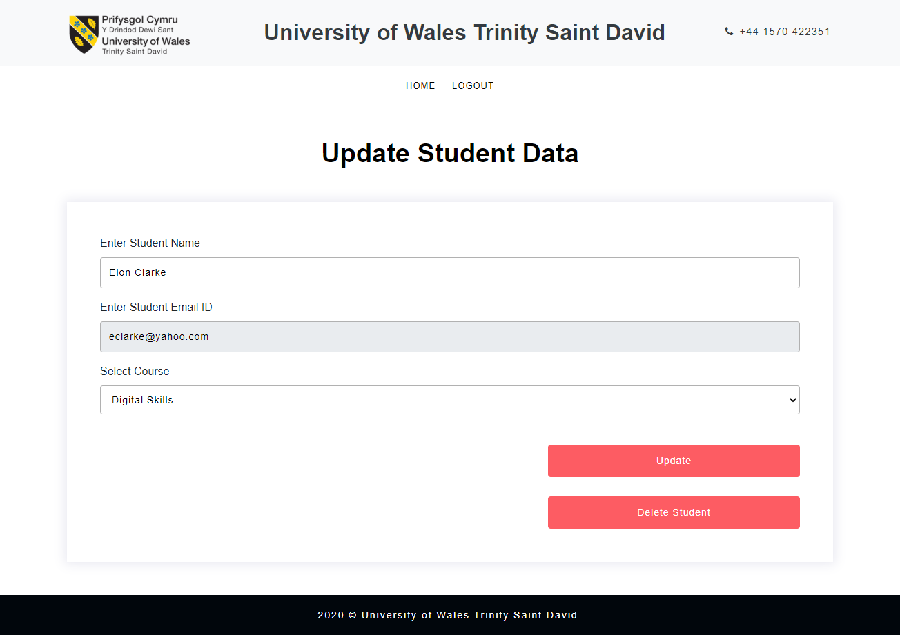

Administrator: Contact us page submissions
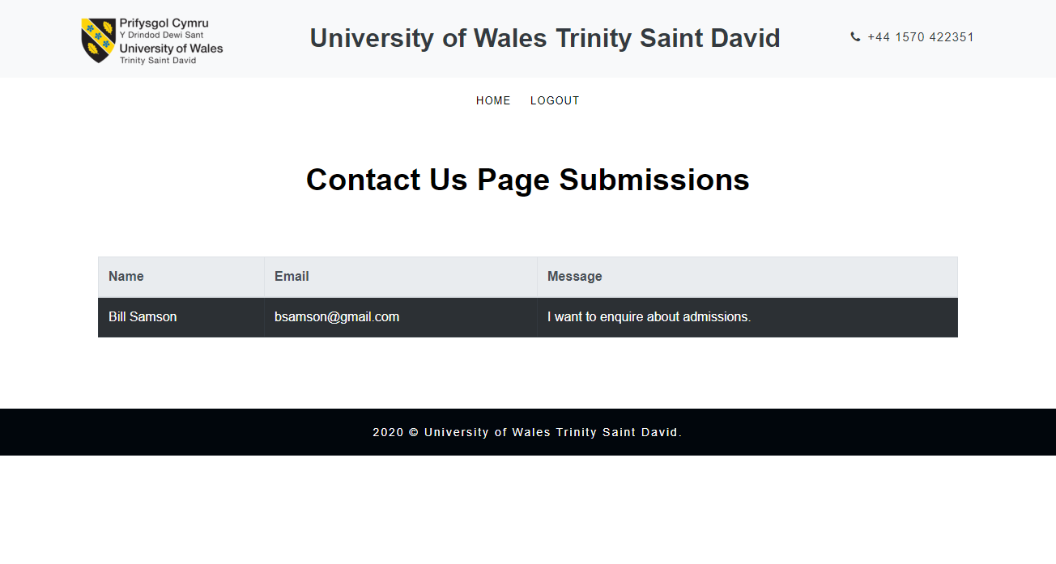

Student


