Entrepreneur Personality Traits & Characteristics to be Successful

Student’s Name: Andra Maria Daniliuc
Student’s ID: 2030171

Entrepreneur Personality Traits & Characteristics to be Successful
Entrepreneurs are crucial to any country's economy because they create jobs, manufacture things, and supply essential services to the general public (Casson, 2020). To put it simply, an entrepreneur is a person or a group of people (entrepreneurs') who spot a business opportunity in a given market and act upon it by creating a good or providing a service that meets the demands of consumers. While everyone might choose to take the entrepreneurial risk, not everyone has what it takes to make it. Many of the world's most prosperous business owners share a set of characteristics that set them apart from the competition. The characteristics of a successful entrepreneur are discussed in this essay.
One of the most important characteristics of a successful entrepreneur is a willingness and ability to succeed. To be determined is to have a burning desire to succeed. Possessing this quality calls for determination and the strength to come back from adversity (Crainer, 2020). Successful business owners also tend to be very dedicated people. Entrepreneurs need to put out 100% effort into making their dreams a reality. An entrepreneur's chances of success improve with focus and commitment. Entrepreneurs who also exhibit high levels of self-confidence are better able to advocate for themselves and their goals in a way that earns respect from others. Confidence in one's abilities is typically the outcome of careful planning, which in turn reduces rates of uncertainty and risk. Self-assurance in proportion to the effort expended is necessary for achieving the desired financial returns (Fatonah, 2018). Confidence is an inevitable byproduct of an entrepreneur's competence and understanding. Confidence also makes it easier for them to take in the perspectives of others.
The ability to think creatively and independently is a must for any entrepreneur. An entrepreneur's best chance of success in today's cutthroat business environment is to constantly innovate and release new and better things for consumers to buy (GREBSKI, 2022). Business owners that know themselves well and use that knowledge to their advantage are more likely to succeed. When a business owner has a strong level of self-awareness, they know their own capabilities and limitations. As a result of this insight, they are better able to focus on, and succeed at, those aspects of business management in which they play a leading role, while delegating those aspects in which they are less competent (Hadi, 2018). Being able to effectively provide, receive, and act upon feedback is enhanced by heightened self-awareness.

Figure 1: An important behavioural trait of an entrepreneur is creativity (Holland, 2016).
Effective listening, conveying ideas vividly, and giving constructive criticism are the top three communication abilities for leaders, according to a study by Wroclaw University (Holland, 2016). Business owners who possess these abilities may have a leg up on the competition. If a company owner is good at listening to their customers, they can take on board suggestions for service enhancements. The trust that is built between a company's leadership and its staff is a key factor in boosting both productivity and profitability.
Startup owners who aren't willing to change course when they need to will struggle to build a business that will survive and thrive over the long term (Ilott, 2017). Entrepreneurs who are too set in their ways and unwilling to adapt to new circumstances will fall behind the competition. This is true whether they are trying to improve their products or their company strategies. Being adaptable is a crucial quality for entrepreneurs, as it allows them to seize opportunities as they arise. Those who run a business risk falling behind the times if they aren't willing to embrace new ideas and adjust to the preferences of their customers.

Figure 2: Risk taking ability of an entrepreneur (Protas, 2021).
One of the most important abilities an entrepreneur may have is the willingness to take measured risks. As the saying goes, "failure to prepare is preparing to fail." Business owners who are prepared to take chances are more likely to gain knowledge that will benefit their enterprise (Protas, 2021). Furthermore, in oversaturated markets, taking calculated risks can help organisations identify innovative methods to set themselves apart from the competitors. Even if the gamble doesn't pay off as planned, the business owner can still take away some useful knowledge that will inform future choices.
There will be good times and bad times in any business. Entrepreneurial success does not happen overnight; rather, it is a long, arduous process (Romanov, 2018). All entrepreneurs, to varying degrees, share the aforementioned characteristics. Developing one's potential in any area requires only time and effort. This means that, with practise, any entrepreneur may develop the aforementioned skills. When an entrepreneur finds a candidate with the qualities necessary to push the company to new heights, it might benefit from the addition of that candidate's skills and experience.

In order to evaluate the macro environment in which businesses operate, the PESTLE analysis has become a standard technique (Artyukhov, 2020). The success of a business might be threatened by fluctuating market conditions. Over the years, managers have relied on the PESTLE framework to analyse the potential benefits and threats to their company's macro environment.
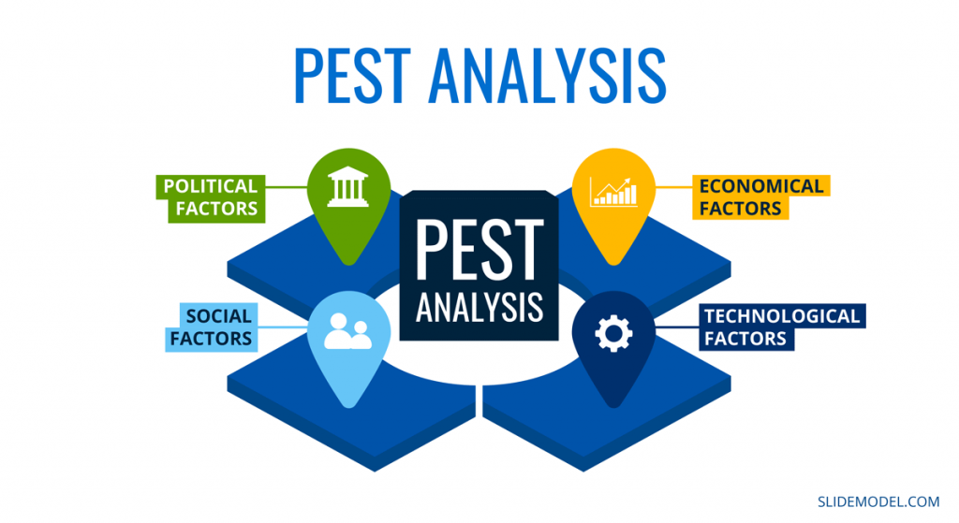
Figure 3: Conducting PEST analysis before starting a business in UK (Schein, 2015).
The political environment is the first step in the PESTLE analysis. This is due to the fact that ensuring a country's political stability is among the highest priorities for any business. In the United Kingdom, starting a business is actively encouraged by the government (Schein, 2015). Furthermore, political stability is present in the UK, thus there is no danger of unstable political influences at the present time. Corruption is nothing to be concerned about because the government of the United Kingdom is constantly working to reduce it. Anybody can start a business, so long as they don't break any laws or engage in any corrupt practises. Also, the UK's foreign trade policy is more flexible than usual since the government wants more people to start businesses so as to boost the economy after the country's losses from the Covid outbreak. It's important to think about tax policy before launching a company, and it appears that the tax system in the United Kingdom is accommodating to new enterprises. The country has well-defined labour laws, so entrepreneurs need not worry about any unforeseen complications when getting their business off the ground. In this era of widespread globalisation, commercial barriers are negligible at best (Steyaert, 2021).
The political climate is just one factor to consider when analysing the macro environment in which a firm operates. There is a wide variety of elements to think about. Managers should analyse many different macroeconomic indicators, such as the stability of the currency, the distribution of wealth and income, the unemployment rate, the rate of economic growth, the cost of wages, and the rate of inflation (Vozikis, 2016). A prospective entrepreneur would be wise to research the expansion prospects of the industry in which he or she is interested in setting up shop. In addition, the currency exchange rate is a critical concern for the company. With that said, after Brexit, the pound has shown remarkable stability, and the associated exchange rate risk is only minor. In addition, the rate of inflation is a factor that should be thought about when launching a firm, as prices should be set reasonably taking inflation into account.
The socio-cultural analysis of a market follows the economic analysis of a market and sheds light on a population's underlying values, norms, institutions, education levels, and consumption patterns. Sociocultural aspects in the United Kingdom are often supportive of new businesses (Yuksel, 2019). The UK has an increasing population, which means that starting a new business will pay off in the long run. In the United Kingdom, consumers span a wide range of ages, which can help businesses reach a wider audience with their product offerings. Also, there are comparatively few cultural barriers in the UK, thus business may be conducted with relative ease. Food entrepreneurs, in light of rising consumer awareness of the need of eating healthfully, would do well to expand their offerings to include more organic options.
Whether it's the ubiquity of online retail these days or the precision with which things can be manufactured in state-of-the-art factories, practically all businesses today rely heavily on cutting-edge technology (Vozikis, 2016). As technical complexity grows, it has a greater impact on business strategy. A prospective UK business owner would be wise to familiarise themselves with the local technological landscape before making any hasty decisions. When deciding whether or not to launch a new venture, prospective business owners should factor in the area's declining prices. There is a favourable environment in the United Kingdom for implementing cutting-edge manufacturing technology, and yet there is a substantial possibility that this technology may rapidly become obsolete. Therefore, if a corporation can adapt to these technological shifts quickly, it will be able to capture a larger market share and greater profits.
When assessing the macro environment in which a company operates, the legal structure must be taken into account. However, many businesses place the highest importance on this factor despite its low ranking in the PESTLE framework. Laws pertaining to discrimination, antitrust, employment, consumer protection, intellectual property, etc., make up a sizable portion of this variable (Protas, 2021). Yet, before beginning operations, a prospective business owner must conduct a thorough examination of these issues. The individual in this role is responsible for protecting the business' copyright and patent. Copyright and patent documentation and approvals are easier to get for new businesses in the UK. Thus, starting a new company is a rather simple process. In addition, employment law is strict, so any business that has workers must be careful to uphold the standards governing their employment or risk being sued by those workers. Therefore, it is important for a new business owner to study the local legal system in order to fully grasp the competitive landscape.
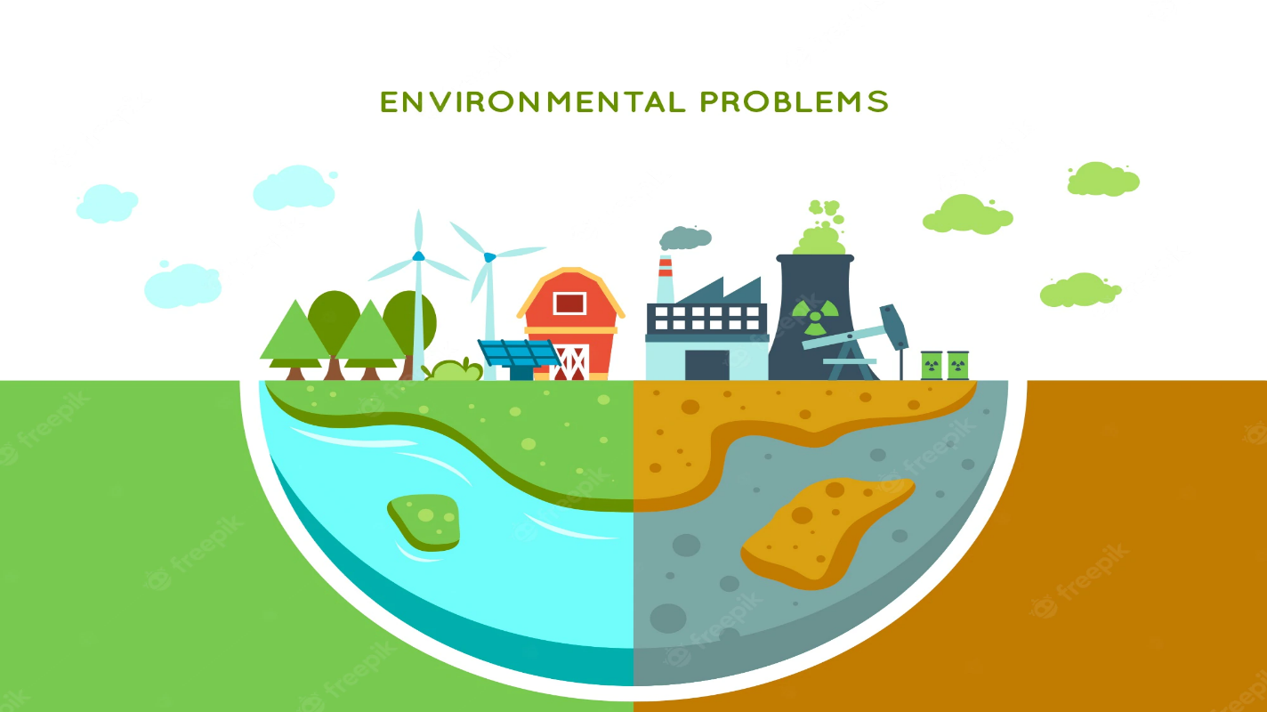
Figure 4: Environmental issues related to business environment under PEST analysis (Hadi, 2018).
The environmental characteristics of a country not only evaluate its climate and geography, but also its resource availability. This is important because items sold in areas with harsh climates have to adhere to standards that differ from those in their nation of origin (Hadi, 2018). Distribution difficulties are compounded by large distances between production facilities and consumer markets. Transporting raw materials or finished commodities might be complicated by the presence of mountains, rivers, or other geographical features. It is incumbent upon managers to assess whether or not the biological and geographical characteristics of a region are compatible with the strategic goals of their organisation. Before launching a company in the United Kingdom, would-be entrepreneurs should research the country's climate, weather patterns, and environmental regulations (GREBSKI, 2022). When deciding what to produce or offer, businesses must also think about whether their choices may have negative effects on local ecosystems or whether local production is prohibited for legal or ethical reasons. If the supply and demand for the product or service depends on the seasons, then climate change must also be properly examined.
The PESTLE Analysis has shown to be a useful tool for analysing the external factors affecting a company during the previous few decades. With this straightforward framework, business leaders may foresee potential dangers to their company and take steps to mitigate them by factoring them into strategic planning for the future (Crainer, 2020). Like any other analysis, this one is a product of its time and the available information to those conducting the study. Hence, it is suggested to carry out the PESTLE analysis on a frequent basis.

References
Artyukhov, A. (2020). PESTEL-analysis of the system ‘state – independent quality assessment agencies’: Political and socio-economic aspects. Economies’ Horizons, (4(15)), pp.42–50. doi:10.31499/2616-5236.4(15).2020.235011.
Casson, M. (2020). Entrepreneurship : theory, networks, history. Cheltenham: Edward Elgar.
Crainer, S. (2020). WHAT IT TAKES: THE ELEMENTS OF ENTREPRENEURSHIP. Business Strategy Review, 22(1), pp.17–37. doi:10.1111/j.1467-8616.2011.00724.x.
Fatonah, S. (2018). SWOT Analysis of Web 2.0 Entrepreneur Strategy in Enhancing Competitive Advantage: A Case Study of IACE Food Start-up Business in Surakarta. KnE Social Sciences, 3(10). doi:10.18502/kss.v3i10.3412.
GREBSKI, M.E. (2022). SWOT ANALYSIS OF INDIVIDUAL COMPONENTS WITHIN THE INNOVATIVENESS ECOSYSTEM. Modern Management Review, 27(2), pp.57–66. doi:10.7862/rz.2022.mmr.11.
Hadi, N.U. (2018). The leverage of entrepreneur skills and entrepreneur traits to business success: a case study of Pakistan’s marble industry. International Journal of Entrepreneurship and Small Business, 33(3), p.315. doi:10.1504/ijesb.2018.10011169.
Holland, D. (2016). The Leadership Traits Shared by Successful Entrepreneurs. Entrepreneur and Innovation Exchange. doi:10.17919/x9qc7f.
Ilott, I. (2017). The Research Assessment Exercise: A Personal SWOT Analysis. British Journal of Occupational Therapy, 60(4), pp.167–168. doi:10.1177/030802269706000407.
LIU, X. (2017). SWOT and PESTEL Analysis on the Coordinated Development of New Urbanization and Agricultural Modernization in Heilongjiang Reclamation Area. DEStech Transactions on Economics, Business and Management, (eced). doi:10.12783/dtem/eced2017/9891.
Protas, E. (2021). Organizational and Legal Characteristics of an Individual Entrepreneur. SSRN Electronic Journal. doi:10.2139/ssrn.3975494.
Romanov, E. (2018). SWOT-analysis: strategy of the organization to the strategy of personal growth. Perspectives of science and education, 36(6), pp.246–253. doi:10.32744/pse.2018.6.27.
Schein, E.H. (2015). Commentary: What is an Entrepreneur? Entrepreneurship Theory and Practice, 19(2), pp.87–88. doi:10.1177/104225879501900206.
Steyaert, C. (2021). Entrepreneurship: in between what? On the ‘“frontier”’ as a discourse of entrepreneurship research. International Journal of Entrepreneurship and Small Business, 2(1), p.2. doi:10.1504/ijesb.2005.006066.
Vozikis, G.S. (2016). Roles of chairs in entrepreneurship: What deans expect. The International Entrepreneurship and Management Journal, 2(1), pp.9–20. doi:10.1007/s11365-006-7086-7.
Yuksel, I. (2019). Developing a Multi-Criteria Decision Making Model for PESTEL Analysis. International Journal of Business and Management, [online] 7(24), pp.52–66. doi:10.5539/ijbm.v7n24p52.

Appendix (A)

SWOT analysis

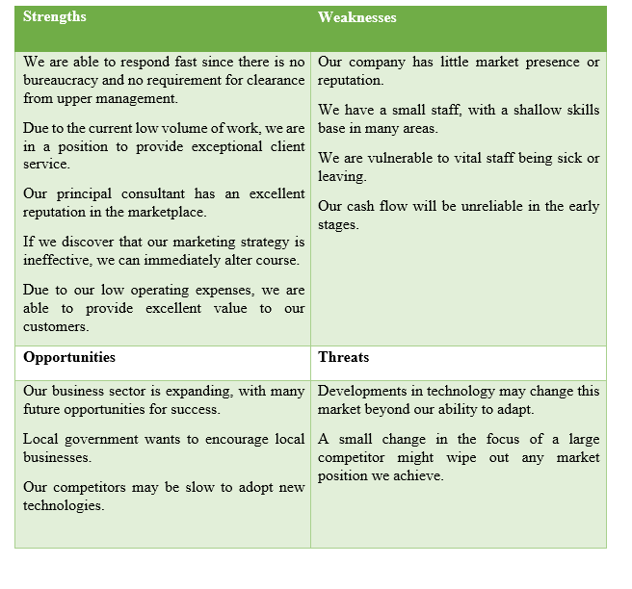

Appendix (B)
Personal skill audit


