Certificate of
Higher Education
(Report)

Professional Carrer
Development

Student name: George Iulian Chiras
Student code: 2120095
Module code: BMSW4005_LON
Lecturer name: Saqib Shamim
Date: 06/01/2023
Table of Content

INTRODUCTION.............................................................................page 3

SELF REFLECTION........................................................................page 4
Self-reflection on the role analysis by Gibbs model..................page 4
Description.....................................................................................page 5
Feeling............................................................................................page 6
Evaluation.......................................................................................page 6
Analysis..........................................................................................page 6
Conclusion.....................................................................................page 7

SWOT ANALYSIS............................................................................page 7

PERSONAL DEVELOPMENT PLAN...............................................page 8

CONCLUSION...............................................................................page 10

REFFERENCES............................................................................page 11

APPENDIX 1..................................................................................page 12

APPENDIX 2..................................................................................page16
INTRODUCTION

The students at the University of Wales Triniti Saint David were given the assignment to conduct an interview with a person working in the field of Professional Development Carrer so that they could gain an understanding of the various opportunities that are open to students who are interested in pursuing a career in the packaging industry.
The kind of communication that was used for the interview as well as the categories of inquiries that had to be posed were not mandated in any way.
Students were given the freedom to choose their own respondents, with the expectation that they would be able to conduct an interview with someone currently working in a field that the student thought to be fascinating.
The report is addressed not just to the author's current classmates but also to those who will be attending university in the near future.
The purpose of this report is to educate students on the responsibilities of the package management team.
In addition, the report will investigate the linkages between career development and plan strategy within the context of the topics and class lectures that have been covered during the course of the semester.

SELF REFLECTION

Self-Reflection on the role analysis by Gibbs Model
Conclusion
Description
Action Plan
Feelings
Evaluation
Analysis

(Gibbs, G. 1988)

Description

The position for which the applicant is applying is that of packaging manager. A person whose jobs it is to oversee packaging process, which is often carried out in factory or warehouse, is known as packaging manager. Oversee other workers within the process and seeing to that items are packaged appropriately and on time for delivery. As a manager of packaging, I need to be accountable for timely upkeep of packaging machinery, the efficient scheduling of workers and availability of both packaging materials and products that need to be packed. An additional responsibility for this function is to oversee the recruiting and training of workers for the packaging line. Many package managers depend on a certain skill set to be successful in their job (Laurence Gartside 2022)
From experience received by university lessons and previews jobs, I can determine the skills that are most important for success in this position by going through the applications that have been submitted where is required the capability of cultivating good interpersonal connections, taking command of a group, and finding solutions to difficult issues (Gibbs, G. 1988).
Here are some samples of duties included in resumes or positions of packaging manager to give an idea of what should expect from someone in that capacity:
- Consolidation, logistic support, and material handling are all aspects of program’s infrastructure that need to pe planned, optimises and improved.

- Prior to submitting QA, finish reports and check all filled-out records for correctness and compliance.

- Restructure the workplace such that it better supports open dialogue and uniform procedures while also fostering more visibility, collaboration, and output.

Feeling

My hope is that by sharing my interview experience with my class colleagues, I will help them get insight into the wide variety of career paths available within the packaging sector. Whenever I talk about the professional packaging industry to my acquaintances or members of my own family, one of two things immediately comes to their minds, professional career development or leadership management. From this report, despite the state of the work market right now, I am certain that earning a Certificate of Higher Education and Leadership Management would make many doors available to me after I have completed my degree. This is due to the fact that I am adaptable and willing to work in a diverse variety of environments and fields of endeavour.

Evaluation

As an interviewee I was confident and try to focus on my plan for the future. Using transferable experience from previous jobs and daily life, information necessary for interview was added on curriculum vitae and answers to the questions that are the most important and connected with most interviews regarding the job role I have in mind to achieve. Lack of language speaking was discovered as I hade consecutive brakes during the answers to the questions I was asked by colleague who played as interviewer. I need to mention experience as interviewee and interviewer was unique and help me to see both sides of applicant and employer roles. Hope the interview bring necessary knowledge of a leadership and management in packaging industry for my colleagues that was attended in class because is the most common job across the countries.

Analysis

During the interview, I really wish I could have asked more questions regarding the production firm and the steps involved in the packing process. Although the job function of the interview was not particularly specific on any of those issues, I believe that having a little bit more details would have been beneficial.

Conclusion

The interview seemed to go well, at least from my point of view. I was given the opportunity to broaden my understanding of a possible employment field and get insight into different paths leading to professional advancement. I have high hopes that if I share the findings of my research with my class colleagues, I will be able to open their eyes to the possibility of pursuing a career in the packaging industry, which is something they may not have given much thought to in the past.

SWOT ANALYSIS

Strength | Weakness
- Because I got into a fantastic pattern around halfway through the previous year, I am confident in my ability to perform well.  - Now that I know what is expected of me, I feel more confident than I did last year.  - Unlike writings, which is not my strong suit, I am adept at giving oral presentations. | - As the semester goes on, it gets harder for me to keep active.  - My ability to schedule my day effectively is one of my weaknesses.  - Because I am going to be taking more courses the next year, I will absolutely have to make extra time in my schedule to devote to studying.
Opportunities | Treats
- I figured it would be helpful to join a group of people studying together so that we could all share our experiences and learn from one other.  - Several of the lecturers were chosen because I am familiar with them and like their methods of instruction. | - Next years, I will be challenging myself by taking classes that are at a higher level than usual.  - I am challenging myself by enrolling in a few classes in areas that are not my natural strength.  - My work schedule is all over the place, therefore I'll need a versatile regimen.

PERSONAL DEVELOPMENT
PLAN

Short term (2-3 months)
Deal with stress

- Keeping my body and mind healthy and maximising my productivity at work depend on my skill at managing stress. Adjusting my usual routine is crucial if I am to learn to cope with stress effectively. Taking good care of myself and making time to unwind are other ways I may manage my stress levels (Bohner G, 2011)

Organise my time better

- The most effective use of my time is planning how I will spend it and keeping track of how long I spend on each activity.

- I can be more timely and less likely to put off tasks until the last minute if I learn to better manage my time.

- Since I'm able to get more done in less time, I'm able to take more time off to recharge.

- It has also helped me form day routines, such as setting a firm deadline and getting an early start on projects.
Medium term (3-6 months)
Take the time to listen carefully

- The ability to listen attentively is crucial in every kind of conversation.
In order to defuse a disagreement or look for answers to relationship difficulties, this method of hearing and responding is essential.

Think things over more carefully

- It is crucial to my success in my present profession that I be able to make accurate judgements on a continuous basis, whether it be high-level strategic decisions or day-to-day managerial or operational imperatives. This is the case regardless of the context.

- The development of a systematic approach to decision-making will allow me to organise pertinent data and clearly define my alternatives, allowing me to make better, more well-considered choices.
Build my own confidence

- Having confidence in myself is important to my professional success.
It's a major factor in my self-perception and how driven I am to work toward my personal development objectives. It is helped me be more optimistic, applaud others' achievements, and take on more responsibility.
Long term (1-2 years)
Connect with newcomers

- I can learn more and advance in my job faster by connecting with other professionals, which is why networking is so important.

- It entails meeting and getting to know individuals who I can aid with my skills and subsequently creating long-term commercial ties and a strong reputation

- Those in my social and professional circles as well as any group members may I know personally all make up my connection.

- If I want to impress future clients and employers, networking is the way to do it.

Develop ability to bounce back from adversity

- Having the mental fortitude to deal with and triumph over setbacks, rejections, and other adverse experiences is why resilience is so valuable.

- A person who is resilient has friends and family that believe in them and assist them get through tough times.

- Perseverance is the capacity to face and overcome difficult conditions.

- It keeps me determined, flexible, and adaptable as I work toward my goal.

Create a growth mentality

- The growth mindset is predicated on the belief that an individual's intrinsic skills may be sharpened and honed further through persistent work and practise. This is an essential component of the growth mentality.

- A perspective like this one help to cultivate a love for learning as well as the persistence that is required for reaching one's professional goals.

- People that have a growth mentality are dedicated to improving their skills throughout the course of their employment, which ultimately is to the advantage of the firm.

- It is the mindset that will bring me where I want to go in life, and as a result, it is necessary for both the process of goal-setting and the progress of the individual.

CONCLUSION

Setting goals for one's own professional growth and making progress toward achieving those goals is one strategy for making the most of one's job situation. It is possible that setting goals like these for one's own personal development might pave the road to a more fruitful and fulfilling work existence. In the part that came before this one, we discussed what constitutes personal growth and analysed several attainable personal development goals from the point of view of a SWOT analysis and a personal development plan (Criss D, 28 October 2022). Having courage is essential in many parts of life, including the performance of one's tasks at work. It is possible to increase one's sense of self-assurance in any facet of one's life by being aware of the variables that contribute to feelings of depression and then taking active actions to remove those reasons. Acting while feeling anxious or unsure is an act of bravery in any situation. It helps to prepare one to deal with the unknowns of the profession and enables one to proceed in a more steady and rational manner.

REFFERENCES

Bohner G, 2011, Attitudes and attitude change. Annual Review of Psychology 62: 391–417.

Criss D, 28 October 2022, 23 Best Personal SWOT Analysis Examples for Students
From: https://helpfulprofessor.com/personal-swot-analysis-examples-for-students/

Gibbs, G. (1988) Learning by Doing: A guide to teaching and learning methods. Further Education Unit. Oxford: Oxford Polytechnic.

Roulston K, 2010, Reflective interviewing: A guide to theory and practice. Los Angeles: Sage.

APPENDIX 1

Job application form
Job Title: Packaging Operator Manager
Your details
Name: George Iulian Chiras
Address: SE9 7JP, 64 Flower Road, London, UK
Phone number: 0735656121
Education and Training
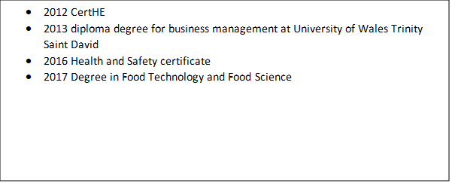Please give details:

Qualifications and skills
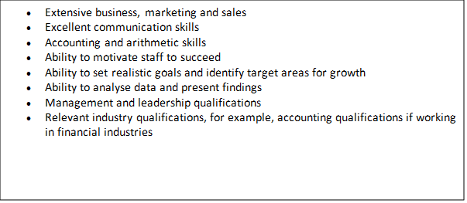Please give details:
Employment history
Your current or most recent employer
Name of employer: Essex Ltd.
Job title: packaging assistant manager
Length of time with employer:2018 - present
Reason for leaving: new opportunities
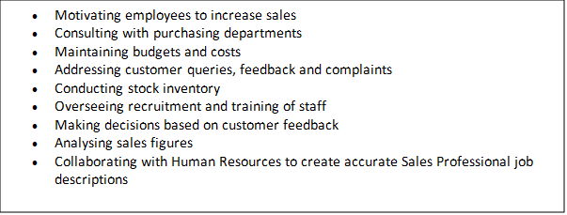Duties:

Previous employers
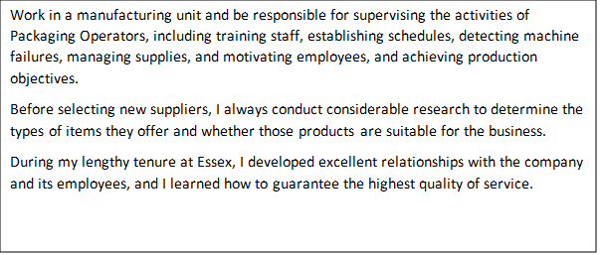Please tell us about your experience you have, and skills used in your last job

Supporting statement
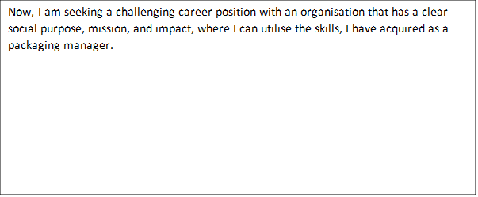Please tell us the reason you applied for this job and why is this roll the choice for you

Right to work in the UK
Do you need permit to work in UK? Yes/No
References
Available on request

Declaration
I confirm that to the best of my knowledge the information I have provided on this form is correct and I accept that providing deliberately false information could result in my dismissal.

Name: George Iulian Chiras
Signature: George Chiras
Date: 18/12/2022

APPENDIX 2

Job interview

Interviewer: Hello, I am Mihai.

Interviewer: I am the general manager of Asahi Ltd. , and you will have this interview with me. So tell me more about you.

Interviewee: Hi, I am George. I like reading marketing books as I studied business management at University of Wales that prove a positive achievement in my career as packaging manager at Essex Ltd. When I am not working, I like to travel through different places and find new culture about people. I am motivated to move forward to succeed in the future by searching for the new opportunities. I feel that communication is one of the most important aspect in my professional life.

Interviewer: What would your priorities be as a packaging manager if you were hired?

Interviewee: As packaging manager, my top priority would be to guarantee that all items are wrapped according to business specifications.
I would also ensure that all employees have access to the equipment and software they need to perform their tasks, as well as any new equipment or software that may be required.
Another objective would be to build positive connections with suppliers in order to obtain the best pricing on packaging materials.

Interviewer: What are the most essential qualities a packaging manager should possess?

Interviewee: Communication is the most critical trait for a packaging manager to possess. This individual must be able to communicate ideas and directions to staff so that everyone understands what is required.
Be organised is also essential since it ensures that all chores are finished on schedule. In addition, I believe that problem-solving skills are necessary, as difficulties may develop during manufacturing.

Interviewer: Tell me why you decide to move to another company please?

Interviewee: I do not want to make a bad impression about actual company I work with, on contrary I enjoy it and bring me happiness, as I have a very good team and we respect each other, but as I said searching for new opportunities is my weakness and I find myself in this new company closer to achieve the success I need, and bring good benefits for both employee and employers.

Interviewer: Describe a situation when you had to deal with a tough customer or client over the packaging of a product.

Interviewee: In my current position as packaging manager for a large corporation, I had a difficult time with a client who was unsatisfied with the packaging of their goods. The client believed that the package was insufficiently eye-catching and did not reflect the product's quality.
After discussion with the customer, we agreed on a new design that would be more cost-effective and better meet their objectives.

Interviewer: How well do you comprehend the legal packing requirements?

Interviewee: Over the past three years, I have worked in the packaging industry, so I am well familiar with the regulatory requirements for packaging. For instance, I am aware that there are distinct labelling standards for food and non-food products. I am also aware that there are particular regulations regarding the information that must be provided on labels, such as nutrition information and lists of components. When designing new packaging, I ensure that my team always follows these rules.

Interviewer: We intend to enhance our environmental sustainability initiatives.
What would you do to lessen our packaging's environmental impact?

Interviewee: I believe that decreasing waste is one of the most important things we can do for the environment, so I would first determine which materials are most appropriate for our products and then look for ways to reduce the quantity of packaging material we use.
For instance, at my previous company, I noticed that we used a lot of cardboard boxes for shipment.
We could have used smaller boxes, but I advised we convert to reusable plastic crates because they are more cost-effective and friendly to the environment.

Interviewer: Very well. This is where the interview is ending, I am pleased to have this conversation with you, next step is to have a meeting with HR and send you email with your employment decision. If you have any question?

Interviewee: Actually, I have.
Interviewer: I am listening.

Interviewee: What do you enjoy most about working here?

Interviewer: There are many aspects of working here that I appreciate, but my favourite is the supportive team environment.

Interviewee: Thank you and I looking forward to our collaboration, I gladly waiting for a positive answer.

Interviewer: Thank you as well.

