How to create a chart in Word Document

- Open your Word Document and place the cursor where you want the Chart to appear
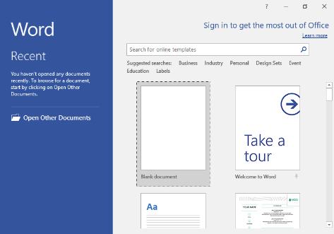

Go to insert tab at the top
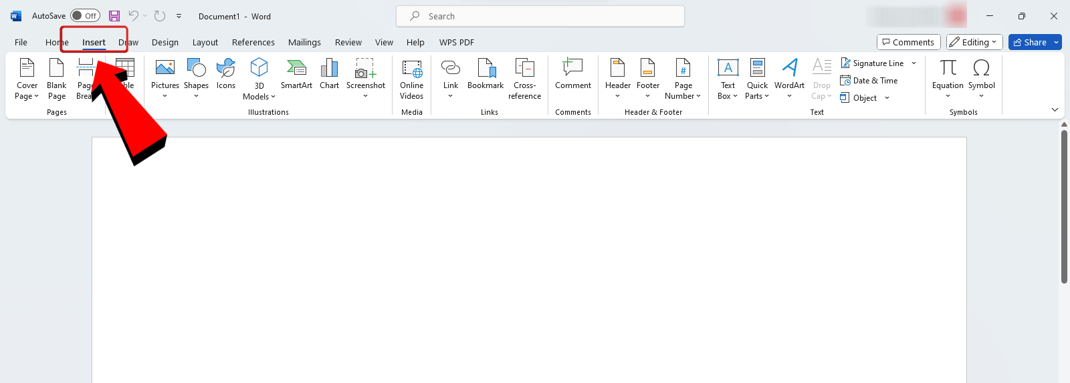

- Click on Chart in the illustrations group and click it


- There will be a pop-up window will appear and you choose the Chart type you want to use for example, Line,Pie,Column,etc
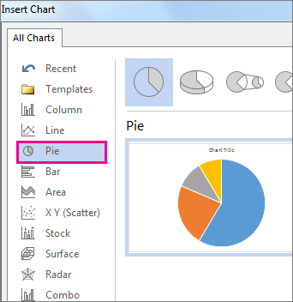

- Word will open a mini Excel spreadsheet and you will need to put your data in the spreadsheet
- Then the Chart will automaticallily open a Excel spreadsheet and youll have to enter your data

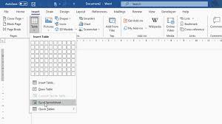

- The chart will update automatically as you change your data
- When done, save and close your spreadsheet window

To edit the Chart
- Click on the chart
- Then click the ‘Chart Design’ or ‘Format’ tab at the top
- Click edit data if you want to change the numbers

