

University of Wales trinity Saint David
Wales institute of Science and Art
Integrating Project Report
(ACHA4008)
Group C
Jacob Jones 2005053
Adam James 2107575
Nick Davey 2104746

Contents

- Content’s page……………………………….1

- Introduction ……………………………………. 1

- Calculations………………………………..5

- Conclusion…………………………….5

- Evaluation……………………………6

Introduction
In this report you will be able to find information on how you are able to get a better understanding on how to work out the science behind a car going down a 50-meter high and 550-meter-long hill, you will see our workings out and how we manage to find the correct findings. In the CAD drawings you can see what type of car we used and the shape and the materials we used to make our car out of.

CAD drawings for our final design
For our final design, we have chosen to go with the budget soapbox. By choosing this design it gives us a more realistic approach of entering the soap box derby. The main benefit of choosing this design is that the materials used will be spruce wood and plywood. These materials are relatively cheap in comparison to their more expensive counterparts, such as aluminium, titanium and carbon fibre. Of course, the more expensive materials will offer much more stability and durability, time and money is also a major factor in the production of our soap box. Wood such as spruce has many positive physical properties including being hard, lightweight and easily manipulated. As a group we decided that this would be the best choice for our soapbox.
The CAD drawings below show how the soapbox would be made if we entered the derby. We have chosen to show the isometric and side views of the design to highlight as much detail as possible. By designing our car on CAD, it gave us the ability to view how the car should look if we were to construct it, saving us a considerable amount of time and money.
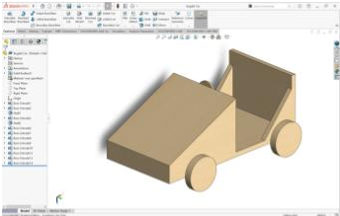
By choosing an isometric projection it gives us the ability to illustrate the 3D nature of our design. It also provides accuracy when measuring is required.

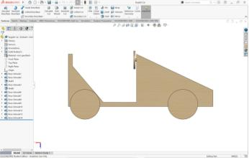
By choosing a side view it allows us to show the depth and height of our design. This view also provides accuracy when measuring is needed.

Evaluation of our final design

If we had an unlimited amount of time to create this soapbox in CAD, it would have been very beneficial for us to calculate the aerodynamics of the car. However, as a group of only 3 this would have been very difficult to complete seeing as each member has had to take on extra roles, reducing the time able to be spent on each aspect. The design process was very enjoyable for all members of the group as we were all able to input what we felt would work and what would be difficult to manage. As a group I feel we all decided that the budget car would be the best to further develop as it is very minimalistic, therefore easily modified without spending a huge amount of time in re designing. One improvement we all agreed on was to create a more streamlined soapbox. The second and third designs we created were somewhat streamlined but these could have been improved on also. In conclusion I feel like we chose the most reasonable soapbox for our design.

Calculations for the soap box
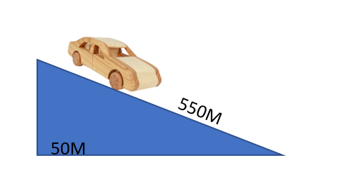
In this experiment the soapbox is expected to travel from a height of 50m to 0m. The length of the course is 550m long. The calculations require gravitational potential, velocity and kinetic energy. To calculate these values, it is required to calculate the mass of both the soapbox and the driver. As a group it has been decided that Jacob, who has a mass of 93kg, will be the driver. To work out how much the soapbox Itself weighs we must first covert the 9 lengths of 2400mm(length), 30mm(width), 25mm(height) of spruce to cubic metres. To do so we must do the following calculations:
2400x30x25= 1800000mm
1800000x9=16200000mm
16200000x10-9=0.0162m^3
The average mass of spruce wood is 1.04tonnes per meter cubed. Therefore:
1.04/0.0162=64.19kg
This must also be done for the plywood section. The dimensions are as followed: 2 boards of 2440mm(length), 1220mm(width) and 18mm(height).
2440x1220x18=53582400mm
53582400x2=107164800mm
107164800x10-9=0.107m^3
The average mass of plywood is 0.55tonnes per cubic metre. Therefore:
0.55/0.0107=51.4kg
With this information we can calculate the mass of the soapbox with the driver:
64.19+51.4+93=208.59kg total mass.
Once the mass value is calculated we can use the following equations to work out the Gravitation potential energy (GPE), Velocity (V) and Kinetic energy (KE).
GPE = mass x gravity x height
Velocity = √2𝑔∆ℎ
KE = 1/2mv^2

Top of the course: 50m
GPE = mgh
GPE =208.59x9.81x50
GPE 102313.50J
Velocity = 0m/s as the soapbox is at rest
KE = 1/2mv^2
KE = 1/2x208.59x0^2
KE = 0J
Bottom of the course: 0m
GPE = mgh
GPE = 208.59x9.81x0
GPE = 0J
Velocity = √2𝑔∆ℎ
Velocity = √2×9.81×(50−0))
Velocity = 31.32 m/s
KE = 1/2mv^2
KE = 1/2x208.59x31.32
KE = 3266.5194J

