Applying Psychological perspectives in Health and Social Care

By
Student Name: Chis Ileana Ioana
Student ID: 1818454

Introduction
Psychology is a thorough study of the mental condition and perspectives along with the behavioural influences from it in peoples. People have to possess better psychological condition for the social wellbeing and healthy life condition. In different life stages, peoples generate different psychological phenomenon which helps them to lead the life based on the psychological needs and demands (The Lancet, 2019). The application of proper psychological perspectives in health and social care services ensure the better care services and satisfactory life condition. The following report is prepared to represent the key psychological aspects in adolescence period along with some renowned psychological development theories and researches.

Task 1

Adolescence life stage
Peoples go through different life stage during the whole lifespan like the childhood, adolescence, younghood, old-age, and among these life stages, adolescence plays the most important role to build the intellectual growth, personality and personal thinking ideologies (Swartz, 2017). The psychological growth in adolescence reflect the future psychological perspectives of peoples. Different theories and research articles have been introduced and published by the specialist and scholars to provide better understanding and acknowledgement about the psychological growth perspectives of adolescence.

Lifespan psychological theories of adolescence development
Theory is mainly the interpretation or summative findings of any research or study, through which the researchers or experts provide a generic overview of any specific context regarding any issue or area. And these theories are used as basics or foundation of further researches in related area or issues (Stages of Adolescent Development, 2020). In adolescence, the peoples go through under some major psychological and physical changes and development. There have some significant theories which represent the key psychological and physical development contexts of adolescence.
Theory of Erik Erikson
Erik Erikson has introduced a lifespan theory of psychological development where he identified the growth of different psychological perspectives in different ages.
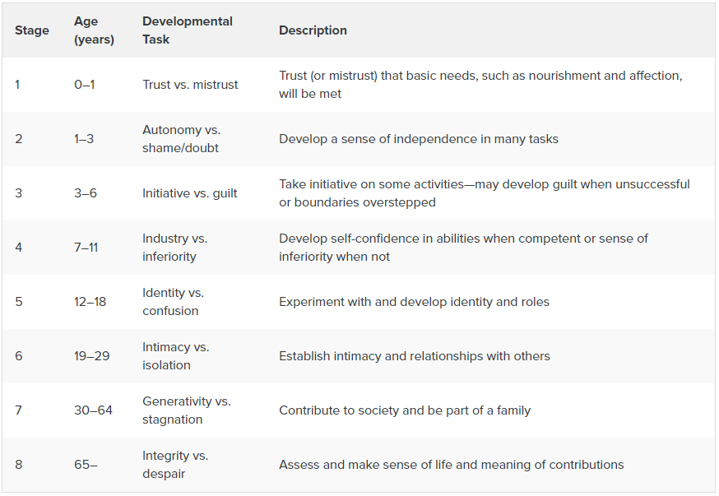
Figure: Erik’s psychological stages of development
Erikson has identified the early adolescence stage under the age of 7-11 with industry vs inferiority where the adolescents build up their self-confidence and mental stability about own self through performing their daily functions (Sanders, 2013). The children either gain confidence or lose confidence through comparing with others and if they see own self as competent one than perform functions like schoolwork, social activities or family functions etc. But if they feel inferior than they lose enthusiasm and lose willing of performing. In main adolescence stage under the age of 12-18, the adolescents face the psychological growth under identity vs confusion where they make themselves confused about their roles and contributions. They generate questions like “who am I” or “what I want in my life” and continuous ask themselves questions like these. Through conducting different self-experiment and implementing self-ideologies, the adolescents create their beliefs about themselves and gain senses of personal identity. the most significant fact is the growth of the thinking perspectives and the adolescents who can’t grow strong sense of personal identity or sense of inner thinking, face problems of losing self confidence in front of others or being weak for self-determination (Learning, 2020). And at the late adolescence stage under the age of later 18 or early adulthood, the adolescents grow the psychological development of intimacy vs isolation. In this stage, the adolescents who have been able to grow sense and self-determination are ready or become willing to get intimidated or to share life with others. And the adolescents who can’t build up enough inner sense and are confused about self-determination become lonely and unable to get intimidated which results in isolation.
Theory of Jean Piaget
Jean Piaget has introduced a cognitive development theory of human lifespan which incudes the psychological development of the peoples in different ages.
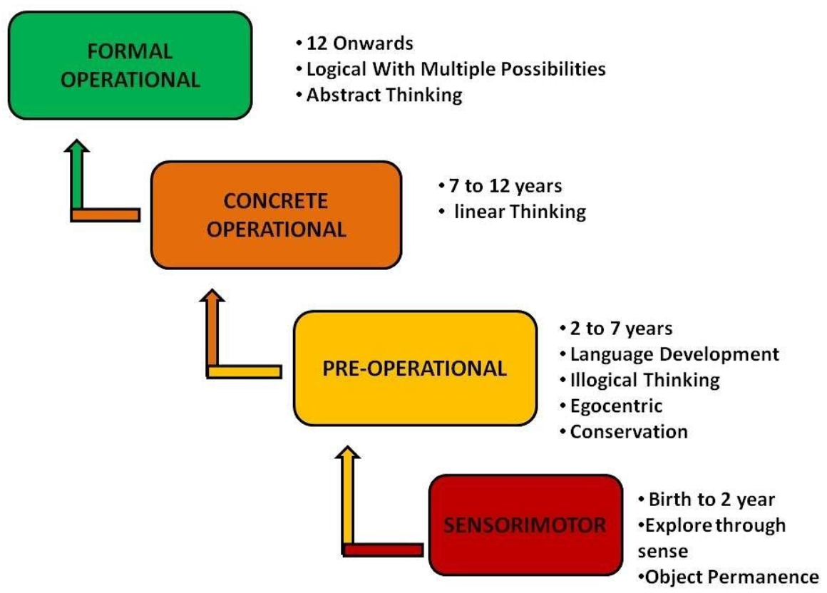
Figure: Jean Piaget’s cognitive development
At first stage of sensorimotor child gain the sense of different object’s performances. In the pre-operational stage, the early late childhood exists where people gain thinking and language skills (Jacksonville, 2020). In early adolescence stage of concrete operation, the linear thinking abilities are acquired and from the adolescence stage people become formally operational and achieve own thinking power.
Theory of Sigmund Freud
Sigmund Freud has developed a psychological development theory which is also known as psychosexual development theory. Sigmund has introduced three distinctive states of psychological development which are mind development, self-development, and psychosexual development (Jacksonville, 2020). The mind development refers the development of subconsciousness which is the iceberg beneath the represented mental state. The self-development includes the self-id, self-ego and superego. The self-id gained after taking birth, ego gained through the growing of self-determination and the superego developed while learning about the rules, standards and other legal aspects and criteria. The psychosexual developments have some key stages as are oral, anal, phallic, latency and genital.
The oral, anal and phallic stages reflect the psychological developments in childhood periods and the latency and genital developments occur from early adolescence periods to late adolescence periods (Homepage - Social-Care.TV, 2020). The psychological growth in adolescence trends toward building friendships and gaining sense of confidence. And throughout the gaining of higher ages, the adolescents became able to do sex and reproductions. The mental growths of adolescent’s trend towards the hunger and motion for relationships and sex.

Human cognition, emotions, behaviour patterns in adolescence
Adolescence is the period of massive change which is consists the change in both of the physical and mental conditions (Hignett and Collins, 2020). Different cognitive and interpersonal changes occur during the adolescence life stage. Different types of environmental, cultural, regional, social factors influence the growth in adolescence. According to the cognitive development theory of jean Piaget, in adolescence period, abstract logic making abilities grow up and moral reasoning power enhances. The cognitive human patterns or emotional and behavioural patterns differs in different ages of adolescence as discussed below:
Early adolescence
The early adolescence is under the age of 12 to 14 (Cornock, 2008) and the major patterns in adolescences are-
- The adolescents begin to gain self-independence
- Begin to think in more complex way which increases the intellectual abilities
- Emphasize on creating new and close relationships and friendships
- Increase the tendency of showing off
- The body structures begin to grow
Middle adolescence
The early adolescence is under the age of 15 to 16 and the major patterns in adolescences are-
- Develops self-involvement and self-conceptualization (Caring Conversations, 2020)
- Creates own body feelings or narcissism
- Intellectual interests increase
- Sexual passions arouse
- Tends to follow role model
- Moral controversies increase
- Body heights and wights increase
Late adolescence
The early adolescence is under the age of 17 to 19 and the major patterns in adolescences are-
- Sense of humour increase
- Personal identity and personality strengthened
- Self-decision making and self-reliance
- Working habits increase
- In depth thoughts about role in life generate (Bolton, 2014)
- Capabilities of sexual intercourse increase
- Generate self esteem
- Girls gain body development and boys continue to growing physically

Research studies
Renata Arrington Sander an associate professor at Johns Hopkins University has publishes a research study on “Adolescent Psychosocial, Social, and Cognitive Development” in which he showed significant development areas in Adolescence life period. He mentioned the adolescence or also known as teenage is the traditional stage of human life cycle which exists between the ages of child hood and adulthood (The Lancet, 2019). The transformation of adolescence begins in later childhood and ends in early adulthood. The typical age period of adolescence is 13 to 19 but the physical and mental transformation of adolescence begins in earlier age like 9 to 11 and ends in later age like 20 or 21 even more later. The developments and distinctive physical and mental transformations in adolescence stage differs based on the traditional cultures and social aspects in different countries. The adolescence period is also represented as the age of beginning of puberty to legal adultery.
Martha Kirk Swartz is a higher professional in Paediatric nurse practitioner specialists have published different research articles for social and health care systems. In her article of “Social and Emotional Learning”, she presented arguments in favour of the need of social and emotional learning (Swartz, 2017). According to the research, during the child and adolescence period, peoples need to get acknowledged about the importance of social and emotional learning to build better social atmosphere. Moreover, the social and emotional learning creates the self and social awareness, and build integrated social relationships through growing effective self-management and decision-making skills and abilities.

Task 2

Psychological theories and researches
The development of modern health and social care phenomenon has significantly emphasized on several potential factors which are interconnected to the health and social care services and ensure quality service and better care operations. The psychological perspectives are much significant, and along with the development of modern health and social care services, the health care organizations are focusing on delivering better experience to the patients and clients. Application of the psychological perspectives in social and health care services ensure the providing of best service. Different theoretical approaches and strategic decisions are applied to ensure the proper psychological treatments to the patients and customers. Moreover, different research articles have been published based on the psychological aspects and the better implementation of the psychological theories and strategic performances while providing the health care services (Stages of Adolescent Development, 2020).
According to different research articles, the theories of practices for applying the psychological perspectives in health and social care can be both staged or open ended. The staged practices refer the application of generic psychological perspectives where the patients and customers possess similar level metal contexts. And the open-ended practices refer the application of customized psychological perspectives where the patients and customers possess different level of mental state due to the diversification in social and biological factors. The theory of Erik Erikson can be stated ag staged theory and the theory of Jaan Valsiner is open-ended. Another significant fact about the theories of implementing psychological perspectives in health and social care services is the continuity and discontinuity. The continuity refers the development of the psychological aspects throughout different life stage is progressive, and the discontinuity refers the psychological aspects as unpredictable and the diversified (Sanders, 2013). The theory of Sigmund Freud is the theory of continuity and the theory of Erik Erikson is discontinued theory. Beside these the theories of the psychological perspectives in health and social care also referred the development psychological aspects static or dynamic. Some theories show the psychological growths are static where they trend towards single direction but the dynamic theories show the psychological growths are dynamic which trend toward diversified levels and stages. Vygotsky provided a static theory for the physiological growth throughout the life span and Piaget’s psychological development theory is adynamic theory.
The application of these distinctive and diversified theories depends on different factors and issues to determine which theory would be most potential and effective in current situation. The psychodynamic factors determine that, the implementation of the theory based on that, the psychological factors and priorities of people changes in different stages of life span. That’s why the life span theories can bring effective outcomes reflecting the overall psychological concerns of peoples during the whole lifespan. The socio-cultural factors like the tradition, ethnicity, religion, lifestyles, education, emotional practices etc. impact the psychological perspectives of people. So, the successful implementation of the psychological theories gets impacted by these socio-cultural issues (Learning, 2020). The increased awareness of the people about the wellbeing of the life and healthy life condition has made them focused to get better psychological improvements from the health and social care services. As a result of which, the health care professionals and practitioners have to go through different research articles and theoretical approaches to gather in depth understanding about people’s psychological aspects to provide them better health care services and satisfactory experiences.

Role of health care professionals
While applying the psychological perspectives in health and social care organizations, the health care professionals have to perform their roles and responsibility. Through performing these roles and responsibilities, the health care professionals can create satisfactory experiences for the patients and customers. The key roles of the health care professionals mentioned below-
- The first consideration is the current life stage of the patients and customers whom are in need of the medical services. The different life stages like the childhood, adolescence or adulthood requires different types of psychological assistance and perspectives (Jacksonville, 2020). The professionals have to possess cognitive knowledge and understanding about the psychological perspectives in different life stages, which will enable them to attending the psychological needs for distinctive aged people.
- The health care professionals have to treat the patients and clients from the family member context to make them psychologically convinced and happy. Treating the patients and customers with integrated relationship development aspects make them feel comfortable and psychologically calm and satisfied.
- One of the major roles of health care professionals is ensuring the proper workplace for practicing the application of psychological perspectives. The necessary equipment and medical instruments needed to be available for providing the medical assistance and health care services.
- Key knowledges and principles are needed to applied for the better decision making and self-management of the professionals. The decision-making power will make the professionals able to provide the most potential and suitable decisions and care services to the patients and customers.
- Providing integrated service as a part of the whole care service system is a significant concern of the professionals (Homepage - Social-Care.TV, 2020). While applying the psychological perspectives, the professionals have to integrate the total care systems as the physical care, mental care, psychological care which make the professionals able to create psychological comfort for the patient.
- For better implementation of psychological perspectives, the professionals need to ensure the connectivity of the psychological treatments to the previous experiences and incidents of the patients and customers to apply the most suitable psychological treatments.
- The health care professionals have to share the same view of mental condition to apply the best psychological perspectives and theoretical approaches for quality health care and medication systems.
- The sharing of the information and data is a much important role of the health care professionals. They have to share any essential information about the treatment and care services (Hignett and Collins, 2020).
- Engaging the patients with the decision-making processes is also a significant role of the professionals. Through making the patients concerned and engaging about how the health care services will be provided make them more comfort psychologically about the service outcomes.
Thus, there have different types of distinctive roles and responsibilities of the health care professionals to apply the psychological perspectives in health care services.

Learning in health and social care practices
The learning from different contexts of health cans social care organizations and services make the health care professionals engage with the personal and professional developments. The learning through application of the psychological perspectives in health care services create a reflective learning phenomenon in workplaces which ensure the operational effectiveness and efficiency of them.
The reflective practice approach in health care organizations refers the practices based on the regular learning through reflecting and evaluating own performances. The reflective learning is now a most potential issue for modern health care systems. According the Kolb’s experiential model, the health care practitioners and professionals gather experiences through performing different service performances (Cornock, 2008). And through reflecting and conceptualizing the experiences, the practitioners and professionals apply the own reflection and concepts in further care services for better outputs and quality service.
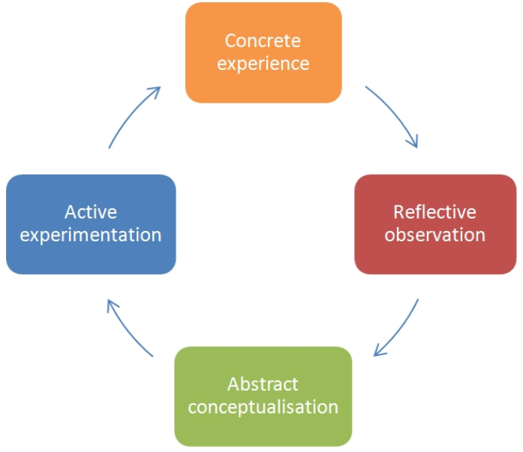
Figure: Kolb’s experiential learning model
Through this continuous learning and improvising of the care service, the health care professionals improve their service quality. And the application of the psychological perspectives, allows them to integrate reflective learning and development.
The learning from different health and social care theories and researches gather cognitive understanding and in-depth learning which conduct personal and professional development among the health care professionals. As the organizational peoples have to gain higher professional skills and abilities to achieve higher professional identity, so they have to engage themselves with personal and professional development (Caring Conversations, 2020). Beside the Kolb’s experiential learning model, there have other renowned models and theories which represent the learning through performing different practices in health care organizations. And as the increased awareness of the people has made them more accorded about the modern health care systems, now they seek for better psychological performance from the health professionals. And the learning from different throes and researches enable the professionals to apply better psychological perspectives for quality service along with the engagement with personal and professional development.

Conclusion
The researches and studies based on human physiology are much potential for the social and health care organizations. As the patients and clients in health and social care organizations desire the quality service and better medical assistance, so implementing these theoretical acknowledgements and understandings will enable the health care practitioners and professionals to ensure psychological betterment of them (Bolton, 2014). Moreover, the dynamic human civilization keeps changing the psychological perspectives of peoples which is complex to address properly which enforce the health and social care professionals to learn the psychological issues and facts properly for betterment of the service needing peoples.

Reference
- Actforyouth.net. 2020. Stages Of Adolescent Development. [online] Available at: <http://www.actforyouth.net/resources/rf/rf_stages_0504.cfm> [Accessed 20 March 2020].
- Bolton, G., 2014. Reflective Practice. 2nd ed. Los Angeles: SAGE.
- Caring Conversations. 2020. Caring Conversations. [online] Available at: <https://www.caringconversations.scot/#> [Accessed 14 March 2020].
- Cornock, M., 2008. Values for Care Practice – Health and Social Care Theory and PracticeValues for Care Practice – Health and Social Care Theory and Practice. Nursing Standard, 23(5), pp.30-30.
- Hignett, K. and Collins, A., 2020. HSJ | Health Service Journal - For Healthcare Leaders. [online] Health Service Journal. Available at: <https://www.hsj.co.uk/> [Accessed 17 March 2020].
- Jacksonville, F., 2020. Child And Adolescent Psychology | Simple Book Publishing. [online] Courses.lumenlearning.com. Available at: <https://courses.lumenlearning.com/atd-fscj-childpsychology/> [Accessed 19 March 2020].
- Learning, L., 2020. Principles Of Psychology | Simple Book Production. [online] Courses.lumenlearning.com. Available at: <https://courses.lumenlearning.com/psychology2x4master/> [Accessed 16 March 2020].
- Sanders, R., 2013. Adolescent Psychosocial, Social, and Cognitive Development. Pediatrics in Review, 34(8), pp.354-359.
- Social-care.tv. 2020. Homepage - Social-Care.TV. [online] Available at: <http://social-care.tv/> [Accessed 16 March 2020].
- Swartz, M., 2017. Social and Emotional Learning. Journal of Pediatric Health Care, 31(5), pp.521-522.
- The Lancet, 2019. No health care without social care. The Lancet, 394(10205), p.1206.

