Student name: Agnieszka Janina Wilkosz
Student ID number: 2115098
Programme: Certificate of Higher Education Skills for the Workplace
Module: Problem Solving and Decision Making
Module code: BMSW 4004
Lecturer:

Assignment Title:

Problem Solving and Decision making

Table of Contents
Introduction 3
Long term absenteeism 3
Scope and impact of absenteeism 5
Analysis of the organisation and the problem 6
• PESTLE 6
Fishbone diagram 8
Proposed solutions to absenteeism 8
Discuss how each solution could solve the problem of absenteeism. 9
the PMI 9
Implement the decision 10
Action plan 10
Conclusion 10
References 11

Introduction

Absenteeism is a common and severe problem in large, small, private and government companies. To better understand the reasons for absenteeism, how it affects organizations and workers, and what steps the company should take to reduce the absenteeism threshold, it is necessary to define it.
"Absence it is simply non-attendance at work by an employee when attendance is expected by the employer." (Briner, R.B., 1996)
However, following another definition, " absenteeism can be involuntary, or it can be voluntary. Involuntary absenteeism is genuine leave taken to be an employee under normal circumstances, which is unavoidable, for example, in cases when the employee is sick. Many researchers classified absenteeism types as necessary (unavoidable) or unnecessary (avoidable) absenteeism. Necessary involuntary absenteeism is an absence where the employee is seriously sick or injured, whereas unnecessary involuntary absenteeism is when an employee has over-interpreted harmless symptoms and thus remained at home." (Gangai, 2014.)
This report focuses on the long-term absence of the employee, which means:
If an employee indicates they are likely to be absent for a minimum of 30 days. (WRIGHT, 1997)
The report will explain the employee absence problem and how it affects organizations, employees, and then analyze the organization and the problem using the PEST and Fishbone diagram. In the next paragraph, solutions to the problem of absenteeism will be proposed, an assessment will be made using the PMI tool, and in the next step, an Action Plan will be presented.

Long term absenteeism

Mid Cheshire Hospital NHS Foundation Trust has problem with long term absences. It is a hospital with more than 4,500 employees. The NHS is one of the few organizations to offer a 24/7 service, 365 days a year. Due to the high rates of long-term absence, the hospital lost £ 1 million per year, and the quality of service deteriorated.
The main reasons for long absences from work are:

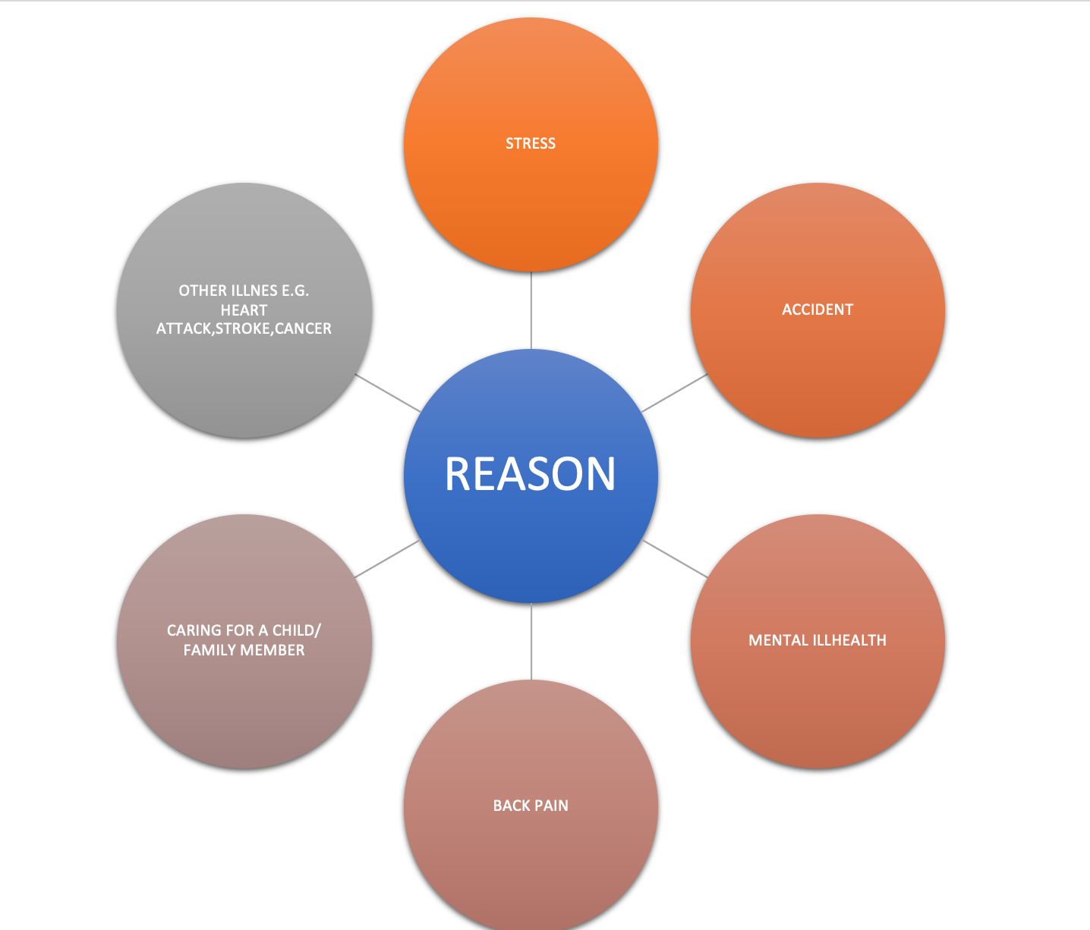

By analysing the data on the NHS website and creating a graph, can see that the leading causes of absences are linked to mental health.

Scope and impact of absenteeism

Absence from work has a severe impact on the organization and employees.
"NHS staff take a combined 16.4 million days off sick per year, costing the health service an estimated £1.1bn, according to new figures". (Anonym, 2017)
The company is losing money. Employees who have a problem arriving at work still receive wages and do not fulfil their obligations. The absent employee is replaced by agency workers or colleagues whom the employer must pay for overtime. In addition to replacing an absent employee, the administrative costs of dismissals, recruitment, and training of new employees must also be added.
Another impact is the loss of productivity and efficiency, which affects the quality and number of mistakes—starting with the loss of the supervisor's productivity because of additional tasks such as administering absences, adjusting workflows, and taking over some tasks. Employees who work overtime are exhausted because they either work longer hours or come on their day off. A tired worker is not as productive and can make a mistake. Let us remember that the mistake made may cost the patient's life or health. New workers will not work as efficiently as experienced workers because they need time to learn.
Because employees are exhausted, and new employees do not know all the rules, accidents and errors can occur more often. Reputation will suffer, and dissatisfied patients may often have reasons to file a complaint. (WRIGHT, 1997)
Absence also significantly affects employees.
Starting with colleagues who have a more significant workload and overtime leads to exhaustion. They work under pressure and in more stressful conditions. Probably no patient would like to be treated by a tired and stressed doctor because it may lead to a mistake, affecting the employee's mental health. Due to the additional time spent at work, the employee loses the balance between private and professional life. The lack of time for personal life may lead to problems in marriage with children, leading the employee to mental health problems or addictions. Absence has an impact on the climate and conflicts at work.
Absence influences the image, reputation, and colleagues' perception of this person. That can lead to conflict and fear when you return to work. Also, it affects the salary. It can lead to financial problems and a loss of social contact. (McFarlane, H.M., 2014.)
Absence can also have a positive effect.
The person can rest and reduce stress. Co-workers experience a greater variety of work, develop new skills, and receive overtime pay. In the case of an organization, the knowledge base is broadened, and the individual becomes more flexible in responding to absences, making it easier to replace an absent employee in the future.

Analysis of the organisation and the problem

• PESTEL

PESTEL analysis is a method used to study the company's macro-environment. Identifies the most important external factors that may affect its functioning (Perera, R., 2017).

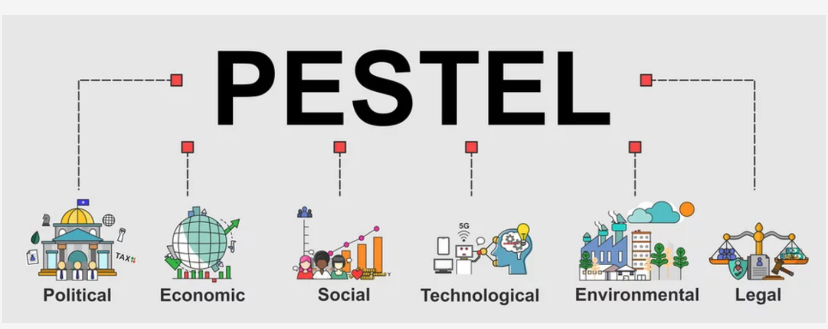

1. Political:
- Brexit:
Many of the employees come from outside England, and after Brexit, it is more difficult to move to England. Firstly, it is at a higher cost, and secondly, not everyone can meet the criteria for a work permit. Many companies, not only the NHS, have a problem recruiting new employees, fewer people on the labour market.
- Changing governments / Changing, health ministers:
NHS managers cannot concentrate on a long-term strategy due to the ever-changing political environment, as each political party has its own rules.
- Wage Legislation - Minimum Wage and Overtime.
This year, from April 1, the minimum wage has increased significantly, and every employee who has reached the appropriate age should earn a minimum salary of £ 9.5 per hour. As pay grows, they create a higher cost for the company.

2. Economic
- Inflation and fluctuations in exchange rates
cause prices to fluctuate, and if they are declining, this has an excellent effect on the NHS, but if they rise significantly, it causes a higher cost. When importing, the exchange rate will play a significant role.
- the Russian-Ukrainian war
has had a significant impact on the economies of all countries. Due to the sanctions imposed on Russia and the horrible situation in Ukraine, it is impossible to import goods from these countries. Considering that Ukraine is the leading producer of grain and oil, now we can observe a problem with purchasing these products, and if the product becomes hardly available, its price increases. And maybe the lack of flour will not directly affect the hospital, but as the price increases, the cost of catering to patients will increase. We also see a significant increase in fuel and gas prices, which leads to a rise in the cost of each NHS unit. The influx of immigrants and people fleeing Ukraine will be additional workers in the labour market and burden every country.
- The level of unemployment
The more people in the labour market, the easier it is to find an employee. On the other hand, as unemployment increases, the level of homelessness a crime increases, which may generate an additional burden for hospitals.

3. Social
- Ageing population
Older people have more health problems.
- More informed customers and their higher expectations.
With the advent of social media and improved educational systems, patients' expectations are higher. Patients tend to have a much better knowledge of the treatment options available to them, but it does create new challenges for the NHS.

4. Technological:
- The pace of innovation & technology.
The overall technological improvements in healthcare. Modern machinery such as complex scanning systems and other tools. The NHS has used these technological advancements to provide quality and speedy healthcare. Change of medical equipment to more modern - more expensive.
- Data Protection/ Cyber Crime
systems secure patients' data and protect against cyber-attacks.

5. Litigation:
- A growing trend across the world is that of litigation.
Patients or families who are unsatisfied with the quality of their care are taking to courts case. The UK has seen a growing number of healthcare-related lawsuits. Unfortunately, this presents a new, hefty expense for the healthcare body as it is forced to invest in expensive legal defences and payout numerous settlements. (Mullerbeck., 2015)
- The restrictions introduced during Covid
made the work of all health institutions much more difficult. Wearing masks was an additional cost, and employees who tested positive had to stay at home, so there was a big problem with employee absenteeism. Life is slowly returning to before Covid, but hospitals still have a heavy burden due to the pandemic. ( de Val, 2021)
- Health & Safety
also has a significant impact because any change in policy and rules is believed to involve additional training for staff and costly modifications.

6. Environmental:
- Global health (pandemics)
here took place COVID 19.
- Environmental Protection
The medical industry is a high contributor to toxic waste. Added to our climate's current crisis, there is heavy pressure on all medical organizations.
- Weather- floods/ storms
Possible damage to the hospital building due to strong wind or floods. (Mullerbeck., 2015)

Fishbone diagram

This method allows you to analyse problems. A fishbone diagram is a visual way of looking at cause and effect. Japanese Professor Kaurou Ishikawa was the first person in the 1950s to describe the cause of a problem using a visual diagram. The bone is a template for separating and categorising causes. The problem or effect is visible on the head of the fish. (Simmonds,2013)
In health and social services, root cause analysis is increasingly used to improve safety and quality and minimise adverse events as it provides retrospective reviews of incidents or events. (anonym, 2013)
The problem in this report is long term absenteeism In Mid Cheshire Hospital.

Proposed solutions to absenteeism

Health promotion: promotion of a healthy lifestyle, free fruit and vegetables, help in quitting smoking, encouraging workers to travel to work by bike, and opening a free gym.
Flexible work hours- Possibility to work from home, such as doctors during visits by phone and completing documentation. Possibility of working hours adapted to private life.
Attractive offer- Attractive hourly wages, the possibility of receiving a bonus for a whole month or quarter worked without absenteeism.
Creating a department- that will provide support and assistance to anyone suffering from a health problem that prevents them from working for more than three days also helps with personal issues.
Checking also short absences from work because long absences often come from short absences.

How each solution could solve the problem of absenteeism.

Health promotion will educate and encourage employees to lead a healthier lifestyle. It will make employees in better physical and mental condition. That can a reduction in the level of absenteeism.
Flexible working hours help the employee to reconcile private life with work. Employees who study or need to care for a family member may still work without having to miss working days. For example, in the worker's family, someone becomes seriously ill and must look after them for the next few weeks. He may work in the evenings. If the company helps under challenging times and understanding, it makes the employee more loyal, reducing the rate of absenteeism.
An attractive offer- people to work motivates money. Therefore, the employee receives a salary and not only works for the word, thank you. Money affects the quality of the work performed. By introducing bonuses for the worked month or quarter, people will think several times and look for a different solution. However, the compensation must apply to both short and long absences because discouraging long absences should not motivate the employee to several short absences.
The final solution proposed is to create a department to manage absences.
People who will check all absences. Then do an analysis, talk to employees, and try to find a solution. Many long absences from work can be reduced if the employer gives the employee adequate support. If the employer does not come to work for a few days due to back pain, should be referred to a doctor or massage. A student who has many tasks to do a month before the end of the semester will not come to work, but if students go to this department together, they can solve the problem. We should remember that doctors, nurses, and other hospital employees face terrible diseases and deaths, work under pressure of stress and time, and appropriate support and help can reduce absenteeism at work. Remember to take care of both long and short absences because often, long absences result from earlier short ones.

PMI

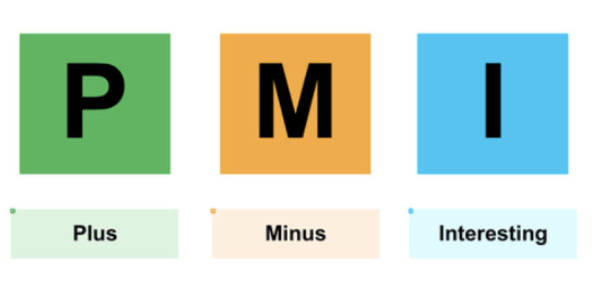

Implement the decision

Action plan

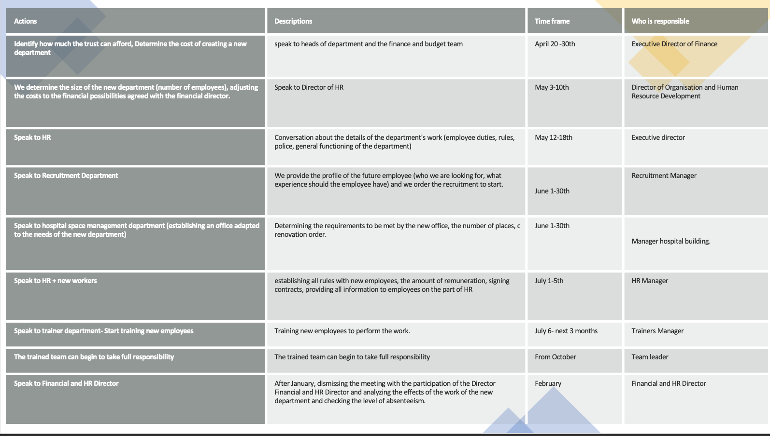

Conclusion

Absence from work is a severe problem all businesses face, especially the NHS. It affects both the hospital and employees. Unfortunately, it has more minuses than pluses. By carrying out a PESTLE analysis, we can see that everything that happens in the world has a significant impact on the functioning of the NHS and thanks to the FISHBONE DIAGRAM, we can better understand the problem of long absenteeism. By carrying out a PMI decision, we were able to choose the best solution to reduce the long-term absenteeism rate in the hospital, then implement an action plan and create a new department to help reduce the absenteeism threshold.

References

- Briner, R.B., 1996. ABC of work related disorders. Absence from work. BMJ: British Medical Journal, 313(7061), p.874.
- de Val, J. et al. (2021) ‘Investigating the challenges and opportunities for medicines management in an NHS field hospital during the COVID-19 pandemic’, European journal of hospital pharmacy. Science and practice, 28(1), pp. 10–15. doi:10.1136/ejhpharm-2020-002364.
- Gangai16, K.N., 2014. Absenteeism at workplace: What are the factors influencing to it?.
- McFarlane, H.M., 2014. Experiences of sickness absence among NHS staff: A grounded theory analysis (Doctoral dissertation, University of the West of England).
- Mullerbeck., 2015. SWOT AND PESTEL / Understanding your external and internal context for better planning and decision-making / UNICEF
- NHS sickness absence “costs £1.1bn per year”’ (2017) Community practitioner : the journal of the Community Practitioners’ & Health Visitors’ Association, 90(4), p. 7–.
- Perera, R., 2017. The PESTLE analysis. Nerdynaut.
- Phillips, J. and Simmonds, L. (2013) ‘Using fishbone analysis to investigate problems’, Nursing times (1987), 109(15), pp. 18–20.
- Using fishbone analysis to investigate problems (2013) NursingTimes.net [Preprint].
- WRIGHT, M.E. (1997) ‘Long-term sickness absence in an NHS teaching hospital’, Occupational medicine (Oxford), 47(7), pp. 401–406. doi:10.1093/occmed/47.7.401.

