

Postgraduate/Distance Learning
Assignment coversheet & feedback form

For completion by the student:
Student Name: Cheryl Abraham

Student University Email: 2510780@student.uwtsd.ac.uk

Module code: HPCA7015  Module title: Foundations in Cultural Astronomy and Astrology | Student ID number:  2510780 |  |  | Educational support needs:  Yes/No
Assignment title: Essay based on a Sky Journal

Assignment due date: 27 November
This assignment is for the 1st 2nd 3rd 4th 5th 6th module of the degree
I confirm that this is my original work and that I have adhered to the University policy on plagiarism.
Signed : Cheryl Abraham
Email submission:if you are submitting this form via email, please tick this box
(as a substitute for your signature) to confirm that you agree to the above declaration.
Assignment Mark
1st Marker’s Provisional mark
2nd Marker’s/Moderator’s provisional mark
External Examiner’s mark (if relevant)
Final Mark

NB. All marks are provisional until confirmed by the Final Examination Board.

For completion by Marker 1 :
Comments:

Marker’s signature: |  |  | Date:
For completion by Marker 2/Moderator:

Comments:

Marker’s Signature: |  | Date:
External Examiner’s comments (if relevant)

External Examiner’s Signature: |  | Date:

Essay based on a Sky Journal
Word count: 2089.
Cheryl Abraham 2510780.

“A writer needs three things – experience, observation, and imagination – any two of which, at times any one of which, can supply the lack of the others.” – William Faulkner

Introduction
Across many cultures, the sky functions as a shared point of orientation that links people to something larger than themselves. It has been imagined as the realm of the divine, the home of gods or ancestors, and a source of common origin, since everyone lives beneath the same expanse. Because of this, the sky often becomes a symbol of unity, continuity, and collective belonging. It also serves as a space where meaning, ritual, myth, navigation, and timekeeping converge, though each culture engages with it in its own way.
This essay analyses my Sky Journal (Abraham, 2025) as a primary source, using a reflexive, autoethnographic approach to examine how everyday encounters with the sky generate personal and cultural meaning. The Moon became the initial focal point of observation due to its accessibility and prominence in the night sky – at least that is what I thought it to be initially. As the journal unfolded, a central theme emerged: the oscillation between connection and disconnection, to myself, to others, and to the natural world.
The journal started with a supermoon on 7 October 2025. It was the day of the full Moon. The Moon was on its 16th day from its 29.5 day cycle, and it was 360,666 km from Earth. This moment marked the starting point of a month engagement with the sky and the meanings that arose from it.

Clouds
The clouds frequently obstructed the visibility of stars and planets, and on many days even locating the Moon became impossible. This recurring limitation often led to frustration, as reflected in one journal entry:
“I wasn’t moved by seeing another painting of clouds in the sky; they leave me with nothing but sadness.”
During these weeks, I often felt sad and disconnected from the sky, as the view was repeatedly dominated by the same heavy clouds that obscured what I longed to see. At one point, I even considered changing my assignment, since I felt little motivation to engage with these white fluffy beings. The clouds evoked no sense of wonder in me, perhaps precisely because they were so abundant and constant. Scarcity, after all, often heightens interest. In this sense, my response diverged sharply from that of the artists discussed in Alexandra Harris’s Weatherland: Writers and Artists under English Skies (2016), many of whom approached clouds as wonderful artistic objects. Edmund Burke, whose aesthetics embraced obscurity, articulated this tension when he wrote:
“To see an object distinctly, and to perceive its bounds, is one and the same thing, whereas when we cannot see distinctly, we know no bounds.”
When something is obscured, its boundaries dissolve, allowing the imagination to extend beyond what is actually present. The journal entries reveal a mind inclined toward analysis and pattern-seeking, and they express a longing for cosmic order, evidence that the universe is neither chaotic nor random. Clouds, however, do not embody this order. Their forms resist stability, as “the cloud form is constantly revised and never finished,” and thus they offer little of the structure or coherence I was searching for. Perhaps, following Plato’s Timaeus, clouds can be understood as being in a state of becoming rather than a state of being, always in motion, never fully formed, and therefore resistant to the stability I sought. This lack of clarity unsettled me; I felt frustrated by my inability to see the sky clearly and truthfully. Clarity offers definition and a sense of certainty, qualities I repeatedly longed for during the month of observation. While keeping this journal, I was also reading Frank Herbert’s Dune (1965), which contains a line that resonated strongly with my experience:
“Deep in the human unconscious is a pervasive need for a logical universe that makes sense. But the real universe is always one step beyond logic.”
Yet, when I revisit the photographs I took of those clouds (see Figures 1 and 2), I find that a sense of beauty emerges despite my earlier frustration. Something that was absent in that moment of direct observation.
For this assignment I also reflected on the sentence, “to think is to walk among clouds.” I would revise it to say: to imagine is to walk among the clouds. Following Harris, Leonardo da Vinci suggested that when artists needed inspiration, they could simply study a stain on a wall. In those random marks, he believed, one might glimpse all kinds of landscapes or figures: human faces, animals, battles, rocks, even seas. He understood that these stains worked much like clouds, they held just enough shape to spark new ideas, yet remained indistinct enough to invite imaginative interpretations. This raises the question of where the boundary lies between imagination and thought. One distinction, however, is that imagination generates possibilities, whereas thought organizes, evaluates, and categorizes them. For this reason, I would locate the imaginative within the realm of clouds, while reserving the realm of thought for something closer to Daniel J. Boorstin’s assertion: “I write to discover what I think.”
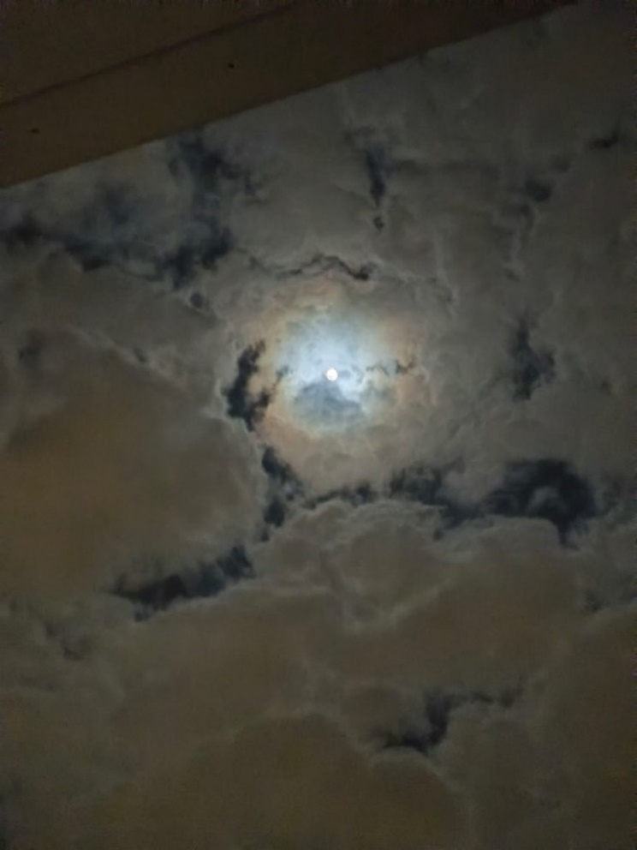

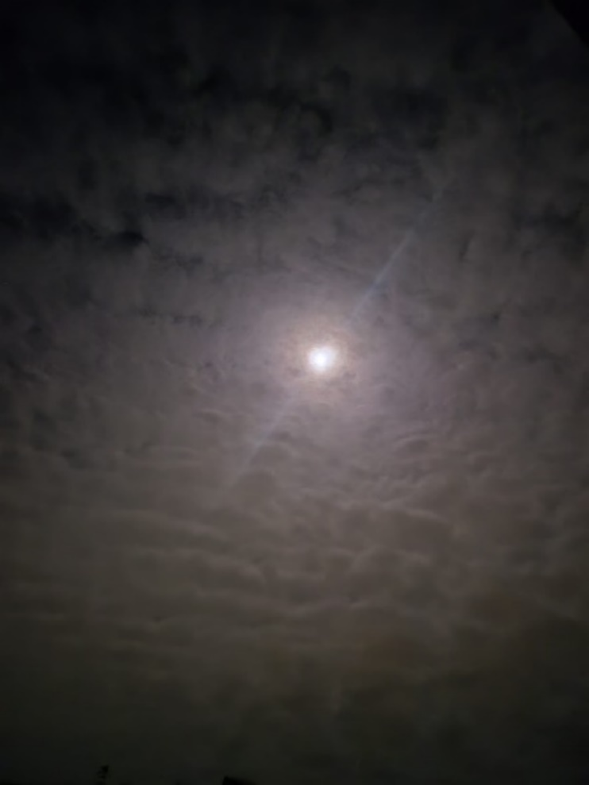

Figure 1 (above) and Figure 2 (right): Clouds
and the Moon photographed from my
bedroom window.

Light pollution
Another factor that obstructed my view of the sky was light pollution. I came to realize that the Netherlands is among the most, if not the most, light-polluted regions in Europe. Demonstrated by Falchi’s atlas (see Figure 1).
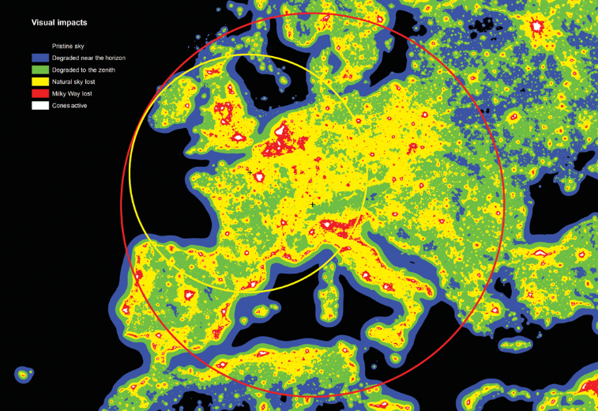
Figure 1: Visual impacts in Europe.

Hamacher goes so far as to describe light pollution as a form of cultural genocide. He argues that for many Indigenous communities, knowledge of the cosmos is integral to cultural practice, daily life, and the transmission of tradition. When the night sky becomes obscured, this relationship is disrupted, weakening the continuity of cultural knowledge. In this sense, the loss of access to dark skies contributes to the ongoing destruction of cultural and ecological systems. Light pollution is also intimately connected to wildlife and ecosystems, human health, energy use and climate change, crime and safety, and night-sky heritage. Although there are a few designated dark-sky areas in the Netherlands, one notable example being ARTIS Zoo in Amsterdam—maintained for the sake of the animals’ health—the question arises: what about us humans? It is not yet possible to answer this question, but what remains is a lingering sense of wonder about how light pollution may influence human mental health.

Dark skies
One of the days brought up a memory of a night sky very different from the ones I was seeing. In September 2025, I visited the windmill at Moore’s Reserve (UK) with my partner. The place had been chosen after discovering the darksky.org map, which highlights areas without any light pollution. The plan was to spend some time looking at the stars, but when we arrived on the hill the sky was covered in clouds. We sat for a while, talked, and eventually walked back down.
Only in the car did the realization come that my pair of glasses had been left behind, so we returned. It was quite late, since we wanted to see the night’s sky. We were both tired, slightly annoyed, and worn out from a long day of walking, including yet another climb in the dark. But when we reached the windmill again, the clouds had cleared completely. The sky was full of stars, and that moment of sudden beauty dissolved some tension between us. We stood taking photos of which two can be seen below in figure 4 and 5.
What stands out in the memory is how the night sky has a way of bringing people together. Also on days when we weren’t physically together, since my partner lives in London and I am currently residing in the Netherlands. On some days, I journalled about asking him whether he could see the Moon. Those brief exchanges always carried a moment of joy. Being and living under the same sky, and looking at the same celestial objects together has a connective element.
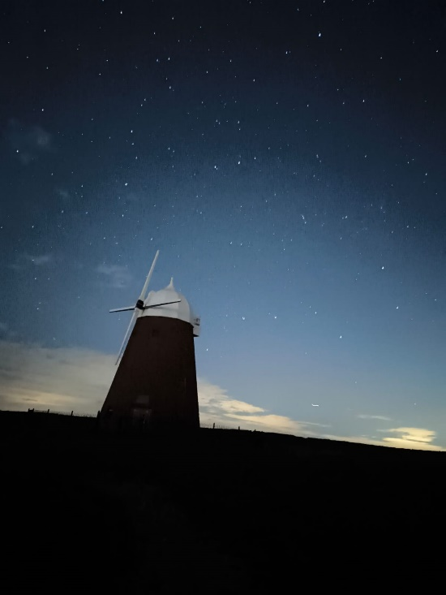
Figure 4: The windmill at Moore’s Reserve.
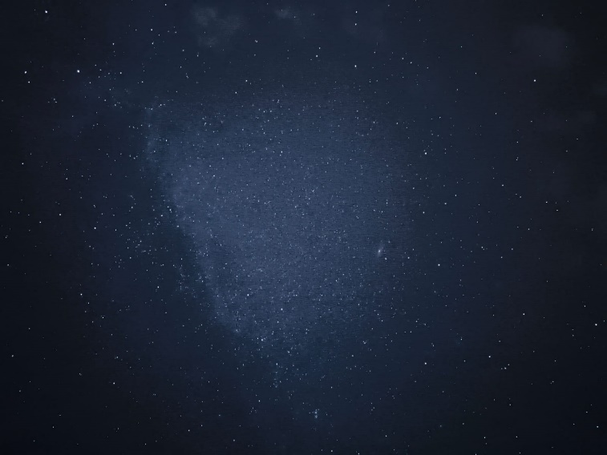
Figure 5: A photo of the night sky at Moore’s Reserve.

Fluid cycles
Another theme that emerged from the journal is the connection between the Moon and female menstrual cycles. From 20–30 October, I spent time in Berlin and attended the Occulture Conference, where Judith Noble delivered a lecture titled Water Into Wine. The lecture revisited her 1980 art installation of the same name (shown at the ICA and later on tour), in which twenty-eight women explored and documented the relationships between menstruation, the Moon, dreams, bodily intuition, and other forms of “body magic.” Speaking from a forty-year distance, Noble reflected on Water Into Wine in relation to her contemporary art-magical practice, offering insight into how these bodily and lunar rhythms continue to inform her work.
She also discussed Lunaception (1975) by Louise Lacey, a book that investigates the relationship between the female body and lunar cycles. In her lecture, Judith shared her own charts of menstrual–moon patterns (see Figure 6) and placed them alongside tidal data, observing the interplay of three rhythms: the lunar cycle, the menstrual cycle, and the cycle of the tides. Listening to her, I became aware of how disconnected I am from the Moon’s influences. On 26 October 2025, I wrote:
“I cannot study my menstrual cycles since I have an IUD, I actually don’t have any consistent cycle. I wonder if my body is entirely disconnected from the Moon. Additionally, in most places in the Netherlands the tides are regulated, with the exception of the north sea. I never really observed the tides as well, even though there is much water around my house – the Ijsselmeer is a big lake just a few minutes from my home – but those waters have no cycle either.”
This contrast between embodied lunar awareness and my own sense of disconnection brought me back to the central tension of the journal: the desire to feel aligned with the sky, and the difficulty of doing so.

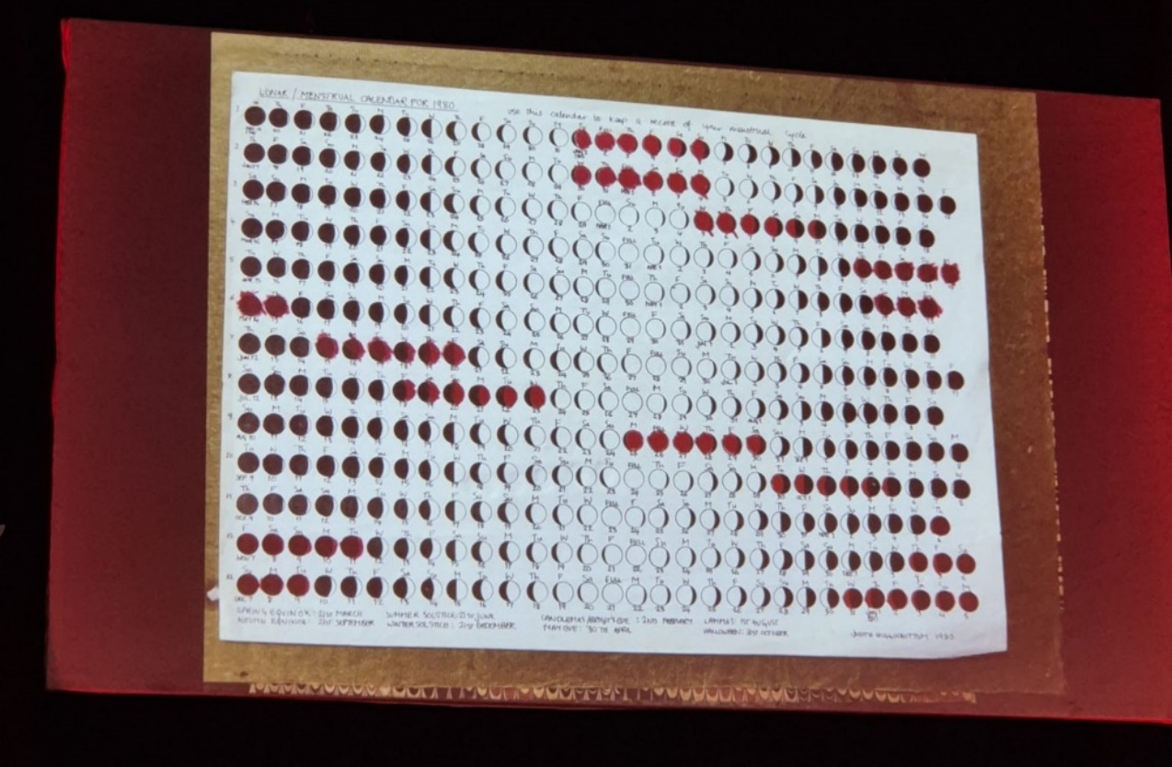
Figure 6: Moon chart for menstrual cycles.

Conclusion
The sky and its celestial objects offer many ways of feeling connected, but also disconnected, from ourselves, from others, and from nature. Celestial bodies with clear boundaries, such as planets and stars, give us something stable to contemplate. Clouds, by contrast, have no fixed shape and can open the door to imagination and invention. The Moon brings yet another layer of meaning, influencing the Earth’s waters as well as human rhythms, including menstrual and fertility cycles. Throughout the journal, I tried to cultivate a sense of connection with the sky, yet I often ended up feeling distant from it. This movement between connection and disconnection became part of the experience itself, revealing how much the act of sky-watching depends on both the availability of the cosmos and the inner life of the observer.

Bibliography
Falchi, Fabio, Pierantonio Cinzano, Daniele Duriscoe, Christopher C. Kyba, Christopher D.
Elvidge, Keith B. G. Gaston, and Alejandro Sánchez de Miguel. “The New World Atlas of Artificial Night Sky Brightness.” Science Advances 2, no. 6 (2016). https://www.science.org/doi/10.1126/sciadv.1600377.
Harris, Alexandra. Weatherland: Writers and Artists under English Skies. London: Reaktion
Books, 2015.
Herbert, Frank. Dune. New York: Chilton Books, 1965.
Pascoe, Bruce, and Duane W. Hamacher. “Whitening the Sky: Light Pollution as a Form of
Cultural Genocide.” The Conversation, October 13, 2020.

William Faulkner, The Art of Fiction No. 12, interview by Jean Stein, The Paris Review, no. 12 (Spring 1956), https://www.theparisreview.org/interviews/4954/the-art-of-fiction-no-12-william-faulkner. Quotation accessed indirectly via a lecture slide from the London School of Astrology.
NASA, “Daily Moon Guide,” Daily Moon Guide | Observe – Moon: NASA Science (accessed 10 November 2025).
Abraham, Sky Journal, November 2, 2025.
Harris, Weatherland: writers and artists under English skies, 217-230.
Harris, Weatherland: writers and artists under English skies, 218.
Ibid.
Herbert, Dune, 604.
This statement was for me neither on page 245 or 201, as mentioned on Moodle. I read parts of the chapters but was unable to trace it.
Harris, Weatherland: writers and artists under English skies, 220-221.
This quotation was mentioned in a writing session by Frank Clifford at the London School of Astrology. Daniel Joseph Boorstin was an American historian; the full quotation reads: “I write to discover what I think. After all, the bars aren’t open that early.” See Why Write? – The Big Picture (Accessed November 22, 2025.)
Falchi, “The New World Atlas of Artificial Night Sky Brightness,” https://www.science.org/doi/10.1126/sciadv.1600377 (Accessed November 18, 2025)
Bruce Pascoe and Duane W. Hamacher, “Whitening the Sky: Light Pollution as a Form of Cultural Genocide,” The Conversation, October 13, 2020.
Dark Sky, “What is Light Pollution,” https://darksky.org/resources/what-is-light-pollution/ (Accessed November 18, 2025)
Dark Sky International. “International Dark Sky Places,” https://darksky.org/what-we-do/international-dark-sky-places/all-places/ (Accessed November 26, 2025.)
Occulture Conference 2025, URL: https://occultureconference.com/ (Accessed November 21, 2025).
Occulture Conference, Judith Noble, https://occultureconference.com/judith-noble/ (Accessed November 21, 2025).
Abraham, Sky Journal, October 26, 2025.

