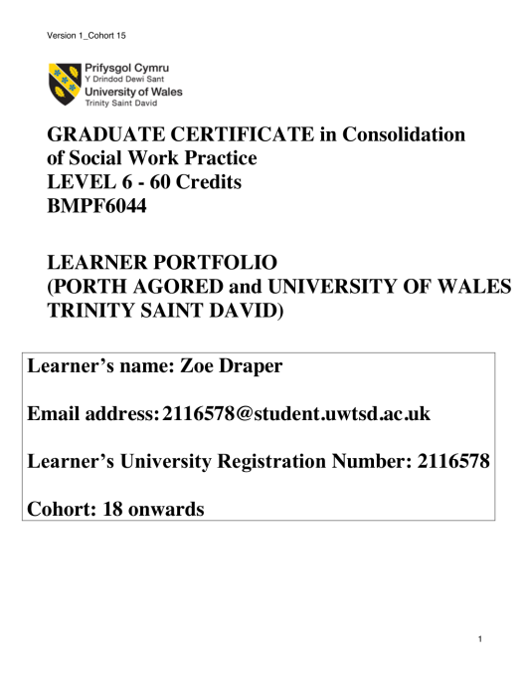

Task 1

Developmental review – Part a

Guidance:
This task should be completed by taking into account the work that you will have undertaken since qualifying, and discussions with your mentor and supervisor/line manager as part of your First Three Years of Practice Individual Plan.
Task one (part a and b) should incorporate the use of a model of reflection.
You must meet the Learning Outcomes for this task (see appendix 5 of the handbook).
Please answer the question below.

Question:

Using a reflective model critically reflect on your professional development since qualifying as a Social Worker. Make reference to the supervision, training, learning and research that has impacted on your work. Based on this and continuing to use a reflective model outline what you have identified and agreed with your manager and/or mentor for your development over the coming 12 months. You must demonstrate how you intend to meet all of the following learning outcomes:-

- applying analysis in assessment to inform interventions;
- working collaboratively with people in need of care and support, their carers and other professionals;
- intervention and application of professional judgement in increasingly complex situations.

750 words (+/- 10%: include your actual word count at the end of each section).

Critical reflection is a holistic process of evaluating my emotional intelligence whilst simultaneously assessing what theories and methods have or could have been used to enhance my practice (Butler, 2013). Emotional intelligence involves assessing how my values; views; emotions and ethics, have affected my practice (Moon, 2005). This reflective commentary will be following Bortons (1970) model of reflection. This model follows a framework of three questions, ‘what? so what?, now what?’.
The setting of my first year of practice was in a statutory childcare team. The main role of the team is to safeguard and promote the wellbeing of children aged between unborn and 18 years. Initially, I had a protected caseload in both the number and threshold of cases. As my experience and confidence progressed through shadowing colleagues and the repetition of practice, the complexity and number of cases continued to grow. Reflection has allowed me to consider that in my first year of practice my overarching emotion was one of being overwhelmed (Gray and Webb, 2010). At first this was caused by a lack of experience, knowledge and confidence and my growing complex caseload caused this feeling to be exacerbated. I was supported in managing these pressures through supervision. Supervision allowed me to share my worries, reflect on my practice and develop as a practitioner (Brown and Rutter, 2015).
One of the main elements of growth in my practice has been through identify how my values and ethics sit alongside my practice (Beckett, 2006). I have and continue to discover who I am as a practitioner through continued practice, supervision and reflection (Butler, 2013). I believe my biggest growth in skills and knowledge has been in my ability to engage with children of varying ages and identifying useful resources such as, utilising the three houses tool in conversations (Weld, 2008). I believe this skill has grown through repetition of practice.
I am focused on continuing to develop as a practitioner and to achieve this I plan to develop my ability to ‘applying analysis in assessment to inform intervention.’ A significant aspect of my role is undertaking a variety of assessments to aid in the care planning of the child. I have had numerous opportunities to both shadow experienced workers undertake assessments and completely them solely. I have considered that I have gained skills in how to effectively communicate with families to obtain information but,I need to develop my experience in good analysis. Critical analysis is a fundamental in a social work delivering an effective and productive assessment (Brown, Moore, Turney, 2012). As my experience develops in writing good analytical assessments, I hope the complexity of the assessments continues and this leads to increases court experience. To progress in this learning objective I plan on reading experienced social workers assessments, seeking feedback on my own and attending relevant training.
Another learning objective I need to develop is my ability to apply ‘professional judgement in increasingly complex situations.’ I aim to achieve this by undertaking increased complex child protection cases and experience in court work. I plan to address this goal with my supervisor and line manager in supervision and requesting cases which they will help me meet this learning objective. Following this I will seek regular supervision and support to ensure that I am making sound professional judgements in complex situations.
I would also like improve my skills in ‘working collaboratively with people in need of care and support, their carers and other professionals.’ My role involves working with a variety of professionals and ensuring good communication to promote information sharing. The lack of communication between professionals in social care has been highlighted numerous times in many child practice reviews (Munro, 2011). I aim to improve my ability to promote good communication between professionals by adopting the signs of safety model of what’s working well, what we are worried about and what needs to happen, in meetings and conversations. I have attended the 5 day training on it and hope to be able to apply this skills into my practice (Turnell & Edwards, 1999).
By meeting these identified learning objectives through various methods such as, training, supervision and reflective practice my I will continue to develop as a practitioner. Ultimately, this will allow me to offer families the best possible support and support them in achieving positive outcomes (BASW, 2011).
WORD COUNT - 723

Task 1 (Part b)
Developmental Review

Guidance:
Please ensure you refer to a reflective model and that you met the require learning outcomes for this task (See appendix 5 of the handbook).

Question:
Using a reflective model critically reflect on your development including reference to training, learning, research and use of supervision since completing Task 1 (part a) (when you began the programme).
Consider in discussion with your mentor/supervisor/line manager the extent to which your learning needs has been achieved. Identify any additional learning needs to support your development in the transition to becoming an experienced practitioner in your future career. You must include a reflection on feedback that you have received from individuals in need of care and support and/or their carers and how this feedback has informed your future professional development.

750 words (+/- 10%: include your actual word count at the end of each section).

This reflective account will focus on the development of my practice throughout the last year. It will specifically focus on how I have met the identified learning outcomes from task 1 part a. To assist in my reflection I will be using Bortons (1970) model of reflection, focusing on the three questions of ‘what? so what?, now what?’.
I believe that I have made process to develop my ability to apply ‘analysis in assessment to inform intervention.’ I have had the opportunity to undertake court work. This has included a complex case of a new born with non-accidental fracture. In relation to this case, I have had to complete, parenting assessments; final care plans and statements. In each document, I have had to analysis the information provided by parents; professionals and the welfare of the child. I have had to consider the risks and benefits of scenarios such as, long term foster carer, adoption and returning to the care of his parents. This work has been challenging but I believe it has significantly developed my ability to analytical and my confidence in making complex decisions. The Victoria Climbe inquiry stressed the importance of social workers undertaking training on risk management (Laming, 2003). Due to limited recourses, I have been unable to undertake any specific training on risk management. I am however due to undertake professional curiosity training. This training will support my progression of analysis as professional curiosity encourages practitioners to develop critical thinking and inform good care planning (Thacker; Anka and Penhale, 2020).
I aimed to progress my ability to apply ‘professional judgement in increasingly complex situations’ by managing an increasing challenging case load which allowed my court experience to grow. Throughout this year, I have had the opportunity to read experienced social workers court reports and understand how their judgment and recommendation to court has been informed by their analysis of what care planning is in the child’s best interest. I was able to apply this in-direct experience when I was required to write care plans and statements for court. In turn, this experience has increased my understanding and ability to apply relevant legislation and theories to complex situations and thus, support sound professional judgments in complex situations (Brammer, 2015). Supervision has also been key in my improvement with this learning objective. Supervision has provided with me an opportunity to discuss and clarify if my professional judgments are well formed and reasoned to a variety of complex situations (Clouder, 2000). I am pleased with my progression for this learning objective. I feel that my confidence has grown in making informed professional judgements. In the future, I hope that my practice can further develop with increased experience in managing a caseload of varying issues and complex situations.
The goals I set to improve my ability in ‘working with collaboratively with people in need of care and support, their carers and other professionals’ was to adopt the signs of safety model into my daily practice. I believe I have drilled this model into my daily practice by using it as the format for any meeting and assessment. This has allowed me to work collaborative with families and professionals as it ensures that their expert opinion is being heard (Turnell and Edwards (1999). This is important as the Social Service and Wellbeing (Wales) Act 2014 highlights the importance of working in co-production with the family and promoting multi-disciplinary working. I feel that this has allowed me to promote clear communication; good information sharing; holistic support and subsequently aided in the removal of one child from a child sexual plan and another from a risky behaviour plan. However, on the observation feedback, the children were unsure to the reason of my visit. Thus, on reflection I could have improved my communication with the children by explaining clearly and slowly to the children the purpose of my visit and, asking them to reflect back their understanding to ensure they understood clearly. Therefore, this feedback has allowed me to reflect on my practice, identify learning and how I will meet these in in future practice.
The following year has been challenging. I have had to manage an increasing complex case load, which therefore results in increasing challenging decisions to make in complex situations. This has improved my knowledge, skills, ability and confidence as a social work practitioner. However, I am mindful that ultimately as social workers, we are involved with unique families and individuals who often require support for their unique complex situation (Adams, Dominelli and Payne, 2009). Thus, I am aware l that my practice always be learning and developing to ensure I am providing the best care and support to families (Dominelli, 2004). I aim to continue my professional development by attending regular training, supervision and, maintain up to date knowledge of legislation; polices; procedures; case law; theories and relevant research.
Word count –809

