

Certificate of Higher Education in Skills for the Workplace
Assignment No.2
Decision making and problem solving

Student name: Jagpreet Kaur
Student ID: 2112515
Module name: Decision making and problem solving
Module code: BMSW4004
Lecturer name: Saqib Shamim
Word count: 2909
Submission date: 22th August 2022

Contents

1) Introduction and defining a complex problem – 3
2) Explanation of communication problems – 4
3) Desicion making techniques – 6
4) Fish bone diagram – 8
5) Fish bone analysis – 9
6) Desicion implementation plan – 9
7) Gang's model – 11
8) Conclusion - 13
9) References - 14

Introduction:
To keep the system smooth it is always important to resolve the problems. At the time of solving problem making a decision is most important part because we implement some methods and make a proper plan to resolve that issue. For this I have also used 7 steps of desicion implementation plan and then fish bone diagram with an analysis. But let's first discuss the problem and vice versa.
A complex problem in the workplace including its scope and impact:
At a work place there is a major complex problem which is communication. Let's discuss its scope and impact briefly.
Communication:
Communication is one of the tools through which we can exchange our ideas, information and messages either by visual signals or by behavior and writing. Having strong communication skills organizations can easily achieve their goals within the time. Basically, there are two modes of communication
- Non Verbal
- Verbal communication.
Verbal communication:
We can use language and words during the verbal communication. By the use of language, we can convey our information and knowledge in a proper way. It also helps to build a relationship between the two people.
Non-verbal communication
Whereas, non-verbal communication is a vast term which facilitates the way in which a message can be sent without the use of any words.
Communication is one of the most important tools, because lack of communication between employer and employee leads to the more complications and problems.
Scope and impact:

Problems due to communication can arise from two different factors, it could be internal or external. Internal factors consist of preconceptions, lack of attention while listening of one’s biasness. Whereas, external factors include the problems which are either due to the medium used for communication or disturbance in the environment. All these distractions together make massive communication problems at workplace.
Workplace interactions usually took place via conferences, meetings or in the canteen area. All kinds of communications have their own issues. However, one of the major problems is not paying attention. Every conversation has its own set of communication problems. But one of the biggest communication problems is not listening well.
Communication problems:
Following is the list of problems caused by communication which you may encounter at workplace.
Filtered Listening:
It occurs when listener already put a filter in his mind before he speaks. It occurs due to the biasness of the listener. Listening to someone with preconceptions definitely leads to communication breakdown.
Stereotyped Listening:
Stereotyped listening is a communication error. It is a popular set idea, image or opinion for a thing, a person or group of people on which people believe blindly. For example, a person may believe that each individual of a country will behave and think in the same manner.
Digital Intervention
Digital intervention is, when an individual do not communicate properly in his real life because of digital world. For example, a person is having conversation with someone and after few minutes his attention diverts towards social media notifications and he cannot listen properly.
Passive listening:
Passive listening is one of the familiar communication errors. It means hearing someone but not listening to them. For example, a person is attending a meeting at workplace and hearing that someone is talking, but he is not listening actually because he is thinking about the grocery or to-do list.
Impact of communication problems:
An organization's high degree of stress is a clear indication that there are issues with communication. With poor communication employees cannot satisfy the employer as well as the client; clients can miss their appointments, team members may not understand their roles and teams can miss their deadlines. In short, the finances, marketing, overall business and total income of the organization will all be significantly impacted by lack of communication. Therefore, it is important to clearly analyze the communication before proceeding to get a possible solution.
Decision making techniques
Decision means the selection of best option. The decision making process involved some steps which increases the chances that you will make satisfactory choice.
Step 1. Identify the decision
The first step of decision making process is the identification of the decision. It is very important to identify the need and nature of the decision.
Step 2. Gather relevant information
The second step is gathering information. One needs to gather some background information before making a decision. Information could be taken from books, online sources, other peoples and self-assessment.
Step 3. Identify alternatives
Third step is about the identification of all possible alternate options. In third step, all the alternatives identified by gathered information will be listed for comparison.
Step 4. Weigh the evidence
In fourth step, you need to visualize all the alternatives one by one to see how it would work if you choose each of them. Alternate endings. Assess what is needed. The identification in step 1 will be accomplished or solved by Using each alternative. As you go through it. As per internal process, you will definitely start liking. Alternatives: Those that seem more. Ability to reach your goal. Finally, place the alternative value systems in order of preference based on your own.
Step 5: Choose from the alternatives:
Once you weigh all the evidence, you are. It seems that the alternative is ready to be chosen. Best for you. You can also select a combination of alternatives. Your choice in step 5 is very possible.
Step 6: Take action:
Now you are ready to take some positive action. You have started implementing the alternative you have chosen.
Step 7: Evaluate your decision and its consequences:
In the final step, imagine the consequences of your decision. And conclude whether it has addressed your need or not which you identified in step 1. If the decision is not met. Identification required; you may want to repeat the process. Steps in the new decision-making process. For example, you may want to collect more detailed information or explore somewhat different information or additional information (Michalos et al., 2018).
Fishbone Diagram:
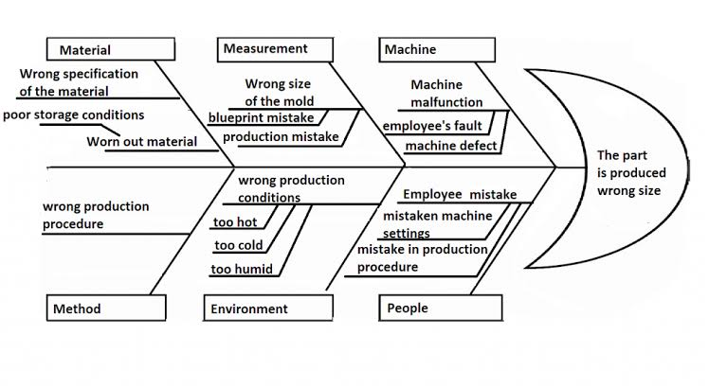
A Fishbone diagram is a visual tool used to recognize, investigate and visually present all the potential causes of a problem to discover root causes. It was discover by a famous Japanese quality control expert Dr. Kaoru Ishikawa at the University of Tokyo 1943, to help employees avoid solutions that may result in another problem. It is sometimes referred to as an Ishikawa diagram or a cause and effect diagram. It is known as fishbone because of its shape similar to a fish skeleton. Fishbone diagrams are typically used in the "analyse" stage of Six Sigma's DMAIC (Define, Measure, Analyze, Improve, Control) problem solving methodology. It is one of the seven basic tools of quality control. The diagram's layout closely resembles the skeleton of a fish. Fishbone diagrams are often drawn from right to left, with large bones of the fish branching out to smaller bones.

Fishbone Analysis
Through fishbone analysis, it was understood that there was a significant correlation between the communication breakdown of the management team and the company with the changes in the company’s structure. The employees were unable to interact with their new coworkers because some of them were new to the insurance domain and some were new to the healthcare department. It was completely uncomfortable for him to initiate. It was difficult even for top management to make a healthy communication with the new team unless the leader took the initiative.
Some issues like stress, lack of conformity, lack of confidence in the new employee, high expectations and low productivity etc. are affecting the overall performance of the company. There may be loss of customers, finance and reputation of the company.
The leader's attention should be undivided- whenever a group meeting or panel meeting is held, full attention should be given to each employee for effective communication. With close attention, one can easily distinguish the person's communication style and provide feedback accordingly. A company should also give a party for employees with an informal session where employees from different divisions could interact and get along well with each other. It will help to enhance the collaboration and learning process.

Decision Implementation Plan :
There are seven basic steps in decision making management: Determining tasks and objectives to be done first, Designing alternative solutions, Gathering relevant data necessary to make a decision, Previous steps. Planning, execution to systematically implement the best solution. Judgment and assessment and formulating any necessary improvements as son of assessment.
Managers should go long and monitor the progress of how the decision is implemented. This can be done by following the five main weapons of management. These are foresight, i.e. they should be focused and develop a plan of action or strategy, organizing the work as a whole, ordering staff to work towards implementation, and coordination and coordination of goals. Coordinating activities to create coordination and control all activities ensuring coordination. to set standards and targets.

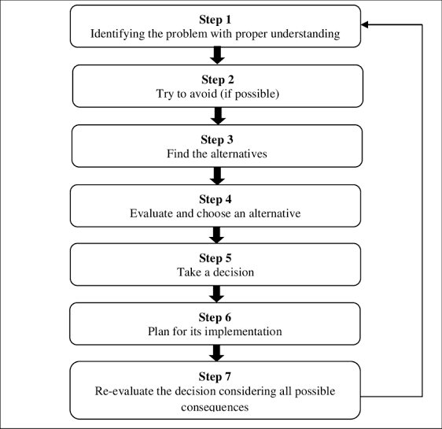

When implementing decisions in global organizations, it is important to consider their organizational structure, organizational culture, and all the stakeholders involved because it is a global organization and therefore the decision implementation will affect many people. Once a decision has been implemented, it is important to evaluate its impact so that management can be informed of progress and able to make any necessary improvements or adjustments.
Management can use survey techniques, for example, to study the impact or change after a decision is implemented. Tools such as questionnaires can be used to monitor or test the effects of change and the data collected can be analyzed and represented in graphs, for
example, trends over time. To show. This will give a clear picture of the impact of decision implementation. The results will dictate whether there are any adjustments to be made, any necessary changes to policies, or whether the decision was a good idea. The criteria set for evaluating the results will be the expected results or desired change. We can also use another organization as a benchmark and compare our results with them. Also, some global standards like International Organization for Standardization, ISO can be the benchmark to evaluate our results.
Examples of Decision Making in the Workplace method of consultation; Where the boss calls all the department heads and discusses the issue and takes a decision. The boss involves all the employees in a meeting where they discuss the problem, come up with a solution, and make a decision. The boss and board of directors discuss issues and make decisions without involving employees. Boss just takes problems by the horns and thinks deeply about it. He finally comes up with a decision.

Gant's model:
The Office of Juvenile Justice and Delinquency Prevention (OJJDP) Comprehensive Gant Model (CGM) is consisting of five stages.

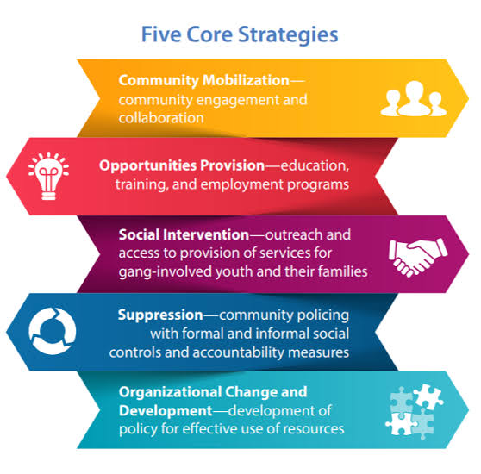

1) Community Mobilization:
Involvement of local citizens, including former gang members, community groups, agencies, programs and staff work within and across coordinating agencies.
2) Providing opportunities:
Education, training, development, employment, and re-entry programs specific to gang involvement including adolescents and young adults.
3) Community intervention:
Youth-serving agencies, schools, street outreach workers, grassroots groups, faith-based organizations, law enforcement agencies, and other criminal justice organizations are reaching out.
4) Suppression:
Formal and informal social control mechanisms and accountability measures, including monitoring or supervision of gang-involved youth by law enforcement and offenders. Justice agencies working in partnership with community-based service providers.
5) Organizational Change and Development:
Implementation of policies and procedures results in effective use of available potential.

Conclusion:
Communication barriers are associated with many problems such as physical, technical, and psychological barriers. In an organization when these barriers were removed it helps in growing profits and make clear understanding between speaker and listener. Every organization has communication problem. To overcome this problem becomes very important for achieving organizational goals.

