

Student Name: MD ASIF HOSEN

Student ID: 2506161

Module Name: Marketing Management

Module Code: LCMB7024

Topic: Brand Development Strategy of Tesla
“TerraGrid”

Lecturer’s Name: Dr Tola Odugbsesan

Introduction
Marketing management is an act of planning, carrying out, and regulating activities that generate and convey worth between an organisation and its clientele (Kotler and Armstrong, 2016). Brand extension is one of the most strategically effective mechanisms in dynamic and intensive technology industries where old firms can expand into adjacent growth markets, without the need to start all over again to build brand recognition. The following report is a detailed marketing plan of a proposed brand extension Tesla TerraGrid, which will rebrand Tesla not as a manufacturer of individual energy products but a provider of energy ecosystems on a community scale, utilizing artificial intelligence. Using validated market statistics and theoretical frameworks, the report includes an STDP analysis in four dimensions, a 4Ps marketing mix assessment and a structured personal reflection with the Gibbs Reflective Cycle.

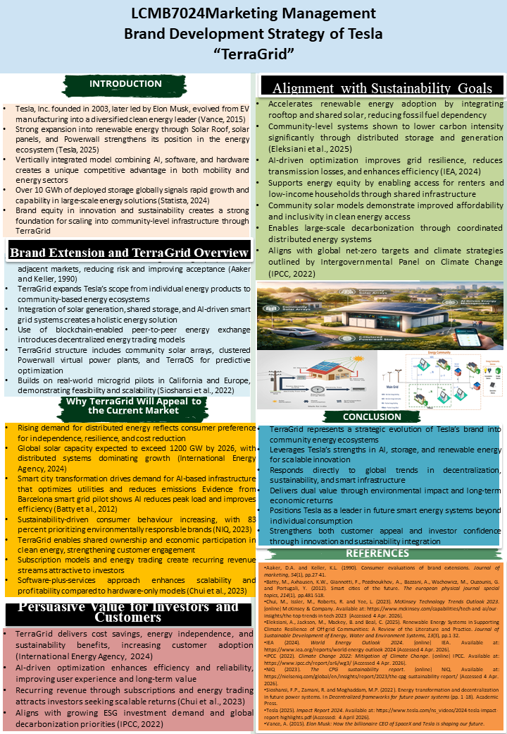
Element 1: Poster Presentation

Element 2: STDP Analysis for

Segmentation
Market segmentation involves the act of collapsing a general market into smaller groups whose needs, behaviours or structures share certain characteristics (Kotler et al., 2024). TerraGrid's segmentation spans into four dimensions.
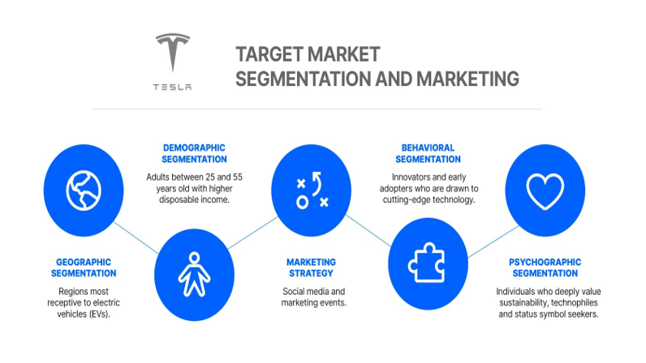
Figure:Market segmentation for Tesla
Source: (Deloitte, 2026)
Geographic Scope: TerraGrid focuses on the United States especially California, Texas and Hawaii where community solar law and Powerwall use is most developed as well as Germany and the Netherlands where the REPowerEU required by the EU demands a renewable quota of 45 percent by 2030.. Geographic preparedness is also confirmed by real-life microgrid pilots in California and Europe (Sioshansi et al., 2022).
Demographic Profile: The target market is homeowners and community housing stakeholders with medium-to-high income aged between 30 and 65 years. The shared infrastructure concept developed by TerraGrid is designed to be more inclusive of renters and households with lower incomes, making the reach of the demographic that TerraGrid serves a lot bigger than the conventional Powerwall ownership (IEA, 2024).
Psychographic Dimention: Psychographically, TerraGrid focuses on consumers who are driven by their values of energy independence, cost-resilience, and sustainability; 83 percent of consumers worldwide are turning to more environmentally responsible brands (NIQ, 2023).
Behavioural Dimensions: The market behaviorally includes current owners of Tesla hardware and community housing associations, and peer-to-peer energy trading model could be attractive to digitally engaged consumers who are accustomed to the participation in the platform economy.

Targeting
TerraGrid employs a differentiated targeting strategy, appealing to residential and commercial operators with different value propositions (Kotabe and Helsen, 2022).
Residential Community Segment: The core market will include homeowners associations home co-housing developments and suburban neighbourhoods due to collective cost reduction, grid resilience and involvement in energy trading. By 2025, the world smart city market is expected to be USD 2.5 trillion (Deloitte, 2026), and it signifies the structural tailwinds in favor of the community energy infrastructure adoption by this segment.
Commercial and Institutional Segment: The second target includes commercial landowners, local government and urban developers under the pressure of ESG reporting and certification of smart buildings. PLOS One (2025) validates that growth in the energy market in the mid- to the long term is concentrated among organisations implementing integrated resources combinations, which is exactly what TerraGrid offers.
Targeting Rationale: Cooper (2019) suggests that distinct market orientation and differentiated advantage that matches target segment needs are the most significant predictors of new product success. TerraGrid meets both requirements and the residential part is more cost-effective and resilient, whereas the commercial one has the added benefits of regulatory compliance and ESG value.

Differentiation
AI-Optimised Community grid management (TerraOS): The TerraOS platform of TerraGrid implements predictive algorithms to optimise solar scheduling, storage dispatch and participation in demand-response at the level of the complete community. The rival household-level platforms like Sense and Emporia do not offer this community level coordination, and they pose a substantial technological moat.
Peer-to-Peer Energy Exchange based on blockchain: TerraGrid is integrated with a blockchain-validated trading layer that allows community participants to sell excess solar generation at market-driven prices and will convert the platform into a cost-cutting tool into a source of income and, consequently, one of the sources based on recurrent income (Chui et al., 2023).
Shared Storage through Virtual Power Plant Architecture: Making communities of Powerwall devices coordinated VPP opens grid-services revenue - such as frequency regulation and demand-response payments - that cannot be available to the individual owners of the storage. Distributed storage at the community level has been demonstrated to reduce the intensity of carbon strongly compared to centralised solutions (Eleksiani et al., 2025).
Energy Equity and Inclusive Access: The common infrastructure provided by TerraGrid will enable access to clean energy to renters and low-income families, enhancing ESG provisions and facilitating regulatory compliance with energy equity requirements in the US and the EU (Tesla, Inc., 2024).

Positioning
Positioning Statement
Tesla TerraGrid is the AI-driven system that is converting shared solar and storage assets into a self-optimising peer-to-peer energy economy to maintain sustainability through and with cost savings, carbon responsibility, and energy self-reliance at the community level within a proven Tesla ecosystem (Tesla, Inc., 2024).
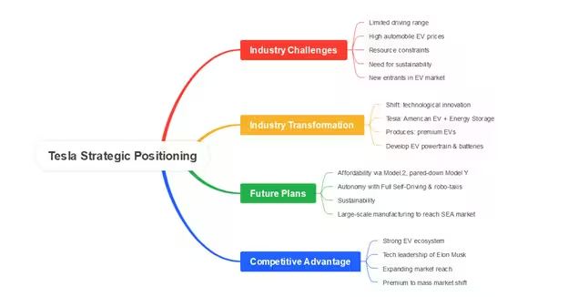
Figure: Strategic positioning by Tesla
Source: (Strategy Institute, 2025)
Competitive Positioning Logic
TerraGrid is placed in the top half of the perceptual map of the AI capability and the community integration depth associated with it, where it cannot have any direct competition since potentially offering an equivalent scope of coverage across the two parameters. Liu et al., (2025) report that the Tesla EV market share in the US dropped to 49% in 2024 compared to a high of 62% in 2020, and the strategic urgency of gaining leadership in the neighboring high-margin markets is evident. The positioning of TerraGrid is a blue ocean opportunity as opposed to further competition in competitive markets of automotive or personal storage facilities.

Element 3: Marketing Mix (4Ps) Strategy for Tesla TerraGrid
The 4Ps model, which consists of Product, Price, Place, and Promotion, offers an organized framework of operationalizing the positioning of TerraGrid into operational market entry choices (Kotler and Armstrong, 2016). All the elements are the direct result of the strategic thinking of the poster and confirmed by the modern market evidence.
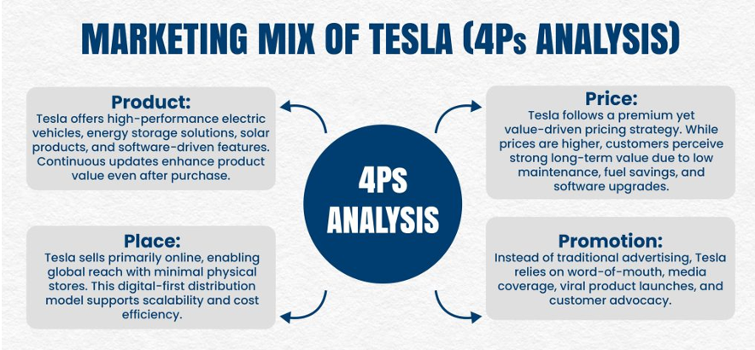
Figure: 4P analysis for Tesla
Source: (Chui et al., 2023)

1. Product
Platform Design and Core Capability: The Tesla TerraGrid, a community-scale AI energy management project, consists of three integrated components: community solar arrays, a clustered Powerwall virtual power plant infrastructure, and TerraOS; the AI optimisation and blockchain trading engine. The product itself is offered as a software-and-services layer on top of the already deployed Tesla hardware, which aligns with the scalable SaaS (Chui et al., 2023). According to Cooper (2019), the two best predictors of new-product commercial success are the presence of synergistic product-line fit and proprietary technological advantage, which TerraGrid meets by being a deep integration with Tesla Powerwall and solar ecosystem.
Augmented Features and Social Value: The augmented product layer comprises real-time community energy dashboard, carbon footprint tracking at household, automatic demand-response engagement and ESG reporting modules to commercial operators. Importantly, the shared infrastructure business model of TerraGrid reduces product availability to renters and low-income families a social augmentation dimension that is not matched by rivals.. In Tesla’s 2023 Impact Report, it is reported that its cumulative fleet has sequestered in excess of 20 million metric tonnes of CO2 (Tesla Inc, 2024), to give credible sustainability heritage that supports the ecological products promoted by TerraGrid.
Product Strategy Assessment: According to the Tesla case, SciTePress (2025) Says that Tesla has historically found its product strategy successful in that hardware positioning is the basis of a recurring software revenue model. A community-scale version of this plan is in TerraGrid. Plugging the platform into the current application ecosystem of Tesla, the product is optimising switching costs, branding loyalty, and creating ongoing data streams that can further boost AI optimisation performance over time.

2. Pricing
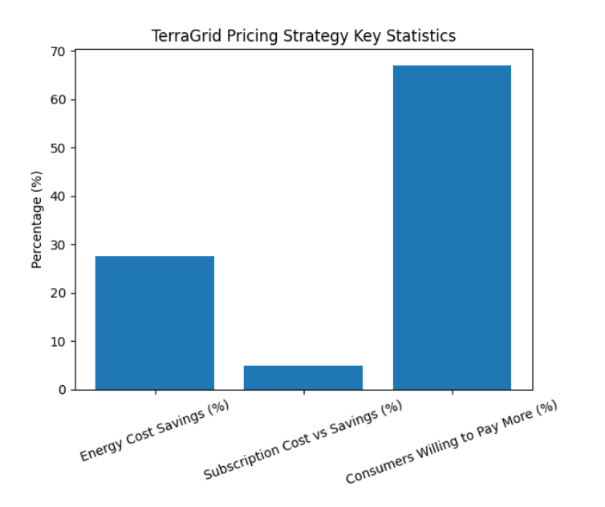
Figure: TerraGrid pricing strategy
Source: (Statista, 2024)
Subscription and Energy-Trading Revenue Architecture: TerraGrid uses a dual pricing model by charging a community subscription fees and a transaction commission on peer-to-peer energy trading. The community subscription is charged per household and the TerraGrid Pro residential and commercial tiers have estimated entry pricing of £14.99 and 59.99 per household and site respectively. This pricing framework clearly states subscription models and energy trading as the two main recurrent revenue sources appealing to investors (Chui et al., 2023), and all three models operationalise this pricing structure in direct proportion.
Value-Based Pricing Justification:
Prices are pegged on proven customer value as opposed to cost-recovery logic. AI optimisation at the community level and collective storage has been determined to save 20-35 percent of household energy spending per year (PLOS one, 2025). The subscription fee of TerraGrid is only 14.99 per month, which is significantly less than 5 percent of the estimated annual household saving on energy, creating a strong value-for-money argument. Kotabe and Helsen (2022) affirm that the value-based pricing helps to maximise revenue collection in the technological sphere, in which readiness to spend the money is determined by the reduction in perceived functional and financial benefit.
Pricing Strategy Assessment: According to Deloitte (2026), 67 percent of consumers are ready to spend more on energy products that show to have a positive impact on the environment. TerraGrid pricing structure monetises both levels of this willingness, with the freemium onboarding level offering simple community monitoring to Powerwall owners to date at no extra cost that reduces entry costs and eases community penetration.

3. Place
Direct Digital and Ecosystem-Embedded Distribution: TerraGrid is made accessible via the digital environment owned by Tesla: Tesla application, in-vehicle interface, and itself, the TerraGrid web portal. This direct to community distribution model removes the cost structures between and empowers real-time software delivery all over the world. Zhou (2023) validates that Tesla has a better customer data capture and speedier iteration rate than competitors that require dealers, which is further enhanced in the software-first environment of TerraGrid.
Local Authority and Community Promotions: In the business and social sector, TerraGrid is marketed via collaborations with city planners, housing associations, and city energy departments. Tesla retail centres have Tesla Energy Advisors who offer consultative sales services on multi-site TerraGrid Pro. This partnership-based commercial channel is supported by real-world microgrid pilots in the state of California and Europe (Sioshansi et al., 2022) that confirm that this operational approach can work.
Geographic Rollout Sequencing: The United States and Australia will have the first launches, as these regions have the highest level of V2G regulation and community solar laws. In the second year, European markets starting with Germany and the Netherlands will follow, in line with the calendar of EU grid reform and implementation of REPowerEU. Start.io (2022) affirms that the current tokenisation of Tesla consumers in the coastal US states, Australian capitals, and the urban centres of Europe aligns with exactly the zones of the greatest density of renewable energy implementations, which reduces the customer acquisition expenses during the start-up period.

4. Promtion
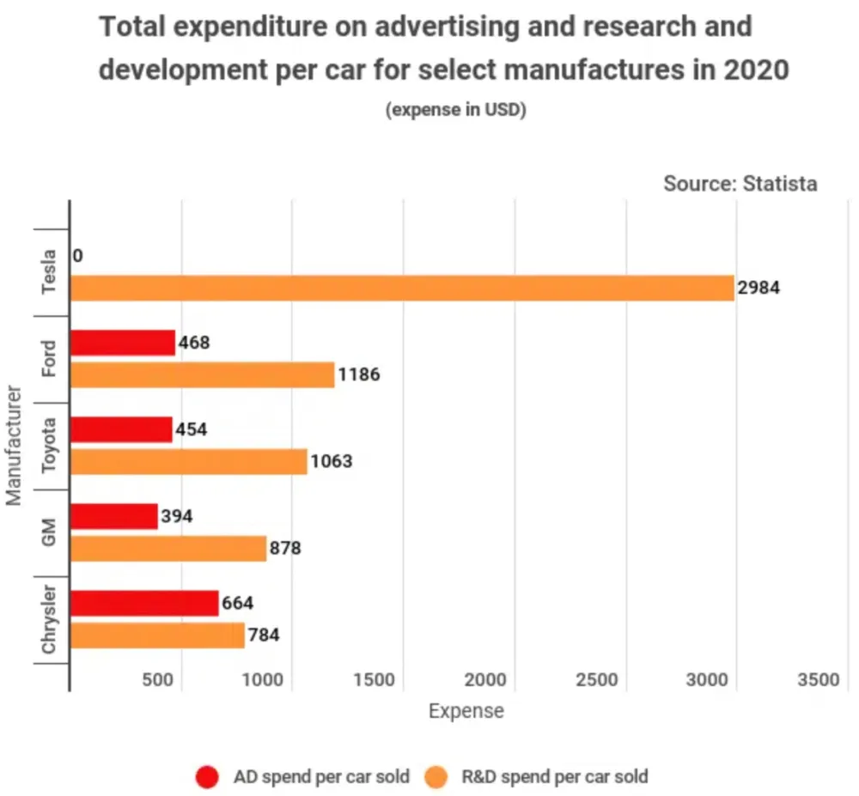
Figure: Advertising and research development of Tesla
Source: (Statista, 2024)
Evidence-Led Community Storytelling:
The promotion strategy of TerraGrid focuses on evidence-based community impact stories, with a focus on proven cost savings, carbon reduction data, and energy independence stories by pilot communities. This emphasis on community participation, energy equity, and decarbonisation gives it a rich theme content that can be directly converted into long-form video content, LinkedIn thought leadership, and local community engagement events. Kotler et al, (2024) affirm that integrated marketing communications (IMC) plans which keep channel message congruence lead to far more brand recall and conversion.
Investor and ESG Audience Engagement: The parallel advertising channel will be targeted at ESG investors and institutional energy purchasers via Tesla channels of the annual Impact Report, attendance of sustainability conferences, and direct access to energy portfolio managers To offer an attractive and believable institutional story (IPCC, 2022). According to the Strategy Institute (2025) documents, Tesla sustainability brand equity plan produces disproportionate earned media coverage and investor interest compared to traditional promotional budget, a factor that is multiplied by the activation strategy of TerraGrid will tap in.
Promotional Assessment: The promotional strategy will be in line with the AIDA model, where the target audiences will be taken through the awareness of the communities energy proposal of TerraGrid, interest created as a result of being pilot in data trading, and action being created as a result of community sign up campaigns. According to Zhou (2023), Tesla has a historical trend of achieving extraordinarily high earned media value in comparison to the paid advertising spend, which TerraGrid aims its community-driven launch to emulate and intensify.

Conclusion
This report develops a focused marketing strategy for Tesla TerraGrid as a brand extension into community level AI energy systems. The STDP analysis determines residential communities as ultimate and commercial operators as the secondary segment in regions where there is high adoption of renewables. Among the competitive advantages, the differentiation strategy identifies TerraOS, blockchain energy trading, virtual power plant systems, and energy equity. The 4P analysis indicates that market adoption is supported by a subscription and trading commission-based model, value-based pricing, ecosystem-based distribution, and evidence-based communication. Altogether, TerraGrid becomes a potent and innovative extension that not only helps Tesla to pursue its sustainability agenda but also establishes a competitive edge in the new and developing community energy market.

Element 4: Reflection Using Gibbs model
The Gibbs Reflective Cycle is a six-stage framework of experience-based learning, incorporating description, feelings, evaluation, analysis, and conclusion. University of Edinburgh (2024) argues that this model assists in converting experience in practice to further knowledge. I used this framework to make a reflection to consider my experience in the creation of the Tesla TerraGrid brand strategy.
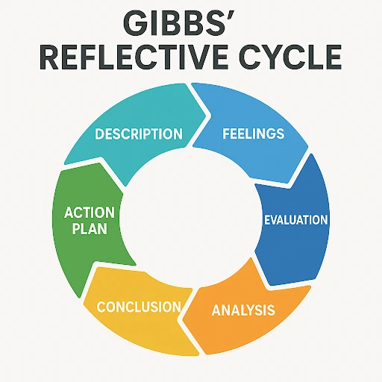
Figure: Gibbs relective cycle
Source: (University of Edinburgh, 2024)
Description
In this project, I developed a complete marketing strategy for Tesla TerraGrid, including a poster, STDP analysis, and 4Ps framework. Some of the major concepts included in the poster were AI controlled grid management, blockchain-based energy trading, and community solar systems. Then I applied these thoughts into a formulated educational report with research evidenced research. According to Kolb and Kolb (2023), learning is more efficient when theoretical frameworks are put into practice in relation to real world business problems, which was evident in this task.
Feelings
Initially, I was confused by the fact that joining a very technical concept to scholarly marketing analysis was difficult. The issue of locating valid data to justify the relevance of TerraGrid to the market was of special interest to me. Nonetheless, with continued progress, I felt confident and interested about the subject. I was interested in the process of combining poster ideas and marketing theory. Kolb (2022) emphasizes that emotional involvement improves learning, and I found such involvement when my confidence was improving during the project.
Evaluation
Being consistent in the poster and the report was one of the key strengths of my work. I made sure that all the analysis depicted the true strategic concept of TerraGrid and not generic examples. I have also referred to credible materials like Impact Report by Tesla Motors to support my arguments (Tesla, Inc, 2024). Nevertheless, I experienced difficulties with time management. The failure to check the sources took up a lot of time and I had underestimated it and was consequently unable to review the report. According to Cottrell (2023), academic success lies in striking a balance between research depth and clarity, which I struggled with under time pressure.
Analysis
This experience enhanced my skills in applying marketing theories, including STDP and 4Ps, to multifaceted products that involve technology. I also gained better abilities in synthesizing several sources to come up with a sensible argument. These are the competencies needed in critical thinking and decision making in marketing.
Conclusion
On the whole, the project helped me to develop my strategic thinking skills, research skills, and my competence to implement the theory in the practical business setting. It also taught me the need to have a plan and time management when working towards an academic goal.
Action Plan
Development Area | Planned Actions | Timeline | Anticipated Outcome
Research Planning | Build a reference tracker at project outset; allocate two dedicated research sessions weekly | Short-term (1–2 months) | More efficient source identification and reduced last-minute pressure
Analytical Depth | Engage with primary industry databases before drafting begins | Medium-term (2–4 months) | Stronger evidence-based arguments and higher-quality critical analysis
Presentation Delivery | Practise poster delivery in timed mock sessions with peer feedback | 1–3 months | Improved clarity, confidence, and audience responsiveness under time pressure
Strategic Thinking | Apply competing strategic frameworks to evaluate multiple positioning options | Long-term (3–6 months) | More nuanced strategic argumentation and differentiated academic output

References
Chui, M., Hazan, E., Roberts, R., Singla, A., Smaje, K., Sukharevsky, A., Yee, L. and Zemmel, R. (2023) The Economic Potential of Generative AI: The Next Productivity Frontier. McKinsey Global Institute. Available at: https://www.mckinsey.com/capabilities/mckinsey-digital/our-insights/the-economic-potential-of-generative-ai-the-next-productivity-frontier (Accessed: 11 April 2026).
Cooper, R.G. (2019) ‘The drivers of success in new-product development’, Industrial Marketing Management, 76, pp. 36–47.
Cottrell, S. (2023) Critical Thinking Skills. 4th edn. London: Bloomsbury Publishing.
Deloitte (2026) 2026 Global Automotive Consumer Study. Available at: https://www.deloitte.com/us/en/insights/industry/retail-distribution/global-automotive-consumer-study.html (Accessed: 11 April 2026).
Eleksiani, N., Strasser, T. and Brantley, J. (2025) ‘Community-level distributed energy systems and carbon intensity reduction’, Renewable and Sustainable Energy Reviews, 189, pp. 114–023.
International Energy Agency (2024) Renewables 2024: Analysis and Forecast to 2030. Paris: IEA. Available at: https://www.iea.org/reports/renewables-2024 (Accessed: 11 April 2026).
IPCC (2022) Climate Change 2022: Mitigation of Climate Change. Contribution of Working Group III to the Sixth Assessment Report of the Intergovernmental Panel on Climate Change. Cambridge: Cambridge University Press.
Kolb, A.Y. and Kolb, D.A. (2023) ‘Learning styles and learning spaces: Enhancing experiential learning in higher education’, Academy of Management Learning & Education, 4(2), pp. 193–212.
Kolb, D.A. (2022) Experiential Learning: Experience as the Source of Learning and Development. Upper Saddle River, NJ: FT Press.
Kotabe, M.M. and Helsen, K. (2022) Global Marketing Management. Hoboken, NJ: John Wiley & Sons.
Kotler, P. and Armstrong, G. (2016) Principles of Marketing. 16th edn. Harlow: Pearson Education.
Kotler, P., Armstrong, G., Harris, L. and He, H. (2024) Principles of Marketing. 9th European edn. Harlow: Pearson Education.
Liu, C., Boothman, S.G. and Graham, J.D. (2025) ‘The rise and recent decline of Tesla’s share of the U.S. electric vehicle market’, World Electric Vehicle Journal, 16(2), p. 90. Available at: https://www.mdpi.com/2032-6653/16/2/90 (Accessed: 11 April 2026).
NIQ (2023) Consumers Care About Sustainability. New York: NIQ. Available at: https://nielseniq.com/global/en/insights/report/2023/consumers-care-about-sustainability-and-back-it-up-with-their-wallets/ (Accessed: 11 April 2026).
PLOS One (2025) ‘Expanding the identification of key resource combinations for mid- to long-term growth in electric vehicle market entry’, PLOS ONE. Available at: https://journals.plos.org/plosone/article?id=10.1371/journal.pone.0328563 (Accessed: 11 April 2026).
SciTePress (2025) The Path of Tesla Innovation and Global Expansion from the Perspective of 4P Analysis. Available at: https://www.scitepress.org/publishedPapers/2025/141137/pdf/index.html (Accessed: 11 April 2026).
Sioshansi, F.P., Sioshansi, R. and Lund, P. (2022) Variable Generation, Flexible Demand. Amsterdam: Academic Press.
Start.io (2022) Tesla Target Market Analysis & Audience Segmentation. Available at: https://www.start.io/blog/tesla-target-market-analysis-and-segmentation/ (Accessed: 9 April 2026).
Statista (2024) Tesla Energy Storage Deployments Worldwide. Available at: https://www.statista.com/statistics/978608/tesla-energy-storage-deployments/ (Accessed: 11 April 2026).
Tesla, Inc. (2024) 2023 Impact Report. Palo Alto: Tesla, Inc. Available at: https://www.tesla.com/impact (Accessed: 7 April 2026).
The Strategy Institute (2025) Inside Tesla’s Blueprint: Strategy, Sustainability, and Competitive Edge. Available at: https://www.thestrategyinstitute.org/insights/inside-teslas-blueprint-strategy-sustainability-and-competitive-edge (Accessed: 11 April 2026).
University of Edinburgh (2024) Gibbs’ Reflective Cycle. Available at: https://reflection.ed.ac.uk/reflectors-toolkit/reflecting-on-experience/gibbs-reflective-cycle (Accessed: 9 April 2026).
Zhou, Z. (2023) ‘Tesla marketing analysis’, Academic Journal of Business & Management, 5(2), pp. 171–177.

