

Programme: Master of Business Administration
Module: Strategic Management (LCMB7003)
Student Name: Muzaffar Sajidbhai Tai
Student Number: 2434313
Lecturer: Zulfiqar Khan
Assignment Title: Individual report
Word Count: 5326
Submission Deadline: 28 November 2025

Table of Contents
1. Introduction 3
2. Selection of Organisation and Target Market 4
2.1 Organisation: Sephora 4
2.2 Target Market: Bangladesh 6
3. Comprehensive Strategic Analysis 8
3.1 PESTLE Analysis 8
3.2 Porters Five Forces Analysis 12
3.3 VRIO Analysis of Sephora 14
3.4 Synthesis 15
4. Strategy Development and Formulation 15
4.1 Market Entry Strategy 15
4.2 Competitive Advantage Strategy 16
4.3 Risk Management 18
4.4 Strategic Fit Summary 18
5. Performance Evaluation Framework 19
5.1 Balanced Scorecard (BSC) 19
5.2 Triple Bottom Line (TBL) 21
5.3 Integration of BSC and TBL 22
5.4 Governance and Reporting 22
5.5 Strategic Implication 23
6. Conclusion and Recommendations 23
References 25

1. Introduction
In a digitally convergent and worldly retail environment, MNCs in the beauty sector find it necessary to venture into emerging markets with high growth in order to maintain competitive edge. Sephora, a French luxury beauty retailer within the LVMH group, is a perfect illustration of strategic agility due to its omnichannel business framework and a global network of store locations in excess of 2,700 locations in more than 35 countries (Pintilie, 2024). The success of the brand in countries like Singapore, Malaysia and India explains its ability to adjust to the regional forces and still have a global image. Based on this successful template, Bangladesh is a strategically feasible frontier to the next stage of internationalisation by Sephora.
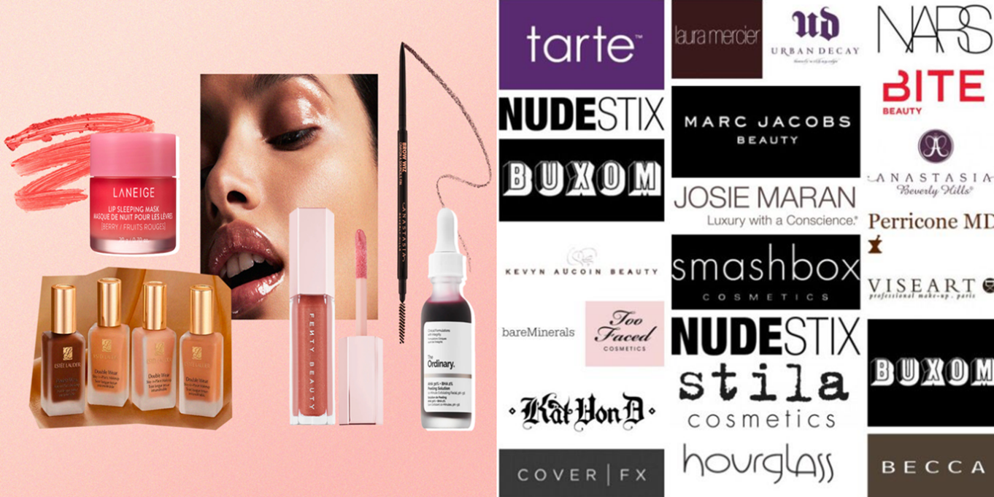
Figure: Sephora’s Products and Brands (Sephora, 2025)
Bangladesh has transformed into one of the fastest growing consumer markets in Asia with a steady GDP growth of approximately 6.3 percent per annum in 2010-2023 (World Bank, 2024). National shopping Romance consumption patterns across the retail sectors are changing because of the emergence of an urban middle-income group (which is projected to rise to 34 million by 2030) and growing levels of digital connectivity (77 million active internet users) (Ahmed, Munir and Islam, 2022). The cosmetics and personal-care sector in the country with a valuation of USD 2.1 billion in the year 2024 is on a swift growth path due to the growing number of consumers using the products, especially the women and the young generation in urban areas, becoming more brand-sensitive and beauty-oriented (Siddiqui, 2024; Fahim, 2024).
This report comes up with a detailed strategic plan of entering the Bangladesh market by Sephora, using strategic frameworks to evaluate the external environment, internal capabilities and best entry mode. It combines theoretical models, such as PESTLE, Porter’s Five Forces and VRIO, with real-life localisation, risk management, and sustainability. The aim is to develop an analytically based, evidence-based expansion plan that makes Sephora’s global brand strengths in line with the emerging socio-economic trends in Bangladesh, ensuring profitable growth and sustained competitive advantage in an otherwise promising but under-penetrated South Asian beauty market.

2. Selection of Organisation and Target Market

2.1 Organisation: Sephora
Sephora is a former French multinational company, now a unit of LVMH luxury goods, dealing in beauty, skincare, cosmetic, and fragrance goods. It has more than 2,700 stores globally in 35 countries. Sephora has a brand portfolio of over 340 brands as well as the Sephora collection globally (Pintilie, 2024). Strategically, Sephora has several advantages that would enable it to be a good company to venture into Bangladesh.
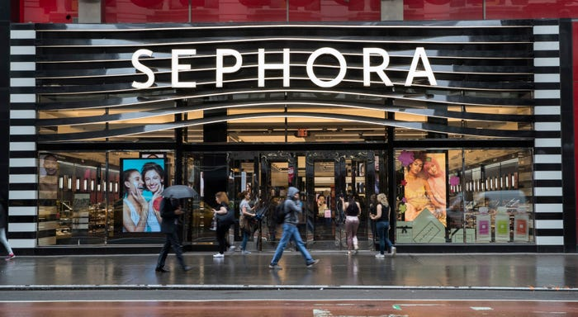
Figure: Retail Juggernaut Sephora (McGrath, 2025)
Omni-Channel Retailing Expertise: Sephora has created an offline physical store and online business mobile application and loyalty points program named Beauty Insider which was launched in 2007 (Bai et al., 2020).
Global Brand Equity: Due to belonging to LVMH with good brand recognition, Sephora has access to the premium and prestige beauty markets, as well as high-end brand alignments.
Scalable Business Model: Sephora has entered numerous differentiated markets, and it is reasonable to assume that it has market entry, brand positioning, and supply chain logistics that are replicable (McGrath, 2025).
Nevertheless, one can also outline the possible limitations:
Premium Price Positioning: Sephora is associated with the prestige beauty segment that might run out of space in a price-sensitive economy such as Bangladesh (Siddiqui, 2024).
Cultural Adaptation & Localisation Risks: The beauty tastes, product quality (halal and skin-tone), and retail structures in Bangladesh are significantly different compared to the mature Western markets; Sephora will have to localise.
Rivalry with Well-established and Local Competitors: In Bangladesh the cosmetics and personal care market has a high local production base, potentially lowering entry barriers when it comes to imported high-end producers (Siddiqui, 2024).
Because of these reasons, Sephora can be considered a good candidate to expand internationally where:
- The target market provides an expanding pool of consumers who are ready to use high-quality beauty products.
- The retail format supports omni-channel formats.
- Differentiation is made possible in competitive dynamics by global brand and experience. The Bangladesh economy is one of the potential matches in such circumstances.

2.2 Target Market: Bangladesh
Bangladesh provides Sephora a good market to expand into considering the demographic, economic, industry specific and competitive factors.
Demographic and Economic Indicators: The population of Bangladesh is over 170 million (2024 estimate) and the median age is approximately 27. Urbanisation is increasing (urban population, some 40% in 2019) that favors retail and high-end products. Disposable incomes are also increasing (Emon, and Nisa, 2024).
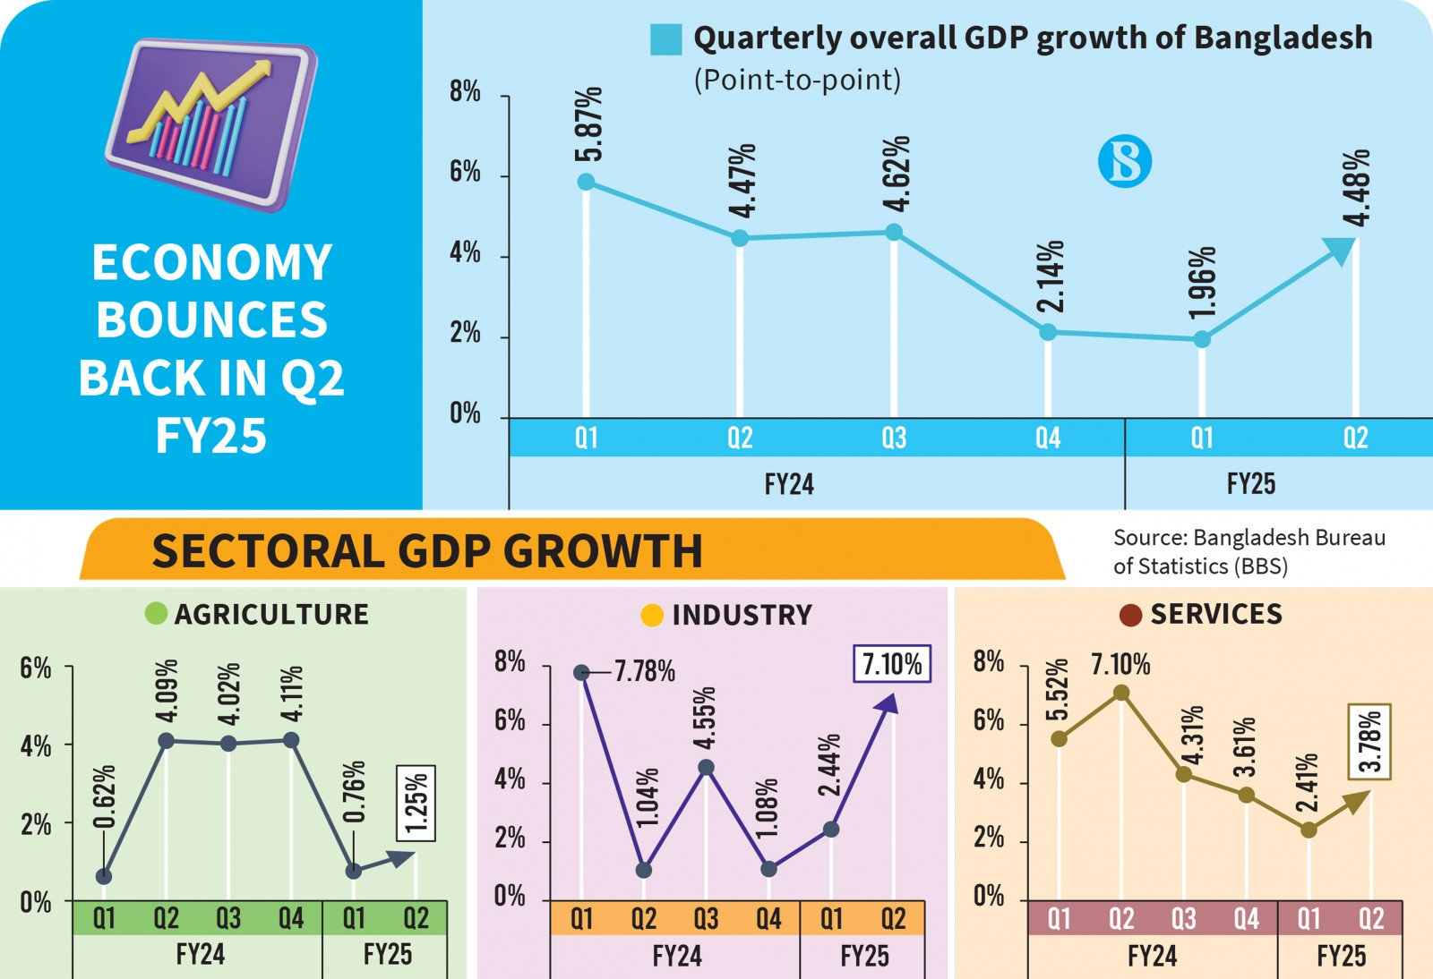
Figure: GDP Growth in Bangladesh (The Business Standard, 2025b)
The growth in the GDP of Bangladesh has been approximately 6–8% per annum in the last ten years, and the urban middle-income population is on the rise. Despite a discrepancy in recent exact figures on the growth of the middle class, there is a clear upward trend in this direction, which favors the possibility of higher expenditure on luxury items like beauty and personal care (Hossain et al., 2021).
Industry Size and Growth Dynamics: The skin-care product market in Bangladesh is estimated to be about USD 1.68 billion in 2024 and is projected to reach USD 2.76 billion by 2034, reflecting a 5.1% CAGR. The larger toiletries and cosmetics business (under the FMCG industry) is estimated at approximately USD 2.8 billion annually and projected to increase around 5% yearly (Mahjabin, 2025). These numbers imply an expanding market share for beauty products, a significant requirement for a high-end entrant such as Sephora.
Consumer Behaviour and Retail Trends: Urban consumers such as younger generations (Millennials and Gen Z) are becoming more concerned with beauty, driven by trends on social media, high-quality standards of personal grooming, and the readiness to explore imported and high-end beauty products. The expanding e-commerce and online sales platforms increase access to traditional retail. For instance, Bangladesh’s e-commerce sector is projected to grow 22.3% annually between 2023 and 2028 (Islam, Ahmed and Khan, 2022).
Competitive and Structural Environment: The domestic market can be described as having a high local manufacturing base. Over 60% of the domestic market share is controlled by local cosmetics and toiletries brands. This means that any new entry will have to have a distinct differentiation either by brand experience, high-end product mix, in-store service, or omni-channel service or risk being commoditised. Regarding distribution, the emergence of contemporary retailing formats (shopping malls, small stores) and the digital medium presents an opportunity to Sephora with its established retail format, the beauty playground.
Market Viability of Sephora: The above factors add up to indicate that Bangladesh has a large and growing market in the beauty and personal care sector, an emerging urban middle class with disposable income, changing consumer behaviour, which matches Sephora’s brand proposition (global offerings, experiential retail, premium positioning), and the development of digital and retail infrastructure that can support multi-channel operation. Combining these factors offers a feasible market entry environment to Sephora.
Environmental Challenge: Price sensitivity among the wider population, regulatory compliance (import tariffs and halal certification), and the risk of brand dilution if Sephora fails to localize offerings to local tastes and budgets are key concerns. There exists a high level of local competition, so Sephora cannot simply rely on global prestige (Shammi et al., 2022). It must create localised value propositions (e.g. smaller store footprints in Dhaka or Mirpur versus large-format flagship stores).
Justification of Choice: The choice of Sephora to expand into Bangladesh can be explained by the synergies between its global retailing capacity and the target market’s growth potential. Other markets may show higher per-capita spending (e.g., the Middle East), but Bangladesh is a highly favourable first-mover premium entrant in South Asia (outside India), where international prestige beauty brands are not yet saturated. The premium-beauty retail in Bangladesh is a greenfield market, allowing Sephora to build a flagship store, shape consumer expectations, and establish brand loyalty before rivals emerge.

3. Comprehensive Strategic Analysis

3.1 PESTLE Analysis
Political Factors: Bangladesh has shown relative political and macroeconomic stability during the past ten years, which has been supported by the presence of consistent policy backing on the growth of the private sector. Global disruptions did not stop the growth of the GDP, which averaged 6.1% between 2015 and 2023 (Oleg Bazaluk et al., 2024).
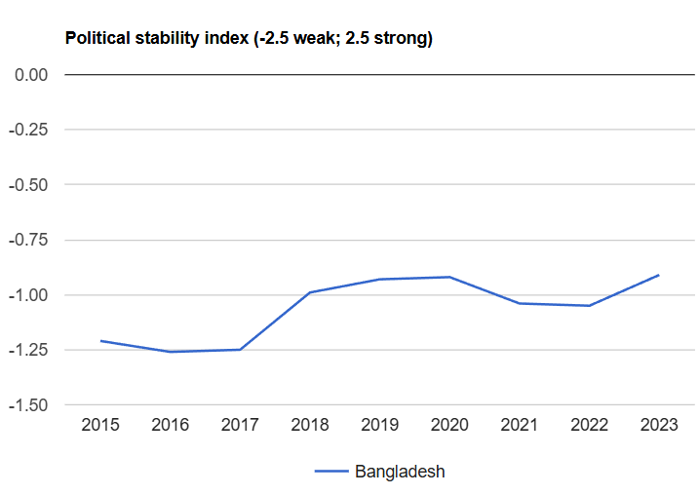
Figure: Political Stability in Bangladesh(The Global Economy, 2024)
Nevertheless, bureaucratic inefficiencies and red tape are still issues. Bangladesh was ranked at 132 out of 190 economies in the World Bank ease of doing business 2020 index, which continues to be reflective of import and customs complexity. In the case of Sephora, these considerations mean that licensing of the stores, tariff clearance and distribution approvals may be delayed, requiring local partnership or third-party logistic assistance to enforce compliance and efficiency.
Economic Factors: Bangladesh has already surpassed the lower-middle-income income level, with GDP per capita reaching USD 2,688 in 2023. The beauty and personal care industry has expanded and is projected to increase to USD 2.12 billion by 2027 compared to USD 1.23 billion in 2020 (Salsabila, Berliana and Yunus, 2025).
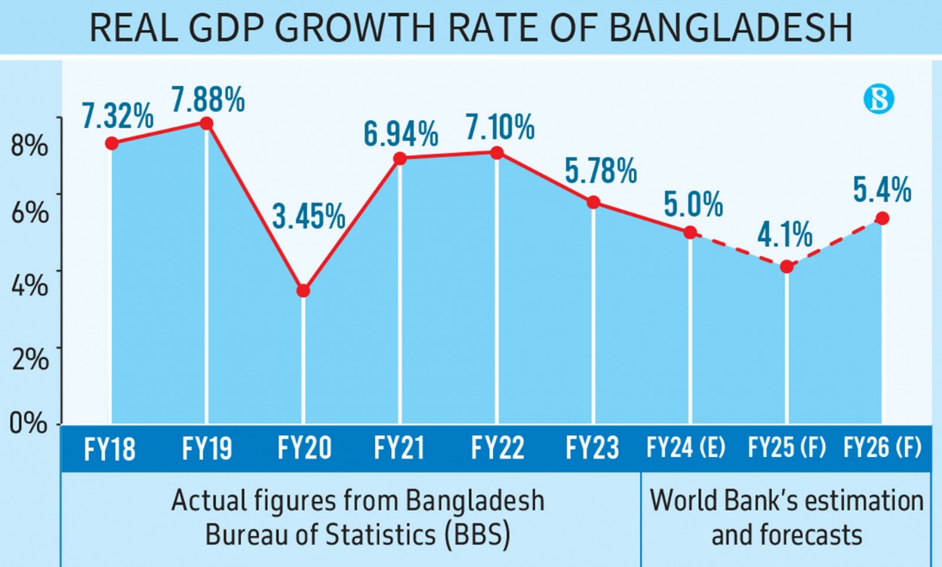
Figure: GDP Growth Rate of Bangladesh (The Business Standard, 2025a)
The growth of urban middle-class, now at 25 million and projected at 34 million in 2030, reflects an affluent pool of consumers of discretionary luxury products. Nevertheless, in 2023, inflation stood at an average of 9.7% and price sensitivity among mass consumers increased (Cho and Cho, 2025). The entry of Sephora thus needs to strike a balance between premium positioning and adaptive pricing to access the aspirational middle-class segment.
Social Factors: Bangladesh has more than 170 million people, and 64% of the population is below 35 years of age, meeting the demographic composition of a developing beauty market. The increasing social-media presence has standardized beauty globally, which is pushing the market to seek foreign brands, with 72% of urban Bangladeshi women aged 18–34 years opting for foreign beauty products over local ones (Misbauddin, Nabi and Dornberger, 2022). The rise of women in the labor market and the cultural transformation towards self-care and grooming drives the market opportunity of Sephora. Nevertheless, the company cannot ignore the cultural trends of promoting low-key beauty standards and halal certification, particularly in the areas beyond Dhaka and Chattogram.
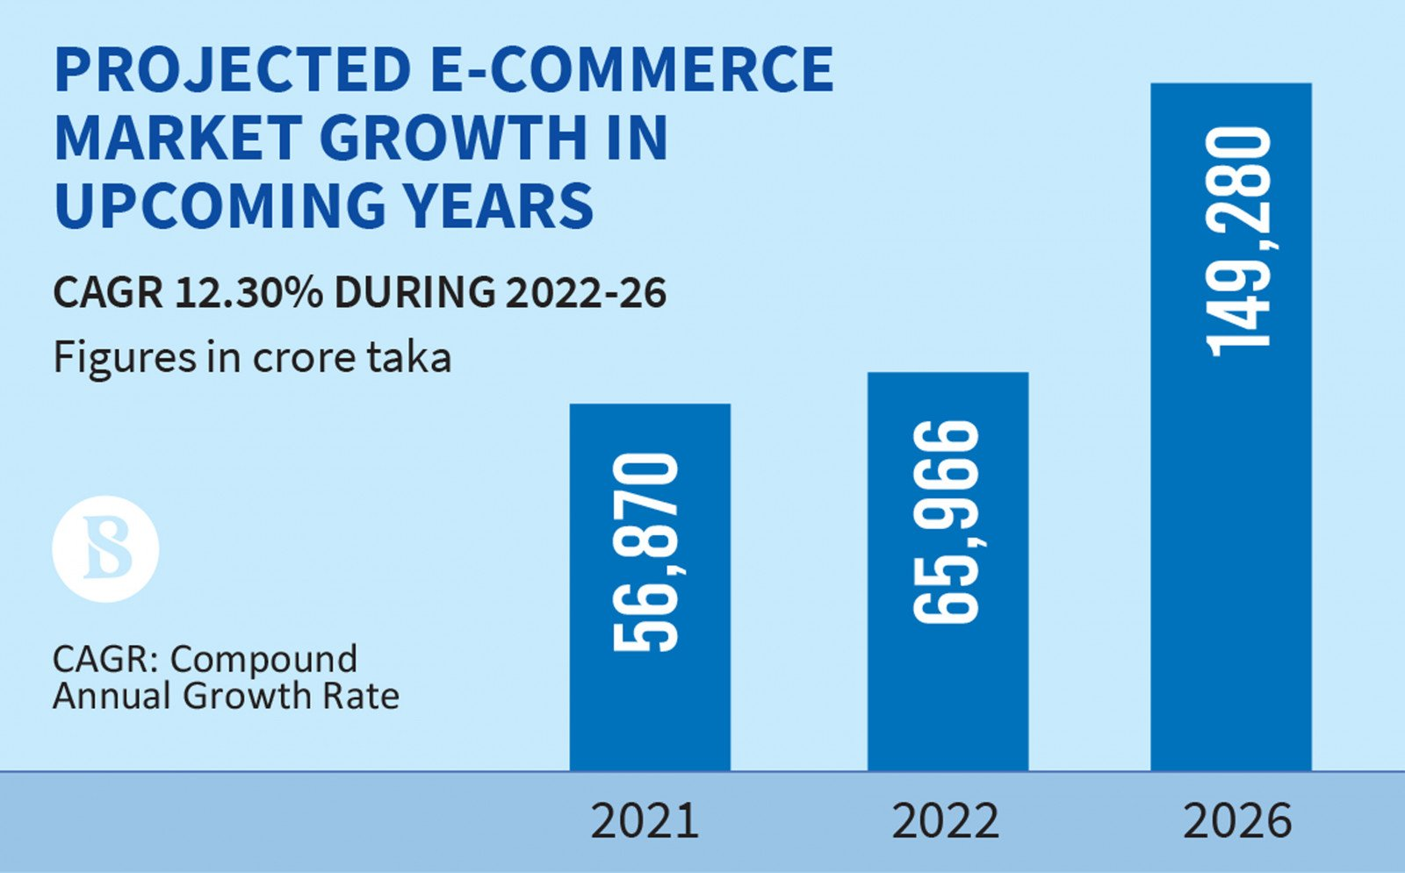
Figure: Doubling Ecommerce Growth in Bangladesh (Karim, 2022)
Technological Factors: The digital commerce ecosystem in Bangladesh has been developing at a very high pace. As of early 2024, internet penetration in this market comprised 75 million users (44% of the population) (Chowdhury, 2025). The CAGR in beauty e-commerce market is estimated at 15.2. The growth of logistics companies like RedX and Paperfly increases the last-mile delivery capacity of omni-channel retail. In the case of Sephora, the environment makes it easy to replicate its international model of phygital, a blend of in-store interactivity and e-commerce fulfilment. But there is an uneven technological preparedness, with gaps in rural connectivity.
Legal Factors: Cosmetics safety, labelling and import certification standards are enforced by the Bangladesh Standards and Testing Institution (BSTI). Cosmetic raw materials are imported more than 90%, increasing compliance and customs-cost exposure. Furthermore, the implementation of 15% VAT on imported luxury products may affect the pricing policy of Sephora (Islam, 2025). To achieve this, the company needs to introduce local sourcing or regional warehousing in South Asia (e.g., hubs in India or Singapore) to maximize costs and simplify compliance.
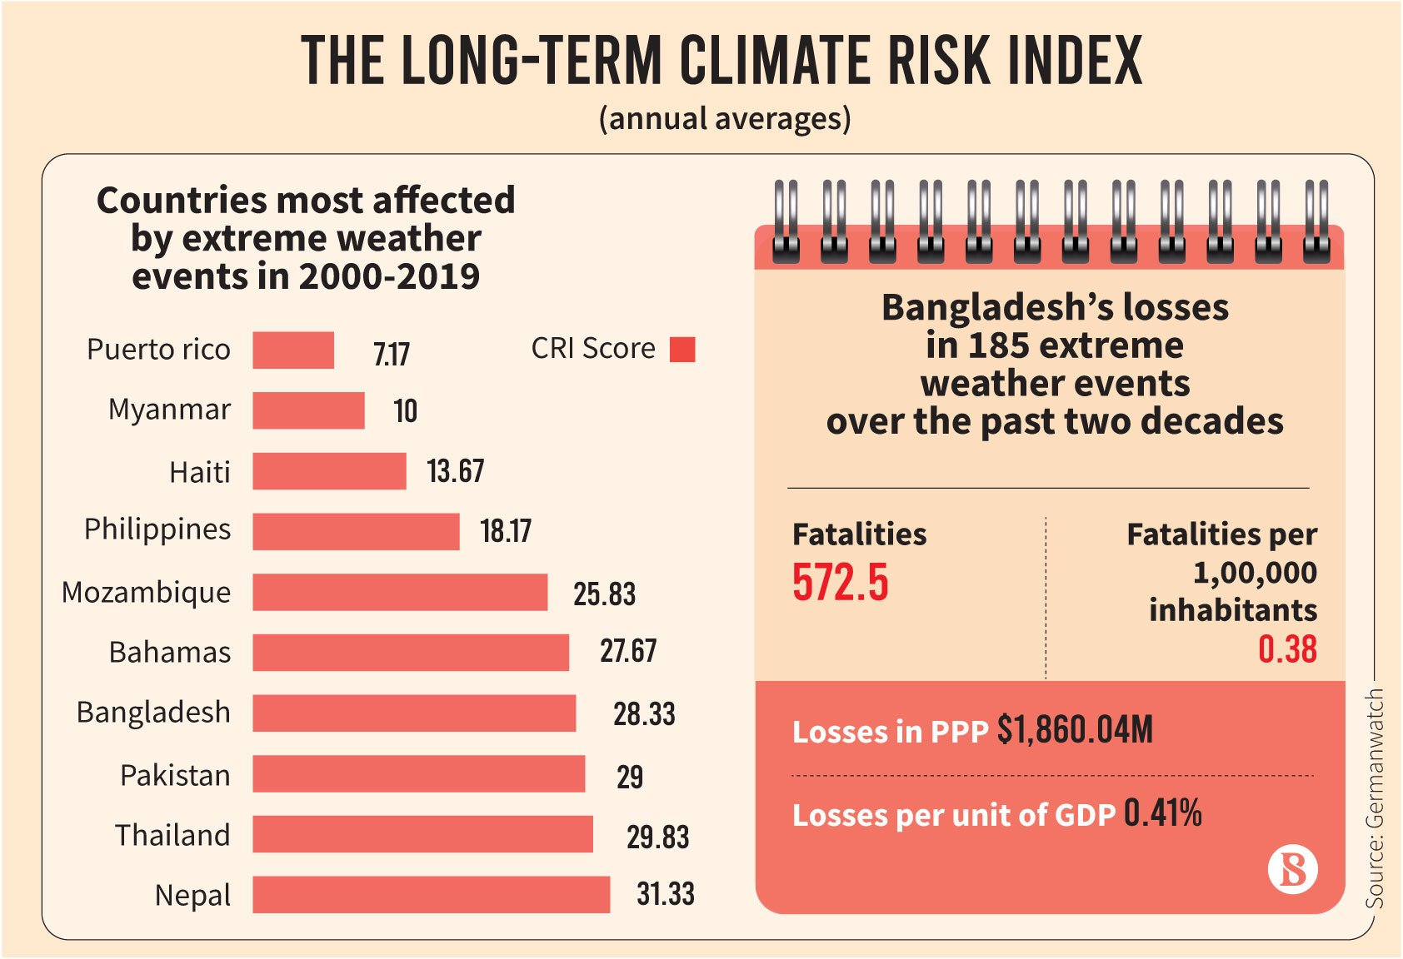
Figure: Climate Risk in Bangladesh (Al Amin, 2021)
Environmental Factors: Bangladesh is one of the ten most climate-vulnerable countries in the world. Emerging consumer consciousness on environmental sustainability is also shaping buying behavior. 48% of urban consumers would buy brands that promote a sustainable eco-friendly or cruelty-free status. Sephora’s sustainability program, including eco-packaging, refill stations, and waste reduction services, might thus appeal to the eco-friendly consumers, both as brand differentiators and as a company aligned to corporate social responsibility (Yeasin et al., 2025).
The macroeconomic environment in Bangladesh presents an attractive yet difficult environment. Strong demographic and consumption dynamics and logistical, legal and regulatory obstacles. Sephora will rely on its ability to use technological nimbleness, high-end brand reputations, and international compliance knowledge to overcome these complexities.

3.2 Porters Five Forces Analysis
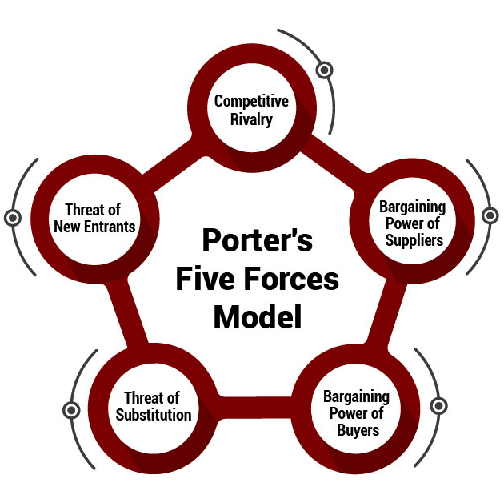
Threat of New Entrants (Moderate): With increasing barriers to entry such as licensing and brand equity, the steady 8%+ CAGR in the beauty market appeals to both domestic and international entrants. Competitive intensity has been heightened by local FMCG companies (e.g., Square Toiletries, Keya Cosmetics) and regional entrants (e.g., The Body Shop in franchise models). The premium positioning and exclusive global brands that Sephora uses to differentiate can moderate such a risk but will need substantial investment in brand education (Oana Turcu and Cristian Brancu, 2025).
Supplier Power (High): More than 90% of the inputs used in the production of Bangladeshi cosmetic are imported (Anindya et al., 2025). This dependence increases the bargaining power of suppliers, especially in global premium products that need to retain their brand consistency. The current supplier setup between Sephora and LVMH-owned and partner brands (e.g., Dior, Fenty, Benefit) minimizes the risk but not the expense exposure. Volatility would be curbed by establishing local warehousing or regional procurement hubs.
Bargaining Power of Buyers (High): Bangladeshi consumers are highly price-sensitive; no high switching costs among beauty brands. An IDLC market review in 2023 revealed that 68% of the respondents view price as the main determinant of purchase. Nonetheless, Gen Zs and affluent millennials are focused on the essence of authenticity, the brand value, and the shopping experience—categories where Sephora can earn loyalty. This makes value-based segmentation approach essential, and entry-level premium lines (e.g., Sephora Collection) may target aspirational buyers, with luxury brands serving niche elites.
Threat of Substitutes (High): Substitutes in Bangladesh comprise low-priced local goods, herbal skincare, and natural beauty remedies, estimated to have a market share of 40% market volume (Rahman, 2025). The fact that natural and halal-certified products are culturally appealing implies that Sephora has to offer an inclusive and region-specific product range. Collaborating with brands that are ethical and sustainable (e.g., Rare Beauty, The Ordinary) will be able to reconcile global trends and local sensibilities.
Industry Competition (Very High): The cosmetics market in Bangladesh is highly competitive, comprising local conglomerates that have well-established distribution channels. Market is moderately concentrated; top five local brands command more than half of the market. Competitive pricing and vigorous marketing are the norms. The entry strategy of Sephora should thus lay more focus on differentiation, using experiential retailing, personalized consultation and exclusive international products in order to circumvent commoditization.
The Five Forces collectively indicate an industry that is competitive and expansive. Price warfare will not give Sephora a sustainable advantage but differentiation and strategic partnerships. A brand with a high position on the value curve makes the industry appealing as long as the entry barriers are planned effectively.

3.3 VRIO Analysis of Sephora
The use of the VRIO framework (Value, Rarity, Imitability, Organisation) to the internal resources and capabilities of Sephora makes it possible to understand which of its strengths may serve as the basis of a long-term competitive advantage in the Bangladesh market.
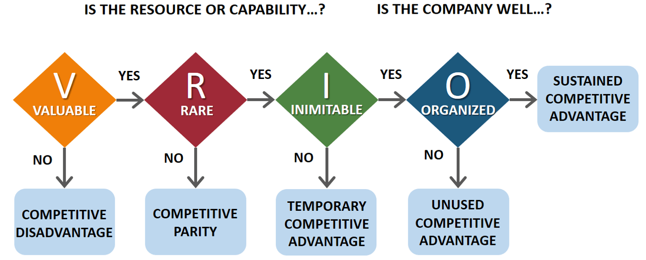
Value: Sephora has a globally known brand name, and its integrated retail strategy (physical flagship stores and integration of e-commerce and mobile apps) creates high consumer value. The varied product mix and the single premium beauty experiences provided by its experience in curating more than 340 brands and its own Sephora Collection. Such features are in line with the premium retail opportunity of the Bangladesh market (growing urban middle-class, digital shopping). Therefore, the resources meet the valuability criteria (Sonia, 2023).
Rare: Brand recognition as such can be duplicated, but Sephora has a unique combination of global prestige, depth of brand-portfolio, and in-store experiential model (e.g., the playground concept, interactive technology) that is not easily duplicated by competitors in Bangladesh, where local manufacturers are the king and international prestige retailers are not as widespread. This implies a level of scarcity that can be exploited within the target market (Hendriana et al., 2025)
Imitable: Although uncommon, some aspects of the Sephora model can be atomic imitable by local or regional competitors in the long run. As an example, local brands can pursue a more premium positioning or omnichannel potential. The scale, brand equity, and network effects of the Sephora model, however, would make imitation expensive and time-consuming. A study shows that the distribution, store format, and integration of Sephora supply chains are less replicable. Accordingly, imitability is moderate to low, which is favourable to sustained benefit (Hendriana et al., 2025).
Organisation: Sephora seems to have structured itself well to capitalise on these assets. Its global presence, robust supply chain, global sourcing and digitalisation indicates organisation preparedness. To Bangladesh, it implies that Sephora possesses the structure, systems and strategic orientation to mobilize its resources.
Assessment and Implication: The internal capabilities of Sephora generally address all the four VRIO conditions suggesting a lasting competitive advantage potential in the high-end Bangladesh beauty market. In the case of strategic planning, it implies that the entry strategy must focus on these core strengths (brand, experience, omni-channel) instead of inundating price-led competition. Sephora should also be careful of localisation (product mix, pricing, store format) without watering down these unique resources. Sephora would consider keeping the upside by tracking the pace of local imitation, investing in digital innovations and supply-chain agility.

3.4 Synthesis
The combination of these frameworks highlights the strategic fit between the capabilities of Sephora and the market dynamics in Bangladesh. On the outside, the market will be characterized by growth, digital acceleration and aspirational consumers. Sephora has rare, precious, and well-structured resources which can be mobilized internally to exploit these opportunities. The issue is how to combine international brand image with local cultural adjustment, operational efficiency, and premium positioning.

4. Strategy Development and Formulation

4.1 Market Entry Strategy
The best entry mode that the Sephora company should use to expand in Bangladesh is a joint venture. Flagship store and e-commerce portal can be used because the dynamics of the beauty market are favourable (e.g., the skin-care products market is projected to grow by USD 8.1 annually since USD 1.23 billion in 2020) and the omni-channel environment is also favourable (Islam, Ahmed and Khan, 2022).
Rationale: A local partner is a strategic ally that offers regulatory and cultural navigation benefits. Partner networks facilitate import/customs and helps localise store design, merchandising and pricing.
A flagship in Dhaka (e.g., in a high-end mall, like Centrepoint, Dhaka or Bashundhara City Shopping Complex) will indicate brand prestige and enable Sephora to recreate its experience in stores worldwide, drawing on its VRIO competitive advantage of brand reputation and store experience.
Similar expansion of an e-commerce channel (and mobile application) would provide a presence outside of Dhaka, leveraging a digital increase in the retail market of Bangladesh (forecast CAGR of about 7.3% of overall retail by 2025–31) (Islam, Ahmed and Khan, 2022).
This joint venture lowers initial risk relative to full ownership in an international market, but still allows enough control over customer experience, which is important with Sephora being a premium player, and the internal VRIO decision that omni-channel and brand resources are the core of competitive advantage.
Implementation Milestones
Year 01: Legal entity, find location in Dhaka high-end mall, develop supply-chain/warehousing (perhaps regional hub through Southeast Asian).
Year 12: Open flagship store (est. 2,0003,000 sq ft), soft-launch e-commerce store, implement loyalty programme (global Beauty Insider model).
Year 2-4: Open 3-5 more stores in Dhaka and Chattogram, increase delivery nationwide on e-commerce, customise product assortment (add halal-certified, local influencer partnerships).
Year 4-5: Go to larger cities (e.g., Sylhet, Khulna) as well, bring in exclusive in-store services (e.g., makeover, technology integration, AR beauty tools) to solidify brand differentiation.

4.2 Competitive Advantage Strategy
Sephora has to implement three overlapping strategic levers to develop and defend competitive advantage in Bangladesh: differentiation, cost-adaptation, and local-global balance.
Differentiation: Ride on its international brand and high-end holding: In a market where local brands hold the majority of the market share (approximately 60% of the market share) and imported luxury brands are underexploited (Bangladesh toiletries and cosmetics market approximately BDT 25,000 crore with value addition of about 5% per year), Sephora can carve out its niche as the luxurious yet convenient beauty destination, luxury meets convenience among urban Bangladeshi shoppers.
Use its omni-channel and experiential retail experience (VRIO: rare, valuable) by providing in-store brand engagement, technology (try-on virtually), loyalty analytics, intuitive online and physical retail. Sell exclusive world brands and limited editions not found through local retail, thus minimizing the risk of substitution and increasing brand value.
Cost-adaptation (value segment hybrid): Although prestige positioning, Sephora needs to contend with local price-sensitivity (buyer power high per Porter). Present premium-priced international brands to high-income customers, and Sephora Collection or more affordable lines to aspiring middle-income segment.
Localisation sourcing or warehousing to counter import duties, logistics costs and currency risk (high supplier power, import dependence, identified in PESTLE and Porter). As an example, regional distribution hubs in South Asia may lower land cost by 8–12% (Chowdhury, 2025). Promote locally (e-commerce flash sales, loyalty levels) to gain volume without damaging prestige brand image.
Local-Global Balance: Localise product assortment significantly such as halal-certified lines, local skin-tone inclusive foundation, localised store atmosphere, in consideration of both social and legal considerations. Enforce global brand consistency in store design, service quality, brand mix, (brand and experience) so that the VRIO advantage (brand and experience) remains intact and not watered down. Invest in local talent and training to provide high service standards and cultural relevance (staff fluent in English/Bengali, skincare consultants).
The combination of these levers can enable Sephora to develop a sustainable competitive advantage, providing what local brands do not (global prestige + omni-channel experience) and responding to local market realities.

4.3 Risk Management
There are several risks associated with expansion: macroeconomic, regulatory, operational and cultural. The most important risks and mitigation strategies are listed below:
Regulatory/Import Risk: Bangladesh imports over 90 percent of cosmetic raw materials (Islam, 2025). Duty of imports, VAT luxury items, regulatory changes (cosmetics control unpredictable) are a threat. Local warehousing, regional procurement center; form local JV partner; flexible product sourcing.
Price Sensitivity & Economic Volatility: Inflation in Bangladesh remained around 9–10% over the last few years decreasing discretionary spending (Yeasin et al., 2025). Tiered pricing, emphasis on flagship experiential value, rather than mere luxury markup, expansion of e-commerce to bigger customer base.
Competitive Imitation and Local Brands: Local brands are expanding and changing much faster. Constant retailing experience innovations, exclusive releases, solid loyalty scheme, focus on brand as a destination rather than product.
Consumer Behaviour & Cultural Adaptation: Consumer awareness is developing, although the preference to modest/halal certified and lower priced grooming products exists. Localise product mix, hire local influencers, create local store experience (women-friendly service, make-up classes, bilingual staff).
Logistics/Infrastructure: Distribution and last-mile delivery in Bangladesh faces bottlenecks in retail infrastructure. Find local logistics partners, roll out in urban first mode, invest in inventory management data analytics.

4.4 Strategic Fit Summary
The strategy offered is consistent with both the external and internal market factors:
JV with flagship and E-commerce Market Entry Mode: It is responsive to regulatory and cost reality and relies on brand Sephora and omni-channel competency. The competitive advantage strategy utilizes the rare and valuable organisational resources (VRIO) of Sephora but adapts to local market conditions (Porters forces, PESTLE).
Risk Management: It guarantees that the threats spotted during the analysis are dealt with in advance. This strategic formulation puts Sephora in a position where it can transition into implementation with a clear understanding that the high-end brand will target the dynamic beauty consumer in Bangladesh supported by strict internal and external fit.

5. Performance Evaluation Framework
The success of the expansion strategy of Sephora in Bangladesh will require a sound evaluation framework. It provides a balance between strategic goals, operational processes and desired outcomes at financial, customer, internal and sustainability levels. To this end, the Balanced Scorecard (BSC) and Triple Bottom Line (TBL) models are embraced to develop an integrated system of performance measurement.

5.1 Balanced Scorecard (BSC)
The Balanced Scorecard, designed by Kaplan and Norton (1992), is a system that connects strategic goals with quantifiable results in four dimensions that include Financial, Customer, Internal Business Processes and Learning and Growth (Barros, 2025). Both views are scaled down below in the Sephora entry plan in Bangladesh.
Perspective | Strategic Objective | Key Performance Indicators (KPIs) | Target (3-Year Horizon) | Data Source
Financial | Achieving profitable market penetration | -Annual sales revenue growth  -Gross profit margin  -ROI on market entry | -15% YoY revenue growth by Year 3  -40% gross margin  -ROI ≥ 20% | Company financial reports, JV statements
Customer | Build brand awareness and loyalty in target segment | -Brand awareness index -Customer retention rate  -Net Promoter Score (NPS) | -60% aided brand awareness among target group  -70% retention among Beauty Insider members  -NPS > 50 | Brand tracking surveys, CRM analytics
Internal Processes | Establish efficient omni-channel operations | -Order fulfilment cycle time (days)  -Stock-out frequency  -E-commerce uptime | -Reducing cycle time < 3 days  -Stock-outs < 5%  -99.5% uptime | Supply-chain & IT performance dashboards
Learning & Growth | Build local workforce capability and innovation | -Employee training hours per FTE  -Staff turnover rate  -Number of new local brand collaborations | -30 hours training per FTE/year  -< 10% turnover -3 local brand tie-ups | HR systems, partner agreements
Financial View: A 15% revenue increase per year and a 40 percent gross margin are realistic. In the example, Sephora + DFS of LVMH was 11% globally with 18.5% operating margin in 2023. This is yet to be replicated in the middle of the economy of Bangladesh, yet it can be achieved by focusing on urban penetration.
Customer Perspective: Customer knowledge and retention plays the key role since the Bangladeshi customers are highly price sensitive. The main retention tool is the Beauty Insider loyalty programme developed by Sephora (which attracted 80% of U.S. revenue in 2023).
Internal Processes: As almost 90% of inputs into the cosmetics are imported, logistics and operational agility are required. New Asia will have sub-three-day order cycles that meet industry e-commerce standards.
Learning & Growth: Sephora depends on the cultivation of local talent and the cultivation of supplier ecosystems. The cultural fit and the local presence can be achieved by the local partnerships (e.g. halal certified or natural brands) which is in line with the concept of diversification suggested by Ansoff.

5.2 Triple Bottom Line (TBL)
The BSC is complemented by the Triple Bottom Line (Elkington 1994) which evaluates economic, social and environmental effects and this is important to global retail expansion that would be sustainable. In the case of Sephora Bangladesh, the structure guarantees that financial profits are accompanied by ethical, social, and ecological accountability.
Dimension | Objective | Indicators & Targets | Strategic Implication
Economic | Promote long-term financial sustainability | -Maintain ROI ≥ 20% by Year 3  -10% annual cost reduction through regional sourcing  -Local supplier participation ≥ 30% | Reinforces Sephora’s competitiveness and supply-chain resilience in a high-import-cost economy.
Social | Advance local employment and inclusive beauty | -Employ > 70% Bangladeshi nationals in operations  -Conduct 12 annual community workshops on women’s empowerment -Introduce inclusive product lines covering diverse skin tones | Builds brand equity through inclusivity and social credibility; aligns with national SDG 5 (Gender Equality).
Environ-mental | Embed sustainability across retail operations | -Introduce refill & recycling stations in all flagship stores  -Achieve 20% reduction in plastic packaging by 2027  -Source 50% products from brands certified cruelty-free | Meets global sustainability standards, enhancing trust among environmentally aware consumers.
TBL goes beyond profitability to quantify social legitimacy and environmental stewardship - key in markets where reputational risk may keep off global participants. The current Sustainable Sephora effort by Sephora that already collaborates with 50+ clean-beauty brands worldwide can also be localised to Bangladesh via partnerships with local entrepreneurs and NGOs (e.g., BRAC, HerStory Foundation).
With the use of the TBL framework, Sephora would make sure that growth would help Bangladesh achieve its social and environmental development objectives - a growing significance in brand perception among urban young people.

5.3 Integration of BSC and TBL
The combination of BSC (quantitative KPIs) and TBL (qualitative sustainability metrics) establishes a balanced performance ecosystem that balances profitability, brand recognition, and sustainability. In the case of Sephora, this two-tier system is consistent with three strategic imperatives:
Strategic Alignment: The two frameworks interconnect with the mission of Sephora, which is to empower self-expression through beauty and ethical consumption. The KPIs make sure that the daily operational indicators (revenue, delivery, retention) are consistent with the long-term sustainability achievement (employment, environmental responsibility).
Accountability and Transparency: Periodic assessment by defining periodical reviews of BSC and annual TBL auditing enhances accountability to shareholders and local stakeholders. Sephora can distinguish itself in a market where ESG transparency is still immature through public sustainability disclosures (Barros, 2025).
Feedback and Adaptation: The agile strategy is supported by constant performance measurement. To illustrate, if online revenue growth does not exceed the 15% goal, Sephora can shift its efforts to online involvement campaigns, which is already infused into its global analytic culture.

5.4 Governance and Reporting
To operationalise this system, Sephora Bangladesh should establish a Performance Governance Committee comprising representatives from Finance, Marketing, HR, and CSR divisions.
- Quarterly reviews will evaluate progress on BSC metrics (financial, customer, process, learning).
- Annual sustainability reports, aligned with Global Reporting Initiative (GRI) standards, will communicate progress on TBL metrics to regulators, consumers, and LVMH shareholders.
- Integration of digital dashboards will allow real-time KPI monitoring, leveraging Sephora’s global analytics infrastructure (e.g., Salesforce CRM, Tableau Retail Analytics).

5.5 Strategic Implication
By aligning quantitative and qualitative metrics, Sephora can:
- Demonstrate financial discipline through measurable ROI and margin targets.
- Build brand legitimacy via ethical and social engagement, reinforcing its differentiation in Bangladesh’s value-driven market.
- Support sustainable scalability by embedding governance, data, and transparency within expansion plans.
This integrated framework positions Sephora not merely as a market entrant but as a transformative actor in Bangladesh’s evolving beauty ecosystem, balancing profitability with purpose.

6. Conclusion and Recommendations
The proposed entry of Sephora in Bangladesh is a strategically good and timely opportunity with favourable macroeconomic conditions and demographic trends. The robust growth of GDP, increasing disposable incomes, and the fast urbanisation of the middle class in the country provide solid roots on which the premium international brands will enter. The above reviews affirm that the changing consumer culture in Bangladesh, because of youthful population and the influence of social media, fits that of Sephora brand which proposes an experience-rich, aspirational beauty shop. However, the regulatory complexity of the market, the limitations of the infrastructure, and the sensitivity of the price require a carefully considered strategy.
The external analysis revealed that the competitive environment is also competitive, but it is still not well-developed in the high-end segment where Sephora has the strongest differentiation potential, including brand exclusivity, omni-channel retailing, and in-store experience. On the internal front, the VRIO model ensured that Sephora has a global brand equity, innovative retail model and powerful organisational capability that can enable it to exploit the opportunities in the Bangladesh beauty industry. All these imply that Sephora can achieve sustainable competitive advantage in case it aligns global brand standard with local flexibility.
The most desired one is joint-venture entry mode that would start with flagship store in Dhaka supported by parallel e-commerce platform. Such a planned expansion limits the risks of the operation, renders it compliant with regulatory standards, and enables learning over time in case of market realignment. Putting emphasis on localisation, Sephora is to implement halal-certified and inclusive cosmetic brands, bilingual customer services, and regional marketing partnerships. This will boost retention rates and reduce the cost of acquiring new clients by increasing its online presence through influencers, personalised suggestions, and loyalty-based analytics.
Integration of sustainability and inclusivity in operations will be instrumental in the long-term legitimacy. Having the profitability to reach the social and environmental value, which is also matched in the state of the Balanced Scorecard and Triple Bottom Line frameworks, Sephora will not only position itself as a market leader in the luxury end of the beauty business in Bangladesh, but also as a socially responsible innovator that reinvents ethical retailing in South Asia.

References
Ahmed, S., Munir, M.S. and Islam, T. (2022) ‘Online Shopping: A Survey on Consumer Buying Behavior in Bangladesh’, European Scientific Journal, ESJ, 18(15), p. 93. Available at: https://doi.org/10.19044/esj.2022.v18n15p93.
Al Amin, M. (2021) Bangladesh remains 7th most vulnerable to climate change, The Business Standard. Available at: https://www.tbsnews.net/environment/climate-change/bangladesh-remains-7th-most-vulnerable-climate-change-191044.
Anindya, F., Maulana, M.I.R., Najla, N., Tomabilang, A.J.I., Hidayati, N. and Ruslan, Mohd.F. (2025) ‘From awareness to action: Strategies for improving halal standards in Korean noodles and cosmetic industry’, Halal Studies and Society, 2(2), pp. 4–6. Available at: https://doi.org/10.29244/hass.2.2.4-6.
Bai, H., He, W., Shi, J., McColl, J. and Moore, C. (2020) ‘Internationalization strategies of emerging market multinationals in luxury fashion retailing: Case study of Shandong Ruyi Group’, Thunderbird International Business Review, 63(3). Available at: https://doi.org/10.1002/tie.22181.
Barros, R.S. (2025) ‘Research on the balanced scorecard for government entities: A literature review’, Journal of Public Budgeting, Accounting & Financial Management. Available at: https://doi.org/10.1108/jpbafm-10-2022-0162.
Cho, M. and Cho, E. (2025) ‘The hidden signals of luxury: Investigating inconspicuous consumption and the mediating role of social connectedness’, Journal of Retailing and Consumer Services, 87, p. 104398. Available at: https://doi.org/10.1016/j.jretconser.2025.104398.
Chowdhury, A. (2025) ‘Vyoma commerce: A blockchain-based decentralized architecture to combat fraud and enhance security and trust in Bangladesh’s e-commerce ecosystem leveraging smart contracts, supply chain transparency, and digital identity’, Journal of Electrical Systems and Information Technology, 12(1). Available at: https://doi.org/10.1186/s43067-025-00245-6.
Emon, and Nisa, N.M. (2024) Exploring the gender dimension in entrepreneurship development: A systematic literature review in the context of Bangladesh. Available at: https://papers.ssrn.com/sol3/papers.cfm?abstract_id=5122782.
Fahim, A. (2024) An exploration of online consumer buying behavior in context of Bangladeshi fast moving consumer goods industry. Available at: https://doi.org/ID%2020104046.
Hendriana, Ully Dwiyanti, Luthfika Dewi Maharani, Pepen Maipalna, Faturrohman Faturrohman and Susi, N. (2025) ‘An analysis of the impact of customer service quality on customer satisfaction at Sephora, Summarecon Mall Bandung’, Jurnal Komputer Bisnis, 18(1), pp. 33–42. Available at: http://jurnal.lpkia.ac.id/index.php/jkb/article/view/599 (Accessed 26 November 2025).
Hossain, A., Hossen, M., Hasan, M.M. and Sattar, A. (2021) ‘GDP growth prediction of Bangladesh using machine learning algorithm’, IEEE Xplore. Available at: https://doi.org/10.1109/ICICV50876.2021.9388593.
Islam, A.S., Ahmed, S. and Khan, R.H. (2022) ‘A review on e-commerce system in Bangladesh: An empirical study’, Proceedings of the 2nd International Conference on Computing Advancements. Available at: https://doi.org/10.1145/3542954.3542994.
Islam, M.M. (2025) ‘Halal supply chain management readiness and halal cosmetics in Bangladesh’, Journal of Islamic Marketing. Available at: https://doi.org/10.1108/jima-05-2022-0130.
Karim, R. (2022) Bangladesh e-commerce sales to more than double by 2026: Research, The Business Standard. Available at: https://www.tbsnews.net/economy/bangladesh-e-commerce-sales-more-double-2026-research-497134.
Mahjabin, L. (2025) Strategic expansion of Savlon brand under ACI through SkinZEN: Entering the skincare market of Bangladesh. doi:ID 21104018.
McGrath, J. (2025) Sephora’s history, from perfume shop to mega beauty retailer, Business Insider. Available at: https://www.businessinsider.com/sephora-history.
Misbauddin, S.M., Nabi, Md.N.U. and Dornberger, U. (2022) ‘Analysing the factors influencing the internationalisation of social entrepreneurship: A study of internationalised social businesses from Bangladesh’, Journal of Social Entrepreneurship, pp. 1–35. Available at: https://doi.org/10.1080/19420676.2022.2143868.
Oana Turcu and Cristian Brancu (2025) ‘Cosmetics industry performance in the European Union: A comparative analysis’, Proceedings of the International Conference on Business Excellence, 19(1), pp. 2267–2276. Available at: https://doi.org/10.2478/picbe-2025-0175.
Oleg Bazaluk, Sheikh Abdul Kader, Nurul Mohammad Zayed, Chowdhury, R., Md. Zahirul Islam, Nitsenko, V.S. and Bratus, H. (2024) ‘Determinant on economic growth in developing country: A special case regarding Turkey and Bangladesh’, Journal of the Knowledge Economy. Available at: https://doi.org/10.1007/s13132-024-01989-8.
Pintilie, M. (2024) ‘Analysis of the Sephora company: Model of a sustainable transnational corporation’, Economics and Applied Informatics, (3), pp. 444–448. Available at: https://doi.org/10.35219/eai15840409472.
Rahman, S.A. (2025) ‘Mechanism of minimizing the negative perception of sugar substitutes in Bangladesh: A strategic roadmap for Zerocal’s market expansion’, BRAC University. Available at: http://hdl.handle.net/10361/26091
Salsabila, N.V., Berliana, S.A. and Yunus, E.N. (2025) ‘The implementation of sustainable supply chain in the beauty and personal care industry in Indonesia: The natural resource-based view’, Journal of Emerging Business Management and Entrepreneurship Studies, 5(1), pp. 1–16. Available at: https://doi.org/10.34149/jebmes.v5i1.180.
Sephora (2025) SEPHORA COLLECTION, Sephora.com. Available at: https://www.sephora.com/brand/sephora-collection.
Shammi, M., Halder, P.K., Tareq, S.M., Rahman, Md.M. and Kabir, Z. (2022) ‘From environmental impact assessment to strategic environmental assessment in Bangladesh: Evolution, perspective, governance and challenges’, Environmental Impact Assessment Review, 97, p. 106890. Available at: https://doi.org/10.1016/j.eiar.2022.106890.
Siddiqui, M.S. (2024) The rise of ‘Made in Bangladesh’ cosmetics, The Business Standard. Available at: https://www.tbsnews.net/thoughts/rise-made-bangladesh-cosmetics-962596.
Sonia, V. (2023) Unfolding customer sentiment: A machine learning approach to Sephora’s reviews. doi:https://norma.ncirl.ie/7619/1/vaibhavsonia.pdf.
The Business Standard (2025a) Bangladesh economy to see weakest growth since pandemic: World Bank, The Business Standard. Available at: https://www.tbsnews.net/economy/bangladesh-economy-see-weakest-growth-pandemic-world-bank-1044901.
The Business Standard (2025b) Growth jumps by 4.48% in second quarter, but poor left more vulnerable, The Business Standard. Available at: https://www.tbsnews.net/economy/bangladeshs-economic-growth-slightly-rises-448-fy2024-25-second-quarter-1110766 (Accessed: 26 November 2025).
The Global Economy (2024) Bangladesh economic indicators, TheGlobalEconomy.com. Available at: https://www.theglobaleconomy.com/Bangladesh/.
World Bank (2024) The World Bank In Bangladesh, World Bank. Available at: https://www.worldbank.org/en/country/bangladesh/overview.
Yeasin, Masud, A.A., Hossain, M.A., Hossain, M.S. and Hossain, M.A. (2025) ‘Eco-friendly supply chains: Unveiling the keys to sustainable success in the textile industry of an emerging economy’, Business Strategy & Development, 8(3). Available at: https://doi.org/10.1002/bsd2.70157.

