University of Wales Trinity Saint David
Wales Institute of Science

Electrical Control Systems
ACHA4010

Tasha Freeman
2419263
27/03/2025
Contents
1 Task 3 1
1.1 Scope Time Division Calculations (3) 1
1.2 Function Generator output square wave (3) 1
1.3 Capacitor charge and discharge wave marked at correct points. (3) 2
1.4 Basic Capacitor Calculations (3) 2
1.5 Capacitor discharge table (2) 2
1.6 Plot log(V) Gradient (2) 3
1.7 Gradient Calculations and Compare(4) 3
1.7.1 Gradient Calculations 3
1.7.2 Comparison table 3
1.8 Capacitor Uses (5) 3
1.9 Inaccuracies Question (4) 4
2 References 5

Task 3

Scope Time Division Calculations (3)

Function Generator output square wave (3)
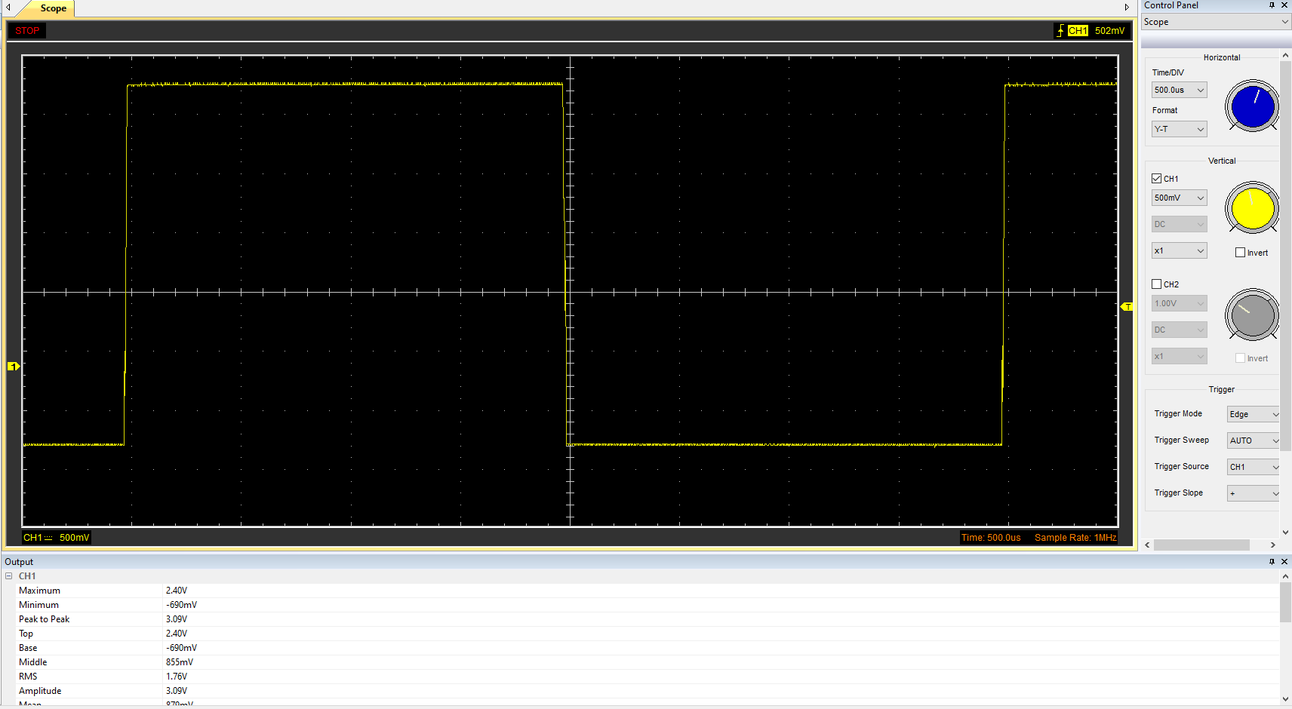

Capacitor charge and discharge wave marked at correct points. (3)
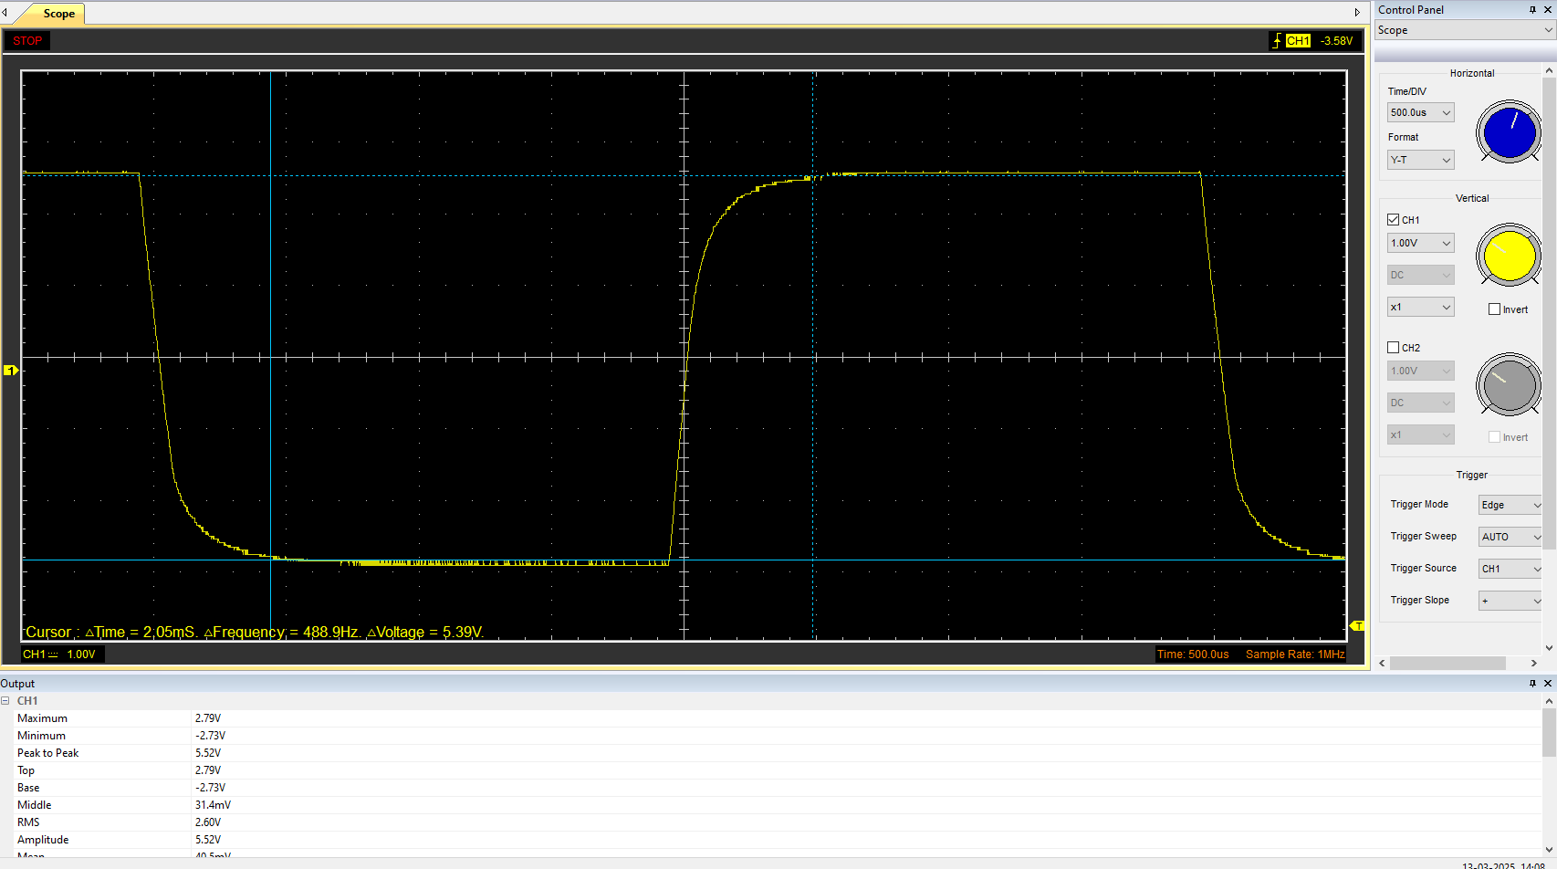

Basic Capacitor Calculations (3)

Capacitor discharge table (2)
Time (s) | Voltage (V) | ln (V) | dy = y2 – y1  dy = ln(V)2-ln(V)1 | dx = x2- x1  dx = Time2 – Time1 | dy/dx
 |  |  | x | x | x

Plot log(V) Gradient (2)

Gradient Calculations and Compare(4)

Gradient Calculations

Comparison table
 | Capacitance | Delta | Percentage difference
Actual | 1 µF | x | X
Marker Calculation
Gradient Calculation

Capacitor Uses (5)
Energy Storage:
Capacitors store electrical energy and can release it quickly, useful in applications like camera flashes or backup power for memory.
Power Conditioning:
They smooth out voltage and power flow in power supplies, filtering out noise and ripple in AC to DC conversion.
Signal Coupling/Decoupling:
Capacitors allow AC signals to pass while blocking DC, commonly used in audio systems and communication circuits.
Filtering:
In combination with resistors or inductors, capacitors are used in filters to allow or block specific frequency ranges (like in radios or equalizers).
Timing Circuits:
When used with resistors, capacitors can create delays or determine oscillation frequency—like in blinking lights or clock circuits.
Tuning Circuits:
In radios and TVs, variable capacitors are used to tune to specific frequencies.
Motor Starters:
Capacitors help start single-phase electric motors by providing the necessary phase shift to create a rotating magnetic field.
Snubber Circuits:
They suppress voltage spikes in switching devices like transistors or relays, protecting components from damage.
Power Factor Correction:
In AC power systems, capacitors improve power factor, making energy delivery more efficient.
Touch Sensors:
Capacitive touchscreens detect changes in capacitance when a finger is near, used in smartphones and tablets.
(Kaiser, 2012)

Inaccuracies Question (4)
One potential source of error in the measurement of capacitance in an RC circuit is the components tolerances. This is because resistors and capacitors are manufactured with tolerances, e.g. ±10%. This means that their real values may be different to what is printed on the component. This can affect the time constant, therefore resulting in discrepancies when calculating capacitance. (A.S. Sedra, 2015)
Another potential source of error in the measurement of capacitance in an RC circuit is temperature. Capacitor values can vary significantly with temperature, for example, an increase in temperature often leads to an increase in capacitance. This means that if measurements are taken under different thermal conditions than what the component was rated for, the capacitance may appear higher or lower than what is expected. (Jacob Millman, 1987)

References

A.S. Sedra, K. S. (2015). Microelectronic Circuits.
Jacob Millman, A. G. (1987). Microelectronics.
Kaiser, C. (2012). The capacitor handbook.

