RESEARCH PORTFOLIO

This small scale phenomenological project needed a wider number of participants to truly identify strong and resounding results, and thus leaves the results weakened. In developing this Practice as Research project, I neglected to establish a core number of participants and this has now limited the data received. Overlooking this essential fundamental factor has cost me deep in the purse, as the results are restricted to only four participants and thus the degree of efficiency in this data collection is inadequate. Although on reading the data there is a seventy-five percent positive affiliation to the research enquiry.
Ethically I considered and respected workshop participants responses and engagement to the disclosed and participatory elements of the workshop. Initially there was a consent form to be signed and the understanding of the work was described, and space given for any questions concerning the workshop and project. One participant on understanding the nature of the work felt that their emotional wellbeing would be too sensitive and fragile to engage in the process of the workshop and declined to attend the workshop. This was unexpected but respected.
Within this process I undertook designing a workshop based on recent relevant experiences I had undertook in workshops of this nature. Leading a workshop was to be a new experience and I doubted my ability and competence in sharing the profound and sometimes subtle esoteric quality of this work. In the initial stage of holding the space in the workshop, I lightly invited one participant whom had experienced similar exercises that I was to share in the workshop, to be supportive if necessary to the other participants. Unfortunately, I feel this was a mistake as I found this invitation allowed for a slightly aggressive and controlling dictation and atmosphere that I had not anticipated in the space. This is a strong lesson in self-belief and in building confidence in the preparation period, so that I can engage in the facilitation with self-reliance. One participant wrote in the optional reflective writing,
“Very natural facilitator, calming influence, did not need assistant.”
As it was I surprised myself in my ambiance and skilfulness of leading and responding to the participants in the series of exercises. Another participant wrote,
“The facilitation skills were a major influence into my response. I felt safe, secure and willing to challenge myself due to your facilitator manner and the constant reassurance.”
I established a safe space and responded to the present needs of the participants. Physical limitations were responded to in the warm up by a positive acceptance and assurance to allow for ease of wellbeing. The exercise ‘The Shoe Game’ where one is placed into a space with eyes closed and another person’s shoes are placed on your feet, you are asked to respond to the impulse that the shoes are giving you and are prompted to run or move like a hero, or do a sexy dance, one participant felt uncomfortable to close their eyes and to trust the supporting spotters. This was responded to with genuine acceptance. I then included this participant by asking them to prompt, to allow for inclusive engagement.
I believe I kept the workshop alive and engaging whilst securing a relaxed atmosphere. It was a joy to share my developing interest and experiences of somatic practices as tools for performance. Although I found that as the workshop developed there was an unforeseen presence of impatience that I believe was due to the participants other University work and dead-lines, and due to the subtle nature of the exercises. Although all participants were informed that the duration of the workshop was to be approximately an hour and a half, I sensed an urgency to be somewhere else and this factored in the omittance of a section of the workshop. ‘The fundamental Journey’ an exercise from Jacques Lecoq’s book ‘The Moving Body’. I suspected that for this group, it may have been a less connective exercise to pursue and may have generated a more mimetic response from the participants and a less physically embodied response.
I have also judged that a peer group is not the most effective group to enable precise results. As in their engagement in the process there was a slight lack of respect and focus towards the project and myself as a peer, which will have affected the development of the participants responses to the work. I also became aware of the importance of a genuine and honest reaction to the questionnaire, therefore I wanted to give time for this impart, and this also contributed to the omittance of the ‘Fundamental Journey.’
When assuming a pedantic opinion on this project, it has failed due to lack of participants. I would also consider changing the duration of the workshop to a period of three hours with a break, to further expand and explore the work, to enhance and strengthen the immersion and allow for a truly involved process, in hope that the participants were committed. My personal reflection on the process as a facilitator is that I am not qualified to teach as my own understanding and experiences are limited, and I need to develop my own practice primarily before embarking on a research project to distinguish relevant results, although saying that it has been a positive experience for myself and the group. I hope to develop these practices and continue to share them enthusiastically.
An unanticipated and unexpected consequence of the members of the group wearing the Neutral Mask was that of discomfort from heat behind the mask, which was frequently lifted from faces. In desiring to cater for a safe and comfortable environment for the group I accepted this, but my impression is that this interruption can interfere with the desired connection.
From the data received and applying this to the personalities present in the workshop I would deem that prior interest in this work would be beneficial to the discovery of techniques that can broaden the development of the performer, as the approach to the work at times showed a lack of attentiveness and commitment. Although as the workshop progressed I could see the development of a deeper sense of awareness and physical presence. To take part in a research project needs commitment, so the results truly reflect the process. I believe this was not wholly taken seriously.
Nevertheless, the data shows that the Neutral Mask work was very accessible and produced affirming results to the enquiry and hypotheses.

HYPOTHESES; Individuals who undertake Somatic practices and performance training in the methods of Neutral Mask by Jacques Lecoq are likely to experience a heightened state of awareness, become further physically embodied and feel freer to express themselves leading to development in performance skills.

The quantitative data from the questionnaire is as follows;
Did you experience a sense of connection to your body whilst laying on the floor breathing into your body parts?
NO VERY LITTLE YES AMAZINGLY SO
1 2 3 4
25% 25% 50%
One participant wrote in the optional reflective writing,
“The beginning exercises really put me in my body, it shifted my focus to me solely.”
This result is seventy-five percent positive, and conveys that breath work and attention given to the body in this manner can lead to a sense of connection and presence in the body.

Did you experience any difference in the body, any feelings of expansion when using the Tennis Ball exercises?
NO VERY LITTLE YES AMAZINGLY SO
1 2 3 4
25% 25% 50%
The Tennis Ball exercise I have commandeered from John Wright’s Mask workshop. It has it roots in ‘Feldenkrais methods’ of exploring the body. The tennis ball is placed under the head, and under the left and right butt cheek, it is rolled around the foot in a series of short exercises and breath work entails. Each time the ball is removed, we rest whilst exploring the changes in our bodies.
“More delicate and improved control of movement is possible only through the increase of sensitivity, through a greater ability to sense differences” (Pergola, Mara Della. 2003)
We may feel longer or wider. Feldenkrais Method offers the practioner the chance to finely tune into bodily awareness. Again, we see a seventy-five percent positive response to this exercise. The purpose and development of these short exercises was to bring the participants into awareness of their bodies. The Feldenkrais Method is used extensively in many genres from the healing of injuries to performance training it is a somatic practice and discipline. Its benefits to the performer are heightened awareness of the self and connection that will aid new choices as a performer.
‘In the creative arts, and particularly in the processes of making dance and theatre, the Feldenkrais method can enhance the ability to think creatively by exploring ways of moving that our outside our usual range and movement habits.’ (Bernhard-Reed, 2016).
The further I research the techniques of somatic practices for the development of the performer, the more resounding and confirming the results are.

Did you experience a new physical quality or originality to your movement whilst engaging in the Shoe Game with eyes closed?
NO VERY LITTLE YES AMAZINGLY SO
1 2 3 4
50% 50%
During the Practice as Research process I have engaged in a five-day Mask workshop with a leading practitioner and director in the field of masks as tools for performance training, John Wright. This was another personal exploration into the use of impulse and mask as a method of training in performance.
“’Impulse’ is an interesting word. It means an ‘unreflective urge’ to do something, a ‘thoughtless motivation’, a ‘sudden desire’ to move in a particular way. We get impulses from almost anything: smells, tastes, sounds, textures and images are all rich sources of personal impulses.” (Wright, 2017).
John Wright’s workshop inspired and influenced two additional exercises into the development and design of my own workshop. One being the Shoe Game. In relationship to impulse I have used the Shoe Game as it is a game that relies purely on the impulse of the unseen and possibly ill-fitting shoes of someone else’s, on one’s own feet. This experience is the motivation for movement. The impulse. The shoes influence you to instinctively change your gait and carriage and how you transport yourself. Focus is solely in the body.

To give the members of the group an understanding and awareness of what an impulse in the body may feel like, I directed them to play catch and to tease each other with when they might throw the ball. This allowed them to recognise how an impulse appears through the body when they instinctively responded to a feeling of when the ball was going to be thrown, but was not.
The Shoe Game taken from John Wright’s Mask workshop, allowed the participant to respond from the impulses that are felt when wearing another person’s shoes.
“The shoes give you an impulse. You see you can be active or passive in the mask but with the shoe game you get a big impulse from a different pair of shoes. Put on a pair of boots your feel one thing, trainers you feel something else. In other words, your feet will be at different angles, you get a different feeling from your feet and you walk differently, and that’s what I mean by an impulse. This unreflective desire to move in a particular way. When you have your eyes closed that feeling is stronger. When you open your eyes and you can see what you are doing and where you are in the space and the feeling is not so strong, but it’s still there and the skill is to see if you can go with the feeling rather than let your spatial awareness take over that’s what that game is about.” (Phone conversation John Wright. 11th January 2018)
Here we have a one hundred percent positive response to the development of new physicality experienced. I consider this data confirms that through somatic exercises one can connect to the body leading to the development of new movement quality that can enrich performance ability. The data reveals that through embodiment there is an expansion of performative expression.

When you had your eyes open could you maintain the same quality of movement in the shoe game?
NO VERY LITTLE YES AMAZINGLY SO
1 2 3 4
25% 50% 25%
From my own qualitative response to observing the participants responding to this task I have concluded that with the opening of eyes the quality of movement became less interesting to watch and you could see the ego appear in the movement. They wanted to be clever and in control. As a performance tool this exercise and data clearly show the new possibilities of movement available through using impulse with eyes closed. The trick I believe as a performer is to sustain these new movement qualities with eyes open.

Did you experience a new physical quality or originality to your movement in the improv with eyes closed?
NO VERY LITTLE YES AMAZINGLY SO
1 2 3 4
25% 50% 25%
In this exercise based on ‘Authentic Movement’ responding again to impulse the participants split in half and witnessed each other. This was done with eyes closed responding to impulse and the results are seventy-five percent in favour of the exercise affording new possibilities to movement. By this stage in the workshop I observed that the members of the group were relaxed and engaging positively to the exercises and the movement quality had become freer and the connection to the impulse was perceivable.

Did your experience with eyes open differ from that of eyes closed?
NO VERY LITTLE YES AMAZINGLY SO
1 2 3 4
25% 75%
The second phase of the exercise was to open your eyes and respond to impulse. There is a clear result here that identifies the awareness of the participants response to movement quality with eyes closed and eyes open, with one hundred percent confirming the difference. We discussed the change and the benefits of finding the quality of movement when eyes were closed and how to embrace this with eyes open. We concluded that these practices needed to be a consistent part of performance training.

Did you experience a heightened state of awareness whilst wearing the Neutral Mask?
NO VERY LITTLE YES AMAZINGLY SO
1 2 3 4
25% 25% 50%
In the optional qualitative descriptive and reflective writing of the workshop experience that participants were invited to impart; these comments stand out;
“I felt a heightened sense of attention to my movement.”
“I felt very in tune with my physicality and expression.”
“The physicalizing of the colours brought heightened awareness to my perception of the world. Colours became personified and gathered meaning and association.”
The purpose in employing a qualitative research methodology in the shape of descriptive writing was to invite an unstructured and unsuggested response to the process, as I have considered that the questions are directive of a specific response.

Did you feel freer to express yourself whilst wearing the Neutral Mask?
NO VERY LITTLE YES AMAZINGLY SO
1 2 3 4
75% 25%
The data reflects positively that through Neutral Mask there is an empowerment to be gained in this training. It creates freedom and opportunity to express physicality that were not available prior to the work. In observing the participants, I saw the beauty of the mask do its work. The members of the group felt hidden and the feelings of responsibility and consequence disappeared. The ego was silent, the need to be perfect or right dissolved. It did not concern ‘how good you could do something’ but the awareness was about what was happening in the present. The movement quality had an abandonment and yet still precision. I focused on the Neutral Mask exercises from Jacques Lecoq’s ‘The Moving Body’ where upon I asks the group to become the different elements from a small raindrop, to a raging sea river and then I asked them to become the sea. Similarly, I requested how did it feel to be a small flame, how did it feel to be a fire, a forest fire. I encouraged the group to use all of their bodies and to use the whole space. Continually asking How do you move as a…?’ ‘How do you feel?’ The next exercise was an exploration of becoming thirteen different colours. The group genuinely seemed to respond to these exercises and the physicalisation was a pleasure to watch.
These exercises are in the chapter ‘Improvisation’, under the sub title ‘Identification with the natural world.’ I selected these exercises as my own experience and observation of them, was that they are very accessible to identify with.
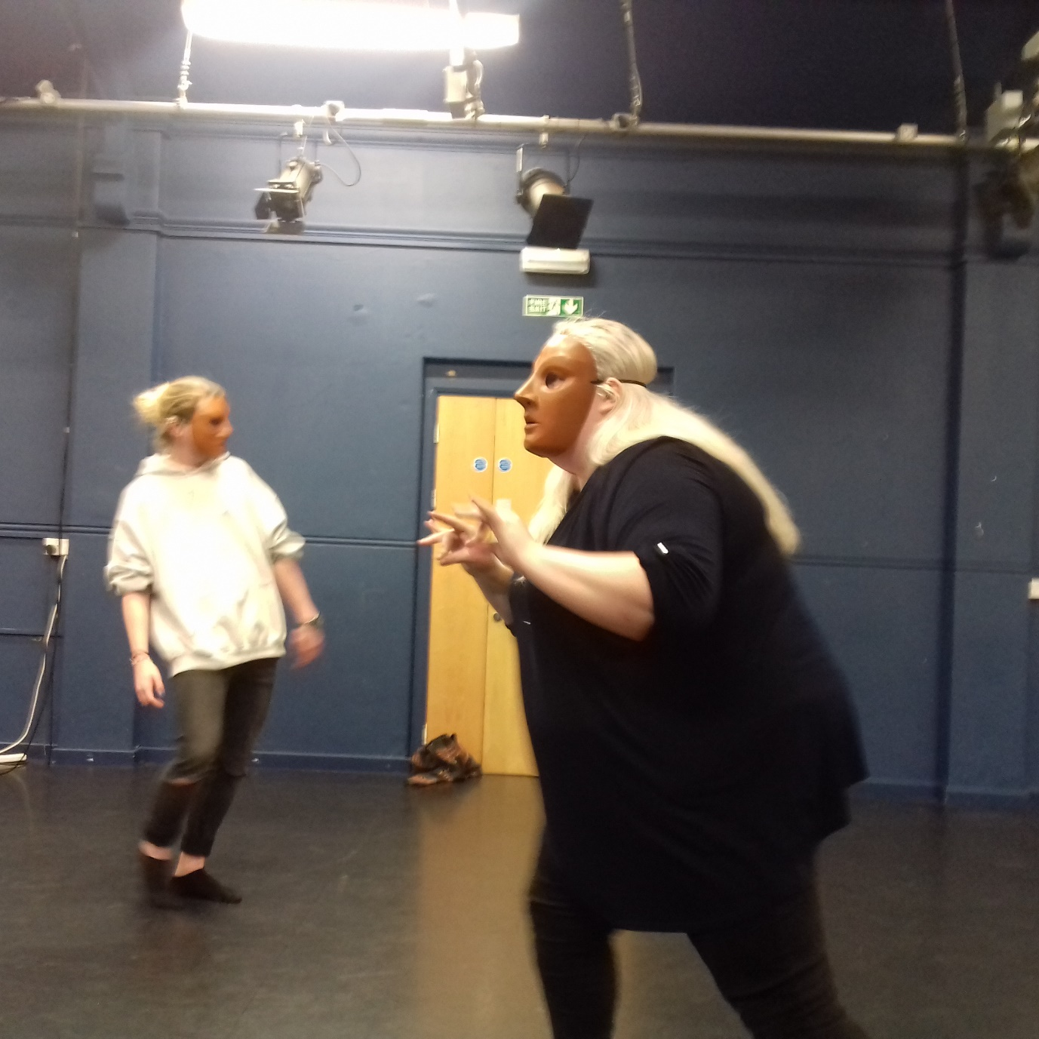

Did you feel that your movement in the Neutral Mask was economical?
NO VERY LITTLE YES AMAZINGLY SO
1 2 3 4
25% 25% 50%
This result shows a fifty-fifty percent outcome to the question. I would like to note that whilst wearing the Neutral Mask it is hard to judge your own economy. You may feel that your movement quality is bigger than it is in actuality. As a witness to the movement of the participants I observed that there were certainly very obvious moments of economy. 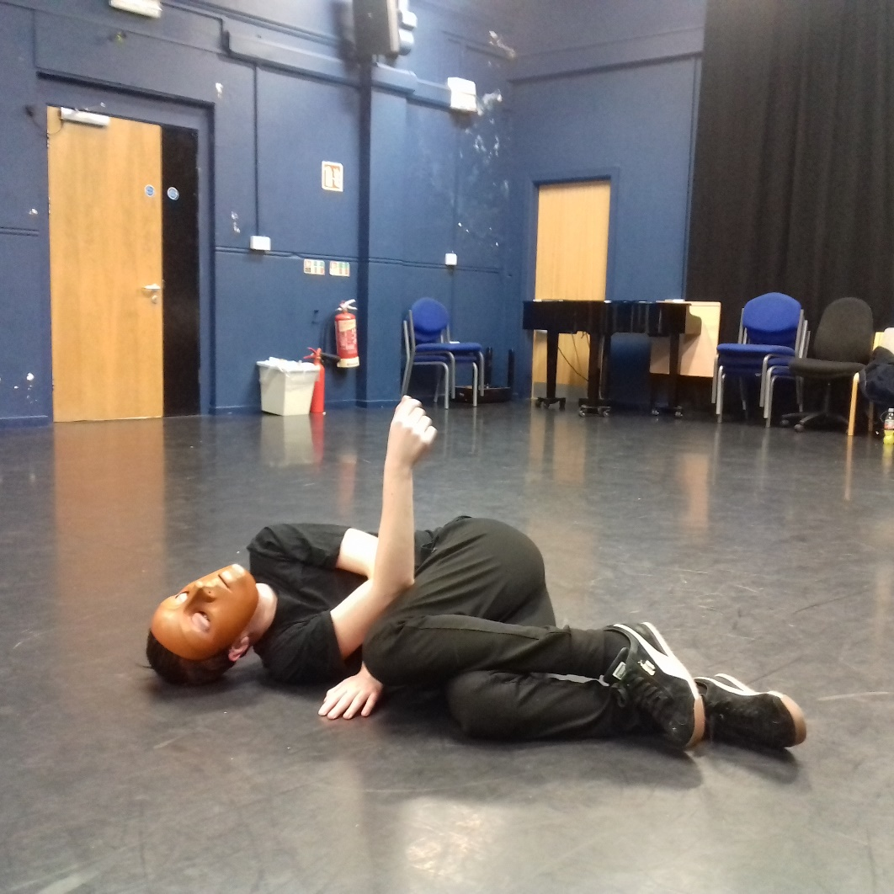

Do you feel this practice can enrich further performance practice?
NO VERY LITTLE YES AMAZINGLY SO
1 2 3 4
75% 25%
The results here confidently indicate that somatic practices and Neutral Mask evoke a strong development in enrichment to the practitioner and performer. The groups new-found self-awareness and the discovery of new movement in a short workshop project such as this, without true qualification to lead the group professionally has nevertheless had a huge impact. I can Imagine these techniques if adopted as a committed practice could completely enhance connection and creativity.
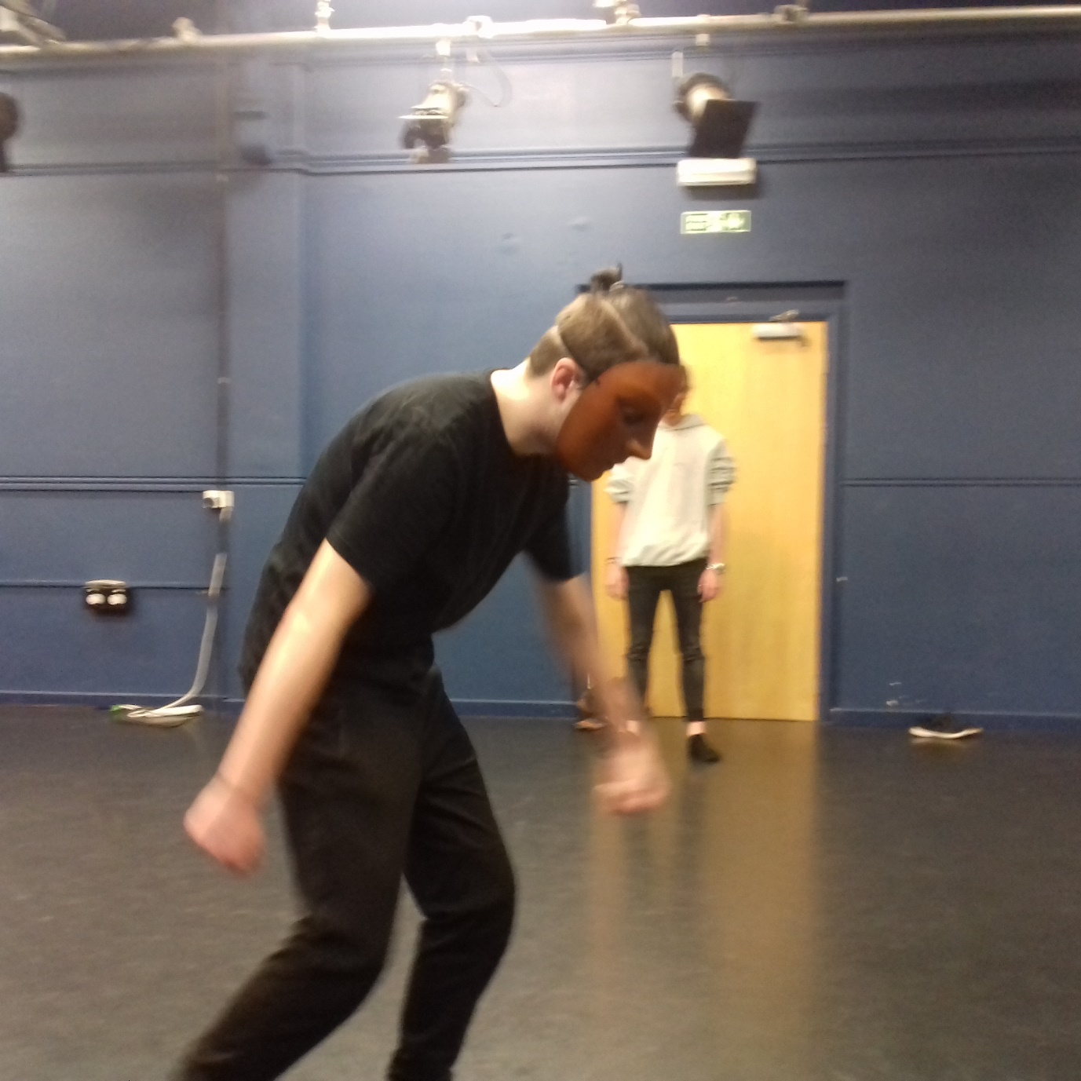
The colour Black.

The participants have heralded a one hundred percent positive response to the question of the practice of Neutral Mask, to be enriching to further performance practice. This is sufficient evidence in justifying the research query.

Did you experience a disappearance of previous performative identification and an emergence of physical expression that was fresh to you?
NO VERY LITTLE YES AMAZINGLY SO
1 2 3 4

25% 25% 50%
The results here are indicating a transformational experience that supports the Practice as Research enquiry, and confirms that through somatic practice and Neutral Mask training new discoveries can affectively develop the performer.

Would you be interested in doing more work of this nature?
NO YES
1 2
25% 75%

As a result of this Practice as Research project I believe I have highlighted the benefits of Somatic practices and Mask work as a transformative method in approaching the development of the performer and hence performance. From a personal perspective I am verifying to myself that physical embodiment allows for a sense of freedom that is separate from the ego and makes one available for a new and dynamic approach to performance and movement quality. Through the recognition of these practices a richness of expression can prevail, and this presence is of significant use in the world of contemporary performance and theatre and that of the development of the performer as an unique and individual artist. I would adhere to these results and would encourage all performers to engage with such work.
I conclude that this series of exercises has been a positive experience for the participants and it is affirming to the practice as research project, that the use of somatic practices and Neutral Mask work is an effective tool in the development of performance training. I trust that this report may inspire further use of somatic and mask work for students at the Townhill University and support essential training in the development of performance.

References

Bernhard-Reed, S. (2016) Feldenkrais and the arts. Available at www.feldenkrais.co.uk/articles/the-arts.html. (Accessed 9th January 2018).
Pergola, M, D. (2003) ‘Working with Actors’, Feldenkrais Journal, 16, pp.33-41.
Wright, J. (2017) Playing the Mask. London: Nick Hern Books Limited.

