
Programme: BA Leadership and Management Skills for the Workplace
Module: Strategic Management for SMEs
Module code: BMSW6104
Assignment Title: Strategic Management for SMEs
Task 1
Company: Miss Macaroon

Student name: Petru Parasca
Student ID: 2123010
Lecturer: Abdallah Naser

Table of Contents
1. Introduction 3
2. Critically appraise the organization’s current strategic direction 4
3. SWOT Analysis 6
4. PESTLE Analysis 8
4.1 Political Factor 8
4.2 Economic Factor 9
4.3 Social Factor 11
4.4 Technological Factor 12
4.5 Legal Factor 13
4.6 Environmental Factor 13
5. Different Theories and impact on the business 13
5. Stakeholder analysis and evaluation 14
5.1 Customers, their relative power, and expectations: 14
5.2 Employees, their relative power, and expectations: 15
5.3 Investors, their relative power and expectations: 15
5.4 Community partners, their relative power and expectations: 15
5.5 Suppliers, their relative power, and expectations: 16
6. The Ansoff Matrix: 19
7. Recommendations 19
8. Conclusion 20
9. References 21

Introduction
Small and Medium Enterprises (SMEs) have a significant and positive impact on the UK economy as well as on the sustainability of business development. The perspective of SMEs highly contributes to economic growth and development, innovation, and an increase in the rate of employment (Sabnis et al., 2023). However, SMEs consist of new start-ups, and new setups of innovating especially in the food business, less than 500 employees are considered in the SMEs. Significantly, around 61 percent of the unemployed population gets the employment opportunity through SMEs. The individuals with passion to pursue their career in the field which they admired. However, food, clothing, and pets caretaker etc.
However, this report highly focuses on the SMEs namely Miss Macaroon which was developed by Rosie Findlay, she has the vision to provide delicious Macaroons and earn through it (Farjam and Rahdar, 2023). In regards, to this concert of Macaroons, frequent training, and started to sell her Macaroons in workshops, seminars, events, and festivals to create awareness about her business (Zahra, 2021). She has the ability and specialization to provide gluten-free macaroons. Significantly, with time business grows with prosperity. However, she invested highly in business equipment and rented a place in which she could open her kitchen and purchase all the necessary items and ingredients. Social enterprises provide the training for the marginalized youth. She significantly provides training programs through which she generates a second source of income (Gerhart and Feng, 2021). This report includes the internal and external analysis to have a broader perspective related to Miss Macaroon. On the other hand, this study utilizes the different stakeholder's analysis and their evaluation to aid in the progress of the business development. In addition, different models and theories have been discussed to support this study (Varma and Dutta, 2022).

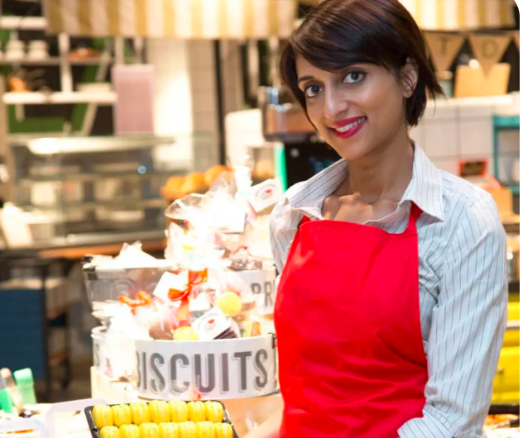
Figuer#2: Miss Macaroons
Source: (Bissar and Özcan, 2022)

Critically appraise the organization’s current strategic direction
Market reputation is essential for the business in developing its standards in the competitive market. However, Miss Macaroon has a significant, unique, and distinct market position in the dessert and sweet market. Moreover, Miss Macaroon has settled by differentiating their business from their competitors (Rekouane, and Khalifa, 2020). By providing high-quality desserts and through positive word of mouth they create their brand position in their customer's minds. However, Miss Macaroon's current position is significant and reliable for sustainability in the competitive market (Freeman, 2023). However, Macaroons with their delicious flavors and colored ingredients. However, in the MBCC Multicultural Business and Community Champion Awards which was held in ten year 2016, Rosie won the most influential business person. Miss Macaroon works as a Social entrepreneur by providing training and workshops to provide information credibility about cooking. Currently, Miss Macaroon supports around 104 young individuals to have a prosperous and bright future (Matos-Filipe et al., 2022).

Figure#3: Award winning Miss Macaroons
Source: (Freudenreich et al., 2020)
In the strategic direction, Miss Macaroon broadly emphasizes market expansion both domestically and internationally. Moreover, various digital platforms such as online marketing, influencer marketing, and partnerships with suppliers can enhance the financial position of the business. Significantly, the other strategic direction include various flavors in the macaroon can enhance the reliability of the business (Kruesi and Bazelmans, 2023). Subsequently, the social impact of Miss Macaroon provides valuable support in the role of business integrity. Frequently, the development of the business along with the social practices enhance the valuable insight of Miss Macaroons. Significantly, this business fulfills its commitments with aligned strategic goals which represent a positive work environment and provide feasibility and flexibility to marginalized individuals by providing them training which leads to the source of earning for them (Lubis, 2022).
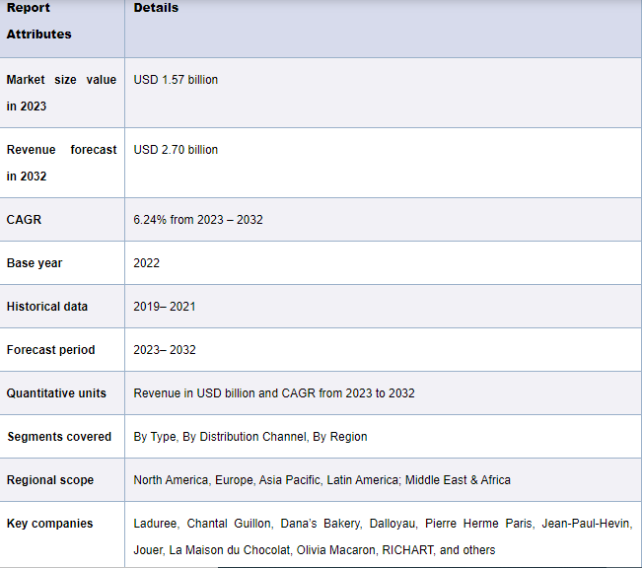
Figure#4: Market Scope
Source: (Polaris, 2024)

SWOT Analysis
Strength  - This idea is reflected in the organization’s strong brand identity as a provider of training and employment for disadvantaged youths.  - Luxury chocolates and pastries including Macaroons are famous for using good quality ingredients and made by specialized and skilled personnel.  - Decision-making as a socially sensitive organization promotes the appeal of customers.  - Creative innovation to create and introduce new products for the market to adapt (Zahra, 2021).  - Arranges some events for the participants, collaborations, and social responsibility activities involving the local inhabitants. | Weakness  - Issues that can be associated with the growth of operations without a negative impact on society.  - The dependency on grants or donations for financing the training programs or social projects.  - Luxury products such as gourmet desserts are not very popular when compared to mass products (Barney and Harrison, 2020).  - Small size include limited resources that can be used to conduct proper marketing and distribution.  - It might remain a perpetual struggle to maintain the dual objectives of making a profit and serving society's needs.
Opportunities  - Existing opportunities in the home market and in the foreign markets to offer gourmet desserts (Park et al., 2020).  - Work closely with retailer’s cafes, and corporate customers to increase the market outlets.  - Expansion of the scope of services through the introduction of new product lines or services for conducting baking workshops or additional catering services.  - CSR offers chances of affiliation with other business organizations that embrace social responsibility agendas.  - Increasing consumer preference towards online buying and direct selling of specialty foods. | Threats  - Competitive rivalry between gourmet dessert brands and local bakeries.  - The changing and shifting of raw materials and business cycles affect consumers' choices for the products they wish to indulge themselves with.  - New legislation governing food safety or new employment laws that affect operations.  - This was because negative publicity or failure to meet the social impact goals could be catastrophic to brand reputation.  - Reliance on suppliers for quality inputs and food packaging materials which affected by the occurrences (Varma and Dutta, 2022).

PESTLE Analysis

4.1 Political Factor
- Impact of Brexit on supply chain and tariffs (Kovid et al., 2021).
- Government Regulations ensure that the business conforms to the Food safety and hygiene measures as laid down by the local and national authorities (Shortridge et al., 2023).
- Tax Policies includes the Effects of applying the VAT and corporate taxes on business activities and earnings.
- Political stability for business operations as well as consumer trust.
- Public Policy Initiatives include Demographic policy favorable for social enterprises and programs for youth employment.

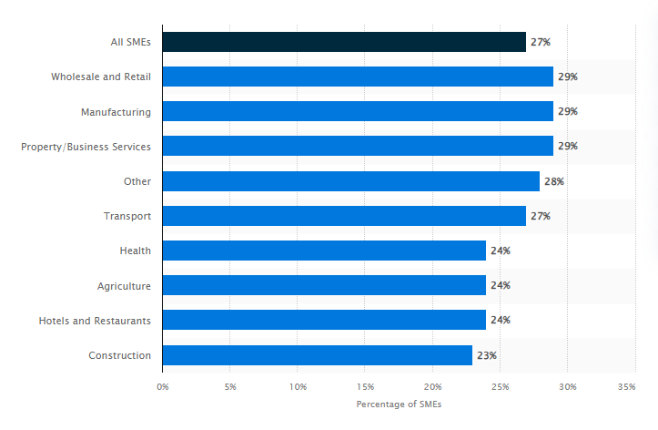

Figure#5: SMEs contributing in UK market
Source: (Statista, 2024)

Economic Factor
- Consumer spending in the trends of disposable income impacting demand for luxury gourmet macaroons.
- Economic Growth includes the macroeconomic condition in a globalized world affecting the economy in terms of consumer confidence and spending.
- Exchange Rates reflect the effect on the importation of ingredients or packaging material expenses that are bought in foreign countries.
- Inflation Rates include the Price stability of raw materials and integrated operating costs (Kovid et al., 2021).
- Various aspects such as inflation rate, interest rates, and the general economic climate are likely to influence consumer expenditure patterns. Thus, during periods of economic recession consumers not afford gourmet macaroons while during periods of economic upturn they afford them.
- In recession, people cut down on their expenses for specialty products such as gourmet macaroons whereas in a bullish market, people be ready to spend more.
- There is competition within the confectionery industry which affects the pricing as well as the profitability of macaroons.
- Fluctuations in prices can be influenced by entrants, changes in competitors’ strategies or innovations in products.
- Fluctuation is transport costs, warehousing, and distribution channel can have an impact on the final price of macaroons. Hence the costs can vary due to changes in petrol prices or alteration of trade relations.

Figure#5: Consumer Spending on Confectionery
Source: (Statista, 2024)
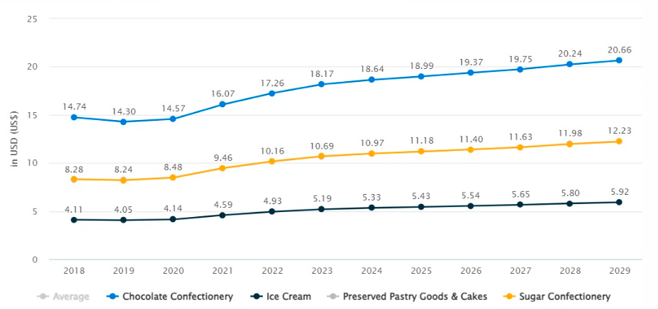
Figure#: Price per unit
Source: (Statista, 2024)
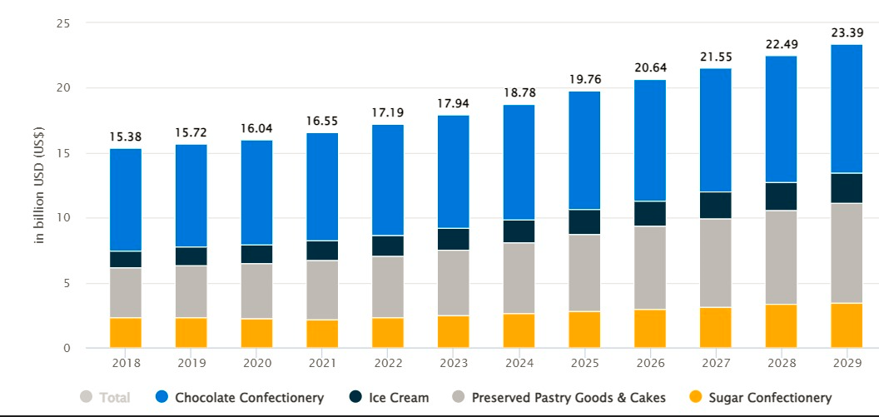
Figure# Average Revenue per capita
Source: (Statista, 2024)
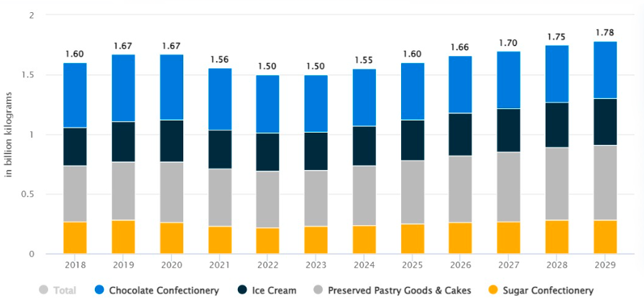
Figure#: Volume change
Source: (Statista, 2024)

Social Factor
- Consumer changing trends are associated with the rise and development of foodie culture in people and their tendencies to consume artisanal and gourmet food products.
- Health and Wellness Trends give consumers a signal to look for healthier options in a dessert (Bahill and Madni, 2023).
- Social Responsibility includes the higher for businesses that extend their support to social-related issues, improving brand reputation.
- Demographic Changes in age characteristics influence the targeting of the product and the actual consumption.
- Cultural Factors include the effect of local and regional palates on the different products that are prepared and served.
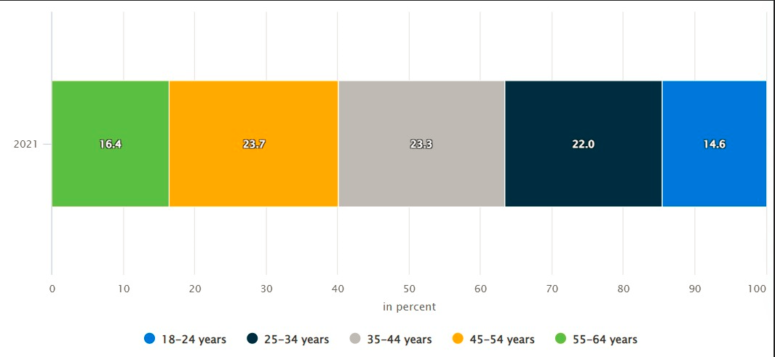
Figure#: Demographics
Source: (Statista, 2024)

Technological Factor
- E-commerce: Digitalization through the creation of online marketing and direct sales to consumers.
- Expansion of new and innovative digital platforms namely Facebook, Instagram, and other sales channels directly do marketing to sell their profits.
- Digital presence by using digital tools such as Mail chimp, Canva, graphic designing, and Google Analytics to increase the visibility and online presence by providing creative content by daily posting on the online pages to interact with customers and create their business awareness.
- Automation uses technology in production to ensure that the quality and quantity of the products are improved.
- Supply Chain Management include Technology of stock control and other physical flows in the supply chain.
- Food Technology include the innovation of the type of ingredients used or the method of processing to enhance the quality and or longevity of the finished product.

Legal Factor
- Food Safety Regulations includes the measures and guidelines as to minimally required levels of health and hygiene during food preparation and food handling.
- Employment Laws include compliance with the rules of employment, wages, working hours, and so on.
- Intellectual Property includes the securing and safeguarding of recipes, the brand trademark, and intellectual property.
- Contractual Obligations issues related to legal aspects in supplier contracts, leasing, and joint ventures.
- Data Protection include Maintenance of the GDPR matters concerning the clients’ information and their protection.

Environmental Factor
- Sustainable Sourcing includes the intensifying pressure, especially from the consumers to employ green and sustainable materials and ingredients.
- Waste Management includes Ideas about how to minimize the amount of packaging and increase the use of recycling services (Rodrigues and Spence, 2023).
- Carbon Footprint reflects the measures to reduce the emission of greenhouse gases in production, distribution, and consumption.
- Climate Change includes the Effects of climate changes and weather conditions on the supplies of the ingredients and costs of manufacturing.

Different Theories and impact on the business
Miss Macaroon supports the theory of social enterprise where the ultimate aim is to serve social objectives whilst also maintaining efficiency (Sabnis et al., 2023). Miss Macaroon incorporates its aim to offer career guidance and job placements to the youth into placement in SMEs. In the view of Belitski et al., (2023), through the sale of gourmet macaroons, the company can get its revenues to support the mentioned social causes, thus giving out a revolving cycle of social change and economic returns. In contrast, RBV postulates that the source of sustainable competitive advantage of a firm is in the firm-specific resources and capabilities (Ramadhanti et al., 2024). Resources for Miss Macaroon are the brand reputation as a socially responsible company, experience in the culinary sphere, necessary for the macaroon production, and connections with local communities and training providers. Contradictory, Sabnis et al., (2023), resources that help the company stand out in the attractive yet saturated market of gourmet desserts and secure its dual, business and social, purpose. In the view of Valenzuela, (2021), innovation theory is introduced to highlight the aspect of sustained innovation as a way of sustaining competitive edge. On the other hand, innovation is also reflected in the product. However, creating new macaroon flavors and venturing into markets it has not tried before as in the case of Miss Macaroon (Ramadhanti et al., 2024).
Moreover, social responsibility also improves through growing training programs as well as adjusting purposes of the social projects for the company concerning the needs of disadvantaged youth and society in general. However, these theories highly support this research. Stakeholder theory is one theory arguing that the interests of all the stakeholders in the business should be taken into consideration by the management (Belitski et al., 2023). Miss Macaroon has its objectives geared toward its stakeholders which include employees, trainees, customers, suppliers, and society. The welfare of different stakeholders is improved since the company only hires young people who have limited opportunity to enter the job market hence improving the company's brand image and customer loyalty since the business is carried out efficient way (Baek and Lee, 2020).

Stakeholder analysis and evaluation

Customers, their relative power, and expectations:
Customers are considered the main stakeholders of the Company. Their source of power originates from the possessions such as financial and human capital.
Customers can withdraw from the chain if the company fails to meet their expectations. Additionally, the success of the company is based on customer satisfaction.
Customers’ expectations from the company include the delivery of high-quality products, ethical practices, and social impact.

Employees, their relative power, and expectations:
Employees possess a direct stake in the company because they develop services delivered by the company, and the quality of their work has a direct influence on customer support. Employees receive wages to support themselves, including other benefits. Therefore, they have a high interest in the company.
Employees did seem to have medium power in the company because of replacement issues, limited career progression, and industry competition.
Employees usually expect the company to pay them fairly and want a supportive environment. Their expectation includes growth, work-life balance, job security, and transparency in terms of recognition and flexibility.

Investors, their relative power and expectations:
The main shareholders that help the company to become financially stable and make the completion of projects by providing funds are Investors, shareholders, and stockholders. The investor provides funding with the expectation of earning a profit on their investment.
They can directly influence the company’s position when they are disappointed with its business plan or objectives. The performance of the company has a direct or indirect impact on these investors, and these investors have a more or less significant influence on the company. Therefore, the company is responsible to all investors and must take their confidence in their opinions.
Investors include both shareholders and debt holders. Shareholders invest capital in the business and expect to earn a certain rate of return on that invested capital. They also expect social impact metrics from the company.

Community partners, their relative power and expectations:
Community partners exist as organizations in the company that already serve the target population in some way.
Community partners help the company to attract more support, whether volunteers or financial contributions.
Their expectation includes collaborative efforts for social good and community development from the company.

Suppliers, their relative power, and expectations:
Suppliers provide the company with the essential raw materials or facilities to carry out its operations. Suppliers are directly involved in the company’s operations. However, suppliers do not exist inside of the company but they are still considered primary stakeholders.
Without their co-corporation and efficiency in providing valuable materials, the company not be able to make good quality products. Suppliers provide resources, and materials, that do not exist in-house with the company, which improves the company’s ability to meet customer needs. In return, suppliers expect Fairtrade practices and sustainable sourcing.
Miss Macaroon's company should adopt a new strategy that helps them to elevate their growth factor. For this instance, the Ansoff matrix can emerge as the best strategy. It helps to classify the best strategic choices and evaluate risk. It can serve as a company tool or it can be applicable in individual departments, such as Marketing. It's rapid and easy to understand. More importantly, it is designed to help the company to focus and develop.
 | Low interest | High interest
High power | - Miss Macaroons Co-founder | -CEO  -Miss Macaroon  -Project owner  -Suppliers
Low power | -Competitors | -Olivia Macaroon  -Le Macaroon  -Project Team  -Miss Macraoon employees

Stakeholder | Internal/External | Power/Interest Stakeholders have | Impact on Project or be Affected by Project | Communication Strategy
CEO | Internal | High Power/High Interest | Miss Macaroons is going to get future investors to work on a project that will generate and increase the financial position. But, if the project fails, it would be hard for the CEO, Miss Macaroons to get another project. | Before the task deadline there is meeting in which each query will be concern.
Project Team | Internal | Low Power/High Interest | Ensuring about the each individual must engage with their designed responsibility and achieve the targeted success. | Weekly Meetings
Project owner | Internal | High Power/High Interest | Miss Macaroons need to be satisfied with the aims, objectives and aligning the goals of the Entrepreneurial events which will be free of sot for the marginalized individuals. | Weekly Meeting and discussion
Le Macaroon | External | High power/low power | The impact of the Le macaroon will effect of the performance of Miss Macaroon financial performance. | Analysis the performance metric and monitoring strategies of Le Macaroon reflects higher tendency of improvement in the productivity of Miss macaroons.
Competitors | External | Low Power/High Interest | Keep updated with the competitors upgrading and implementing unique selling point. However, monitoring the competitor’s strategies and evaluating their performance. | Data analytics
Suppliers | External | Low Power/High Interest | They can impact on the supply chain distribution. | Communicating with suppliers enhance the credibility in working environment.
Miss Macaroon employees | Internal | Low Power/High Interest | The employees of Miss Macrons need to be satisfied with the require task so that a successful project can be developed, which will promote productivity in the company. | Weekly discussion and progress
Olivia Macaroon | External | Low Power/High Interest | Through using social media and different digital tools will impact highly on engaging customer attraction and improves the financial performance. | Advertisement through print and digital media.

The Ansoff Matrix:
The Ansoff Matrix, known as the Product/Market Expansion Grid. Ansoff Matrix is a two-by-two outline that is used by management teams to evaluate growth initiatives. It helps the company to conceptualize the level of risk linked with diverse growth policies. The matrix is founded on the ideology that two key methods exist to develop a company: expanding to new markets or developing new contributions. By the implication of these tactics, the Ansoff matrix focuses on the four methods for expansion namely market penetration, product development, market development, and diversification.
- Market Penetration: It helps the company to focus on expanding sales of existing products in existing markets: The market penetration strategy of the Ansoff matrix helps the company to determine strategies to sell more of its existing products to the existing customer. Which is usually based on aggressive promotion and distribution. By using this strategy, the company will be able to grow its market share in its existing market scenario.

Recommendations
- The expansion of the product range should be diversified Miss Macaroon can decide to add new flavors to the products on a timely basis and even give them a seasonal theme. Also, in-line products like pastries or confectioneries should be done because they have the advantage of branding and customers.
- The extension of the market and the distribution are said to be very essential for growth. It is suggested that the company should concentrate on expanding the sales territory within the United Kingdom and think about the international markets. Employing coffee and food specialists in cafés, restaurants specialty food retailers to expand distribution channels for the consumable. Furthermore, it will strengthen the online and e-commerce sites, due to the increasing demand for gourmet foods online, which can become profitable.
- Miss Macaroon should scale up financial sustainability by providing a clear financial strategy that will ensure that the business does not solely focus on the aspect of making profits but has to meet the intended social impacts. This involves looking for other sources of funding or investment to finance expansion and sustainability projects.
- Developing a strategy that includes marketing and branding, with emphasis placed both on the quality of the product and social aspects of the enterprise. Advertising to specific groups of consumers, online marketing strategies, sponsorship in food fairs, and other related events will enhance brand awareness and consumer awareness. The use of social media platforms to push the Company's social responsibility stories will appeal to the new wave of consumers who are socially responsively aware.

Conclusion
This study was based on the SMEs in which Miss Macron's start-up business was selected. However, the business was established in the years 2011, to pursue the visionary goals of becoming a chef and an entrepreneur. However, this is a social enterprise At the start there were certain hurdles and difficulties in accomplishing the goals and maintaining the financial position. However, in the strategic direction, Miss Macaroon broadly emphasizes market expansion both domestically and internationally. Moreover, various digital platforms such as online marketing, influencer marketing, and partnerships with suppliers can enhance the financial position of the business. Furthermore, internal and external analysis was included to have a better perspective on the market analysis for Miss Macaroons. However, theories such as Resource-based view theory, social enterprise, and innovation theory were included to support this research. However, Stakeholders analysis and its evaluation were included significantly, Employees possess a direct stake in the company because they develop services delivered by the company, and the quality of their work has a direct influence on customer support. The performance of the company has a direct or indirect impact on these investors, and these investors have a more or less significant influence on the company. Suppliers provide the company with the essential raw materials or facilities to carry out its operations. Suppliers are directly involved in the company’s operations.

References
Amy North, 2021. https://bakeryinfo.co.uk/movers/miss-macaroon-founder-wins-natwest-everywoman-award/662715.article Accessible on 5th July 2024.
Ansoff matrix: Overview, strategies, and examples (no date) aware digital. Available at: https://awware.co/blog/ansoff-matrix/ (Accessed: 05 July 2024).
Baek, C.W. and Lee, J.H., 2020. Quality evaluation of macaroons added with moringa leaf (Moringa oleifera Lam.) and green tea powder. Food Science and Preservation, 27(5), pp.555-565.
Bahill, A.T. and Madni, A.M., 2023. Overarching Process for Systems Engineering and Design. In Handbook of Model-Based Systems Engineering (pp. 195-256). Cham: Springer International Publishing.
Barney, J.B. and Harrison, J.S., 2020. Stakeholder theory at the crossroads. Business & Society, 59(2), pp.203-212.
Belitski, M., Korosteleva, J. and Piscitello, L., 2023. Digital affordances and entrepreneurial dynamics: New evidence from European regions. Technovation, 119, p.102442.
Bissar, S. and Özcan, M.M., 2022. Determination of quality parameters and gluten-free macaron production from carob fruit and sorghum. International Journal of Gastronomy and Food Science, 27, p.100460.
Brian Baker, C. (2023) What is an investor and what do they do?, Bankrate. Available at: https://www.bankrate.com/investing/what-does-an-investor-do/#:~:text=An investor is a person, who returns if they are successful. (Accessed: 05 July 2024).
Canada, G.A. (2023) Spotlight – market diversification, GAC. Available at: https://www.tradecommissioner.gc.ca/guides/spotlight-pleins_feux/spotlight-diversification-pleins-feux-diversification.aspx?lang=eng (Accessed: 05 July 2024).
Farjam, S. and Rahdar, L., 2023. Identifying Factors Affecting the Job Crafting of Marketing Employees in the Export Department of Zar Macaroon Company. Commercial Surveys, 21(121), pp.89-107.
Freeman, R.E., 2023. The politics of stakeholder theory: Some future directions. In R. Edward Freeman’s Selected Works on Stakeholder Theory and Business Ethics (pp. 119-132). Cham: Springer International Publishing.
Freudenreich, B., Lüdeke-Freund, F. and Schaltegger, S., 2020. A stakeholder theory perspective on business models: Value creation for sustainability. Journal of Business Ethics, 166(1), pp.3-18.
Gerhart, B. and Feng, J., 2021. The resource-based view of the firm, human resources, and human capital: Progress and prospects. Journal of Management, 47(7), pp.1796-1819.
Global data, 2024. https://www.globaldata.com/store/report/uk-confectionery-market-analysis/#:~:text=UK%20Confectionery%20Market%20Overview,1%25%20during%20the%20forecast%20period. Accessible on 5th July, 2024.
Global data, 2024. https://www.marketresearchintellect.com/product/global-macarons-market-size-and-forecast/. Accessible on 5th July 2024.
Jagarlamudi, L., 2022. Bakery and confectionery products: Processing, quality assessment, packaging and storage techniques. CRC Press.
Kovid, R.K., Kumari, D. and Pandey, S., 2021. Strategic response to the corona pandemic crisis: A case of Indian women entrepreneurs. In Stakeholder strategies for reducing the impact of global health crises (pp. 68-84). IGI Global.
Kruesi, M.A. and Bazelmans, L., 2023. Resources, capabilities, and Competencies: a review of empirical hospitality and tourism research founded on the resource-based view of the firm. Journal of Hospitality and Tourism Insights, 6(2), pp.549-574.
Lubis, N.W., 2022. Resource-based view (RBV) in improving company strategic capacity. Research Horizon, 2(6), pp.587-596.
Matos-Filipe, P., García-Illarramendi, J.M., Jorba, G., Oliva, B., Farrés, J. and Mas, J.M., 2022. The usage of transcriptomics datasets as sources of Real-World Data for clinical trialing. bioRxiv, pp.2022-11.
Park, Y.M., Kim, D.H., Kim, S.J. and Kim, M.R., 2020. Effect of storage conditions on the storage characteristics of macarons. Food Science and Preservation, 27(3), pp.291-298.
Polaris Market Research, 2024. https://www.polarismarketresearch.com/industry-analysis/macarons-market. Accessible on 5th July 2024.
Ramadhanti, T.F., Hendrasto, N. and Zaerofi, A., 2024. The Usage of Digital Marketing Channels by Micro, Small, and Medium Enterprises (MSME) in Nganjuk Regency. Applied Marketing and Sustainability, 2(1).
Rekouane, L. and Khelifa, L., 2020. Henrik Ibsen’s A Doll’s House (1879) and August Strindberg’s Miss Julie (1889): A Freudian Study (Doctoral dissertation, Université Mouloud Mammeri Tizi Ouzou).
Rodrigues, H. and Spence, C., 2023. Looking to the future, by studying the history of edible flowers. International Journal of Gastronomy and Food Science, p.100805.
Rosales, R.S.T., Fostering Community Involvement, Innovation and Development Through Traditional Products. B-Business Administration/Economics, p.125.
Sabnis, N., Wittchen, D., Reed, C.N., Pourjafarian, N., Steimle, J. and Strohmeier, P., 2023, April. Haptic servos: Self-contained vibrotactile rendering system for creating or augmenting material experiences. In Proceedings of the 2023 CHI Conference on Human Factors in Computing Systems (pp. 1-17).
Shortridge, K., Hogan, H., Grauer, Y., Newman, L.H., Han, M., King, J., Ng, A., Jones, E. and Zanfir-Fortuna, G., 2023. The Very Hungry Defender: Metamorphosing Security {Decision-Making} by Incorporating Opportunity Cost.
Stakeholder expectations definition (2023) NASA. Available at: https://www.nasa.gov/reference/4-1-stakeholder-expectations-definition/ (Accessed: 05 July 2024).
Statista, 2024. https://www.statista.com/outlook/cmo/food/confectionery-snacks/confectionery/united-kingdom#revenue . Accessible on 5th July 2024.
Types of stakeholders and their role in the company (2021) alva. Available at: https://www.alva-group.com/blog/types-of-stakeholders-and-their-role-in-the-company/ (Accessed: 05 July 2024).
Using the Ansoff Matrix to plan market strategy (2019) Lucidchart. Available at: https://www.lucidchart.com/blog/ansoff-matrix (Accessed: 05 July 2024).
Valenzuela, N., 2021. Corporate Social Responsibility As A Response To Covid-19.
Varma, D. and Dutta, P., 2022. Getting start-ups back on feet post COVID-19: A case study of a food-tech start-up that reshaped its business model. Global Business Review, p.09721509221074096.
Varma, D. and Dutta, P., 2022. Getting start-ups back on feet post COVID-19: A case study of a food-tech start-up that reshaped its business model. Global Business Review, p.09721509221074096.
Zahra, S.A., 2021. The resource-based view, resourcefulness, and resource management in startup firms: A proposed research agenda. Journal of Management, 47(7), pp.1841-1860.

