  Construction methods comparison for miss a client  A technical case study | module:  Fundamentals of construction technologies.  Michael Sutton (2405606)  Quantity surveying

Heading | Page number
Introduction: | 1
Offsite construction: | 1-2
Comparative technical detailing: | 2-11
Ground floor + wall junctions: | 3-5
Window opening details: | 6-8
Eaves + roof structure: | 9-11
Brief comparison: | 11-12
Recommendation: | 12
References: | 12-14

Contents:

Introduction:
The aim of this report is to provide a detailed comparative analysis between 3 different construction methods that can be used in client A’s house. The 3 methods are; twin timber frame, Structurally insulated panels (SIP’s) and Brick and block. The comparison will take into account the wall types compatibility with the requirements for the house, off site construction methods and the current Welsh building regulations. The requirements for the build are as follows; triple-glazed powder-coated aluminium windows, insulated ground floor with underfloor heating, solid timber upper floors, and a roof structure of raised tie trussed rafters finished with OSB sheathing and a metal profile finish. With this comparison of the most appropriate wall type will be recommended.

Offsite construction:
Off-site construction is where elements of a building are produced to their final form at a separate location to the site where they will be installed to the building. (Designing buildings 2022) there are 4 main types of off-site construction:
  - Panelised systems:
Flat panels used for floors, roofs, and walls are produced in factories made from materials including wood and steel, these panels are then transported and installed on-site. This method is beneficial as it allows for flexibility in design, vastly reduces construction time, and increases accuracy and quality with the factory manufacturing. (OCRC 2024) This method is most applicable with the twin timber frame option, where Structural Insulated Panels (SIPS) can be installed. This would include pre-fabricated floor or wall panels being installed with the timber framing, which will form the load bearing and insulative envelope for the house. (NHBC 2021)
  - Volumetric systems:
Factory produced items are stacked or adjoined to create pre built modules, these modules are then transported to site. These modules will be installed and little extra superstructure work will be needed to create a finished building. This method is beneficial as it reduces time of development, increases productivity as items are fabricated as work proceeds, and the finished product is at a higher consistency and quality. (Foot Anstey 2020) This method is also most applicable with the twin timber frame option as timber frames are suitable for prefabrication due to their lightweight for instalment and transportation ease. Whole sections of the house such as bathroom pods and entire room units could be lifted into position and installed to the raft foundations. (Stelling properties 2020)
  - Sub-assemblies and components:
Sub-assemblies entails the prefabrication of non-load bearing items that include chimneys, roof trusses and utility systems. These items are built to their final form in a factory and simply installed to the building as work proceeds. This works to streamline the construction process, enhances quality and are highly adaptable. (Darren Edwards-Clarke 2023) this method would be most applicable to the brick and block construction option as this method predominantly uses traditional on-site techniques but sub-assemblies products can be installed Aswell. For example prefabricated roof trusses can be installed as the brickwork is taking place reducing the amount of time that a carpenter is needed on site. (NHBC 2021)
Hybrid systems:
Volumetric and panelised systems are used together to create the bulk of the building being constructed. As discussed in the sections above these two methods would be crafted off site and installed. This method combines the benefits of both methods of construction. (RIBA 2012) this method is most applicable to the twin timber frame option as the bulk of the building can be built using the volumetric systems and can be finished using timber wall and roof panels. (Robert Lawson 2012)

Comparative technical detailing:
  - Ground floor + wall junctions:
Twin timber frame:
  - 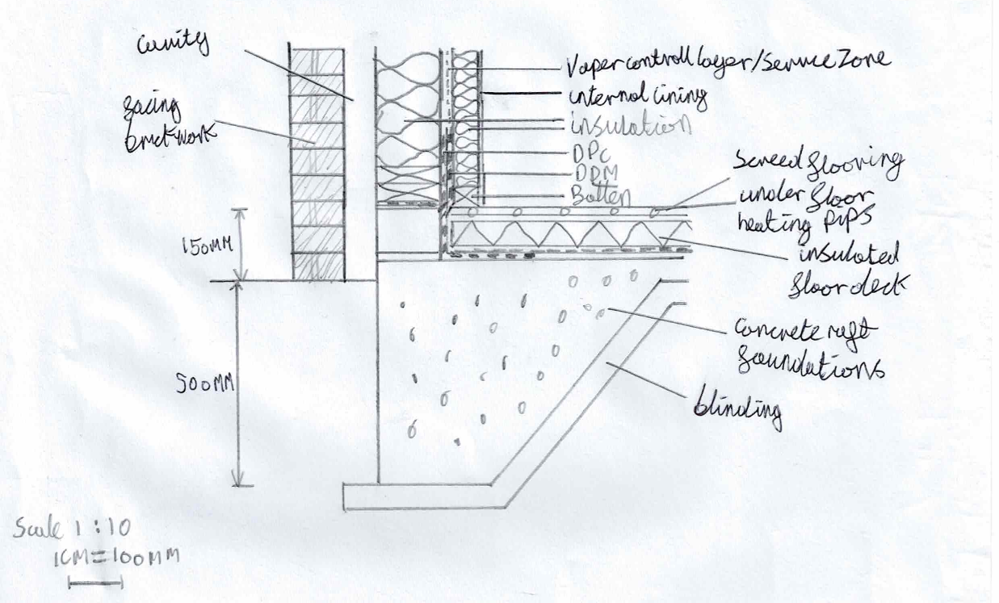
- The way timber framing will perform as a structural component for walling depends on its moisture content. Thus timber must be kept protected with a DPC, DPM and a vapor control layer. (Robin Lancashire 2011)
- As the walling layers are consistent throughout the building, loadbearing walls can be used where the floor and roof will span in between the walling transferring the load into the foundations. (James Norman 2018)
- Without the use of fire resistant boarding the insulation must be non-combustible. (gov.wales 2020)
- Twin timber frames require either the use of OSB board or air-tight membranes in order to meet standards for airtightness. (Seamus O'Loughlin 2025) with the selected use of airtight membrane this will need to be sealed where it interacts with the ground floor.
- The use of independent frames and the insulation being a sound absorbent material, the designed wall should meet the minimum 45db sound absorption. (gov.wales 2022)
- The maximum u-value for walls in dwellings is 0.18,(Gov.wales 2024) the u-value with the 200mm of batt insulation is 0.15. (URSA 2025)

Structural insulated panels: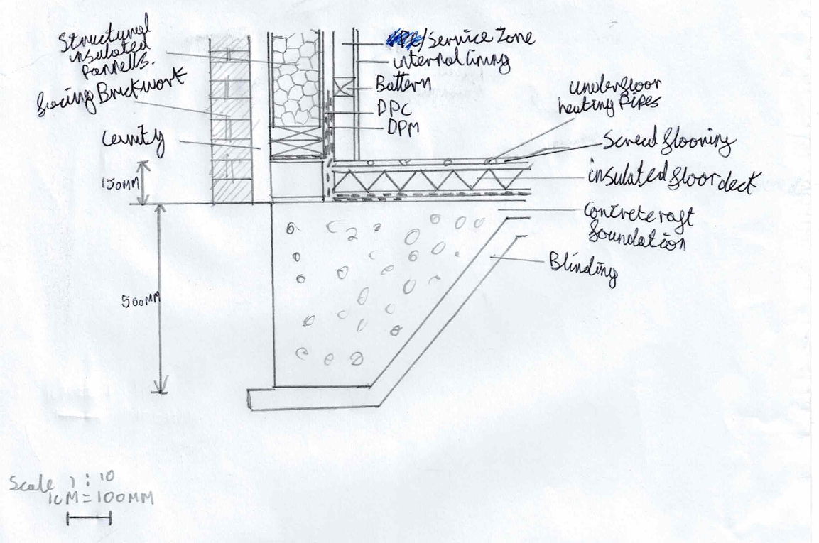
- With SIPS panels are installed to the Walling’s and interlock to create a monolithic shell which produces a load bearing strength 7 times greater than timber framing. (DICE 2025)
- with their panelised construction style SIP’s guarantee high levels of air tightness within the walling when paired with an incorporated vaper control layer. (UKSIPS 2025)
- with the designed walls using internal linings and being isolated from the floors the minimum 45db absorption should be met. (gov.wales 2022)
- The cores of the SIP’s are typically made from combustible material, thus sips must be lined with internal linings that meet class 0 standards. (gov.wales 2020)
- The maximum u-value for walls in dwellings is 0.18,(Gov.wales 2024) a u- value of 0.17 is achieved with the 169mm SIP’s. (SIPSECO 2025)
Brick block walling: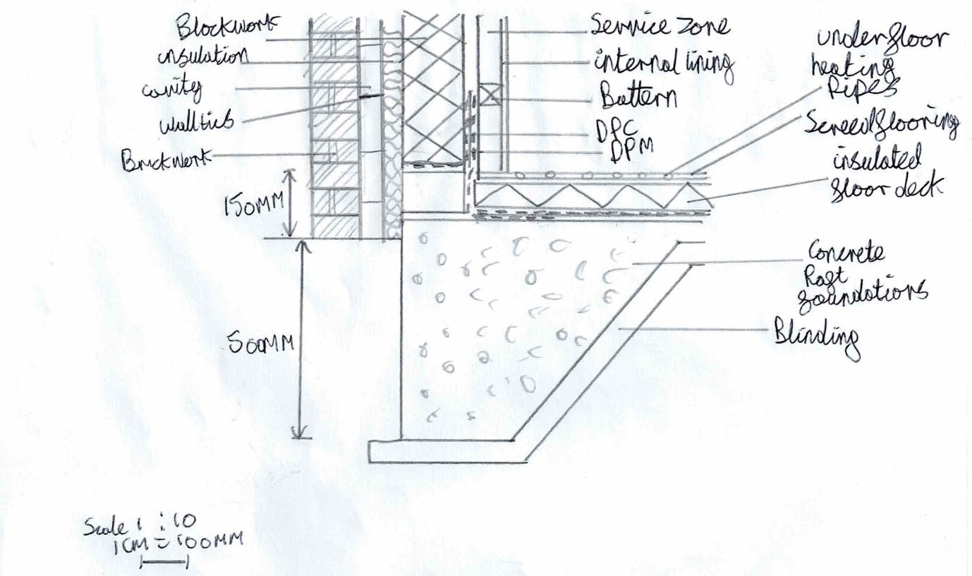
- Being a cavity wall to meet the structural requirements each leaf must be greater than or equal to 90mm thick and the cavity must be greater than or equal to 50mm. (gov.uk A 2017)
- With the designed wall having the recommended 50mm cavity, plasterboard lining and sealing around junctions the minimum 45db absorption should be met. (gov.wales 2022)
- As the building is more than 5 metres high the blocks used in the blockwork must be fire resistant for up to 60 minutes. Cavity barriers must also be used at any gaps to prevent fire spread. (gov.wales 2020)
- The maximum u-value for walls in dwellings is 0.18,(Gov.wales 2024) the 50mm of batt insulation has a u-value of 0.037 (insulation shop 2025)

  - Window opening details:
Twin timber frame: 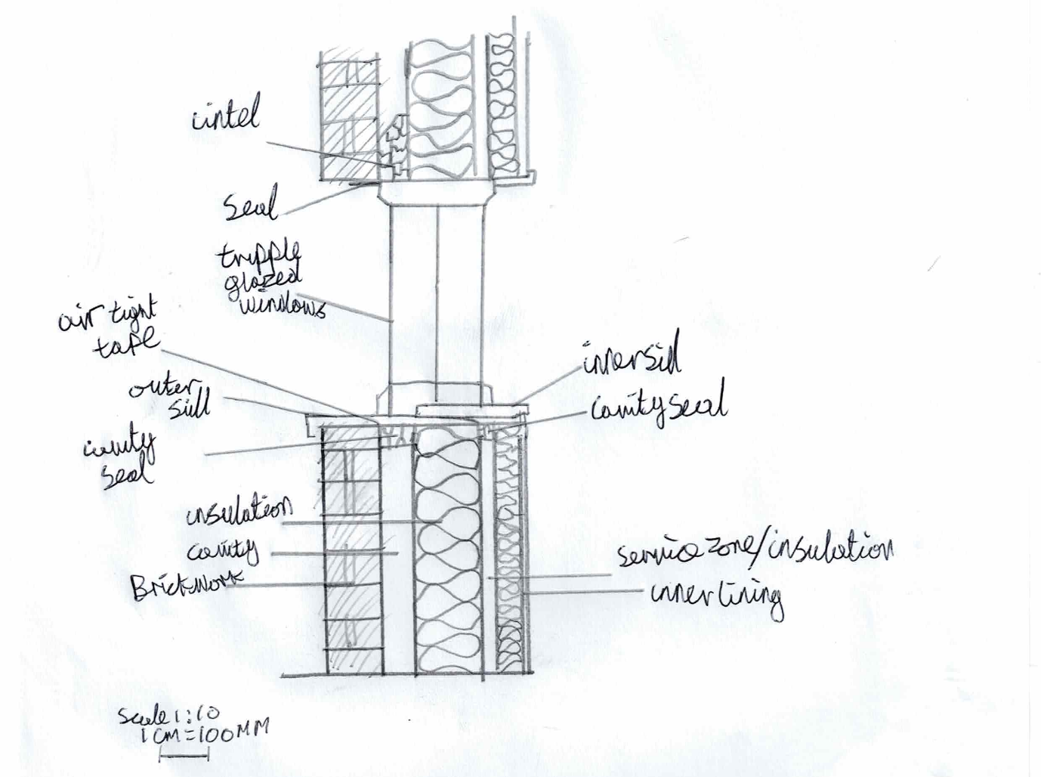
- Windows located 800m or less from the floor level are considered unsafe in twin timber frame walling thus the windows must be higher than this level (gov. wales B 2017)
- Windows are required to align with the insulation leaf of the wall to ensure a maintained thermal barrier and additional insulation will be needed at the meeting points.(gov.wales B 2024)
- With the extra weight of a triple glazed window additional structural fixings need to be installed to the timber frame. (gov.wales A 2017)
Structural insulated Pannels: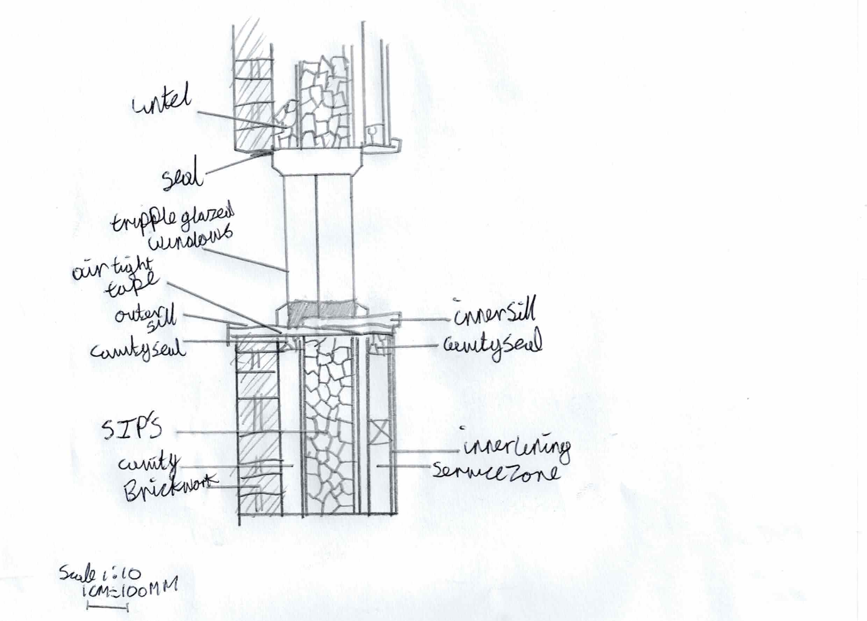
- With the rigid structure of SIP’s the heavy triple glazed units require robust fixings attaching the elements together (gov.wales B 2017)
- For SIP’s to abide by welsh regulations windows must be aligned with the pannels to prevent breaks in the thermal envelope. (gov.wales b 2022)
- Metal flashing is required above the window to deflect rain. (gov.wales b 2022)
- Any gaps between the window and the SIPS must be sealed, in this deshighn with air tight tape(gov.wales A 2017)
Brick and block: 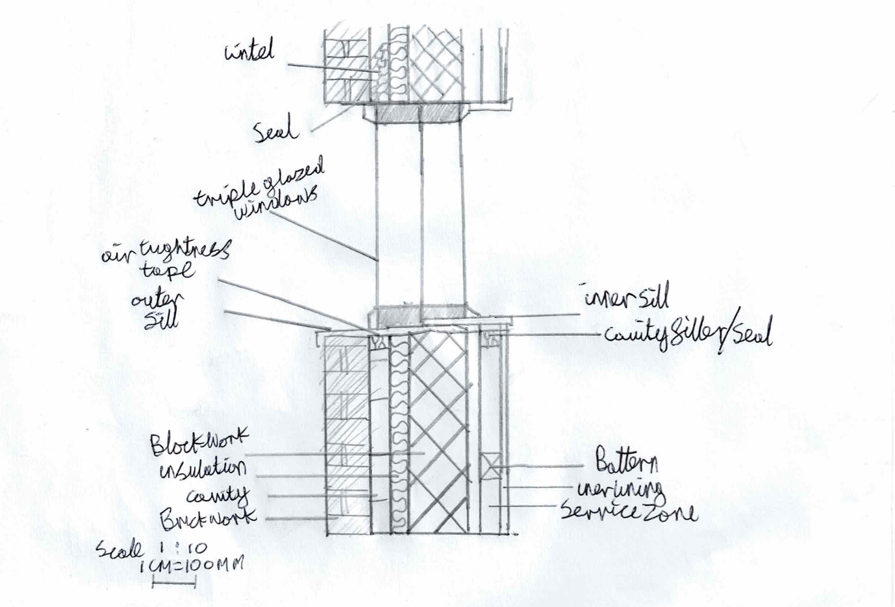
- Brick and block walling requires an integrated DPC between the installed frames to stop the spread of moisture. (gov.wales B 2017)
- Cavity closers are required in the cavities of a brick block wall to insulate between the windows frame and the wall. (gov.wales B 2024)
- To prevent cold bridging windows should be aligned with the walls insulation leaf. (gov.wales B 2024)
- Lintels must be sized taking into account the weight of the window. (gov.wales A 2017)

  - Eaves + roof structure:
Twin timber frame: 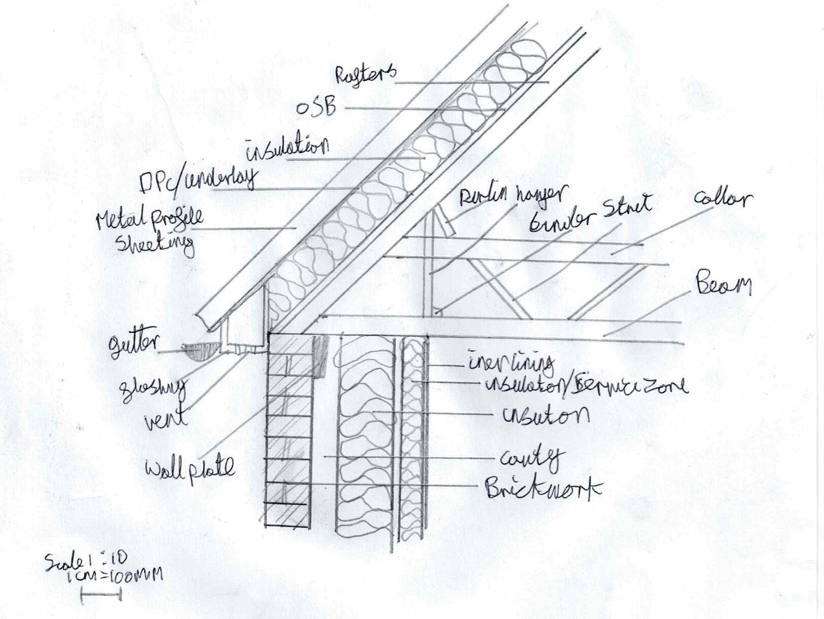
- Building regulations specify twin timber framing requires Diaphragm action (the OSB sheathing) to transfer the wind loads into the walls. (gov.wales A 2017)
- Wall plates are required at a minimum of 1 in every 3 rafters across the span of the trussed rafters. (gov.wales A 2017)
- A DPC underlay must be installed under the metal profile sheeting to prevent condensation in the roof. (gov.wales C 2017)
Structural Insulated Pannels: 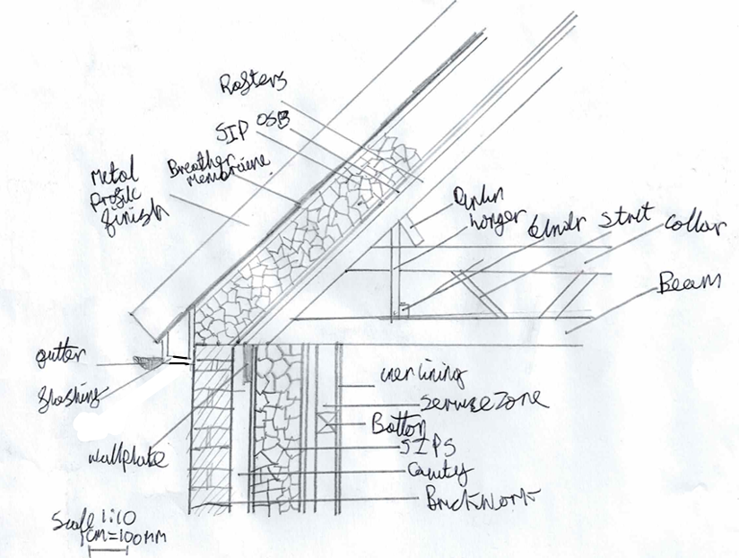
- The SIP’s are required to span within the supporting elements in order to reach the required roof strength (gov.wales A 2017)
- Where the sips interacts with other elements of the roof structure there must be a seal to prevent the ingress of moisture at these points. (gov.wales C 2017)
- Where the pannels meet there must be adequate sealing and fastening to stop uplift forces from pulling them apart. (gov.wales A 2017)
- No vent is required for sips as this will cause condensation build up with the SIP’s. (gov.wales C 2017)
- Flashings must fully encompass the SIP’s. (gov.wales C 2017)

Brick and Block:
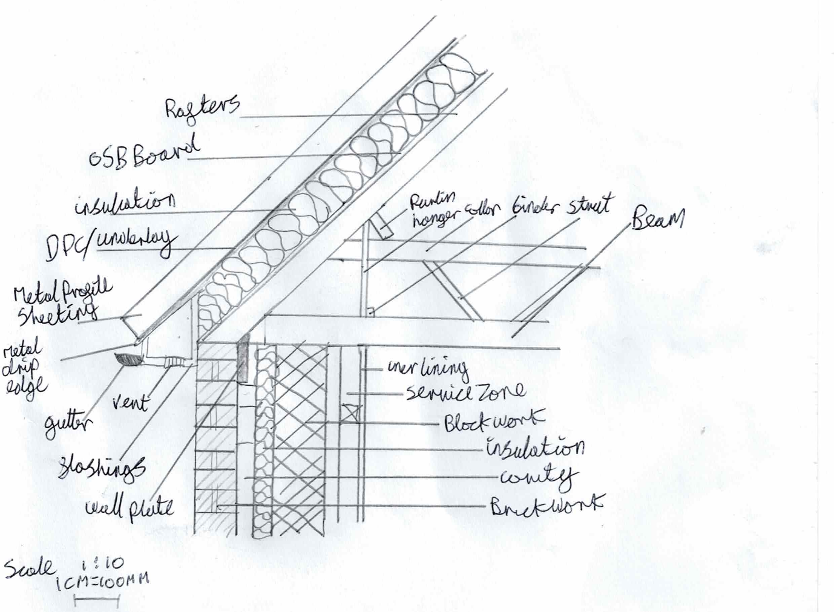
- The trusted rafters must be tied into the masonry works using Galvanised straps at a maximum spacing of 2m to resist wind uplift. (gov.wales A 2017)
- A 25mm ventilation gap is included in the eaves to limit the risk of condensation (gov.wales C 2017)
- Insulation must not block the path of ventilation in the eaves section of the roof. (gov.wales C 2017)

Brief comparison:
All 3 of the construction methods offer a variety of different advantages and disadvantages with the requirements of the clients and regulations that apply to the performance of these aspects. In terms of insulation twin timber frame achieves the greatest u-value. Sips offer the highest structural strength which is beneficial if the client is looking to install anything that exceeds usual weights in a residential property. Twin timber frame and SIP’s are more compatible with off-site construction methods compared to brick block walling that is limited due to the amount of work required on-site. Sips and brick block both do not require additional support where windows are installed. Both twin timber framing and sips are inherently more suspectable to fire damage due to the amount of combustible materials used compared to brick and block. Brick and block construction hass the best thermal mass out of the 3 options meaning that fluctuations in temperatures will be minimalised. Brick and block will provide a longer lifespan with a potential of 100+ compared to sips and twin timber 60+.

Recommendation:
Twin timber framing

Based on my comparative analysis of the 3 different wall types, I recommend client A use twin timber framing. One of the main benefits of the use of twin timber framing is its compatibility with a variety of off-site construction methods, that can work to reduce the construction times and increase the quality of the building. Twin timber framing also provides the greatest u-vale out of the 3 walls which in turn will give the best energy efficiency. With the sites previous use as agricultural land this can suggest potential for ground movement, twin timber frame will tolerate these movements far better than either of the other options. Twin timber framing is also the most compatible wall type with the use of tie trussed rafters ensuring stability of the roof structure. The triple glazed windows will work with twin timber, however additional support will be needed where they are installed.

References:
Designing buildings (2022) Off-site construction. Available at: https://www.designingbuildings.co.uk/wiki/Off-site_construction

NHBC (2021) Modern methods of construction: building on experience. Available at: https://www.nhbc.co.uk/foundation/modern-methods-of-construction-building-on-experience
Foot Anstey (2020) What is volumetric construction?. Available at: https://www.footanstey.com/our-insights/articles-news/what-is-volumetric-construction/
Stelling properties (2020) A Guide to Volumetric Construction. Available at: https://www.buildoffsite.com/content/uploads/2022/10/Volumetric-PDF-Booklet_A5.pdf
Darren Edwards-Clarke (2023) The Partel Guide to Modern Methods of Construction (MMC). Available at: https://www.partel.co.uk/blog/guide-to-modern-methods-of-construction/
RIBA (2012) BIM Overlay to the RIBA Outline Plan of Work. Available at: https://mono.eik.bme.hu/~zrostas/assets/files/CPM_RIBAOutlinePlanofWork_BIMOverlay.pdf
Robert Lawson (2012) Application of Modular Construction in High-Rise Buildings. Available at: https://www.researchgate.net/publication/273750778_Application_of_Modular_Construction_in_High-Rise_Buildings
Robin Lancashire and Lewis Taylor (2011) timber frame construction designing for high performance 5th edition. Available at: https://products.ihserc.com/tmp_stamp/00756878845/RZHYRGAAAAAAAAAA.pdf?sess=00756878845&prod=CIS1
James Norman (2018) Structural Timber Elements A pre-scheme design guide. Available at: https://products.ihserc.com/tmp_stamp/00756878845/UAXASGAAAAAAAAAA.pdf?sess=00756878845&prod=CIS1
gov.wales (2020) Approved Document B Volume 1 2020. Available at: https://www.gov.wales/sites/default/files/publications/2021-12/building-regulations-guidance-part-b-fire-safety-volume-1-dwellinghouses.pdf
Seamus O'Loughlin (2025) Twin-Stud Timber Frame. Available at: https://viking-house.co.uk/timber-frame-house.html#:~:text=Air-tightness%20is%20achieved%20using,achieving%20the%20Passive%20House%20standard.
gov.wales (2022) Approved Document E: resistance to the passage of sound. Available at: https://www.gov.wales/sites/default/files/publications/2022-04/building-regulations-guidance-part-e-resistance-passage-sound.pdf
Gov.wales (2024) Approved Document L Vol 1 Dwellings - Conservation of fuel and power. Available at: https://www.gov.wales/sites/default/files/publications/2024-05/building-regulations-approved-document-l-vol-1.pdf
URSA (2025) URSA MINERAL WOOL URSA Cavity Batts Insulation for Masonry Cavity Walls. Available at: https://www.uvalueinsulations.co.uk/images/uploads/product/URSACavityBattTERRA.pdf
DICE (2025) The Pros and Cons of Building with SIPs. Available at: https://diceconsult.co.uk/journal/the-pros-and-cons-of-building-with-sips
UKSIPS (2025) UKSIPs Tech Bulletin - Thermal:Layout 1. Available at: https://www.sipbuildingsystems.co.uk/pdf/TB4_Thermal.pdf
SIPSECO (2025) SIP Panel U-Values Guide. Available at: https://www.sipsecopanels.co.uk/learning-hub/sip-panel-u-value-calculator/
gov.wales A (2017) 170403building-regs-approved-document-a-structure-en.pdf. available at: https://www.gov.wales/sites/default/files/publications/2019-04/170403building-regs-approved-document-a-structure-en.pdf
insulation shop (2025) 50mm Rockwool Full Fill Cavity Insulation Batt (pack of 12). Available at: https://www.insulationshop.co/50mm_rockwool_cavity_insulation.html?srsltid=AfmBOoqGaiTPy9yVkG_1IdLxdw1c6iCak-Ftltc0Z8-xgRulUUqljtfi
gov.wales B (2017) building-regulations-guidance-part-n-glazing-safety.pdf. available at: https://www.gov.wales/sites/default/files/publications/2019-05/building-regulations-guidance-part-n-glazing-safety.pdf
gov.wales C (2017) Approved Document C: site preparation and resistance to contaminants and moisture. Available at: https://www.gov.wales/sites/default/files/publications/2019-05/building-regulations-guidance-part-c-resistance-to-contaminants-and-moisture.pdf
gov.wales b (2022) The Building Regulations (Amendment) (Wales) (No.2) Regulations 2022 (WGC 005/2022). Available at: https://www.gov.wales/building-regulations-amendment-wales-no2-regulations-2022-wgc-0052022-html?utm_source=chatgpt.com
gov.wales B (2024) Building regulations: insulation. Available at: https://www.gov.wales/building-regulations-insulation

