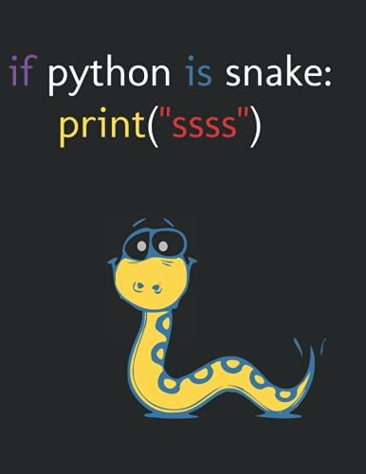

Software Development
Daniel Popescu
29.04.2022
Module Code: ACCB4017

A1. In phyton, what is a variable and why are they important in writing programs?

In Phyton a variable is like a container where data values is stored. This could be a later recalled in the coding process to complete an action. Variables works as an address where the data is stored in memory.
A phyton variable may be one type and later could be changed in another type.
For example:
miles_to_the_litre = 11.2
print(miles_to_the_litre)

Where miles_to_the_litre is a variable
We also can see what’s inside the variable a by printing the variable with print
print (miles_to_the_litre), when run this command will print 11.2.
We can assign another value to another variable
b = 5
Now b refers to the value 5.
A variable could refer to a string as well.
C = ‘’hello there’’`
Speaking about programming languages, there are two types.
Dynamic and Static. Phyton use dynamic typed, which means interpreter type checking while code runs. In static type, the checking is done at compile time.
Other Dynamic typed languages are PHP and JavaScript.
Statically typed languages are Java, C++, C.

A2. if / else

If and else statement is used to take decisions. In a given condition these statements decide and execute the true and false part.
As an example we take temperature as a variable.
Temperature = 40, we want to display a message to the user. We use if statement .
If temperature > 35: , if this expression is true the following statements will be executed.
Print(‘’it is hot’’)
Print(‘’hydratases’’) , these are indented and belong to this block. Both will be printed.
temperature = 40
if temperature > 35:
print('Is hot')
print('hydratases')

In most cases we have multiple conditions. If so we introduce an elif statement (short for else if)
Elif temperature > 25:
Print(‘’it is nice’’)
elif temperature > 25:
print('it is nice')

If none of the previous conditions are true we can use else statement.
Temperature = 15
Else:
Print(‘’freezing’’)
temperature = 15
else:
print('frezing')

A3. loops for

Loops are needed in a program when we desire to repeat a task for many times.
A good example would be when we want to make a call and it does fail.
Print(‘’Calling user’’)
Would not be nice to repeat this code every time. So instead we use loops, which means repetition.
For number in range(4) . Where 4 is number of attempts to call.
Print(‘’attempt’)
When call has been made we can use statement
Successful = true
If successful:
Print(‘’successful’’)
Break - we use this to stop other attempts to call.
In case of no answer we can use else statement.
Successful = false
Else:
Print(‘’attempted 4 times and failed to answer’’)
For loop works with sequence like list or string
Here I created a list
a = ['Daniel', 43, 5.7]
for i in a:
print(i)

Here is a string where will print letter by letter.
a = 'Daniel'
for i in a:
print(i)

Using ‘’while’’ . This loop works with conditions where for loop works with sequence.
We want print Daniel five times.
d = 1
while d<=5:
print('Daniel')
d=d+1

important here is to have
Initialization d = 1
Condition while d<=5:
Increment or decrement (d=d-1)
D=d+1

Exercice 1

First we ask user to enter name. We use \n to tell computer it will follow another action.
name = input('What is your name? \n')
age = int(input('How old are you? \n'))
if age > 125:
print('You are death')
height = int(input('Enter your height in cm: '))
print('Thank you, see details above')
We use integer function to tell computer we work with numbers.
We use if to limit variable to more realistic case. And print a message to user if an unrealistic age has been used.
if age > 125:
print('You are death')

Same with Height:
if height >250:
print('Wrong, unless you are a monster. Tray again, but last as I dont know to insert loop now \n')
height = int(input('Enter your height in cm: Last try \n'))

And final result:

name = input('What is your name? \n')
age = int(input('How old are you? \n'))
if age > 125:
print('You are death \n')
age = int(input('How old are you,? Last try \n'))
height = int(input('Enter your height in cm: '))
if height >250:
print('Wrong, unless you are a monster. Tray again, but last as I dont know to insert loop now \n')
height = int(input('Enter your height in cm: Last try \n'))
print('Thank you, here are your details: ', 'Name: ',name, 'Age: ', age, 'Height: ', height)

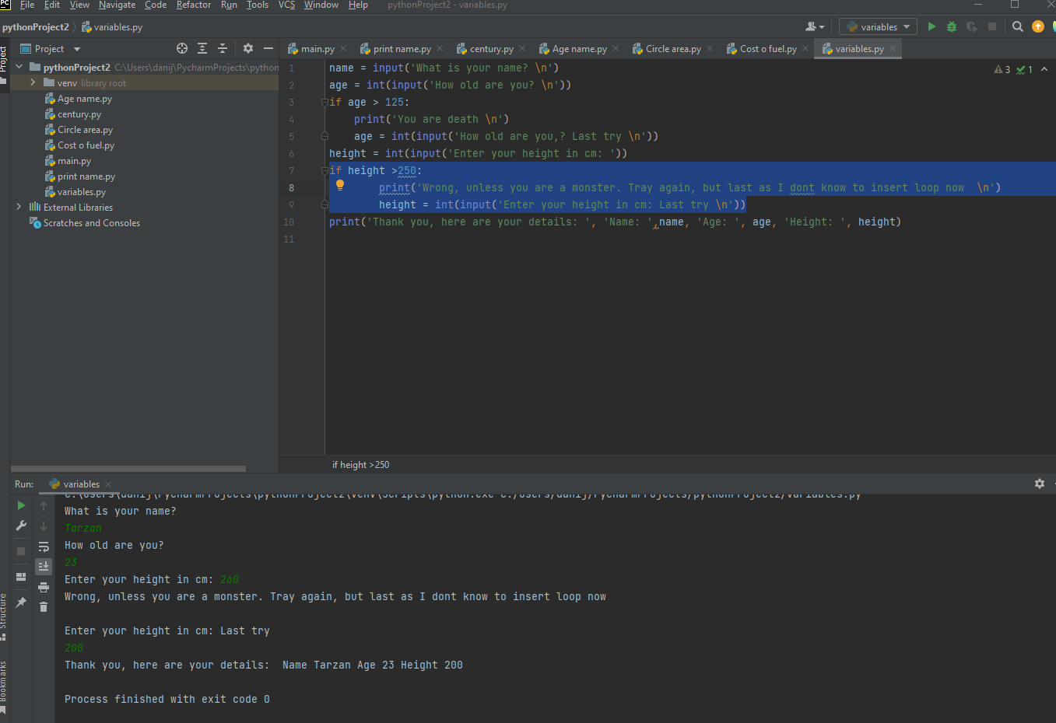

Exercice 2

First we need the radius of the circle. We ask the user to enter the radius of the circle.
radius = input('Enter the radius of the circle')

This will take input as string value but we do not need string value, we need a number. We need to ad float function. Any number entered will be stored on the variable radius.
radius = float(input('Enter the radius of the circle'))

We know the area formula and we can write it as this for now. Also we’ll print the area.

radius = float(input('Enter the radius of the circle'))
area = 3.14*radius*radius
print('area of circle is:',area)

We now can run test the circle area. As shown below it works.
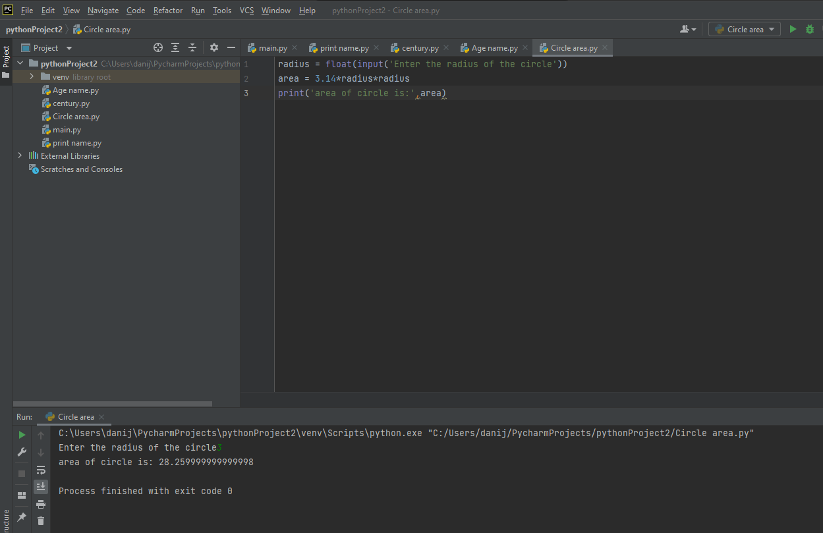

We now can get the proper value of pi. We’ll import math and use math.pi instead 3.14.

import math
radius = float(input('Enter the radius of the circle'))
area = math.pi*radius*radius
print('area of circle is:',area)

Now we’ll ask user to enter rectangle Width and Length. The input function will return the value.
import math
radius = float(input('Enter the radius of the circle :'))
area = math.pi*radius*radius
print('area of circle is:',area)
input('Enter the width of the rectangle :')

But we need the float value and to store this value in a variable called width.
width = float(input('Enter the width of the rectangle :'))

Same with Length.
length = float(input('Enter the length of the rectangle :'))

We store the rectangle area in a variable called areaRectangle
width = float(input('Enter the width of the rectangle :'))
length = float(input('Enter the length of the rectangle :'))
areaRectangle = width * length

Same with the square shape
import math
radius = float(input('Enter the radius of the circle :'))
area = math.pi*radius*radius
print('area of circle is:',area)
width = float(input('Enter the width of the rectangle :'))
length = float(input('Enter the length of the rectangle :'))
areaRectangle = width * length
print('area of rectangle is: ',areaRectangle)
side = float(input('Enter the side value of the square :'))
areaSquare = side * side
print('area of square is :',areaSquare)

Now Area of shaded circle is calculated by
Area of largest object minus Area of smaller objects inside it.
Ash = Ac – As -Ar
sub = area - areaSquare - areaRectangle

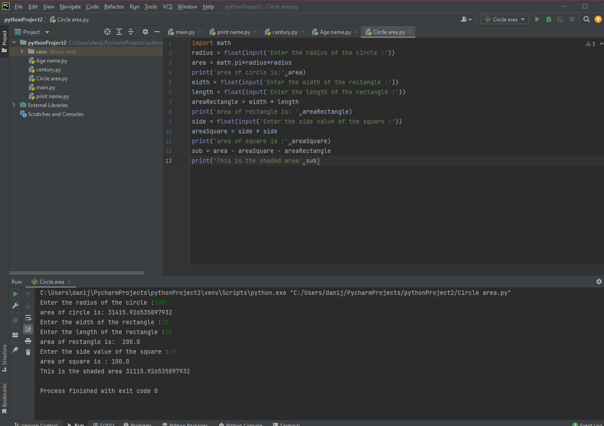

Exercise 3

On this exercise we ask the user to enter milage for every day of the week. I store every value in a variable for each day. Ex. milesMo for Monday. I use an input function and because we do not only use the display massage as a string value but to calculate the milage I use float function to see if it works. Or I can use function int, as integer form so computer knows we works with numbers.

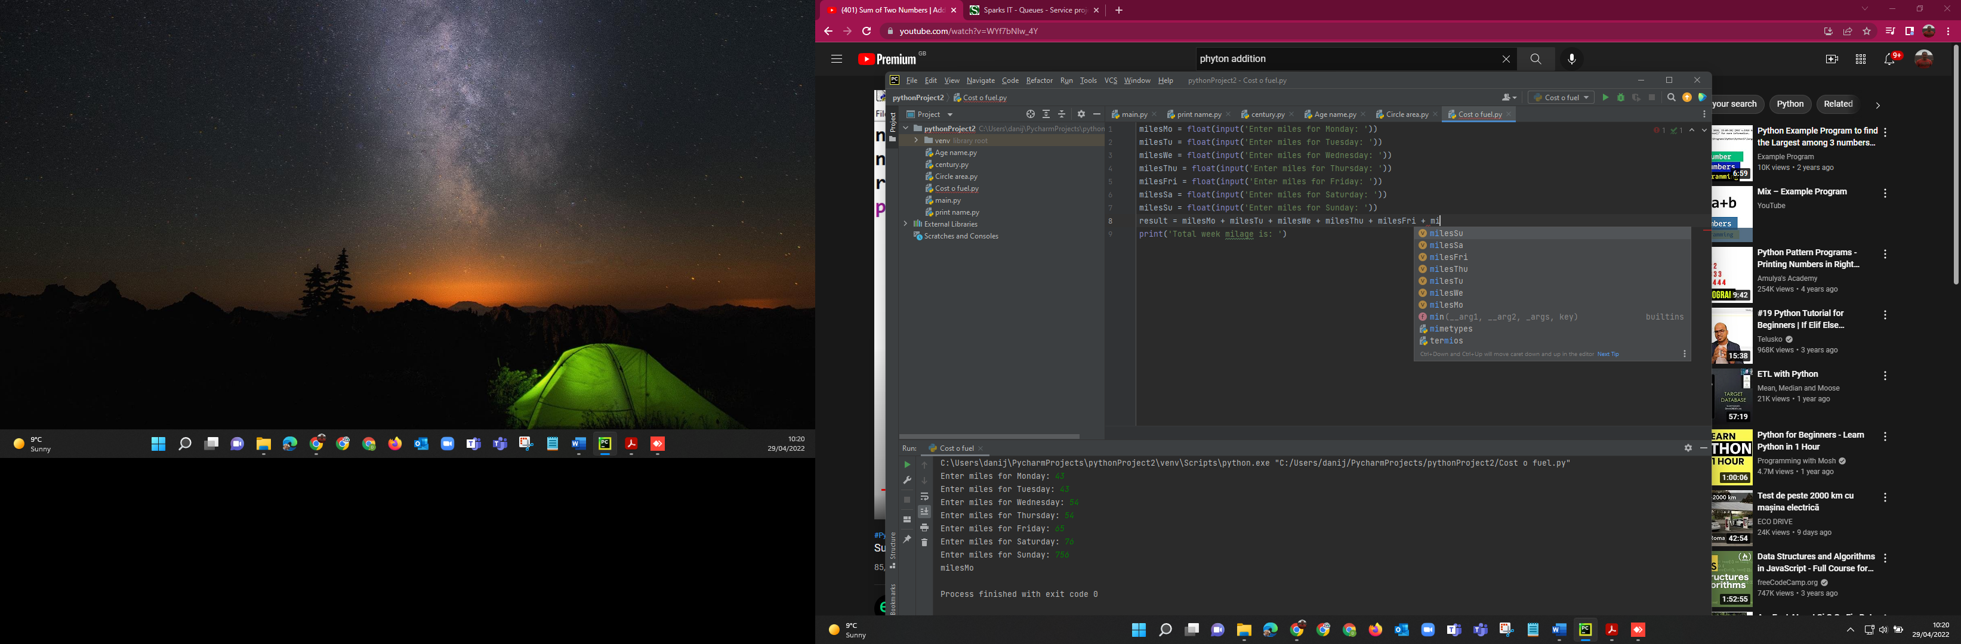

Then addition operator has been used. Then we store this addition in another variable called result.
result = milesMo + milesTu + milesWe + milesThu + milesFri + milesSa + milesSu

Printed the total miles for the week
print('Total week milage is: ', result)

Then added the variable known for miles to the litre.
miles_to_the_litre = 11.2

Used division to see total litres used and displayed for user as well.
division = result / miles_to_the_litre
print('Total liters used:', division)

Then used multiplication to find out total cost of petrol and displayed for user.
multiplication = 1.35 * division
print('total cost of petrol is: ', multiplication)

Entire codding bellow:
milesMo = float(input('Enter miles for Monday: '))
milesTu = float(input('Enter miles for Tuesday: '))
milesWe = float(input('Enter miles for Wednesday: '))
milesThu = float(input('Enter miles for Thursday: '))
milesFri = float(input('Enter miles for Friday: '))
milesSa = float(input('Enter miles for Saturday: '))
milesSu = float(input('Enter miles for Sunday: '))
result = milesMo + milesTu + milesWe + milesThu + milesFri + milesSa + milesSu
print('Total week milage is: ', result)
miles_to_the_litre = 11.2
division = result / miles_to_the_litre
print('Total liters used:', division)
multiplication = 1.35 * division
print('total cost of petrol is: ', multiplication)



