Rebecca Reynolds (1701301)
BMMB7012
Marketing management
Planning for innovative customer service


Executive summary

The aim of this report was to develop and launch a new innovative customer care programme to enhance the customer journey through value creation. The case study chosen was ASOS. ASOS is a British online fashion organisation that owns over 850 brands (ASOS, 2021). In 2021, the organisation purchased Arcadia brands for £265 million. ASOS have already stated that they have no plans on keeping existing stores and will move everything online.

The main objectives of this report are:

• To improve on customer relationships and experiences by deploying an augmented reality app and pop events to enhance the customer journey through creating value for the customer while maintain social distancing.

•To increase brand awareness after the purchase of Arcadia group and the shift towards online shopping by creating innovative strategies to interact with consumers.

•To provide recommendations to ASOS to achieve their aim of creating an innovative customer care programme.

After conducting an environmental analysis, it was clear that consumers’ confidence has been shifted to use more digital technology rather than going into stores. With it being ASOS’s plan to close Arcadia’s physical stores and move this fleet of much-loved brands to operate online only, this will inevitably affect the typical customer experience. To develop from this the firstly, an augmented reality app can make the difference for an organisation in the competitive market. This will allow the consumers to try on their outfits virtually. Secondly, pop up events are seen as an effective way to increase brand awareness and improve customer relationships. Both of these strategies meet the objectives of this report. It has been found that creating value for consumers is important in retaining consumers,

The recommendations for resources:

- Employee training through CMI guidelines to build on knowledge and marketing practical skills.
- An app that uses AI
- A marquee to help the delivery of the pop-up events for incremental weather
- Working with stakeholders and media channels in order to promote ASOS’ products and events.
- Cleaning products and signs to apply with the COVID-19 rules.
- Employees with knowledge of analytical tools

Recommendations of monitoring

- Analytics, such as google analytics.
- Surveys can be used to measure performance by using direct mailing or on the website and app.
- KPI’s can be used to measure performance. This can be beneficial by providing an overview of customer engagement and financial figures.
- Annual report.
- Benchmarking from ASOS’ competitors.

Table of Contents
Executive summary 1
1. Introduction 4
2. Main findings 4
2.1 Environmental analysis 5
2.2. Marketing objectives 5
2.3. Strategic objectives 6
2.4. Innovative customer service strategy 6
2.5. Creating value 9
3. Managing the journey 11
4.Conclusion 12
5.Recommendations of resources 13
6. Recommendations of how the performance will be monitored. 13
7. References 14
8.Appendices 19
8.1.Appendix 1-Summary 19
8.2Appendix 2- Swot analysis 19
8.3 Appendix 3- Pestle 19
8.4 Appendix 4- Marketing mix 7p’s 20

1. Introduction

ASOS is a British online fashion and cosmetics retailer founded in 2000 (Asos, 2021). The organisation offers branded and own label products across womenswear and menswear. ASOS operates and distributes their product globally and sells from over 850 brands. After the unprecedented times, Asos purchased Arcadia group (Topshop, Topman, Miss Selfridge and HIIT brands) for £265 million according to O’Connel (2021). According to ASOS (2021) the organisation bought the brands from Arcadia because they generated approximately 60% of their 2020 revenues online. Therefore, this complements ASOS’s existing portfolio. ASOS have already stated that they have no plans on keeping existing stores and will move everything online.

The report will develop on from the presentation on how the chosen organisation can launch a new innovative customer care programme. The aim will be creating an innovative customer care programme to enhance the customer journey through creating value in activities and experiences. The topics that will be discussed are innovation strategies, value creation, managing consumer journey and monitoring tools.

2. Main findings

2.1 Environmental analysis

The presentation has analysed the external environmental by using the PESTEL framework, the internal environment, marketing mix, marketing strategy, customers journey, value creation and recommendations. The internal and external environment were studied from Fleming et al, (2021) and Gurel and Tat (2017) as seen in appendix 2 and 3.

The main results showed that consumers confidence has been affected by fears of health and economic factors (Jahshan, 2021). There has been a weaker presence of traditional outdoor advertisement and shopping center visits due to physical distancing rules. To add, people are more likely to shop local and online due to this according to Fleming et al, (2021). On the other hand, the retail industry is extremely high as there are top retail brands in both online and offline segments which have a respectful reputation (Gurel and Tat, 2017).

The internal factors shows that Asos as the organisation are focused on delivering the best-in-class customer experience which is represented by their strong performance across all markets (Asos annual report, 2020). The weaknesses of the organisation are that 30% purchases are returned to Asos resulting in additional charges for the company (Asos, 2021).

2.2. Marketing objectives

After conducting the environmental analysis, the objectives of this report are;

• To improve on customer relationships and experiences by deploying an augmented reality app and pop events to enhance the customer journey through creating value for the customer while maintain social distancing.

•To increase brand awareness after the purchase of Arcadia group and the shift towards online shopping by creating innovative strategies to interact with consumers.

•To provide recommendations to ASOS to achieve their aim of creating an innovative customer care programme.

2.3. Strategic objectives

To fulfil the aim and objectives of this report, firstly to achieve the first objective to improve customer relationships, by using a strategy of pop events and an AI app this will be implemented over the next two years by prioritising innovation. Secondly, with the same time frame over the next two years, to increase brand awareness ASOS can provide their consumers with recognition using loyalty programmes. The strategic objectives will be implemented through communication of the leader of the organisation with the objectives being clearly communicated to the employees of the organisation. Once the strategy has been communicated, new roles and responsibilities will be implemented to employees through training. Therefore, time will be dedicated and effort to achieve the objectives. According to the CMI (2020) the best strategy implementation is to ensure that the plans are aligned with the companies aims and values.

2.4. Innovative customer service strategy

By developing the internal strength of the organisation as identified in the appendices (Appendix 2) leaders and employees can be creative with forwarding their ideas and to put them into action. Kotler (2017) states that by dividing a large market into smaller segments, the product can be reached more effectively. Berbegila et al., (2021) supports this by highlighting that market segmentation is important for a strong marketing strategy and can be the difference for organisations in a competitive market. ASOS have already used strategies to enhance their marketing by the content in ASOS brand magazine as consumers are encouraged to buy if they shop online. To be competitive in the next normal, organisations need to identify the current behaviours that will define consumers experience in the near future. They must then ensure that these opportunities are aligned with their business strategies and capabilities. ASOS’ content marketing involves the use of celebrities which appeals to their target market of 20–30-year-olds. Content marketing can be used with ASOS is strategies.

With it being ASOS’s plan to close Arcadia’s physical stores and move this fleet of much-loved brands to operate online only, this will inevitably affect the typical customer experience. ASOS currently do not connect to their consumers in a way that some of their competitors do. To respond to the marketing environment a strategy to innovative ways to connect with ASOS’ customers, is that ASOS invest in an augmented reality (AR) application for customers to virtually try on outfits to create the sense of enjoyment back to their shopping experience. Augmented reality refers to technologies that can give a user the reality of digital information and images Javornick (2016) which can help achieve the objective to improve customer relationships. The benefits of this application are that it makes consumers shopping experience more convenient and enjoyable and provides a 24-hour service. An example of IKEA AR app shows how successful the technology is as it has been downloaded in the millions (Dacko, 2017). However, the limitations are highlighted by Nikhashemi et al (2021) suggesting that there is little research on relationship with AR and customer engagement. Reports have suggested that after the national download, the AR apps are never used again.

ASOS have a problem of return rates as identified as an internal weakness (Daily telegraph, 2020). With a high abandonment of consumers leaving their shopping carts and high return rates, this can have a tremendous impact on Asos is financial performance. To connect with consumers and provide them with value, ASOS’ app can be augmented reality branded by an in multi-channel strategy. According to Hiken (2017) AR has been used by retailers as part of their service to focus on connecting with consumers and their own brands. To carry out the strategy, the app and the organisations website can be updated to include the AR to allow consumers to virtually try out outfits. According to Lavoye et al (2021), someone with expertise is needed to implement the AR and needs knowledge of the advanced technology which can be expensive. To monitor the performance of the app, analytics can be used to assess if it is doing well. According to Jayaram et al., (2015), analytics can help gather accurate data to improve the consumers service and help keep track of the organisation’s goals. It will Provide ASOS with engagement metrics to allow evaluation to take place which will allow the organisation to adapt and change the technology to improve its service.

Mckinsey (2021) research found that since the covid-19 pandemic, the retail sector has seen a decline in stores outlets and have therefore increased reliance on the convenience of digital channels. According to Emmanuelli et al (2020) Consumers are now spending more time online than in previous times especially in the pandemic. Digital channels will provide organisations to help them meet changing customer needs and expectations and enable them to be ready for future disruptions in the industry. Even with ASOS’ strong digital presence there needs to be innovation to continue going forward. In appendix 4, a marketing mix has been discussed. In order for the strategies to meet the needs of the target audience, ASOS can partner with online marketplaces such as the popular ticktock and Instagram.

The Mckinsey (2021) State of Fashion report emphasises to retailers that the experience economy will return, and retailers should prepare for the return. As part of Asos is strategy innovative ways to connect with consumers, pop events can help Asos meet and connect with their consumers. According to Underwood (2021) pop up events can be poised to be very popular during the current environmental pressures from COVID-19. Pop- up energy has moved up and experiential events have seen a revival. The events can increase brand awareness as it is a way of interacting with the organisation’s consumers.

By having pup up events allows the organisation to meet potential consumers and create their own opportunities to create brand awareness. Those staff who work on the pop up can give the consumer something to remember in order to stand out. AR can be integrated with the pop-up allowing consumers to use the technology to market the organisation brand. According to Underwood (2021) pop up benefits are a way of connecting with consumers and no matter the scenario, customer sanitation and social distancing guidelines can be implemented, and momentum can build through the events. To advertise the strategies, ASOS are known for their powerful presence online, therefore they could use twitter discounts, newsletters and direct mailing of a magazine.

To differentiate themselves from their competitors, Schmitt (1999) says experiential marketing is used by brands to build awareness and relationships of the brand beyond the product use. As ASOS is online and there are no face-to-face meetings, the strategy can create opportunities to become face to face with existing and potential consumers, to connect them to the brand. Schmitt (1999) suggests that positive experiences an organisation delivers to its consumers is essential to the success of the company (Yuan and Wu, 2008). This tactic can be used for the consumers to develop recognition after consumers attend ASOS’ events.

By using concentrated marketing strategy, the organisation can achieve a strong market position because Asos can learn develop their knowledge on their consumer needs (Kotler et al., 2017). Evidence has been shown that concentrated marketing can be highly profitable. However, it is seen as a higher risk and other competitive competition can enter the same segment. Jobber and Fahy (2012) state that concentrated marketing can create a large response thereby long waiting lists are created. It is clear from the presentation that ASOS are proud to discuss the strategies that inspire happiness for their consumers. Although with many retailers now moving online, there is a risk that competition can gain competitive advantage in creating value by giving their consumers a better service.

To deliver the service, employees can go through training days so that they can provide consistency. According to CMI (2020) training employees can mean the employees can perform more tasks and which maximises return on investment. To keep employees motivated rewards such as promotions and courses can show that ASOS are loyal to their employees, and this will make employees loyal to the brand by giving a quality service.

2.5. Creating value

Creating customer value is seen as the pillar of marketing and a competitive strategy. Asos can increase their reputation and brand loyalty to bring themselves in a stronger position to ensure customer recognition (Kotler et al., 2017). Thus, consumers will look at ASOS as their first choice for their clothing. Smith and Colgate (2007) describe value creation as the process of creating the worth of a product or service, it is a primary aim of any business entity. Figure one is a model from Morgan and Hunts (1994). The theory relates to retaining existing consumers over attracting new ones as it costs a lot less. An example of organisations creating value for their consumers are airlines. Many airlines have loyalty programs which has proven successful with repurchases. With the goal in value creation to achieve lifetime loyalty this can be used by ASOS and adapted

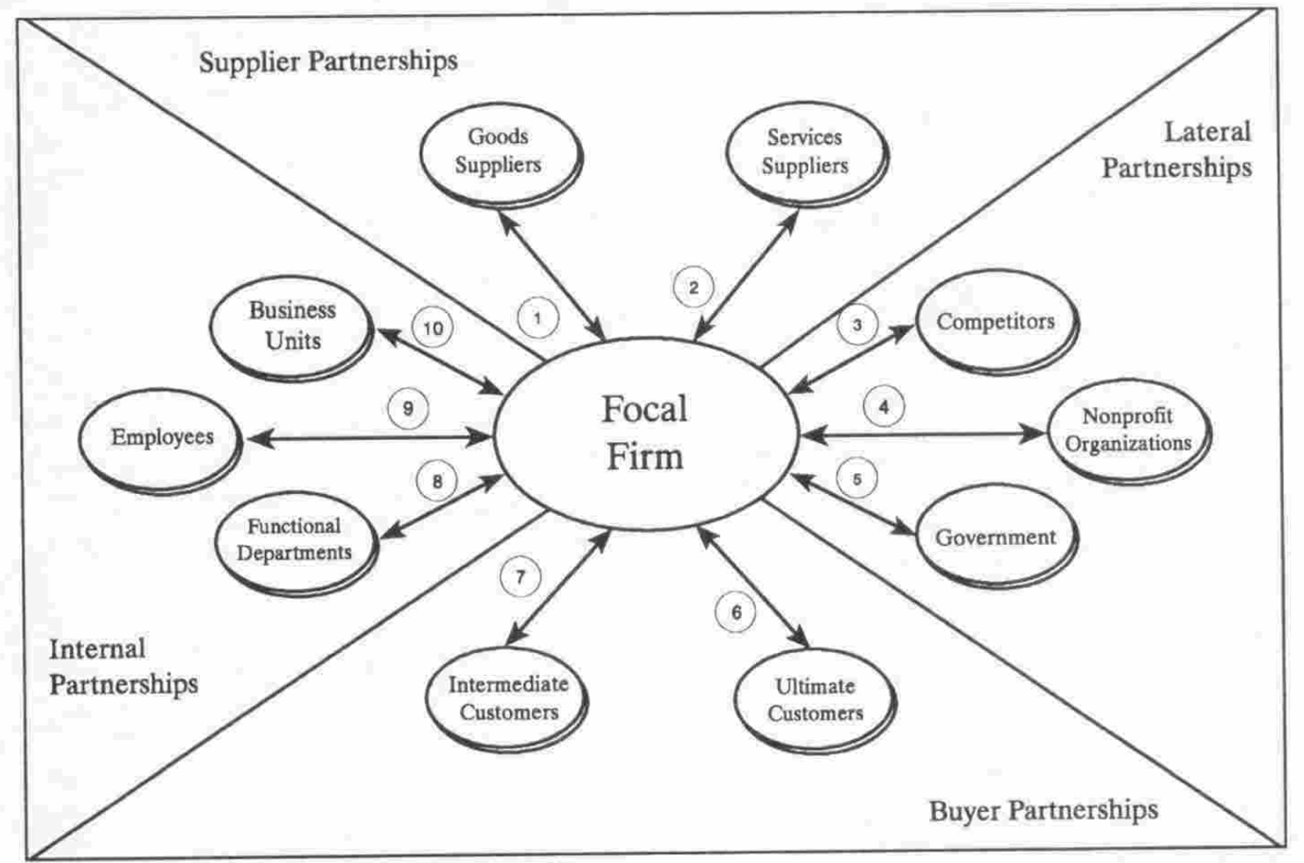

Figure one: The relational exchange of relationship marketing. (Morgan and Hunt 1994).

The main purpose of a loyalty programme is to give organisations consumers recognition for their interaction and loyalty towards their brands. ASOS can create a programme that allows consumers who buy their products to build up points. For example, the more consumers spend there could be a tier bases system implemented such as a membership level. The more points a customer builds the higher they move up the tier system and thereby getting bigger discounts and points. This can link into the pop-up event strategy as different memberships can allow closed event invitations

Moving forward, service quality within the retail industry is significant for satisfying customers and preserving and creating loyalty to their consumers. The SERVQUAL model can be used to analyse the gap between consumers perception and expectations. There are five dimensions, tangibility, reliability, responsiveness, empathy and assurance (Naik et al., 2010). According to Pahand- Malaysia (2011) the benefits of this model are that it can measure consumer perception of service which can result in consumer retention which can overall make gains on financial performance. A service will be excellent if perceptions exceed expectations of consumers and if it equals expectations then will be classes as poor. It is known that ASOS have had their employees in poor working environments and poor working conditions (Hammett, 2019). With consumers recognising these conditions and employees unhappy, service can be poor, and customers will not be satisfied (Naik et al., 2010). Customer satisfaction should be manged to recognise if costumers see that ASOS ore exceeding in expectations. The limitations of the model are the validity, its suggested that it does not provide enough measuring service quality across different services (Kim and Yun, 2003).

3. Managing the journey

Managing a customer’s journey is a leading management objective. Abbot (1995 and Alderson (1957) used the notion ‘’what people really desire are not products but satisfying experiences (Lemon and Verhoef, 2016. p.g 70). Schmitt (1999) empathises the importance of consumer experience especially in today’s society. Customers now interact with companies through touchpoints in multiple channels. Opportunities and challenges arise from customer-to-customer interactions using social media. For ASOS, their whole process should be seamless. Brand awareness, products, engagement and purchase should be tailored.

There are three main stages, prepurchase, purchase and post purchase. Each stage has touchpoints. First stage involves initial interaction with the organisation, secondly purchase covers all interactions and the actual purchase of the product and lastly, post purchase involves usage and consumption (Lemon and Verhoef, 2016). ASOS need to manage each stage efficiently and can use different tools to manage the consumer’s journey. Analytics have been discussed in the report to manage performance. ASOS already have information from their consumers from performance indicators. Big data analytics can help organisations understand the consumer journey. Surveys are a great way of benchmarking the journey. It needs to user friendly. Additionally, multichannel analysis is used by many organisations. Key insights from specific channels from direct mailing, online channels and mobile channels. This can be used throughout the journey of the consumers and specific multichannel segments can be identified in terms of consumer preference and can store a lot of data. A seamless experience will be beneficial for the overall consumer journey according to Lemon and Verhoef, 2016). However, all this can come with challenges for example the costing and resources needed. ASOS need to allocate the priority resources and manage changes throughout touchpoints (Holmlund et al., 2020).

4.Conclusion

ASOS analyse the internal and external environment. After identifying the weaker presence of indoor retail shopping and the shift to online shopping (Gurel and Tat, 2017), ASOS have already taken advantage of the increase digitalisation through purchasing the Arcadia brand. ASOS focus on delivering the best-in-class customer experience and can develop this through innovation.

The above strategies are ways ASOS can use innovation to increase brand awareness and improve customer relationships through experiences using AI apps and pop-up events. The marketing objectives of this report were achieved as innovation was explained to enhance the customers journey through creating value. It was clear that AOS need to do more to be competitive in the next normal and take the opportunities to connect more with their consumers as emphasised by Mckinsey (2021) article.

Experiential marketing can be used to help build awareness and relationships of the brand. Positive experiences are pivotal for the success of the organisation and ASOS can increase their market position by developing their customer needs. ASOS can create a seamless journey through the main stages of prepurchase, purchase and post purchase (Lemon and Verhoef, 2016). Analytics are a beneficial way to gather data to help ASOS improve their service.

5.Recommendations of resources

To achieve the reports objectives, after identifying the results from the presentation and the report, the below recommendations will be achievable.

- Employee training through CMI guidelines to build on knowledge and marketing practical skills.
- An app that uses AI
- A marquee to help the delivery of the pop-up events for incremental weather
- Working with stakeholders and media channels in order to promote ASOS’ products and events.
- Cleaning products and signs to apply with the COVID-19 rules.
- Employees with knowledge of analytical tools

6. Recommendations of how the performance will be monitored.

To see how the performance is going, the strategies will be monitored by

- Analytics, such as google analytics.
- Surveys can be used to measure performance by using direct mailing or on the website and app.
- KPI’s can be used to measure performance. This can be beneficial by providing an overview of customer engagement and financial figures.
- Annual report.
- Benchmarking from ASOS’ competitors.

7. References

Asos (2020) ASOS annual report [online] Available at: https://www.asosplc.com/~/media/Files/A/Asos-V2/reports-and-presentations/2020-annual-report.pdf (Accessed on: 08/05/2021).

Berbeglia, F., Berbeglia, G. and Van Hentenryck, P., (2021). Market Segmentation in Online Platforms. European Journal of Operational Research. [online] Available at: https://www.sciencedirect.com/science/article/pii/S0377221721002824?casa_token=n70uS-2pmF0AAAAA:6ve0OwWqb0wydk_B8q0sb7HCEDtpbrYmyulJcIe-fS9_uBrm4z8TKhRlMLSjRpR4UpRxtzMpfoAP (Accessed: 10/05/2021).

CMI (2020) ‘Implementing strategy’. [Online]. Available: https://www.managers.org.uk/knowledge-and-insights/research/implementing-strategy/ (Accessed: 10.05.2021).

Dacko, S-G., (2017) Enabling smart retail settings via mobile augmented reality shopping apps. Change, 124, pp. 243-256.

Diebner, R & Silliman, E & Ungerman, K & Vancauwenberghe, M. (2020) ‘Adapting customer experience in the time of coronavirus’. [Online]. Available: https://www.mckinsey.com/business-functions/marketing-and-sales/our-insights/adapting-customer-experience-in-the-time-of-coronavirus, [2021 May 10].

Fleming, R. & Brookes, E. & Evison, L. (2021) ‘The impact of COVID-19 on the retail industry’. [Online]. Available: https://www.alvarezandmarsal.com/insights/impact-covid-19-uk-retail-industry, [2021, May 09].

Gürel, E. and Tat, M., 2017. SWOT analysis: a theoretical review. Journal of International Social Research, 10(51).

Hammett, E., (2019) ASOS must tackle brand criticisms to reignite profit. Marketing week. [Online]. Available: https://www.marketingweek.com/asos-brand-growth/ (Accessed:28.05.2021).

Hilken, T., J. Heller, M. Chylinski, D. I. Keeling, D. Mahr, and K. De Ruyter. 2018. “Making Omnichannel an Augmented Reality: The Current and Future State of the Art.” Journal of Research in Interactive Marketing 12 (4): 509–523.
Holmlund, M., Van Vaerenbergh, Y., Ciuchita, R., Ravald, A., Sarantopoulos, P., Ordenes, F.V. and Zaki, M., (2020). Customer experience management in the age of big data analytics: A strategic framework. Journal of Business Research, 116, pp.356-365.

Jahshan, E. (2021) ‘Retail Think Tank upbeat about sector’s health in second half 2021’. [Online]. Available: https://www.retailgazette.co.uk/blog/2021/01/retail-think-tank-upbeat-uk-retail-health-second-half-2021/, [2021, May 09].

Javornik, A. 2016a. “Augmented Reality: Research Agenda for Studying the Impact of Its Media Characteristics on Consumer Behaviour.” Journal of Retailing and Consumer Services 30: 252–261. Elsevier.
Jayaram, D., Manrai, A.K. and Manrai, L.A., (2015). Effective use of marketing technology in Eastern Europe: Web analytics, social media, customer analytics, digital campaigns and mobile applications. Journal of Economics, Finance and Administrative Science, 20(39), pp.118-132.
Jobber, D. and Ellis-Chadwick, F. (2012) Principles and Practice of Marketing 7th Edn Maidenhead: McGraw Hill
Kim, Y.P., Kim, K.W. and Yun, D.G., (2003). Exploration and Development of SERVQUAL. The Asian Journal on Quality, 4(1), pp.116-130.

Kotler, P., Armstrong, G. & Harris, L.C., (2017). Principles of marketing. (7th ed) Pearson higher education.

Lavoye, V., Mero, J. and Tarkiainen, A., 2021. Consumer behavior with augmented reality in retail: a review and research agenda. The International Review of Retail, Distribution and Consumer Research, pp.1-31.

Lemon, K.N. and Verhoef, P.C., 2016. Understanding customer experience throughout the customer journey. Journal of marketing, 80(6), pp.69-96.

McKinsey (2021) The State of Fashion [Online] Available at: https://www.mckinsey.com/~/media/McKinsey/Industries/Retail/Our%20Insights/State%20of%20fashion/2021/The-State-of-Fashion-2021-vF.pdf (Accessed: 03/05/2021)

Morgan, R and Hunt, S (1994) “The commitment-trust theory of relationship marketing”, Journal of marketing, Vol. 58 Issue: 3, pp.20-38.

Naik, C.K., Gantasala, S.B. and Prabhakar, G.V., 2010. Service quality (SERVQUAL) and its effect on customer satisfaction in retailing. European journal of social sciences, 16(2), pp.231-243.

Nikhashemi, S.R., Knight, H.H., Nusair, K. and Liat, C.B., (2021). Augmented reality in smart retailing: A (n)(A) Symmetric Approach to continuous intention to use retail brands’ mobile AR apps. Journal of Retailing and Consumer Services, 60, p.102464.

O’Connel, D., (2021) Thousands of jobs at risk as Asos strikes Arcadia deal. BBC News [Online] Available at: https://www.bbc.co.uk/news/business-55884596 (Accessed:10.5.2021).

Pahang-Malaysia, M.S.C., 2011. Beyond SERVQUAL: A paradigm shift. Australian Journal of Basic and Applied Sciences, 5(7), pp.129-134.

Sánchez-Gutiérrez, J., Cabanelas, P., Lampón, J.F. and González-Alvarado, T.E., 2019. The impact on competitiveness of customer value creation through relationship capabilities and marketing innovation. Journal of Business & Industrial Marketing.

Schmitt, B (1999) ‘Experiential Marketing’, Journal of marketing management, Vol. 15 Issue: 3, pp.53-67.

Smith, J and Colgate, M (2007) “Customer Value Creation”, Journal of Marketing Theory and Practice, Vol. 1 Issue:15, pp.7-23

The Daily Telegraph., (2020). Business Insight Asos. Daily telegraph (London, England : 1969), p.2

Underwood, E., (2021) Is this the summer of the pop-up store? [Online] Available at: https://www.thedrum.com/news/2021/05/10/the-summer-the-pop-up-store (Accessed: 27.05.2021).

Yuan, Y.H.E. and Wu, C.K., 2008. Relationships among experiential marketing, experiential value, and customer satisfaction. Journal of Hospitality & Tourism Research, 32(3), pp.387-410.

8.Appendices

8.1.Appendix 1-Summary

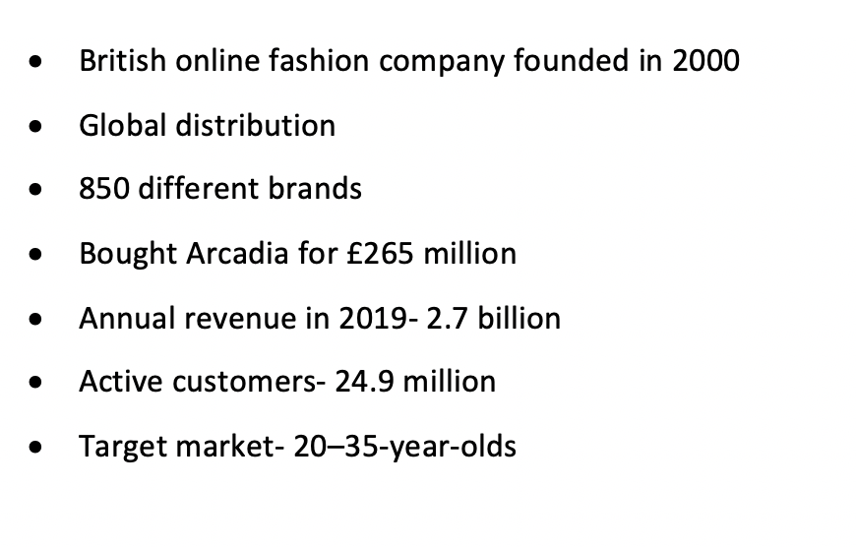

8.2Appendix 2- Swot analysis

Strengths | • Asos are focused on delivering the best-in-class customer experience which is represented by their strong performance across all markets.  • Due to store closures because of COVID-19, Asos have taken advantage of their online platform.
Weaknesses | • The weaknesses of the organisation are that 30% purchases are returned to Asos resulting in additional charges for the company (Asos, 2021)
Opportunities | • The opportunities identified are that Asos can connect with consumers across the globe due to expanding globalisation and with the purchase of the arcadia brands will mean additional consumers
Threats | • The external threats are Competition threats. The retail industry is extremely high as there are top retail brands in both online and offline segments which have a higher brand reputation than Asos.  •Threat can be a shift in e-commerce market dynamics (Gurel and Tat, 2017)

8.3 Appendix 3- Pestle

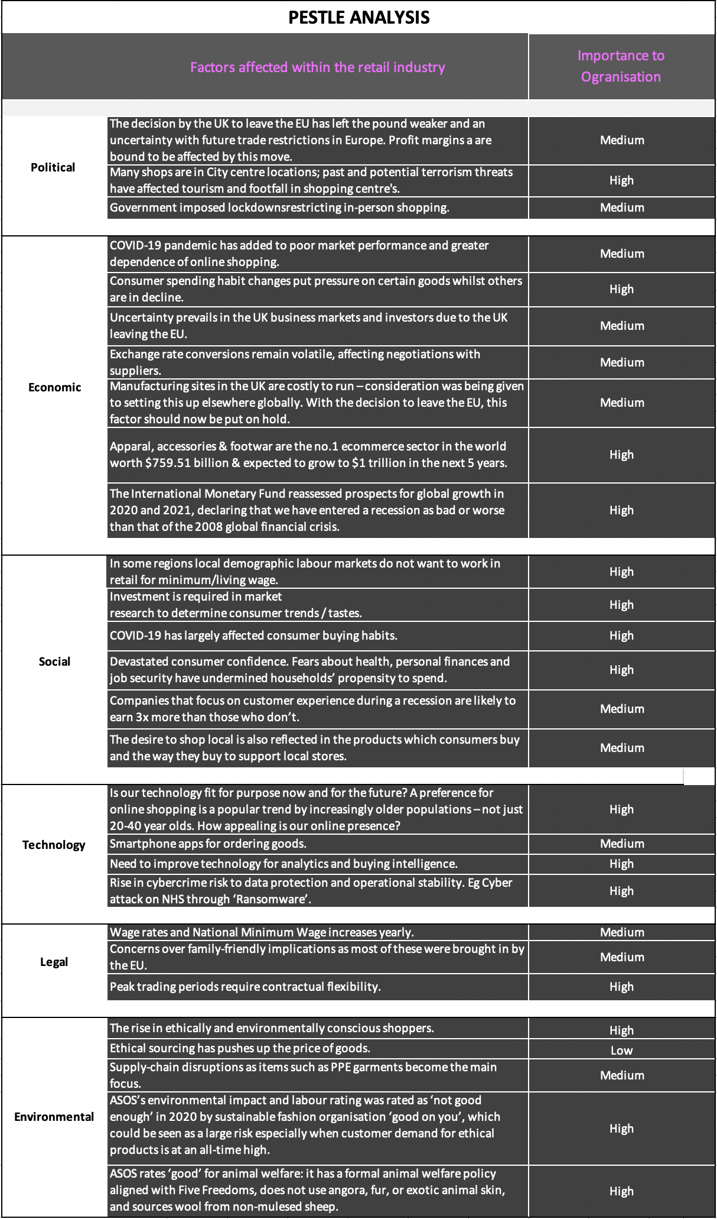

8.4 Appendix 4- Marketing mix 7p’s



