International Financial Management
Assessment I
(Rework)
Amazon

Student name: Yani Yanakiev
Student number: 1920744
Lecture: David Coker
Date: 06.01.2023

Business Overview
Amazon is an online retail company founded by Jeff Bezos on 5th July 1994 in Bellevue, Washington, United States. The company starts its business as an online bookstore. After an investment of $100,000 by Madrona Venture Group's Tom Alberg in 1995, the company began to grow and sell more than 100 books per day. But for Bezos, that wasn't enough, and for a few years, he expanded the business and started selling video cassettes (VHS), DVDs, and new and used computing software. Later, they begin to sell furniture, groceries and almost everything. As an online retailer, Amazon.com can offer its customers everything they need, such as clothes, electronics, beauty products and many more.
The expansion doesn't stop here. In 1998 Amazon launched in the United Kingdom and started growing up more and more. In 1999, Time magazine recognised Amazon's success in making online shopping popular. The magazine further named Jeff Bezos as the person of the year. (History Computer Staff, 2021)
In 2001, Amazon grew even more and reached a revenue of $1 billion, increasing yearly. Because of the big success in the e-books market, Amazon launched a Kindle e-book electronic reader in 2007, which was a massive success for the company.
The company's success doesn't stop here. In June 2017, the company introduced their plans to acquire whole foods. They plan to open more than 400 physical supermarkets, which will spend $13.4 billion, to challenge Walmart's supremacy.
From its beginning, Amazon launches its online services in many countries like Canada, France, Germany, Japan, Spain, China, Mexico, India, Ireland, Australia, and Italy. In total, Amazon operates in 13 countries, but that doesn't stop them from shipping worldwide to more than 100 nations and continues.
From its beginning in 1995, the company became a global online retailer with more than 175 fulfilment centres worldwide, most located across North America and Europe and with more than 1,608,000 employees worldwide.

Competitors
Like every business, Amazon has its competitors, e-commerce, services, and physical store. Online stores like eBay, Walmart, Alibaba, Netflix, Rakuten, and Flipkart are only some of Amazon's competitors.
Online shopping is one of the sectors which has been growing so fast in the past ten years. For example, in 2012, online sales were only 9.3% of the total retail sales. According to the last database provided by the office for national statistics, online shopping increased to 30.7% of the total retail sales, as can be seen in Fig 1 and Fig 2 below.
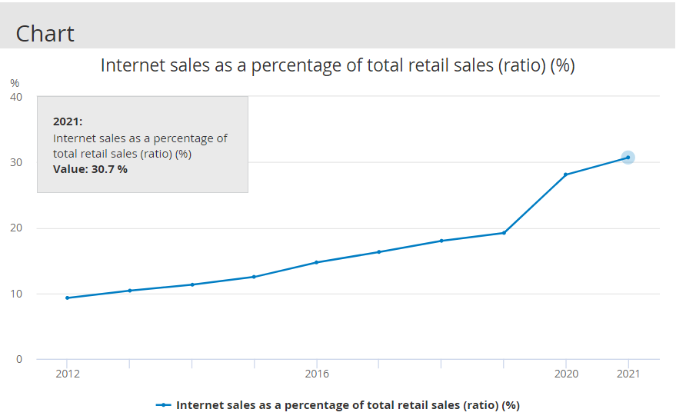
Fig 1
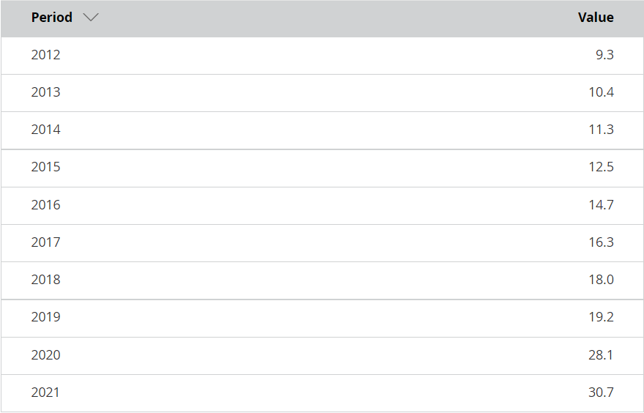
Fig 2
Although Amazon is the largest consumer marketplace online, small business owners have one massive benefit. (Keenan, 2021) In other words, small business owners have an advantage over Amazon and other similar selling sites because of their unique and specialised products, which cannot be found anywhere else. This personalised shopping experience helps customers to be happy and memorable with products that "the mass" cannot find anywhere else.
- eBay
When talking about Amazon, we cannot skip its biggest e-commerce competitor eBay. Of course, eBay cannot compare with revenue or customer services, but it's still a competitor. For F.Y. 2021, eBay's sales revenue is $10.3 billion compared to $470 billion made by Amazon, which significantly outpaced its competitor. The situation is the same with net income, where Amazon have $33.36 billion versus $5.7 billion for eBay.
Some Amazon products can also be found on eBay, even from the same sellers. Most of the time, those products become cheaper for customers to buy from eBay instead of Amazon. The difference is that eBay sellers can auction their products, while Amazon doesn't offer auctions.
- Walmart
Walmart is another Amazon competitor, especially in the U.S. market. Those two brands don't stop comparing each other on logistics, innovations, and sustainability. Walmart is a leader in the physical space with their stores, but when it comes to online sales, Amazon is the preferred way from the customers. Regarding revenue, Walmart is leading over Amazon accordingly, with $488 billion for Walmart and $398.8 billion for Amazon. With the rising online sales, the expectations are that by 2024 Amazon will hurdle Walmart as the biggest U.S. retailer.
- Netflix
Amazon prime is a service the company offers customers who want faster shipping. This is a subscription service which allows the customers not only to order and receive their products delivered faster but also includes Prime Video and Prime Music. Prime Video is a video-on-demand service that offers the customer's own production of movies and series, the same as their biggest competitor in this segment, Netflix. If we must compare both services, we can say that Prime Video is less expensive than Netflix and offers more future for its price (Prime delivery and Prime Music). Still, when it becomes content, Netflix is the service with a more extensive catalogue. All Netflix content is included in their subscription plan when some of the content in Amazon Prime needs to be paid extra. However, both platforms invest much in original programming and have award-winning original content.

International financial management
International financial management is international finance involving currency, political situations, etc. Every multinational corporation, such as Amazon, must properly manage international finances. That helps the company to achieve the same level of effectiveness and efficiency in all markets.
Amazon and its competitor eBay are the world's biggest online marketplaces, helping small businesses reach new opportunities and grow their business domestically and internationally. Small business possibilities come with new challenges in currency exchange, international payments, logistics and customer satisfaction.
The currency exchange must be an optimised process for money transfer that include services like risk management, competitive exchange rates, a wide range of currencies and countries whit which the company works and same-day swift payment. Amazon also applies this method and helps small businesses to trade without paying big commissions by using a usual bank exchange where the bank commissions and fees take a significant portion of the company's profit.
Inflation can always affect exchange rates, reflecting the company's profitability ratio. In other words, the company pays a significant amount in exchange for its assets, which will decrease the company revenue in inflation of exchange rates. Can be created an exchange rate difference during the time of the transaction. This usually happens when the trade that has been recorded (with a specific day and time of the rate) is different from the payment time where the exchange rates are changed. This could cost a company interaction following to loss in profitability or increase the company profit margin when the exchange rates are growth by the payment time. To reduce the loss cost by the exchange rate, Amazon is making certain attempts to hedge its exposure. In these circumstances, the variable costs expended have been subtracted from the company's gross profit, allowing it to continue operating without suffering a significant disruption. Amazon uses derivative financial instruments in foreign exchange rates to hedge the risk of fluctuations.
Specifically, the Company has designated a cross-currency swap agreement as a cash flow hedge of the foreign exchange rate risk on a portion of the PEACS. We account for the swap agreement as a cash flow hedge of the risk of exchange rate fluctuations on the debt principal and interest. (Jenson, 2001)
Amazon as the most significant worldwide retailer has a diversified business model. This business model follows a highly successful business. In other words, Amazon integrates this model when it develops new services and products beyond its limits. The company aims to surprise its customers with unique, helpful, and valuable goods from its competitors at affordable prices. The company constantly explores new markets and reaches new customers in every possible way.
Amazon has internationally focused stores with a global emphasis, and the net sales are made there. Most of the costs immediately associated with such activities are denominated in local functional currencies. The local currency is the one which either supports or operates their stores. All liabilities and assets of the subsidiaries are transferred into U.S. dollars. The effect of foreign exchange rates changes versus the U.S. dollar on the net sales, operating expenses and operating income can be seen below (in millions):
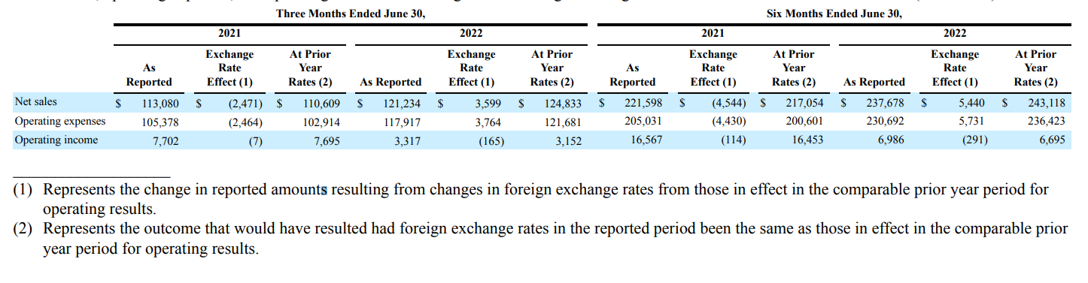
(Olsavsky, 2022)
Like every international company, Amazon is exposed to foreign exchange rate fluctuations, and because of those fluctuations, it can record gains or losses reflecting its revenue. Amazon is a big international company expanding its global operations and increasing its exchange rate fluctuations. In foreign countries, Amazon holds cash equivalents and uses marketable securities like Euros, British Pounds, Japanese Yen and Canadian Dollars. In other words, when the U.S. dollar increases its value compared to the above currencies, cash equivalents and marketable securities balances may be materially less than expected and vice versa.

Amazon Dividend Policy
According to the EMH (efficient market hypothesis), stocks always trade at their fair value on stock exchanges, making it impossible for investors to either purchase undervalued stocks or sell stocks for inflated prices. (Benzinga, 2013)
According to the latest data from NASDAQ from 4th January 2023, Amazon's market cap is $868.57 billion, which doesn't stop the e-commerce giant from being one of the lingering holdouts in paying dividends to its shareholders. Amazon doesn't pay dividends to its shareholders. Instead, to return cash to its stakeholders, Amazon continues infusing its money into the business.
As per the latest data from NASDAQ, Amazon's price earning per share is $85.14, which is -50.04% compared with $127.74 for the same day in 2022 (4th January). There is a considerable drop in the price per share, but that can be explained by the last year's economic tremors caused by the COVID-19 pandemic, where Amazon increased its revenue. Thanks to their customers stuck at home because of the pandemic and using the online retailer more than ever. Amazon has a long way to go, and new peaks are to be reached before it starts paying dividends to its shareholders. In Fig 3 and Fig 4 below can be seen the temp of Amazon's earnings per share for the last year and the previous 5 years. From those figures can be seen how profitable the company is and how good it will be for the investors to get their dividends, just if Amazon chose to do it:
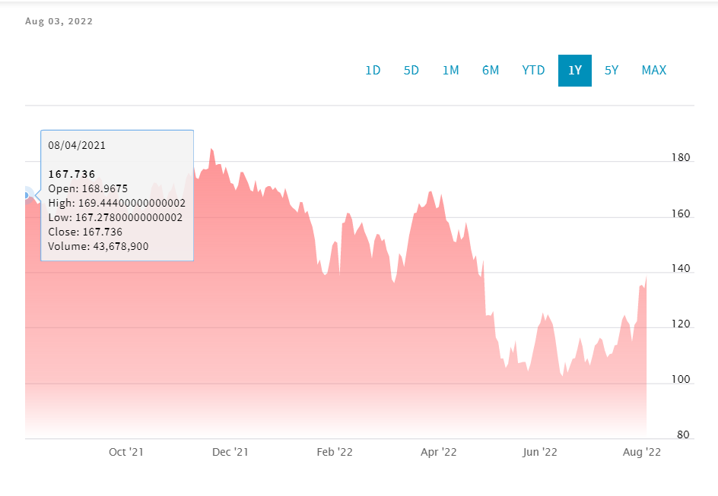
Fig 3
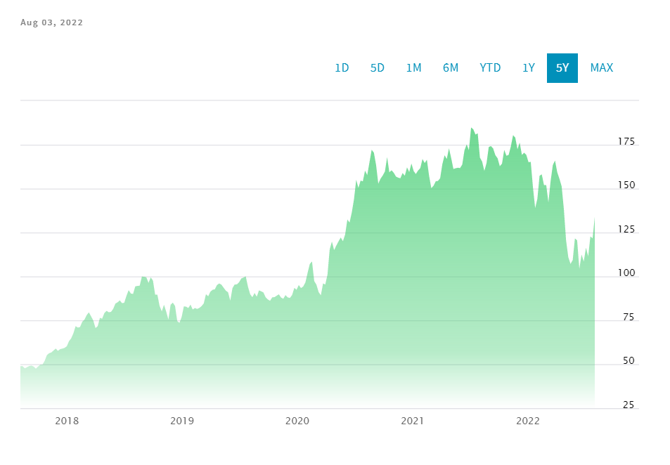
Fig 4
There are many factors Amazon decided not to pay dividends. Thousands of companies are paying dividends to their shareholders, but only a few have a long history of increasing their dividends yearly.
For example, the Dividend Aristocrats are a group of 66 stocks in the S&P 500 that have raised their dividends for 25+ years in a row. (Ciura, 2022)
This Amazon decision doesn't stop investors from putting more and more money into the company because it is one of the leaders with a continuous growth stock. This is obvious when we check Amazon's history for the past 10 years and see that generating returns of more than 30% per year. On the other hand, for income investors, Amazon is not such an attractive option because of the lack of dividend payments.
The company can use its profit for whatever they want, like reinvesting in future growth, debt payments, dividend payment or share buyback, but only if Amazon decides to do it. The company reinvests the profit into its business which helps to expand faster, and at the same time, it minimises its tax load. Amazon's capital reinvestment each year is mostly by using cash flow from operations.
Dividends are certainly a nice thing to have since you can use them as cash or reinvest them. But you can make plenty of money over time by investing in quality businesses, like Amazon, with growth as a clear top priority. (Backman, 2022)

Conclusion
Amazon is one of the most impressive growth companies in history. From an unsecured start as an online book retailer to a dominant media streaming giant and cloud service provider in the online retail industry. The decision not to make a dividend payment to its investors is a clever way to show the world that there is more to be seen from the company. Amazon's future expansion includes physical grocery stores, more extensive media content, health care and more. The company's priority is to continue growing and reach new higher levels of profit caps which for the investors means not to expect their dividends any time soon.

References
Adcock, P. (2022) How Many Countries Does Amazon Operate In? – A Full List.
Available at: https://www.sbxl.com/how-many-countries-does-amazon-operate-in/
(Accessed: 27 July 2022)
Amazon, (2019) Why Amazon warehouses are called fulfilment centres.
Available at: https://www.aboutamazon.co.uk/news/operations/why-amazon-warehouses-are-called-fulfilment-centres#:~:text=Amazon%20operates%20more%20than%20175,across%20North%20America%20and%20Europe.
(Accessed: 27 July 2022)
Backman, M. (2022) Why Doesn't Amazon Pay a Dividend?.
Available at: https://www.nasdaq.com/articles/why-doesnt-amazon-pay-a-dividend
(Accessed: 04 January 2022)
Benzinga, (2013) How I Explain Amazon's Stock Performance.
Available at: https://www.benzinga.com/markets/13/11/4048075/how-i-explain-amazons-stock-performance
(Accessed: 04 January 2023)
Ciura, B. (2022) Will Amazon Ever Pay A Dividend?.
Available at: https://www.suredividend.com/amazon-dividend/
(Accessed: 04 August 2022)
Fortune, (2022) Amazon.
Available at: https://fortune.com/company/amazon-com/#:~:text=Amazon.com%20is%20an%20American,digital%20streaming%2C%20and%20artificial%20intelligence.
(Accessed: 3 August 2022)
Ghosh, P. (2021) Despite Huge Cash Piles, Facebook, Amazon, Google Are Unlikely To Pay Out Dividends Anytime Soon, Say Analysts.
Available at: https://www.forbes.com/sites/palashghosh/2021/04/21/despite-huge-cash-piles-facebook-amazon-google-are-unlikely-to-pay-out-dividends-anytime-soon-say-analysts/?sh=14cdfcce26a6
(Accessed: 4 August 2022)
History Computer Staff (2021) Amazon: Complete Guide — History, Products, Founding, and More.
Available at: https://history-computer.com/amazon-history/
(Accessed: 24 July 2022)
Jenson, W. C. (2001) QUARTERLY REPORT PURSUANT TO SECTION 13 OR 15(d) OF THE SECURITIES EXCHANGE ACT OF1934: FORM 10-Q, Washington: UNITED STATES SECURITIES AND EXCHANGE COMMISSION.
Keenan, M. (2021) Alexa, What Are Amazon's Main Competitors? And Why Are They Successful?.
Available at: https://www.shopify.co.uk/blog/amazon-competitors
(Accessed: 24 July 2022)
Macrotrends, (2022) Amazon: Number of Employees 2010-2022.
Available at: https://www.macrotrends.net/stocks/charts/AMZN/amazon/number-of-employees
(Accessed: 28 July 2022)
Myers, B. (2022) Netflix vs. Amazon Prime Video: Which Is the Better Deal?. [Online]
Available at: https://www.fool.com/the-ascent/personal-finance/articles/netflix-vs-amazon-prime-video-which-is-the-better-deal/#:~:text=Prime%20Video%20is%20less%20expensive,investing%20heavily%20in%20original%20programming.
(Accessed: 30 July 2022)
NASDAQ, (2022) Amazon.com, Inc. Common Stock.
Available at: https://www.nasdaq.com/market-activity/stocks/amzn
(Accessed: 4 August 2022)
Office for National Statistics, (2022) Home Business, industry and trade Retail industry Internet sales as a percentage of total retail sales (ratio) (%).
Available at: https://www.ons.gov.uk/businessindustryandtrade/retailindustry/timeseries/j4mc/drsi
(Accessed: 28 July 2022)
Olsavsky, B. T. (2022) QUARTERLY REPORT PURSUANT TO SECTION 13 OR 15(d) OF THE SECURITIES EXCHANGE ACT OF 1934, Washington: UNITED STATES SECURITIES AND EXCHANGE COMMISSION: FORM 10-Q.
Redman, R. (2022) Amazon to hurdle Walmart as biggest U.S. retailer by 2024. [Online]
Available at: https://www.supermarketnews.com/consumer-trends/amazon-hurdle-walmart-biggest-us-retailer-2024
(Accessed 28 July 2022)
Samson, R. (2021) The Business Strategy of Amazon.
Available at: https://www.profolus.com/topics/the-business-strategy-of-amazon/
(Accessed: 04 January 2023)
Shah, S. (2022) A Fundamental Analysis of Amazon and eBay.
Available at: https://www.investopedia.com/articles/markets/062315/fundamental-analysis-amazon-and-ebay.asp#:~:text=For%20FY%202021%2C%20Amazon%20significantly,versus%20%245.7%20billion%20for%20eBay.
(Accessed: 28 July 2022)
Weber, J. (2021) Will Amazon Stock Ever Pay Dividends? What To Consider.
Available at: https://seekingalpha.com/article/4442367-will-amazon-stock-ever-pay-dividends
(Accessed: 4 August 2022)
Wei, J. (2022) Amazon's Key Financial Ratios.
Available at: https://www.investopedia.com/articles/markets/120115/amazons-3-key-financial-ratios.asp
(Accessed: 04 January 2023)

