Creation of a Decision Support Tool to Support Identification of Patients suitable for discharge from Critical Care

Service transformations have been introduced in multiple clinical settings to address a clinical issue or improve current practice. As part of some of the service transformations implemented, decision support tools have been developed and utilised. Osheroff et al. (2012) identified that decision support tools improve medical decision-making by collating health and patient information and relevant current clinical standards. Sim et al. (2001) added that decision support tools consist of technical architecture that matches patient information to a digital library and then provides the end user with an outcome based on an analysis of all available information. Sutton et al. (2020) noted that the current use of decision support tools is used at the patient side in the clinical environment and utilises clinicians’ knowledge with the decision support outcome. However, Sutton et al (2020) also noted that decision support tools are starting to be developed with the ability to analyse data and produce outcomes that would otherwise be uninterpretable by humans.
Sutton et al. (2020) identified that decision support tools could be classified as either knowledge-based or non-knowledge based. Berner (2007) documented that knowledge-based decision support tools are rules based and looks at the data obtained, applies the set rules and provides an outcome or plan. Berner (2007) expanded on this and stated that non-knowledge based decision support tools use a data source as in knowledge-based tools but not expert knowledge. Instead, they utilise a combination of or individually artificial intelligence or statistical pattern recognition to interpret the data and provide a result or outcome.
Critical care units across Wales have high patient flows both as admissions to units but also discharges to ward environments or home. Discharge from critical care in a timely manner has been a high priority for the Welsh Government, as identified in their recent delivery plan for the critically ill (Welsh Government, 2016). There are several clinicians involved in identifying if a patient is medically fit for discharge from critical care. However, the clinical responsibility to declare a patient medically fit for discharge lies with the consultant overseeing the patients care. As part of the process of stating the patient is medically fit for discharge, the consultant will review all clinical data relating to the patient. This clinical data includes information from the bedside, such as patient observations and trends, medication prescriptions and administration and clinical assessments and reviews of the patient. Clinical data can also be reviewed using national systems, including pathology and microbiology data and trends and radiological images and reports. The collation and review of the data are then assessed by the consultant and a decision is made also utilising their own experience of whether the patient no longer needs care within critical care. The components that currently make up this decision can be seen in the diagram below.
Figure 1 – Components of the Current Decision Process
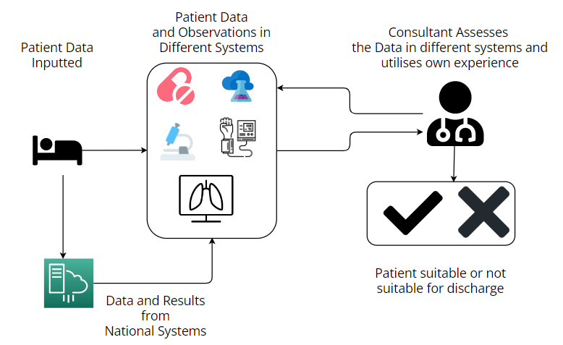
The development of a decision support tool to collate all this clinical data from the various sources and provide analysis and suggested outcome will support the consultant with their decision. This will also allow the consultant to utilise their experience with the support of a knowledge-based analysis and current best practice to support and validate their decision. As part of the development of a decision support tool to support the operation process identified above, a review of the data used will need to be undertaken. This data collection will then feed into whether the decision support tool will be knowledge-based or non-knowledge based. This will influence if the data used and analysed will be rules based or rely on artificial intelligence, machine learning or statistical pattern recognition. The components which make up this potential decision support tool can be seen in the below diagram.

Figure 2 – Components of the Potential Decision Support Tool
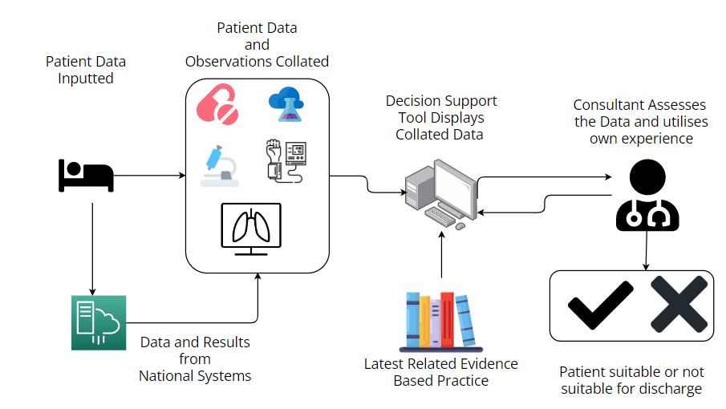
Critical Literature Review
The development of a decision support tool for discharging a patient from critical care will now look at current literature related to this operational process. The literature review will look at reports and a search will be undertaken using keywords relating to critical care and decision support tools for discharge. The search will be limited to articles since 2012 to ensure the results reflect current practice and best guidance. Although the search will look for peer-reviewed articles, a broader search will take place if needed to identify grey literature which supports the above search terminology.

Screening
The first database to be used as part of the literature review was the Cumulative Index to Nursing & Allied Health (CINAHL). The initial search looked for any field for the terms “critical care or intensive care or icu” and “AND discharge” which produced 18,939 results. This was further refined by including the search term “AND decision support tools” which reduced the results to 25. As part of the search, a start date was set as 2012 and a filter to only show articles written in the English language. This did not refine the results further leading to a final total of 25.
The National Library of Medicine PubMed database was then used to support the initial search using CINAHL. The initial search again looked for any field for the terms “critical care or intensive care or icu” and “AND discharge” which returned 38,235 results. Again, this was refined by adding the search term “AND decision support tools” which reduced the results further to 81 results. A start date of 2012 and a filter to show articles only written in English reduced the results to 71.

The Cochrane Library was the third database to be used as part of the literature review. The initial search looked for all text that contained the search terms “critical care or intensive care or icu” and “AND discharge”. This returned 9870 results initially but refining the search with the term “AND decision support tools” reduced the results to a total of 1389. A date range filter was applied to show results from 1st January 2012 which reduced the results further to 1257 results. The results did not have a filter to show articles written in English as the Cochrane Library translated articles into English automatically. A new search criteria of “NOT paediatrics” and “NOT child” were added which helped reduce the number of results to 739. The search was refined by selecting relevant topics for the literature review. The topics selected were pain and anaesthesia and then the subtopics of post-anaesthetic unit / intensive care unit which subsequently led to the results being reduced to 181.
The fourth database used was Library Search @ UWTSD. The same criteria for the previous database searches were undertaken with the initial search of the terms “critical care or intensive care or icu” and “AND discharge” providing 4479 results. The addition of the term “AND decision support tools” reduced the total amount of results to 25. A date range was then used to show only results from 2012 onwards and a filter was used to show only articles written in the English language. This reduced the total number of results to 20.

Exclusion Criteria
The results from the four searches were collated together with 14 duplicate records removed. A total of 283 records were then screened looking at the article title for relevance to the literature search strategy and the article abstract to identify if the article was still relevant. This led to 270 records being excluded from the search strategy due to needing to meet the required criteria of relating to adult critical care, intensive care or icu discharge processes and decision support tools.
The 13 remaining articles were then attempted to be retrieved to allow a full text screening. However, one article was unable to be retrieved and therefore was excluded prior to a formal assessment of eligibility. The 12 articles that were taken forward for assessment of eligibility were screened with articles further excluded if they were related to the wrong clinical setting, not relevant to the literature review, or not relevant to the discharge process. No articles were excluded due to them relating to the wrong clinical setting, a further 2 were excluded due to not being relevant to the literature review and another 2 were excluded due to not relating to the discharge process.
Studies were then identified from other methods than through databases and registers. 2 results were found through organisations and a further 4 results were found through citation screening. The above process was also followed with all reports being successfully retrieved. When the same exclusion criteria were applied, none of the reports met the criteria to be excluded.

Finalised Screening
Therefore, 8 reports were brought through to the final review of the literature identified through searches of databases and registers. There are also 6 further reports which were identified through alternate methods.
As shown below, a PRISMA flow diagram (Page et al. 2021) has been created to show the identification, screening and included results of the above literature review search strategy.

Figure 3 – PRISMA flow diagram of literature review search strategy
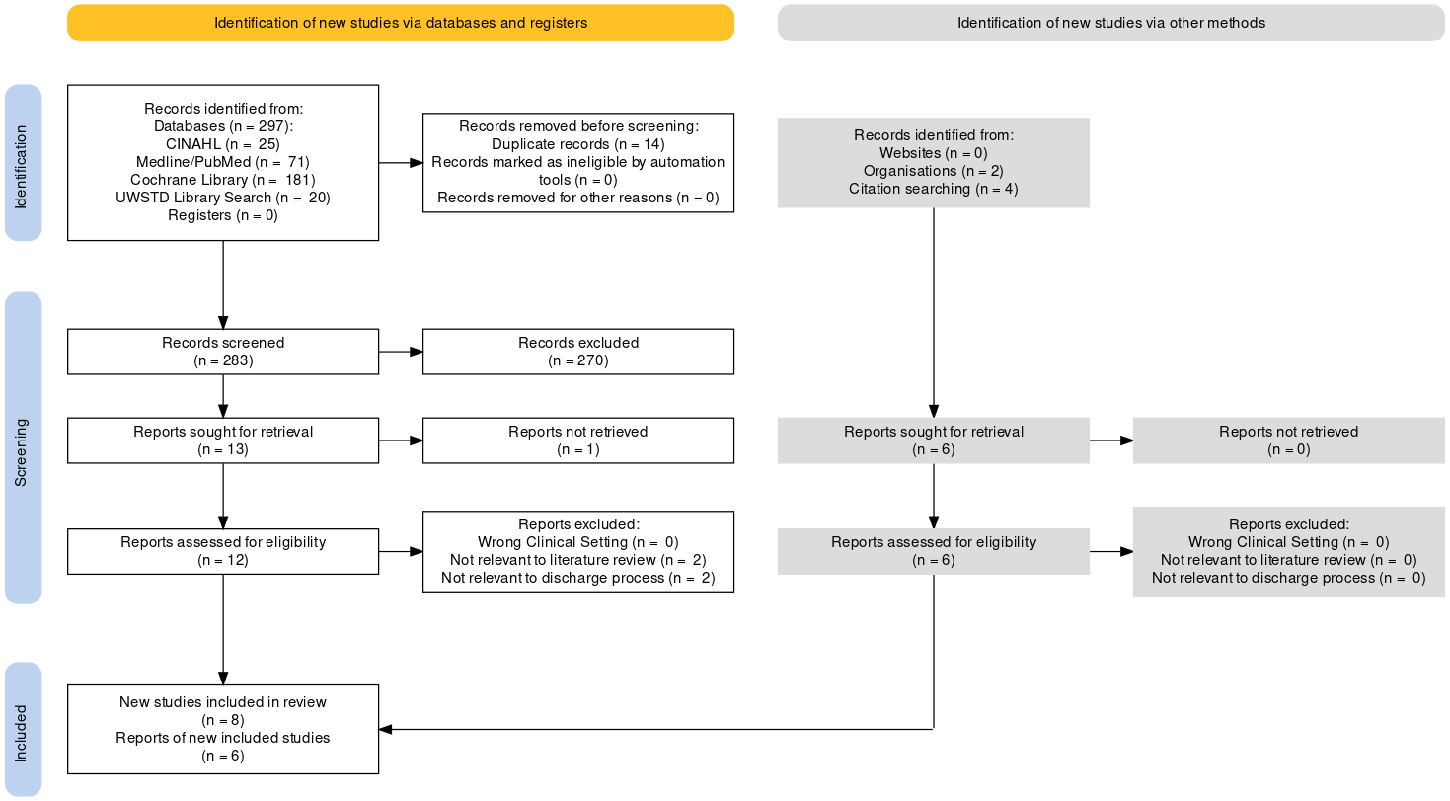
The 14 results will now be reviewed, classified, and scored based on credibility and relevance to the proposed decision support tool and literature review.
The first article to be reviewed is by de Vos et al. (2022) which identified that there are no current machine learning tools to support decision making regarding discharge readiness from critical care within the Dutch intensive care setting. The study looked at a machine learning prediction model being developed and how it can be applied to a 7-state Markov model which reflected the current care pathway within intensive care. The study theorised with a cohort of 1000 patients entered into the model and found that using the machine learning prediction model provided cost savings compared to current normal care. They also found that there would be an associated reduction in ICU length of stay which was a vital driver of the results. However, as this was a theoretical study, further work will be required to prove that the findings are achievable and not affected by other unidentified variables. As no real analysis was undertaken, this article will have limited input into the decision support tool. It was also identified in the declaration of conflicts of interest that the article authors were employed by the company developing the machine learning prediction model so there may be some unintentional bias in the results.
The study by Bowles, Hollan and Potashnik (2012) was included as although it does mention a decision support tool for discharge, it is for secondary care and not specifically for intensive care units. As intensive care units fall under secondary care, the study was included as it was felt during the screening that it supports the aims of the literature review. They identified that the discharge process and identification of patients suitable for discharge were very complex, and practice varied due to no standardised tools being used. As part of their study, decision support tools were created using an evidence base looking at discharge planning and a support system to help with decisions regarding discharge. Throughout the study they collected data of current patients and the discharge process without the use of their tools. They then used this as a benchmark and implemented their discharge decision support tools to provide further data to compare against the benchmark. They found that their tools helped identify patients who should be prioritised for discharge planning or referred for further reablement prior to being discharged. As they identified earlier, there is currently no standard approach, but they feel the use of these decision support tools can help alleviate this issue. This study will support the development of the decision support tool in particular lessons learnt from the pre-implementation period and the testing and evaluation process.
The review by Stelfox et al. (2013) found that when a patient is discharged to ward based care from intensive care that this is one of the most challenging and high-risk transfers of care. The review looked at a protocol for a scoping review, however it did not look at existing studies. This review provided no further evidence to support the creation of a decision support tool for discharge.
Ofoma et al. (2018) looked at studies that found multiple factors which help predict the likelihood of a patient being readmitted to intensive care post discharge. They found that four broad themes contained nine factors that could contribute to the patient’s readmission to critical care post-discharge. As part of interviews with physicians and nurses, it was identified that physicians reported organisational factors and communication as part of the process factors more than nurses. However, all other factors were evenly reported by both clinical groups. The factors identified will be utilised in creating the decision support tool to help with the implementation plan and understanding current issues and factors in the process.
The clinical trial by Bench et al. (2015) looked at an information pack for patients and their families to support them both pre and post discharge from intensive care. They assessed the effect the information pack had on the patient’s wellbeing and whether it supported the transition to ward based care. They found that the clinical trial provided preliminary data, but further work would be required to identify which patient groups would benefit from the information pack to help with their transition to ward based care. The clinical trial results will be used to help with the decision support tool and ensure the effect on the patient is considered.
The study by Milton et al. (2020) looked at a discharge screening assessment to identify patients who will need physical interventions post intensive care. They found that the assessment had a modest value in predicting patients likely to need follow up physical intervention post intensive care. This assessment will be a crucial consideration in the development of a decision support tool to help identify patients’ suitability for discharge from intensive care. This is due to the factors identified to help predict the patient’s condition post discharge.
Cosgriff, Celi and Sauer (2018) looked, as part of their journal, at improving clinical decision making through machine learning. Using feature engineering, they utilised existing electronic health record data and trained models on transfers of care from critical care to wards. The data points identified in this study will help identify variables that could feed into a decision support tool and help with ensuring the correct outcome is identified by the decision support tool.
Vollam et al. (2015) looked at a systematic review protocol on the effect of out of hours discharge from intensive care on patient outcomes including mortality and readmission. This identified the review protocol that they would undertake. The review needs to provide more support to the development of the decision support tool. However, a further literature review found the follow-on results by Vollam et al. (2018). In their results they identified a high correlation between readmission to intensive care and increased in-hospital death rates with patients discharged from intensive care out of hours. The results will be taken into consideration as well as the differing definitions of out of hours they found as part of their analysis. This will ensure that the decision support tool as part of training will be used in a clinically appropriate time frame and support the reduction of out of hours discharges.
As part of a review of the identified literature, the below table shows a grading on the effectiveness of the evidence in supporting the development of a decision support tool. The table has been created based on comments identified above for each item of literature. A quality rating has also been applied utilising the principles of the Cochrane GRADE approach set out by Schünemann et al. (2013).

Figure 4 – Grading of Identified Literature
Reference | Pros | Cons | Quality Rating
de Vos et al. (2022) | Large cohort of patients  Machine learning model developed | Not used in a clinical environment  Potential risk of unintentional bias | Moderate
Bowles, Hollan and Pitashnik (2012) | Decision support tool used in a clinical environment  Covers secondary care | Not specific to intensive care | High
Stelfox et al. (2013) | Looks at the process of discharge from intensive care to the ward | Protocol for a scoping review | Low
Ofoma et al. (2018) | Multiple factors identified that predict likelihood of readmission to intensive care | Single centre study | Moderate
Bench et al. (2016) | Discharge support for patients and families | Not specific to the identification of a patient being medically fit for discharge | Moderate
Milton et al. (2020) | Assessment developed which helps predict patients likely to need follow up treatment on the ward | Looks at the patient’s physical recovery and no other contributing factors | Moderate
Cosgriff, Celi and Sauer (2018) | Machine learning from electronic health record data  Data points important to discharge readiness identified | Not used in a clinical environment | Moderate
Vollam et al. (2015) | Related to effect of out of hours discharge on patient mortality and readmission to intensive care | Protocol for a systematic review | Low

The remaining literature from other methods will now be reviewed in the same format as performed above.
University of Pennsylvania School of Nursing (2018) published a news article regarding the development of a clinical decision support tool to help clinicians identify a patient’s suitability for discharge or whether they required further post-acute care. The tool used data from the electronic health record and subject matter experts to provide their clinical opinion and guidance. As part of a review, they found that readmission rates were reduced due to the tool. This strengthens the view that a decision support tool for discharge is valuable and the use of electronic health record data alongside clinical opinion and guidance from subject matter experts is key in the development of a discharge tool.
As part of the broader search, a website by Medical Information Mart for Intensive Care (MIMIC) (2020) was identified. This contains a publicly available dataset with anonymous data which can support machine learning. The anonymous data set can be used if machine learning is applied in the creation of a non-knowledge based decision support tools.
Through citation searching, four articles were found. McWilliams et al. (2019) developed an automated tool to identify patients who are ready for discharge. They used data from their own critical care unit as well as datasets from MIMIC. They found that they had several patients discharged without readmission, but the tool developed identified very few of these patients. However, this study will provide useful information to ensure the lessons learnt are acknowledged and considered with the development of a decision support tool creation.
Johnson et al. (2016) looked at the previously identified MIMIC database. The article looks at the MIMIC database in more detail and the data points captured. This supports the findings by McWilliams et al. (2019) that the MIMIC database can be used to provide a baseline of information and support with machine learning due to the quality of the data contained.
Abhyankar, Demner-Fushman and McDonald (2012) looked at the use of laboratory data in the context of supporting a wider data set of information and to provide a fuller clinical picture. The work undertaken helped standardise codes for laboratory test results which varied between local testing centres. They also fed this data into the MIMIC database to allow secondary use of the data. Therefore, if laboratory data is going to be used in the decision support tool to help provide an outcome on discharge suitability, the MIMIC database can support creating a baseline of data and support another element of machine learning.
Saeed et al. (2011) identified in their article that they have developed an intensive care database to support research. They also found that the database can help evaluate clinical decision-making tools and algorithms. The database they developed has been shared into the MIMIC database and contributed to a specific database within MIMIC for intensive care. Therefore, the MIMIC ICU database can be used to help support testing a newly created decision making tool before being trialled in a live clinical environment.
Based on the above literature search and review it is clear that there needs to be more articles in relation to a specific decision support tool for the discharge of patients from intensive care to ward based care. The literature highlights some factors that can help identify patients possibly ready for discharge or who may need further reablement and areas for machine learning to support decisions regarding discharges.
A further literature search looking for decision support tools regarding discharge of patients found limited results. There were no results specific to decision support tools for discharge but multiple results regarding medicine reconciliation prior to discharge being enhanced due to the use of a tool. These results provided no support to the wider aim of the literature review. Therefore, there is clearly a gap within the evidence base with limited literature regarding decision support tools to support the discharge process for patients from intensive care.

Implementation Issues
Implementing the proposed decision support tool provides several risks and constraints that must be considered and mitigated. Middleton, Sittig and Wright (2016) documented six axes which can help frame discussion and review of barriers and enablers that support effective use of CDS. One of these axes was implementation and integration. They found that variability in clinical practice and workflows led clinicians to view decision support tools as unsuitable. They also found that there is a risk of ignored alerts and advice, which could be due to various factors such as out of date or missing data, irrelevant alerts and clinical experience providing a different outcome.
The proposed decision support tool as outlined in Figure 2 highlights multiple areas of integration required with other systems.
As part of the initial requirements gathering, a full list of systems that the decision support tool will need to integrate with will need to be collected. The project will then need representatives from these systems to ensure seamless integration and collation of data. The integrations will need to go through thorough testing to ensure that there is no risk of missing or incomplete data shown within the system.
The most critical risk is the decision support tool identifies that a patient is suitable for discharge when they are not. This is mitigated by ensuring that the clinician makes the final decision on whether the patient is suitable for discharge. As the decision support tool will collate all the patient data and observations and feeds in latest evidence based best practice, the clinician will have all the information and guidance needed to support their decision. This means that human factors and experience can be factored into the decision, ensuring a holistic decision is made.
Although clinicians will have support in decision making and make the final decision, there is a risk that a patient is marked as suitable for discharge. However, a factor not considered may lead to them being readmitted to critical care and therefore create a risk of there being a higher amount of readmissions. This can be mitigated in the development phase of the decision support tool. All information that currently helps inform a discharge decision will be collected as part of the requirements gathering. Best practice guidance will also be used to identify any other factors that have yet to be considered at the requirement gathering stage. This will mitigate the risk of potential for readmission by ensuring all factors that influence a patient’s suitability for discharge and potential factors that could lead to readmission are factored into the decision support tool.
There are external factors to critical care which can affect the implementation of the decision support tool. Although the decision support tool may lead to a patient being classed as fit for discharge, for a timely discharge to take place it requires a bed available on a suitable ward for the patient to be discharged to. This can be mitigated by the decision support tool having a checklist of key factors which will classify the patient as suitable for discharge. This will enable discharges to be pre-empted and help support the wider hospital with planning of bed availability and pre-allocate beds to a potential critical care discharge. Engagement with the system’s end user and whose role will be affected by the implementation will be key to ensure support of the system by the wider hospital team.
The next external factor can be mitigated through a thorough implementation plan. Training will need to be delivered to end users on how to use the system to ensure a successful implementation and help ensure a positive user experience. An implementation team would need to be planned to ensure they can support the staff training, co-ordinate the release of staff and how the decision support tool will be rolled out and implemented across the critical care unit.

Evaluation
As part of the evaluation of the proposed decision support tool, multiple areas would need to be assessed. These areas include the user experience, the effectiveness, the safety, and the efficiency of the decision support tool.
The user experience of any decision support tool is a key factor in the successful implementation of any system or software. Deng et al. (2010) found that the user experience is directly related and attributable to user satisfaction with digital clinical systems. They also found that if the user satisfaction and experience were poor, the user was less likely to want to continue using the system and would revert to an alternate or previous way of working.
When assessing the user experience of the decision support tool, it needs to be clearly defined who the end users of the decision support tool are. In regard to the proposed decision support tool, it will primarily be used by critical care consultants. This is due to it being their responsibility to declare a patient medically fit for discharge. However, the decision support tool has the potential to be used by other critical care doctors, nurses and ward managers to help identify potential discharges as part of their daily assessment of patients and staffing needs. The initial implementation will focus solely though on critical care consultants. However, it will remain in scope for future development of other clinicians using the system and develop the decision support tool for wider clinical use. Therefore, the user experience of the critical care consultants will be assessed in regard to the use of the decision support tool.
Bassford et al. (2019) created a study looking at a support tool for supporting admissions into critical care. They found that the user experience of those who used the tool found it be beneficial and provided further reassurance. However, this was only the experience of a minority of users due to users not using the tool. This was due to multiple factors, but the major barrier was perceived to be an increase in documentation. The lessons learnt from this study should be taken into consideration when developing the proposed decision support tool to ensure similar issues are not encountered which affect the users’ experience.
Morville (2004) developed a user experience diagram looking at factors that need to be considered as part of the user’s experience other than just the usability of the system. These factors can be used to base a feedback form on to support assessing the user experience. The first factor looks at how useful the solution is. This can lead to an initial question being posed asking the user if the system is more useful than the previous way of working. This can also form part of an analysis through time and motion studies to help with benefit realisation and whether the proposed decision support tool enhances the current process. The next factor looks at how usable the tool is. This could provide a series of questions to ask about the ease of use of the system and how user friendly it is. The third factor is desirable which looks at ensuring the user gains a positive experience from using the decision support tool. This can be assessed through open questions asking the users opinion on the system and if they felt it supported their role and decision making. The fourth factor looks at if the system is findable. This specifically relates to navigability of the system and if the user can find the different parts of the system easily. A rating can be created on the feedback to generate quantitative data to feedback on different areas of the system and the ease of use for the user to find them. The next factor looks at whether the system is accessible. Although this is specific to people with disabilities and additional learning needs, this can be a target parent child question to form part of the feedback form. The initial parent question would ask does the user identify as having a disability or additional learning needs. If No is selected the user can be moved on to the next question but if they select Yes, it opens further child questions. The child questions can ask statements regarding ease of use and accessibility and if the form does not contain any user details a multi check box can be used to ask which disability or additional learning need they identify with and an option of Other if the one they identify with is not listed. The sixth element looks at if the tool is credible. This can be looked at outside of a feedback form and prior to implementation as part of the testing process. A user can be asked to make a decision about a patient’s readiness for discharge based on the current process and then using the decision support tool in a testing environment to see if the same outcome would be achieved and the time difference that both processes take. The final element looks at the tool and if it is valuable. This would be a part of a benefits realisation and not included in a feedback form. The tool can be assessed whether it is valuable or not based on time releasing savings for the clinician and how long it takes to assess all the data, cash releasing savings due to a reduced length of stay of patients and reduced length of delay to being discharged from critical care.
All of the questions identified to be included in a feedback form can be included in a pre-implementation survey to benchmark post-implementation results against. Although the factor regarding accessibility relates specifically to the decision support tool, it can be used to highlight issues that are unknown about the current way of working.
The effectiveness of the decision support tool can be assessed in a multi-factorial manner. Data is currently captured on whether a patient’s discharge is delayed and by how long. This can be used as a baseline of data to create an interruption diagram of where the decision support tool is implemented and the effect of discharge delays. However, the decision support tool cannot account for other external factors that can influence a delayed discharge from critical care such as bed availability, staffing levels and admissions into the hospital. In order to mitigate these external factors, pre-implementation data can be collected on patients with similar reasons for admission and similar treatments received. This can then be used to identify at what point of their stay within critical care their suitability for discharge was evaluated. This would create an average day for multiple conditions and factors whether discharge suitability is assessed. This can also be linked into the decision made, the reasons why and how long from the initial assessment until they are classed as medically fit for discharge from critical care. This data can then be reassessed post-implementation of the decision support tool to identify if it promotes the initial assessment of discharge readiness and the gap between the initial assessment and confirmation of the patients discharge status. An additional factor that would also need to be considered in the above decision process is the clinician’s experience. This is due to their clinical experience influencing their confidence in this decision making and the ability to assess the likelihood of readmission.
The safety of the system would need to be assessed prior to implementation. This would be through a risk analysis being undertaken to look at the system, highlight the risk and how the risk will be mitigated. As part of clinical risk management, DCB0160 (NHS Digital, 2018a) and DCB0129 (NHS Digital, 2018b) will need to be adhered to ensure appropriate clinical risk management of the deployment, development, and maintenance of a healthcare IT system. A review of incident reports relating to patients which have occurred due to a delayed discharge can be reviewed with a baseline created pre-implementation to measure against post-implementation. The system’s safety can also be assessed by looking at the mortality rate of patients whose discharge have been delayed and the rate of patients who survive through to discharge from the hospital. This can also be baselined pre-implementation to identify if the decision support tool has provided the intended benefit of reduced patient mortality.
Multiple data items are also collected as part of routine data collection within critical care. These include unit capacity, bed occupancy trends, time from patient accepted to being admitted, time from the patient being medically fit for discharge to physically leaving the unit and follow up reviews undertaken on patients by the critical care outreach team. This data provides an original baseline for the data to be reviewed post implementation of the proposed decision support tool. This data can be used to support an evaluation of the efficiency, effectiveness, and safety of the implemented decision support tool.

References
Abhyankar, S., Demner-Fushman, D. and McDonald, C.J. (2012) ‘Standardizing clinical laboratory data for secondary use’, Journal of Biomedical Informatics, 45(4), pp. 642–650. Available at: https://doi.org/10.1016/j.jbi.2012.04.012.
Bassford, C. et al. (2019) ‘Developing an intervention around referral and admissions to Intensive Care: A mixed-methods study’, Health Services and Delivery Research, 7(39), pp. 1–284. Available at: https://doi.org/10.3310/hsdr07390.
Bench, S. et al. (2015) ‘Evaluating the feasibility and effectiveness of a critical care discharge information pack for patients and their families: A pilot cluster randomised controlled trial’, BMJ Open, 5(11). Available at: https://doi.org/10.1136/bmjopen-2014-006852.
Berner, E.S. (2007) Clinical Decision Support Systems. New York: Springer Science+Business Media, LLC.
Bowles, K.H., Holland, D.E. and Potashnik, S.L. (2012) Implementation and testing of interdisciplinary decision support tools to standardize discharge planning, NI 2012 : 11th International Congress on Nursing Informatics, June 23-27, 2012, Montreal, Canada. International Congress in Nursing Informatics (11th : 2012 : Montreal, Quebec). U.S. National Library of Medicine. Available at: https://www.ncbi.nlm.nih.gov/pmc/articles/PMC3799081/?report=classic.
Cosgriff, C.V., Celi, L.A. and Sauer, C.M. (2018) ‘Boosting clinical decision-making: Machine Learning for Intensive Care Unit Discharge’, Annals of the American Thoracic Society, 15(7), pp. 804–805. Available at: https://doi.org/10.1513/annalsats.201803-205ed.
de Vos, J. et al. (2022) ‘The potential cost-effectiveness of a machine learning tool that can prevent untimely Intensive Care Unit Discharge’, Value in Health, 25(3), pp. 359–367. Available at: https://doi.org/10.1016/j.jval.2021.06.018.
Deng, L. et al. (2010) ‘User experience, satisfaction, and continual usage intention of it’, European Journal of Information Systems, 19(1), pp. 60–75. Available at: https://doi.org/10.1057/ejis.2009.50.
Johnson, A.E.W. et al. (2016) ‘Mimic-III, a freely accessible Critical Care Database’, Scientific Data, 3(1). Available at: https://doi.org/10.1038/sdata.2016.35.
McWilliams, C.J. et al. (2019) ‘Towards a decision support tool for Intensive Care Discharge: Machine learning algorithm development using electronic healthcare data from Mimic-III and Bristol, UK’, BMJ Open, 9(3). Available at: https://doi.org/10.1136/bmjopen-2018-025925.
Medical Information Mart for Intensive Care (2020) MIMIC. Available at: https://mimic.mit.edu/ (Accessed: December 22, 2022).
Middleton, B., Sittig, D.F. and Wright, A. (2016) ‘Clinical decision support: A 25 year retrospective and a 25 year vision’, Yearbook of Medical Informatics, 25(S 01). Available at: https://doi.org/10.15265/iys-2016-s034.
Milton, A. et al. (2020) ‘ICU discharge screening for prediction of new‐onset physical disability—A multinational cohort study’, Acta Anaesthesiologica Scandinavica, 64(6), pp. 789–797. Available at: https://doi.org/10.1111/aas.13563.
Morville, P. (2004). User experience design. Available at: http://semanticstudios.com/user_experience_design/ (Accessed: January 20th 2023)
NHS Digital (2018a) DCB0160: Clinical Risk Management: its Application in the Deployment and Use of Health IT Systems, NHS Digital. NHS. Available at: https://digital.nhs.uk/data-and-information/information-standards/information-standards-and-data-collections-including-extractions/publications-and-notifications/standards-and-collections/dcb0160-clinical-risk-management-its-application-in-the-deployment-and-use-of-health-it-systems (Accessed: January 23, 2023).
NHS Digital (2018b) DCB0129: Clinical Risk Management: its Application in the Manufacture of Health IT Systems, NHS choices. NHS. Available at: https://digital.nhs.uk/data-and-information/information-standards/information-standards-and-data-collections-including-extractions/publications-and-notifications/standards-and-collections/dcb0129-clinical-risk-management-its-application-in-the-manufacture-of-health-it-systems (Accessed: January 23, 2023).
Ofoma, U.R. et al. (2018) ‘A qualitative exploration of the discharge process and factors predisposing to readmissions to the Intensive Care Unit’, BMC Health Services Research, 18(1). Available at: https://doi.org/10.1186/s12913-017-2821-z.
Osheroff, J.A. et al. (2012) Improving outcomes with Clinical Decision Support: An implementer's guide. Chicago, IL: HIMSS.
Page, M.J. et al. (2021) ‘The Prisma 2020 statement: An updated guideline for reporting systematic reviews’, BMJ [Preprint]. Available at: https://doi.org/10.1136/bmj.n71.
Saeed, M. et al. (2011) ‘Multiparameter intelligent monitoring in Intensive Care II: A public-access intensive care unit database’, Critical Care Medicine, 39(5), pp. 952–960. Available at: https://doi.org/10.1097/ccm.0b013e31820a92c6.
Schünemann, H. et al. (2013) Overview of the GRADE approach, GRADE handbook. Available at: https://gdt.gradepro.org/app/handbook/handbook.html (Accessed: December 18, 2022).
Sim, I. et al. (2001) ‘Clinical Decision Support Systems for the practice of evidence-based medicine’, Journal of the American Medical Informatics Association, 8(6), pp. 527–534. Available at: https://doi.org/10.1136/jamia.2001.0080527.
Stelfox, H.T. et al. (2013) ‘Identifying Intensive Care Unit Discharge Planning Tools: Protocol for a scoping review’, BMJ Open, 3(4). Available at: https://doi.org/10.1136/bmjopen-2013-002653.
Sutton, R.T. et al. (2020) ‘An overview of clinical decision support systems: Benefits, risks, and strategies for Success’, npj Digital Medicine, 3(1). Available at: https://doi.org/10.1038/s41746-020-0221-y.
University of Pennsylvania School of Nursing (2018) New Decision Support Tool improves discharge outcomes, Penn Nursing. Available at: https://www.nursing.upenn.edu/details/news.php?id=1245https%3A%2F%2Fmimic.mit.edu%2F (Accessed: December 20, 2023).
Vollam, S.A. et al. (2015) ‘Out-of-hours discharge from intensive care, in-hospital mortality and Intensive Care Readmission Rates: A systematic review protocol’, Systematic Reviews, 4(1). Available at: https://doi.org/10.1186/s13643-015-0081-8.
Vollam, S. et al. (2018) ‘Out-of-hours discharge from intensive care, in-hospital mortality, and Intensive Care Readmission Rates: A systematic review and meta-analysis’, Intensive Care Medicine, 44(7), pp. 1115–1129. Available at: https://1doi.org/10.1007/s00134-018-5245-2.
Welsh Government (2016) Together for health – a delivery plan for the critically ill - NHS Wales. Available at: http://www.wales.nhs.uk/documents/delivery-plan-for-the-critically-ill.pdf (Accessed: December 13, 2022).

