
Module: Global Business Challenges
Module code: BMMB7006
AI Growth Risks and Corporate Governance: Strategic Advisory for HSBC
Prepared for: The Board of Directors, HSBC Holdings plc

Student Name: Foysol Ahmod
Student ID: 2421468

Word Count: 5432
Submission Date: 27/4/26

Table of Contents
Executive Summary 3
1. Introduction: The Agentic AI Era and Corporate Governance 4
2. The Transatlantic Regulatory Divide: Navigating Institutional Isomorphism 6
2.1 The UK's FCA-Led Agile Framework and Consumer Duty 7
2.2 The US NIST AI RMF 1.0 as a Global Benchmark 7
3. Technological Sovereignty: TCE and Supply Chain Resilience 9
3.1 The Make-or-Buy Cloud Dilemma and Vendor Lock-In 9
3.2 Environmental Impact and Sustainable Supply Chains 11
4. Strategic Positioning and Internal Capabilities 11
4.1 The Resource-Based View and the VRIO Framework 11
4.2 Aligning Architecture via the McKinsey 7S Framework 12
4.3 Competitor Analysis: JPMorgan Chase's Internalisation Strategy 14
5. Algorithmic Fairness, Inequality, and Socio-Economic Risk 15
5.1 Stakeholder Theory vs. Shareholder Primacy 15
5.2 Digital Redlining, the Gini Coefficient, and the Palma Ratio 15
6. Cross-Cultural Change Management and Leadership 17
6.1 Overcoming the 93% Human Barrier 17
6.2 Hofstede’s Dimensions in Global Rollouts 18
7. Strategic Implementation Roadmap and Risk Mitigation 21
8. Conclusion and Final Recommendations 23
9. Bibliography 24

Executive Summary
The following strategic advisory document provides a critical examination of the deep institutional vulnerabilities and governance mandates brought about by HSBC Holdings plc’s global rollout of autonomous artificial intelligence. In the global banking industry's definitive adoption of agentic artificial intelligence (AI) able to execute complex capital orchestration and offer real-time risk assessments, technological advantage has become a pivotal point of competition. Nonetheless, this rapid shift leaves HSBC in a dangerous situation, vulnerable to fragmented regulatory regimes, the serious socio-economic and global risks of "digital redlining" and significant operational resistance from human employees.
Shifting focus from traditional operational audits, this briefing is a line and staff brief from the perspective of latest academic theories including Institutional Theory, Transaction Cost Economics (TCE), Resource-Based View (RBV) and Stakeholder Theory for the Board of Directors. The analysis scrutinises the contrasting regulatory climates of the United States and United Kingdom, from the responsive Financial Conduct Authority (FCA) dominated model to the highly prescriptive US National Institute of Standards and Technology (NIST) AI Risk Management Framework. Moreover, the report highlights the huge supply chain risks inherent in reliance on big cloud providers, explaining why HSBC needs to maintain tight internal governance of the corporate algorithm kernel, to prevent control by the vendors.
Finally, the report demonstrates that if artificial intelligence is viewed solely from a technological standpoint, this will only result in institutional failure. To ensure sustained and market leading positions, it is crucial for HSBC to establish an independent AI Ethics Committee, rigorously enforce the robust US NIST standards across all global offices to reconcile normative isomorphism, and prioritise culturally sensitive leadership. Only in this way can the firm break down human-centric barriers to scaling AI in enterprise.

1. Introduction: The Agentic AI Era and Corporate Governance
By the year 2026, the worldwide financial services landscape has undeniably transitioned into a transformative era. Having progressed beyond the theoretical limits of machine learning, providers have now fundamentally integrated autonomous artificial intelligence. Now, AI underpins the operational backbone of commercial and capital markets globally (Businesstats, 2026). The technology has progressed from predictive analytics, which merely model the likelihood of events using past data, to more advanced "agentic AI". These systems can independently initiate and complete complicated, multistep processes. Occurring in an unstable macroeconomic backdrop characterised by uncertain central bank policies, lacklustre global growth and fierce margin pressures (Sloman, Wride and Garratt, 2018; Sloman and Jones, 2020), this digital revolution offers unprecedented opportunities for cost and process acceleration. However, carefully managing such transformation is a formidable challenge for legacy institutions burdened by legacy technology (Abonamah and Abdelhamid, 2024; Madanchian and Taherdoost, 2025). As illustrated by Xu et al. (2024), the use of artificial intelligence to enhance risk management dramatically shifts the speed and efficiency of regulatory compliance, as long as broader governance frameworks are robust enough for managing machines that make its own decisions.
For a systemically important financial institution like HSBC Holdings plc, the undertaking of agentic AI precursory work represents an epic "science-push" advancement. As originally proposed by Schumpeter (1942), science-push innovations show how major technological breakthroughs, and not consumer preference, drive innovation in an "innovator's world". The global economic perspective of this transformation requires contextualising the banking industry within its breadth. Recent projections suggest that global commercial banking revenues will reach a total of 3.79 trillion USD by 2026, managing 13 billion individual account relationships worldwide (IBISWorld, 2026). Questions of technological sovereignty are huge for HSBC because the nature of agentic AI must be understood within these numbers. The latest algorithms are now reshaping consumer lending and risk assessment, automating complex corporate insurance policies, and processing anti-money laundering (AML) scans with unprecedented speed and accuracy, with financial institutions saving 15 million USD a year on average (for large institutions with $1 billion in assets) on false positive detections, which have been reduced by 40% to 60% (Gitnux, 2023). Yet, the Board of Directors must recognise that a frenzied dash towards adopting AI introduces unprecedented risks with data, ethics and reputational risks. This digital transformation is set to be undertaken within a heightened socio-economic backdrop, in which public trust (just 20%) in large-scale institutions remains shaky in the shadow of past decades of financial crises (Statista, 2026; Steger, 2021).
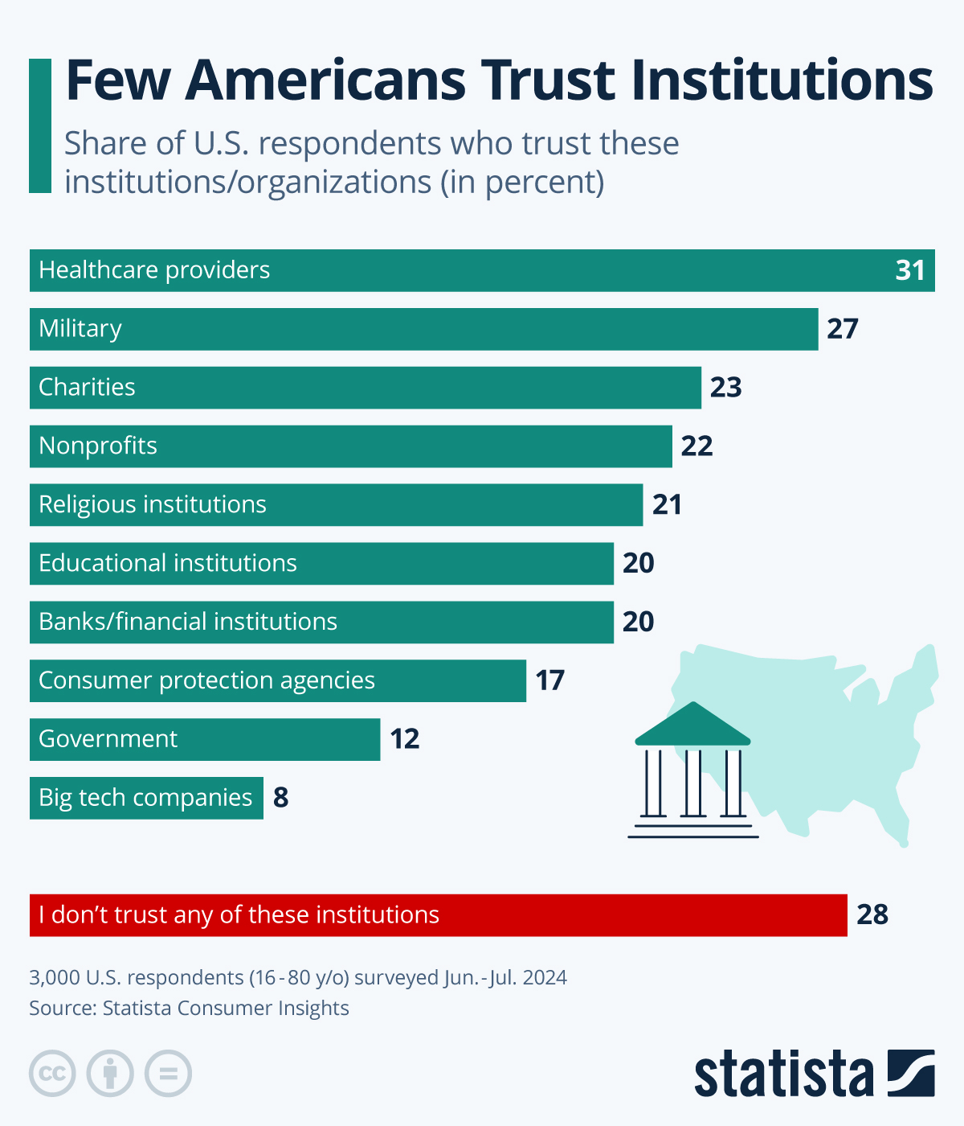
Figure 1: Few Americans Trust Institutions (Statista, 2026)
Given HSBC's historical fight for international compliance with anti-money laundering rules, artificial intelligence governance must be viewed as a critical board-level issue - not simply an operational concern left to the IT manager. Corporate governance has existed since the Cadbury Report (1992) to resolve the "agency problem" of a fundamental clash of interests between the shareholders and the top management of corporations. Cadbury established three non-negotiable tenets of leadership: accountability, probity and transparency. The advent of AI supercharges this agency problem and seriously threatens these pillars. In the current era, data engineers and closed-source algorithms hold a very large, very cloaked influence over international financial markets and set up a dangerous power imbalance between technical experts and the Board. Managers are made to sign off on software frameworks they do not understand (module code, for instance), directly violating the accountability mandate. As such, twenty-first-century corporate governance requires C-suite executives to proactively act as organisational guardians, interpret warring international regulatory responses and avoid severe fines resulting from unfair AI models (Tan, 2024).

2. The Transatlantic Regulatory Divide: Navigating Institutional Isomorphism
In rolling out its artificial intelligence systems across the globe, HSBC must grapple with divergent regulatory regimes. Institutional Theory (DiMaggio and Powell, 1983) suggests organisations must respond to the dominant imperatives of the environment to survive and remain legitimate. The theory suggests three distinct forces of isomorphic change shaping businesses. The Board needs to anticipate these various pressures when designing a compliant global network.
The first is coercive isomorphism that symbolise the explicit, mandatory influence of government laws and regulations, statutory standards and directives from central bank authorities. The second force is mimetic isomorphism, which explains the practice of firms imitating the business models of the most prominent firms during periods of high market uncertainty. In banking, mimetic isomorphism presents a severe systemic threat. Just as all financial institutions copied flawed, underlying collateralised debt obligation (CDO) models that preceded the 2008 global economic downturn (Levitt and Dubner, 2007), a situation that sees multiple international banks mindlessly replicate no more than the same initial AI models sourced from the same cloud computing firm could see simultaneous, catastrophic "flash crashes" across global markets. The third isomorphic force is normative isomorphism, which occurs when the intercorporate mobility of specialised professionals, such as information scientists and compliance ethicists who implement a shared set of professional norms from one organisation to another. For HSBC, the most important strategic risk is navigating the widening coercive regulatory gap between the market dominant UK and the United States.

2.1 The UK's FCA-Led Agile Framework and Consumer Duty
Instead of a blanket legislative bill on artificial intelligence, the UK's regulatory strategy emphasises a multifaceted and innovation-promoting approach (UK Government, 2026). The UK government encourages existing industry-specific regulators, such as the Financial Conduct Authority (FCA) and the Prudential Regulation Authority (PRA), to provide guidance based on broad principles of safety, robustness, and explainability, among others.
This strategy provides rapid technological experimentation for domestic HSBC operations, and a relatively modest short-term regulatory cost. Since the FCA has a natural understanding of financial markets, its regulatory framework for AI is highly specialised to the banking context, rather than clumsy impositions of social media regulations. On the other hand, this distributed approach leads to considerable long-term uncertainty. Crucially, the FCA's signature "Consumer Duty" rule, brought in to ensure banks and other firms can and must act to deliver good outcomes for retail consumers (FCA, 2022) explicitly contradicts the opacity of AI black boxes. If a powerful neural network rejects credit for a Small and Medium-sized Enterprise (SME) without an apparent rationale, then the bank breaches the Consumer Duty obligation to offer a clear explanation. This leaves HSBC's lawyers and compliance officers in a delicate conundrum between corporate pressures for faster AI efficiency and the peremptory legal need for human comprehensibility.

2.2 The US NIST AI RMF 1.0 as a Global Benchmark
In contrast, the US has heavily championed the NIST AI Risk Management Framework (NIST, 2023). While initially proposed as a non-binding protocol rather than binding law, the NIST AI Risk Management Framework (RMF) has almost overnight become the de facto global protocol for corporate AI risk management. This trend has been hastened by the excessive normative and coercive grounds of US federal regulators who now consider the framework to represent the standard of corporate care. The protocol demands intensive and ongoing auditing under the four pillars: Govern, Map, Measure and Manage.
For the successful integration of artificial intelligence technologies in the highly lucrative US market, HSBC needs to flawlessly operate in these four categories:

Figure 2:Four Pillars of the US NIST AI RMF 1.0
Key regulators are now using compliance to the NIST framework to assess a bank's internal risk management processes. Failing to identify the downstream implications of an autonomous trading bot puts the bank at great risk of incurring significant penalties. As such, to ensure robust integration of these transatlantic standards, HSBC should continue to implement the US NIST AI RMF 1.0 globally. In doing so, HSBC enjoys "normative isomorphism" (DiMaggio and Powell, 1983) voluntarily adhering to the highest international professional standards, regardless of the UK's regulatory demeanour. Attempting to maintain different compliance systems, a relaxed system in Europe and a fortified system in the US, presents dangerous complexity and risks with international data transfers.

3. Technological Sovereignty: TCE and Supply Chain Resilience
Worldwide rollout of artificial intelligence forces the Board to navigate a key "make or buy" decision on the bank's digital supply chain (Hamilton and Webster, 2018). The question of in-house development or outsourcing to the technology giants is pivotal for the bank's future sovereignty and resilience.

3.1 The Make-or-Buy Cloud Dilemma and Vendor Lock-In
Transaction Cost Economics (TCE) is the best framework for appraising this decision-making dilemma (Williamson, 1981) and can be supported by contemporary principles of managerial economics (Baye, 2017; Griffiths and Wall, 2011; Png and Lehman, 2007; Samuelson and Marks, 2014). TCE compares the relative cost structures involved with planning, adapting and managing business processes under alternate governance arrangements. It is based on three fundamental insights about human and organisational limitations:

Figure 3: Three Fundamental Insights About Human And Organisational Limitations
To date, HSBC is also highly reliant on technology partnerships with the likes of Google Cloud, Microsoft Azure and Amazon Web Services to power its generative AI. But developing algorithmic intelligence is highly asset specific (Smith et al., 2012). Although multinational corporations frequently employ "captive offshoring" (Tallman, 2011) to reduce costs in their conventional manufacturing, this exact same offshoring approach taken with a bank's algorithmic brain is highly risky.
Informed by its technology partnerships with Google Cloud (Google Cloud, 2023), HSBC, under CEO Georges Elhedery's direction, is in the process of proposing to eliminate up to 20,000 jobs (around 10 percent) of its global workforce (MLQ AI, 2026). The implementation of an AI-driven 'Dynamic Risk Assessment' architecture successfully slashed AML false positives by upwards of 60 percent (Google Cloud, 2023; HSBC, 2023), effectively removing the requirement for thousands of human compliance investigators in the middle and back-office (MLQ AI, 2026). This situation epitomises the TCE warning about outsourcing. If HSBC outsources the logical processing layer of its AI entirely to a third party, this unavoidable bounded rationality of the contract combined with the possibility of opportunism by the vendor spreads an unacceptable level of risk. This scenario creates a serious risk for "vendor lock-in". But if HSBC moves its entire credit profiling system and AML system to a single vendor and that vendor then exploits its market power to increase the price of processing credit risk and AML by 40 percent, HSBC will be stuck. The astronomical switching costs in such a catastrophic situation, involving enormous capital expenditures, severe service disruptions and major compliance issues to disentangle highly specialised data systems of one provider from another, is prohibitively expensive.
To get out of this bind, some financial institutions engage in "multihoming" strategies, such as using multiple competing AI ecosystems to maintain bargaining power (Zhou et al., 2025). Yet, multihoming amply increases in-house technological complexity and vulnerabilities to cyberattacks. Also, as Yang and Li (2025) in their study of transnational data governance, over-dependency on foreign cloud networks leads to serious problems relating to data sovereignty (particularly interchange between Asian and European legal firms. Thus, TCE strongly recommends that while HSBC can safely lease commodity processing power and server storage, the institution must strictly internalise its proprietary decision algorithms and data governance processes in house. By ensuring technological sovereignty, HSBC will avoid the pitfall of having technology vendors sidestep banks in the future to offer end-customer services.

3.2 Environmental Impact and Sustainable Supply Chains
Finally, the environmental impact of the gigantic outsourced digital supply chain must be taken into consideration. Training sophisticated Large Language Models requires gigantic data centres that produce massive carbon emissions and require gigantic amounts of water for cooling. As delineated by Klassen, Gualandris and Diebel (2020) in sustainable networks of commerce, companies are under intense public scrutiny for the environmental damage inflicted by their entire multi-level supply chains, from beyond their corporate offices. Therefore, HSBC must carefully analyse the renewable energy practices of its cloud partners to ensure that a ruthless quest for wider market share and domination in the field of artificial intelligence does not inadvertently cause the bank's highly acclaimed ESG (Environmental, Social and Governance) and "Net Zero" ammunition to backfire.

4. Strategic Positioning and Internal Capabilities
In order to successfully counter the increasingly mobile and digital threat of the new generation of fintech disruptors, HSBC needs to effectively leverage on its legacy assets through careful internal coordination and skill evaluations.

4.1 The Resource-Based View and the VRIO Framework
The Resource-Based View (RBV) argues that an enterprise secures enduring competitive dominance only by developing assets by investing in assets that meet the criteria of the VRIO matrix: Valuable, Rare, Inimitable and Organisation-wide support (Barney, 1991). In assessing the HSBC vision to adopt artificial intelligence, the Board must consider whether the resources meet this four-fold criteria:
- Valuable: Is the asset useful in capturing an opportunity or warding off a threat? Second-generation algorithms are clearly valuable; they will lease to dramatically reduce costs of processing and revealing new revenue opportunities.
- Rare: Is the asset possessed by a relatively few competitors in the market? Given cloud computing and the open-source software foundations of AI are rapidly becoming universally accessible via the Big Tech platforms, the underlying software code is no longer rare.
- Inimitable: Would it be prohibitively costly or otherwise impossible for competitors to replicate? This is where HSBC has the huge advantage. Its enormous, well-established databases of historical transaction data, containing billions of global SWIFT transfers and its own, decades-long credit histories are indisputably inimitable.
- Organisation: Does the corporation have the capability to collect value? If management is not adaptable, and departments are not integrated, no matter how many and how powerful the data sets, there is no business value (Barney, 1991; Johnson et al., 2020).
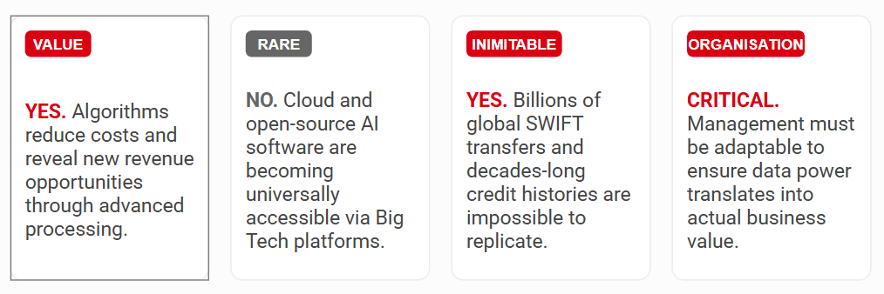
Figure 4: Summary of HSBC VRIO Analysis
HSBC's last and highest line of defence is in ensuring that its algorithms are only trained on its unique financial archives. These archives lead to predictive insights that fintech disruptors simply cannot offer simply because they do not have the same operational experience and vast data sets as the traditional banks.

4.2 Aligning Architecture via the McKinsey 7S Framework
However, owning inimitable data is futile without a bank architecture capable of leveraging it. As the McKinsey 7S Framework (Waterman, Peters and Phillips, 1980) explains, for companies to succeed, they need to align seven constructed and coexisting operational components. This framework can be divided into the "Hard S's", the tangible structural elements and "Soft S's", the intangible cultural elements which are resistant to change.
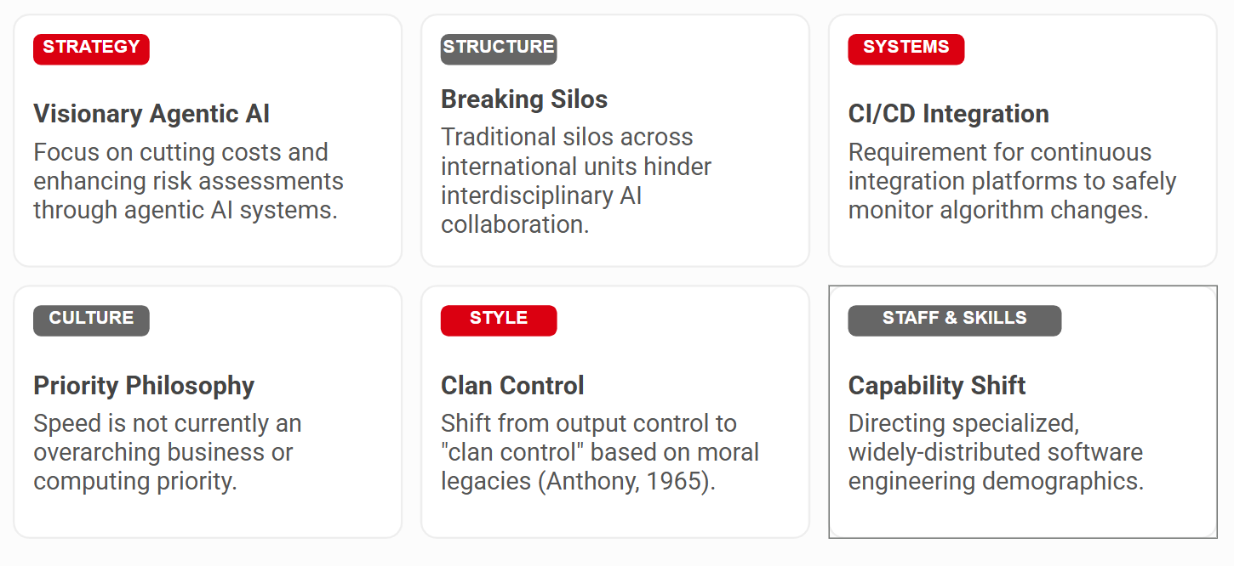
Figure 5: McKinsey 7S Framework for HSBC
Most significantly, this internal restructure must ruthlessly attack a striking weakness in the bank's current Skills, perhaps the most critical Soft S in the 21st century. Legacy bank personnel are deep in expertise that has been honed over decades in traditional financial forecasting, manual underwriting and retrospective compliance reviews. By contrast, they are woefully short of the technical skills required to govern an independent AI ecosystem. Indeed, deficient knowledge and training is reported by almost 60% of financial industry respondents as the greatest impediment to responsible AI implementation (McKinsey and Company, 2026). For instance, existing risk professionals are seldom trained to audit deep neural networks, apply complex prompt engineering or understand the cutting-edge cryptography needed to protect a hybrid-cloud server network.
This critical skills imbalance creates a dangerous knowledge gap, forcing HSBC into its difficult and dangerous relationship with external technology conglomerates and its cloud providers. If the in-house workforce is unable to independently audit the underlying mathematical and data integrity of an externalised algorithm, an institution gives up its technological sovereignty. Unless the bank undertakes intense educational initiatives to correct the very clear skills gap, modern legacy employees will quickly become totally technologically redundant. As a consequence of this, the Board will be entirely dependent on third party corporations to understand the algorithms that actually control the bank's global capital deployment and regulatory compliance, which in turn, breaks the core tenets and practices of corporate governance.

4.3 Competitor Analysis: JPMorgan Chase's Internalisation Strategy
A rigorous competitor analysis is required to properly assess HSBC's strategic positioning. Amongst the global banking system, JPMorgan Chase presents an effective counter-narrative. Rather than wholly outsourcing its information systems to technology vendors and cloud conglomerates, JPMorgan has invested enormous resources into internalised AI, successfully executed the core principles of Transaction Cost Economics.

Figure 6: Competitive Landscape: Strategic Brand Identity
This behaviour is visibly demonstrated by their internal AI use cases, where the successful automation of document processing alone has saved them 360,000 annual manual work hours (Articsledge, 2024). Through deep internalisation of its key algorithmic architecture, JPMorgan has managed to avoid unnecessary vendor exploitation, fluctuates cloud costs and global data privacy breaches. HSBC needs to critically assess this mimicry. If HSBC continues to allow itself to over-rely solely on rented algorithmic talent, it risks losing its software autonomy: it will always remain dependent on its competitors for technological supremacy, who wholly own and manage their software from conception to deployment.

5. Algorithmic Fairness, Inequality, and Socio-Economic Risk
The widespread implementation of AI fundamentally jeopardises consumer data privacy, especially as global jurisdictions enact over 150 new data privacy regulations, and threatens the essential core of public trust (Usercentrics, 2026). In an environment of heightened public scrutiny, corporate ethics should transcend mere public relations on the surface. As Kay (2011) beautifully describes in his book Obliquity, challenging goals such as corporate profitability are often best attained via oblique means; prioritising ethical approaches to explainable AI over short-term profits will strengthen HSBC's competitive advantage in the marketplace much more than uninhibited innovation.

5.1 Stakeholder Theory vs. Shareholder Primacy
Modern Corporate Social Responsibility (CSR) concepts and Stakeholder Theory (Freeman, 1984) legally and morally demand that HSBC forget the archaic philosophy espoused by Friedman's doctrine of shareholder primacy. Shareholder primacy holds that the corporation has only one social objective; this is to maximise the profits of its shareholders. By contrast, Stakeholder Theory states that a corporation owes a duty to create value for all stakeholders (including employees, suppliers, customers, regional communities and the environment).
Hence, the Board should assess its AI rollout plan using the Triple Bottom Line, meaning that it should consider Profit, Planet, and People (Elkington, 1994). If artificial intelligence will undoubtedly generate immense cost savings and meet the bank's duty of care to shareholders (Profit), it also presents a profound threat to financial equity and the security of consumers (People), especially in emerging economies where digital literacy is much less developed (Zhou et al., 2022).

5.2 Digital Redlining, the Gini Coefficient, and the Palma Ratio
When past financial data, tainted by generations of systemic discrimination, is harnessed by machine learning modelling pipelines, new algorithms will systematically amplify these forms of discrimination, at a record pace. This practice is well known in the banking industry as "algorithmic redlining". It's when models continually deny credit to minority and socio-economically vulnerable populations by using arcane, proxy data indicators (such as home zip code, tertiary institution, or internet web-browsing patterns), and thus lock them out of the means to accumulate wealth (World Economic Forum, 2026).
To assess the magnitude of this macroeconomic risk, the Board needs to analyse key economic indicators such as the Gini Coefficient and the Palma Ratio.
- The Gini Coefficient is a mathematical formula for measuring disparity of income and wealth on a scale from 0 to 1, where 0 represents absolute equality (everyone has an equal share of the wealth) to 1, absolute inequality (one person has all the money).
- The Palma Ratio provides a more targeted representation of the ratio of the gross national income (GNI) share of the top 10% of citizens to the share of the bottom 40% (Sloman, Wride and Garratt, 2018).
As the Global Multidimensional Poverty Index (Alkire et al., 2025) explains, the multidimensional disadvantages to vulnerable communities are devastating. Wealth-impoverished neighbourhoods will, by their very nature, not have digital "smart" infrastructure and will therefore not be included in the enormous volumes of data used to train global financial algorithms. If HSBC's AI-based credit decision making algorithms are trained only upon data from the rich, deeply connected internet age, and not subjected to independent fairness reviews and audits, they will be endemic with "data poverty".
This type of digital discrimination is already taking place. 450 participants focused research in 2025 conclusively demonstrates that female credit applicants consistently received algorithmically derived credit scores 6-8 points lower than men with identical credit histories (Real World Data Science, 2025). And, in tests of Large Language Models (LLMs) for determining credit, they often proposed higher interest rates or mortgage denials for African Americans (Real World Data Science, 2025). Using these models will systematically amplify the global wealth divide by evidenced denials of access to capital by those who need capital to establish businesses and to mortgage homes (Yang and Lee, 2024). Monetising AI without imposed stringent CSR standards directly increases the Gini coefficient, as a technological dividend is generated, benefiting a few elite groups, by moving the index towards the value of 1 and entirely contravening philosophies of poverty reduction (Pimpa, 2011; Perrini, Russo and Tencati, 2007; Townsend, 2006).
The studies conducted by Wen and Holweg (2024) show phenomenologically that accelerating the implementation of untested AI technologies usually seriously erodes customer trust. Indeed, if the senior management places more emphasis on the speed of loan applications processed rather than verifying the neutrality of algorithms in use, as discussed by Levitt and Dubner (2007) about the perils of misaligned corporate incentives, the consequence will be devastating. The case study of global corporations failing to consider regional social and ecological responsibility highlighted by Griffin and Pustay (2015) clearly demonstrates the devastating reputational and economic damages resulting from the huge Investor-State Dispute Settlement (ISDS) lawsuits against Chevron in Ecuador. The biased nature of algorithms also has the same potential to trigger enormous, destructive international class-action lawsuits against HSBC, damaging its reputation.

6. Cross-Cultural Change Management and Leadership
And even though 100% error-free servers with 100% regulatory compliance, the biggest challenges to scaling AI lies in the psychology of humans.

6.1 Overcoming the 93% Human Barrier
A breakthrough study in 2026 conducted across multiple companies revealed an incredibly startling fact: an alarming 93% of corporate leaders cite the human components, management conflicts and deep employee resistance as the key barriers to scaling artificial intelligence (AI) (Croft et al., 2026). As Westover (2025) reminds us, when redesigning companies for sustainability, innovation must be embedded and pervasive: widespread and massive in human change management capacity. The employee trauma within an institution such as HSBC is enormous when considering current news of a 20,000-person workforce reduction internationally, attributed to automation. Firms that heavily invest in software and do not heavily invest in human change management inevitably see a disaster of talent loss.
When trying to understand the "93% Human Barrier" and the ensuing revolts, we need to further develop the theoretical line of argument by considering the concept of "algorithmic aversion". Algorithmic aversion is not caused by irrational fears of computers on the part of employees and the average consumers. Instead, they accurately perceive these independent "Black Box" systems as lacking any moral responsibility in its execution of financial judgements. This then results in profound emotional turmoil when the black box is trusted to make independent human-affecting decisions without human supervision (SQ Magazine, 2026; Pew Research Center, 2026). This subtext in turn substantially alters the human-factors debate, as evidence demonstrates that insider resistance is often an ethical response to a legitimate concern for corporate governance, instead of technophobia.

6.2 Hofstede’s Dimensions in Global Rollouts
As a "world" corporation, HSBC is obliged to delicately negotiate quite divergent cultural responses to artificial intelligence in its various international centres (for example London, New York and Hong Kong). Hofstede's Cultural Dimensions (Hofstede, 1980; 2011) must be applied to understand these crucial behavioural differences across a variety of factors:
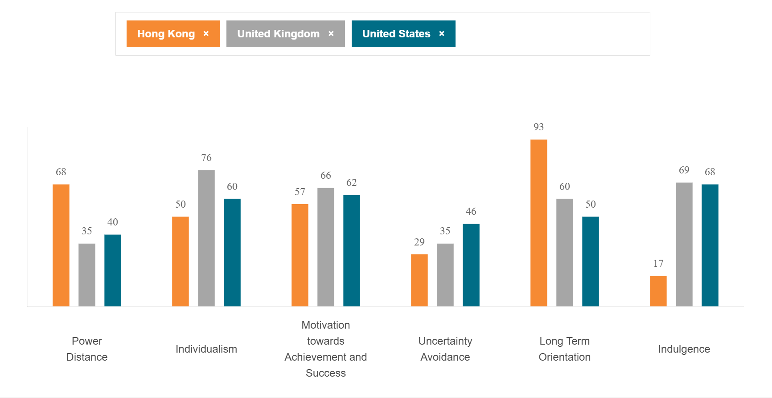
Figure 7: Hofstede' Country Comparison Tool for Hong Kong, UK AND USA (The Culture Factor Group, 2026)
Uncertainty Avoidance (UAI): This measurement relates to whether or not a society is risk-averse. Demographics with high Uncertainty Avoidance scores have a much smaller tolerance for uncertainty. In such cultures, employees will demand extremely rigorous and invasive documentation of financial algorithms ("White Box" models) and will heavily favour heavily documented iterative rollouts of financial algorithms to alleviate their collective fear of failure.
Power Distance Index (PDI): This describes the extent to which the less powerful members of organisations and societies accept and expect an unequal distribution of power. Where there is a high Power Distance Index in a culture, inferiors will be extremely reluctant to question decisions arrived at by an algorithm if they perceive that the AI-based platform was imposed upon them by top management at the corporate headquarters. This is supremely dangerous, as it would mean that severe issues in the AI algorithm for AML monitoring may not even be considered by junior staff for fear of facing retaliation.
Individualism vs. Collectivism (IDV): This dimension measures the degree of collectivism that exists within a country. In very individualistic cultures such as the UK or the US, AI software that helps individuals increase their productivity to earn an individual bonus target is likely to be swiftly adopted. By contrast, in "collectivist" societies, a computer system that upsets group harmony or removes valued staff will face fierce, cohesively united, and tenacious resistance.
Masculinity vs. Femininity (MAS): In highly "masculine" environments driven by extreme competition, heroic individualism and material success, artificial intelligence will likely be pushed to its limits by lending teams in an effort to meet ambitious sales targets without moral compass. In "feminine" cultures that emphasise co-operation, collective decision-making and the quality of life, the ethical concerns around a technology and its socio-economic ramifications will appropriately be at the fore.
Long-Term vs. Short-Term Orientation (LTO: Implementing an enterprise-level AI strategy requires tremendous short-term capital investments in return for long-term operational benefits. Immediately oriented cultures, deeply influenced by stock exchange quarterly revenues, may very well end up harassing the Board for quick financial results, thus arbitrarily omitting important ethical and safety auditing stages.
The critical importance of these concepts are aptly illustrated in the "When in China" case study (Chirino-Klevans, 2014). This case demonstrates how the failure to successfully negotiate high context communicative cultures, in which implicit relationship development and intrinsic emotional intelligence skills are fundamental to achieving company success will inevitably lead to corporate breakdown. A London-based head office unilateral, "top-down" mandate to adopt the "Black Box", mystical and unexplainable artificial intelligence (AI) process that eliminates the human aspect of relationship building between the regional wealth advisors and their customers will be met with massive push-back.
To offer a palpable example of some of the huge operational risks of ignoring such cultural factors, one must imagine a scenario where an agentic AI system rejects a business loan. If this agentic information system inexplicably refuses important finance to a long-standing SME customer, the ensuing response by the regional branch manager will diverge drastically based on their cultural programming. In a London branch, with empirically Low Power Distance and High Individualism (Hofstede, 2011) the regional relationship manager is highly likely to challenge the machine's determination. Empowered by a culture of open inquiry, the London manager would likely insist on full transparency on the part of the analytics department, will adamantly stand up for their single client, and would rapidly escalate the conflict to the company's AI Ethics Committee if they felt that systemic bias was evident.
On the other hand, if the same artificial rejection were to occur in an office in Hong Kong, a culture with traits of High Power Distance and extreme Collectivism (Hofstede, 2011), the response would be very different. In this high context culture, the regional manager is culturally symbolic of respecting the highest authority in the central head office; and the software used in the London head office is viewed as the unquestioned, final decision. This employee is likely to suppress any individual doubts about the software's impartiality and submit the software's rejection decision to the customer, unmentioned, in pursuit of group harmony and avoidance of upsetting his/her managers. This cultural tendency is highly dangerous in the age of AI because it ensures that gross algorithmic, localised data, or biased (against the customer) anti-money laundering (AML) tracking errors will never be documented by subordinates obliged by their cultural deference to remain silent. This highlights the fact that not understanding how to operate in high-context cultures where the relationship with others is critical to success, leads to systemic business failure in digital rollouts (Chirino-Klevans, 2014). As such, one-size-fits-all, global rollouts of "Black Box" technology are bound to fail. The Board needs to implement a "Global Mindset" (Bartlett and Ghoshal, 1990; Kossow, 2024) with culturally and empathically adept leadership that promotes psychological safety. HSBC needs to introduce human-in-the-loop (HITL) mechanisms to ensure employees that autonomous technology is there to complement - not to compete - its human counterpart (Kou and Lu, 2025).

7. Strategic Implementation Roadmap and Risk Mitigation
To translate these high-level strategic guidelines into practical implementation, HSBC needs to follow a highly detailed, staggered multi-year plan to implement such transformational initiatives. This roadmap is designed to be a blueprint for ensuring that digital change is completely in service to corporate governing norms and thrives within detailed global legislation.
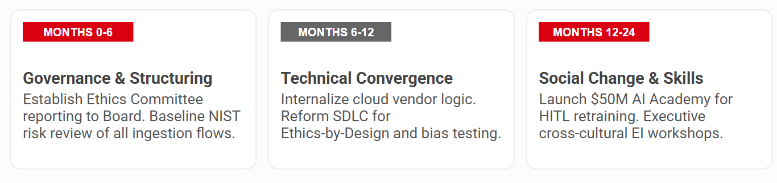
Figure 8: Summary of Implementation Roadmap
Months 0-6: Governance & Structuring
- Establish the AI Ethics Committee: Assemble a handpicked multidisciplinary AI Ethics Committee including external governance lawyers, lead data engineers and ethicists for algorithms. This board of oversight should report only to the Board of Directors, deliberately skipping regional product leads to finally remove conflicts of interest associated with premature product release (Cadbury, 1992).
- Baseline NIST Review: Carry out a rigorous internal review of all existing and potential AI solutions using the strict standards of the National Institute of Standards and Technology (NIST) AI Risk Management Framework (Govern, Map, Measure, Manage). This includes comprehensively documenting all data ingestion flows and identifying any algorithms which potentially trigger all high-risk regulatory classifications.
Phase 2: Technical & Vendor Convergence (6-12 months)
- Internalisation Protocol: Rigorously audit and review existing commercial contracts with cloud vendors. Ensure that the vendor-specific proprietary algorithmic logic and fundamental data governance framework are hosted securely on HSBC premises to protect IP and address extreme TCE risks.
- Ethics-by-Design Integration: Reform the key Software Development Life Cycle (SDLC). Only allow algorithms to be implemented after serious testing for algorithmic bias, including verification for digital redlining signals in protected class groups, is approved by the AI Ethics Committee (Floridi, 2019).
Phase 3: Social Change & Reskilling (Months 12-24)
- Cost Estimates and The AI Academy: Set up a well-funded "AI Academy" to anticipate and proactively retrain employees whose roles will be automated, thus facilitating their transition into critical human-in-the-loop (HITL) auditing functions. This highly targeted training program will cost a projected 50 million USD over the next two years - a highly targeted investment that will prevent the considerable costs of layoffs and the very difficult work shortage conditions for tech talent.
- Cross-Cultural Training: Offer emotional intelligence-intensive workshops for the entire executive team, with a strong focus on capability to seamlessly integrate new automated technologies in high-context and high uncertainty avoidance cultures.
Risk Mitigation Matrix
A critical component of this transformation plan is a foolproof mitigation plan. If a value-added legacy credit risk assessment framework is found by the AI Ethics Committee to have irreparable, systemic biased internalised within it, and/or a new operationalised algorithm is detected to have critical "predictive drift" errors, the mitigation matrix mandates a system-wide "kill-switch" be activated. This process requires legal compliance with a complete return to human, non-algorithmic underwriting procedures until the entire algorithmic process can be removed and rebuilt, ensuring that the financial institution can never wholly depend on a non-compliant, non-explainable machine learning environment.

8. Conclusion and Final Recommendations
HSBC is obliged to stick to a rapid and completely accountable approach in incorporating agentic AI technologies into its operations if it is to maintain its dominance in the stigmatised international finance industry. Believing artificial intelligence is merely a software upgrade blatantly overlooks the absolute risks of giant geopolitical, policy, ethical and human risks that have the capacity to cripple the business.
In order to effectively eliminate these globalization risks and establish an extremely competitive moat, the Board of Directors must immediately tighten the Phase 1 governance strategies. By self-imposing the demanding US NIST guidelines across all of its overseas branches to ensure normative isomorphism, significantly internalising prototype algorithmic logic to prevent vendor abuse and cloud computing addiction and utilising culturally sensitive change management to retrain traditional corporate employees, HSBC will decisively triumph over the human barriers to digital integration. By measuring artificial intelligence only in the context of strict corporate governance, in lieu of straightforward processing power, HSBC will protect the organisation from disastrous fines and cement itself as the global ultimate standard-bearer for reinstating absolute trust of key stakeholders.

9. Bibliography
Abonamah, A. A. and Abdelhamid, N. (2024) 'Managerial insights for AI/ML implementation: a playbook for successful organizational integration', Discover Artificial Intelligence, 4. Available at: https://doi.org/10.1007/s44163-023-00100-5.
Alkire, S., Mishra, R., Selden, L. and Suppa, N. (2025) Global Multidimensional Poverty Index 2025: Overlapping Hardships: Poverty and Climate Hazards. Oxford Poverty and Human Development Initiative (OPHI) and United Nations Development Programme (UNDP). Available at: https://ophi.org.uk/sites/default/files/2026-01/GMPI_2025_Overlapping_2.pdf.
Anthony, R. N. (1965) Planning and Control Systems: A Framework for Analysis. Boston: Harvard Business School.
Articsledge (2024) 'JPMorgan Chase AI implementation case study'.
Barney, J. (1991) 'Firm resources and sustained competitive advantage', Journal of Management, 17(1), pp. 99-120.
Bartlett, C. A. and Ghoshal, S. (1990) Managing Across Borders: The Transnational Solution. London: Hutchinson Business Books.
Baye, M. (2017) Managerial Economics & Business Strategy. 9th edn. New York: McGraw-Hill Education.
Businesstats (2026) Artificial intelligence (AI) in finance — 2026 statistics, use cases & market data. Available at: https://businesstats.com/ai-in-finance/ (Accessed: 23 March 2026).
Cadbury, A. (1992) Report of the Committee on the Financial Aspects of Corporate Governance. London: Gee.
Chirino-Klevans, I. (2014) 'When in China...': A Teaching Case in Global Leadership. Kenan-Flagler Business School.
Croft, J., Vaid, S., Cheng, L. and Whillans, A. (2026) 'Where Senior Leaders Are Struggling with AI Adoption, According to Research', Harvard Business Review, February. Available at: https://hbr.org/2026/02/where-senior-leaders-are-struggling-with-ai-adoption-according-to-research.
DiMaggio, P. J. and Powell, W. W. (1983) 'The iron cage revisited: Institutional isomorphism and collective rationality in organizational fields', American Sociological Review, 48(2), pp. 147-160. Available at: https://doi.org/10.2307/2095101.
Elkington, J. (1994) 'Towards the sustainable corporation: Win-win-win business strategies for sustainable development', California Management Review, 36(2), pp. 90-100. Available at: http://dx.doi.org/10.2307/41165746.
FCA (2022) 'A new Consumer Duty', Financial Conduct Authority. Available at: https://www.fca.org.uk/publications/policy-statements/ps22-9-new-consumer-duty (Accessed: 25 March 2026).
Floridi, L. (2019) 'Translating principles into practices of digital ethics: Five risks of being unethical', Philosophy & Technology, 32(4), pp. 733-744. Available at: https://doi.org/10.1007/s13347-019-00354-x.
Freeman, R. E. (1984) Strategic Management: A Stakeholder Approach. Boston: Pitman.
Gitnux (2023) Ai In The Banking Industry Statistics | Fact-Checked 2026. Available at: https://gitnux.org/ai-in-the-banking-industry-statistics/ (Accessed: 24 March 2026).
Google Cloud (2023) HSBC - Opening up a world of opportunity. Available at: https://cloud.google.com/customers/featured/hsbc.
Griffin, R. and Pustay, M. (2015) International Business. Global Edition. Harlow: Pearson.
Griffiths, A. and Wall, A. (2011) Economics for Business and Management. Harlow: Pearson.
Hamilton, L. and Webster, P. (2018) The International Business Environment. New York: Oxford University Press.
Hofstede, G. (1980) Culture's Consequences: International Differences in Work-Related Values. Beverly Hills, CA: Sage Publications.
Hofstede, G. (2011) 'Dimensionalizing Cultures: The Hofstede Model in Context', Online Readings in Psychology and Culture, 2(1). Available at: https://doi.org/10.9707/2307-0919.1014.
HSBC (2023) Annual Report and Accounts 2023. Available at: https://www.hsbc.com/-/files/hsbc/investors/hsbc-results/2023/annual/pdfs/hsbc-holdings-plc/240226-annual-report-and-accounts-2023.pdf.
IBISWorld (2026) Global Commercial Banking - Market Research Report. Available at: https://www.ibisworld.com/global/industry/global-commercial-banks/1750/.
Johnson, G., Whittington, R., Regner, P., Scholes, K. and Angwin, D. (2020) Exploring Strategy: Text & Cases. 12th edn. Harlow: Pearson.
Kay, J. (2011) Obliquity: Why our goals are best achieved indirectly. London: Profile Books.
Klassen, R. D., Gualandris, J. and Diebel, W. (2020) 'More Sustainable Supply Chains: Is the Journey More Important than the Destination?', in Choi, T. Y. et al. (eds.) The Oxford Handbook of Supply Chain Management. Oxford: Oxford University Press, pp. 779-804.
Kossow, M. (2024) Overview from the national culture, organizational culture, and internationalization perspective. London: Routledge.
Kou, G. and Lu, Y. (2025) 'FinTech: a literature review of emerging financial technologies and applications', Financial Innovation, 11(1). Available at: https://doi.org/10.1186/s40854-024-00668-6.
Levitt, S. D. and Dubner, S. J. (2007) Freakonomics: A Rogue Economist Explores the Hidden Side of Everything. London: Penguin.
Madanchian, M. and Taherdoost, H. (2025) 'Strategic execution of AI in global enterprises', Journal of Digital Innovation.
McKinsey and Company (2026) State of AI trust in 2026: Shifting to the agentic era. Available at: https://www.mckinsey.com/capabilities/tech-and-ai/our-insights/tech-forward/state-of-ai-trust-in-2026-shifting-to-the-agentic-era (Accessed: 20 March 2026).
MLQ AI (2026) JPMorgan CEO Reveals AI-Driven Employee Redeployment Initiative. Available at: https://mlq.ai/news/jpmorgan-ceo-reveals-ai-driven-employee-redeployment-initiative/.
Morrison, J. (2020) The Global Business Environment Towards Sustainability. 5th edn. London: Red Globe Press.
NIST (2023) Artificial Intelligence Risk Management Framework (AI RMF 1.0). National Institute of Standards and Technology. Available at: https://nvlpubs.nist.gov/nistpubs/ai/nist.ai.100-1.pdf.
Perrini, F., Russo, A. and Tencati, A. (2007) 'CSR Strategies of SMEs and Large Firms, Evidence from Italy', Journal of Business Ethics, 74(3), pp. 285-300. Available at: https://doi.org/10.1007/s10551-006-9235-x.
Pew Research Center (2026) Key findings about how Americans view artificial intelligence. Available at: https://www.pewresearch.org/short-reads/2026/03/12/key-findings-about-how-americans-view-artificial-intelligence/.
Pimpa, N. (2011) 'Multinational Corporations: Corporate Social Responsibility and Poverty Alleviation in Thailand', in The first International conference on Interdisciplinary Research and Development, pp. 1-8.
Png, I. and Lehman, D. (2007) Managerial Economics. Oxford: Blackwell.
Real World Data Science (2025) Understanding and Addressing Algorithmic Bias: a Credit Scoring Case Study. Available at: https://realworlddatascience.net/applied-insights/case-studies/posts/2026/02/11/algorithmic_bias_credit_scoring.html.
Samuelson, W. F. and Marks, S. G. (2014) Managerial Economics. Study Guide. London: John Wiley & Sons.
Schumpeter, J. A. (1942) Capitalism, Socialism and Democracy. New York: Harper & Brothers.
Sloman, J. and Jones, E. (2020) Essential Economics for Business. 6th edn. London: Pearson.
Sloman, J., Wride, A. and Garratt, D. (2018) Economics. 10th edn. London: Pearson.
Smith, D., Allen, B., Weigelt, K. and Doherty, N. (2012) Managerial Economics: Theory, Applications, and Cases. New York: W. W. Norton & Company.
SQ Magazine (2026) EU AI Act Compliance Cost Statistics 2026: Key Trends Now. Available at: https://sqmagazine.co.uk/eu-ai-act-compliance-cost-statistics/ (Accessed: 25 March 2026).
Statista (2026) Chart: Few Americans Trust Institutions. Available at: https://www.statista.com/chart/33957/share-of-us-respondents-who-trust-institutions/ (Accessed: 22 March 2026).
Steger, M. B. (2021) Globalization: A Very Short Introduction. 5th edn. Oxford: Oxford University Press.
Tallman, S. (2011) Global Strategy: Global Dimensions of Strategy. Chichester: John Wiley & Sons.
Tan, T.H. (2024) 'E-Banking SAF: A TOGAF-NIST Aligned Security Architecture Framework for E-Banking Systems', 2024 The 7th International Conference on Information and Computer Technologies. Available at: https://doi.org/10.1109/ICICT62343.2024.00007.
The Culture Factor Group (2026) Country comparison tool. Available at: https://www.theculturefactor.com/country-comparison-tool?countries=hong+kong%2Cunited+kingdom%2Cunited+states (Accessed: 22 April 2026).
Townsend, P. (2006) What is poverty? An historical perspective. London: International Poverty Center.
UK Government (2026) Establishing a pro-innovation approach to regulating AI. Available at: https://www.gov.uk/government/publications/establishing-a-pro-innovation-approach-to-regulating-ai/establishing-a-pro-innovation-approach-to-regulating-ai-policy-statement (Accessed: 27 March 2026).
Usercentrics (2026) Over 150 data privacy statistics companies need to know about in 2026. Available at: https://usercentrics.com/guides/data-privacy/data-privacy-statistics/ (Accessed: 24 March 2026).
Waterman, R. H., Peters, T. J. and Phillips, J. R. (1980) 'Structure is not organization', Business Horizons, 23(3), pp. 14-26. Available at: https://doi.org/10.1016/0007-6813(80)90027-0.
Wen, Y. and Holweg, M. (2024) 'A phenomenological perspective on AI ethical failures: The case of facial recognition technology', AI & SOCIETY, 39(4), pp. 1929-1946. Available at: https://doi.org/10.1007/s00146-023-01648-7.
Westover, J.H. (2025) 'Sustainable AI Transformation: A Critical Framework for Organizational Resilience and Long-Term Viability', Sustainability, 17(21), p. 9822. Available at: https://doi.org/10.3390/su17219822.
Williamson, O. E. (1981) 'The Economics of Organization: The Transaction Cost Approach', American Journal of Sociology, 87(3), pp. 548-577. Available at: https://www.jstor.org/stable/2778934.
World Economic Forum (2026) Global Risks Report 2026. Available at: https://www.weforum.org/publications/global-risks-report-2026/ (Accessed: 26 March 2026).
Xu, H., Niu, K., Lu, T. and Li, S. (2024) 'Leveraging artificial intelligence for enhanced risk management in financial services: Current applications and future prospects', Engineering Science & Technology Journal, 5(8), p. 2402. Available at: https://doi.org/10.51594/estj.v5i8.1363.
Yang, B. and Li, M. (2025) 'Offshore Embeddedness Beyond the Wall: Data Governance Landscape', Politics and Governance, 13, p. 10437. Available at: https://doi.org/10.17645/pag.10437.
Yang, Q. and Lee, Y.-C. (2024) 'Ethical AI in Financial Inclusion: The Role of Algorithmic Fairness on User Satisfaction and Recommendation', Big Data and Cognitive Computing, 8(9), p. 105. Available at: https://doi.org/10.3390/bdcc8090105.
Zhou, S., Tang, S., Li, D. and Tong, T. W. (2025) 'Multihoming: an internationalization strategy in a world of artificial intelligence ecosystems', Journal of International Business Studies, 56(9), p. 1188. Available at: https://doi.org/10.1057/s41267-025-00813-y.
Zhou, X., Yang, Z., Hyman, M. R., Li, G. and Munim, Z. H. (2022) 'Guest editorial: Impact of artificial intelligence on business strategy in emerging markets: a conceptual framework and future research directions', International Journal of Emerging Markets, 17(10), pp. 917-929. Available at: https://doi.org/10.1108/IJOEM-04-2022-995.

