Name: Naseem Khan 1807432
Module: BMHP5013
Lecturer: Besty Jose
Public Health Policy

REPORT ON COVID-19

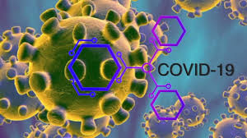

CONTENTS PAGE

Introduction …………………………………………………………………...pg 3
What is Covid-19 ……………………………………………………………..pg 3,4
Monitoring and surveillance of Covid-19…………………………………...pg 4,5
Three public health and social policies introduced to control the
infection rate of Covid-19…………………………………………………….pg 5,6
Human behaviour and the Heath Belief Model…………………………….pg 6,7
Two potential Covid-19 vaccinations………………………………………..pg 7
Recommendations…………………………………………………………….pg 7,8
Conclusion……………………………………………………………………..pg 8
Appendices…………………………………………………………………….pg 9,10
References……………………………………………………………………..pg 11,12,13

Introduction
This report will look into the worldwide pandemic as we know Covid-19. Firstly, we will briefly look into the history of coronavirus. The monitoring and surveillance of the virus will be looked into and the strategies used to monitor Covid-19 will be addressed in this report. Upon such finding the strategies used to take control of the virus will be critically evaluated. Public health/social policies will be investigated as to how the infection rate was controlled and how the policies changed our lifestyles. Models will be used to look into the health behaviour changes and change of lifestyle during the pandemic. We will look into the issues surrounding the BAME population. An explanation of how the U.K government is supporting the ongoing Covid-19 research will be addressed as well as looking into two eminent vaccine trials currently underway in the U.K. Recommendations on how to improve the control of the virus will be given as well as how to address the health and well being of the BAME population. Lastly a sound conclusion will be drawn.
What is Covid-19
The World Health Organisation (WHO) (2020) has stated that Coronavirus (Covid-19) is an infectious newly discovered disease. Most people who are infected by the disease will experience a mild to moderate respiratory illness and will recover without the need for specialist treatment.
In December 2019, the Covid-19 outbreak began in Wuhan, the world was taken back by the virus in early 2020. Conspiracy theorists conspired against the 5G network, there were many theories such as Covid-19 was deliberately created so that the 5G engineers could install the technology anywhere, this theory was not thought out properly as the roll out of 5G is being done in phases, worldwide installation would have caught everyone’s eye (Hadi, M.U et al, 2020).
January 29th, 2020 is then the U.K first two patients tested positive for the virus. On January 30th, 2020, the World Health Organisation declare a global health emergency after thousands of new cases are confirmed in China. March 10th,2020 6 people in the U.K have died from the virus and 373 have now tested positive. (British Foreign Policy Group 2020).
Samira Ben Omar (2020) described that he BAME population seem to have been the worst effected group, there are numerous reports and articles that provide evidence for the disproportionate impact on the BAME communities. Demographic evidence shows us the differences of those who have experienced Covid-19 in London based on geography and race. Evidence was collected from the eight North west London boroughs to highlight the importance of geography and race. The latest published report from ONS (office of National Statistics) describes a greater mortality risk in BAME groups when affected with Covid-19. Black ethnicity groups had over 3.4 X greater risk of dying from the virus compared to the white groups followed by the Asian groups. (Raisi-Estabragh, Z, et al, (2020).
Monitoring and surveillance of Covid-19
Public Health Surveillance is a tool used to monitor and measure what is going on in the population. Early surveillance can measure the need to implement interventions. Surveillance is extremely important in world outbreaks such as Covid-19 as it allows decisions makers to lead and manage more effectively by providing timely useful evidence within their decision making when implementing strategies to control virus outbreaks (ncbi.nlm.nih.gov/books).
A number of measures were taken by organisations across England in the surveillance of Covid-19, acute respiratory outbreaks in institutional settings that included care homes and hospitals are gathered by the Respiratory Surveillance section at Public Health England in Colindale through the HPZone health management system. Respiratory sampling of individuals was encouraged to identify the virus. Public Health England also use syndromic surveillance systems teams to collect and analyse anonymised health data from a number of sources, keeping an eye out for trends and higher than normal levels of illnesses. Bulletins are published to keep health professionals up to date. Internet surveillance such as google health app is also being used to monitor the amount of times an individual has a generic query about coronavirus. Flu Survey is an internet-based surveillance system that has been designed to monitor trends in flu like illnesses from registered participants which enables the platform to capture respiratory symptoms, exposure risks and behaviours amongst registered participants to contribute to the National surveillance of Covid-19.
The Royal College of General Practitioners weekly returns service which is run by the Research and Surveillance Centre provides clinical surveillance date from around 500 GP practices across England and is another surveillance tool used to monitor Covid-19. The Royal College of General Practitioners has always used swabbing to monitor Influenza, it has been expanded to include the swabbing of patients with ILI or LRTI which was implemented in late February due to the current pandemic.
CHESS - COVID-19 Hospitalisation in England Surveillance System (CHESS), this is a surveillance system put in place for serious Covid-19 cases that required hospitalisation and ICU/HDU. CHESS allows the monitoring of severe Covid-19 infection rate on the health service and population, it allows provides Public Health England with real time data enabling them to forecast and estimate the burden of the disease and how to utilise the health service (Public Health England 2020). This surveillance was based on the people living in the U.K rather than travellers entering the country from high risk countries, the first few hundred cases confirmed during the first phase of the virus in the U.K were identified through CC surveillance and not contact tracing. This was not an efficient way of monitoring the situation, tougher measures should have been put in place to address the severity of the number of cases rising in the U.K on a daily basis.
Three public health social policies introduced to control the infection rate of Covid-19
1. Wash hand, cover face, stay 2 meters apart. (Gov.uk). The virus can live for up to 24 hours indoors so washing your hands can reduce you from passing the virus on. The virus is transmitted by droplets in the air by wearing a mask you can reduce the dispersion of the droplets. Staying 2 meters apart from one another will reduce the risk of you passing on the virus to someone else. Hands, face, space are simple but vital social policies put in place in order to minimise the spread of the virus.
2. National lockdown, 23rd March 2020, Boris Johnson addressed the nation on air stating that we can only go out for essential food and medicine. Schools, places of work, high street stores, pub, clubs, gyms, places of worship etc will now close in order to stop the virus from spreading further. There was fear of the nation not coping with such an outbreak as there would not be enough ventilators, hospital beds, and NHS staff available to cope with the pandemic. (British Foreign Policy Group 2020).
3. Track and Trace app, the government urged all smartphone users to download the NHS track and trace smartphone app in the U.K and Wales. This app used Bluetooth technology to record the amount of times an individual spends near another app user, the distance between them is recorded, alerts are then sent to when they have been in close contact to people who have later on tested positive for Covid-19. The app will advise the user to self-isolate, to check symptoms, book a test if required and get their results (O’Dowd, A., 2020).
The first social policy is a good practice policy and was put in place almost straight away when there was first news of the pandemic. Most workplaces, retail stories etc follow this policy, the majority of the public abide by this rule. There are some individuals who believe they do not need to wear a mask where required, this is their own belief and mindset which cannot be changed, there are some individuals who are exempt from wearing the face mask as they have a medical condition. Children under the age of 11 are exempt from wearing a face mask. We can not personally control how far people stand apart from each other and whether or not they have sanitised their hands. The government cannot control how public sectors work but can encourage good practice, as mentioned previously everyone has a different attitude to the pandemic, some may even say “it is a conspiracy”, “covid-19 is not real” etc. Face masks have become mandatory in the U.K, the police now how the power to stop and fine individuals for not wearing face masks where required.
The national lockdown some may argue should have been put in place a lot sooner, lives could have been saved. U.K government ministers stated that they relied on science and experts to make the right choice at the right time, but their critics have argued that they ignored key evidence and acted too little too late. (Cairney, P., 2020.) The lockdown affected many in different ways, there was uncertainty about returning to work, many places of work closed as they could not afford to keep up expenses. The Furlough scheme was put in place but there was uncertainty around how long this scheme would last for. The self-employed in the UK were given grants to help them during the lockdown, but many feared this would not be enough to keep them financially stable.
The trace and trace app had been criticised as it may violate data protection laws and human rights, safeguarding may be inadequate and will open the door to extensive government surveillance even after the management of the current pandemic (Guinchard, A., 2020). The track and trace app in the U.K proved unsuccessful and was then scrapped during the first wave of the pandemic which caused months of delay. The NHS track and trace app after being trailed in London, Newham and in the isle of while was finally launched on September the 24th 2020 (Wired 2020).
Human Behaviour and the Health belief model
The transmission of virus’s is greatly dependent on how we behave as humans. Significant and thoughtful behaviours are required in order to slow the transmission of Covid-19 throughout the world, we need to continue to undertake to comply with the changes we face throughout the current pandemic. To reduce the viral transmission, we need lasting behavioural change, social psychology as well as understanding the virology and epidemiology aspect needs to well be thought of in order to implement lasing behaviour change. Ongoing work and detailed analysis allow an immediate response to specify how a global effort can slow the spread of the virus by what we know about social behaviour. Appendix 1 shows us that individuals all over the world did follow the restrictions put in place by their government, it also shows that females followed rules better than males. We can see from the graph that the U.K population did follow the restrictions put in place but could have done better, also the UK did not do as well as other countries by taking adequate health precautions and giving health advice (Clark, C et al 2020).
The Health Belief Model is a theoretical model that is widely used for understanding health behaviours. One of its uses is to explain and predict induvial changes of health behaviours as well as being used as a guide to health promotion and disease halting programs. The key element within the model focus on individual beliefs about health conditions which can predicts health related behaviours amongst individuals. The key factors that the Health belief model that influence health behaviours are factors are how an individual perceives the threat to sickness or a disease, the belief of the consequences, the benefits of potential benefits of action, how barriers to action are perceived, being exposed to factors that require prompt action and the confidence in having the ability to be successful (Rural Health Information Hub 2020). Appendix 1 clearly shows how individuals behaviours affected them during the lockdown. There was an increase in psychological distress, loneliness, more drinking weekly and every day, smoking was also on the rise. The factor that had the highest rise was the psychological distress on individuals.
The NHS recognised that the BAME population has been the worst effected during the pandemic, a risk assessment was published on the 30th of April 2020 to take precautionary measures to protect the NHS staff members. Having adequate personal protection equipment as well as being able to seek help and guidance around any Covid-19 concerns (NHS England 2020). On the 16th of June 2020 Public Health England published a report namely “understanding the impact of Covid-19 on BAME groups” the report found several factors that have an affect on this group being effected such as inadequate housing, ethnicity and income inequality, working in occupations with higher risk of the virus, more likely to use public transport, NHS are less likely to speak up if concerned about PPE and systemic discrimination at work (wmca.org.uk 2020). Appendix 3 shows the numbers of death in the U.K by ethnicity, we can clearly see how the virus effected the BAME population.
Potential Covid-19 vaccines
The government is support clinical research for a vaccination by investing £3.36 million pounds for new studies to develop a Covid-19 vaccination quickly and effectively. This investment will help aid the studies in partnership with Imperial College London, and the Royal Free London NHS Foundation. A further £19.7 million pounds will be invested to process blood samples from clinical trials.

Recommendations on controlling Covid-19

Individuals need to follow the governments advice, stay home, stay safe, there are some people who do not and will not adhere to such rules. There needs to be more surveillance and tougher measures on people who break policies and rules. All U.K places of work, should have enough PPE to protect their staff, especially the NHS. We know that the current pandemic has drawn out health inequalities especially the BAME community, this community need to be more educated about the virus as English may not be their first language. As stated by Power, M., et al (2020) there are inequalities within the food system, may poor people are struggling to get hold of essential food to support themselves and their families. Panic buying lead to empty shelves, and less food in food banks. The government needs to support food banks in making sure people can get hep when needed. Nutrition is vital on the impact on the wellbeing of individuals.

Conclusion
We have looked at all the factors and issues arounds Covid-19. The government has tried its best to support all those effected by the virus by providing financial support, providing PPE, closing of schools etc. We are aware that the BAME population were the worst affected by the virus. How the surveillance was monitored could have been carried out in a more efficient way, all people coming in and out of the U.K should have been monitored, relevant tests should have been carried out to provide more accurate numbers. Overall the government have explored as many options as they deem fit by working with all organisations and agencies to do what is best for the publics interest and in trying to control the virus. The future does not look dim as there we are in progress of rolling out the first ever vaccination in a matter of weeks.

APPENDICES
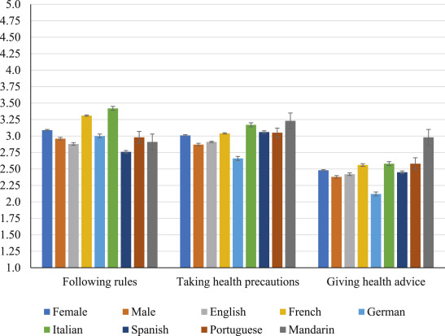
Appendix 1

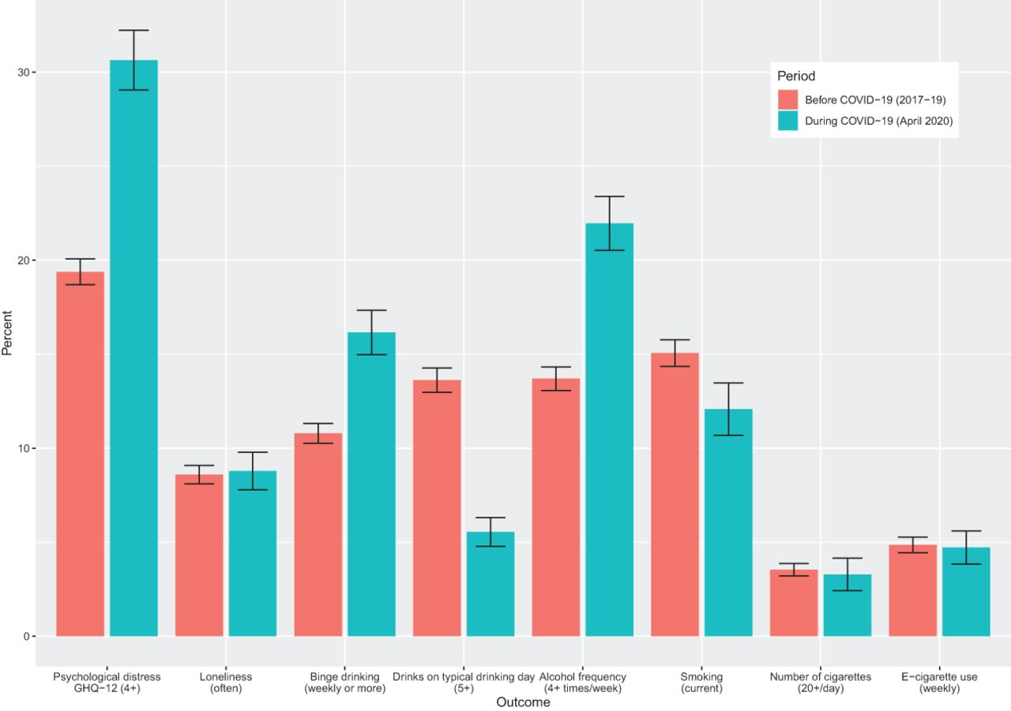
Appendix 2
Appendix 3
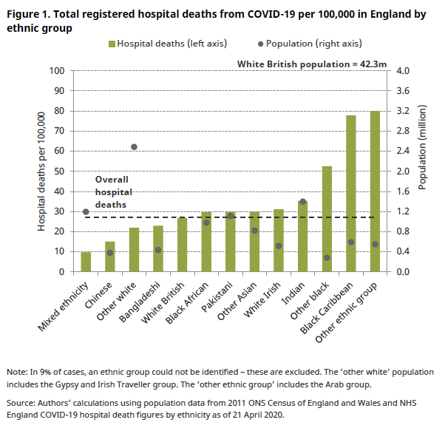

REFERENCES
British Foreign Policy Group (2020), 08 April Covid-19 Timeline. Available at https://bfpg.co.uk/2020/04/covid-19-timeline (Accessed 12th November 2020).
British Foreign Policy Group (2020), 08 April Covid-19 Timeline. Available at https://bfpg.co.uk/2020/04/covid-19-timeline (Accessed 16th November 2020).

Cairney, P., (2020). The UK government’s COVID-19 policy: assessing evidence-informed policy analysis in real time. British Politics, pp.1-27.

Clark, C., Davila, A., Regis, M. and Kraus, S., (2020). Predictors of COVID-19 voluntary compliance behaviours: An international investigation. Global transitions, 2, pp.76-82.

Gov.UK (2020), Expert partnership to explore and establish Human Challenge studies of COVID-19 in the UK, Available at: https://www.gov.uk/government/news/expert-partnership-to-explore-and-establish-human-challenge-studies-of-covid-19-in-the-uk (Accessed: 17th November 2020).

Gov.UK (2020). New campaign to prevent spread of coronavirus indoors this winter, Available at https://www.gov.uk/government/news/new-campaign-to-prevent-spread-of-coronavirus-indoors-this-winter (Accessed: 13th November 2020).

Guinchard, A., (2020). Our digital footprint under Covid-19: should we fear the UK digital contact tracing app? International Review of Law, Computers & Technology, pp.1-14.

Hadi, M.U. and Ali, M.K., 2020. Debunking the Fabricated Myths Around 5G.
Jit, M., Jombart, T., Nightingale, E.S., Endo, A., Abbott, S. and Edmunds, W.J., (2020). Estimating number of cases and spread of coronavirus disease (COVID-19) using critical care admissions, United Kingdom, February to March 2020. Eurosurveillance, 25(18), p.2000632.

Nerve Tumours UK (2020), Who is exempt from wearing a face mask? UK exemptions rules explained - and how to get a hidden disabilities exemption. Available at:https://nervetumours.org.uk/news/who-is-exempt-from-wearing-a-face-mask-uk-exemptions-rules-explained-and-how-to-get-a-hidden-disabilities-exemption (Accessed 11th November 2020).
NHS England (2020), Addressing the impact of Covid-19 on BAME staff in the NHS. Available at: https://www.england.nhs.uk/coronavirus/workforce/addressing-impact-of-covid-19-on-bame-staff-in-the-nhs (Accessed: 17th November 2020).
NHS (2020), App to track close contacts is launched in England and Wales. Available at: https://www.covid19.nhs.uk/?utm_campaign=App_Launch_England&utm_medium=paid_social&utm_source=Google&utm_content=PPC&gclid=EAIaIQobChMIr_jw_MaP7QIV2JTVCh0XDQRFEAAYASAAEgLIiPD_BwE (Accessed 17th November 2020).
Niedzwiedz CL, Green MJ, Benzeval M, et al Mental health and health behaviours before and during the initial phase of the COVID-19 lockdown: longitudinal analyses of the UK Household Longitudinal Study J Epidemiol Community Health Published Online First: 25 September 2020. doi: 10.1136/jech-2020-215060
Nsubuga P, White ME, Thacker SB, et al. (2006), Public Health Surveillance: A Tool for Targeting and Monitoring Interventions. 2nd Edition. New York: Oxford University Press.
Omar, B.S, (2020)’How is Covid-19 affecting BAME communities’, Trust Blog. 5th August. Available at https://www.imperial.nhs.uk/about-us/blog/how-covid19-affects-bame-communities (Accessed 11th November 2020).

Power, M., Doherty, B., Pybus, K. and Pickett, K., (2020). ‘How COVID-19 has exposed inequalities in the UK food system: The case of UK food and poverty’. Emerald Open Research, 2.

Public Health England (2020). Protecting and Improving the Nation’s Health. Available at https://www.england.nhs.uk/coronavirus/wp-content/uploads/sites/52/2020/03/phe-letter-to-trusts-re-daily-covid-19-hospital-surveillance-11-march-2020.pdf.

Raisi-Estabragh, Z., McCracken, C., Bethell, M.S., Cooper, J., Cooper, C., Caulfield, M.J., Munroe, P.B., Harvey, N.C. and Petersen, S.E., (2020). Greater risk of severe COVID-19 in Black, Asian and Minority Ethnic populations is not explained by cardiometabolic, socioeconomic or behavioural factors, or by 25 (OH)-vitamin D status: study of 1326 cases from the UK Biobank. Journal of Public Health, 42(3), pp.451-460.

Rural Health Information Hub (2002), The Health Belief Model. Available at https://www.ruralhealthinfo.org/toolkits/health-promotion/2/theories-and-models/health-belief (Accessed 14th November 2020).

Smith, L.G.E, Gibson, S. (2020) ‘Social psychological theory and research on the novel coronavirus disease (COVID‐19) pandemic: Introduction to the rapid response special section’, Wiley Public Health Emergency Collection, 9th July. Available at https://www.ncbi.nlm.nih.gov/pmc/articles/PMC7361416 (Accessed 15th November 2020).

The Centre for Evidence Based Medicine (2020). BAME Covid-19 deaths, what do we know? Rapid Data & Evidence Review, Available at https://www.cebm.net/covid-19/bame-covid-19-deaths-what-do-we-know-rapid-data-evidence-review/ (Accessed: 15th November 2020).
West Midlands Combined Authority (2020), West Midlands Regional Health Impact of COVID-19 Task and Finish Group. Available at https://www.wmca.org.uk/media/4122/regional-health-impact-of-covid19-v5.pdf (Accessed 4th November 2020).

Wired (2020) Everything you need to know about the new NHS track and trace app. Available at https://www.wired.co.uk/article/nhs-covid-19-tracking-app-contact-tracing (Accessed: 10th November 2020).

