Task 3 – Model refinement and validation

3.1 Model Refinement
The ideal otto cycle model that was developed in task 1, provided a simplified representation of the combustion process by assuming there is instantaneous heat addition at top dead centre (TDC), constant thermodynamic properties and identical compression and expansion behaviour. Although these assumptions allow the basic thermodynamic cycle to be modelled, the comparison with the experimental Ford Sigma engine data analysed in task 2 showed that they don’t accurately represent the behaviour of a real spark ignition engine.
The analysis of the measured pressure trace showed that combustion occurred progressively over a finite crank-angle duration rather than instantaneously at TDC. The measured data also showed that the compression and expansion processes exhibited different polytropic behaviour, thus indicating that the heat transfer and other irreversible losses have influenced the engine cycle. These observations were incorporated into the refined simulation model to improve it agreement with the experimental data.
Analysis of the Ford Sigma pressure-volume data in Task 2 produced compression and expansion polytropic indices of 1.33 and 1.27, respectively. These experimentally derived values were incorporated into the refined model to improve agreement with the measured pressure trace. The trapped cylinder mass was calculated from the measured displacement volume, inlet air density and volumetric efficiency, while the fuel mass was determined assuming a stoichiometric air-fuel ratio of 14.7:1. A combustion efficiency of 90% was applied in order to account for any incomplete conversion of chemical energy into useful thermal energy.
Unlike the ideal Otto cycle, combustion was represented using a Wiebe heat-release function, this allows energy to be released progressively throughout the combustion event. This refinement produces a gradual pressure rise that more closely resembles the measured Ford Sigma cylinder pressure trace.

3.2 Combustion timing and combustion behaviour
To reproduce the combustion behaviour that was observed experimentally, a single-zone Wiebe combustion model was implemented. The Wiebe function describes that the cumulative mass fraction burned throughout the combustion and provides a realistic approximation of flame development in spark ignition engines. Rather than assuming instantaneous combustion, the model distributes heat release over a finite crank-angle duration, producing a smooth increase in cylinder pressure.
The combustion timing parameters were then optimised using MATLAB’s fminsearch optimisation routine. The objective of the optimisation was to minimise the Root Mean Square Error (RMSE) between the measured and simulated pressure traces.
The optimisation produced the combustion parameters shown in the table below;
PARAMETER | VALUE
Optimised start of combustion (SOC) | -20.67° CA
Optimised burn duration | 58.24° CA
Table 1 -- Optimised Combustion Parameters
The optimised start of the combustion event occurs before TDC, allowing sufficient time for flame development before peak cylinder pressure is reached. The combustion then continues throughout approximately 58° crank angle, extending into the early stages of the expansion stroke. This behaviour closely matches the combustion characteristics observed in the measured Ford Sigma pressure trace.
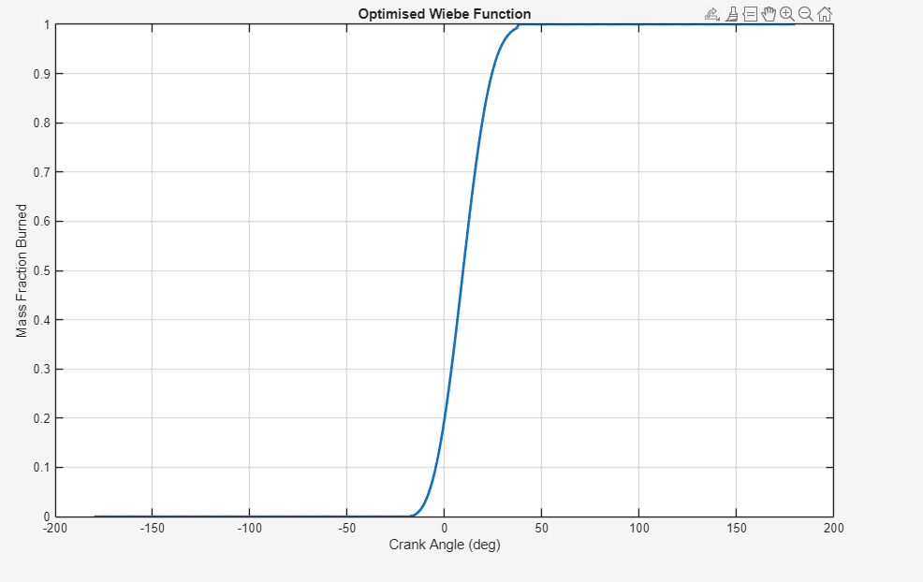
The figure below illustrates the optimised Wiebe combustion profile

Figure 1 -- Optimised Wiebe function
The S-shaped curve represents three stages of combustion. Initially, combustion progresses slowly while the flame kernel develops following ignition. The burn rate then increases rapidly during the main combustion phase before gradually approaching complete combustion. This behaviour is considerably more representative of real spark ignition combustion than the instantaneous heat addition assumed by the original Otto cycle model.

3.3 Model validation
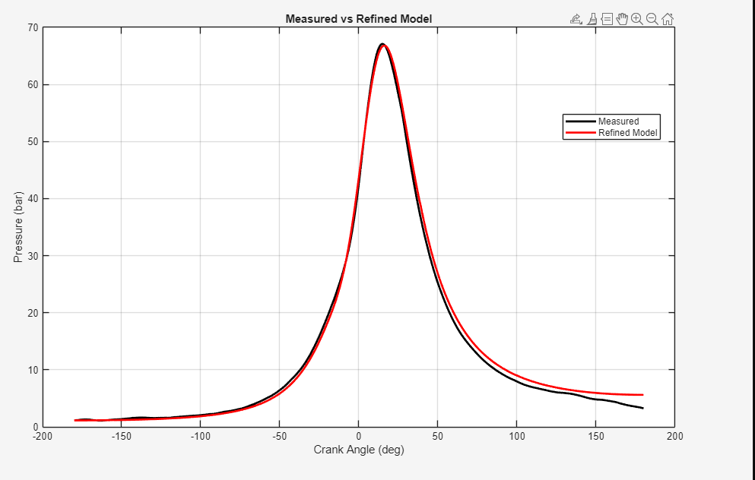
The refined combustion model was validated by comparing the predicted cylinder pressure directly with the measured Ford Sigma engine data. The figure below compares the measured and simulated pressure traces over one complete engine cycle.

Figure 2 -- measured vs simulated pressure

The refined model reproduces the measured pressure trace with excellent accuracy throughout both the compression and combustion phases. During the compression phase, the predicted pressure closely follows the measured data, indicating that the experimentally determined compression polytropic index provides a realistic representation of the measured compression process.

Following ignition, the gradual pressure rise produced by the Wiebe combustion model closely matches the measured combustion event. The predicted peak pressure of 66.81 bar (969 psi) differs from the measured peak pressure of 67.10 bar (973.2 psi) by only 0.29 bar (4.21 psi) corresponding to a peak pressure error of 0.43%. the model also predicts the peak pressure at 16° ATDC, only 1° crank angle later than the measured value of 15° ATDC.
These results demonstrate that the combustion timing has been successfully calibrated using the experimental Ford Sigma data.
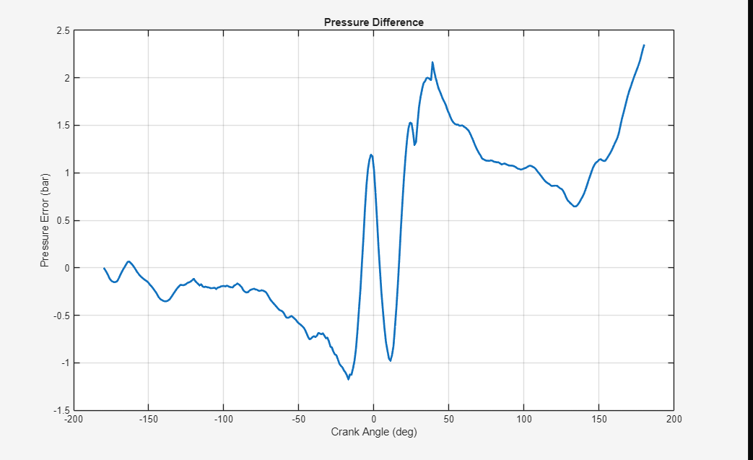
The pressure difference between the measured and simulated results are shown in the figure below:

Figure 3 -- Pressure difference

The pressure error remains relatively small throughout the engine cycle, with the largest differences occurring during the expansion stroke. During this period the model slightly overpredicts cylinder pressure, suggesting that expansion losses within the real engine are greater than those represented by the simplified thermodynamic model. This behaviour is expected because the current model neglects heat transfer between the combustion gases and the combustion chamber walls.

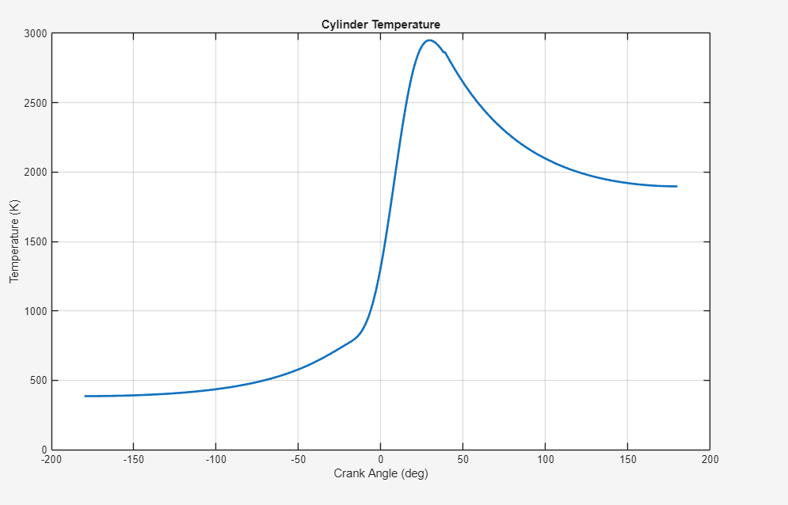

Figure 4 -- a graph to show the cylinder temperature

The validation metrics are shown in the table below:
Validation Metric | Result
Measured peak pressure | 67.10 bar (973.2 psi)
Model peak pressure | 66.81 bar (969.0 psi)
Peak pressure error | 0.43%
Measured peak angle | 15° ATDC
Model peak angle | 16° ATDC
Timing error | 1° CA
RMSE | 0.983 bar (14.26 psi)
Correlation coefficient | 0.9987
Table 2 -- shows the model validation results
The RMSE of 0.983 bar (14.26 psi) indicates that the average pressure prediction error remains below 1 bar throughout the whole engine cycle. In addition, the correlation coefficient of 0.9987 demonstrates an extremely good agreement between the measured and predicted pressure traces. Together, these validation metrics confirm that the refined model reproduces both the magnitude and timing of the combustion process with a high degree of accuracy.

3.4 Model validation results
Although the refined model demonstrates excellent agreement with the measured Ford Sigma pressure data, several simplifying assumptions remain. The model assumes a constant ratio of specific heats throughout the engine cycle, whereas the value varies with gas temperature and composition during combustion. Heat transfer between the combustion gases and the cylinder walls is also neglected, leading to slightly higher predicted cylinder pressures during the expansion stroke.
The combustion process is represented using a single-zone Wiebe model, which assumes that the cylinder gases are perfectly mixed. Consequently, the model cannot represent flame-front propagation, local temperature gradients or detailed combustion chemistry. In addition, residual exhaust gases, blow-by-losses and cycle-to-cycle combustion variability are not included.
Future improvements could include the implementation of variable specific heat ratio, thus incorporating an empirical heat-transfer correlation such as the Woschni model, and extending the simulation to a multi-zone combustion model. These modifications would improve the prediction of the cylinder pressure and temperature whilst providing a more detailed representation of the combustion process.

3.5 conclusion
The ideal Otto cycle model developed in Task 1 was successfully refined using the combustion characteristics obtained from the Ford Sigma engine data analysed in Task 2. The incorporation of experimentally derived compression and expansion polytropic indices together with a Wiebe combustion model produced a significantly more realistic representation of the combustion process.
Validation against the measured pressure trace demonstrated an extremely good agreement between the simulation and experimental data. The model predicted the peak cylinder pressure within 0.43% of the measured value, while the peak pressure timing differed by only 1 crank angle degree. Furthermore, an RMSE of 0.983 bar (14.26 psi) and a correlation coefficient of 0.9987 confirmed that the refined model accurately reproduced the measured pressure trace throughout the engine cycle.
Although further improvements could ne achieved by including heat transfer, variable thermodynamic properties and more advanced combustion modelling, the refined simulation provides a realistic representation of the Ford Sigma engine and demonstrates that incorporation the measured combustion characteristics significantly improves the predictive capability of the original ideal cycle model.

