

LOCATION: Swansea | LLEOLIAD: abertawe
LEVEL 5 | LEFEL 5
EXAMINATION PERIOD | CYFNOD ARHOLIADAU
may 2024 | mai 2024

MODULE CODE: ACDA5006
Transducers and Signal Conditioning

TIME: 2 HOURS
answer all questions

Equipment or materials required – Calculator, Graph Paper
Adnoddau neu ddefnyddiau sydd eu hangen - Dim

50 MARKS AVAILABLE IN TOTAL.
QUESTIONS HAVE UNEQUAL WEIGHTING.
PLEASE PLAN YOUR TIME CAREFULLY.
ANSWER ALL QUESTIONS

- (20 Marks available)
Define the following terms:
  - Transducer
[2 Marks]
  - Accuracy
[2 Marks]
  - Precision
[2 Marks]
  - Repeatability
[2 Marks]
  - Reproducibility
[2 Marks]
  - Range
[2 Marks]
  - Nonlinearity
[2 Marks]
  - Resolution
[2 Marks]
  - Sensitivity
[2 Marks]
  - Hysteresis
[2 Marks]

- (4 Marks available)
The following table shows the output measurements of a voltmeter under two sets of conditions: used in an environment kept at 20°C, which is the temperature that it was calibrated at; and used in an environment at a temperature of 50°C

Voltage readings at calibration temperature of 20°C  (assumed correct) | Voltage readings at temperature of 50°C
10.2 | 10.91
15.3 | 16.265
20.5 | 21.725
24.9 | 26.345

- Determine the zero drift when it is used in the 50°C environment, assuming that the measurement values when it was used in the 20°C environment are correct.
[2 Marks]

- Calculate the zero drift coefficient
[2 Marks]

- (8 Marks available)
For the transducer characteristics given in the table below, where X is the value of the measurand, and Y is the transducer output in volts.

X | 0 | 10 | 20 | 30 | 40 | 50 | 60 | 70 | 80 | 90 | 100
Y | -2.71 | -0.69 | 0.85 | 1.79 | 3.69 | 5.04 | 5.97 | 8.32 | 9.5 | 11.33 | 12.41

- Plot the characteristics and draw a line of best fit.
[4 Marks]
- Determine the maximum non-linearity of the transducer and express it as a percentage of full-scale deflection.
[2 Marks]
- Calculate the sensitivity of the transducer.
[2 Marks]

- (8 Marks available)
Fig Q4 shows a simple signal conditioning circuit.
  - Describe the function of the following circuit elements:
    - Network R4, D1 & D2
    - U1A
    - U1B, R1, R2, R3
    - RV1
[4 Marks]

  - Given the Zener diode of 5.1V, an input voltage of 2.7V, and a voltage of 1.8V present on the wiper of RV1; calculate the output voltage.
[4 Marks]
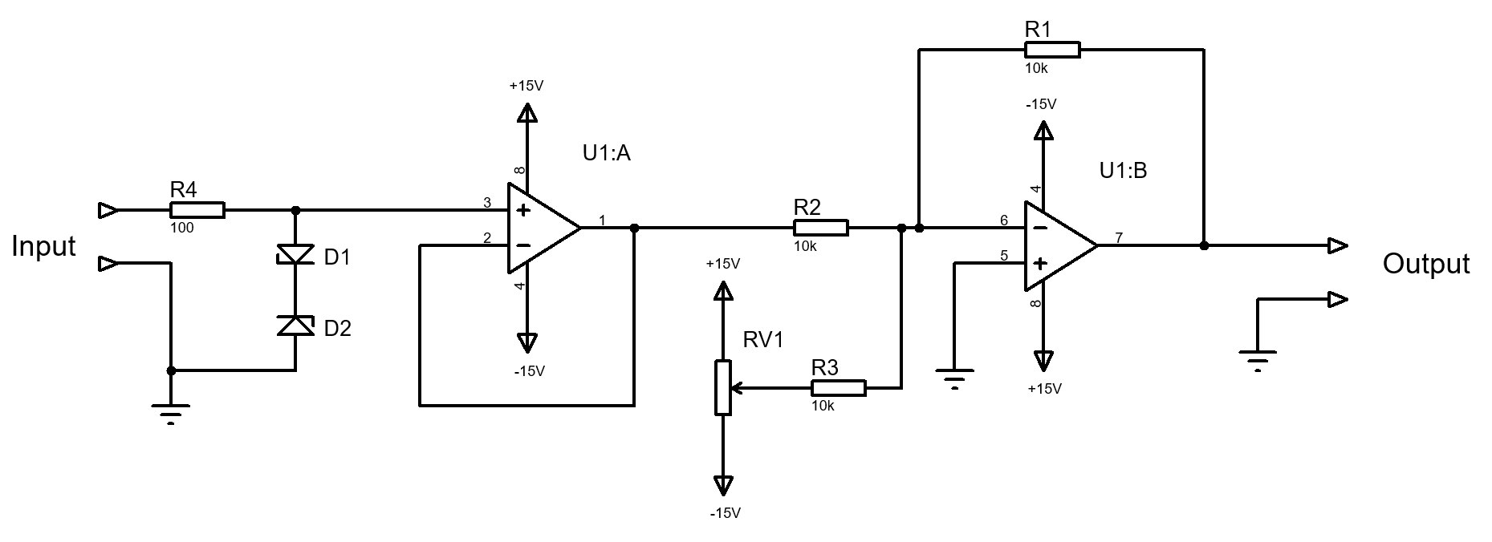
Fig Q4

- (10 Marks available)
Compare and contrast the requirements and specifications for a temperature sensor for the following applications:
  - Air temperature measurement for a weather station
  - Coolant temperature of a car engine.
[10 Marks]

Diwedd/End

