

Student name: ABOSEDE ADESANYA
Student ID: 2428011

Module name: Introduction to Physiology
Module code: [BMHP5023-LON]
Lecturer name: LOU ANGELA WELLS

Assessment: 1

Table of Contents
1. Introduction 2
2. Blood Sugar Regulation 2
3. Cellular Metabolism 3
4. Recording and tracking blood sugar levels for type 2 diabetes 4
5. Recommendations 6
6. Conclusion 8
7. References 9

1. Introduction
Diabetes mellitus is a long-term metabolic disorder characterised by chronic hyperglycaemia due to abnormalities in insulin production or activity. There are two main phenotypic groups: Type I diabetes, an autoimmune condition characterised by the body's inability to produce insulin, resulting in absolute insulin deficiency, and Type 2 diabetes, which is defined by insulin resistance and inadequate insulin secretion. The latter type is the most epidemiologically dominant and is closely related to lifestyle determinants that are changeable (Singh et al., 2025).
Several risk determinants support the development of Type 2 diabetes, especially obesity, dietary overload, sedentary lifestyles, tobacco consumption, and genetic predisposition. These factors undermine the ability of the body to maintain normal levels of blood glucose, which triggers persistent hyperglycaemia. The endocrine system, and especially the pancreas, plays a central role in glycaemic homeostasis by the secretion of hormones, mainly insulin and glucagon.
In primary care practices, practice nurses are at the centre of the stage concerning patient education on diabetes management. People do not know how their lifestyle habits influence the development of diseases. Accordingly, this report outlines the regulatory processes that control blood glucose, the cell bioenergetics of energy generation, the necessity of tracking glycaemic swings and the importance of lifestyle change in effective management of Type 2 diabetes (Sanches et al., 2023).

2. Blood Sugar Regulation
Homeostasis of glucose is enforced through a highly sensitive regulatory mechanism that helps in keeping glucose levels in the serum within a thin physiologically tolerable range. The most vital part of this process is the pancreas, a set of organs that cannot be ignored and must, in every case, include the islets of Langerhans that produce and secrete hormones that regulate glycaemic levels (Ojo et al., 2023).
Insulin is released into the circulation when the level of blood glucose rises, for example after a carbohydrate-rich meal. Insulin causes the uptake of glucose transport proteins to the skeletal muscle and hepatic cell membranes, therefore increasing glucose absorption by the cells. The glucose that is absorbed is either directly oxidised to make ATP or stored as glycogen to be used in future. This is a physiological negative feedback mechanism that returns the level of blood glucose to the normal physiological range. Conversely, pancreatic α -cells secrete glucagon when the glycaemic levels drop, for example, when fasting or exercising. The activation of hepatic glycogenolysis by glucagon transforms stored glycogen into glucose, which is released into the bloodstream and blood glucose levels (Powers et al., 2022).
The regulation system in patients with type 2 diabetes mellitus is dysfunctional. The peripheral tissues become insulin resistant, in which case the insulin ability of the insulin receptors to bind insulin, or insulin-induced downstream signalling pathways, is reduced. This causes glucose to stay in the extracellular space, causing hyperglycaemia. Over time, this can place increased strain on the pancreas, which may produce more insulin to compensate, eventually leading to reduced insulin production (Młynarska et al., 2025).
The inability to regulate normal glucose may trigger serious clinical consequences. Continuous hyperglycaemia causes endothelial damage, encourages atherogenesis, and inhibits renal filtration, thus raising the chances of cardiovascular disease, nephropathy, and neuropathy. Hence, glycaemic regulation is essential to physiological-level homeostasis and the reduction of long-term morbidity (Vanweert et al., 2022).

3. Cellular Metabolism
Cellular metabolism is a set of biochemical responses that happen in the cell to produce the energy necessary to support life. Glucose, which is a result of carbohydrate breakdown, is the major energetic source used by the organism. The oxygen, which is obtained in the respiratory system simultaneously, is also essential. Cellular respiration in concert is the combination of glucose and oxygen, which produces adenosine triphosphate (ATP), the power source of energy used to run various cellular functions (Ahmad et al., 2022).

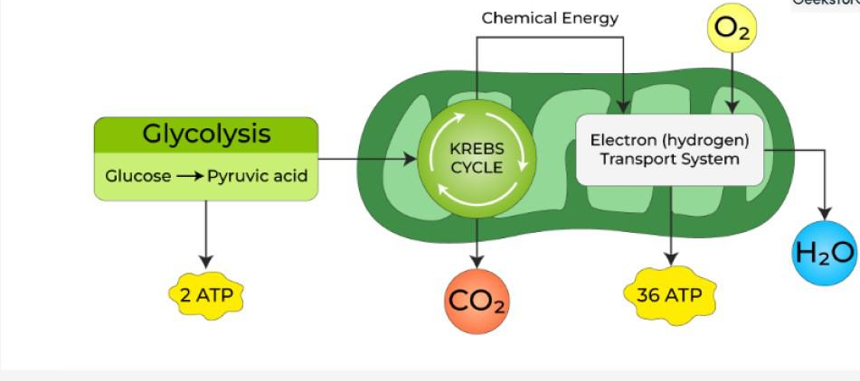
Diagram of Cellular Respiration
Source: GeeksforGeeks. (2025)
Cellular respiration is subdivided into three major stages. The first stage, which is glycolysis, is a process that takes place in the cytoplasm where a glucose molecule is broken down into smaller molecules, leading to the production of ATP. The second stage, the Krebs cycle, occurs in the mitochondria and generates high-energy molecules that carry electrons. The final stage, the electron transport chain, also occurs in the mitochondria and requires oxygen. Oxygen acts as the final electron acceptor, allowing the production of a large amount of ATP (Currie et al., 2024).
The overall process can be summarised as:
Glucose + Oxygen = Carbon Dioxide + Water + Energy (ATP)
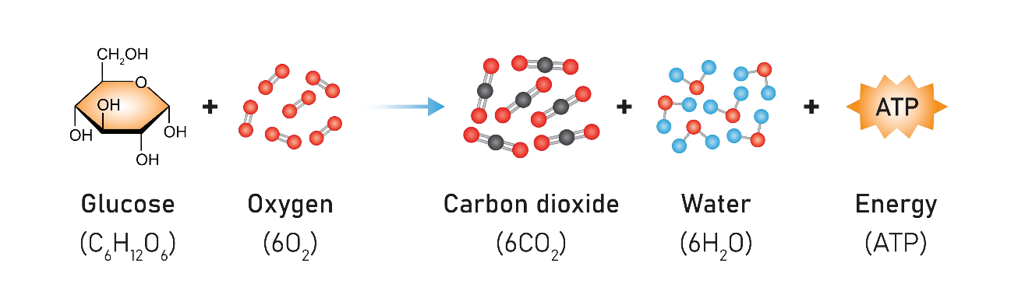
Process of aerobic respiration
Source: Monash University. (2025)
The produced ATP is also essential to physiological processes like muscle movement, nerve signalling and maintaining body temperature (Kaptoge et al., 2023).
The insulin resistance in individuals with type 2 diabetes mellitus inhibits the effective movement of glucose into cells. As a result, in the presence of hyperglycaemia, the utilisation of glucose in the intracellular compartments of the cell is impaired, which provokes fatigue and worsens cellular activity. Furthermore, prolonged hyperglycaemia has an adverse impact on vessels and organs, which explains the need to maintain normal metabolic processes (Wagenknecht et al., 2023).

4. Recording and tracking blood sugar levels for type 2 diabetes
The process of tracking and recording blood glucose levels is a basic part of Type 2 diabetes management, since it allows for maintaining treatment control and preventing complications (Ogrotis et al., 2023). Glucose monitoring can either be done using self-monitoring tests like glucometers that provide real-time readings or using clinical tests like HbA1c that provide a mean reading of blood glucose over a two to three-month period.
Regular monitoring provides the patients with an opportunity to identify trends and understand the effects of different determinants on glucose dynamics, such as diet, physical activity, psychosocial stressors, and pharmacotherapy (Bielka et al., 2024). As an example, hyperglycaemic excursion can be triggered by carbohydrate-rich foods and can be prevented by exercise. At the same time, healthcare professionals can compare the effectiveness of interventions and make the required changes to treatment or care regimes (Thorens, 2024).
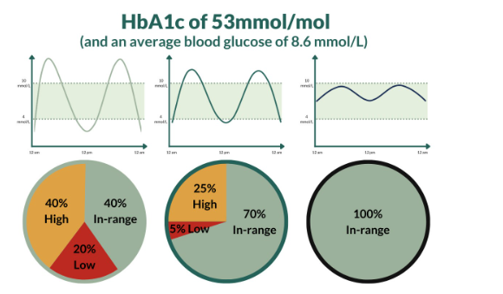
HbA1c explanation
Source: NHS Scotland. (2025)
https://diabetesmyway.nhs.uk/resources/internal/hba1c-and-time-in-range-explained/
The importance of tracking blood glucose levels is essential, as it can prevent the short-term and long-term consequences (Capozzi et al., 2022). Failure to provide regular monitoring would expose patients to prolonged hyperglycaemia that damages blood vessels and organs in the long run. This increases the threat of potential development of serious complications, such as cardiovascular disease, nephropathy, neuropathy, and retinopathy. Besides, the unknown hypoglycaemic conditions can present in the form of dizziness, confusion, loss of consciousness and, in the worst case, medical crises.
Furthermore, established documentation of the glucose levels enhances patient involvement and self-management, which are crucial in effective diabetes management (Venugopal et al., 2023). This practice will make the patients take ownership of their health and adhere to the therapeutic regimens prescribed. Practice nurses in primary care settings are decisive in teaching patients how to measure, document and interpret glucose values correctly. This support improves patient confidence as well as leading to better health outcomes (Hu, 2022).
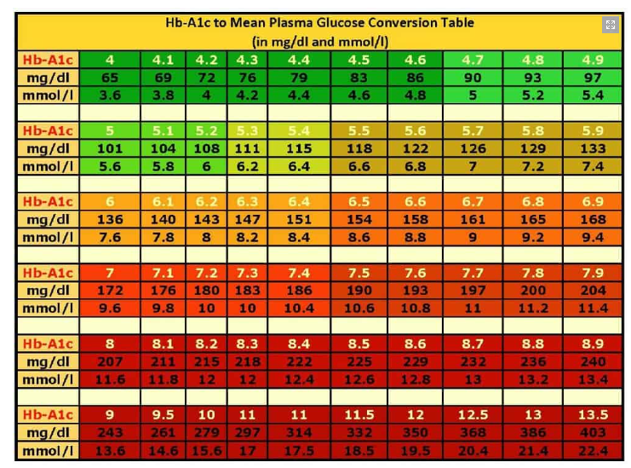
HbA1c explanation
Source: NHS Scotland. (2025)

5. Recommendations
The integrated management of type 2 diabetes mellitus requires the use of evidence-based lifestyle intervention, pharmacological treatment, and ongoing health promotion strategies. The ultimate objective is to maximise glycaemic regulation, decrease the risk of complications, and improve the overall well-being (Pleus et al., 2022).
One of the pillars of management is the adoption of a well-rounded, balanced, nutrient-rich diet. There have always been clinical trials indicating that diets with reduced refined sugars and processed foods and increased whole grains, fruit, vegetables, and fibre contain better post-prandial glucose. Foods with low glycaemic index (GI) reduce sharp glycaemic bursts and, thus, stabilise the glucose levels in the bloodstream. Accurate portioning and maintaining a constant eating schedule are also beneficial in maintaining stable glycaemic levels throughout the day.
Physical exercise is a very important non-pharmacological intervention. The moderate-intensity exercise that is involved, including fast walking, cycling, or swimming, at least 150 minutes per week, is related to the increase in insulin sensitivity and the uptake of glucose by skeletal muscle. Essentially, exercise also enables management of weight, which is an essential aspect due to the strong connection between adiposity and insulin resistance (Isitt et al., 2022).
The use of smoking cessation is a critical suggestion to diabetic patients, as it is a risk that is compounded by the presence of cardiovascular disease. Cessation of tobacco consumption enhances endothelial performance, decreases systemic inflammation, and leads to the improvement of overall health outcomes. To promote this behaviour change, healthcare providers should provide structured counselling and evidence-based cessation programmes.
Diet and exercise have a close relationship, but weight management has major effects on glycaemic control. Even slight changes in body mass index may result in significant changes in fasting glucose and HbA1c levels and, henceforth, the dependence on pharmacotherapy. Formalised weight loss programs, which are administered in collaboration with a dietician or expert trainers, are recommended (Ajjan et al., 2023).
Pharmacologic treatment is important in a high number of patients. It is essential to comply with recommended hypoglycaemic medications, such as oral medications and injectable medications, where necessary, and insulin or injectable medications. Timely therapeutic adjustments are made with the help of routine self-monitoring of blood glucose or continuous glucose monitoring systems. Periodic clinical examinations identify possible complications in time and treat them.
The sustained disease control involves health promotion and education. Patients can be empowered to manage themselves through structured educational programmes provided by multidisciplinary teams comprising primary-care nurses and diabetes educators. Healthy behaviours are strengthened, and psychosocial support is given through community-based initiatives and peer support groups (Espinola et al., 2025).

6. Conclusion
Type 2 diabetes mellitus is a complex long-term illness that has a significant adverse impact on glucose homeostasis. The pancreatic insulin and glucagon secretions have an endocrine interaction that holds the key to glycaemic balance. As the phenomenon of insulin resistance appears, the level of glucose in the blood is constantly high, and the range of undesirable metabolic consequences is triggered (Sagastume et al., 2022).
This report highlights the central role of cellular metabolism, in which the oxidation of glucose and the use of oxygen lead to the synthesis of adenosine triphosphate. Impaired glucose uptake inhibits these metabolic processes in the environment of insulin resistance, which explains the close relationship that exists between endocrine malfunction and energy metabolism. It is stressed that a careful recording and tracking of glucose measurements should be performed, which will allow the patients to identify patterns, make choices related to therapy, and engage in active disease maintenance.
The evidence provides support for the idea that lifestyle modifications, i.e., nutrient-rich diets, regular physical exercise, quitting smoking, and weight management, can form the basis of glycaemic control and alleviation of complications. These are supplemented by pharmacologic adherence and regular check-ups, which provide full coverage of the disease.
The roles of healthcare professionals, especially nurses working in primary-care units, cannot be ignored in patient education, empowerment, and encouraging self-management. Patients, with the help of structured guidance and assistance, are motivated to take an active part in their health, which eventually results in better outcomes (Kurnik Mesarič et al., 2023).
Altogether, a patient-centred, multidisciplinary and proactive intervention strategy is needed to maintain metabolic health, prevent complications, and improve the quality of life of type 2 diabetes patients in the long run.

7. References
Ahmad, E., Lim, S., Lamptey, R., Webb, D. R., & Davies, M. J. (2022). Type 2 diabetes. The Lancet, 400(10365), 1803-1820.
Ajjan, R. A., Heller, S. R., Everett, C. C., Vargas-Palacios, A., Higham, R., Sharples, L., ... & Stocken, D. D. (2023). Multicenter randomised trial of intermittently scanned continuous glucose monitoring versus self-monitoring of blood glucose in individuals with type 2 diabetes and recent-onset acute myocardial infarction: results of the LIBERATES trial. Diabetes Care, 46(2), 441-449.
Bielka, W., Przezak, A., Molęda, P., Pius-Sadowska, E., & Machaliński, B. (2024). Double diabetes—when type 1 diabetes meets type 2 diabetes: definition, pathogenesis and recognition. Cardiovascular diabetology, 23(1), 62.
Capozzi, M. E., D’Alessio, D. A., & Campbell, J. E. (2022). The past, present, and future physiology and pharmacology of glucagon. Cell metabolism, 34(11), 1654-1674.
Currie, C. J., Currie, J. G., Holden, S. E., Morgan, C. L., Heywood, B. R., Peters, J. R., & Livingstone Development Team. (2024). The descriptive epidemiology of type 2 diabetes in the United Kingdom from 2004 to 2021. medRxiv, 2024-03.
Espinola, O. P., Tobias, D. K., & Manson, J. E. (2025). The role of lifestyle interventions for the prevention and treatment of type 2 diabetes: a narrative review. American Journal of Lifestyle Medicine, 15598276251372427.
GeeksforGeeks. (2025, July 23). Diagram of cellular respiration.
https://www.geeksforgeeks.org/biology/diagram-of-cellular-respiration/
Hu, J. (2022, January). Cell Respiration—Energy Production of Cells. In 2021 International Conference on Culture, Design and Social Development (CDSD 2021) (pp. 77-80). Atlantis Press.
Isitt, J. J., Roze, S., Sharland, H., Cogswell, G., Alshannaq, H., Norman, G. J., & Lynch, P. M. (2022). Cost-effectiveness of a real-time continuous glucose monitoring system versus self-monitoring of blood glucose in people with type 2 diabetes on insulin therapy in the UK. Diabetes Therapy, 13(11), 1875-1890.
Kaptoge, S., Seshasai, S. R. K., Sun, L., Walker, M., Bolton, T., Spackman, S., ... & Hata, J. (2023). Life expectancy associated with different ages at diagnosis of type 2 diabetes in high-income countries: 23 million person-years of observation. The Lancet Diabetes & Endocrinology, 11(10), 731-742.
Kurnik Mesarič, K., Pajek, J., Logar Zakrajšek, B., Bogataj, Š., & Kodrič, J. (2023). Cognitive behavioural therapy for lifestyle changes in patients with obesity and type 2 diabetes: a systematic review and meta-analysis. Scientific Reports, 13(1), 12793.
Młynarska, E., Czarnik, W., Dzieża, N., Jędraszak, W., Majchrowicz, G., Prusinowski, F., ... & Franczyk, B. (2025). Type 2 diabetes mellitus: new pathogenetic mechanisms, treatment and the most important complications. International journal of molecular sciences, 26(3), 1094.
Monash University. (2025). The process of aerobic respiration.
https://www.monash.edu/student-academic-success/biology/cellular-respiration/the-process-of-aerobic-respiration
NHS Scotland. (2025). HbA1c and time in range explained.
https://diabetesmyway.nhs.uk/resources/internal/hba1c-and-time-in-range-explained/
Ogrotis, I., Koufakis, T., & Kotsa, K. (2023). Changes in the global epidemiology of type 1 diabetes in an evolving landscape of environmental factors: causes, challenges, and opportunities. Medicina, 59(4), 668.
Ojo, O. A., Ibrahim, H. S., Rotimi, D. E., Ogunlakin, A. D., & Ojo, A. B. (2023). Diabetes mellitus: From molecular mechanism to pathophysiology and pharmacology. Medicine in Novel Technology and Devices, 19, 100247.
Pleus, S., Freckmann, G., Schauer, S., Heinemann, L., Ziegler, R., Ji, L., ... & Hinzmann, R. (2022). Self-monitoring of blood glucose as an integral part of the management of people with type 2 diabetes mellitus. Diabetes Therapy, 13(5), 829-846.
Powers, A. C., Niswender, K. D., & Evans-Molina, C. (2022). Diabetes mellitus: diagnosis, classification, and pathophysiology. Diabetes, 1000, 415.
Sagastume, D., Siero, I., Mertens, E., Cottam, J., Colizzi, C., & Peñalvo, J. L. (2022). The effectiveness of lifestyle interventions on type 2 diabetes and gestational diabetes incidence and cardiometabolic outcomes: a systematic review and meta-analysis of evidence from low-and middle-income countries. EClinicalMedicine, 53.
Sanches, J. M., Zhao, L. N., Salehi, A., Wollheim, C. B., & Kaldis, P. (2023). Pathophysiology of type 2 diabetes and the impact of altered metabolic interorgan crosstalk. The FEBS Journal, 290(3), 620-648.
Singh, A., Shadangi, S., Gupta, P. K., & Rana, S. (2025). Type 2 diabetes mellitus: a comprehensive review of pathophysiology, comorbidities, and emerging therapies. Comprehensive Physiology, 15(1), e70003.
Thorens, B. (2024). Neuronal glucose-sensing mechanisms and circuits in the control of insulin and glucagon secretion. Physiological reviews, 104(4), 1461-1486.
Vanweert, F., Schrauwen, P., & Phielix, E. (2022). Role of branched-chain amino acid metabolism in the pathogenesis of obesity and type 2 diabetes-related metabolic disturbances. BCAA metabolism in type 2 diabetes. Nutrition & diabetes, 12(1), 35.
Venugopal, S. K., Sankar, P., & Jialal, I. (2023). Physiology, glucagon. StatPearls [Internet].
Wagenknecht, L. E., Lawrence, J. M., Isom, S., Jensen, E. T., Dabelea, D., Liese, A. D., ... & Divers, J. (2023). Trends in incidence of youth-onset type 1 and type 2 diabetes in the USA, 2002–18: results from the population-based SEARCH for Diabetes in Youth study. The lancet Diabetes & endocrinology, 11(4), 242-250.

