

Assessment 1 – Reading Task Template
PART 1: Upload your photo of your A3 in-class notes here:
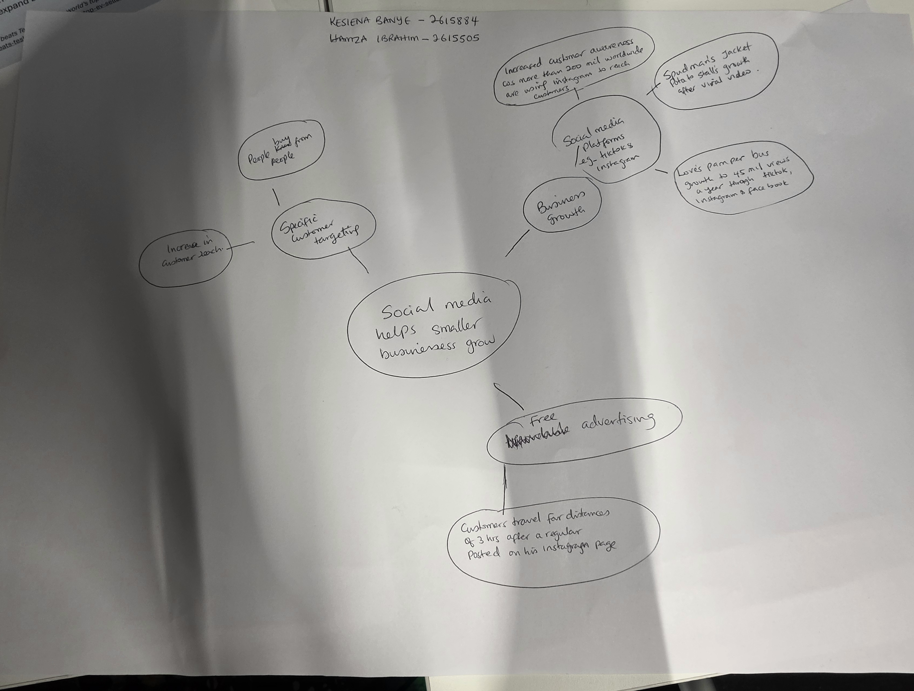

- What is the main idea of the whole text?
-The text is about how social media has made an impact on small businesses.
- Through social media, small businesses are able to get customers and grow their business.

- What is one key point that supports the main idea, and which specific example from the text shows this?
-Social media has enabled business growth for small businesses through instagram etc, according to the government business academy; more than 200 million businesses worldwide are using Instagram to reach customers.

- What is a different key point that supports the main idea, and which specific example from the text shows this?
-Specific target marketing through social media, people buy from people these days rather than through adverts; shop owner Murat Mutlu says customers started travelling long distances to try his food after one of his regulars posted about the shop online.

- Which part of the text do you think is most important, and why?
-I think the fact that small businesses stand a better chance to compete with larger businesses with exposure to social media, because they can reach far more customers with social media.

Reflection:
- What did you find difficult in this task (including in-class components), and why was it difficult?
-I found it a bit difficult to identify some key ideas initially because there was so much information, there were lots of examples that I was confusing for key ideas initially.

- What helped you with this difficulty, and how did it help you?
-I used what I learnt in class, eg Looking for repeated words.
-Reading the text more than once.
-Also, identifying the important points that explain or support the main idea.

