
Module Name: Problem Solving and Innovation
Module Code: BMSW4014
Assessment 2: A Critical Analysis of External Factors Influencing the Creator Economy / Influencer Industry
Student Name: Cristina Mihaela Severin

Student Number: 2504651

Lecturer: Chris Wilkin
Deadline: Friday 10th July 23:59 PM

Contents
Introduction 3
STEEPLE Analysis 3
Social 3
Technological 4
Economic 5
Environmental 6
Political 6
Legal 7
Ethical 7
SWOT Analysis 7
Future Lens 8
Recommendations 8
Conclusion 9
Reference List 9

AI Acknowledgement

I confirm that I have not presented any AI-generated materials as my own work.
I confirm that I have copies of my drafts, notes, and other resources I used, which I may be asked to provide in evidence.

I confirm that I have images AI-generated in text.

Introduction

The creator economy people making and profiting from content via platforms like TikTok, YouTube, and Instagram has evolved from a niche pursuit into an industry worth more than $250 billion by 2026 (Grand View Research, 2026). Such growth has certainly not occurred in a bubble. Factors external to the sector that include technological, regulatory, and behavioural influences are redefining what being a creator is, and how a business can be built around it. In this report, these factors are analysed via the STEEPLE framework, translated into a SWOT analysis, and followed by a future-oriented DPSIR analysis and two recommendations.

STEEPLE Analysis

Social
Consumers want authenticity, but creating it comes at the cost of those who give it. A study conducted by a Harvard-linked institute revealed that 10% of creators experience suicidal tendencies associated with their job, twice the proportion found in the general public, with 62% experiencing burnout and 89% not having access to specialist mental care (Harvard T.H. Chan School of Public Health, 2025; Tube filter, 2025). In another peer-reviewed scoping review, there have been similar findings related to burnout, anxiety, and depression amongst creators who have constantly been under algorithmic and parasocial pressures from the audience (Sanz-Valero and Ronda-Pérez, 2025). This is not only personal but commercially significant too.
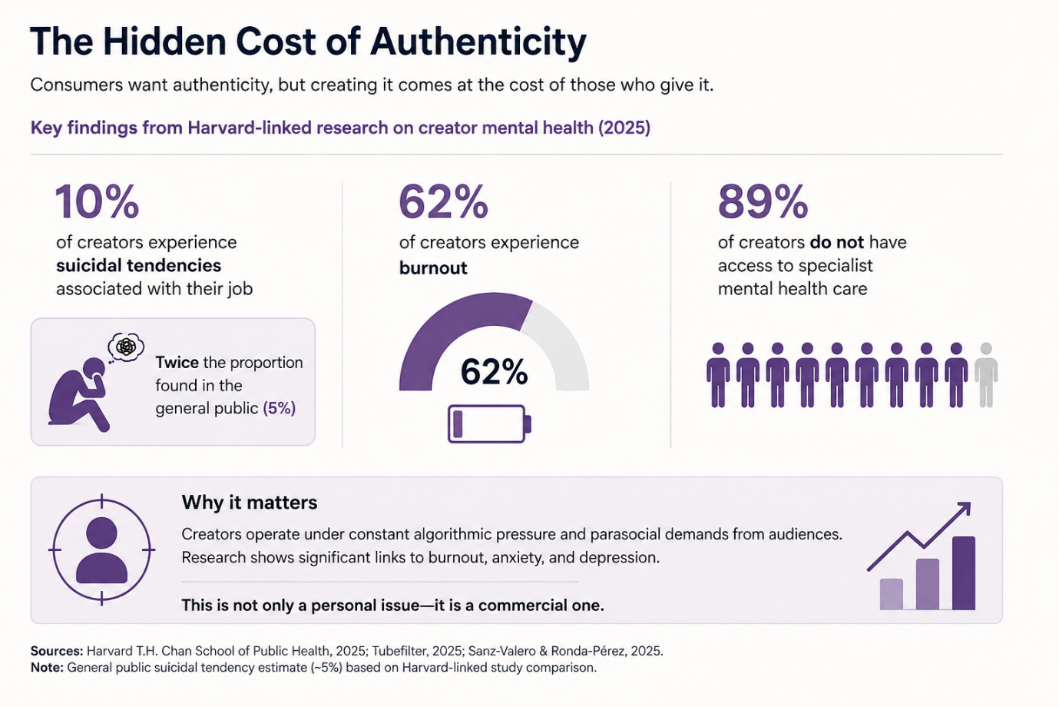

Technological

Generative AI is no longer merely assisting in production; it is becoming a competitor. Virtual influencers like Lu do Magalu reportedly rake in around forty times more money than a human content creator earns in a single post, and the virtual influencer industry is valued at $11.74 billion by 2026, projected to be worth $154.6 billion by 2032 (SQ Magazine, 2026). Moreover, platforms are employing AI to automate the process of matching creators with brands; TikTok's Symphony Agent was rolled out in June 2026 to draft campaign briefs and pair creators with briefs without any human involvement (Digital Applied, 2026).

Economic

The creator economy people making and profiting from content via platforms like TikTok, YouTube, and Instagram has evolved from a niche pursuit into an industry worth more than $250 billion by 2026 (Grand View Research, 2026). Such growth has certainly not occurred in a bubble. Factors external to the sector that include technological, regulatory, and behavioural influences are redefining what being a creator is, and how a business can be built around it. In this report, these factors are analysed via the STEEPLE framework, translated into a SWOT analysis, and followed by a future-oriented DPSIR analysis and two recommendations.
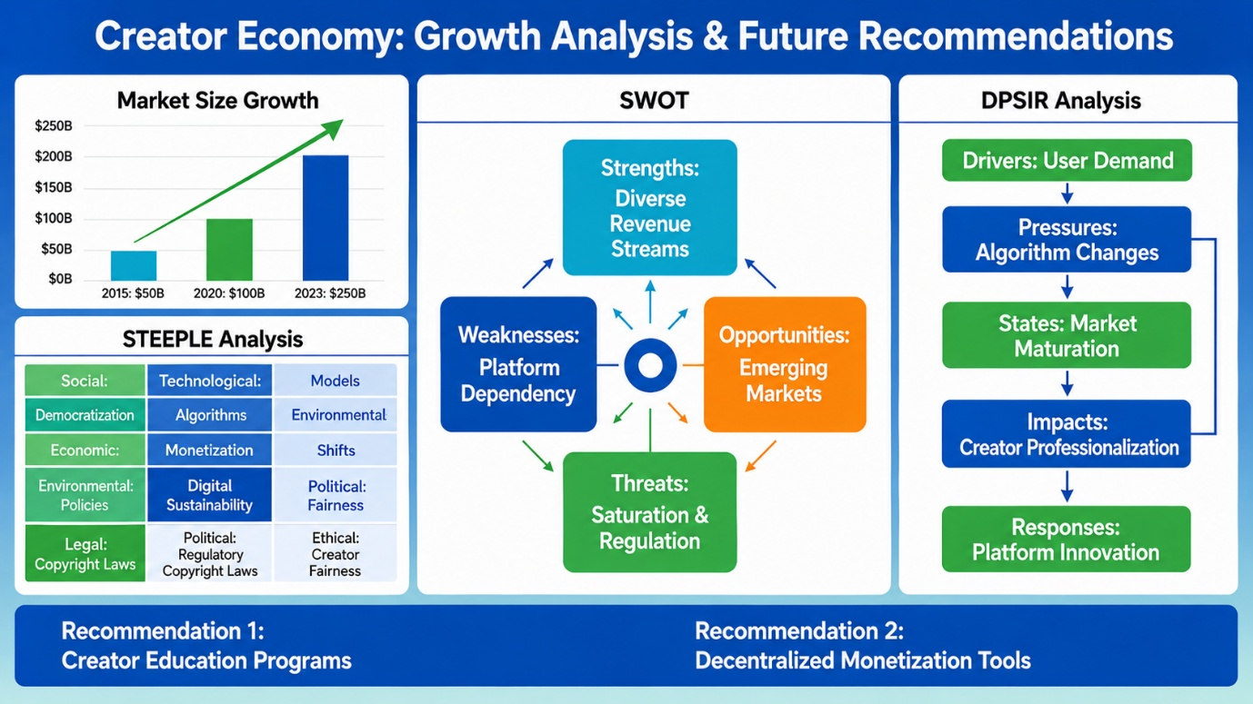
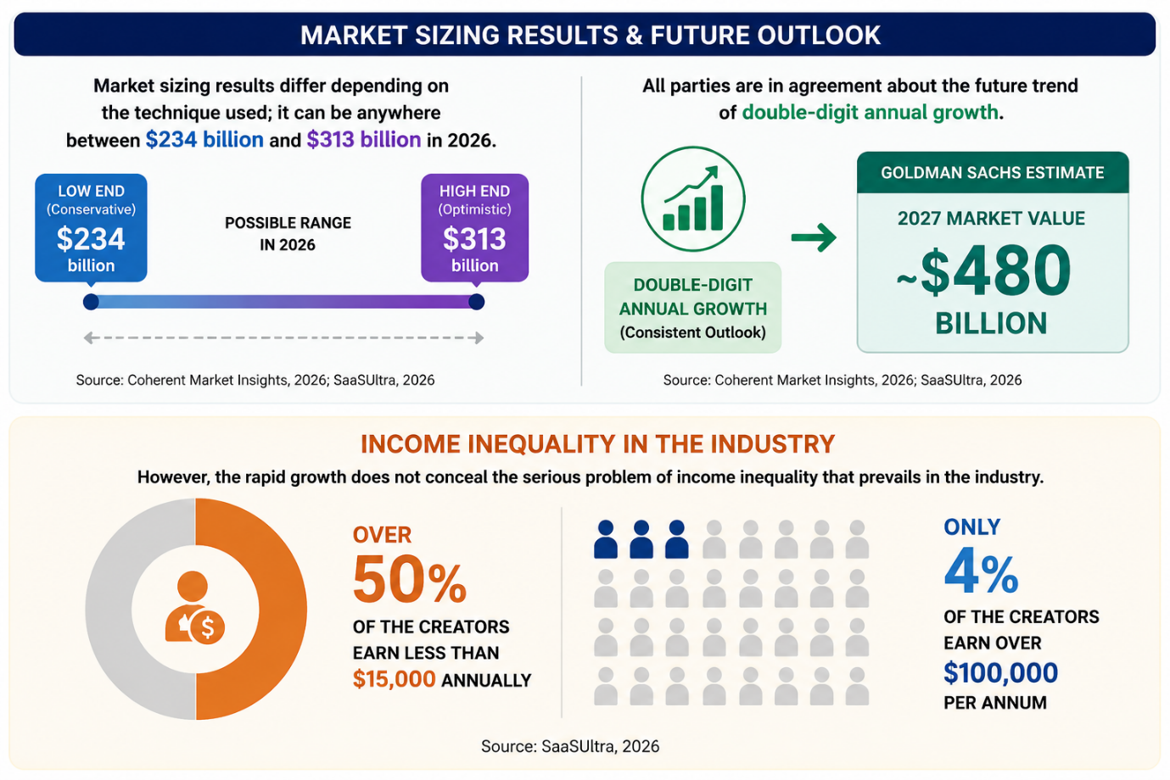
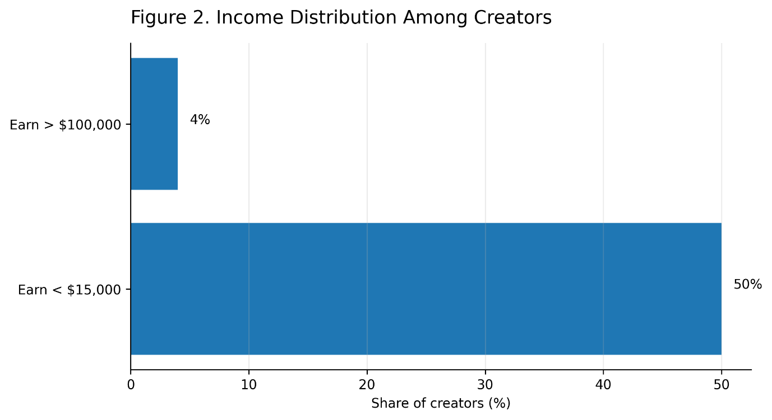
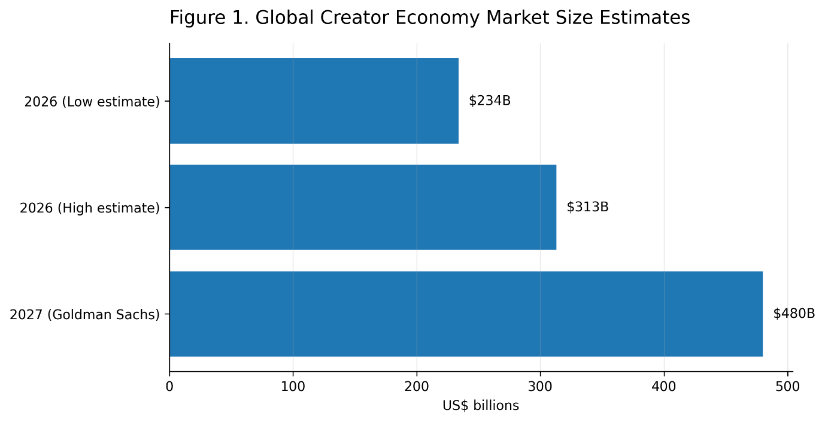

Environmental

Content creation has its environmental impact too. The process of streaming and AI-enabled editing requires electricity from data centres, which at present are estimated to use nearly one-fifth of the total electricity generated in Ireland and may rise to up to 32% by 2026, according to a report from the International Energy Agency. One single AI question consumes far less electricity than streaming a video for an hour, but the massive amount of content created in a $250 billion industry makes it into an externality.

Political

Geopolitics is now right in the centre of platform strategy. The restructuring of TikTok that was imposed by the US Act on Protecting Americans from Foreign Adversary Controlled Applications, completed in January 2026, saw Oracle, Silver Lake, and MGX gain management stakes, while ByteDance still controls the core algorithm under license. This solution is criticised as only partial in addressing the national security challenge it sought to address (ITIF, 2026). Within the EU, the investigation of the "addictive design" of TikTok carried out by the European Commission under the Digital Services Act, as well as the draft proposal of a Digital Fairness Act focusing specifically on influencer marketing, clearly demonstrates this trend (Lievens, Shala and Verdoodt, 2026; Osborne Clarke, 2026a).

Legal

There have been some very tough measures in UK disclosure legislation. In addition, the ASA has adopted an "Active Ad Monitoring" system which looks out for advertisements which fail to disclose themselves, and the Digital Markets, Competition and Consumers Act 2024 has granted the Competition and Markets Authority the right to fine companies up to 10% of their worldwide revenue in case of significant consumer protection infractions without having to go through a judicial process (ASA/CAP, 2025; Osborne Clarke, 2026a). The use of ambiguous terminology like "#gifted" or "PR trip" will not cut it anymore for the ASA; only outright disclosure, e.g., 'Ad ', is acceptable under CAP Codes.
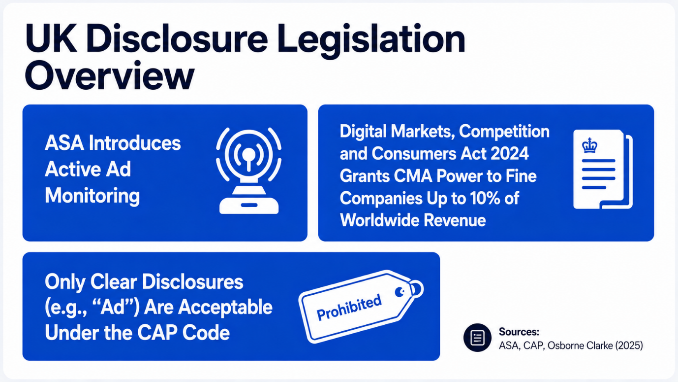

Ethical

Disclosure laws are necessary as deceit is profitable in the short run. Indeed, the same regulatory reasoning has already been applied to the world of AI in that virtual influencers are obligated to disclose both the business partnership and their synthetic nature, whereas deepfake-driven influencer fraud cost the global economy an estimated $23.7 billion in 2026 (SQ Magazine, 2026). Authenticity has thus emerged as the key ethical currency within the industry, the violation of which (inadvertently through undisclosed advertising or intentionally through AI) is precisely what the regulators, and more consumers, are pushing back against.
All of the seven factors presented above are interconnected and not separate from each other. Indeed, technological innovation (AI) drives further economic disruption (narrowing human-creator margins), which is causing negative social consequences (burnout, precarity), all of which are being addressed by politics and law (DSA, DMCC Act, and Digital Fairness Act) through the same goal – namely, that of disclosure and authenticity.

SWOT Analysis

- Strengths: Low barriers to entry and easy audience reach enable creators to establish businesses independent of conventional media intermediaries (Coherent Market Insights, 2026). This advantage is based on the technological STEEPLE factor discussed above.
- Weaknesses: Concentration of income and dependence on one platform (SaaSUltra, 2026) make most artists inherently vulnerable, which is a direct result of the factors described above; the rapid development of the industry has resulted in creating a labour force with virtually no protection.
- Opportunities: Diversified revenue sources like subscriptions, digital products and affiliate marketing earn an extra £56000 in annual income on average (SaaSUltra, 2026), while AI technology reduces production time for those who embrace it rather than competing against it.
- Threats: Regulatory tightening (fines levied under the DMCC Act, the EU's proposed Digital Fairness Act) increases compliance costs, while the development of AI-powered virtual influencers challenges the value of being human, and geopolitical actions, such as those seen in the TikTok restructuring case, demonstrate that the whole platform and its audience can be altered through government actions beyond the creator's control.
- Thus, according to Johnson, Whittington, Scholes, Angwin and Regnér's (2020) concept of strategic fit of the organisation with its environment, resiliency in this sector is structural and not creative. It is those creators who have diversified revenue streams and consider compliance as a necessity rather than red tape that are resilient to the problems outlined above.

Future Lens

Application of DPSIR approach (European Environment Agency, 1999): Driver: monetization platforms models and proliferation of AI tools; Pressure: oversaturated feeds and decreasing reach; State: a market where human content is relatively rare and synthetic content abounds; Impact: eroding trust and rising creator burnout; Response: regulation (DSA, DMCC Act, future Digital Fairness Act), as well as platform wellness programs like YouTube's Creator Wellness Program (The Creator Economy, 2026).
Three major trends are expected to shape the landscape for the coming years: first, the number of AI influencers will continue increasing at an expected compound annual growth rate of 41% until 2032, but not as a substitute but as an addition to human creators in trust-driven categories (SQ Magazine, 2026). Second, regulatory convergence regarding disclosure – commercial and AI – will put an even higher burden of compliance on the whole chain of suppliers: brands, agencies, and creators (Osborne Clarke, 2026b). Third, market saturation will reinforce the trend already revealed by data: multi-income creators consistently earn more than single-income ones, so professionalisation, rather than audience numbers, will be the key difference between creators.

Recommendations

Individual creators must first consider diversifying their income away from brand partnerships as the top priority, rather than the fallback option, because three or more sources of revenue are already associated with significantly greater earnings and less reliance on the algorithms and policies of one platform (SaaSUltra, 2026). Organisations in this ecosystem, whether agencies or platforms, would do well to start designing systems for AI disclosure and advertisement compliance verification at onboarding and contracting time because regulatory agencies are already doing just that (ASA/CAP, 2025; Osborne Clarke, 2026a).

Conclusion
It is clear what path the creator economy will follow when it comes to development. At the same time, its structural vulnerability is what needs to be mentioned. STEEPLE and SWOT analysis reveal the same idea: opportunities and threats for this industry are connected to the same process, and those who understand this can benefit.

Reference List

1.ASA/CAP (2025) Recognising ads: Social media and influencer marketing. Available at: https://www.asa.org.uk/advice-online/recognising-ads-social-media.html
2. Carbon Brief (2025) AI: Five charts that put data-centre energy use – and emissions – into context. Available at: https://www.carbonbrief.org/ai-five-charts-that-put-data-centre-energy-use-and-emissions-into-context/.
3. Coherent Market Insights (2026) Global Creator Economy Market Size and Forecast, 2026–2033. Available at: https://www.coherentmarketinsights.com/industry-reports/global-creator-economy-market.
4. Cosmetics Design Europe (2025) 52% of content creators say they have experienced 'burnout'. Available at: https://www.cosmeticsdesign-europe.com/Article/2025/07/17/52-of-content-creators-say-they-have-experienced-burnout/.
5. Digital Applied (2026) AI in Influencer & Creator Marketing: 2026 Playbook. Available at: https://www.digitalapplied.com/blog/ai-influencer-creator-marketing-2026-playbook.
6. European Environment Agency (1999) Environmental Indicators: Typology and Overview. Copenhagen: EEA.
7. Grand View Research (2026) Creator Economy Market Size, Share | Industry Report, 2033. Available at: https://www.grandviewresearch.com/industry-analysis/creator-economy-market-report.
8. Harvard T.H. Chan School of Public Health (2025) Content creators are struggling with mental health, study finds. Available at: https://hsph.harvard.edu/news/content-creators-are-struggling-with-mental-health-study-finds.
9. Institute for Technology, Information and Future (ITIF) (2026) Five Takeaways from the TikTok Deal. Available at: https://itif.org/publications/2026/01/26/five-takeaways-from-the-tiktok-deal.
10. Johnson, G., Whittington, R., Scholes, K., Angwin, D. and Regnér, P. (2020) Exploring Strategy: Text and Cases. 12th edn. Harlow: Pearson.
11. Lievens, E., Shala, V. and Verdoodt, V. (2026) 'Just one more video…: down the (legal) rabbit hole of TikTok's addictive design', Verfassungsblog, 2 March. Available at: https://verfassungsblog.de/tiktok-dsa/.
12. Osborne Clarke (2026a) Advertising and marketing | UK Regulatory Outlook January 2026. Available at: https://www.osborneclarke.com/insights/regulatory-outlook-january-2026-advertising-marketing.
13. Osborne Clarke (2026b) Advertising and marketing in 2026: what businesses might expect in the UK and EU. Available at: https://marketinglaw.osborneclarke.com/advertising-regulation/advertising-and-marketing-in-2026-what-businesses-might-expect-in-the-uk-and-eu/
14. SaaSUltra (2026) Creator Economy Statistics and Market Size 2026. Available at: https://www.saasultra.com/creator-economy-statistics/.

